AnalystLab Africa - Experience Lab Internship

FinTrust Digital Bank - Week 1

Track : Data Analytics
Submitted by : Yawa Jacqueline GBEDEVI
Project : FinTrust Financial Intelligence & Digital Banking Support Solution

General Week 1 Requirements

Understanding FinTrust's Business Problem

What problem is FinTrust trying to solve?
FinTrust is a digital bank. It holds a lot of data about its customers and their transactions, but it is not yet using this data well enough. It wants to use this data, together with artificial intelligence, to better understand its customers, spot risky transactions, improve how it operates internally, and respond better to customers.

Why is this problem important ?
A bank that does not understand its customers and transactions well is making decisions blindly. It can miss fraud, misuse its money and time, or fail to see where to improve service. Understanding the data also helps keep customer trust and meet banking industry rules.

How can my track (Data Analytics) contribute?
Before building advanced models or tools, the team first needs to understand what the raw data says, for example, who the customers are, how they transact, and where the problems lie. The job of the Data Analytics track is to give a first clear picture of the situation, with simple figures that everyone can understand and follow.

What type of output can my track provide, across the full 4 weeks of the project?
- A data understanding report on what the customer and transaction files contain, their quality, and their limitations.
- Clear answers to concrete questions about customer behaviour, transaction activity, and risk trends.
- A KPI table that the bank can track on an ongoing basis.
- A working Power BI dashboard, with charts, filters, and KPI cards.
- Data-driven recommendations, for example on channels or customer segments to watch.
In short, my track delivers, by the end of the project, a monitoring tool, which is the dashboard, and an analysis that helps FinTrust make better decisions, and that also serves as a foundation for the other tracks.

Resource Review

FinTrust_Customer_Data
- Content: information on 1,500 customers (age, gender, city, segment, account type, tenure, digital engagement score, income band, preferred channel, account status).
- Planned use: base for segmenting customers and cross-referencing their profiles with their transaction behaviour.
- Limitations: no missing values found.

FinTrust_Transaction_Data
- Content: 12,000 transactions (customer, date/time, type, amount, channel, device, location, status, risk indicator) covering January to March 2026.
- Planned use: analysis of transaction behaviour, joined to the customer table through Customer_ID.
- Limitations: 96 missing values each in Device_Type and Location.

FinTrust Project Brief
- Content: FinTrust's full business context, the business problem, objectives, key questions, project scope, and success criteria.
- Planned use: reference document used to frame my analytical questions and KPIs.
- Limitations: general framing, to be cross-checked with the specific Week 1 assignment instructions.

FinTrust 4-Week Master Roadmap
- Content: the week-by-week breakdown of activities expected from each track.
- Planned use: base for my Week 2 to Week 4 plan.
- Limitations: an illustrative roadmap, not a strict specification.

FinTrust Data Dictionary
- Content: the official definition of each field in the customer file.
- Planned use: to validate my interpretation of columns rather than guessing their meaning.
- Limitations: only covers fields in the customer table, not the transaction table.

Data Analytics Track Objectives
- Build a thorough understanding of FinTrust's customer and transaction data, documenting its structure, quality, and relationship.
- Answer FinTrust's key business questions on customer segments, transaction behaviour, and the most used channels.
- Define a set of relevant, measurable KPIs that FinTrust's management can track on an ongoing basis.
- Design a clear, useful dashboard that communicates the main insights to non-technical stakeholders.

Success Criteria
- The data is well understood. I have clearly explained what the two files contain, their quality, and their limitations.
- My questions address FinTrust's real needs and can genuinely be answered with the data available.
- My KPIs are useful and clear, each with a simple definition and data that is actually available.
- The dashboard is easy to understand, even for a non-technical person.
- My work can be used by the other tracks starting in week 2, especially the Data Science track.
- I am honest about limitations: every assumption or missing piece of data is clearly flagged.

Plan for Weeks 2 to 4

Week 2
I clean the data by fixing the missing values found, carry out the analysis using Python and SQL, and start building the dashboard. I also share the first useful findings with the Data Science track.

Week 3
I complete the dashboard, deepen the analysis, validate that my results are reliable, and prepare what I will hand over to the other tracks for integration.

Week 4
I test the dashboard, refine the visuals and messaging, finalise my recommendations, and prepare my final presentation.

Data Analytics Track-Specific Analysis

Part A - Business Understanding

What business questions should FinTrust's management be able to answer?
- Who are our main customers, and how are they distributed by age, city, income, or account type?
- Which transaction types are most used (withdrawal, transfer, payment...)?
- Which channels do customers prefer (mobile app, USSD, web)?
- Are some customer groups more active or more valuable than others?
- How many transactions fail or get reversed, and why?
- Which behaviours look like risky transactions?

What decisions could data analysis support?
- Deciding where to invest to improve the customer experience.
- Adapting FinTrust's offers to the customer segments that bring the most value.
- Spotting transactions that need review more quickly.
- Deciding which customers to re-engage, for example those whose account becomes Dormant.

What stakeholders could benefit from these analyses?
- FinTrust's management, to track overall performance.
- The product/marketing team, to better target offers.
- The risk and compliance team, to monitor suspicious transactions.
- The customer support team, to understand where customers run into problems.
- The Data Science track of this project, for its work on risk.

Part B - Data Understanding

FinTrust_Customer_Data
- Number of records: 1,500 customers
- Number of columns: 12
- Fields: Customer_ID, Customer_Name, Age, Gender, City, Customer_Segment, Account_Type, Tenure_Months, Digital_Engagement_Score, Monthly_Income_Band, Preferred_Channel, Account_Status
- Data types: text for most fields, integers for Age and Tenure_Months, decimal for Digital_Engagement_Score
- Categorical variables: Gender, City (8 cities), Customer_Segment (Everyday, Premium, SME, Student), Account_Type, Monthly_Income_Band, Preferred_Channel, Account_Status
- Numerical variables: Age (18 to 65 years), Tenure_Months (1 to 96 months), Digital_Engagement_Score (16.7 to 100)
- Date/time variables: none in this file
- Missing values: none across the 1,500 rows
- Data-quality issues: no duplicate Customer_ID, nothing concerning at first glance

FinTrust_Transaction_Data
- Number of records: 12,000 transactions
- Number of columns: 11
- Fields: Transaction_ID, Customer_ID, Transaction_DateTime, Transaction_Type, Amount_NGN, Channel, Device_Type, Location, International_Transaction, Transaction_Status, Risk_Review_Flag
- Data types: text for most fields, decimal for Amount_NGN, date/time for Transaction_DateTime
- Categorical variables: Transaction_Type (6 types), Channel (5 channels), Device_Type, Location (8 cities), International_Transaction, Transaction_Status (Successful, Failed, Reversed, Pending), Risk_Review_Flag (No, Yes)
- Numerical variable: Amount_NGN
- Date/time variable: Transaction_DateTime, from 1 January to 31 March 2026
- Relationship between the two datasets: linked through Customer_ID; one customer can have several transactions (between 1 and 20). Every Customer_ID in the transaction data exists in the customer table, and every customer has at least one transaction.
- Missing values: Device_Type and Location each have 96 missing values
- Data-quality issues: no duplicate Transaction_ID, no negative or zero amounts

Part C - Analytical Questions
- Which customer segments (Everyday, Premium, SME, Student) generate the most transactions, and for what amounts?
- Does a customer's age or digital engagement score influence which channel they use most?
- Which transaction types are most frequent, and which represent the largest total value?
- Which channel generates the most activity, and which has the most failed or reversed transactions?
- What share of transactions is flagged for risk review, and does this vary by channel, transaction type, or whether the transaction is international?
- Do customers with a Dormant or Restricted account show different transaction behaviour than Active customers?

Part D - KPI Planning
KPI | Definition | Why It Matters | Required Data
Transactions per month | The total number of transactions made each month | Shows whether activity on the platform is growing or shrinking | Transaction_DateTime
Total transaction value | The sum of all transaction amounts | Gives a sense of how much money flows through FinTrust | Amount_NGN
Failed transaction rate | The percentage of transactions with the status Failed | Helps spot technical or customer experience problems | Transaction_Status
Risk-flagged transaction rate | The percentage of transactions with Risk_Review_Flag = Yes | Helps the risk team track how flagged cases evolve | Risk_Review_Flag
Most used channel | The channel (Mobile App, ATM, Web, USSD, POS) with the most transactions | Shows where customers prefer to act, useful for prioritising improvements | Channel
Average active customer | The average number of transactions per customer over the period | Shows how much customers actually use their account | Customer_ID, Transaction_ID
Customer segment breakdown | The percentage of customers in each segment (Everyday, Premium, SME, Student) | Helps understand the makeup of the customer base | Customer_Segment
Dormant account rate | The percentage of accounts with the status Dormant | Helps identify customers who need to be re-engaged | Account_Status

Part E - Dashboard Wireframe
The proposed dashboard is organised into 4 sections, with filters at the top of the page (period, customer segment, channel, city).
- Section 1 - Overview: 4 KPI cards (number of transactions, total amount, failed transaction rate, risk review rate).
- Section 2 - Customer behaviour: customer breakdown by segment, and preferred channel by segment.
- Section 3 - Transaction activity: transaction volume over time, and breakdown by transaction type.
- Section 4 - Risk: risk review by channel, and comparison between domestic and international transactions.
This dashboard should make it quick to see which customer segments are most active, which channels have the most issues, and where risky transactions concentrate.
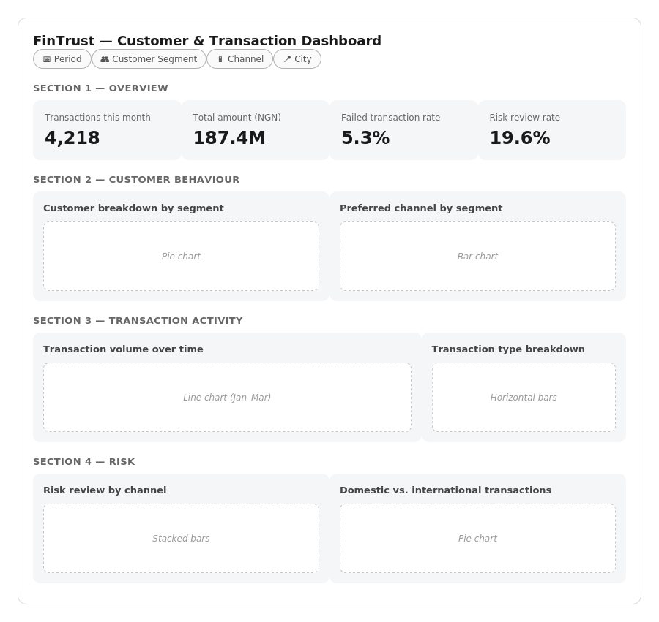
- Risk Register
Risk | Probability | Impact | Mitigation
Missing values in Device_Type and Location limit some analyses | Low | Low | Flag these cases clearly and exclude them only when necessary
The dashboard takes longer to build than planned | Medium | Medium | Start practising Power BI from week 2 onward

Future Dependencies with Other Tracks
No formal collaboration is required this week, but here are the dependencies I anticipate from week 2 onward.
Dependency | From | To | Why It May Matter | Expected Week
Risk-related transaction patterns | Data Analytics | Data Science | The Data Science track will need my observations on flagged transactions to build its predictive model | Week 2
Validated data structure and quality | Data Analytics | ML Engineering | The ML Engineering track can build on my data profiling to design a reliable pipeline | Week 2-3
Customer behaviour insights | Data Analytics | Generative AI | The GenAI track can use my insights to better ground the assistant's responses | Week 3
KPI list and analysis results | Data Analytics | Project Management | The Project Management track needs my results for the overall reporting plan | Week 2

Professional Documentation
- Github Link: https://github.com/jgbedevi/fintrust-digital-bank-data-analytics.git
- X Post: https://x.com/jgbedevi/status/2101703405647396869?s=46
- LinkedIn: https://lnkd.in/p/dGxSMr6q

