Verification Layer Project Summary
BC municipal bylaw rule verification prototype
Prepared: 2026-06-08 | Scope: extraction handoff, deterministic verification, benchmark, review dashboard, and verified-only GIS/Felt export.

Executive Summary
I built a verification-first layer for municipal zoning rule extraction. The upstream extraction pipeline generates candidate rules from bylaw text and tables, but my layer decides whether each candidate is trustworthy enough for downstream use. The system treats extraction as proposal generation and verification as the authority. This matters because zoning rules can be mis-scoped, copied from the wrong table cell, missing exception context, or valid only as a cross-reference. A GIS workflow should not consume those rules unless the evidence supports every critical field.
The current project is publish-ready as a benchmark-driven prototype. It has a reproducible Burnaby R1 run, a Vancouver holdout run, a Streamlit dashboard, adversarial safety checks, and verified-only GIS/Felt handoff files. The strongest result is safety: verified precision is 1.00 on the measured benchmark, false verified rules are 0, false proposal approvals are 0, and 8 adversarial poisoned candidates are blocked.
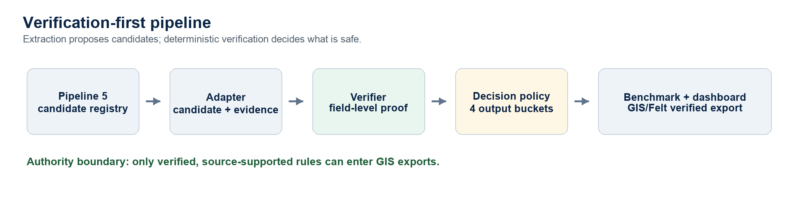

What I Built
The main engineering contribution is a deterministic rule verification pipeline. It adapts Zihao's Pipeline 5 rule registry into a clean candidate/evidence contract, normalizes candidate fields, checks cited evidence field by field, and separates outputs into verified, review_needed, rejected, and not_used buckets. Only verified rules enter the GIS contract. Review, repair, semantic, and LLM-assistant modules are deliberately advisory; they help explain or prioritize work but cannot promote a rule.
The verifier supports text evidence and table evidence. For tables, it uses a TabVer-style proof: table title, row header, column header, and cell value each support different parts of the rule. For prose, it uses local text-span proof so a candidate is not verified from an unrelated number elsewhere on the page. This design prevents broad context from accidentally proving the wrong rule.

How Verification Works
Each rule is checked as a collection of claims. The verifier asks whether the evidence supports the rule family, numeric value, unit, operator direction, applies_to field, scope, condition, and exception status. Missing or uncertain evidence goes to review. Hard contradictions, such as a value not appearing in evidence or a unit incompatible with the rule family, go to rejected. Cross-reference and administrative artifacts go to not_used so they remain auditable without polluting GIS outputs.
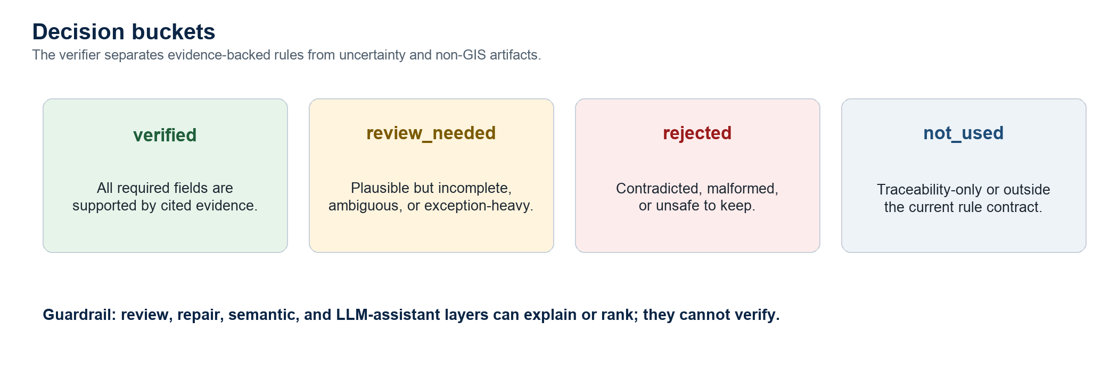

Outputs And Downstream Handoff
The project writes rich verifier outputs for audit and a slim verified-only contract for downstream use. The full proof traces stay in verified_rules.json and review_needed.json. The GIS-facing contract is intentionally smaller: it contains only the rule fields and a compact citation. This keeps downstream tools from depending on internal verifier details.
Output | Purpose
verified_rules.json | Full verified rules with source evidence and proof traces.
review_needed.json | Plausible but incomplete or legally ambiguous rules for human review.
rejected_rules.json | Contradicted or unsafe malformed candidates.
not_used.json | Traceability-only or out-of-contract extraction artifacts.
gis_rule_contract.json | Authoritative verified-only contract for GIS.
gis_felt_export.json | Map/dashboard-oriented projection from verified rules only.

Benchmark And Safety Results
The benchmark measures candidate recall, verified recall, verified precision, source-support failures, proposal decision safety, proof/decision consistency, and adversarial robustness. The Burnaby benchmark is the in-domain test. The Vancouver holdout is a cross-city check showing that the verifier's safety logic transfers when the rule family is supported by the contract.
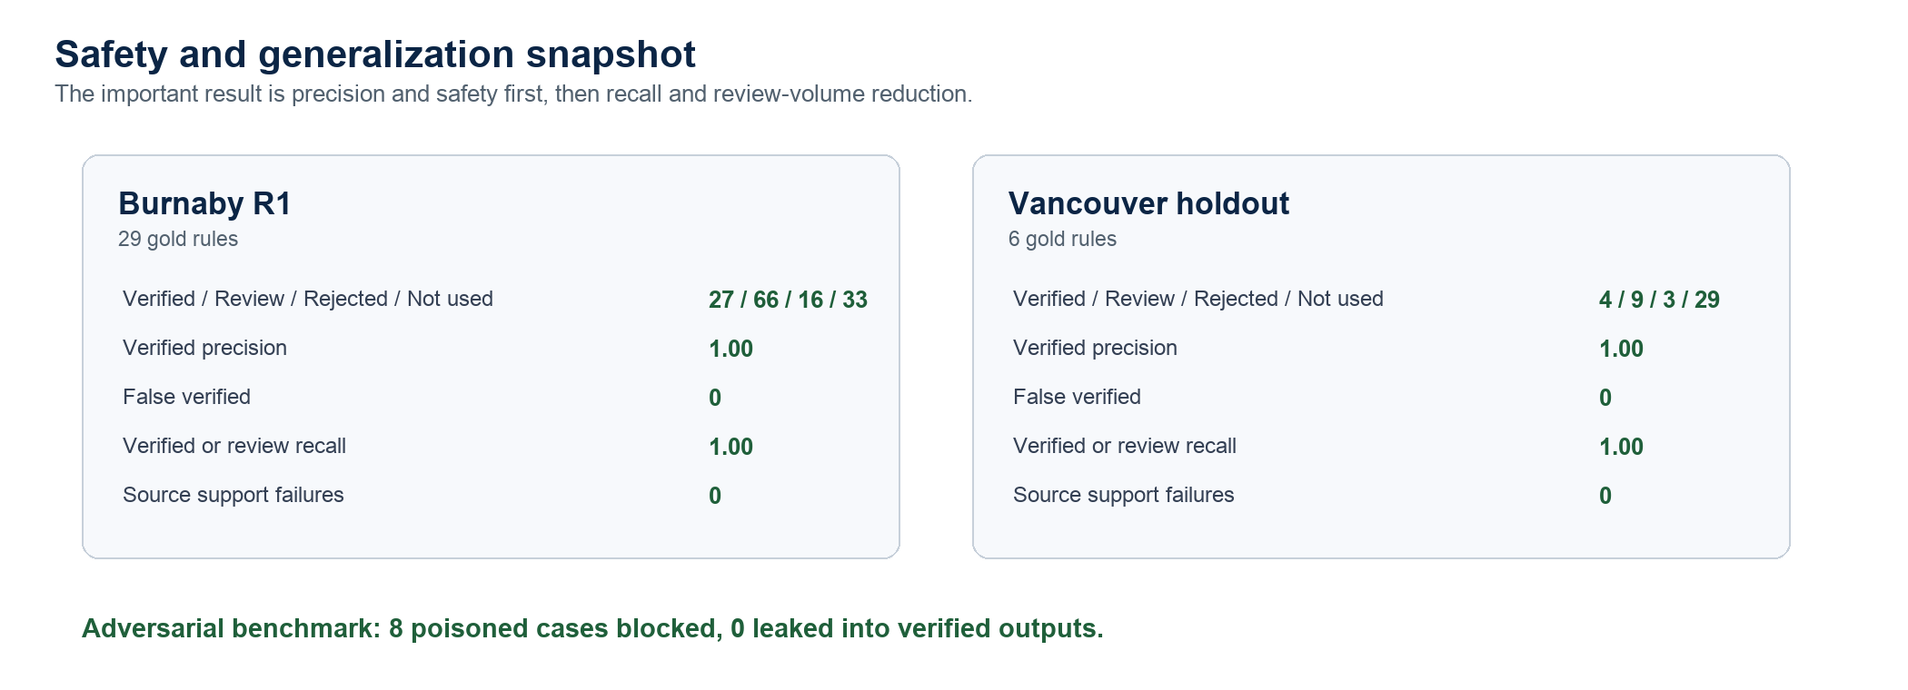
Metric | Burnaby R1 | Vancouver Holdout
Candidate rules | 142 | 45
Verified / Review / Rejected / Not used | 27 / 66 / 16 / 33 | 4 / 9 / 3 / 29
Verified precision | 1.00 | 1.00
False verified rules | 0 | 0
Verified or review recall | 1.00 | 1.00
False approvals | 0 | n/a

Why This Is Significant
The project converts a risky extraction workflow into a controlled model-validation workflow. Instead of asking whether an extracted rule looks plausible, it asks whether the evidence proves it. This gives the system implementation controls, explainability, uncertainty handling, and measurable safety gates. The benchmark is not a decoration: every verifier change is expected to preserve verified precision, false approval count, and source-support integrity.
This is also significant for multi-city bylaw work. The Burnaby run proves the system can support detailed GIS-relevant zoning constraints. The Vancouver holdout shows where the verifier generalizes and where the rule-family contract needs expansion. The system does not hide this limitation. It keeps out-of-contract rule families in not_used and review outputs instead of pretending they are verified.

Current State And Next Work
The current stage is no longer 'make it work.' The safety baseline is stable. The next useful work is verified-recall improvement without weakening the gates: add more general rule families such as floor-area ratio, improve parent-clause context for short subclauses, and continue testing on additional BC bylaws. The dashboard should continue to help reviewers understand why a candidate is blocked and which evidence would be needed to promote it safely.
- Keep deterministic verification as the only promotion authority.
- Use semantic or LLM layers only for retrieval, explanation, triage, or review assistance.
- Expand supported rule families only with tests and benchmark evidence.
- Send only verified, source-supported rules to GIS and Felt exports.

