Classifying Foods by Image
Modelling with Advanced Machine Learning Methods

Summary
Food classification models have many potential applications in the health and food industries. The Food-101 dataset [1] contains 750 training images for each of 101 categories of food. This dataset was used to train eight classification models for comparison, built using ResNet18 and EfficientNetV2-S pretrained backbones with four heads implementing different training strategies: linear probing, LoRA, task-specific adapters, and BatchNorm tuning. Professor Shan Du provided six test sets [2] to evaluate the models, each containing 250 images for each food category. Models were trained using five epochs each. The original clean test set was used to determine model accuracy, and five modified variants were used to determine robustness. The most performant model was built using EfficientNetV2-S and LoRA, with an accuracy of 0.822 on the clean test set and a mean robustness of 0.809. The model performs well on masked, rotated, and slightly blurred images, however, it struggles if there is too much blur or downsampling. The model built using EfficientNetV2-S and BathNorm tuning performs nearly as well as the best model, but has far fewer trainable parameters. Decreasing validation loss across epochs suggests the models are currently being underfit. To obtain an improved model, these two models could be trained with more epochs and compared again.

Introduction
Machine learning focuses on developing models that can learn patterns from data and improve their performance over time. One of the most common tasks in this field is classification, where a model assigns an input to one of several predefined categories. In image classification, inputs are assigned to one of several predefined categories. In image classification, inputs are represented as numerical values corresponding to pixel intensities, allowing models to learn visual patterns directly from data.
Deep learning has become a powerful approach for solving image classification problems due to its ability to model complex relationships. Neural networks achieve this by applying multiple layers of transformations, each extracting increasingly abstract features from the input. While simple models can approximate many functions, deeper architectures are more effective because they break down complex patterns into smaller, more manageable representations.
Convolutional neural networks (CNNs) are particularly well-suited for image data. These models use convolutional filters to detect local patterns such as edges, textures, and shapes, and then combine these features to form higher-level representations. Modern architectures such as ResNet and EfficientNetV2 have demonstrated strong performance on large-scale image classification tasks and are commonly used as pretrained backbones for transfer learning [3].
Training deep neural networks involves optimizing a large number of parameters using a gradient-based method. While full-tuning of all parameters can achieve high performance, it is often computationally intensive and requires significant memory and training time. To address this, transfer learning is widely used, where pretrained models are adapted to new tasks using smaller datasets.
As deep learning models grow in size, parameter-efficient fine-tuning (PEFT) methods have attracted significant attention for reducing computational cost while maintaining performance. Instead of updating all model parameters, these methods introduce a small number of additional trainable components. Important approaches in this category include LoRA, task-specific adapters, and BatchNorm tuning. LoRA modifies existing layers by adding low-rank updates, while task-specific adapters insert small neural modules into the networks to capture task-specific information. BachNorm tuning, on the other hand, updates only the normalization parameters of the network, enabling lightweight adaption. These methods allow models to adapt efficiently without significantly increasing complexity.
In this project, Gradient-weighted Class Activation Mapping (Grad-CAM) is used to visualize the regions of an image that contribute most to the model’s decision. Grad-CAM produces heatmaps that highlight important regions of the input image, helping determine whether the model is focusing on meaningful features or irrelevant background information.
In this project, we investigate how different fine-tuning strategies affect the performance of image classification models on the Food-101 dataset. This dataset comprises 101 food categories, making it a challenging benchmark for evaluating model generalization. We compare linear probing, LoRA, task-specific adapters, and BachNorm, using pretrained ResNet18 and EfficientNetV2-S pretrained backbones. This project explores the trade-off between model performance and computational efficiency. Metrics such as accuracy, robustness, number of trainable parameters, and computational cost are used to compare different methods. By analyzing these factors, we aim to understand how parameter-efficient techniques can be applied to achieve a balance between accuracy and efficiency in particular deep learning applications.

Methodology

Overview of the Pipeline
The overall pipeline for the project follows a structured deep learning workflow for image classification. The process begins with data preparation, followed by model initialization using pretrained, followed by model initialization using pretrained architectures, application of different fine-tuning strategies, and finally evaluation on both clean and corrupted datasets.
The goal of this pipeline is to systematically compare how different training strategies affect model performance, robustness, and efficiency. In particular, the focus is on parameter-efficient methods that update only a subset of model parameters during training. At a high level, the pipeline consists of four stages:
- Dataset preprocessing
- Feature extraction using pretrained backbones
- Applications of different training strategies
- Evaluation using multiple performance metrics

Dataset and Preprocessing
The Food-101 dataset was used as the primary dataset for this project. It consists of 101 food categories, with 750 training images and 250 test images per class. The dataset presents a challenging classification problem due to high intra-class variation and visual similarity across classes.
Before training, images were preprocessed to ensure compatibility with pretrained convolutional neural networks. This included resizing images to a fixed size and normalizing pixel values. Data was loaded in batches to enable efficient training using mini-batch gradient descent.
Robustness measures a model's performance on a modified test set relative to the clean test set. To evaluate model robustness, five transformed test set variants were used: little-blur, medium-blur, rotation, masking, and downsampling. These transformations simulate real-world conditions where image quality may be degraded.

Pretrained Backbone Architectures
Two convolutional neural network architectures were used as backbone models: RestNet18 and EfficientNetV2-S. Both models were initialized with ImageNet-1K weights, allowing them to leverage pretrained visual features. Convolutional neural networks are particularly effective for images for image data because they preserve spatial structure and learn hierarchical representations. As shown in Figure 1, CNNs process images through multiple layers, gradually transforming raw pixel data into high-level features raw.

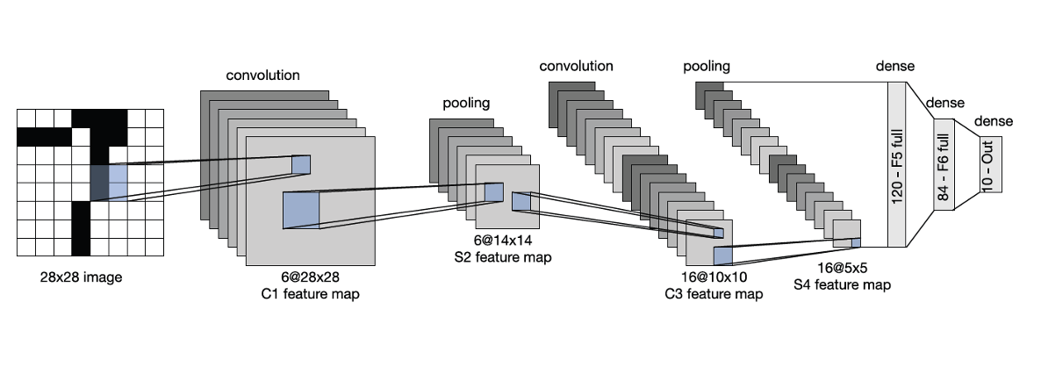
Figure 1: Example CNN architecture illustrating convolution, pooling, and fully connected layers [4].

Lower layers of the network typically set simple patterns such as edges and textures, while deeper layers capture more complex structures such as object parts and full objects. This hierarchical learning allows pretrained models to generalize effectively to new datasets. For this project, the final classification layer of each model was replaced with a new fully connected layer corresponding to the 101 output classes.

Training Strategies
The pretrained models were adapted to the Food-101 dataset, and several fine-tuning strategies were implemented. These methods differ in how many parameters are updated during training and how the model adapts to the new task.

Linear Probing
Linear probing was used as the baseline method. In this approach, all layers of the pretrained backbone are frozen, and only the final classification layer is trained. This method assumes that the pretrained model has already learned useful feature representations that can be directly applied to the new task. As a result, training is computationally efficient since only a small number of parameters are updated. However, since the other layers can not be modified, the model may not fully adapt to the new dataset, limiting performance.

Low-Rank Adaption (LoRA)
Low-Rank Adaptation (LoRA) is a parameter-efficient method that introduces small trainable updates to linear layers. Instead of updating the full weight matrices, LoRA adds a low-rank approximation that captures task-specific changes. This approach significantly reduces the number of trainable parameters, making training more efficient while still allowing the model to adapt. LoRA follows the general principle of modifying neural network layers during training while keeping most parameters fixed. The idea aligns with the broader concept of efficient parameter updates in deep learning.

Task-Specific Adapters
Task-specific adapters were implemented by inserting small neural models into selected layers of the backbone networks. These adapters learn task-specific transformations while preserving the original network structure. Adapters follow a residual learning approach, combining the original output with the adapter output. This is conceptually related to residual connections used in networks such as ResNet.

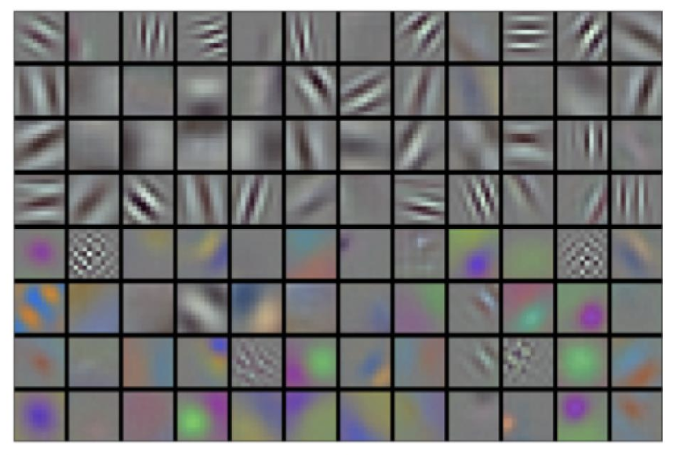
Figure 2: Example of features learned by early layers of a convolutional neural network, showing detection of edges, textures, and patterns [5].

Each adapter module consists of a small transformation applied to future maps, typically using convolutional layers and nonlinear activation functions. During training, only the adapter parameters and the final classification layer are updated. This allows the model to adapt to the new task while retaining most of its pretrained knowledge.

BatchNorm Tuning
BatchNorm tuning is a lightweight fine-tuning approach that updates only the batch normalization layer parameters. These parameters control the scaling and shifting of feature distribution within the network. By updating only these parameters, the model can adjust internal feature distributions to better match the new dataset without modifying the full set of weights. This makes BatchNorm tuning computationally efficient, but it may limit the model’s ability to fully adapt to complex tasks.

Training Procedure
All models were trained using a consistent setup to ensure a fair comparison. Adam optimizers were used, and each model was trained for five epochs. Training neural networks involves alternating between forward and backward propagation. During forward propagation, the input is passed through the network to generate model parameters. Forward and backward propagation are interdependent processes where intermediate values from the forward pass are used to compute gradients during backpropagation. This iterative process continues across epochs until training is stopped.

Evaluation Strategy
Model performance was evaluated using both clean and corrupted test datasets. The clean dataset was used to measure classification accuracy, while the variants were used to evaluate robustness under various modifications. Metrics used for evaluation included. For each model the inference speed, computational complexity (FLOPs), and number of trainable parameters were computed for comparison as well. These metrics provide a comprehensive assessment of both model performance and computational efficiency.

Model Interpretability using Grad-CAM
Grad-CAM provides visual explanation of the decision-making process through heatmap visualization. Grad-CAM identifies parts of an input image that make the greatest contribution to the output class label. The technique uses the gradients of the target label with respect to the feature maps from the last convolutional layer. The gradient produces a localization map, which is overlaid onto the input image to identify regions of interest. The Grad-CAM technique was employed for studying how various models work when fine-tuned. It enables determining if the model relies on the right parts of the image, like the food object, or focuses on other elements unrelated to classification.

Experiments

Custom Models

Linear Probing (Baseline) Models
From a copy of both our Resnet and Effnet backbone pretrained models, we prepared our Resnett and Effnet baselines by freezing all layers except for the last classification layer. Training of each model was performed on our downstream Food-101 dataset. The same training routine was applied to each model on our train set with a batch size of 32. The training routine consisted of 5 epochs using Adams solver filtered for only the active layers (final classification layer). For each epoch both the train and test cross entropy loss were evaluated and stored, as well as the train and test accuracies. The models were saved for future reference. We observed the following results for each epoch:

Metric | Epoch 1 | Epoch 2 | Epoch 3 | Epoch 4 | Epoch 5
ResNet Train Loss | 4.2206 | 3.5218 | 3.1157 | 2.8743 | 2.7094
ResNet Train Acc | 0.1156 | 0.2860 | 0.3514 | 0.3850 | 0.4048
ResNet Val Loss | 3.6423 | 3.0294 | 2.6766 | 2.4494 | 2.2975
ResNet Val Acc | 0.2744 | 0.3952 | 0.4394 | 0.4741 | 0.4920
EffNet Train Loss | 4.2537 | 3.6832 | 3.3260 | 3.1051 | 2.9523
EffNet Train Acc | 0.1502 | 0.2897 | 0.3247 | 0.3444 | 0.3604
EffNet Val Loss | 3.7791 | 3.2391 | 2.8949 | 2.6821 | 2.5139
EffNet Val Acc | 0.3391 | 0.3882 | 0.4173 | 0.4372 | 0.4533

Table 1: Linear Probing Baseline models Accuracy and Loss per epoch.

We observe the metrics for each epoch for each of our linear probing models in Table 1. We can observe that the Effnet baseline is generally more accurate than the Resnet baseline. The strong influence of the backbone on model performance and other metrics is further discussed later.

Low-Rank Adaption (LoRA) Models
We created both Resnet and Effnet Lora models from copies of our pretrained Resnet and Effnet Backbone models. For each of these Lora models the original model weights were frozen, and small trainable adapter matrices were added to both the linear and convolutional layers. Training of each model was performed on our downstream Food-101 dataset. The same training routine as mentioned earlier was applied to each of our Resnet and Effnet Lora models. The only difference was that we used Adams solver filtered for only the active parameters of the Lora models. For each epoch both the train and test cross entropy loss were evaluated and stored, as well as the train and test accuracies. The models were saved for future reference.

Task Specific Adapters Models
We created Resnet and Effnet Task Specific adapters models from copies of our Resnet and Effnet backbones. We performed freezing of all but the final classification layer, and also inserting and activating small adapted neural model layers into specific layers. An increased bottleneck dimension of 128 was used to increase the adapter's capacity to learn and overall model accuracies. The same training routine as mentioned earlier was performed on each model with the Adams solver filtered on only the active parameters.

Batchnorm Tuning Models
We performed batchnorm tuning on copies of both of our Resnet and Effnet backbone models. We froze all layers except the final classification layer and BatchNorm2d layers for each of these copies. Training of each model was performed on our downstream dataset for 5 epochs with a batch size of 64. The training routine recorded the train accuracy and train cross entropy loss for each epoch. We used the Adams solver filtered for only active parameters. Unfortunately this model was trained before we recorded each epoch's validation accuracy and loss, so we only have per epoch data for the train accuracy and loss.

Evaluations
We ran an evaluation routine on all 8 of our custom models. Each custom model performed predictions on the entire test set while being timed, and the average test accuracy and inference speed (evaluation time per image) were returned. This was performed on all test set variants, including: clean, blur little, blur medium, down sampled, masked and noise rotation. The results for each model on each test set were saved and analyzed. The FLOPs counts of each model were also calculated to analyze computational costs. Several plots were created to visualize the results:

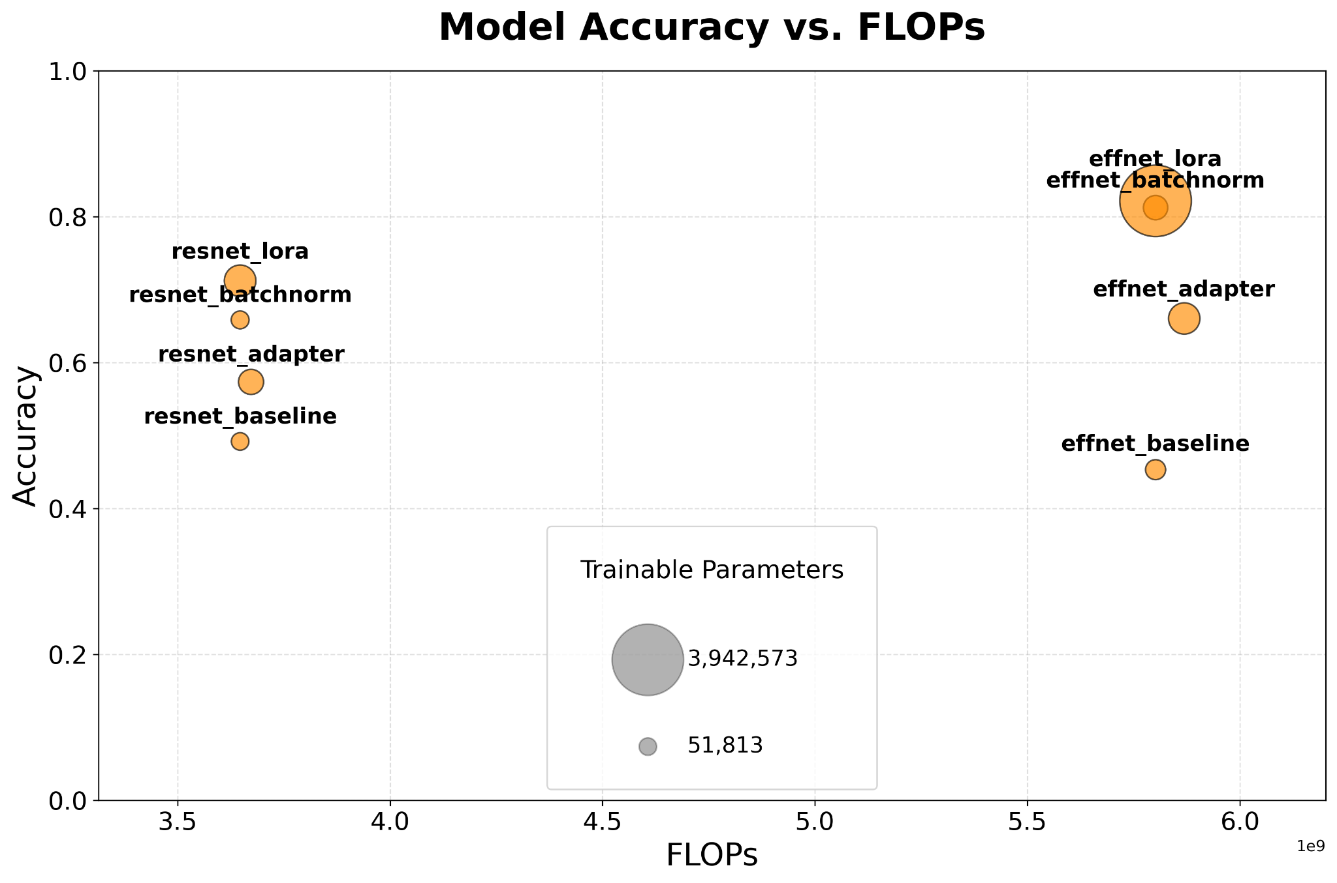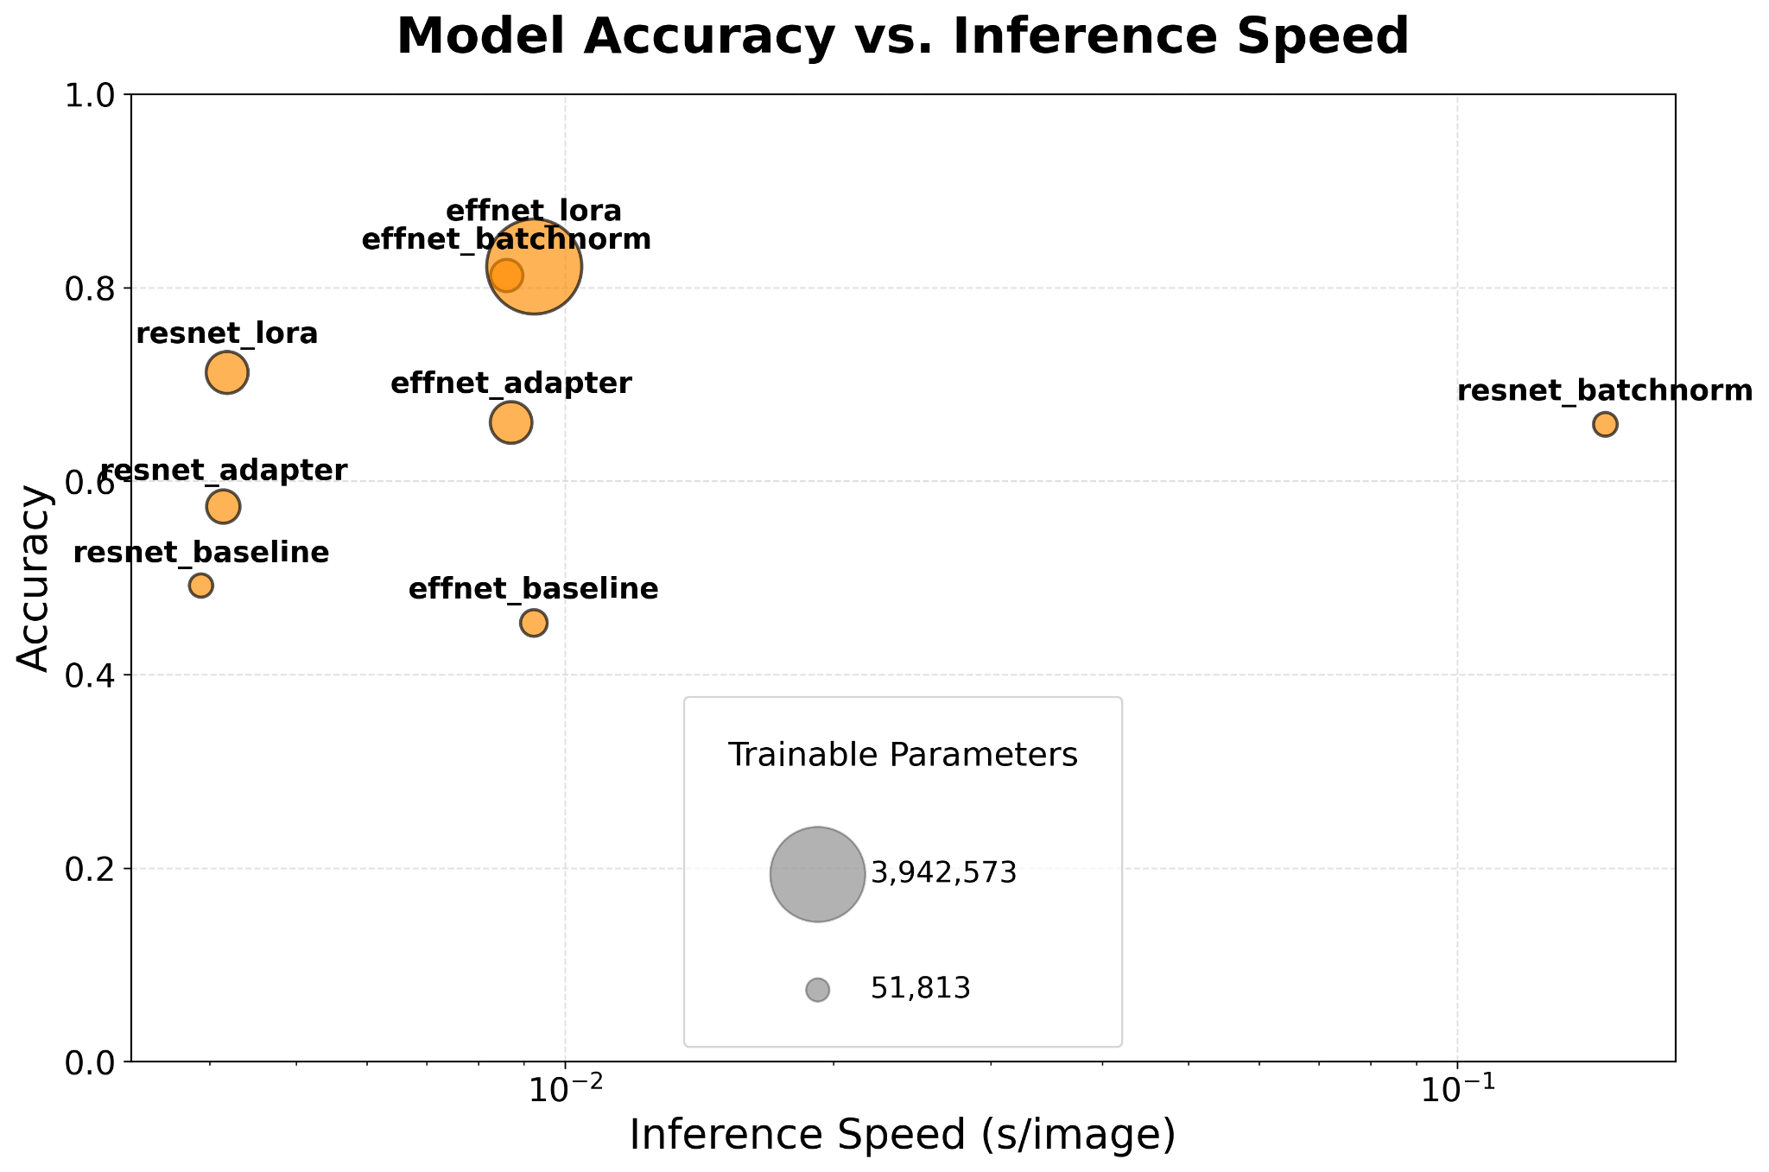
Figure 3: Plots to illustrate the relationships between FLOPs, Inference Speed, Accuracy and Trainable Parameters of all of our custom models.

From the leftmost plot in figure 3 we can observe a clear distinction between the FLOPs counts between models with different backbones. The FLOPs counts of the models appear to be clustered according to backbone, as this seems to be the dominating predictor of FLOPs count. All custom models with an Effnet backbone have a significantly larger FLOPs count than those with a Resnet backbone, likely due to Effnet's compound scaling strategy, which simultaneously increases network depth, width and resolution, further prolonging computation time. The model variant does not appear to have any significant influence on the FLOPs count. We also observe the Effnet backboned models to have a slightly superior accuracy compared to the Resnet backboned models across all custom model types. This general superiority in accuracy is also likely because of the compound scaling of Effnet, which balances 3 dimensions (network, depth and width), whereas Resnet typically scales only by depth. The Lora and Batchnorm models are noticeably more accurate than the baseline and adapter models. This is likely because of their ability to better balance adapting to new data while retaining pre-trained knowledge. Linear probing only trains one classifier layer and adapters can struggle to optimally adapt the internal structure of the model to new data. There is not a clear or strong relationship between the number of trainable parameters and accuracy or FLOPs count, however, the most accurate model does happen to have the most trainable parameters.
The rightmost plot in figure 3 demonstrates that there is no clear relationship between accuracy and inference speed for these custom models. What we see is an identical relationship between accuracy and inference speed as in the Accuracy VS FLOPs figure. The inference speed in the plot is clustered and dominated by the backbone type. The backbone type is what most strongly influences the inference speed, with all Effnet backboned models being slower than all Resnet backboned models. The model variant type does not seem to have any significant influence on inference speed, which further emphasizes this clustering. Effnet backboned models likely have a higher inference speed because it is optimized for lower FLOPs rather than hardware utilization, leading to memory bottlenecks. There is a noticeable outlier in this figure, the Resnet Batchnorm model has a significantly greater inference speed than all other models. This is likely due to technical issues which prolonged the training process, so this outlier will be ignored.
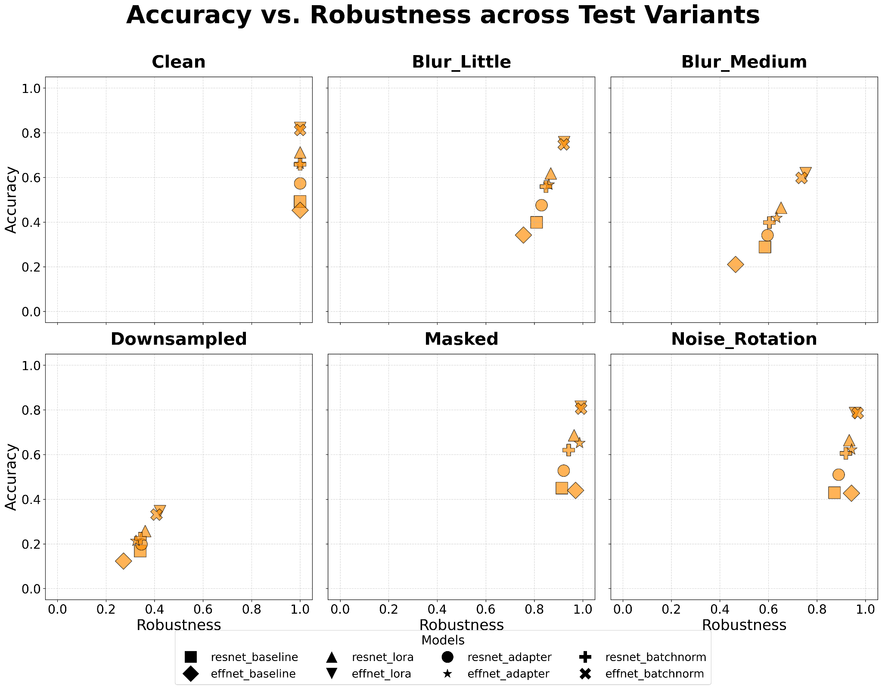
Figure 4: A plot illustrating the relationships between accuracy and robustness across all test set variants for all custom models.

We can observe from figure 4 above that the ranking of the models' accuracies are similar amongst all test-set variants. Models with higher accuracy on the clean set generally have higher accuracy on all test-set variants when compared to models with lower accuracy on the clean set. We also observe that models with higher clean set accuracy tend to be more robust overall, with a nearly linear relationship between accuracy and robustness on each test set variant. This suggests that more accurate models tend to be more robust regardless of the shift in the data-set, suggesting no significant differences in these trends between the test variants. We also observe that each model's accuracy is lowest on the downsampled set, suggesting that image resolution is an important requirement for models to be able to accurately identify spatial information.

We have aggregated our evaluation results for each model into a single table for analysis:

Model | Trainable Parameters | FLOPs | Accuracy | Speed | Variant Accuracy | Variant Robustness | Variant Speed
effnet_lora | 3,942,573 | 5.802 × 10⁹ | 0.8218 | 0.00924 | 0.6649 | 0.8091 | 0.00884
effnet_batchnorm | 283,253 | 5.802 × 10⁹ | 0.8125 | 0.00861 | 0.6539 | 0.8048 | 0.00806
resnet_lora | 609,533 | 3.647 × 10⁹ | 0.7122 | 0.00418 | 0.5380 | 0.7553 | 0.00399
effnet_adapter | 598,661 | 5.869 × 10⁹ | 0.6606 | 0.00871 | 0.4947 | 0.7490 | 0.00839
resnet_batchnorm | 61,413 | 3.647 × 10⁹ | 0.6586 | 0.14658 | 0.4814 | 0.7309 | 0.14224
resnet_adapter | 315,237 | 3.673 × 10⁹ | 0.5736 | 0.00414 | 0.4108 | 0.7161 | 0.00405
resnet_baseline | 51,813 | 3.647 × 10⁹ | 0.4920 | 0.00391 | 0.3466 | 0.7044 | 0.00404
effnet_baseline | 129,381 | 5.802 × 10⁹ | 0.4533 | 0.00923 | 0.3086 | 0.6807 | 0.00925
Table 2: Aggregated Evaluation Results for all Custom Models.

Model Focus
We utilized grad-CAM to visualize which regions of an image the models focus on, and why different model variants fail on specific test variants. We applied grad-CAM to the same sample of 5 images from each test set for each model. The resulting heatmaps were interpreted to identify patterns amongst different test set variants for different models. The blue regions of the heatmaps are areas of less focus, while the red areas are regions of the image of higher model focus.
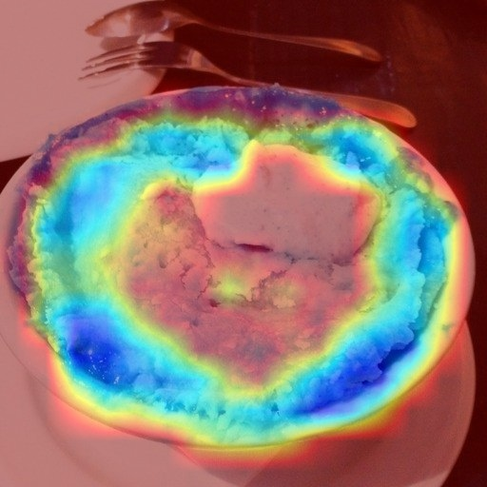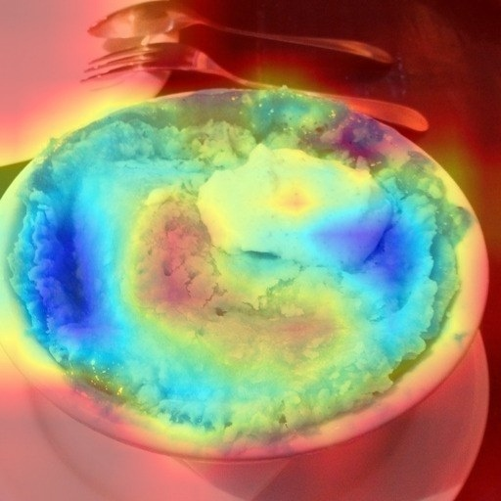
Figure 5: grad-CAM heatmaps of the Resnet Batchnorm model (rightmost image) and the Resnet Adapter model (model image) on a clean test set image.

We observe from various heatmaps that on test sets with higher model accuracy scores, or with models that have higher overall accuracy, the heatmaps show a difference in focus level between the object and its background. In figure 5 we can see that for the clean test set, even less accurate models are still able to identify spatial information about the object, this is seen from the difference in color between the object and background.



Figure 6: Grad-CAM heatmaps of the Resnet Batchnorm model (leftmost image) and the Effnet Batchnorm model (rightmost image) on a downsampled image.

The downsampled test set has the lowest accuracy scores amongst all model variants. In figure 6 we see an example of models interpreting images from this dataset. There is a noticeable lack of spatial interpretation in the heatmap compared to the heatmaps from the clean test set in figure 5. There is a lack of differentiation in focus level between the object itself (apple pie) and its background or other surrounding objects. The entire image nearly has the same focus level, suggesting that the model struggles to even notice the object, not just classify it. This highlights the importance and need of higher resolution images in order for models to be able to accurately identify spatial information and make accurate classifications.

Conclusion and Future Work

We can observe from Table 1 that our most accurate and robust model is the Effnet Lora model, with an accuracy of 0.82. However, this model also has the slowest inference speed, by far the greatest number of trainable parameters and has one of the highest computational costs. Even though this custom model is most accurate and robust, it does not demonstrate the greatest trade offs between accuracy, inference speed and efficiency and it is by far the longest one to train. A better trade off option is the Effnet Batchnorm model, which is 2nd most accurate (0.81) and robust, touching very close to the Effnet Lora model in these metrics. But the Effnet Batchnorm model has far fewer trainable parameters, making it more efficient for training. This model still has a slow inference speed and high FLOPs count, so it is still not an ideal trade off. The model with possibly the greatest trade offs of all is the Resnet Lora model, which has the 3rd highest accuracy (0.71), few trainable parameters, a much faster inference speed and low FLOPs count. As demonstrated earlier, the backbone type seems to have the strongest influence on model speed and computational costs, which is why we observed clustering in some plots. We have also become familiar with a linear trend between model accuracy and robustness.

To reflect on our training process and consider improvements, we have plotted the validation loss of each custom model per epoch:

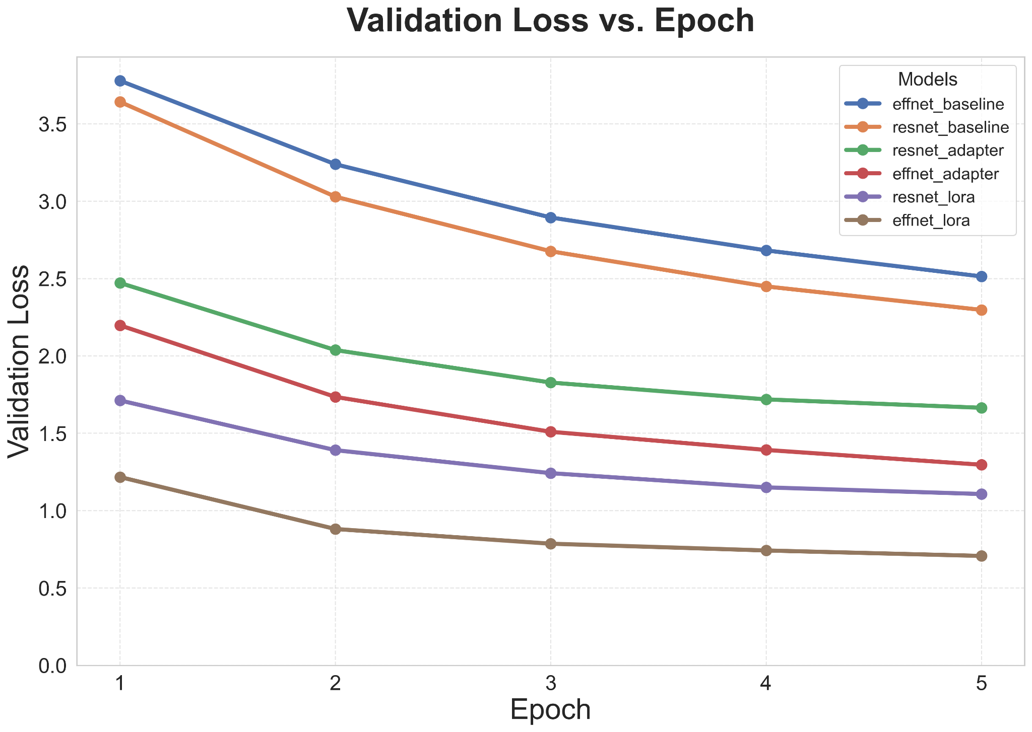
Figure 7: A plot which shows the trend between Validation Loss and Epoch for our custom models.

From figure 7 above we can observe that we are underfitting our custom models. The trendlines of each model do not reach a plateau, the validation loss continues to decrease per epoch, suggesting it could continue to decrease if we trained more epochs. The batchnorm tuning models are excluded from this analysis because they were trained before we started recording validation loss per each epoch, so we do not have epoch validation loss data for them. This plot suggests that in the future we could likely achieve greater accuracy amongst all of our models by training them for more epochs. It is possible that the relationship between accuracy and robustness may deviate from its current linear fashion after training the models for more epochs. Another improvement that could be made is to perform hyperparameter tuning on all of the models to further achieve greater model performance. In the future we could also consider investigating the extreme outlier of inference speed of the Resnet Batchnorm model.

References
[1] L. Bossard, M. Guillaumin, and L. Van Gool, "Food-101," version 1.0, ETH Zurich; Hugging Face, 2014. [Online]. Available: https://huggingface.co/datasets/ethz/food101
[2] S. Du, "6 Test Sets," University of British Columbia Okanagan, 2026. [Online]. Available: https://drive.google.com/file/d/1MvkUSd2ESqBzXgObUYBBxOH6kMFLDP5B/view
[3] Tan, M. & Le. Q, “EfficientNetV2: Smaller models and faster training”, 2021, Available: https://arxiv.org/abs/2104.00298
[4] S. Du, “Data 586: Advanced Machine Learning - Convolutional Neural Networks [Lecture slides]”, University of British Columbia.
[5] S.Du, “Data 586: Advanced Machine Learning - Representation Learning [Lecture slides]”, University of British Columbia.

Contributions
The completion of this project and report was a combined effort by Jamie Breault, Andre Gnandt, and Spandan Dey for the Advanced Machine Learning course in the Master of Data Science program at UBC Okanagan. A presentation was given to the class as part of the project as well. The tables below outline the contributions of the group members.

Contribution | Completed By
Backbones | Jamie Breault
Linear probing | Jamie Breault
LoRA | Spandan Dey
Task-specific adapters | Spandan Dey
BatchNorm tuning | Andre Gnandt
Model evaluation | Jamie Breault
Performance plots | Jamie Breault
Grad-CAM analysis | Andre Gnandt
Table 3: Contribution summary for coding tasks.

Contribution | Completed By
Summary | Jamie Breault
Introduction | Spandan Dey
Methodology | Spandan Dey
Experiments | Andre Gnandt
Conclusion | Andre Gnandt
References | Spandan Dey
Contributions | Jamie Breault
Table 4: Contribution summary for writing tasks.

Contribution | Completed By
Presentation slides | Jamie Breault
1st speaker | Spandan Dey
2nd speaker | Jamie Breault
3rd speaker | Andre Gnandt
Table 5: Contribution summary for the project presentation.

