FRB_finder.py converts simulated FRB data produced by simpulse to a filterbank file, allowing it to be used with SIGPROC. It is imporant to know if SIGPROC's hunt program can find FRBs produced by simpulse. To test this, FRB_finder.py can run the filterbank file through hunt and plot the SNR of the best FRB it finds at each DM. That is the plot seen below to the left. Below to the right is the same plot execpt the data was produced by SIGPROC's fake program instead of simpulse. Care was taken to make sure the data sets produced by simpulse and fake were as similar as possible. You can find these plots in the SNR_vs_DM directory in my github account (jgbreault).

Simpulse Fake
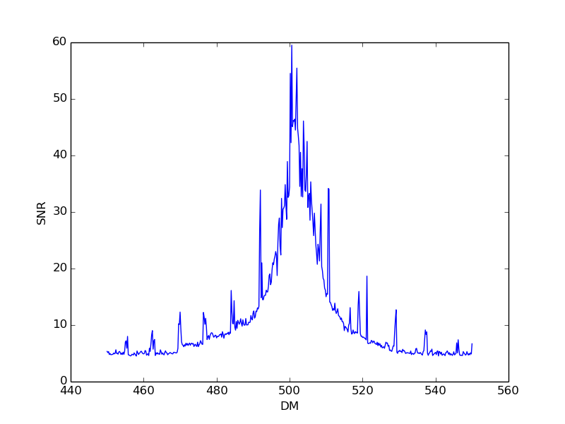
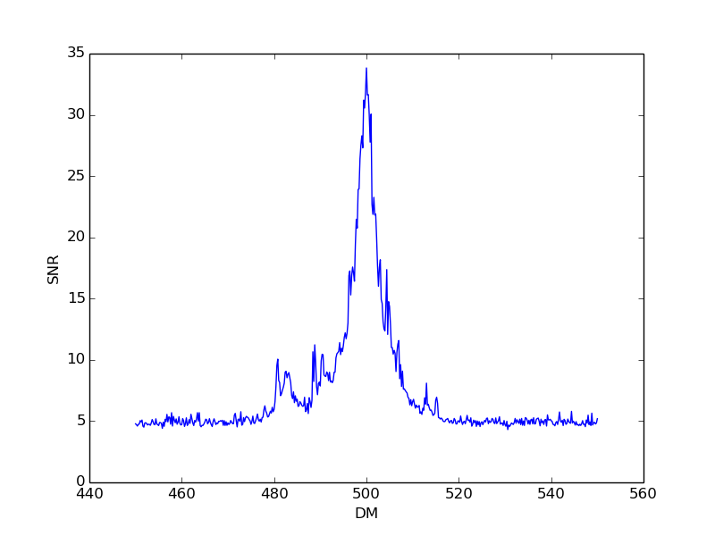
Both plots have a major peak at approxiamtely 500 as expected since the FRBs were set to have a DM of 500. The strange thing is that the simpulse plot has regularly spaced minor peaks and the fake plot does not. The FRBs found at these minor peaks were found to have occured at the correct time, however, hunt found them to be more than an order of magnitude wider than what they actually were. Also, these minor peaks go away if the observation time is made very large. More tests need to be done to determine the cause of these minor peaks.

As stated previously, the data sets produced by simpulse and fake were made as similar as possible, however, one unavoidable difference between them is the pulse profile. Simpulse simulated FRBs are gaussian pulses and fake simulated FRBs are square pulses. Browse through the pulse_profile directory to see images of these pulse profiles. One notable feature of the simpulse FRBs is that even when their width seems to be dominated by intrinsic width as opposed to being dominated by dispersion across a single frequency channel, the width of the pulses are many times larger than what the intrinsic width was set to. Tests need to be done to determine if this is a problem with simpulse and if any of this could be responsible for the minor peaks.

