University of Waterloo
Science

Quantifying Umbilical Slippage in the SNO+ URM

SNOLAB
Sudbury, Ontario
Jamie Breault
20517925
2B Honours Physics
April 25, 2016
82 Rosslinn Road
Cambridge, Ontario
N1s 3K1
April 25, 2016
Jeff Chen
Physics and Astronomy
University of Waterloo
Waterloo, Ontario
N2L 3G1
Dear Jeff Chen:
This report, entitled “Quantifying Umbilical Slippage in the SNO+ URM” was prepared as my 2B Work Report for SNOLAB. The purpose of this report is to quantify the slippage of the umbilical used in SNO+’s Umbilical Retrieval Mechanism and to determine if it can or needs to be reduced.
SNOLAB operates as a clean room located 2 km underground focusing on experiments relating to neutrino and dark matter physics. Among the experiments is SNO+, a liquid scintillator detector. Its main goal is to observe neutrinoless double beta decay, which would imply that neutrinos are their own antiparticle. This is the experiment I worked on during my time at SNOLAB, and Prof. Christine Kraus was my supervisor during this time.
This report was written entirely by me and has not received any previous academic credit at this or any other institution. I would like to thank Dr. Erica Caden for regularly offering valuable advice and guidance regarding my work on the URM. I would like to thank her for proofreading my report as well.
Sincerely,
Jamie Breault
20517925
Table of Contents
Table of Contents ii
List of Figures and Tables iii
Summary iv
1 Introduction 1
2 The Umbilical Retrieval Mechanism 3
3 Defining Slippage 5
4 Slippage Test Procedure 6
4.1 Quality Control 6
4.2 Preparation 8
4.3 Conducting the Slippage Test 8
5 Results from a Previous Slippage Test 9
6 Challenges 10
6.1 Challenges Before Testing 10
6.2 Challenges During Testing 11
7 Results 12
8 Conclusion 16
9 Recommendations 17
Bibliography 18

List of Figures and Tables
Figure 1. Side view of the URM 1
Figure 2. Deployment of a calibration source into SNO+ 2
Figure 3. Cross-section of an umbilical 2
Figure 4. Drive pulleys and guide pulley 3
Figure 5. Front and rear storage pulleys 4
Figure 6. The encoder mounted atop the large drive pulley 5
Figure 7. Bubbles and dirt within the umbilical around a piece of tape 7
Figure 8. Wires within the umbilical overlapping each other 7
Figure 9. The exterior storage pulleys 7
Table 1. Resistances of the umbilical wires before and after testing 12
Figure 10. Change in umbilical position plot for extension 14
Figure 11. Change in umbilical position plot for retraction 14
Figure 12. Slippage frequency histogram for extension 15
Figure 13. Slippage frequency histogram for retraction 15

Summary
The Umbilical Retrieval Mechanism (URM) is a part of the calibration hardware for SNO+, a multipurpose neutrino physics experiment. It is used to deploy calibration sources attached to the end of an umbilical into the experiment’s acrylic vessel (AV), a spherical vessel filled with a detecting medium called linear alkylbenzene LAB [1]. LAB is a mineral oil that can cause the umbilical to slip, causing the source’s measured position within the AV to be inaccurate. This report quantifies the severity of the umbilical’s slippage and discusses whether it needs to be reduced.
Before the slippage could be tested, several problems had to be overcome, most of which were associated with the encoder, an instrument that determines the distance the umbilical travels. The encoder’s mount was improved to increase the encoder’s contact with the umbilical. The encoder exhibited signs of wear from prolonged use as well, and was consequently replaced.
Once the slippage test was complete, it was evident that the current design of the URM yields insignificant slippage for both extension and retraction. It is recommended to begin testing other parts of the URM, namely the slippage of the load-bearing support rope.

1 Introduction
SNO+ is a liquid scintillator detector located in a class 2000 clean lab approximately 2 km below the earth’s surface near Sudbury, Ontario. SNO+ is a neutrino physics experiment. Its main objective is to detect neutrinoless double beta decay, which would suggest that neutrinos are their own antiparticle [1].
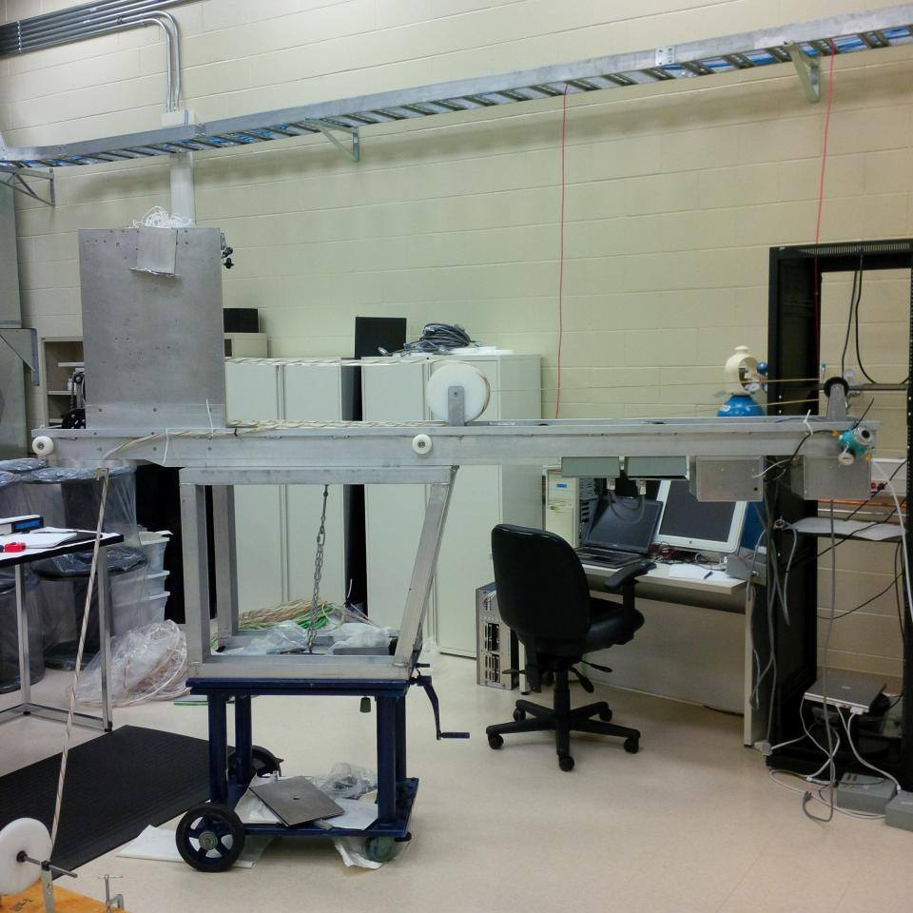
Figure 1. Side view of the URM.

SNO+ is currently under construction. It is comprised of a transparent acrylic vessel referred to as the AV. It is encompassed by the Photomultiplier Tube Support Structure (PSUP), a geodesic dome 18 m in diameter containing over 9400 photomultiplier tubes (PMTs). The AV is filled with linear alkylbenzene (LAB) which is a liquid scintillator, meaning that it emits photons when energetic particles interact with it [1]. The PMTs detect the emitted photons. In order for the energy of the photons to be measured accurately, calibration of the PMTs is required. During calibration, the umbilical retrieval mechanism (URM) (Fig. 1) is used.
The URM is part of the calibration hardware for SNO+. It deploys several different types of calibration
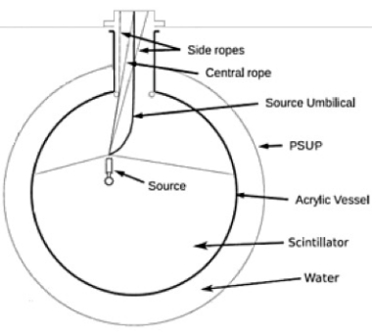
Figure 2. Deployment of a calibration source into SNO+ [2].

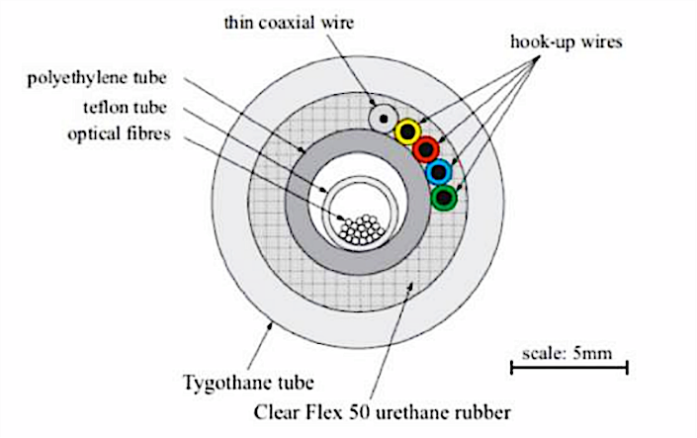
Figure 3. Cross-section of an umbilical [2].

sources into the AV on the end of an umbilical (Fig. 2). The umbilical contains electrical wires and optical fibers (Fig. 3) which are required for the calibration sources to function. The calibration process involves positioning the sources throughout the AV. The URM controls the vertical position of the sources while side rope motor boxes control the horizontal position. Though the sources require the umbilical, it is not entirely responsible for holding their load. This is the role of a support rope that is deployed alongside the umbilical.
The original URM was designed for SNO+’s predecessor, SNO, which used heavy water as a detecting medium [1]. SNO’s URM was not designed to deploy into LAB. LAB is much more slippery than heavy water [2]. Slipping of the umbilical leads to inaccurate measurements of the calibration source’s position within the AV, leading to poor calibration of the PMTs. LAB is incompatible with some materials in the SNO umbilical as well. For these reasons, the design of the URM has changed. It is crucial to quantify the umbilical’s slippage in SNO+’s URM to determine whether the URM must vary from its current design.
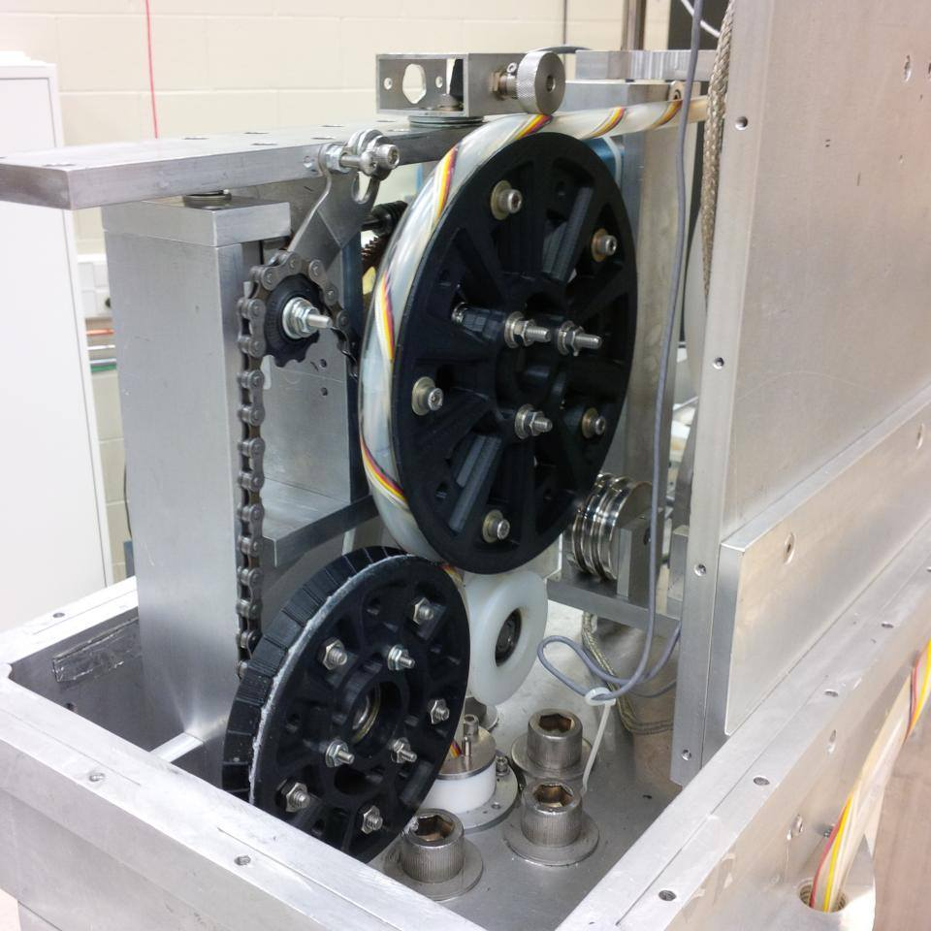
C
B
A
Figure 4. The large drive pulley (A), the medium drive pulley (B), and the small guide pulley (C).

2 The Umbilical Retrieval Mechanism
When the experiment is being calibrated, the URM is positioned on top of the AV. At the front of the URM, there are three pulleys (Fig. 4). The largest of the three, named the large drive pulley, is driven by a small motor. The next largest, named the medium drive pulley, is driven by the same motor through a chain and sprocket system. The chain is connected to the two pulleys such that they can only rotate in opposite directions. This way they work together to move umbilical up and down. Both pulleys are grooved where contact is made with the umbilical in order to increase friction. The grooved parts of both pulleys move at the same speed even though the pulleys are of different sizes because the radius of each sprocket is proportional to the radius of its respective drive pulley. The medium pulley in SNO’s URM was not driven and none of the pulleys were grooved. These were added as an attempt to decrease slippage. Distances can be inputted into a computer program that controls the motion of the guide pulleys and thus the umbilical. The smallest of the three pulleys is not driven. Its only purpose is to help guide the umbilical. Consequently, it is referred to as the small guide pulley. There is a series of springs that keep the pulleys pressed up against the umbilical and each other.
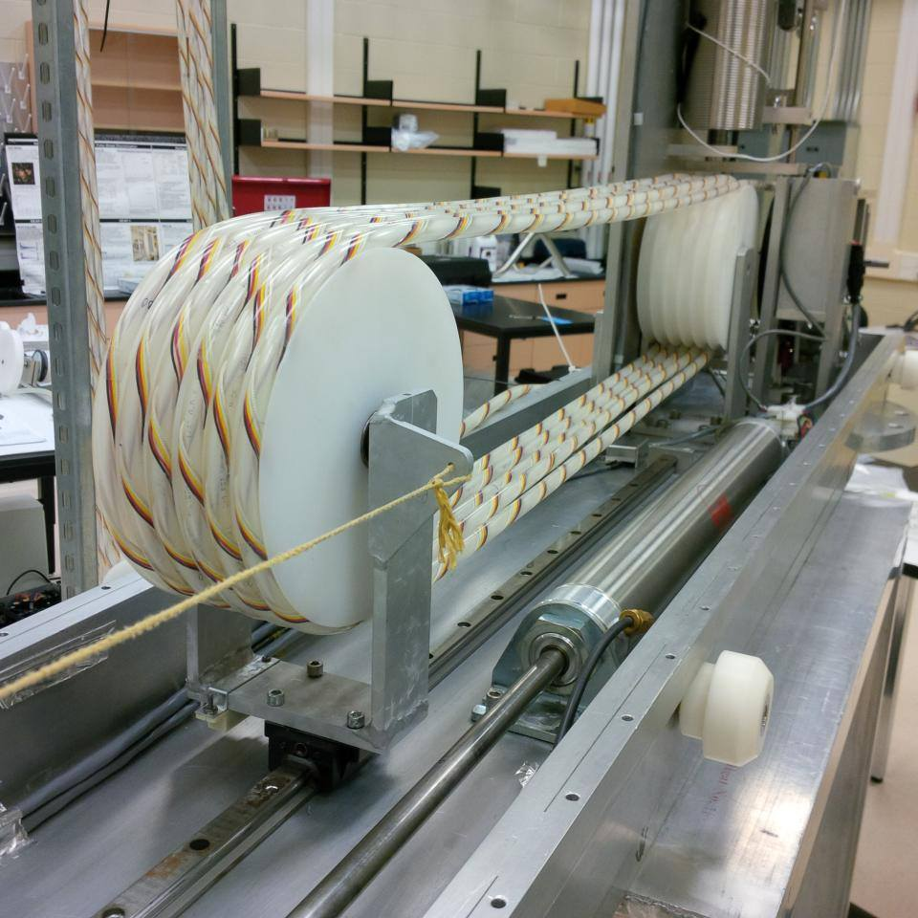
B
A
Figure 5. The front storage pulleys (A) and the rear storage pulleys (B).

The umbilical itself is 30 m long and is stored within the URM, wound around two groups of storage pulleys (Fig. 5). The front storage pulleys are fixed, however, the rear storage pulleys are free the move forward and back along a straight track. When the umbilical extends into the AV, the rear storage pulleys are forced forward as a result of less of the umbilical being present inside the URM. Similarly, when the URM retracts, the rear storage pulleys are forced back by a tensioning system that provides a constant backward force on the mobile pulleys.
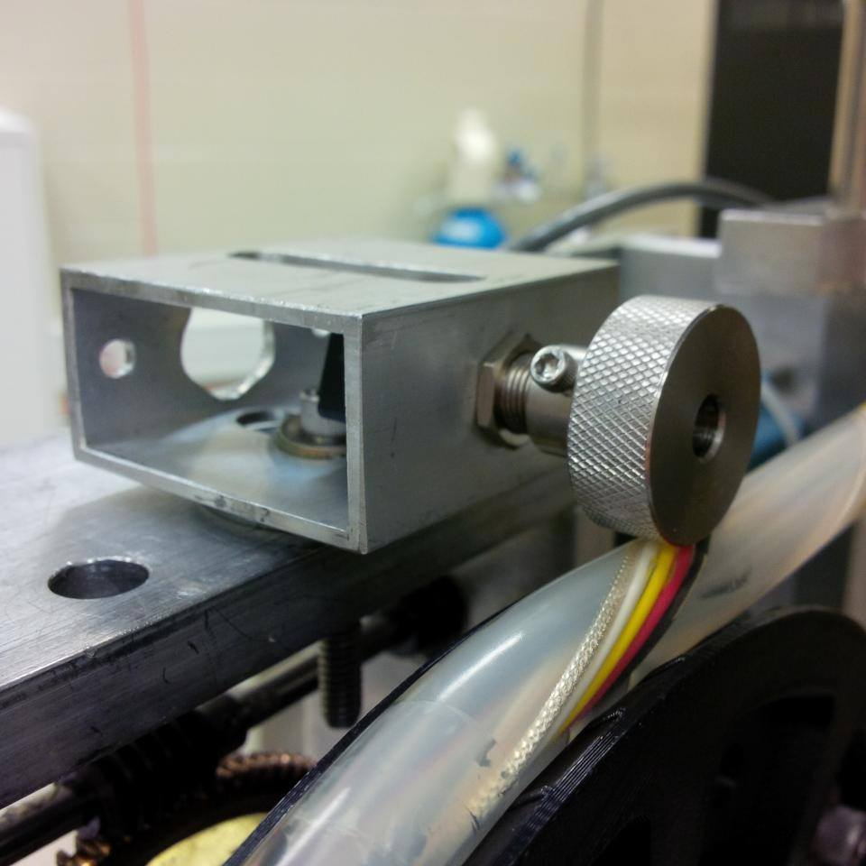
Figure 6. The encoder mounted atop the large drive pulley.

While the URM is operating, the encoder is used to determine the length of the umbilical within the AV. The encoder is an instrument comprised of a wheel in firm contact with the umbilical (Fig. 6). The umbilical rotates the encoder as it moves under it. The encoder outputs the position of the umbilical based on the number of times it rotates.

3 Defining Slippage
The slippage of the umbilical is calculated using the following equation, where S is the slippage, D is the true distance the umbilical travels, and D_{encoder} is the distance that the encoder measures the umbilical to travel.
$$S = \frac{D-D_{encoder}}{D}$$
The slippage is usually expressed as a percentage. This value only expresses the severity of the slipping between the encoder and the umbilical. There is also slipping between the umbilical and the guide pulleys. This means the umbilical will travel slightly less than the input distance, however, this effect is not of great concern. The accuracy of the encoder’s measurements are much more important than that of URM inputs because the encoder is responsible for determining the position of the calibration source within the AV.

4 Slippage Test Procedure
The procedure below outlines the steps taken to test the slippage of the umbilical.

4.1 Quality Control
Before the umbilical is mounted on the URM, the resistance of each of the wires is measured using a multimeter. The resistances are measured once more after the test is complete. An increase in resistance indicates that the wires may have been damaged from the operation of the URM.
Next, the entire umbilical is visually inspected for manufacturing imperfections including the presence of bubbles, dirt, and wire overlaps (Fig. 7 and Fig. 8). The position and type of each imperfection is recorded.
At this point, the umbilical is fed into the URM, through the drive pulleys and around the storage pulleys. Care is taken to ensure no twists are present in the
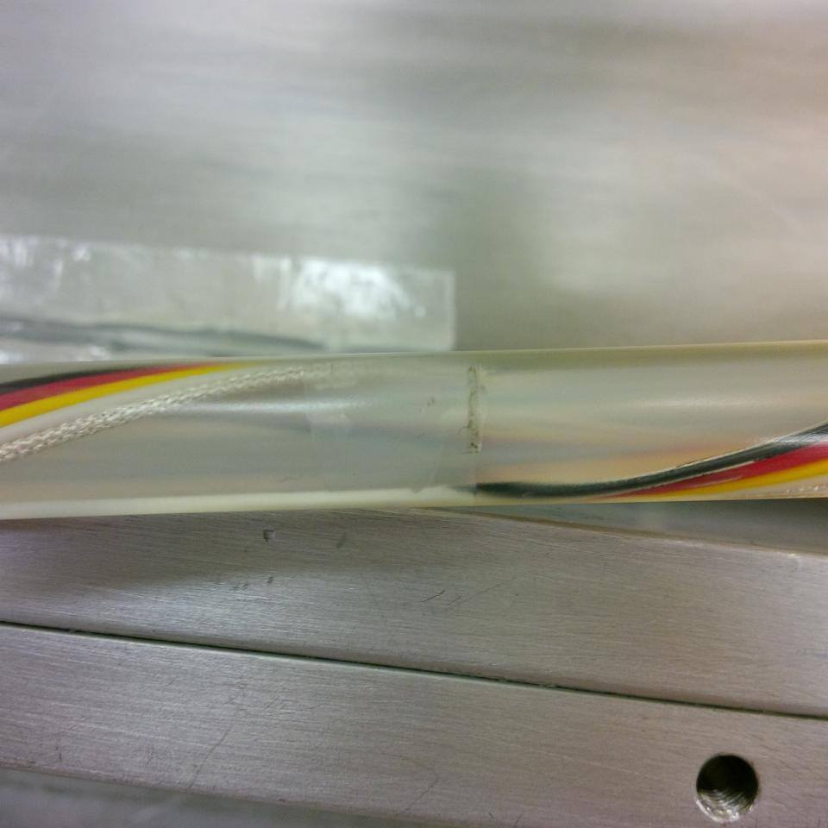  B  A | 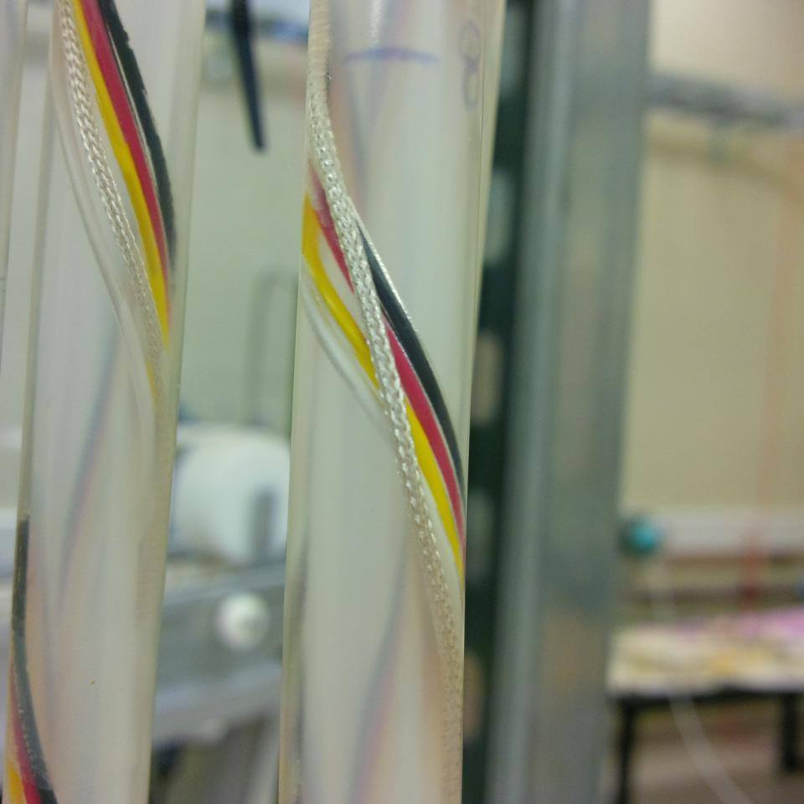
Figure 7. Bubbles (A) and dirt (B) within the umbilical around a piece of tape. | Figure 8. Wires within the umbilical overlapping each other.
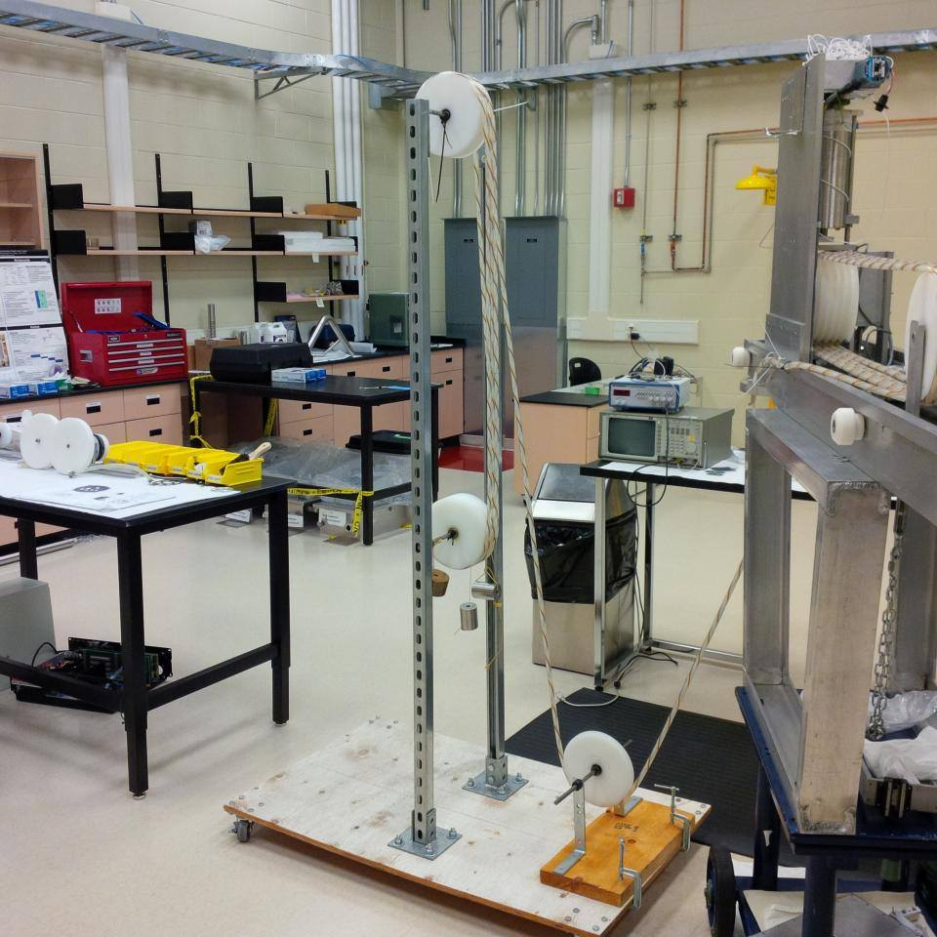
Figure 9. The exterior storage pulleys.

umbilical while it is being fed, for it is not possible to remove these twists once the umbilical is on the URM. When approximately half of the umbilical is in the URM, the remaining amount is fed onto an assembly of exterior storage pulleys that are used only during testing (Fig. 9). The exterior storage pulleys allow the slippage over long distances to be tested easily without the umbilical coming in contact with potentially unclean surfaces such as the floor.

4.2 Preparation
The umbilical is then graduated using a ruler and a permanent marker. Every 30 cm, a mark is made directly on the umbilical. The position of each mark relative to the end of the umbilical is written next to it. These marks are used later on to help determine the true distance the umbilical extends and retracts during testing.
At this point, LAB is applied to the umbilical by rubbing it with a LAB dampened wipe. LAB is applied to a section of the umbilical near the guide pulleys. Then the URM is commanded to move such that the guide pulleys are in contact with the LAB soaked section.

4.3 Conducting the Slippage Test
The true initial position of the umbilical is determined by measuring the distance from the bottom of the URM to the nearest mark below it. The true initial position is the sum of this distance and position of the mark. The initial encoder reading is taken as well. The URM is then commanded to either extend or retract the umbilical a certain distance. LAB is applied to the dry sections of the umbilical as it moves such that the part of the umbilical that is in contact with the drive pulleys is always wet with LAB. The thin layer of LAB on the umbilical evaporates quickly, so LAB is reapplied to sections that have already been wetted at least every 15 minutes.
Once the umbilical comes to a complete stop, the true final position of the umbilical is measured, along with the final encoder reading. The difference between the final and initial values yields the true distance the umbilical traveled and the distance encoder measured the umbilical to travel. The slippage calculations are made from these two values. Ten trials are completed for inputs of 10 cm, 20 cm, 50 cm, 100 cm, 200 cm, 500 cm, and 1000 cm respectively for both extension and retraction. This is to determine whether slippage varies with distance.

5 Results from a Previous Slippage Test
The umbilical’s slippage in the presence of LAB has been tested previously. In August 2015, a test showed that on average the slippage was 5.08% for extension and 2.68% for retraction [2]. Though these values are tolerable, it is worth investigating whether they can be improved. Slippage can be accounted for if it is well defined and consistent, however, since there are small variances in slippage between extensions/retractions, it is preferred to reduce slippage so that it is consistently under 1%.

6 Challenges
Several problems with the URM were encountered both before and during testing. For the most part, these problems were minor and solved easily.

6.1 Challenges Before Testing
Before any changes were made to the URM, an attempt was made to replicate the results from the previous test using a new umbilical. Unfortunately, there was a problem with the chain and sprocket system. The system would often skip a link while in operation. Upon inspection, it was discovered that the skips were caused by the large drive pulley’s sprocket. The centre of the sprocket was not well aligned with the axle, causing the chain to oscillate between being taut and having slack once every rotation. The skips occurred when there was an excessive amount of slack. This was solved by enlarging the holes that hold the sprocket in place, allowing for a greater freedom of positon. Once the sprocket was properly aligned, the chain system stopped skipping links.
Another problem was soon encountered regarding the encoder’s mount. Initially, the encoder was mounted to the URM using a thin aluminum L-bracket that could be easily bent. This made it impossible for the encoder to maintain strong contact with the umbilical because the umbilical kept pushing up on the encoder, bending the mount until strong contact was lost. This problem was quickly solved by replacing the L-bracket with a piece of thick aluminum square tubing, increasing the mount’s rigidity.
At this point an attempt was made to test the umbilical, but it was soon discovered that the measurements produced absurd slippage values, upwards of 50%. There was a high degree of variance amongst the slippage values as well. Close inspection of the encoder revealed that it had a gritty feeling hindering rotation, especially when a radial force was applied. This was not surprising given that this encoder was used in the original SNO experiment, making it approximately 20 years old [3]. The encoder was replaced with a new one of the same model and it rotated much more smoothly.
All of these changes were made just to ensure that the setup was in proper working order.

6.2 Challenges during Testing
As planned, ten trials were done for inputs of 10 cm, 20 cm, 50cm, 100 cm, 200 cm, and 500 cm for both extension and retraction. However, only four 1000 cm trials were taken for extension and one for retraction. This is because the motor that drives the guide pulleys started to make very loud screeching noises during these trials, so testing was stopped prematurely. Luckily, enough data was already collected in order to conduct a meaningful analysis.

7 Results
As stated in the procedure, the resistances of the wires within the umbilical were measured both before and after the slippage test. These values are shown below in Table 1. None of the wires experienced an increase in resistance from the operation of the URM.
Wire Name | Resistance Before Testing (Ω) | Resistance After Testing (Ω) | Change in Resistance (Ω)
Inner Coaxial Wire | 24.0 | 23.8 | -0.2
Outer Coaxial Wire | 1.8 | 1.8 | 0.0
Red Wire | 2.5 | 2.5 | 0.0
White Wire | 2.5 | 2.5 | 0.0
Black Wire | 2.6 | 2.6 | 0.0
Yellow Wire | 2.5 | 2.5 | 0.0
Table 1. Resistances of the wires within the umbilical before and after testing.

During the visual inspection of the umbilical, bubbles and dirt were found at the majority of locations where the wires are taped to the inner polyethylene tube. Bubbles and dirt were nearly exclusively observed at these locations. 64 wire overlaps were observed spread over the entire length of the umbilical.
Figure 10 shows the change in true umbilical position and change in encoder reading plotted against each other for all extension trials. Figure 11 shows the same information, but for the retraction trials. Both plots clearly follow a linear distribution implying that slippage does not vary with distance. This is expected because there is no known mechanism through which slippage would increase or decrease for longer distances.
Figure 12 and 13 show the distribution of calculated slippage values for extension and retraction respectively. The average slippage was calculated to be 0.79% for extension and 0.57% for retraction. For the most part, the values are localized around the average, roughly following a normal distribution. Several of the slippage values are negative, mostly from the 10 cm and 20 cm trials. They are likely due to error in the true umbilical position measurements. The uncertainty in these measurements is estimated to be 2 mm.
Though this test was only meant to reproduce the previous results, it lead to greatly reduced slippage values. This is likely because of the changes that were made to fix the encoder’s mechanical problems. The percent discrepancy between the previous and new values for slippage is 84% for extension and 79% for retraction. All percent discrepancies were calculated using the equation below.
$$Percent Discrepancy= \frac{|Previous-New|}{Previous}$$

Figure 10. Plot showing the results for the change in true umbilical positon vs. change in encoder reading for extension.

Figure 11. Plot showing the results for the change in true umbilical positon vs. change in encoder reading for retraction.

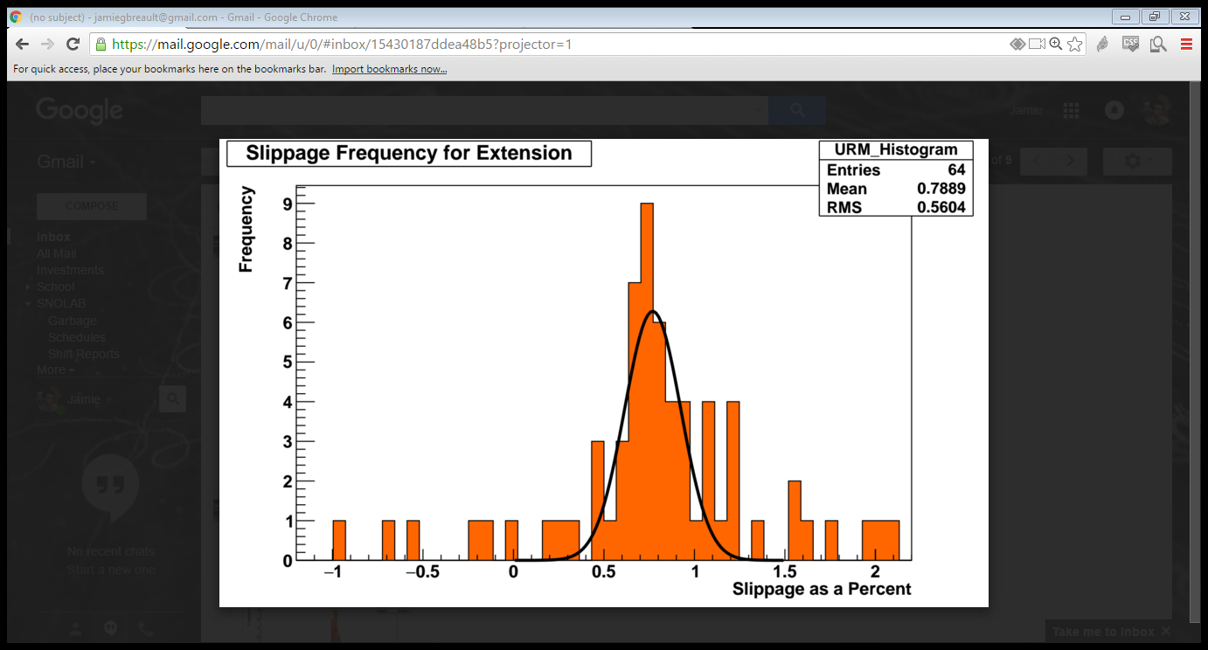
Figure 12. Histogram showing the distribution of slippage values calculated from the extension trials.

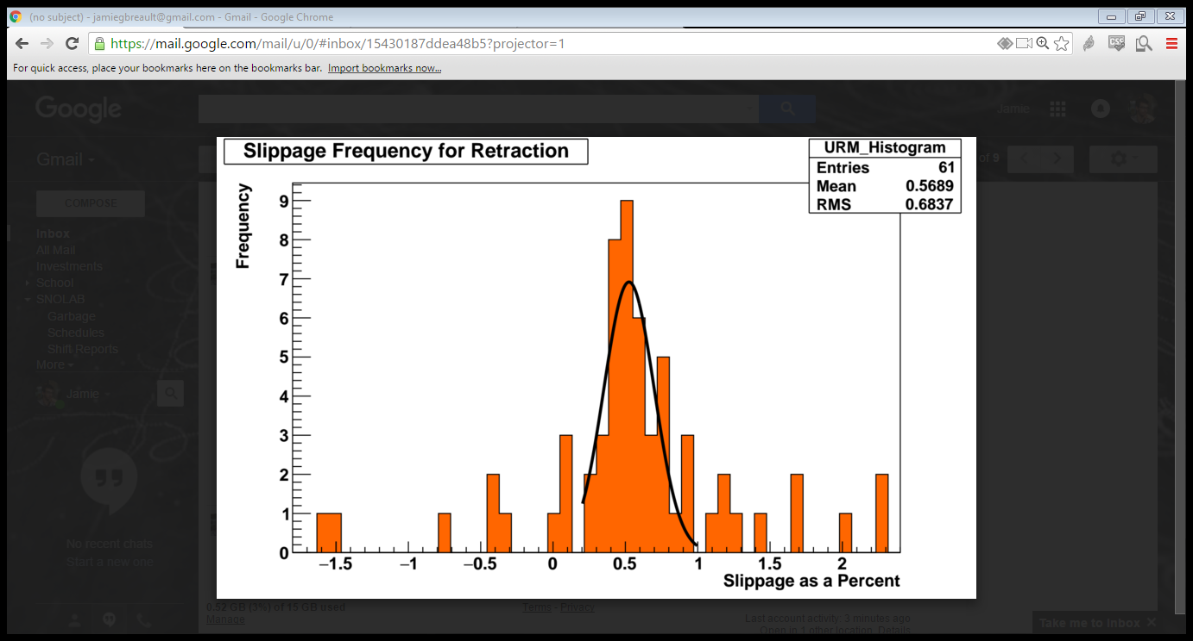
Figure 13. Histogram showing the distribution of slippage values calculated from the retraction trials.

8 Conclusion
Since the wires within the umbilical did not experience an increase in resistance during testing, it can be inferred that operating the URM does not damage the wires. Furthermore, this shows that the presence of imperfections within the umbilical such as wire overlaps do not impact the integrity of the wires.
Though the design of the URM was not changed significantly, the average slippage for both extension and retraction are significantly less than those determined in previous test. This is likely do to the changes made to the encoder. The rigid mount ensured the encoder maintained firm contact with the umbilical, and replacing the encoder was a clear necessity.
The average slippage has been reduced to less than 1% for both directions and it is constant over all distances. If the umbilical extends 10 m, the difference between the true position and the encoder-determined position of the calibration source will be less than 10 cm. For this reason, it can be concluded that the current design of the URM is adequate with regard to the slippage of the umbilical.

9 Recommendations
The resistance measurements show that imperfections within the umbilical did not affect the integrity of the wires over the duration of the test, however, it is not clear that this will hold true over the long-term use of the umbilical. Longer tests can be done, however, an attempt should still be made to reduce the quantity of imperfections in future umbilicals. Simply taking more care during the manufacturing process may be enough to greatly reduce the number of imperfections.
Since the previous encoder exhibited wear over the 20 year period it was used, the encoder should be checked regularly to determine if it needs replacing. At least once per year should be sufficient based on the lifetime of the previous encoder. A spare encoder should be reserved for when it is required.
Now that the umbilical’s slippage has been reduced to a tolerable level, other areas of the URM can be explored and tested such as the slippage of the load-bearing support rope.

Bibliography
- Andringa, S., et al (2016). Current Status and Future Prospects of the SNO+ Experiment. Advances in High Energy Physics, 2016. doi: 10.1155/2016/6194250
- Richardson, R. (2015). Umbilical Retrieval Mechanism [PowerPoint slides]. Retrieved from https://www.snolab.ca/snoplus/private/DocDB/cgi/ShowDocument?docid=3262
- Caden, E., (10:00 am, April 11th, 2016, Laurentian University). Personal conversation regarding the URM.

