/*

* Name : Jung Geon Choi

* Student Number : 025651134

* Due Date : Apr. 09, 2014

* Course Code : BTD210

* Course Section : B

*/

/*

* I declare that the attached assignment is wholly my own work in

* accordance with Seneca Academic Policy. No part of this assignment has

* been copied manually or electronically from any other source (including

* web sites) or distributed to other students.

* Name ___Jung Geon Choi____________________ Student ID _025651134______

*/

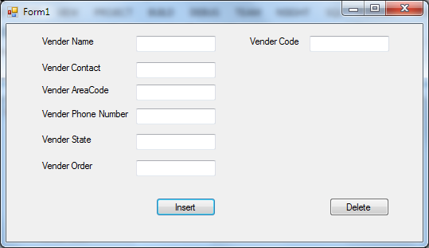

Imports System.Data.SqlClient

Public Class Form1

Private Sub insertButton_Click(sender As Object, e As EventArgs) Handles insertButton.Click

Dim con As New SqlClient.SqlConnection("Data Source=(local);Initial Catalog=Saleco;Integrated Security=True")

Dim cmd As New SqlCommand()

cmd.Connection = con

con.Open()

cmd.CommandText = "INSERT INTO VENDOR (V_NAME, V_CONTACT, V_AREACODE, V_PHONE, V_STATE, V_ORDER) VALUES ('" & Me.V_NAME.Text & "','" & Me.V_CONTACT.Text & "','" & Me.V_AREACODE.Text & "','" & Me.V_PHONE.Text & "','" & Me.V_STATE.Text & "','" & Me.V_ORDER.Text & "')"

cmd.ExecuteNonQuery()

Dim msg = "customer records added successfully"

' Define a title for the message box.

Dim title = "Info"

' Add the title to the display.

MsgBox(msg, , title)

con.Close()

End Sub

Private Sub DeleteButton_Click(sender As Object, e As EventArgs) Handles DeleteButton.Click

Dim con As New SqlClient.SqlConnection("Data Source=(local);Initial Catalog=Saleco;Integrated Security=True")

Dim cmd As New SqlCommand()

cmd.Connection = con

con.Open()

' CHECK WHETHER THE ENTERED CODE IS VALID

cmd.CommandText = "SELECT COUNT(*) FROM VENDOR WHERE V_CODE='" & Me.V_CODE.Text & "'"

Dim count As Integer = Integer.Parse(cmd.ExecuteScalar())

Dim title = "Info"

If count > 0 Then

cmd.CommandText = "Delete from Vendor where v_code = " & Me.V_CODE.Text

cmd.ExecuteNonQuery()

Dim msg = "Product quantity in stock updated"

' Add the title to the display.

MsgBox(msg, , title)

Else

Dim msg = "Product code does not exist!"

' Add the title to the display.

MsgBox(msg, , title)

End If

con.Close()

End Sub

End Class