# Joey Gauthier

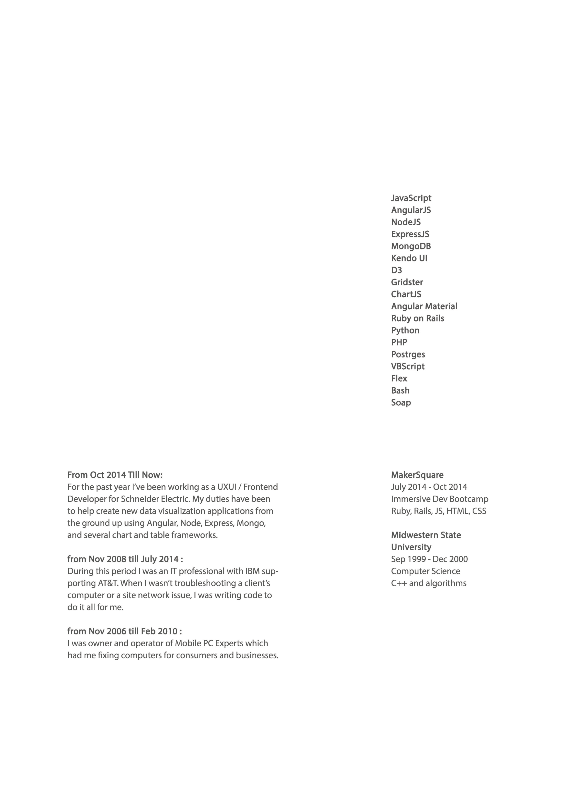

Web Developer / UXUI

AngularJS JavaScript MVC / MVVM Design Application Architecture

## Personal Statement

Having worked in many different technical fields, picking up new skills and adapting to change is second nature to me now. Between all of the apps I currently have in production I’ve gone from backend to frontend, Ruby on Rails to JavaScript, and graphic designer to server administrator / development operations. When my work isn’t pushing me to learn new skills I spend time writing apps and scripts to automate and enrich my life and I take online classes to learn more languages and frameworks. Technology is a part of my identity.

I found my calling to write code while working as an IT professional for IBM. Writing scripts to automate tasks saved me time and effort and led to me writing full applications that combine all of my previous work into a GUI. I realized that I enjoyed the problem solving involved in writing code and I haven’t stopped since.

## Work Experience

Technologies

Education

Contact Details 14419 Pebble Run

### Manor, TX 78653

(512) 698-0111

[digitaljedi@outlook.com](mailto:digitaljedi@outlook.com) [http://joeyg.me](http://joeyg.me/)