# SQL CAPSTONE PROJECT

**Data Analysis:** There is 17 rows and 1000 columns in Dataset with no null values.

**Product Analysis:** There is 6 total distinct Product line.

1. Health and Beauty
2. Electronic Accessories
3. Home and Analysis
4. Sports and Travel
5. Food and Beverages
6. Fashion and Accessories

There is 3 distinct Cities.

1. Yangon
2. Naypyitaw
3. Mandalay

There is 3 distinct Payment methods.

1. E-Wallet
2. Cash
3. Credit Cards

**Sales Analysis:** Food and Beverages are the Highest sales in Jan month and rather Health and Beauty has lowest sales. As Female customer are more in dataset so we can focus on the gender wise on them and in best way we can increase the Health and Beauty product sales.

**Customer Analysis:** So there is Member and Normal Customer type with Male and Female Gender format.

1-- What is the count of distinct cities in the dataset?

select distinct City from sales_mst;

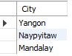

2-- For each branch, what is the corresponding city?

select Branch, City from sales_mst group by Branch, City order by Branch;

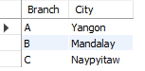

3-- What is the count of distinct product lines in the dataset?

select count(distinct product_line) as count_of_product_Line from sales_mst;



4-- Which payment method occurs most frequently?

select Payment, count(Payment) from sales_mst where Payment='Ewallet'

union

select Payment, count(Payment) from sales_mst where Payment='Cash'

union

select Payment, count(Payment) from sales_mst where Payment='Credit card';

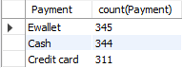

5-- Which product line has the highest sales?

select Product_line, Total from sales_mst order by Total desc limit 1;



6-- How much revenue is generated each month?

select monthname(str_to_date(Date, '%d/%m/%Y')) as monthname,

sum(gross_income) as Revenue_Genrated

from sales_mst group by monthname order by Revenue_Genrated desc;

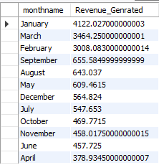

7-- In which month did the cost of goods sold reach its peak?

select monthname(str_to_date(Date, '%d/%m/%Y')) as monthname,

cogs

from sales_mst order by cogs desc limit 1;



8-- Which product line generated the highest revenue?

select Product_line,

sum(gross_income) as Revenue_Genrated

from sales_mst group by Product_line order by Revenue_Genrated desc limit 1;



9-- In which city was the highest revenue recorded?

select City,

sum(gross_income) as Revenue_Genrated

from sales_mst group by City order by Revenue_Genrated desc limit 1;



10-- Which product line incurred the highest Value Added Tax?

select Product_line,

Tax

from sales_mst order by Tax desc limit 1;



11-- For each product line, add a column indicating "Good" if its sales are above average, otherwise "Bad."

select Product_line, Average_Sales, Total,

case

when Total > Average_Sales then 'Good'

else 'Bad'

end as Sales_performance from (select *,

avg(Total) over (partition by Product_line) as Average_Sales

from sales_mst) as avg_sales;

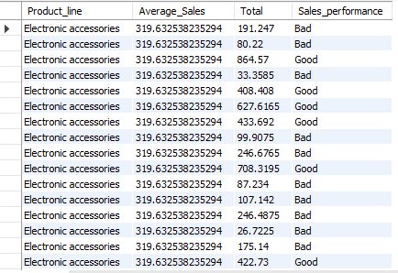

12-- Identify the branch that exceeded the average number of products sold?

select Branch, Total from sales_mst where Total >

(select

avg(Total) as Average_Sales

from sales_mst );

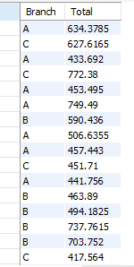

13-- Which product line is most frequently associated with each gender?

with gender_product_line as (

select Gender, Product_line, count(*) as Count,

Row_Number() over (Partition by Gender Order by count(*)desc) as rnb

from sales_mst

group by Gender, Product_line

)select Gender, Product_line, Count from gender_product_line where rnb=1;



14-- Calculate the average rating for each product line.

select Product_line, avg(Rating) as Average_Rating from sales_mst group by Product_line order by Average_Rating desc;

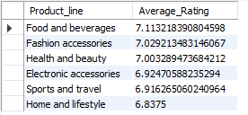

15-- Count the sales occurrences for each time of day on every weekday?

select Case

when Date_Format(STR_TO_DATE(Date, '%d/%m/%Y'), '%w') = 0 then 'Sunday'

when Date_Format(STR_TO_DATE(Date, '%d/%m/%Y'), '%w') = 1 then 'Monday'

when Date_Format(STR_TO_DATE(Date, '%d/%m/%Y'), '%w') = 2 then 'Tuesday'

when Date_Format(STR_TO_DATE(Date, '%d/%m/%Y'), '%w') = 3 then 'Wednesday'

when Date_Format(STR_TO_DATE(Date, '%d/%m/%Y'), '%w') = 4 then 'Thursday'

when Date_Format(STR_TO_DATE(Date, '%d/%m/%Y'), '%w') = 5 then 'Friday'

else 'Saturday'

end as Weekday,

substring(Time, 1, 2) as Hour_of_Day,

count(*) as Sales_Occurrences

from sales_mst group by Weekday, Hour_of_Day;

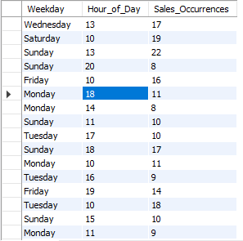

16-- Identify the customer type contributing the highest revenue?

select Customer_type, sum(gross_income) as Revenue_Genrated

from sales_mst

group by Customer_type

order by Revenue_Genrated desc limit 1;



17-- Determine the city with the highest VAT percentage.

select City, sum(Tax) as Tax_Genrated

from sales_mst

group by City order by Tax_Genrated desc limit 1;



18-- Identify the customer type with the highest VAT payments.

select Customer_type, sum(Tax) as Total_Vat

from sales_mst

group by Customer_type

order by Total_Vat desc limit 1;



19-- What is the count of distinct customer types in the dataset?

select distinct Customer_type, count(Customer_type) as count_Cust_Type

from sales_mst

group by Customer_type;



20-- What is the count of distinct payment methods in the dataset?

select distinct Payment, count(Payment) as Count_Payment_Method

from sales_mst

group by Payment;

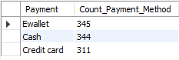

21-- Which customer type occurs most frequently?

select Customer_type, count(*) as Frequency

from sales_mst

group by Customer_type

order by Frequency desc limit 1;



22-- Identify the customer type with the highest purchase frequency.

select Customer_type, Total

from sales_mst

group by Customer_type, Total

order by Total desc limit 1;



23-- Determine the predominant gender among customers.

select Gender, count(*) as Gender_count

from sales_mst

group by Gender

order by Gender_count desc limit 1;



24-- Examine the distribution of genders within each branch.

select Branch,

Gender,

count(*) as Gender_Count

from sales_mst

group by Gender, Branch

order by Branch, Gender;

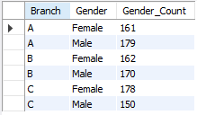

25-- Identify the time of day when customers provide the most ratings.

select Rating, case

when cast(Substring_index(Time, ':', 1) as UNSIGNED) < 12 then 'MORNING'

when cast(Substring_index(Time, ':', 1) as UNSIGNED) < 18 then 'AFTERNOON'

else 'EVENING' end as timeofday from sales_mst

group by Rating, timeofday

order by Rating desc limit 3;

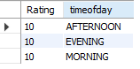

26-- Determine the time of day with the highest customer ratings for each branch.

With Highest_rating_Branch_wise as

(

select Branch, Rating, case

when cast(Substring_index(Time, ':', 1) as UNSIGNED) < 12 then 'MORNING'

when cast(Substring_index(Time, ':', 1) as UNSIGNED) < 18 then 'AFTERNOON'

else 'EVENING' end as timeofday,

Rank() Over(Partition By Branch Order by Rating desc) as Rating_Rank

from sales_mst

group by Branch, Rating, timeofday

)

select Branch, timeofday, Rating from Highest_rating_Branch_wise where Rating_Rank=1;

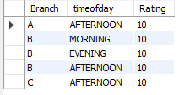

27-- Identify the day of the week with the highest average ratings.

select Case

when Date_Format(STR_TO_DATE(Date, '%d/%m/%Y'), '%w') = 0 then 'Sunday'

when Date_Format(STR_TO_DATE(Date, '%d/%m/%Y'), '%w') = 1 then 'Monday'

when Date_Format(STR_TO_DATE(Date, '%d/%m/%Y'), '%w') = 2 then 'Tuesday'

when Date_Format(STR_TO_DATE(Date, '%d/%m/%Y'), '%w') = 3 then 'Wednesday'

when Date_Format(STR_TO_DATE(Date, '%d/%m/%Y'), '%w') = 4 then 'Thursday'

when Date_Format(STR_TO_DATE(Date, '%d/%m/%Y'), '%w') = 5 then 'Friday'

else 'Saturday'

end as dayname,

avg(Rating) as AVG_Rating

from sales_mst

group by dayname

order by AVG_Rating desc limit 1;



28-- Determine the day of the week with the highest average ratings for each branch.

With Ranking_Branchwise_avgRating as

(

select Branch, Case

when Date_Format(STR_TO_DATE(Date, '%d/%m/%Y'), '%w') = 0 then 'Sunday'

when Date_Format(STR_TO_DATE(Date, '%d/%m/%Y'), '%w') = 1 then 'Monday'

when Date_Format(STR_TO_DATE(Date, '%d/%m/%Y'), '%w') = 2 then 'Tuesday'

when Date_Format(STR_TO_DATE(Date, '%d/%m/%Y'), '%w') = 3 then 'Wednesday'

when Date_Format(STR_TO_DATE(Date, '%d/%m/%Y'), '%w') = 4 then 'Thursday'

when Date_Format(STR_TO_DATE(Date, '%d/%m/%Y'), '%w') = 5 then 'Friday'

else 'Saturday'

end as dayname,

avg(Rating) as AVG_Rating,

Rank() Over(Partition by Branch Order by avg(Rating) desc) as Ranking

from sales_mst

group by Branch, dayname

)

select Branch, dayname, AVG_Rating from Ranking_Branchwise_avgRating where Ranking=1;

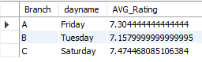

----------------------------------------------------*******--------------------------------------------------------

Stu_ID: S7475

Name: Lokesh Mohanlal Joshi

Place: Bhatapara(C.G)