**Name:** Joseph Géigel

**Date:** May 17, 2023

**Course:** Foundations of Programming: Python

**Assignment:** 05

**GitHub URL:** <https://github.com/jgeigeluw/IntroToProg-Python>

The To Do List Script: Working with Dictionaries

# Introduction

The previous assignment paper discussed the use of lists and loops to create a script that produced an inventory of items in a house. This time we introduce the concept of *dictionaries*. With dictionaries, data is not stored in a sequence, but in pairs of *keys* and *values* that work similarly to a physical dictionary with words and definitions. Implementing dictionaries and while loops, the script discussed in this paper will allow users to review, add and remove tasks from a text file that contains a table of tasks and assigned priority values.

# What is a Dictionary?

Unlike lists, dictionaries in Python are not sequences. Dictionaries let you organize information in pairs of *keys* and *values.* Like a physical dictionary, where each word has a definition, in a Python dictionary, each *key* gets a *value.* (Dawson, 2010) This introduces a fundamental difference between lists and dictionaries: accessing the elements within it. Elements in a list can be accessed by indexing, where an integer represents the position of a data element in the list. However, in dictionaries, data elements (values) are accessed by referencing their key. Keys are immutable, unique within a dictionary, and they are typically strings or numbers. (Dawson, 2010)

## Creating Dictionaries

Another difference between dictionaries and lists can be found in the syntax of both data types. Values stored in a list are enclosed by brackets [ ] and separated by commas, while key-value pairs in a dictionary are enclosed by curly braces { }. Additionally, in dictionaries, key-value pairs are separated by commas, but the relationship between a key and its value is represented by a colon. (Dawson, 2010) This is an example of a dictionary that contains data about a student:

student = {“name”: ”Carlos”, “age”: 20, “major”: “Geography”, ”grades”:[90,97,89,91]}

In this example, the name of the dictionary is student and it contains the name, age, major and grades of a student. The name and major keys contain string data values, age is an integer, and grades is a list of integers.

## Accessing Dictionary Values

As mentioned earlier, keys are used to access the values in a dictionary, but there are a few ways of doing that. The most basic one is to retrieve the value by directly accessing it with a key, which can be done by simply entering the name of the dictionary and putting the key in brackets. (Dawson, 2010) In this example, the key name is used to retrieve the value Carlos from the student dictionary.

>>> student[“name”]

‘Carlos’

Another way of accessing the values in a dictionary consists in using the get()method. This method has the capability of handling situations where a key or value does not exist within in a dictionary, which would typically result in an error if the programmer simply tried to retrieve a value by entering a non-existent key. (Dawson, 2010) To use this method, you would enter the name of the dictionary, followed by .get and the desired key within parentheses. The example below shows how to use the get method to obtain the value Carlos from the student dictionary.

>>> print(student.get(“name”))

‘Carlos’

## Adding are removing key-value pairs

Since dictionaries are mutable, you can add and remove key-pairs in them. Adding a key-value pair can be done by entering the name of the dictionary, followed by a key name in brackets, and an assignment operator that is followed by a new key value. (Dawson, 2010) Our student dictionary already showed the major of the student, but we can also store information about the student’s minor. This example shows how to add that key-value pair.

student[“minor”]= “Anthropology”

Removing a key-value pair from a dictionary is also possible. This can be done by using the del statement in Python. The delete statement must be followed by the dictionary name and the name of the key to be removed in square brackets. (Dawson, 2010) We can use this method to delete the key-value pair that we just added to our student dictionary.

del student[“minor”]

# The To Do List Script

This paper introduces a script that uses a dictionary to organize a series of tasks with different priority levels and writes that information to a text file. The script allows the user to perform several actions on the text file, such as: reviewing current data stored in the text file, adding new tasks and priorities, and removing tasks from the file.

## Starter Script

One characteristic of this script is that it was created from an existing incomplete script that guided the development of the code. The starter code (figure 1) for the To Do List script included an outline of the general goals of the final product and possible steps to follow. The initial script suggested that the To Do List script needed to include: a section that loaded existing data to the script, a menu of options for the user, and five possible conditions that would guide the development of the code. These five conditions are determined by user input from the options displayed in the initial menu, and they allow these actions:

1. Show the current items in the table
2. Add a new item to the list/table
3. Remove an item from the list/table
4. Save tasks to the text file
5. Exit the program

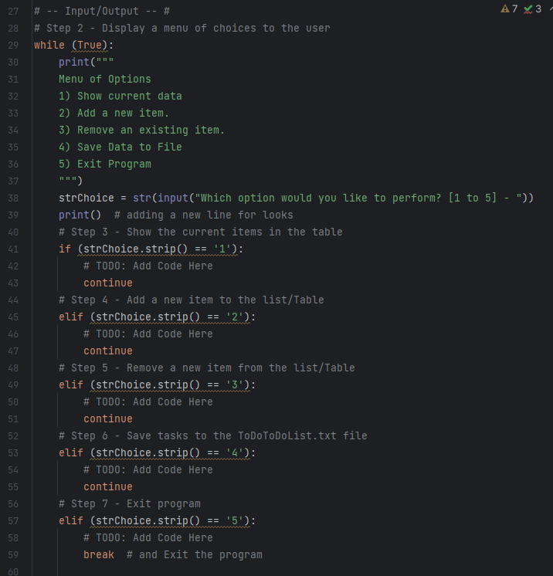

Figure . Portion of the starter script used to create the To Do List script.

## Declaring variables

Four variables are declared at the beginning of the script (figure 2). The first one is the objFile variable that identifies the text file where a list of tasks and priorities will be written down. This file is stored in the same folder where the script is saved. After declaring that file object variable, the next one is dicRow, a variable representing a dictionary for each row of data where each *task* is a key, and each *priority* is a value. Then we have the lstTable variable, a list that acts as a table of data rows. Keys and values from the dictionary are appended to this list that will then be used to write to the text object file. Finally, we find strChoice, a variable that captures the menu option selected by the user of the program in order to perform one of the actions in the while loop.

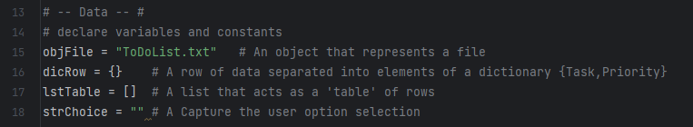

Figure . Declaring variables and constants.

## Loading existing data from file

This script populates a list of tasks and priorities by reading all the lines in an existing text file. To do this, the script opens a file object in read mode and iterates through each line using a for loop. In this for loop, a list of tasks and priorities is created by splitting each row at the comma that separates a task from its priority level. This results in a list for each line, where index value [0]represents the task name, and index value [1] represents the priority level assigned to that task. These two list items are used to define the values associated to the “Task” and “Priority” keys in the dicRow dictionary. A dicRow dictionary is created for each row of data, i.e. for each task, and then those key-pair (*Task-Priority*) values are appended to a list named lstTable by using the .append list method.

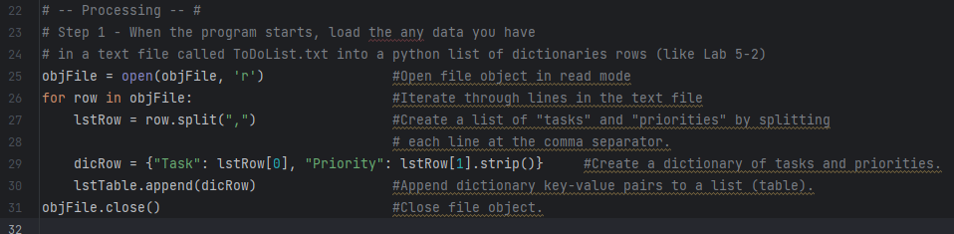

Figure . Loading data from existing text file.

## Displaying a menu of choices

Like in the previous *Home Inventory* script, the *To Do List* script presents the user a menu of choices that represents actions to be taken by the program based on the selection that the user makes. Each option is represented by a number that the user inputs when prompted by the program. These options include showing the current data, adding or removing tasks, saving the data to the text file, or exiting the program. Immediately after displaying the menu of options, the user is prompted to select an option by the question: *“Which option would you like to perform? [1 to 5]”.* Then the user would select an option by entering one of the numbers in the menu.

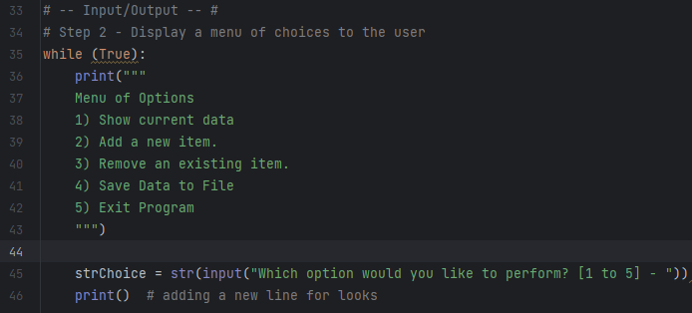

Figure . Display menu of choices.

## Option 1: Show current tasks

If option #1 is selected by the user, the program will display the data that is currently in the lstTable list. This list is initially populated from data stored in the ToDoList.txt file object, but it could also contain tasks and priorities added by using the script that have not been yet written to the text file. Figure 5 shows the code implemented for option 1, where tasks and priorities in each row of lstTable are printed after a for loop iterates through all the lines in the list. The result of executing this option is seen in figure 6, where current data is presented in lines with tasks on the left, and priorities on the right.

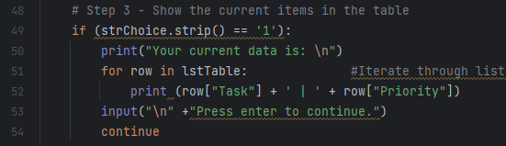

Figure . Display current data in list.

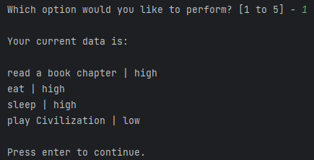

Figure . Output from selecting option 1.

## Option 2: Add new tasks and priorities

When option #2 is selected, the program allows the user to add new tasks and priorities to the list (lstTable). Tasks added here are not immediately saved to the text file, but they can be saved by selecting option 4 after adding the tasks, or by saving to file before exiting the program (option 5). Figure 7 shows a *while* loop within the *elif* statement that executed option 2. In this while loop, two user inputs are captured: strTask and strPriority. These two inputs are used to populate the new key-value pair that is appended to lstTable in line 60 of the script (see figure 7). After the newly added tasks and priorities are appended to the list, the strChoice input variable is presented again, but this time to ask the user if more tasks need to be added. The reason why a while loop was implemented here is to allow the user to add additional tasks after the first one if desired. This is accomplished by the continue statement that runs if the user selects “y” after the “Add more tasks?” prompt.

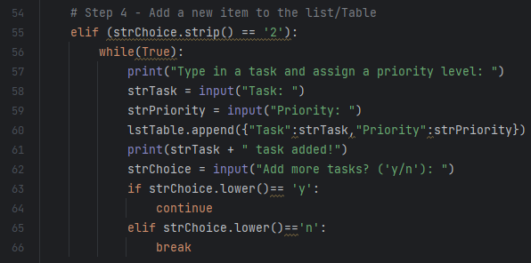

Figure . Adding new tasks.

## Option 3: Removing a task

Option #3 allows the user to remove a task from the list. This option captures the name of the task to be removed by using the strTask input variable. The program then implements a for loop to find the task to be removed, and the remove list method to take the row associated to the selected task off the list.

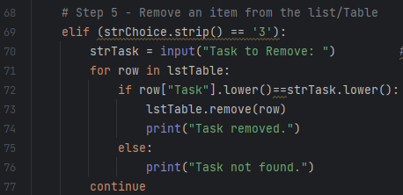

Figure . Removing tasks from list.

## Option 4 and 5: Saving data to the text file and exiting the program

Finally, the user can select from options 4 and 5 after reviewing, adding or removing tasks. Option #4 lets the user save current list data to the ToDoList.txt file. During the execution of the program, changes made to the list of tasks and priorities are only stored in memory, and not automatically saved to the file object. If option #4 is selected, the program opens the ToDoList.txt file object in write mode and uses the write method to write each row in lstTable to new lines in the text file. After writing down all items in the list (table), the program closes the file. The user can then select another option to make more changes to the list of tasks or to exit the program.

The last alternative is option #5. This option allows the user to exit the program. When selecting this option, the user is prompted with the question *“Would you like to save your data?”*. If the user selects to save the data, the program performs the same actions that would be executed by selecting option #4: opening file in write mode, writing down tasks, and closing the file, and then exits the program. This allows the user to save the data and close the program in only one option selection or if option #5 was selected by error. If the user chooses not to save the data, the program simply closes and no changes are saved. Figure 9 shows the Python code associated to saving the data and exiting the program.

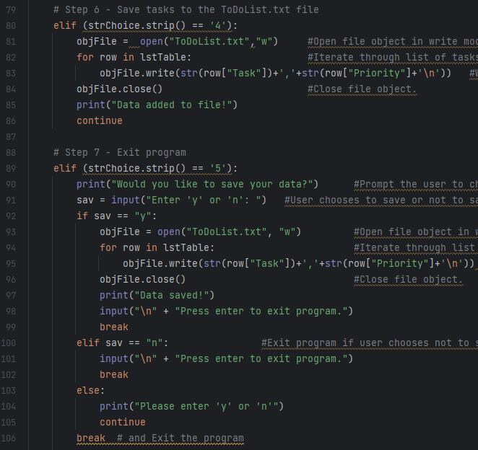

Figure . Saving data and exiting.

## Output Example

The output from running the To Do List Script is an updated ToDoList.txt file with tasks and priorities as assigned by the user. Figure 10 shows a run of the script in PyCharm, where the user selects option 1 and the program prints the current data in the list as it was extracted from the file object.

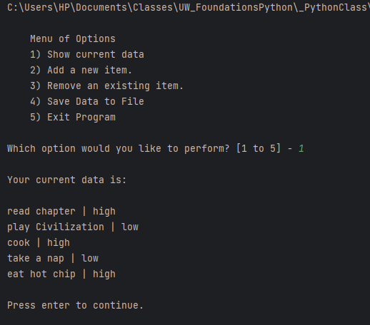

Figure . PyCharm run of the script. User selects option 1.

After selecting this option, the user could select option 2 and add a new task named “go for a walk” and assign it a priority value of “low” as shown in figure 11. Then, the user could also select option 3 and remove a task, in this case the removed task is “cook”. Figure 12 displays the updated list of current data after these two operations are executed.

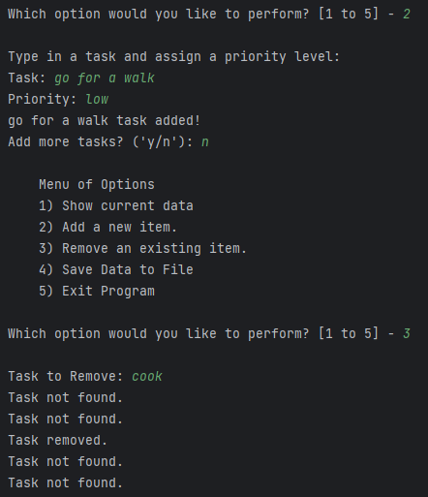

Figure . Adding and removing tasks by executing script in PyCharm.

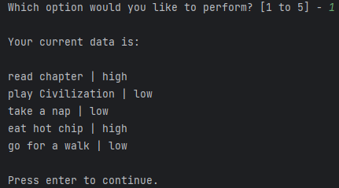

Figure . Updated data list after adding and removing tasks.

If the user wishes to save the data, they could select option 4 or 5. If selecting option 4, the user would be notified that the data has been saved and they could continue making edits. However, if the user chooses option 5, the program would prompt the user to save the data and if “y” is entered, the program would save the data and exit as shown in figure 13.

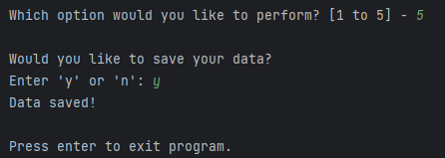

Figure . User selects option 5 to save data and exit the program.

The final output text file looks like the one shown in figure 14. It is a table of tasks and their respective priority levels as assigned by the user of the To Do List Python program.

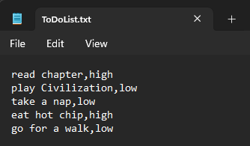

Figure . Final output text file.

# Summary

Previously we had examined how to store data in sequences, such as lists, but this paper introduced an alternative and powerful way to organize data by using dictionaries. Dictionaries store information in key-value pairs where each key represents a value in the same way that a word represents a definition in a physical dictionary. In addition, this paper discussed how to create, access and modify dictionaries. Finally, we implemented dictionaries to develop a To Do List script that allows the user to review, add or remove tasks and priorities from a text file object using Python.

# References

Dawson, M. (2010). *Python Programming for the Absolute Beginner* (Third Edition ed.). Boston, MA, United States of America: Course Technology PTR.