Ja
MVC Notes
Created: Oct 11, 2016
Last Modified: October 11, 2016 01:05:47 PM
MVC Notes - Table of Contents
1 SectionHeader_1 Tjhos os emdi etc etc etc 3
1.1 SectionHeader_2 3
1.2 SectionHeader_2 3
1.3 SectionHeader_2 3
1.4 SectionHeader_2 3
1.4.1 SectionHeader _3 3
1.4.2 SectionHeader_3 3
1.4.2.1 SectionHeader_4 3
1.4.2.1.1 SectionHeader_5 3

- Conventions

- Controllers are place in the 'controllers' folder, and by convention named controllernameController.
- Views related to a particular controller go into the Views folder in a folder named for the the corresponding controller, ie, Controller = TestController, View will go into Views\Test.
- Can have multiple views associated with a controller.
- In order for a view to be available to multiple controllers, place the view in the Shared folder.

- View Data

- To associate a model with a view several ways of doing this:
- In the controller, can add the ViewModel object to the ViewData array, before calling the view. ViewBag is merely another way of referencing the ViewData object.
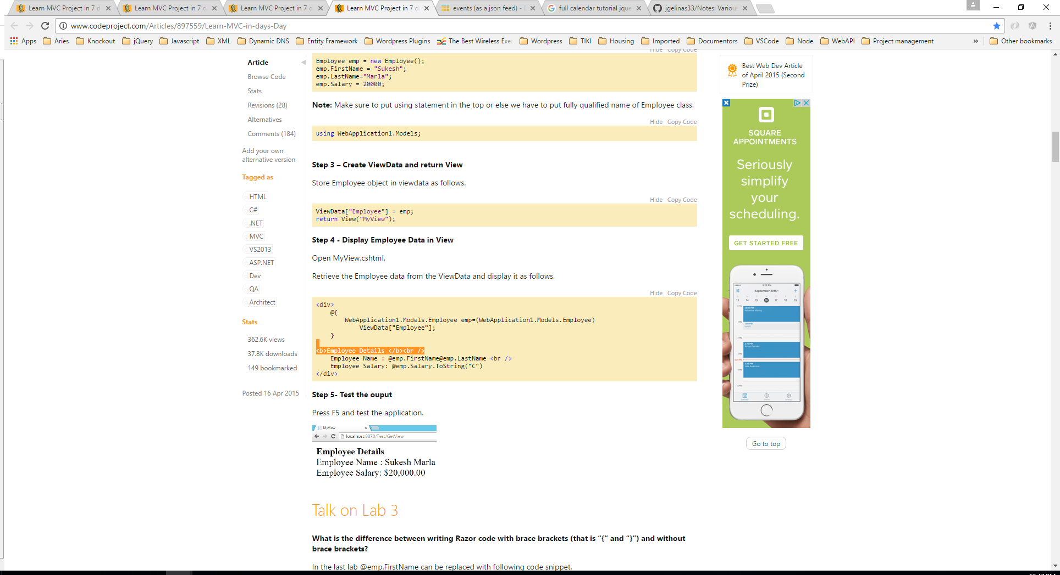
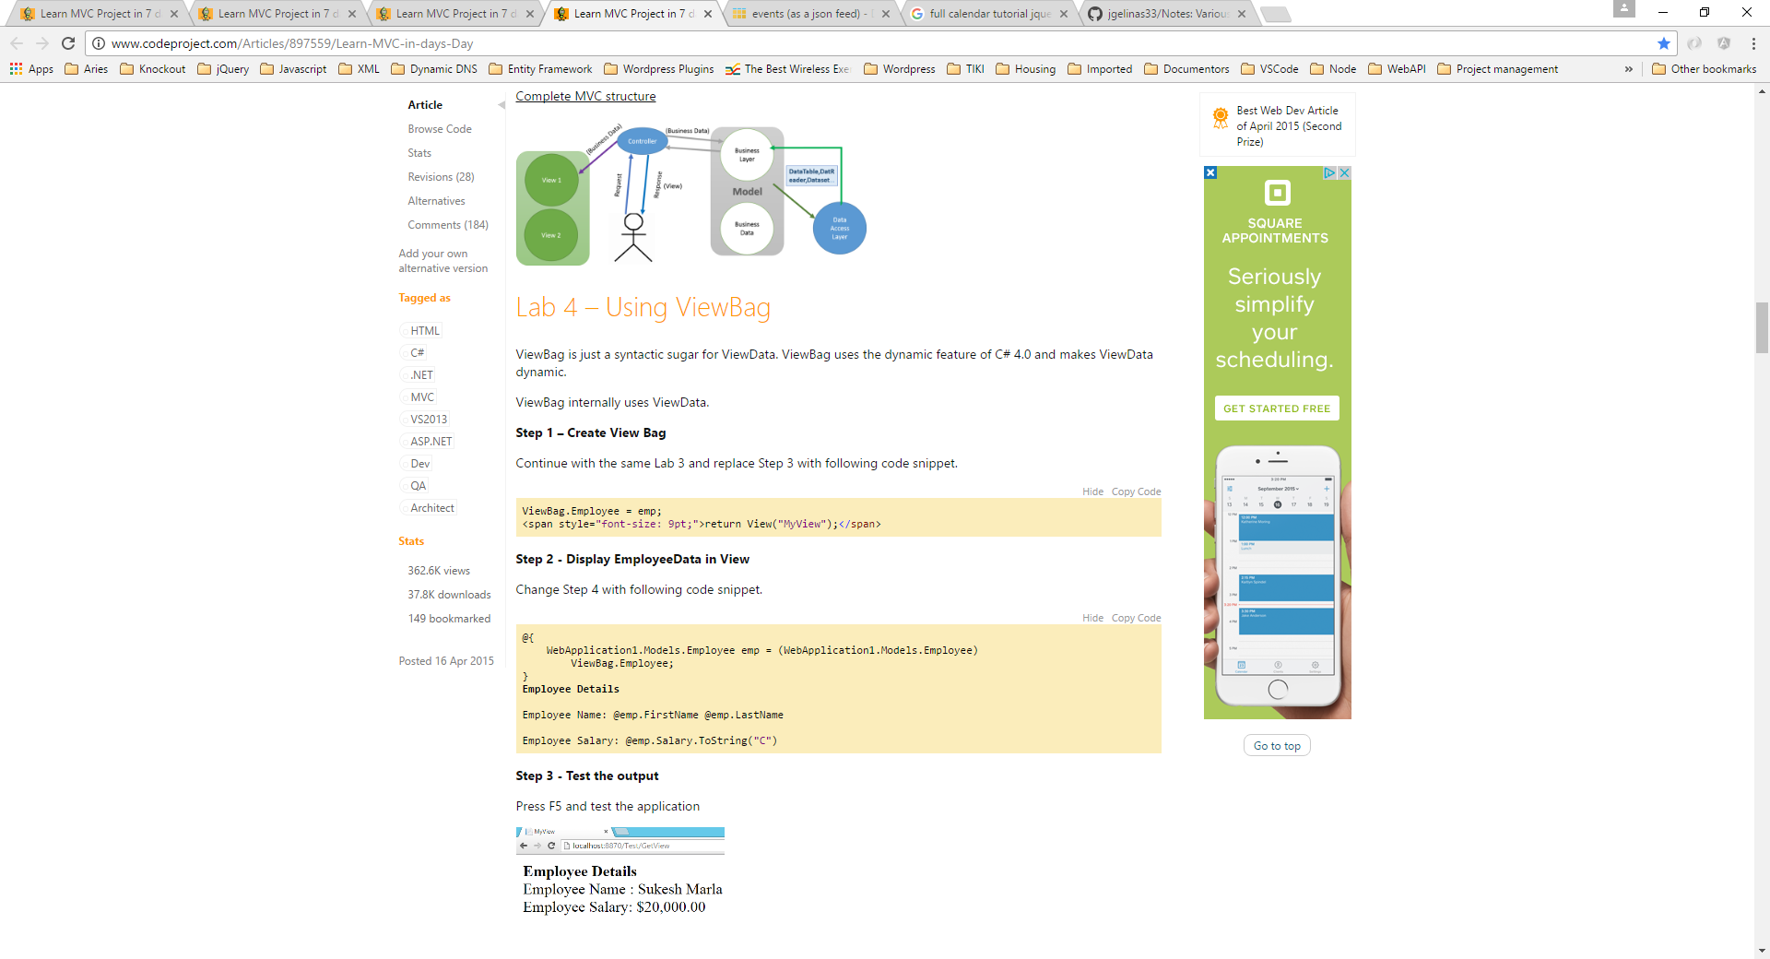
- Model can be directly placed in the cshtml page as well for type safety – no need to unbox.
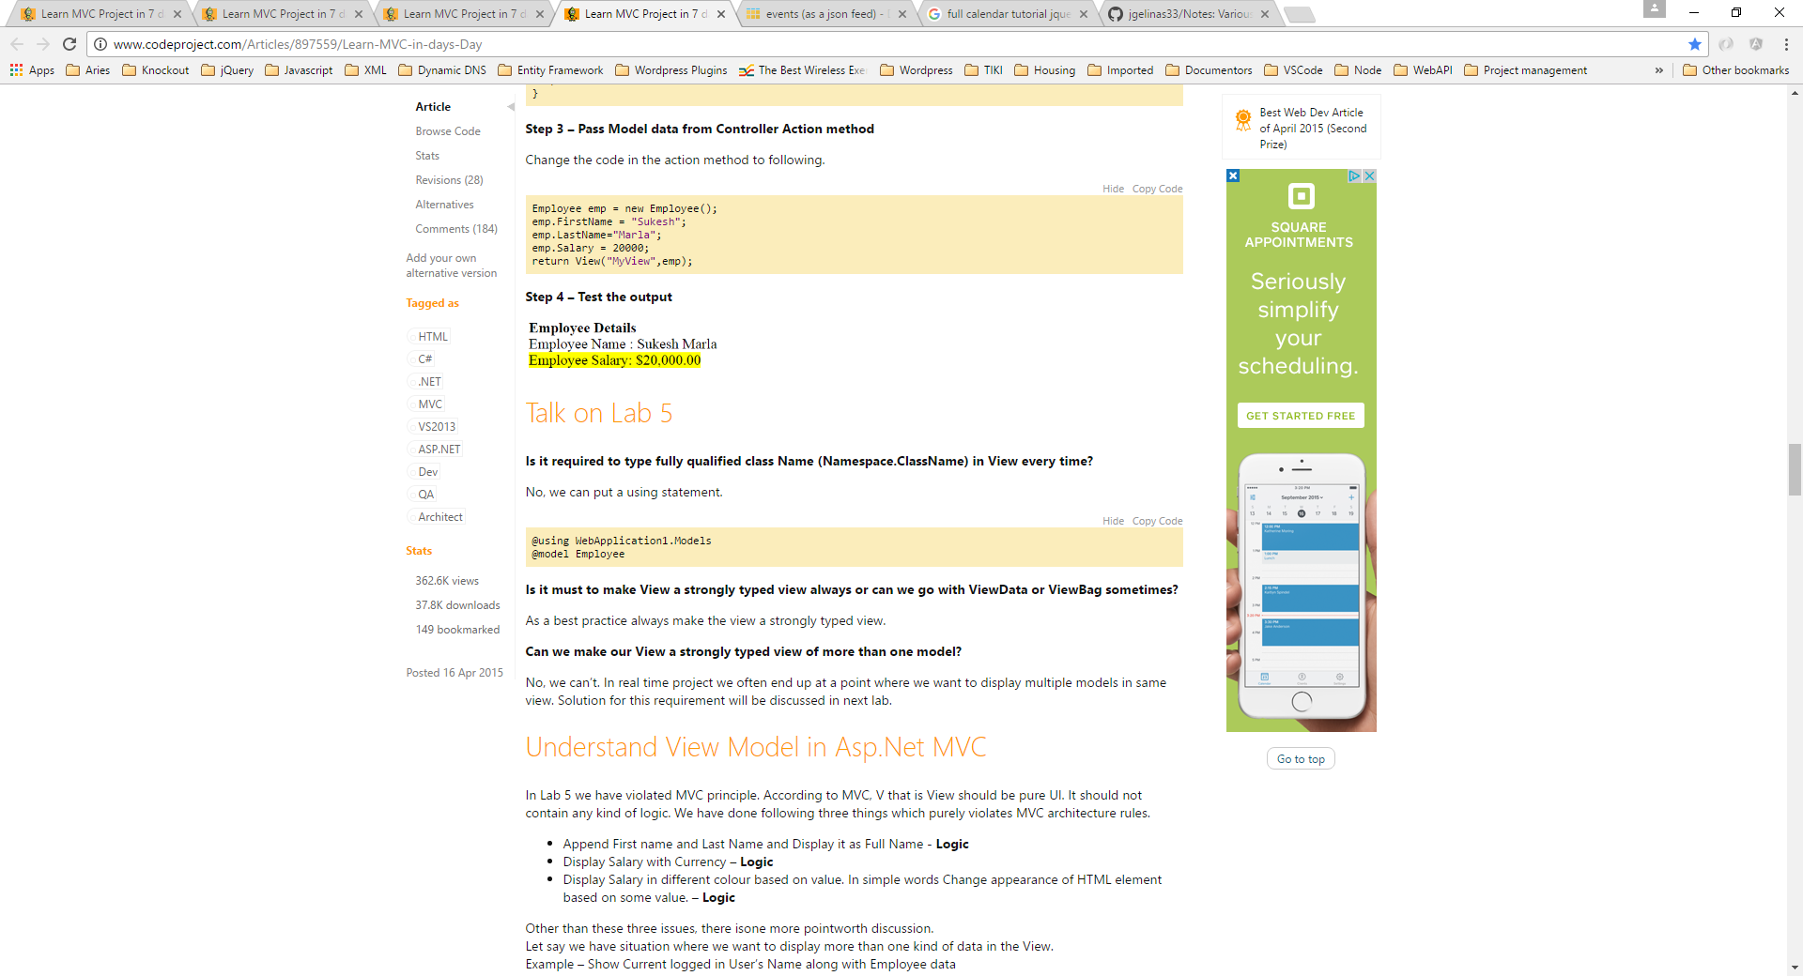
- Relationship between view and model is 1:1.

