Ja
Angular Notes
Created: Jun 14, 2016
Last Modified: August 31, 2016 04:30:55 PM
Table of Contents
1 Common Tools 3

- Raw Notes

- App directive
  - ng short for angular
  - app directive tends to go in the html tag of the page
  - only one per page (probably hence single-page applications are done with angular)
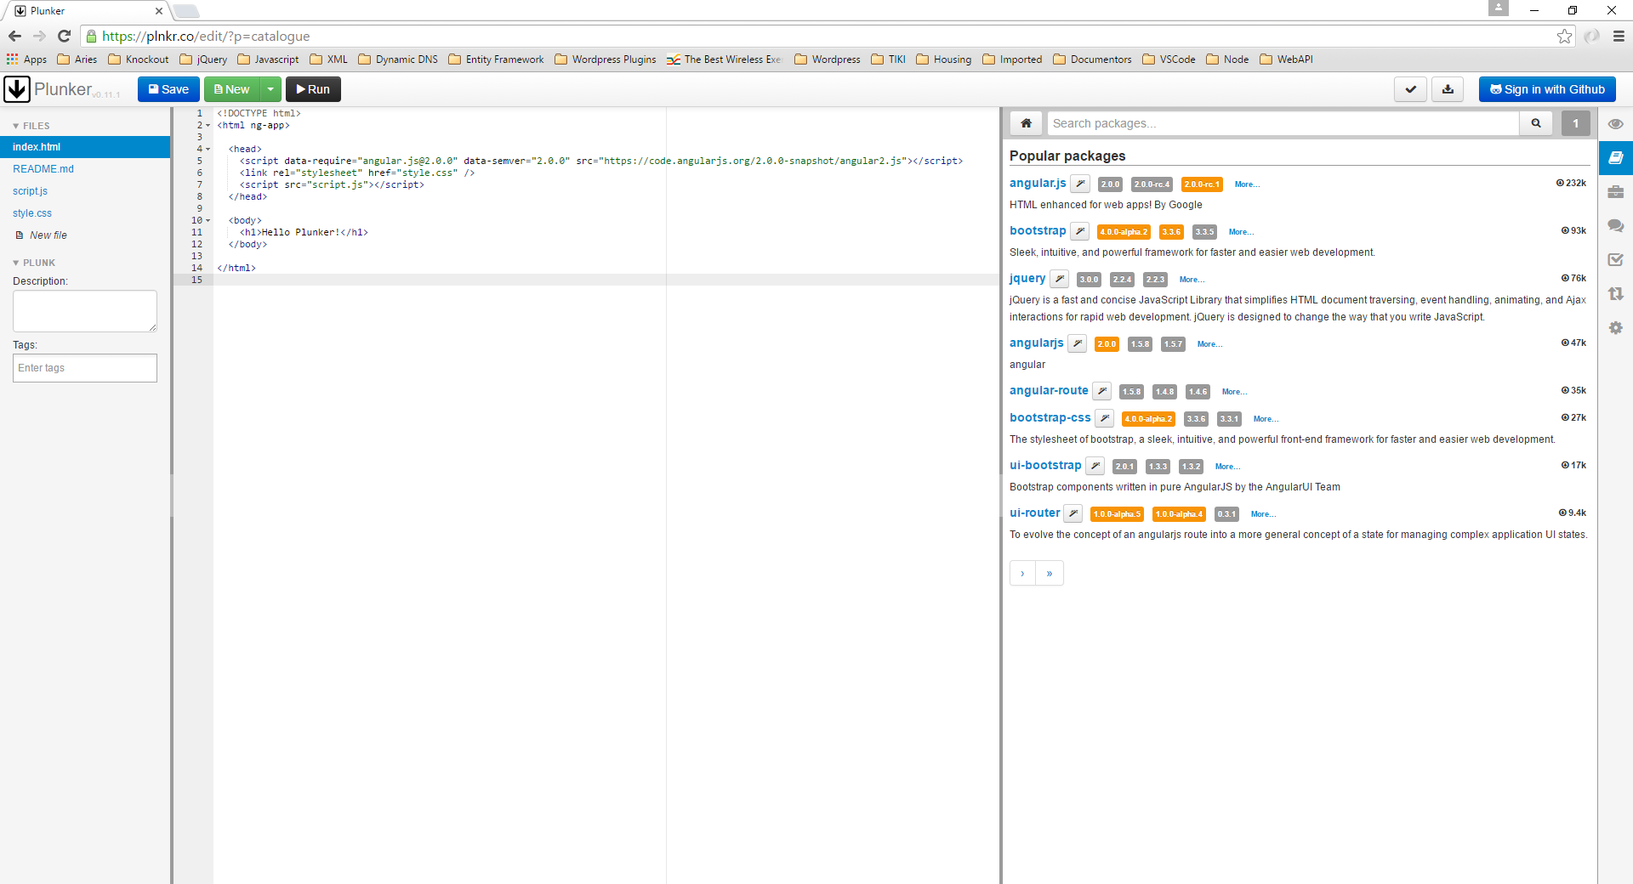
- Double curly braces considered a 'binding expression' that angular will interpret.
  - {{ 843/42}} – division interpreted by angular

- Plunkr – like jsfiddle.

- Controllers
- ng-app

- This is the starting point for an angular application. All angular code within the element that contains the directive will be considered.

- Include reference to application module in html page:
  - <script src="~/app/app.module.js"></script>

- Typically put in the page body tag
  - <body ng-app="app" >
  - “app” is the name of the module in the above referenced script file
  - angular modules tend to take the form of an Immediately Invoked Function Expression(IIFE)
  - So, within the app.module.js as it was named above, place the IIFE
(function () {
'use strict';

angular.module('app', []);
})();

- jhk

- Events
  - Event Directives:
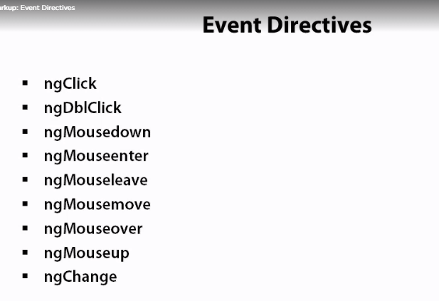
    - NgChange
ng-model required.
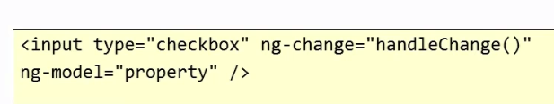
- Directives – Other
  - ng-bind
Does the same thing as the curly braces:
<div>{{session.upVoteCount}}</div>
<div ng-bind=”session.upVoteCount”></div>
  - ng-bind-template
Allows concatenation of bind statements using the curly braces:
<div ng-bind-template= “{{event.name}} {{event.date}}”></div>
  - ng-bind-html
Requires angular-sanitize.js.
Allows input of html snippets
  - ng-cloak
Mimics the functionality of jquery on.ready – keeps binding from happening until all elements that need to be bound are loaded.
Usually put in the body tag - <body ng-cloak>
Requires the following css rule in a css file to work correctly:
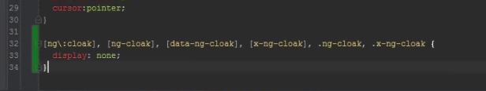
  - ng-model
Points to the data model within a controller.
Will create properties if they are yet to exist in the model.
<input id="eventImageUrl" type="url" ng-model="event.imageUrl" class="input-xlarge" placeholder="url of image..." />

