Ja
Javascript Notes
Created: Jun 14, 2016
Last Modified: July 1, 2016 11:20:50 AM
Table of Contents
1 Common Tools 4
2 Modules 5
2.1 Related Software 5
2.2 Immediately-Invoked Function Expressions (IIFE) 6
2.2.1 Basic IIFE structure: 6
2.3 Revealing Module Pattern 6
2.3.1 Singletons 6
2.3.2 Instantiable By Constructor 7
2.4 Asynchronous Module Definition Format 8
2.4.1 Module Loader: RequireJS 8
2.4.2 Format Examples: 9
2.5 CommonJS Format 10
2.5.1 Module Loader: SystemJS 10
2.5.2 Format Examples 11
2.5.2.1 Example using basic exports object assignment. 11
2.5.2.2 Example using module.exports object literal assignment 11
2.5.2.3 Example with requirements included 12
3 Node.js 13
3.1 Node Pacakage Manager (NPM) 13
3.1.1 package.json 13
3.1.2 Command to Add NPM package to project 14
4 ECMA Script 2015 (ES2015) 15
4.1 Modules 15
4.1.1 Exporting (reveal module API) 15
4.1.1.1 Examples: 15
4.1.1.1.1 Export of individual functions at the function level 15
4.1.1.1.2 Default module function to export at function level 15
4.1.1.1.3 Default function export at end of module 15
4.1.1.1.4 Function export at end of module 15
4.1.1.1.5 Function export at end of module using aliases 16
4.1.2 Importing (asynchronous loading of module/functions) 16
4.1.2.1 Examples: 16
4.1.2.1.1 Import all functionality from module into object 16
4.1.2.1.2 Import individual functionality from module with aliases 16
4.1.2.1.3 Import individual functionality from module with native names 16
4.1.2.1.4 Import default function from module 17
4.1.2.1.5 Import default function as well as individual functions 17
4.1.3 Transpilers 18
4.1.3.1 Babel 18
4.1.3.1.1 Install 18
4.1.3.1.2 Run 18
4.2 Bundlers 19
4.2.1 Browserify 19
4.2.1.1 Install 19
4.2.1.2 Run 19
4.2.2 WebPack 19
4.2.2.1 Install 19
4.2.2.2 Package install to use Babel to transpile to CommonJS 20
4.2.2.3 Run 20

- Common Tools

- Visual Studio Code – basic dev env for javascript.
- Objects
  - Object.defineProperty
- task is the actual created object
- writable: cannot reassign property/function, in this case, cannot reassign toString function.
- enumerable: hides the property from the list of available properties
- configurable: keeps property/function from being re-defined.
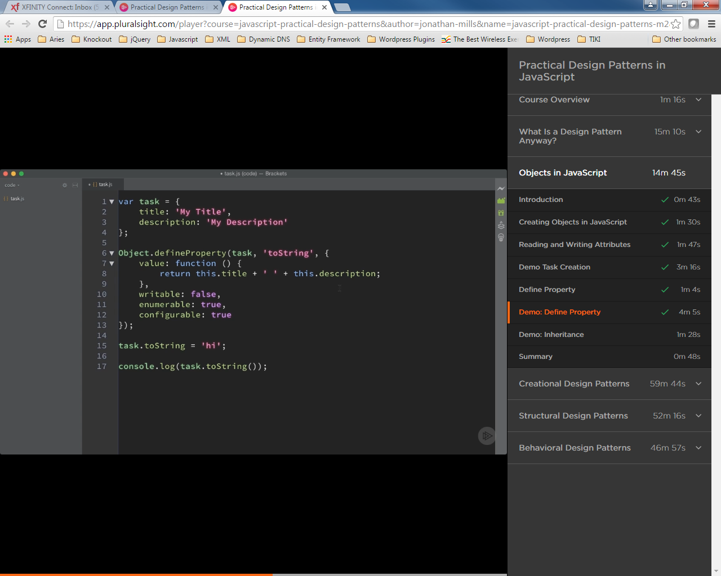
  - Object.create – inheritance
  - urgentTask has included in itself the task object functionality
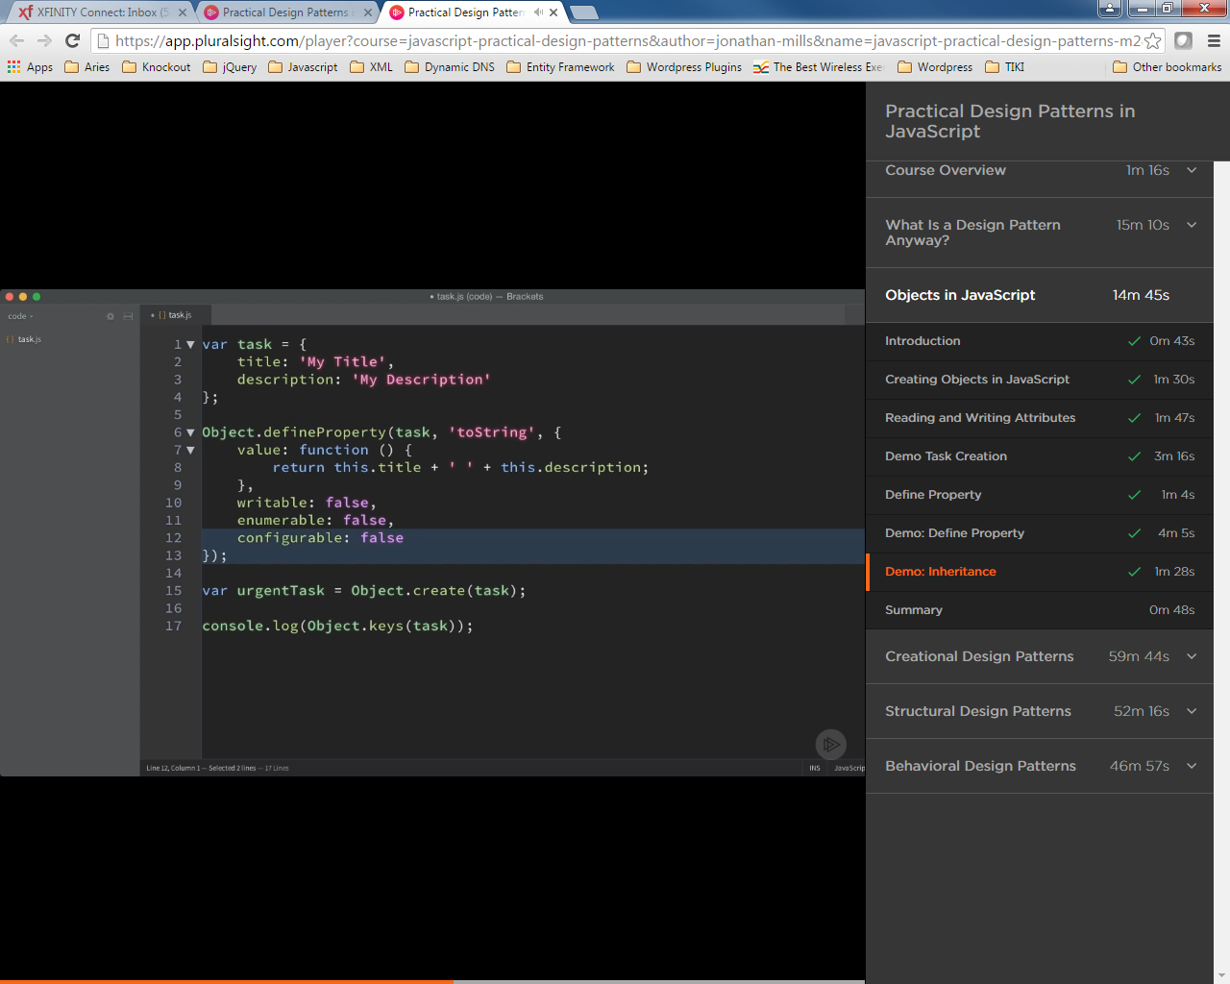
  - Constructor Pattern
- new keyword creates object
- Function acts like a class
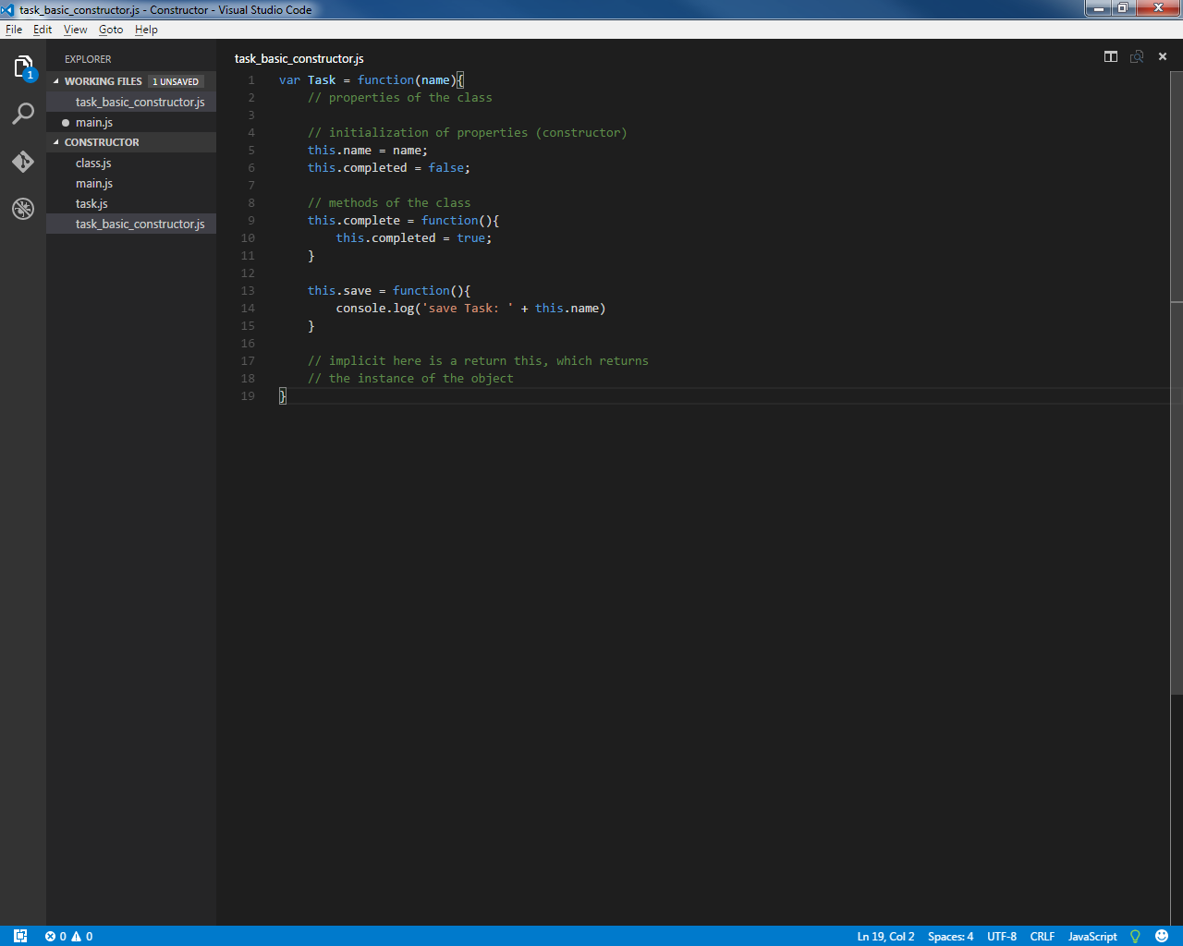
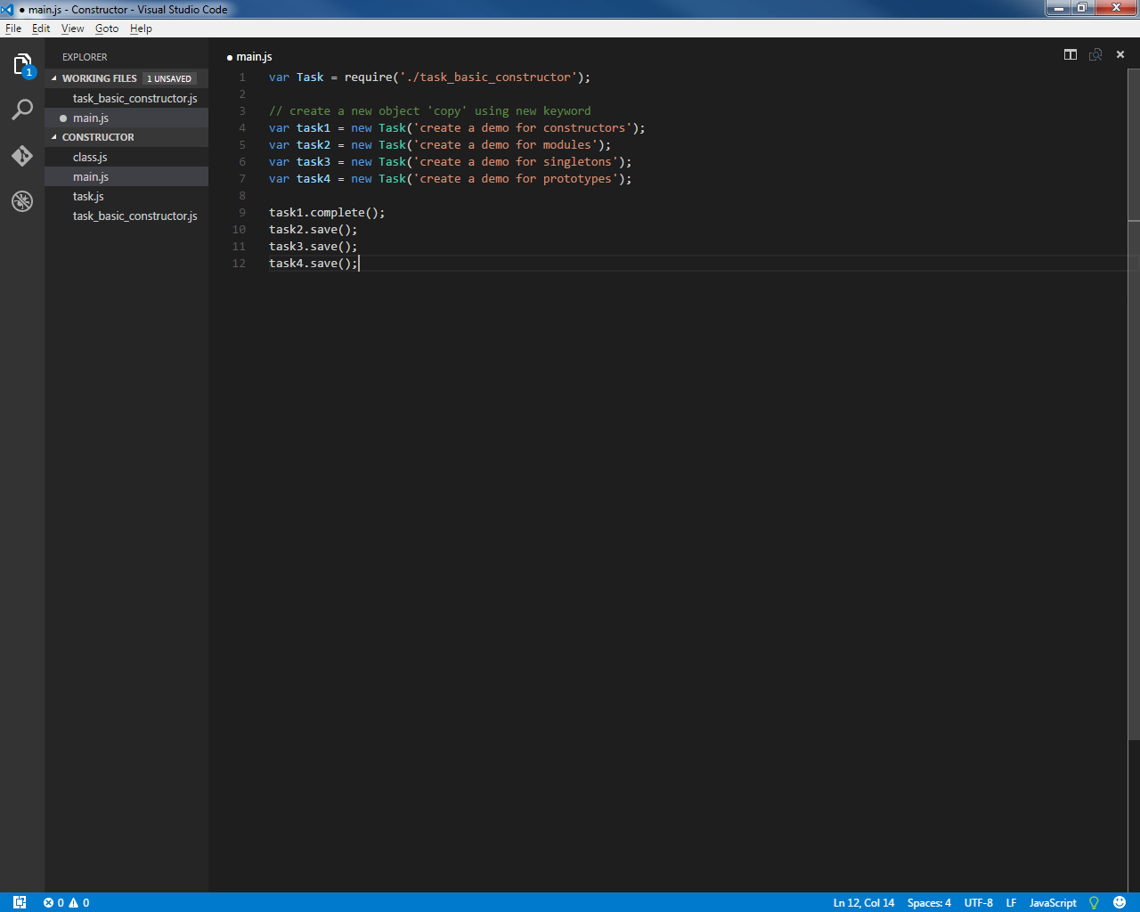
    - Prototype
  - Centralizes functionality with an object's prototype so that subsequently created objects can use prototype functionality common to the object and that functionality is not 'copied' to each instanced object of the type.
  - this relates to the individual instantiated object, not the object containing the prototype.
  - Every object instantiated from base object, now shares functionality – a sort of inheritance.
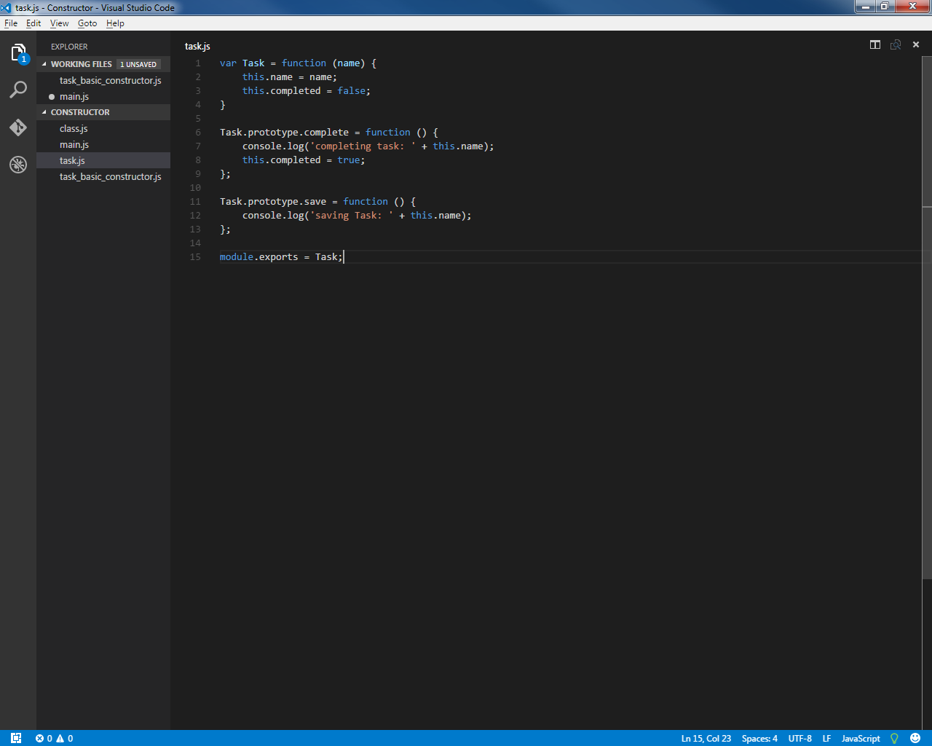

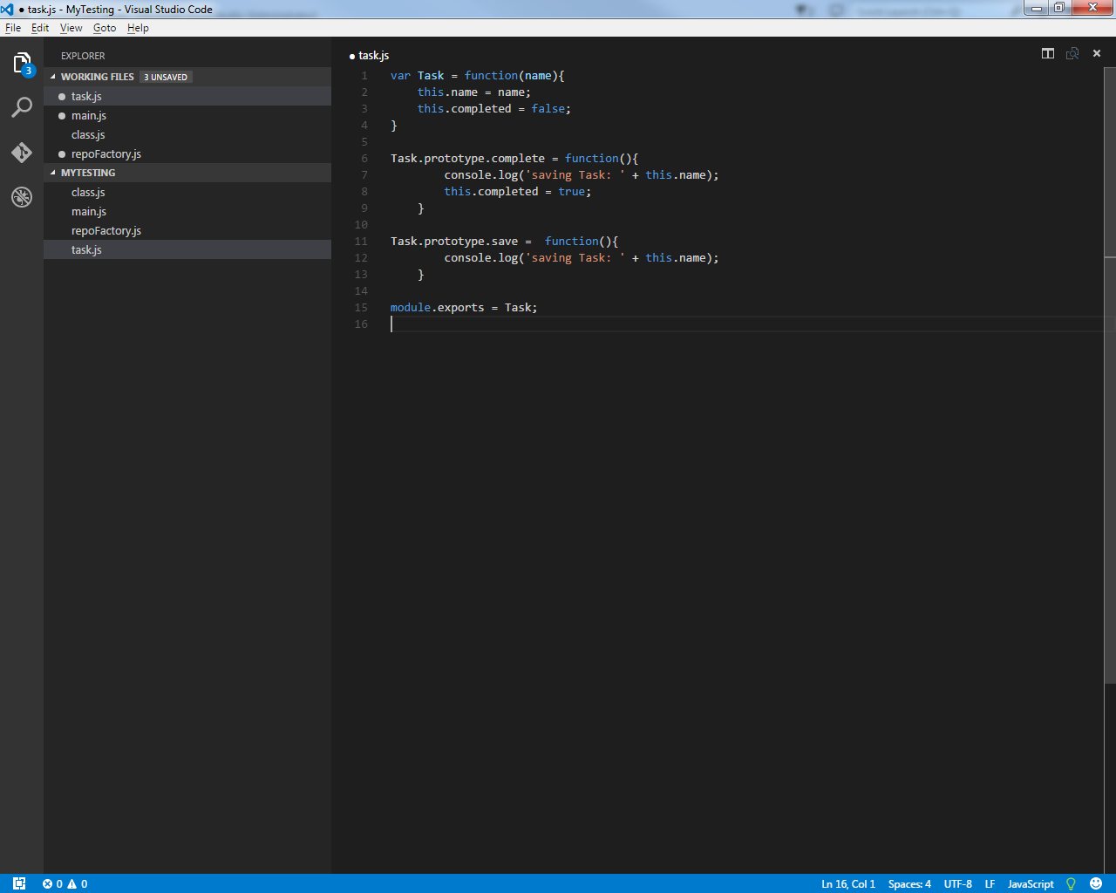
  - Factories
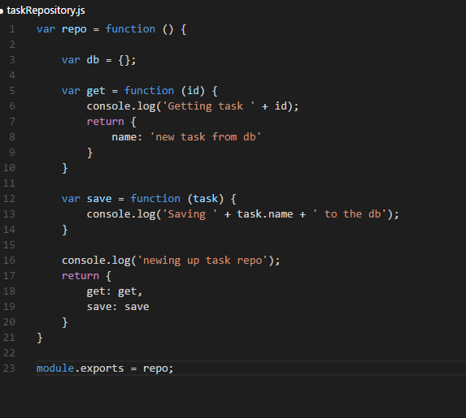
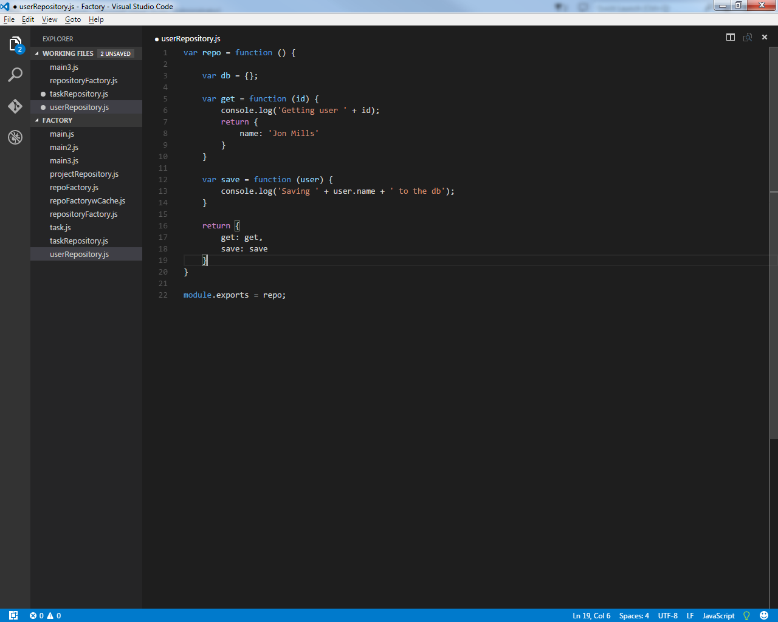
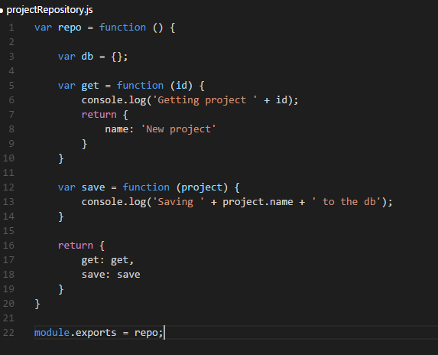

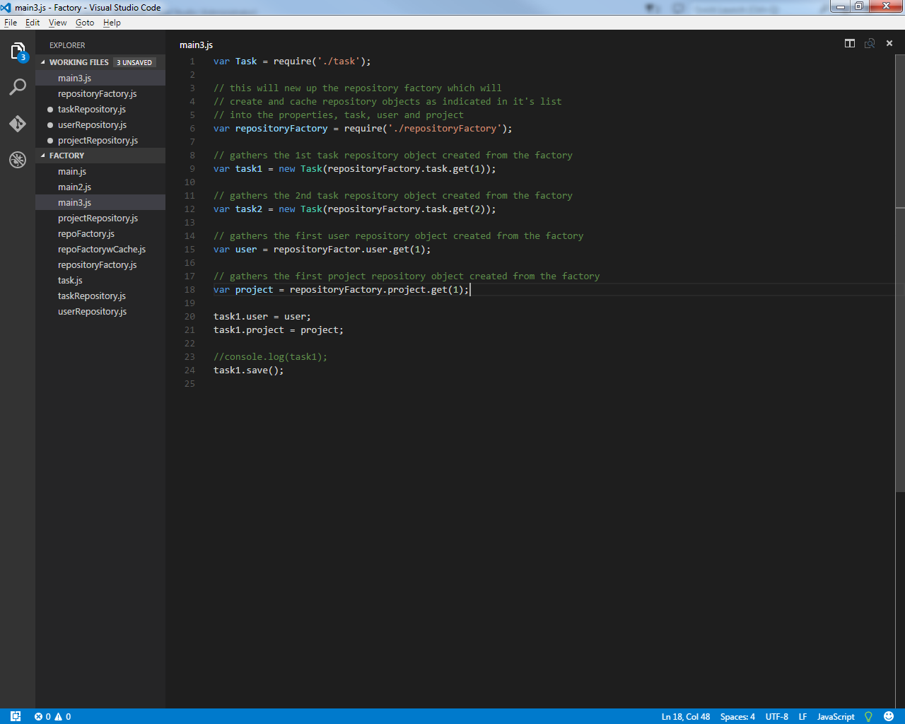
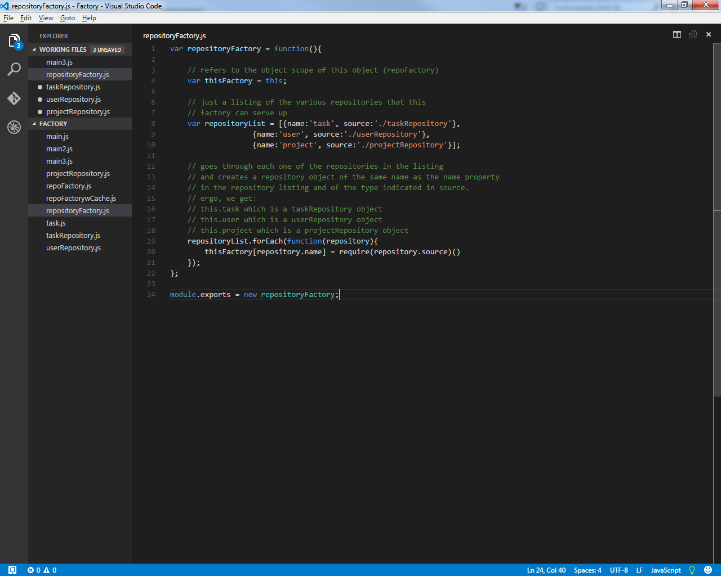
  - Decorating –
    - inheriting and adding/overriding existing functionality
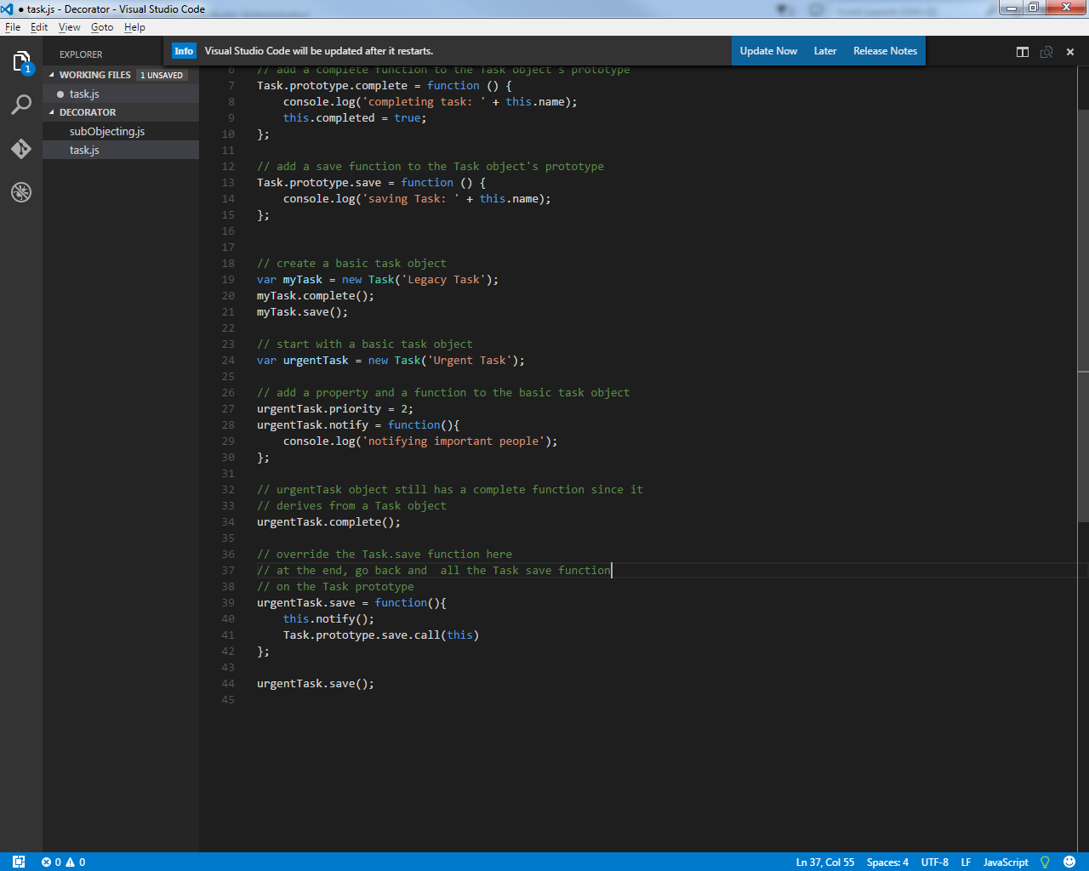
    - Capturing the base object's prototype
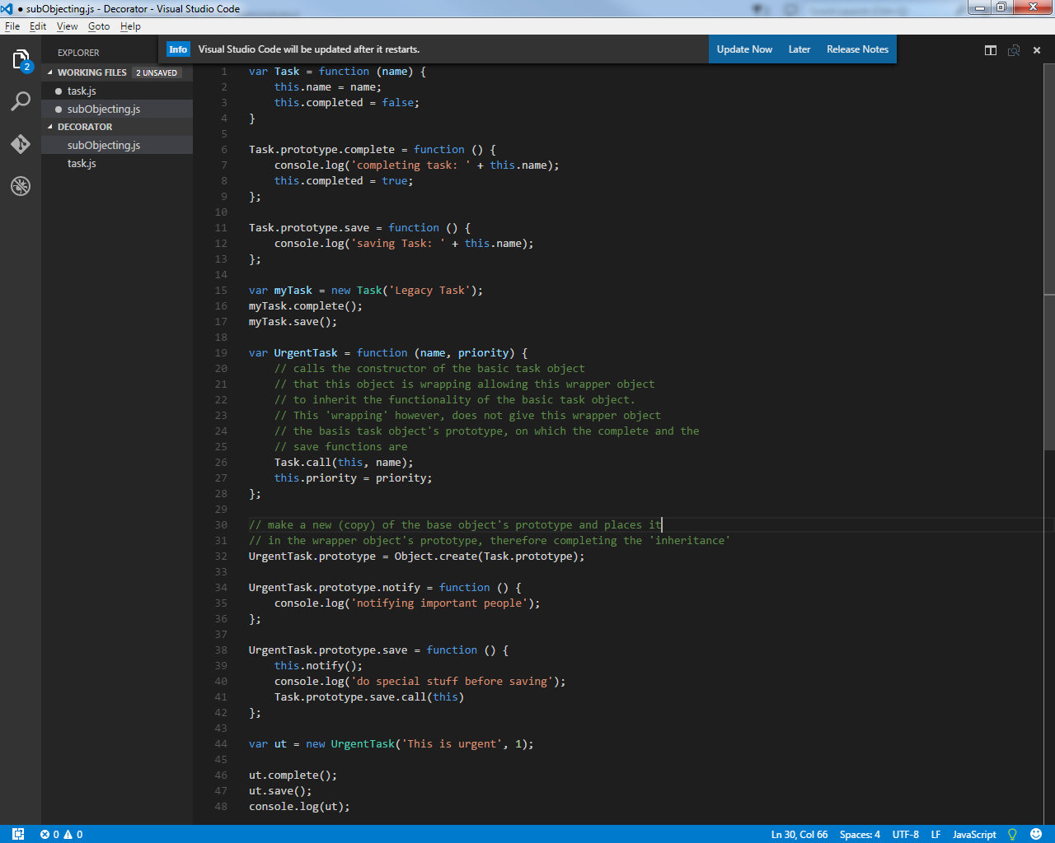
  - Observer Pattern
Uses a callback function to another object that is called when necessary:
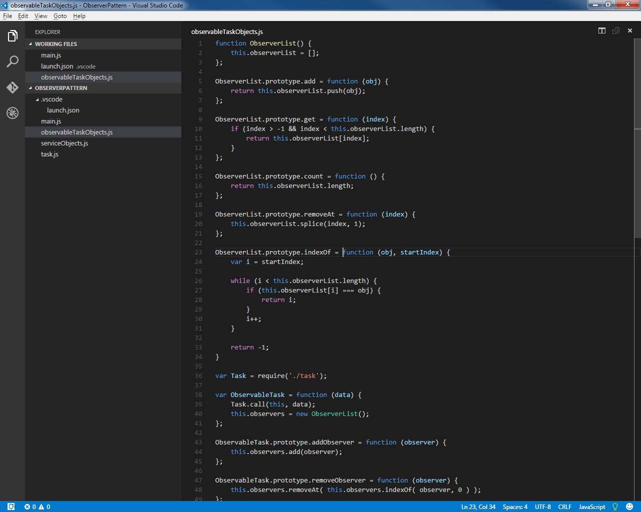
ObserverList object acts as a list container to hold references to object callback functions.
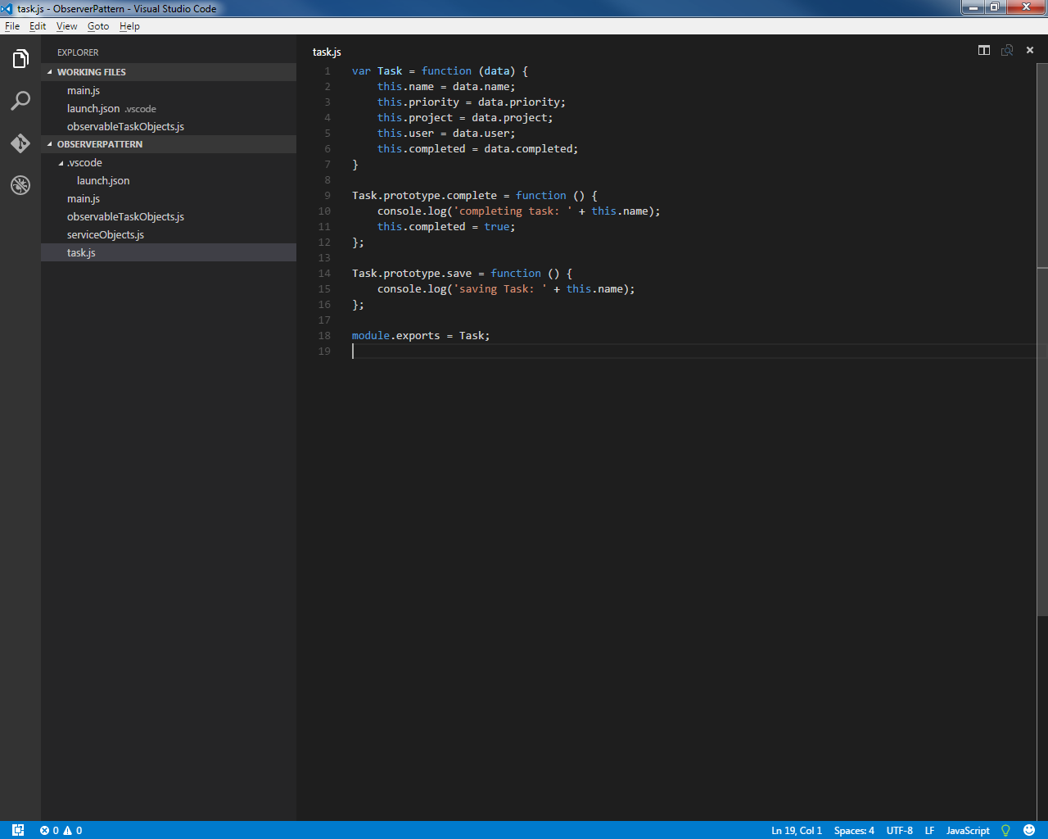
Task object acts as a 'base' object

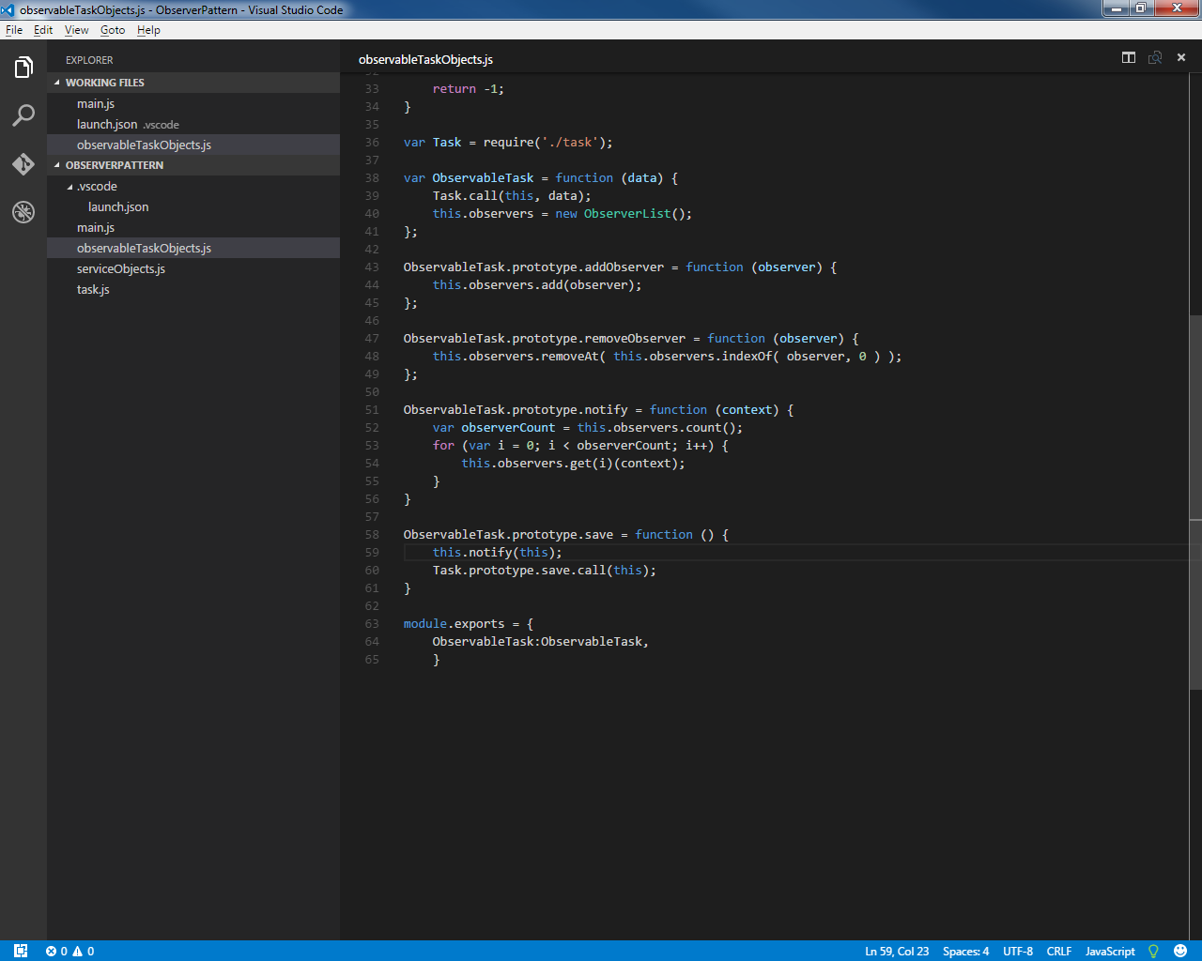
ObservableTask object is based on the Task object.
Has an ObserversList object to contain all object function callbacks to be called. These are the objects that are 'observing' functionality within the ObservableTask object.
The notify function on the object's prototype goes through all of the callbacks in the ObservableList object and fires the callback function , in this case, as the first step in the save function.
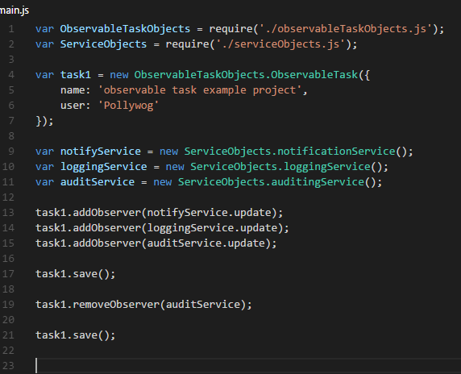
- Modules
  - Related Software
Node.js (nodejs.org) – javascript database
also including is Node Package Manager (npm) to help load javascript libraries.
SystemJS – module loader
RequireJS – module loader
Babble – transpiles ECMA2015 to ECMA5 compatible code

  - Immediately-Invoked Function Expressions (IIFE)
Can help to encapsulate variables and give them a module scope instead of the default global scope of javascript.
Anonymous function that is invoked at the time that it is declared.
No function name.
Can accept parameters. Parameters are populated in final parentheses clause.
    - Basic IIFE structure:
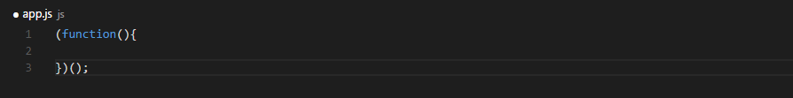
  - Revealing Module Pattern
Name of module added to the global scope via global variable.
Can be implemented either Singleton (one function for entire application) or with a constructor for multiple instantiation.
Variables and functions within module remain local to the module.
Public API (functionality) exposed by return statements pointing to internal functionality.
Does not support dependency loading when necessary, still requires script tags to be arranged properly so that all dependencies are pre-considered.
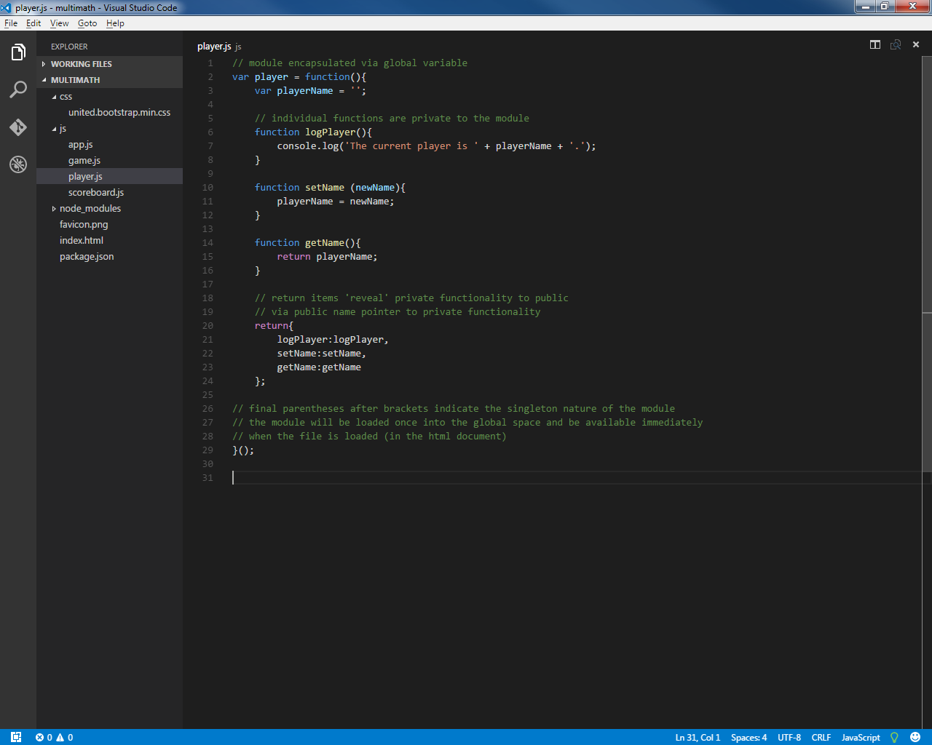
    - Singletons
    - Instantiable By Constructor
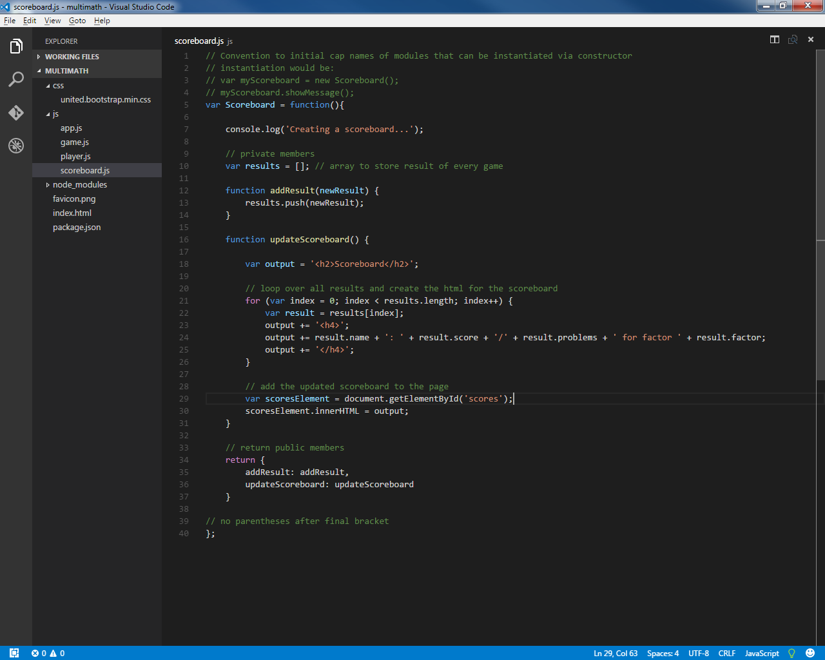
  - Asynchronous Module Definition Format
    - Module Loader: RequireJS
- requirejs.org
- Can be loaded into project using Node Package Manager command line interface:
  - change directory to project folder directory
  - command: npm install requirejs -- save
    - save command adds entry to package.json file indicating dependency
    - related javascript files will be added to parent folder node_modules
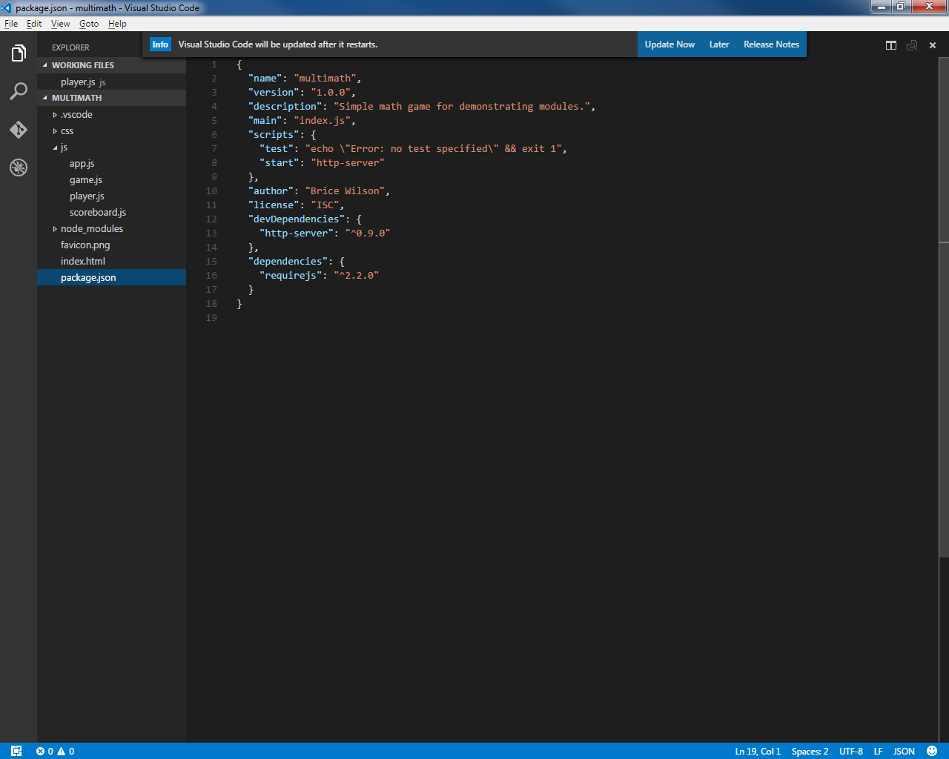
  - Adds dependency to package.json file

- can remove other javascript library dependencies and merely point to requirejs library in application startup html file.
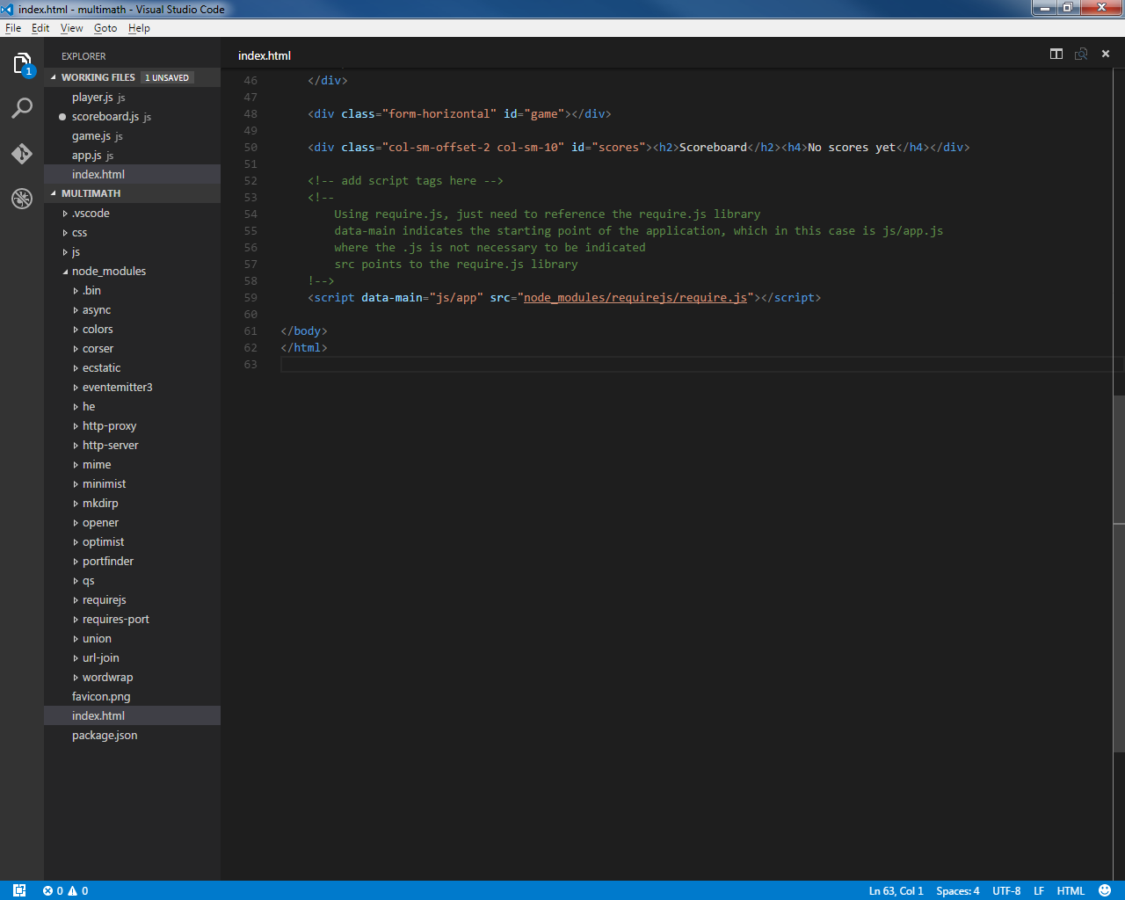
    - Format Examples:
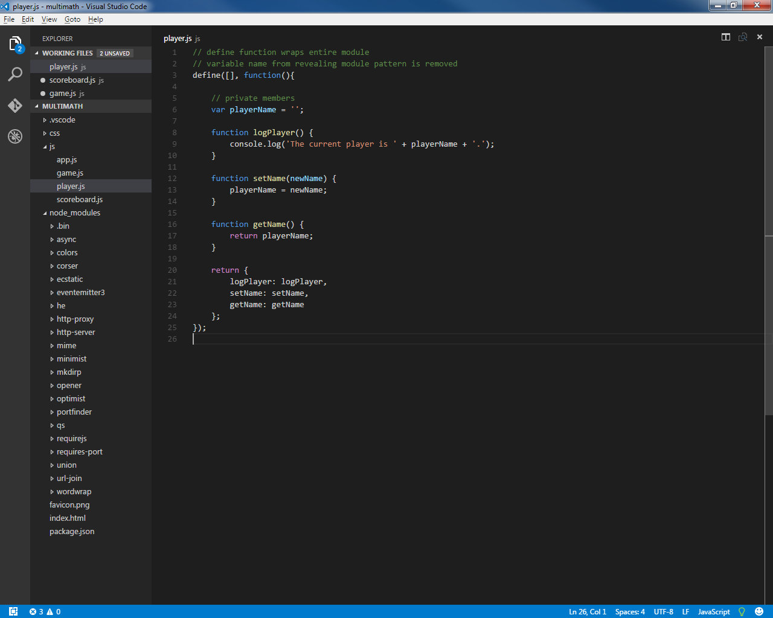
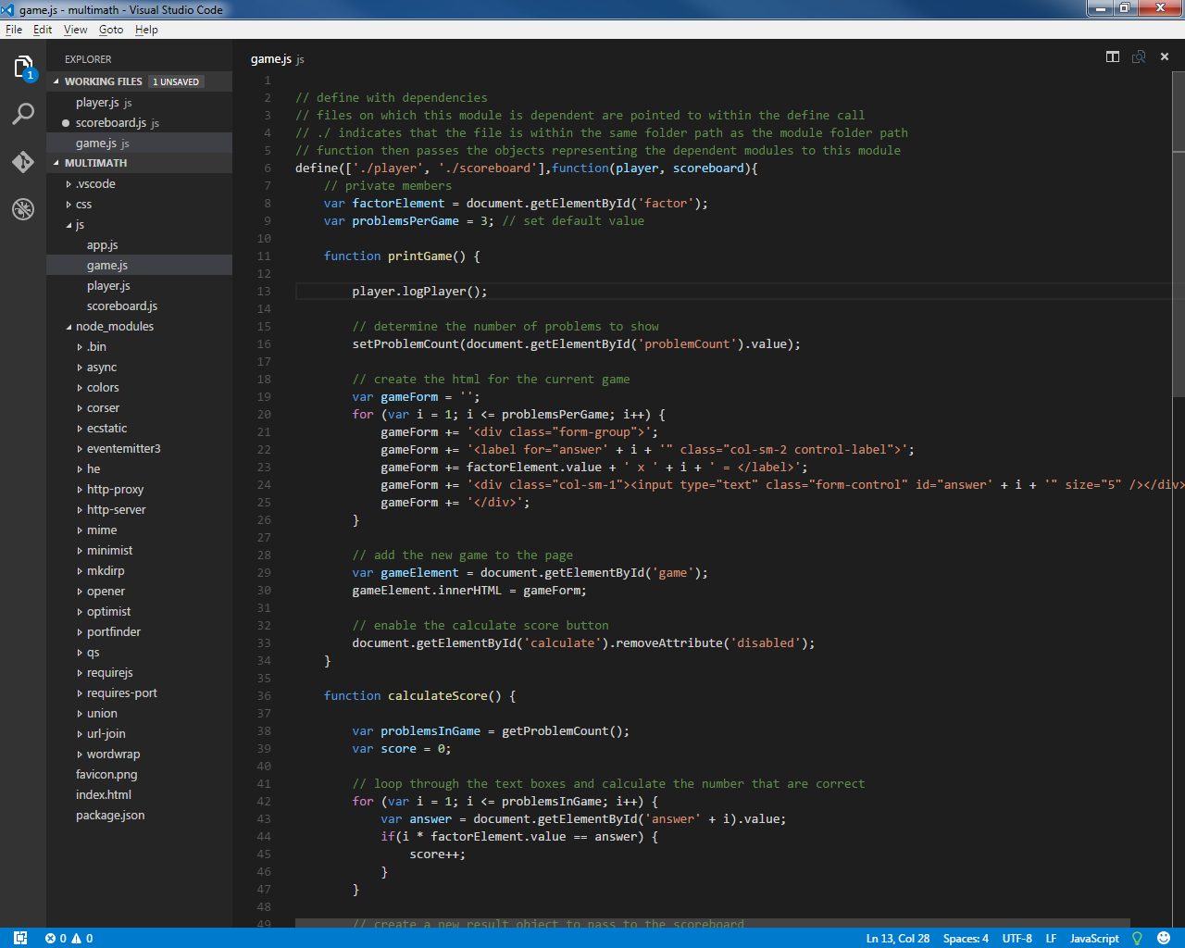
  - CommonJS Format
    - Module Loader: SystemJS
- Https://github.com/systemjs/systemjs
- Can be loaded into project using Node Package Manager command line interface:
  - change directory to project folder directory
  - command: npm install systemjs -- save
    - save command adds entry to package.json file indicating dependency
    - related javascript files will be added to parent folder node_modules
  - Adds dependency to package.json file
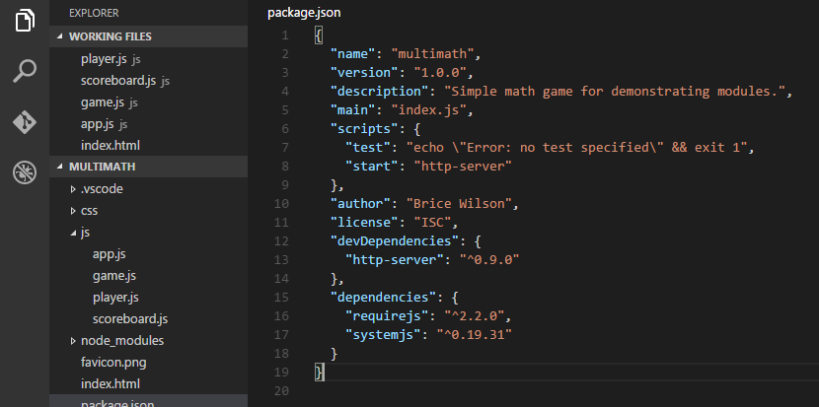
- load SystemJS library and configure
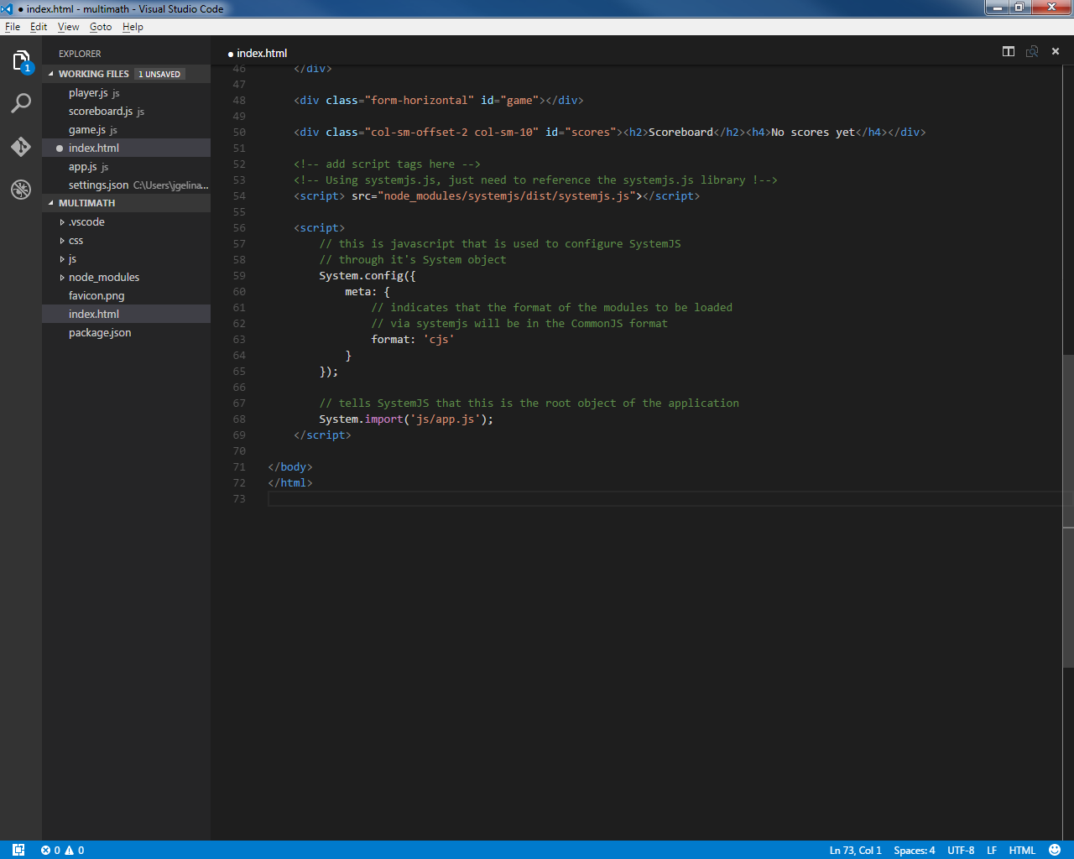
    - Format Examples
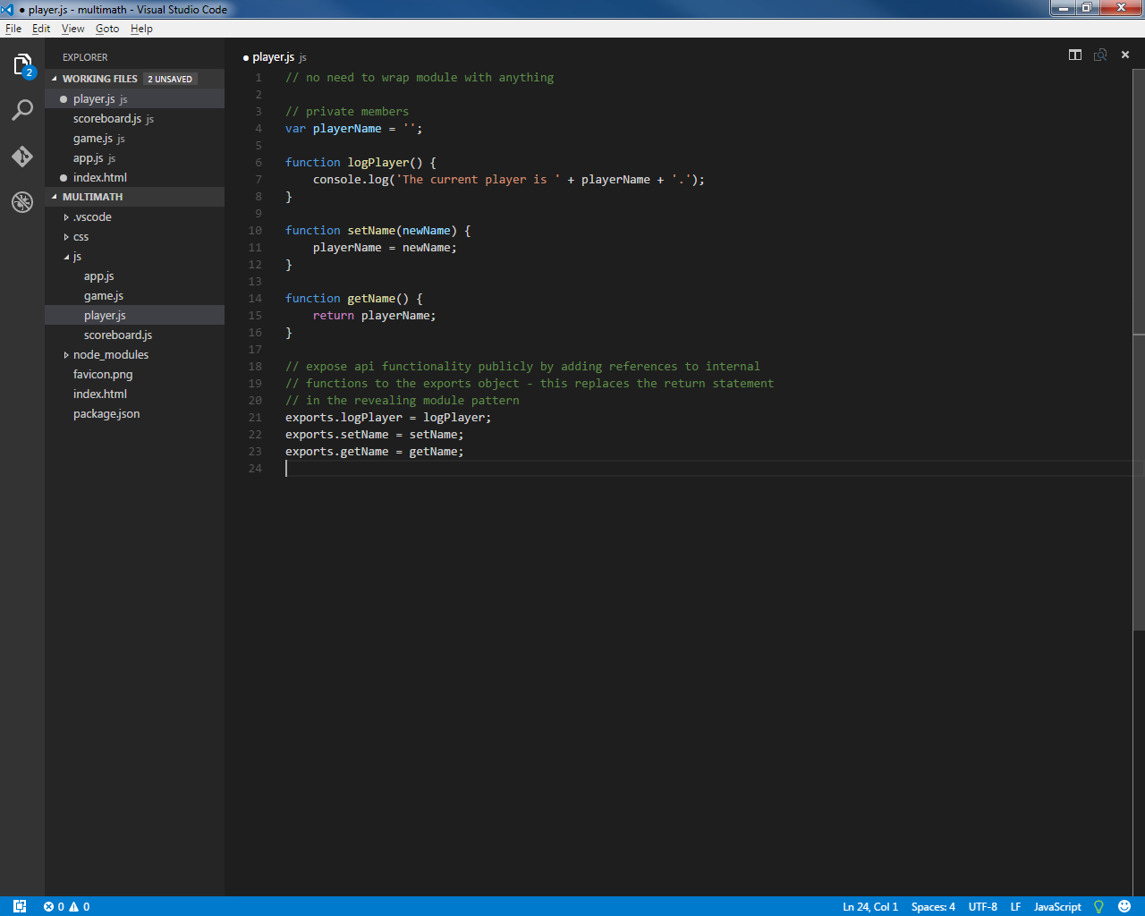
      - Example using basic exports object assignment.

      - Example using module.exports object literal assignment
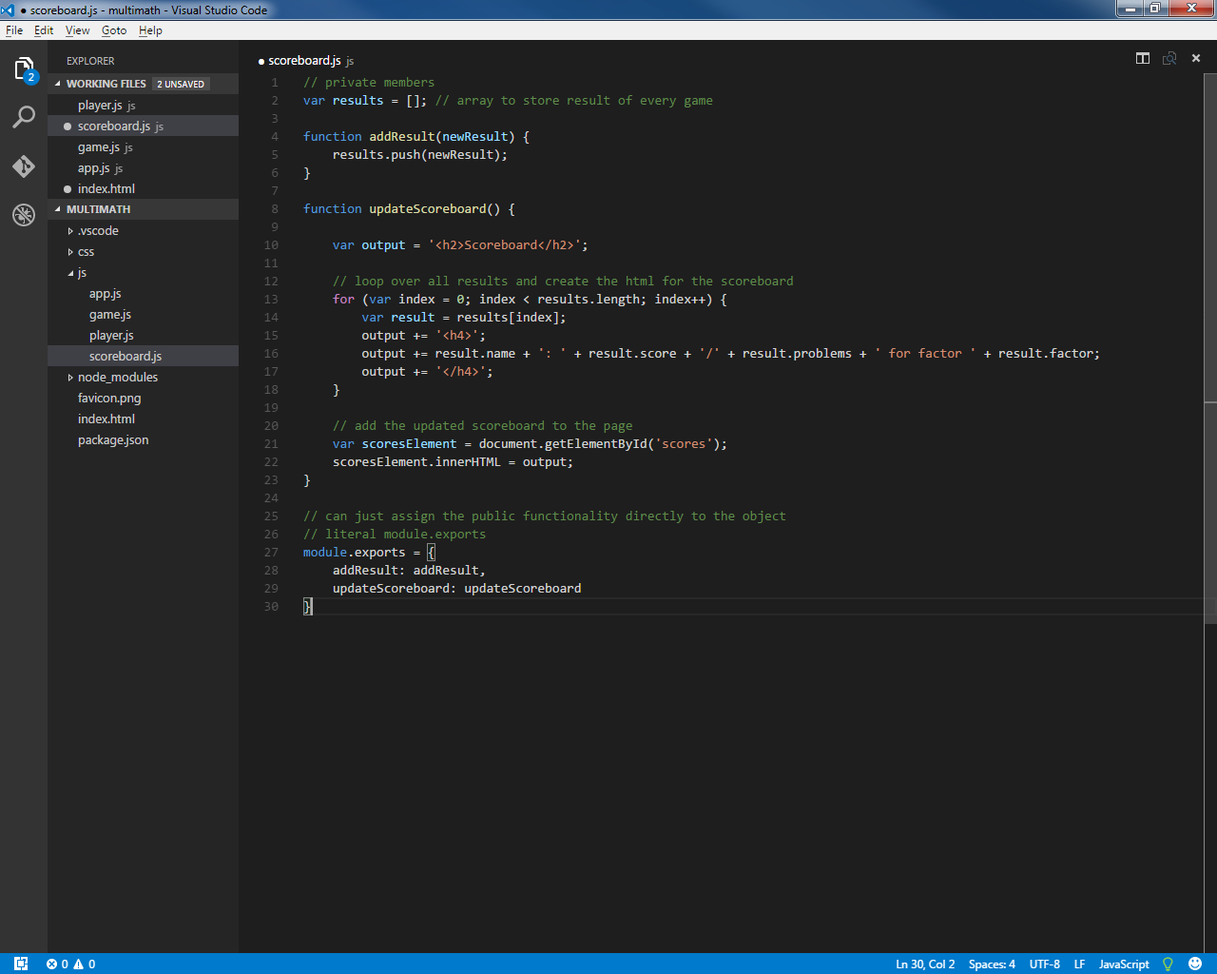
      - Example with requirements included
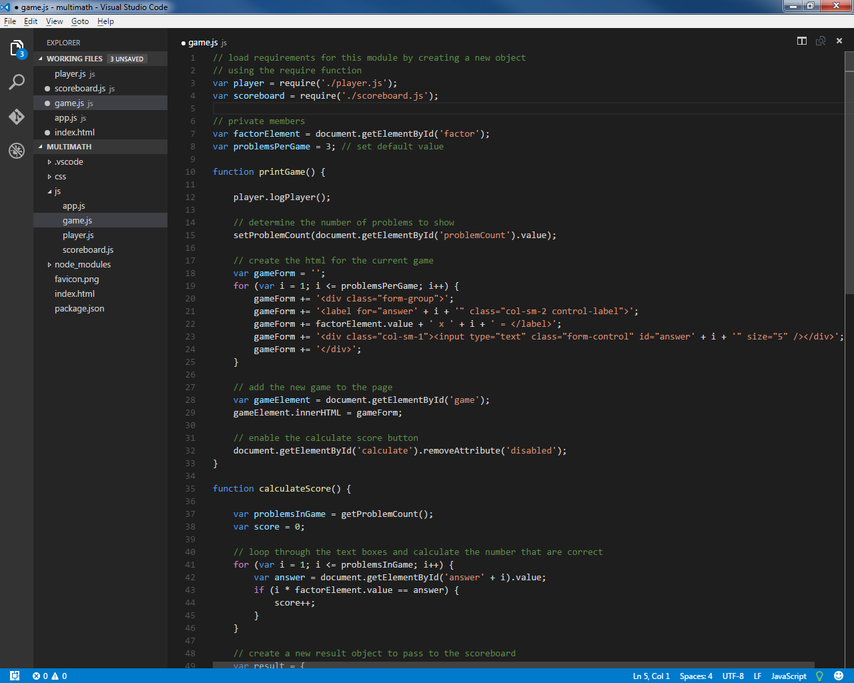
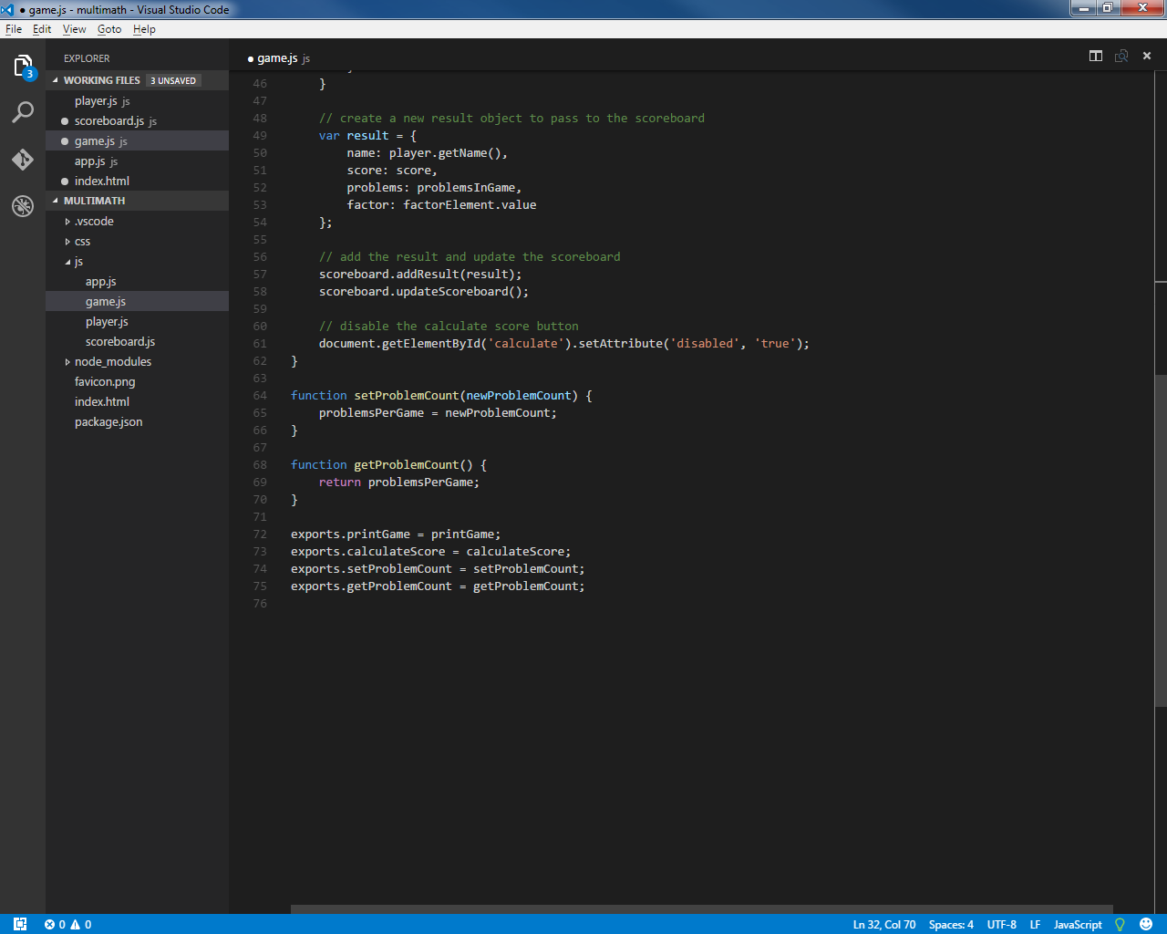
- Node.js

- Nodejs.org
- Server-side javascript interpreter/platform.
- Download includes Node Package Manager (NPM).
- Uses the CommonJS module format
  - Node Pacakage Manager (NPM)
- NPM is Node's package manager and has access to hundreds of javascript libraries that it can load from it's website (npmjs.com)
- NPM can be accessed through command prompt: npm NPM_COMMAND
    - package.json
- Included in the project's base folder when npm is used for the application.
- Used as a configuration file to indicate to npm the current project configuration and all packages that project requires.
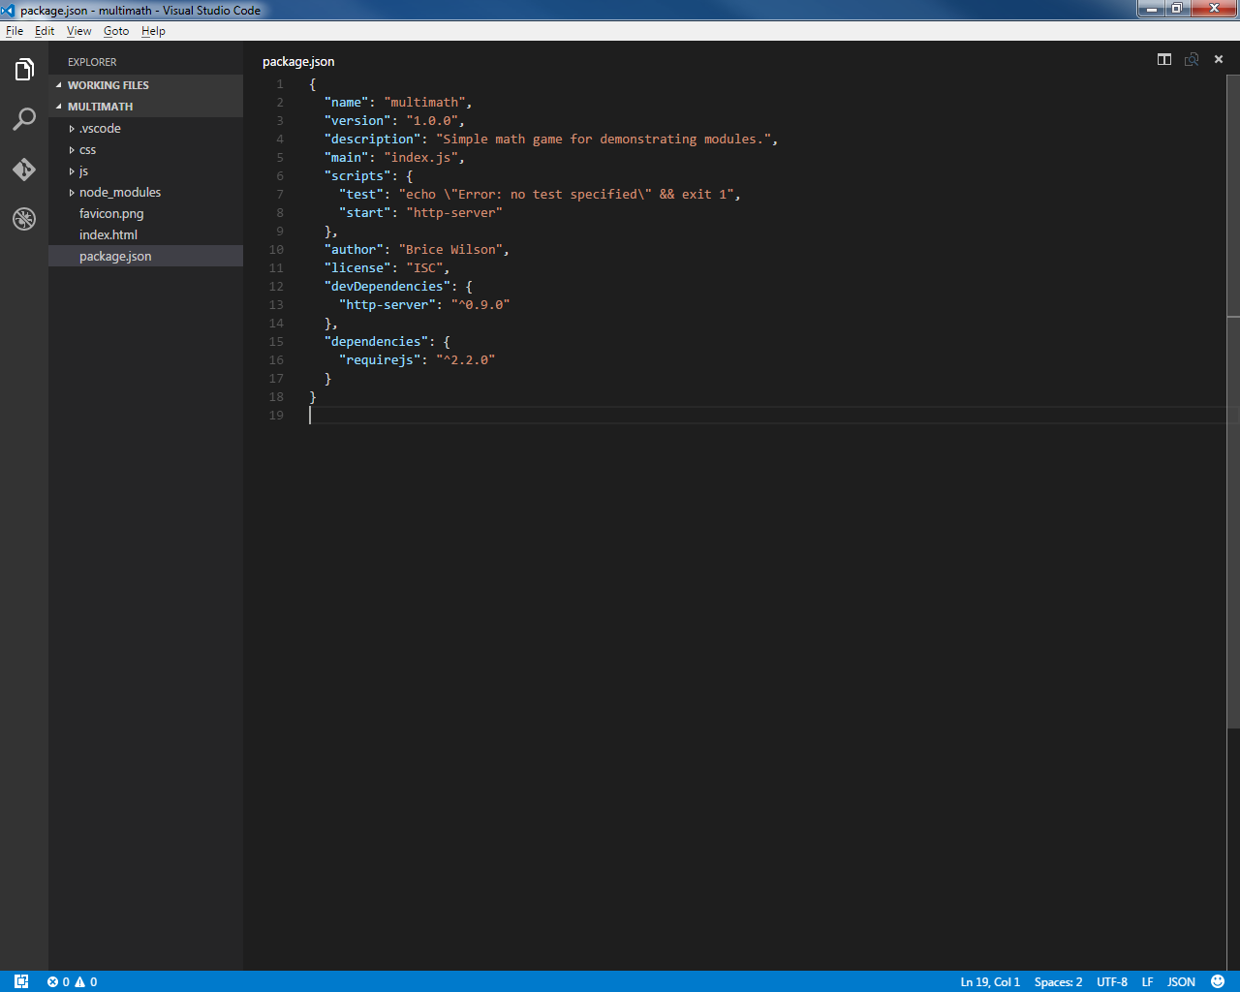
    - Command to Add NPM package to project
- With command prompt/node command prompt
- Navigate to project base directory
- Command = npm install NameOfPackageToInstall --save (saves the dependency in the package.json config file.
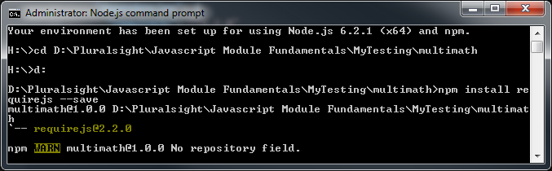
- ECMA Script 2015 (ES2015)

- Support for modules is native to the language.
- Support for asynchronous loading of required/dependent libraries is native.
- As of this writing (June 2016) – must be transpiled to ECMA Script 5 (ES5) for current browsers.
  - Modules
- Can import an entire module or just portions of modules.
- Exporting reveals the public API of the module.
    - Exporting (reveal module API)
- Done at the end of a module to publicly reveal module API
- Formats
  - https://developer.mozilla.org/en-US/docs/Web/JavaScript/Reference/Statements/export
      - Examples:
        - Export of individual functions at the function level
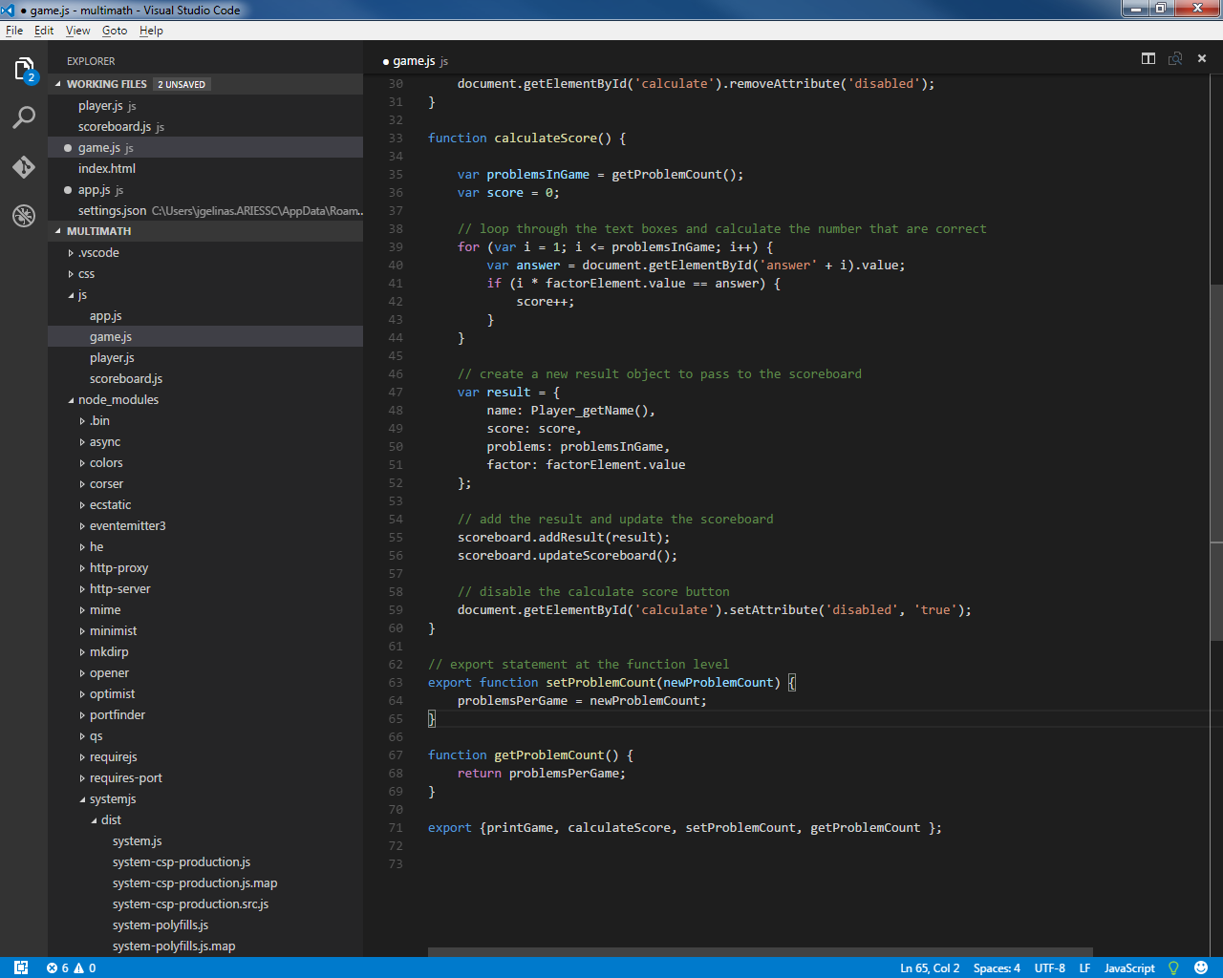
        - Default module function to export at function level
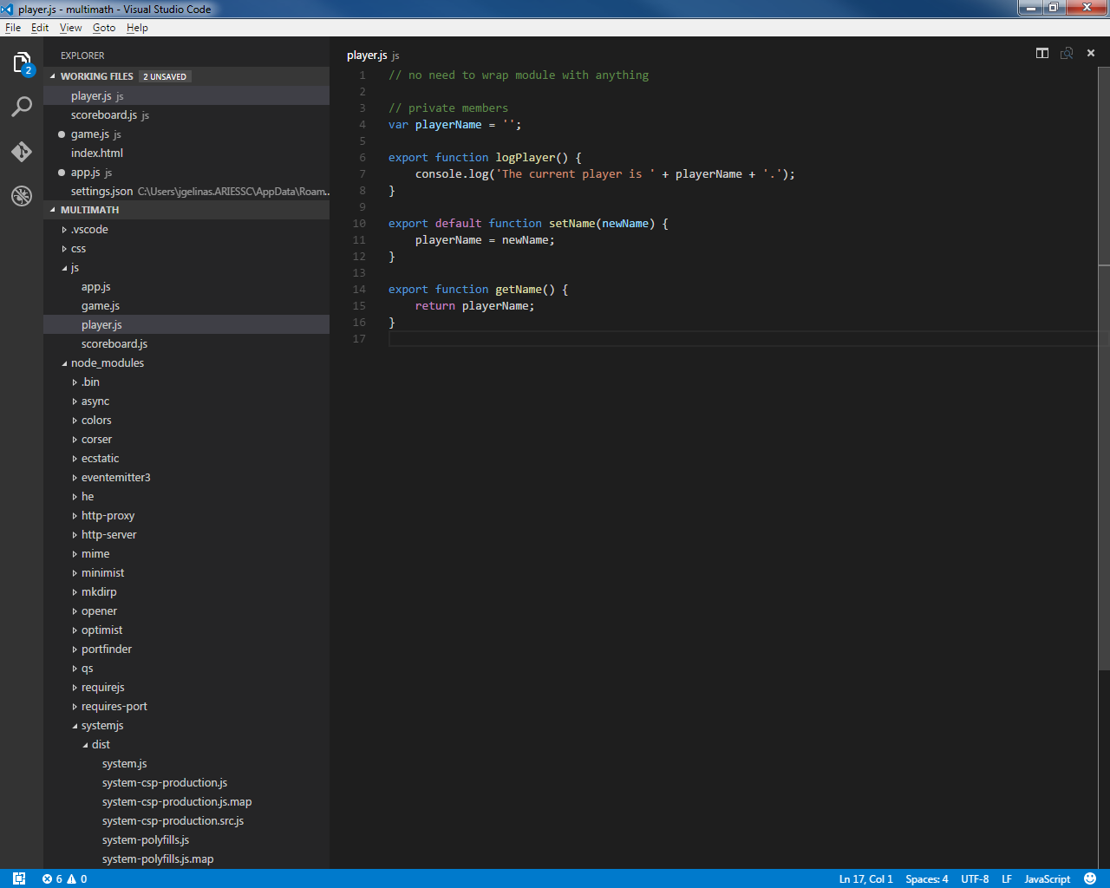
        - Default function export at end of module
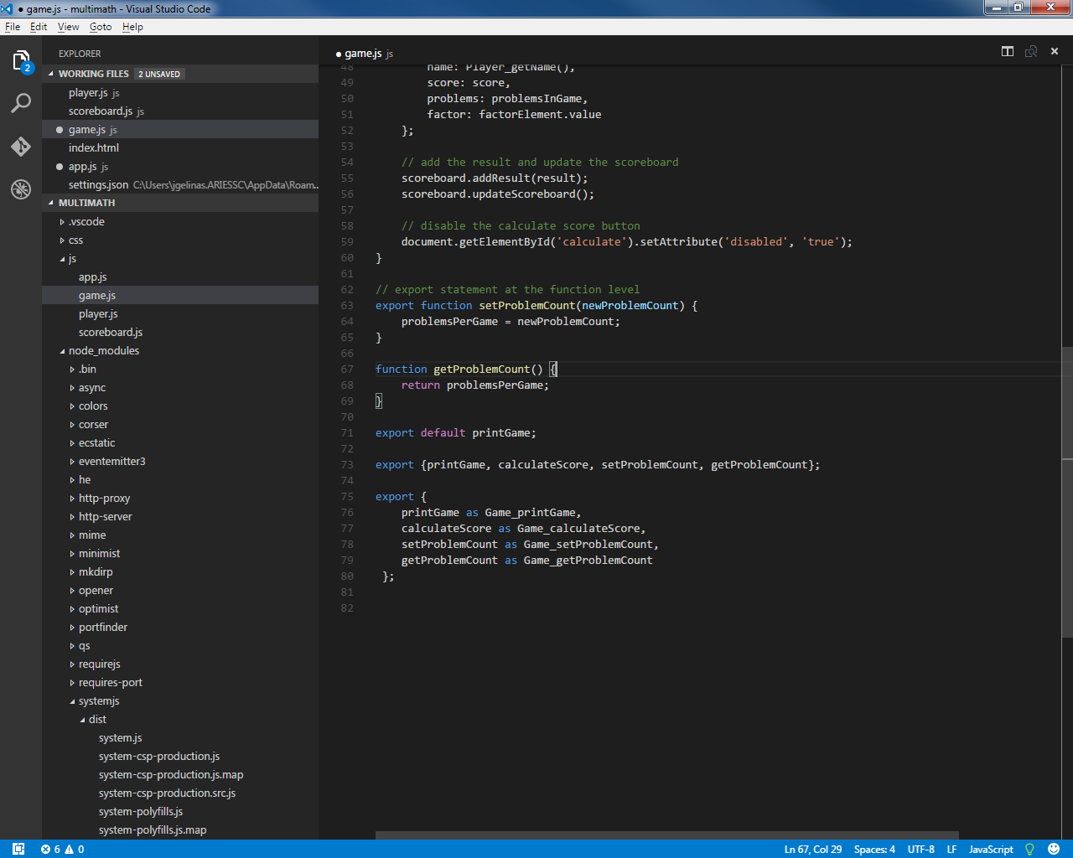
        - Function export at end of module
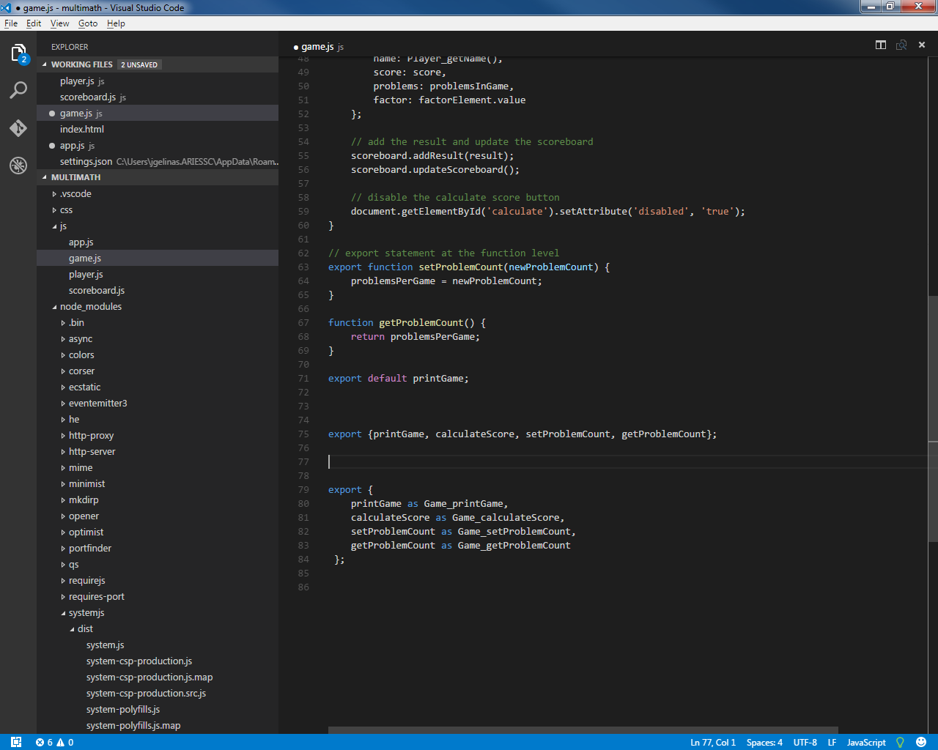

        - Function export at end of module using aliases
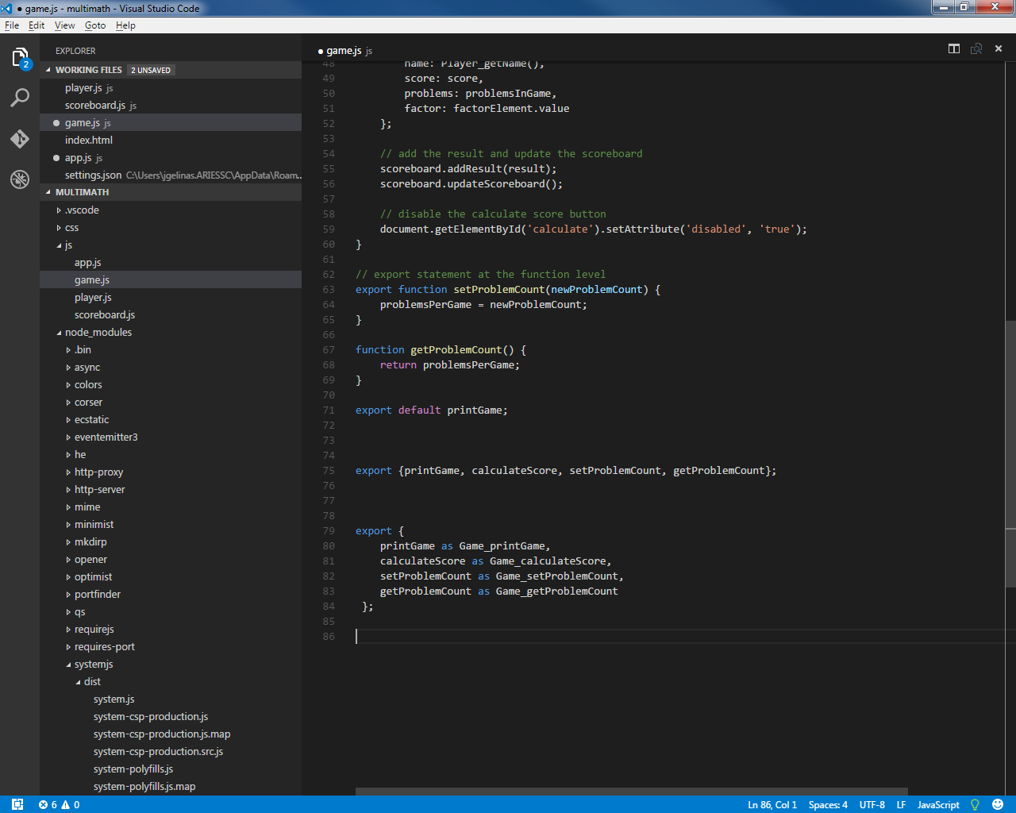
    - Importing (asynchronous loading of module/functions)
- Done at the beginning of a module to publicly reveal module API
- Formats
  - https://developer.mozilla.org/en-US/docs/Web/JavaScript/Reference/Statements/import
      - Examples:
        - Import all functionality from module into object
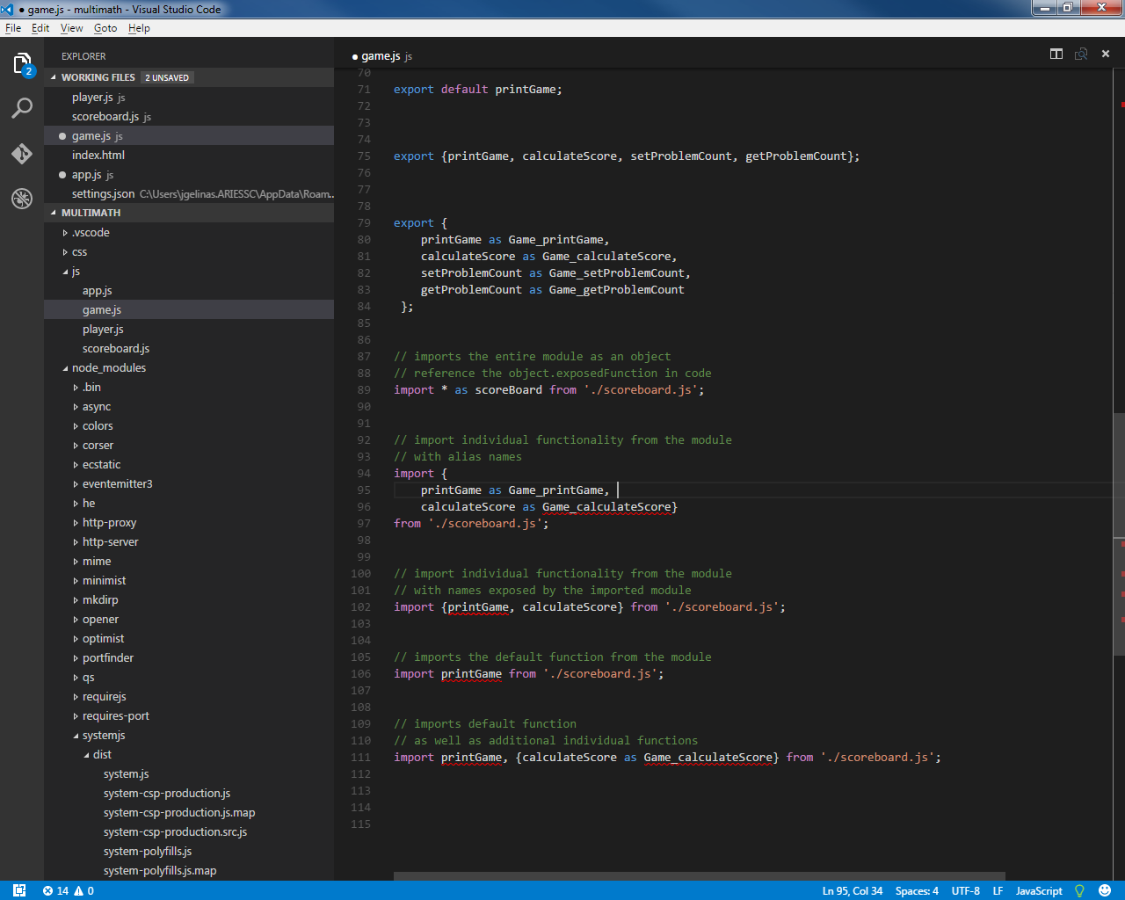
        - Import individual functionality from module with aliases
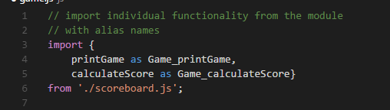
        - Import individual functionality from module with native names
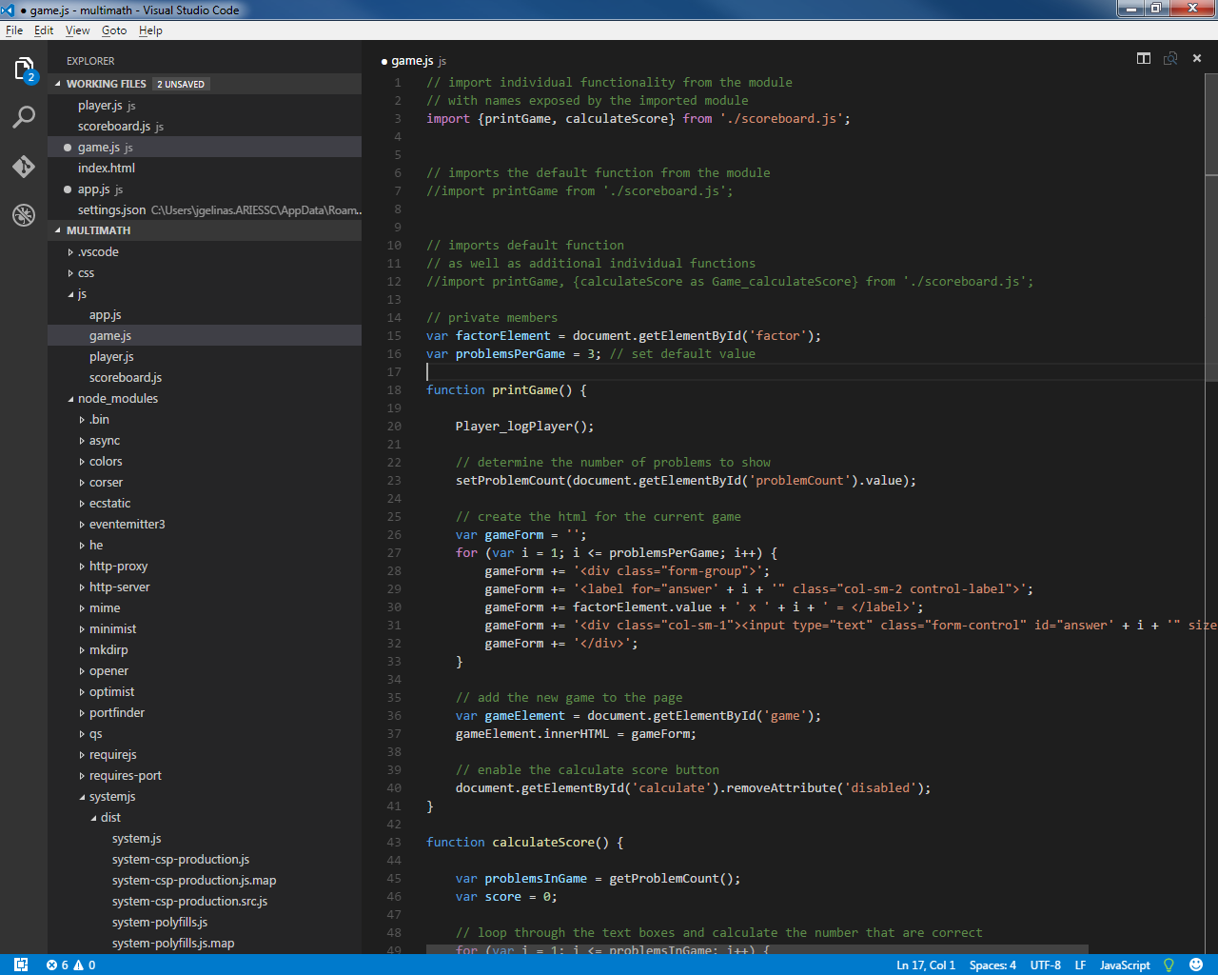

        - Import default function from module
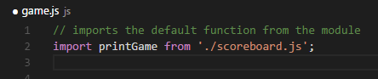
        - Import default function as well as individual functions
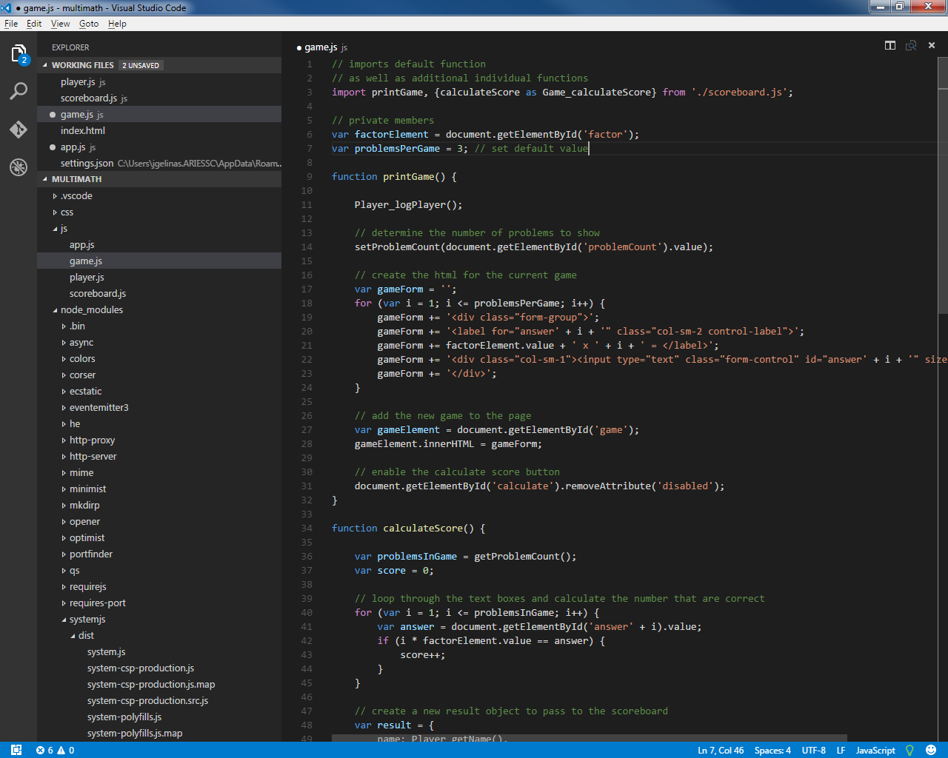
    - Transpilers
- Tools that compile javascript written in ES2015 to format current compatible with current browsers.

      - Babel
        - Install
- https://babeljs.io
- Try it out link - http://babeljs.io/repl/
- Can be loaded into project using Node Package Manager command line interface:
  - change directory to project folder directory
  - install Babel Client via command line: npm install babel-cli -- save-dev
    - save command adds entry to package.json file indicating development dependency
    - related javascript files will be added to parent folder node_modules
  - install es2015 bundled presets via command line: npm install babel-preset-es2015 -save-dev
  - Adds dependency to package.json file in devDependencies section.

        - Run
- With command prompt, move to the folder where babel executable file was installed (node_modules/.bin)
- Command line that indicates to Babel to transpile all js files in the js directory of the project: babel ..\..\js –presets es2015 –out-dir ..\..\build
  - Tells Babel that the input directory for files to transpile are in the js directory.
  - Babel should use the es2015 presets to do the transpile
  - Babel should put the transpiled files to the build directory

  - Bundlers
  - Alternative to module loaders
  - Orders file loading correctly considering dependencies
  - Combines modules into fewer files.
    - Browserify
      - Install
- Bundles CommonJS modules
- http://browserify.org
- npm command to install Browserify globally on the machine: npm install -g browserify
- npm command to install Browserify locally to the dev dependency section: npm install browserify --save-dev
      - Run
      - With command prompt, move to folder where browserify was installed (node_modules/.bin)
      - make sure all js files to be bundled are using CommonJS dependency format.
      - Browserify will follow the require statements in each file to determine dependencies.
      - Command line that indicates to Browserify to bundle all js files in the js directory of the project: browserify ..\..\js\app.js - -outfile ..\..\build\bundle.js
    - WebPack
      - Install
    - Bundles AMD, CommonJS and ES2015 formatted modules
    - Allows code splitting which allows bundling code into multiple bundles
    - Can also bundles other 'types' of files, including css, images etc...
    - http://webpack.github.io
    - npm command to install locally: npm install webpack - -save-dev
      - Package install to use Babel to transpile to CommonJS
      - Will apply Babel loader to transpile ES2015 modules first.
      - Relies on Babel core package and ES2015 presets package see Babel 5.1.3.1
      - Command line install: npm install babel-loader babel-core - -save-dev
      - Add webpack.config.js configuration file for loader to root of application.
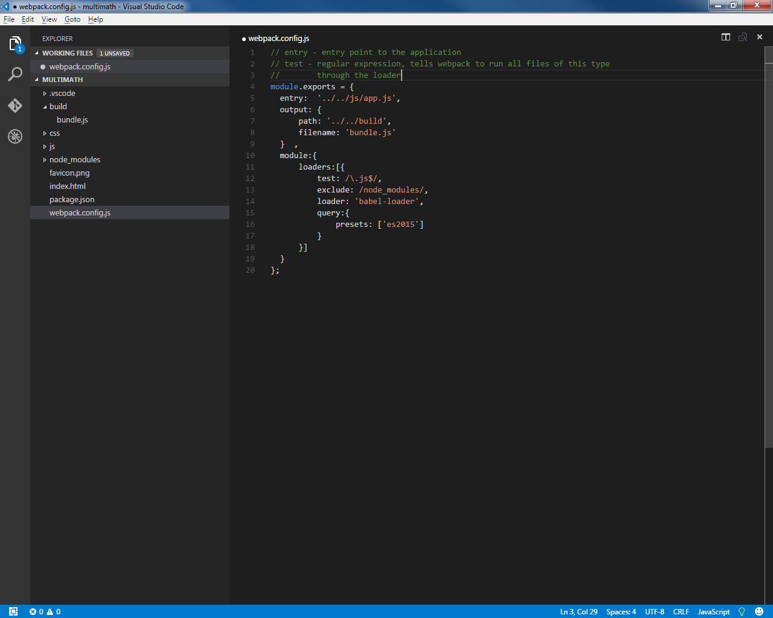
      - Run
      - With command prompt, move to folder where webpack was installed (node_modules/.bin)
      - Command line that indicates to Webpack to bundle all js files in the js directory of the project if not using loader: webpack ..\..\js\app.js ..\..\build\bundle.js
      - Command line using loader (uses config file for input/output etc.): webpack --config ../../webpack.config.js

  - Classes


