Ja
Node JS
Created: Jul 11, 2016
Last Modified: August 16, 2016 08:46:25 AM
Table of Contents
1 Callbacks 3
2 Events 4
2.1 Inheriting From the EventEmitter 5
3 Modules 6
4 Streams 7
4.1 Readable Streams 7
4.2 Writable Streams 7
4.3 Piping 8

- Callbacks

- Node handles everything as a non-blocking callback (asynchronous)
- Model is Request/Reply – actively make the request and await a reply to the callback function.
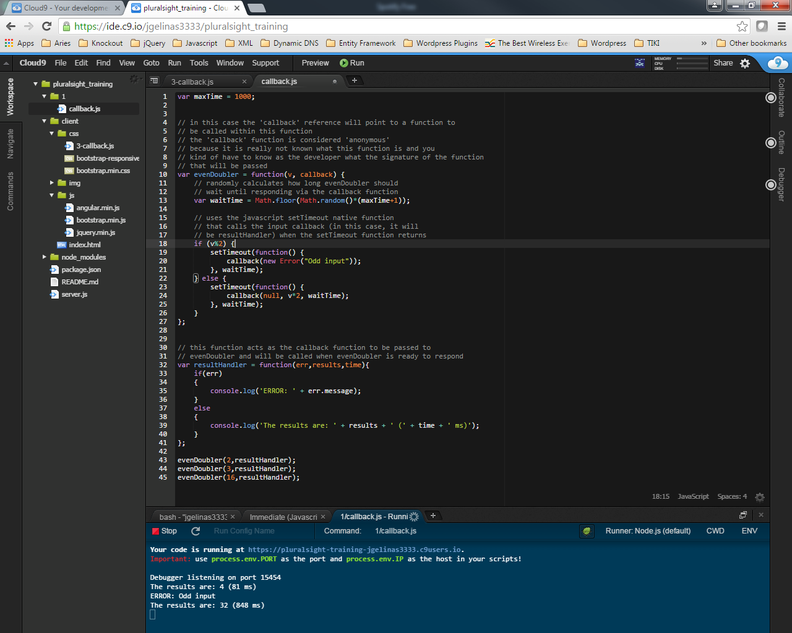
- Events

- More of a Publish/Subscribe methodology
- To use events, need to requires('events').EventEmitter
- Publisher of an event – emitter.emit('event', [arguments])
  - 'event' can be any string
  - arguments indicate an arry of argument values that the event will emit
- Subscriber to an event – emitter.on('nameofevent',listener) – listener being a function that will do something when the event fires
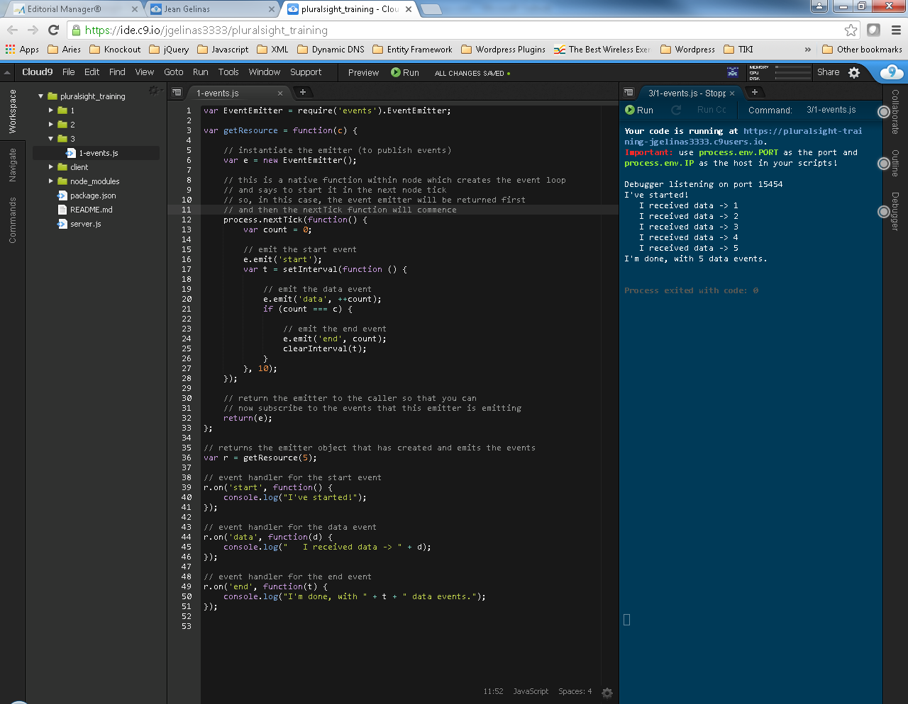
  - Inheriting From the EventEmitter
Inheritance is done in Node via the 'util' library
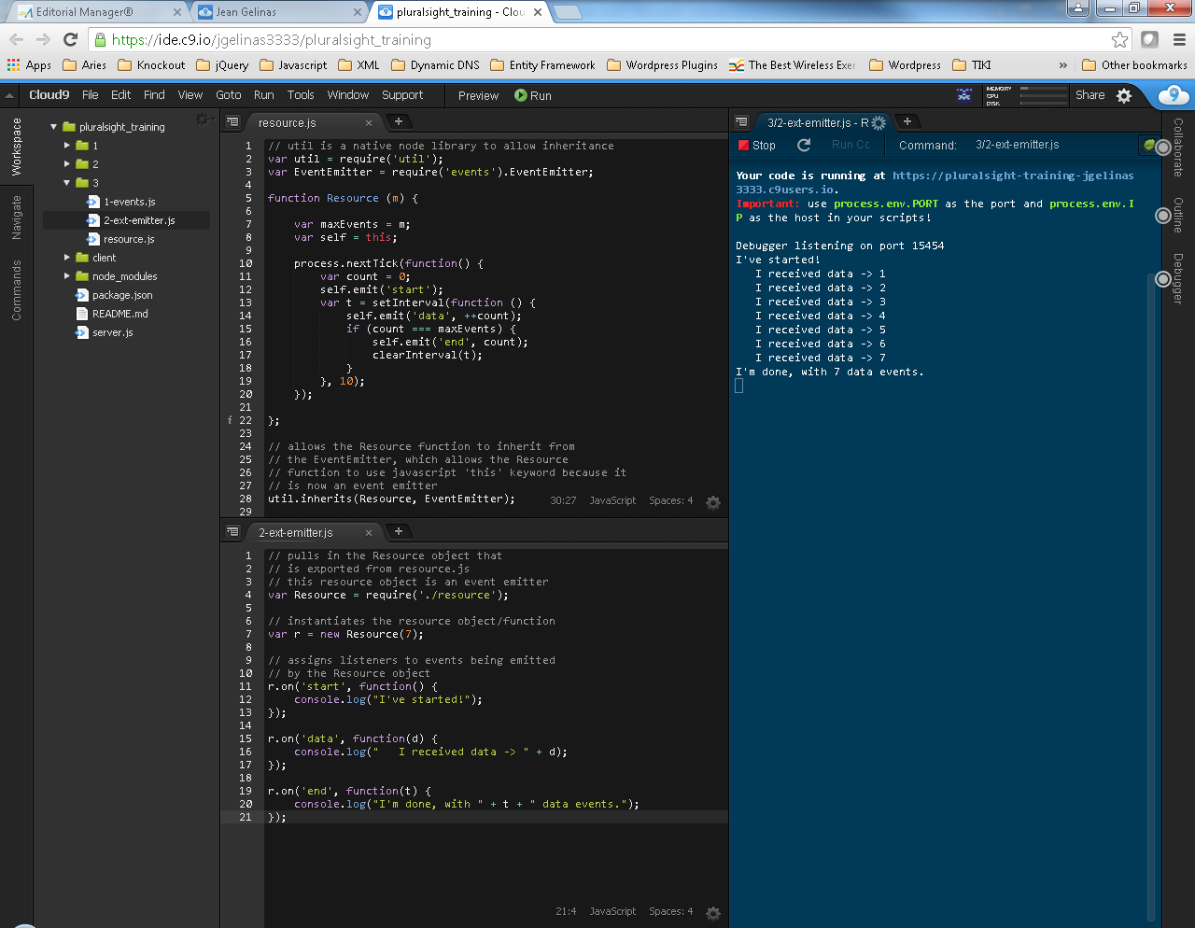

- Modules

- require command used to load modules into your project – works same as commonjs format
- NPM (Node Package Manager) can be used to load various modules/packages into your project.
          - NPN registry - https://www.npmjs.com
          - Install a module via command: npm install module_name.
          - By default gets installed in the project's node_modules folder.
- To publish your own module/package to NPM registry:
          - Need to include a package.json file in your project root
                - {
“name”: module/package name,
“version”: module/package version
“dependencies”: (required dependencies from the NPM registry)
{
“module_name”: “version”
}
“main”: entry point of your application, ie “lib/cool.js”
}
          - Need to create an account on the NPM registry, usually via command npm user
          - From project root, run command npm publish . in order to publish the package/module to the npm registry.

- Streams

- IO Handling – network traffic (http/https/tcp/ip), files etc...
  - Readable Streams
  - readable – indicates if the stream is ready to be read
  - available events – data, end, error, close
  - available functions – pause(), resume(), destroy(), pipe()
  - Writable Streams
  - writable – indicates if the stream is ready to be written to
  - available events
    - drain – indicates that it is safe to write to the stream
    - error
    - close
    - pipe
  - functions
    - write()
    - end()
    - destroy()
    - destroySoon()

  - Piping

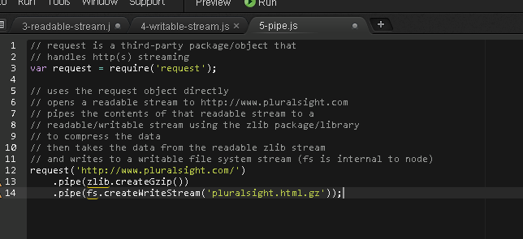

- APIs

