EM_SITE_MGNT

MASTER_CONFIG

checkCIFUrl

checkCIFTimeout

checkCIFUserName

checkCIFPwd

Journal

ACTION_LINK_PAGE

Add record for each page to get link based on ID generated by record added in ACTION_LINKS

ACTION_LINKS

+ checkCIF Results record

~~ADMINACCESSFUNCTIONS~~

~~+ Add record for checkCIF configuration page in Policy Manager~~

~~AUTHORROLE~~

~~+ VIEWCIFCHECKRESULT column~~

+ CIF_RESULTS table – mapping table maps cif file to results files

+ CIF_REQUEST_STATUS

~~+ CIF_FILE_TRAFFIC_LOG~~

DETAILS_PAGE_LAYOUT_ITEMS

checkCIF Results * record

~~DFILETYPE~~

~~+ CIF_CHECK column~~

DEEPLINK_TYPE

~~EDITORROLE~~

~~+ VIEWCIFCHECKRESULT column~~

~~+ INITIATECIFCHECK column~~

~~MASTER_CONFIG (new records)~~

~~+ Enable CIF Check~~

~~+ CIF Check Trigger – Original PDF Building by Author~~

~~+ CIF Check Trigger – Original PDF Building by Editor~~

~~+ CIF Check Trigger – First Reviewer Invited/Assigned~~

~~+ CIF Check Trigger – Revised PDF Building by Author~~

~~+ CIF Check Trigger – Revised PDF Building by Editor~~

~~+ CIF Check Trigger – Author Notified of Accept~~

~~+ CIF Check Trigger – Author Notified of Revise~~

~~+ CIF Check Trigger – Create Submission~~

~~PUBLISHERROLE~~

~~+ VIEWCIFCHECKRESULT column~~

~~+ INITIATECIFCHECK column~~

~~REVIEWERROLE~~

~~+ VIEWCIFCHECKRESULT column~~

~~PDFBUILDER~~

~~REQUEST_TYPES~~

~~+ checkCIF request type row~~

TRANSLATION:

Pages.Admin.PolicyManager.LinkConfigureCIFCheck

Configure checkCIF

Common.CustomInstructions.Default.ViewCheckCIFResultInstructions

The files shown below are eligible for analysis using the checkCIF tool from the International Union of Crystallography (IUCr). If the files have already been sent to the checkCIF tool, the analysis report can be viewed by clicking the 'Completed' link.

Policy Manager

+ On/Off Switch

Role Manager

Publishers/Editors – View checkCIF Results

CIF_RESULT table

SOURCE_FILE_CATALOGUE_ID - source file (foreign key, cascade delete)

RESULT_FILE_CATALOGUE_ID - results file (foreign key, cascade delete)

CIF_REQUEST_STATUS table

STATUS - state of the request

SOURCE_FILE_CATALOGUE_ID - file that's being analysed (foreign key, cascade delete)

DATE_INITIATED - when the request was sent

stored proc: getByDocumentID

stored proc: getBySourceCatIDs

~~JG CIF_FILE_TRAFFIC_LOG~~

~~emulate FILE_TRAFFIC_LOG table~~

~~JG CIF permissions for roles~~

JG PRODUCTION_TASKS

~~JG DFILETYPE~~

~~include cif~~

~~JG MASTER_CONFIG~~

~~add checkcif rows~~

JG DETAILS_PAGE_LAYOUT_ITEM

add checkcif row

~~JG ADMINACCESSFUNCTIONS~~

~~add checkcif row~~

DEEPLINK_TYPE

add checkcif results pdf deeplink row

~~JG ASYNCH~~

~~request_types~~

~~request_priorities~~

~~JG EM_SITE_MGNT~~

~~master_config~~

~~url, timeout, username, password~~

------------------

AP Asynch Job - Send analysis request / receive response

ActionLinkManager

- GenerateCIFResultsLink(documentID)

CIFManager

- bool DisplayCIFResultsLink(documentID)

~~JG Expose new MASTER_CONFIG settings via Facade~~

Zip File Generation

Production Task Export

------------------

2.3.1 Configure CheckCIF page

2.3.2 Add/Edit Submission Item

2.3.3 PDF Builder - insert cif results link

2.3.5 Add/Edit Submission Production Task

RoleManager Pages

Add CIF Results Action Link

Details Page

Tech Check

Create Submission Confirmation

File Inventory

List in 2.13.1

CIF Results Page

Add CIF Job Triggers

Build PDF

Create Submission

First Reviewer Invited/Assigned (end of invite reviewers workflow)

Notify Author - Accept/Revise

Upload Companion File

Transmittal Form

Assign Production Task

2.10.1 Assignment Files

2.10.2 Production Task Assignment Files

Batch Assign Production Task

Email Attachments

File Transfer Stats

Q&D Stats

Merge Field

site cleanout

cif file traffic log

archiving (?)

transmittal

transmittalForm.asp

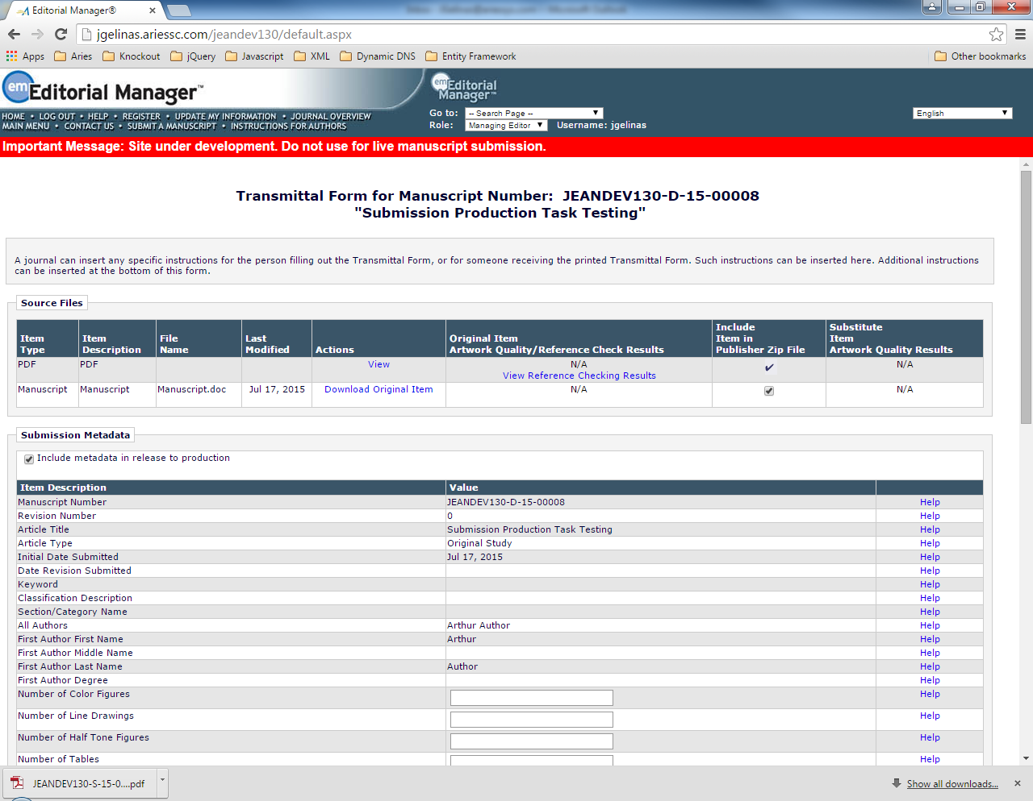

2.10

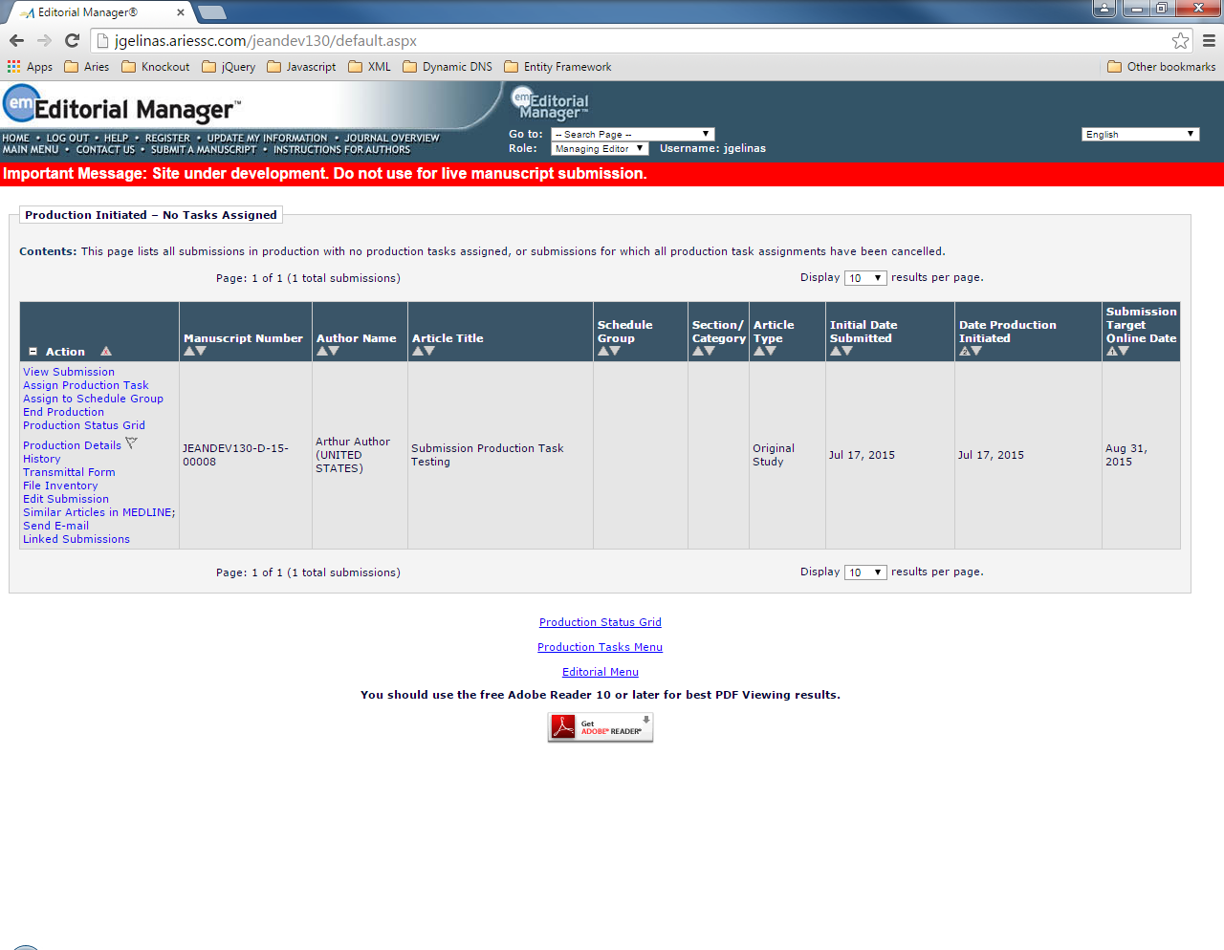

AssignProductionTask.aspx

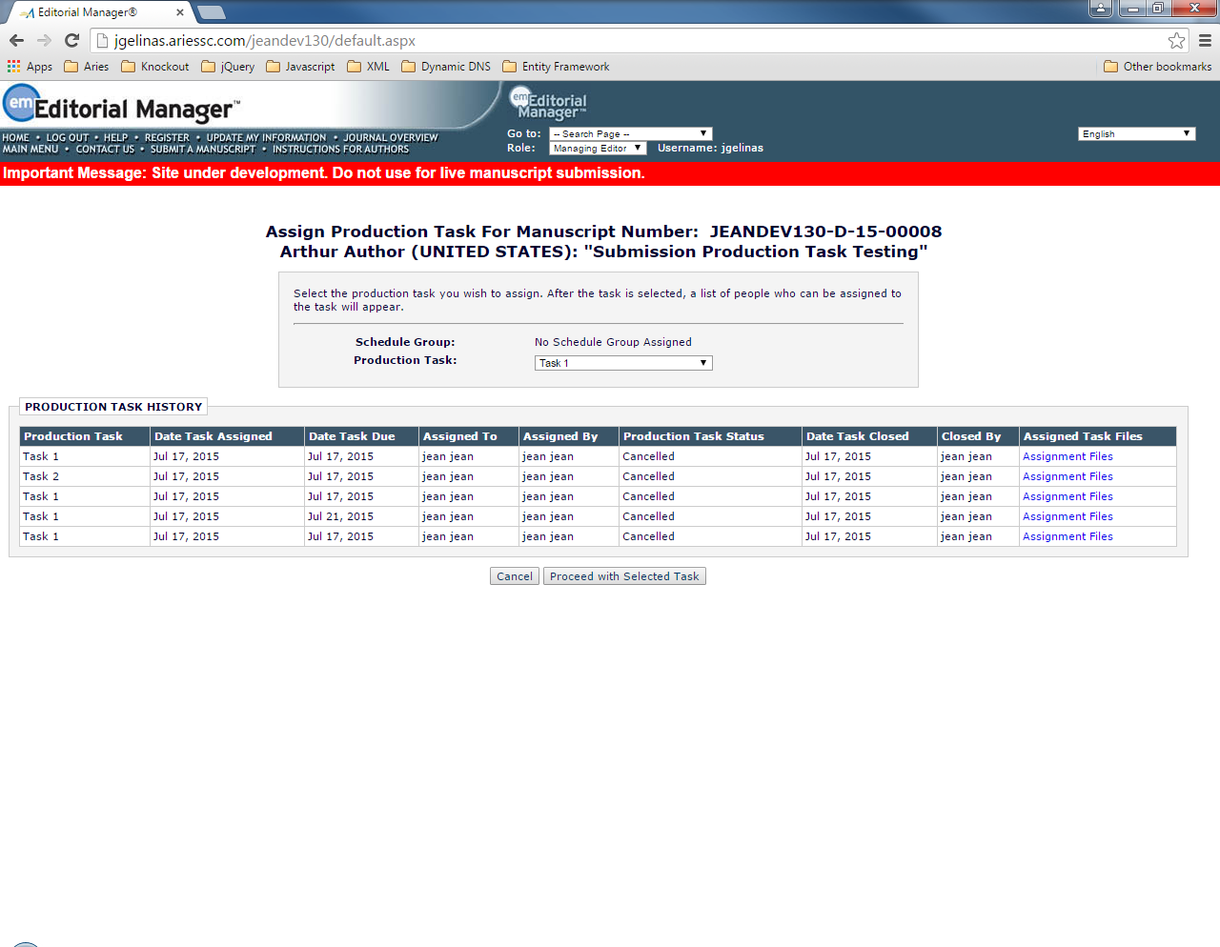

assignProductionTask.asp

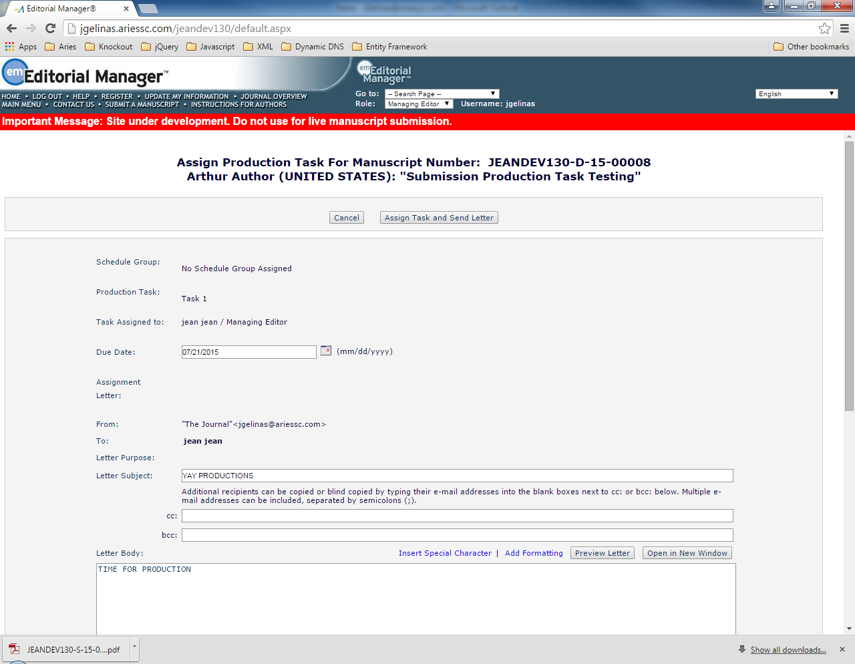

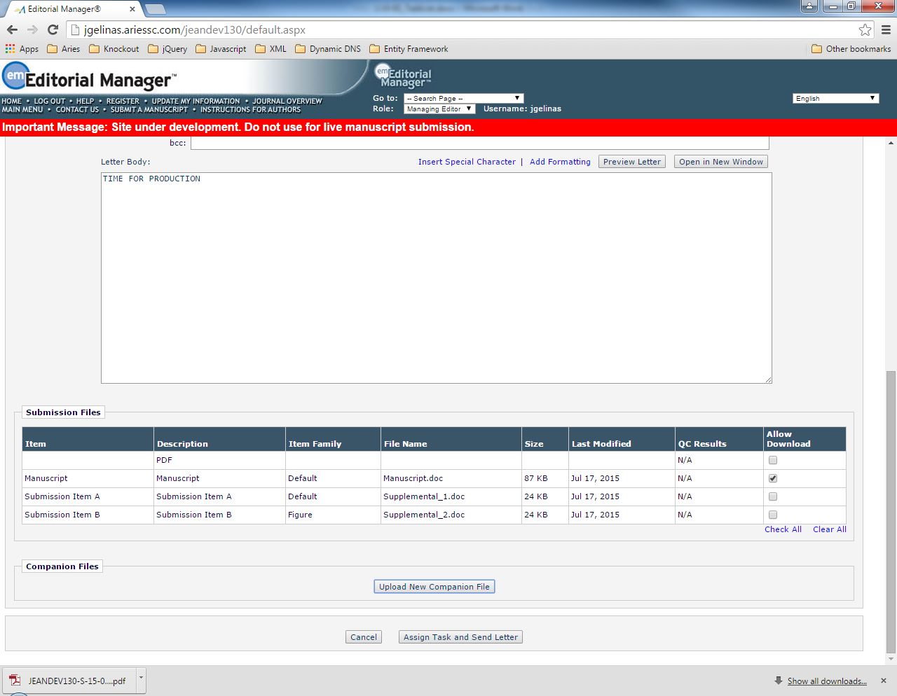

addCompanionFile.aspx

addCompanionFile.aspx

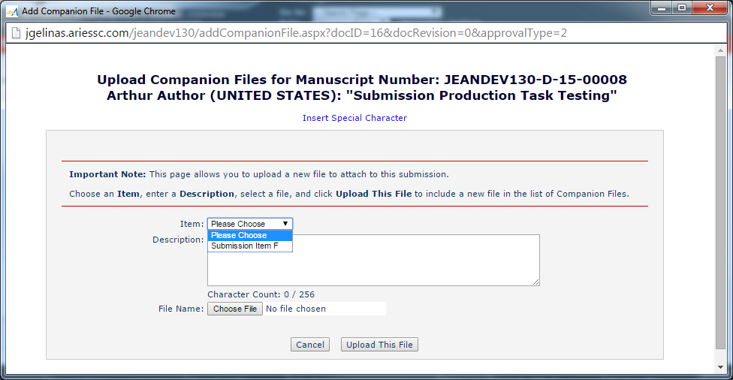

What 2.10 changes in assignProductionTask.asp

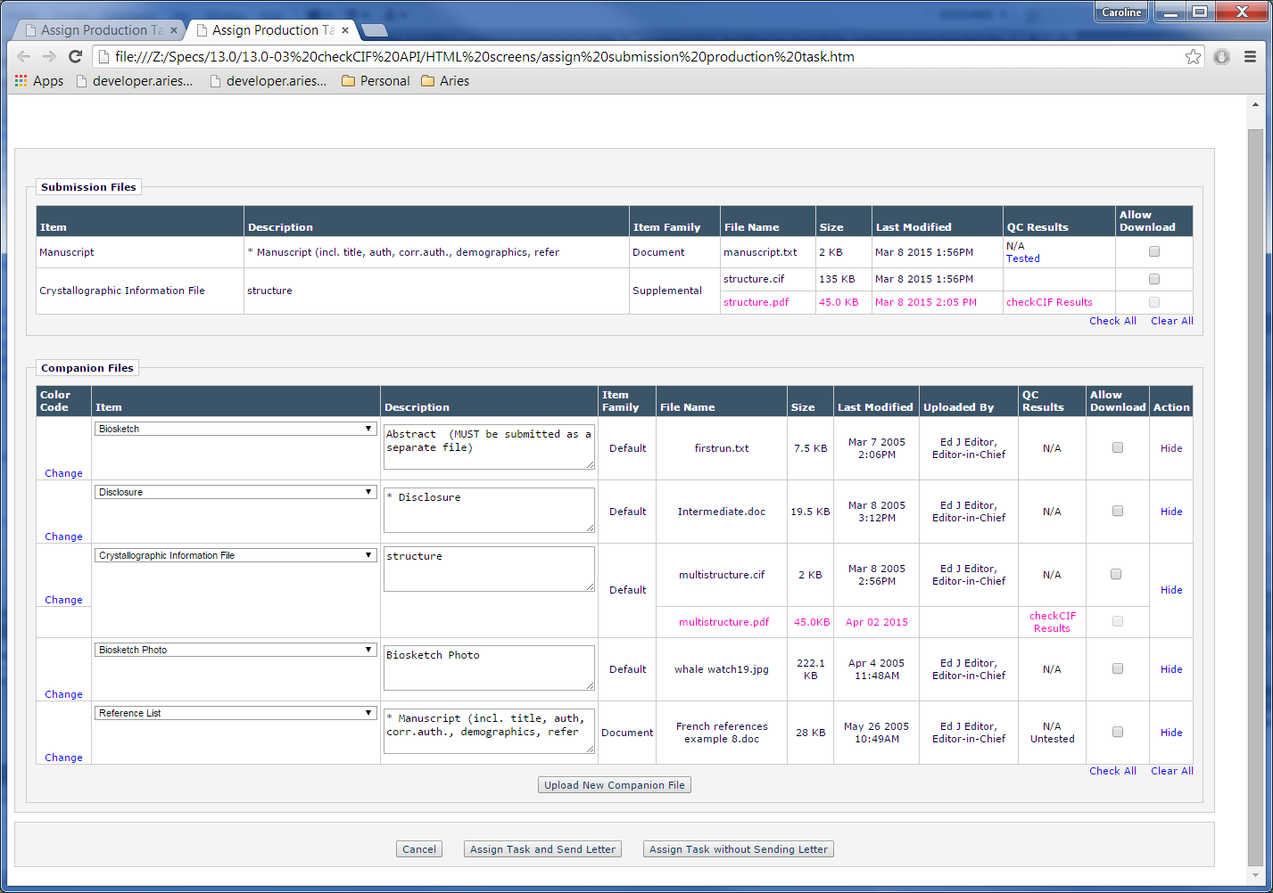

Submission Files

assignProductionTask.js.getSubmissionFilesForAssignment

~~usp_SelectSubmissionFileRecordsByRoleProdID~~

~~FILEVIEW_SUBMISSIONFILES (view)~~

SUBMISSION_FILES (table)

docFilesObjectArray (docFilesUtil.js.docFileObject)

docFilesUtil.js.getDocFilesObjectArray

getSubmissionFiles

prSelectSubmissionFileRecordsByDocument

~~FILEVIEW_SUBMISSIONFILES (view)~~

SUBMISSION_FILES (table)

docFilesObjectArray (docFileObject)

docFilesUtil.js.getPdfFileInfoForSub

don't think need to do anything here

Companion Files

assignProductionTask.js.companionFileInfo

usp_SelectCompanionFileRecordsByRoleProdID

~~FILEVIEW_COMPANIONFILES (view)~~

COMPANION_FILES (table)

usp_SelectCompanionFileRecordsByDocument

~~FILEVIEW_COMPANIONFILES (view)~~

COMPANION_FILES (table)

Submission files grid build starts at 3121

Companion Files grid build starts at 3338

2.10.1

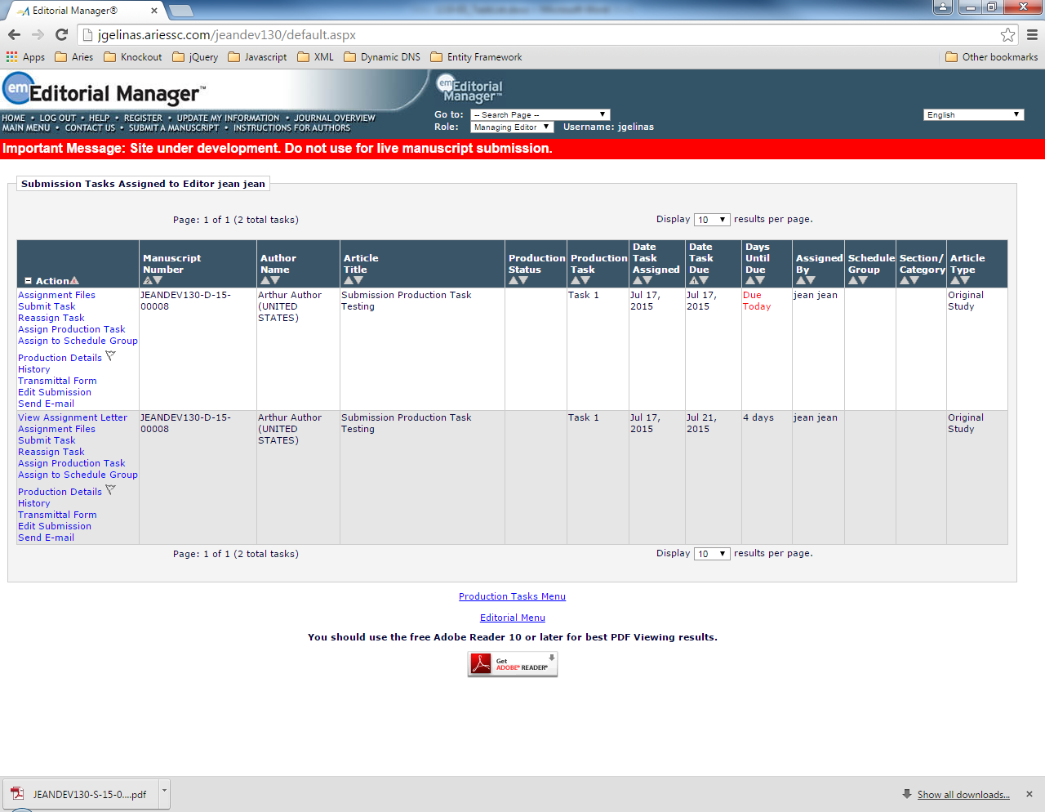

viewAssignmentFiles.asp

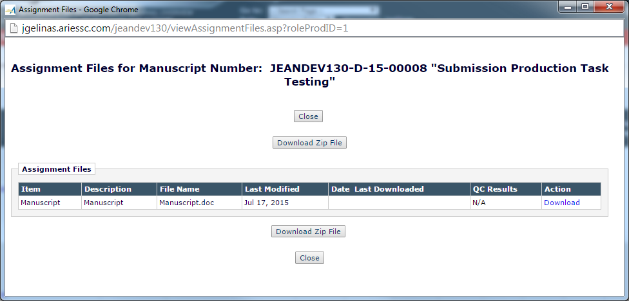

adhocZip.asp

changes for viewAssignmentFiles.asp

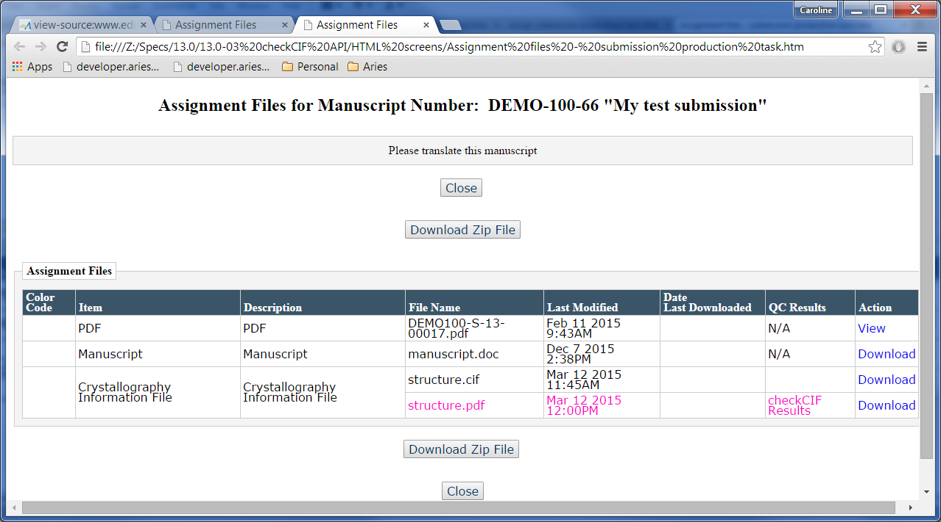

2.10.2

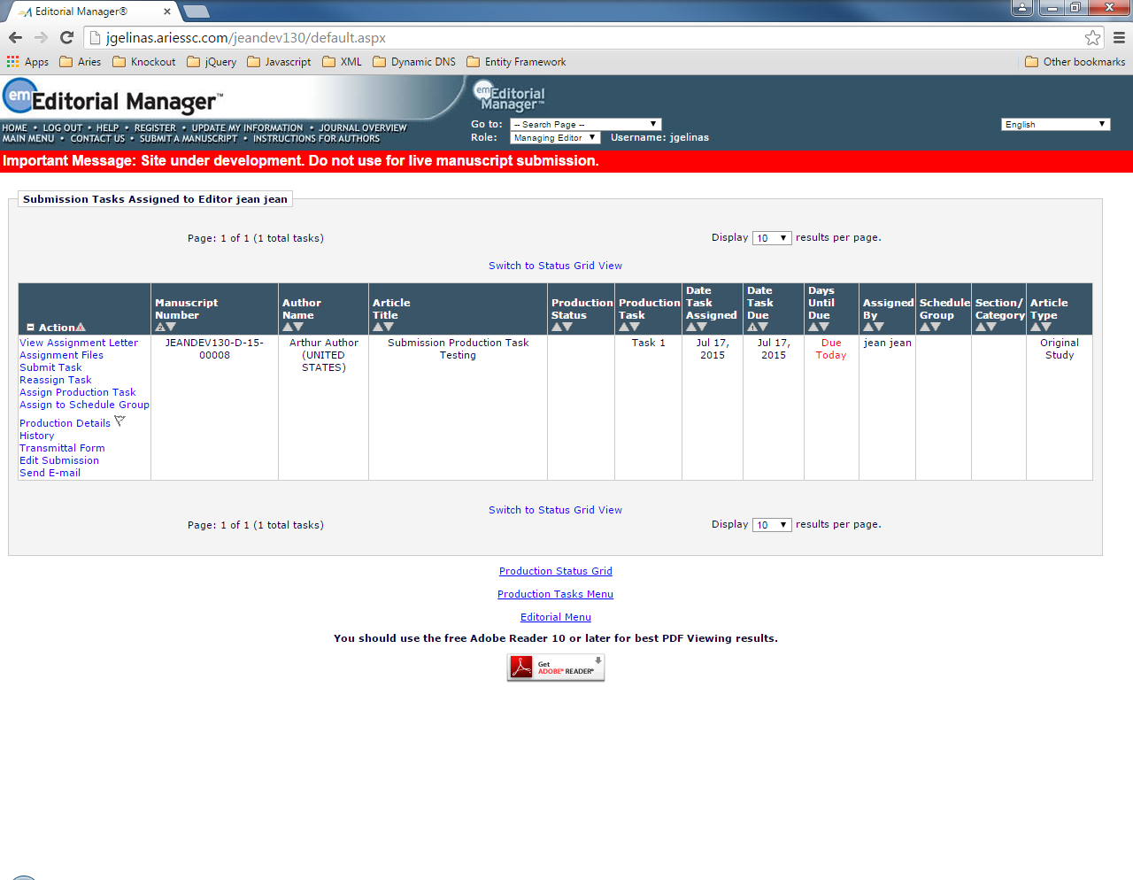

AssignProductionTask.aspx

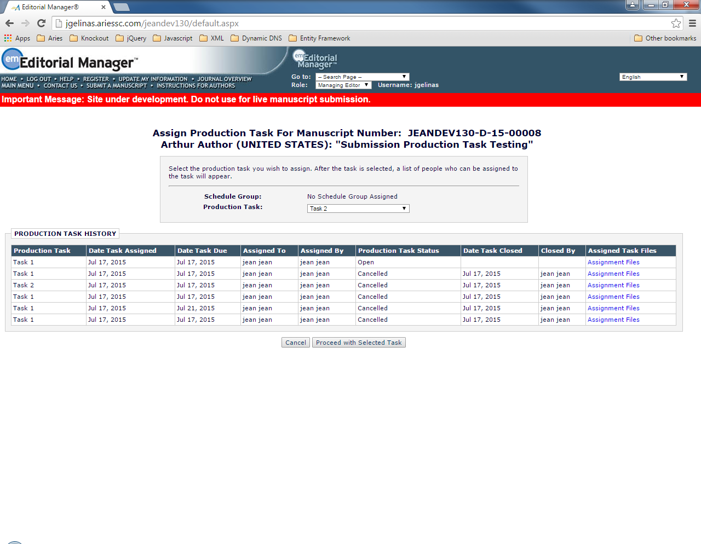

ProdTaskAssignFilesSummary.aspx

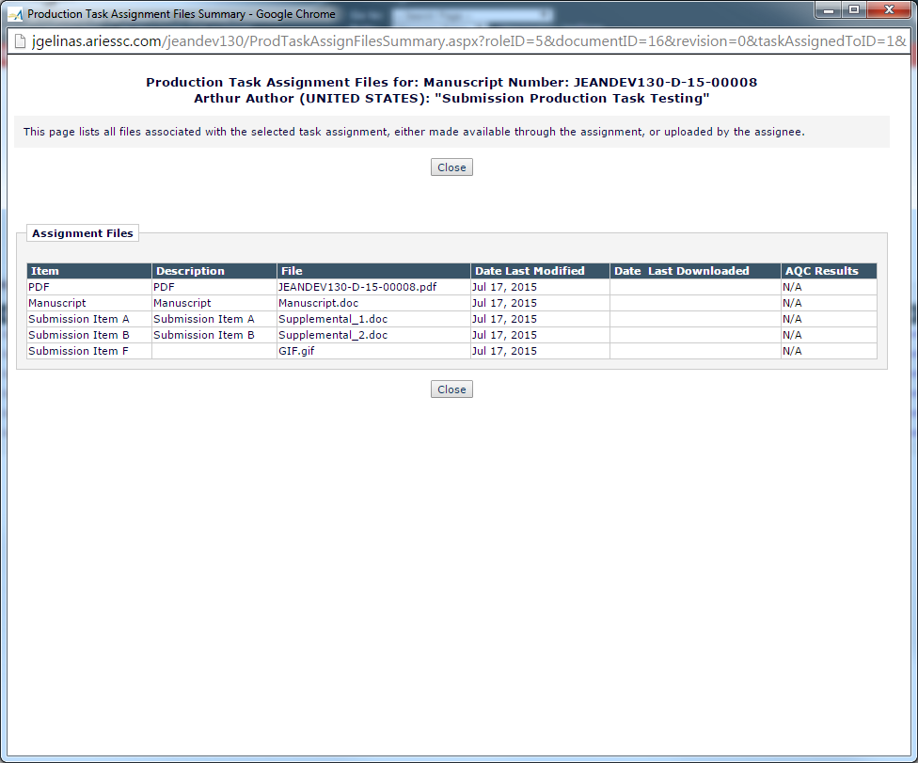

Changes for ProdTaskAssignFilesSummary.aspx

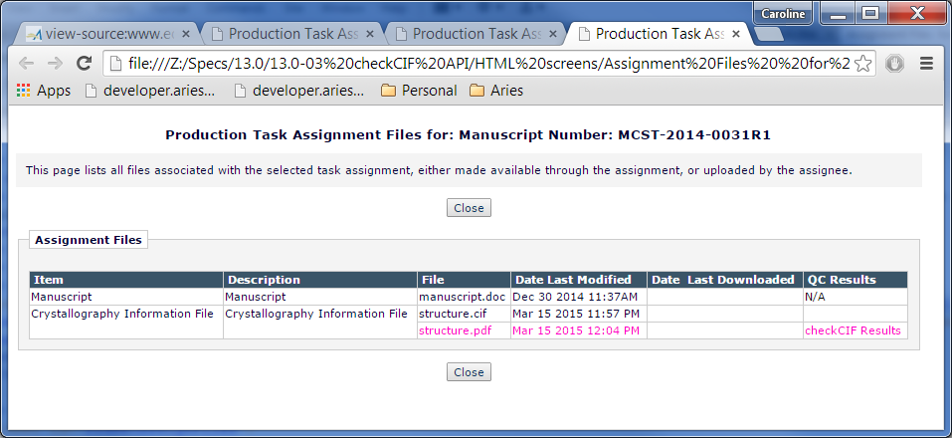

2.11

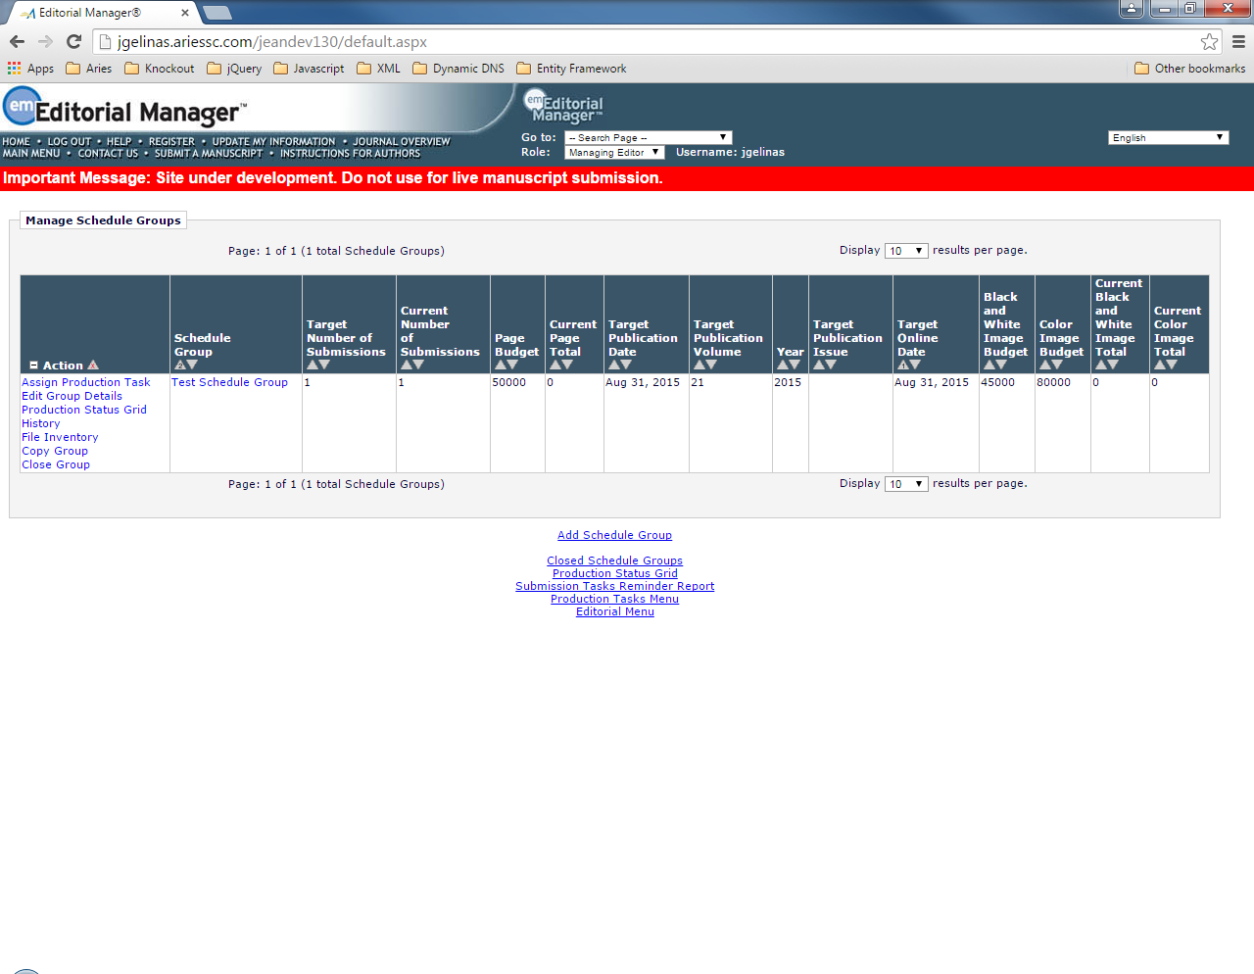

AssignScheduleGroupProductionTask.aspx

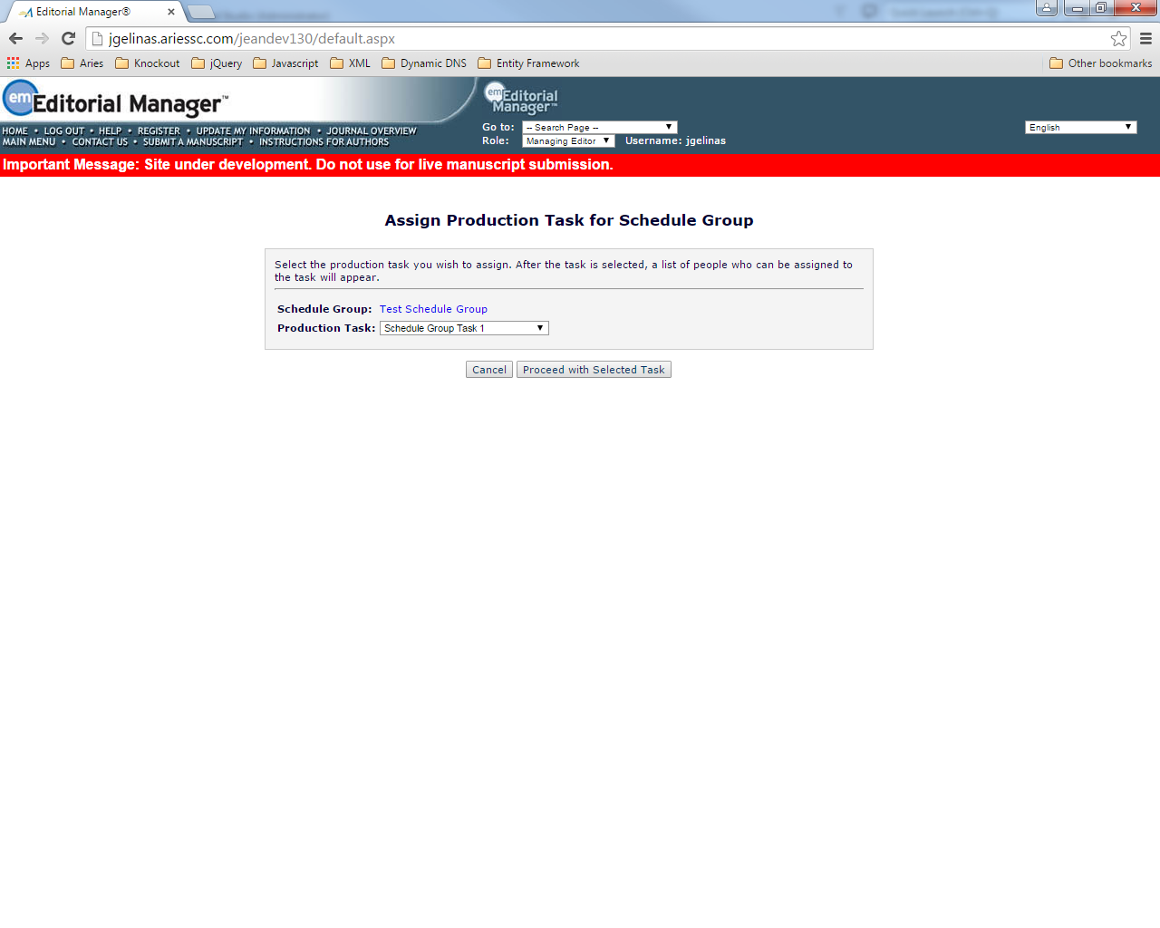

assignScheduleGroupProductionTask.asp

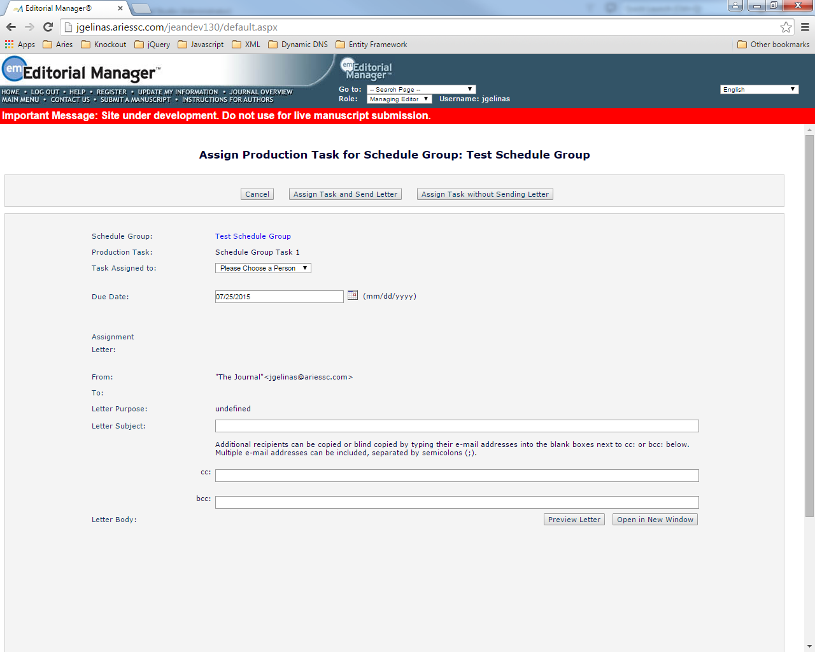

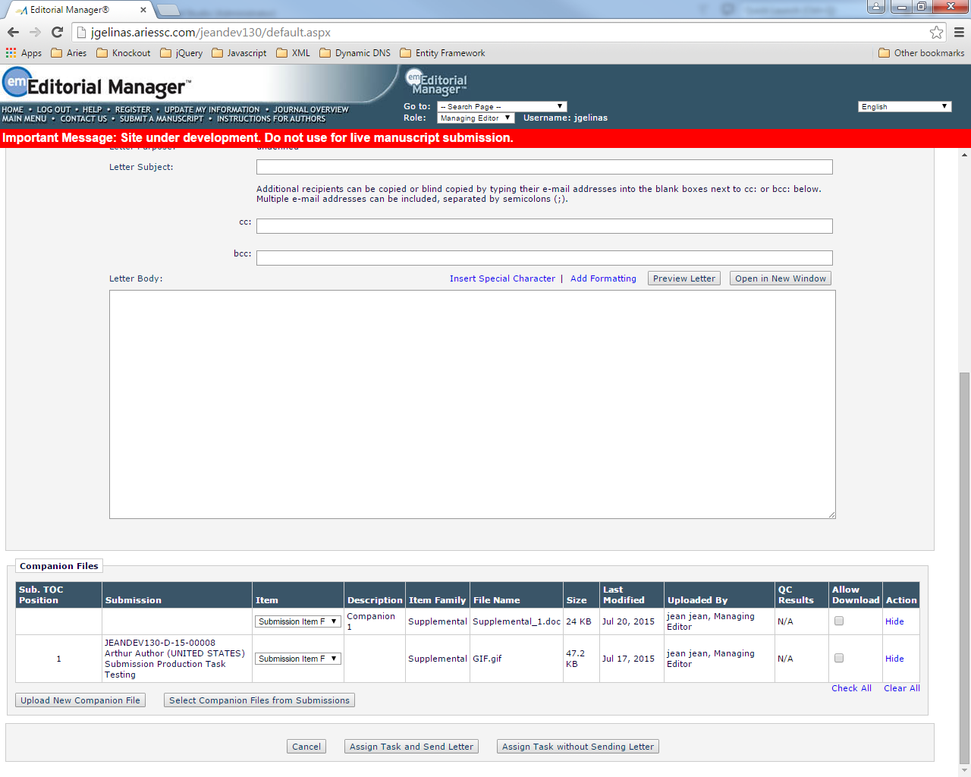

SelectAssocCompanionFiles.asp

addCompanionFiles.aspx

Changes to assignScheduleGroupProductionTask.asp

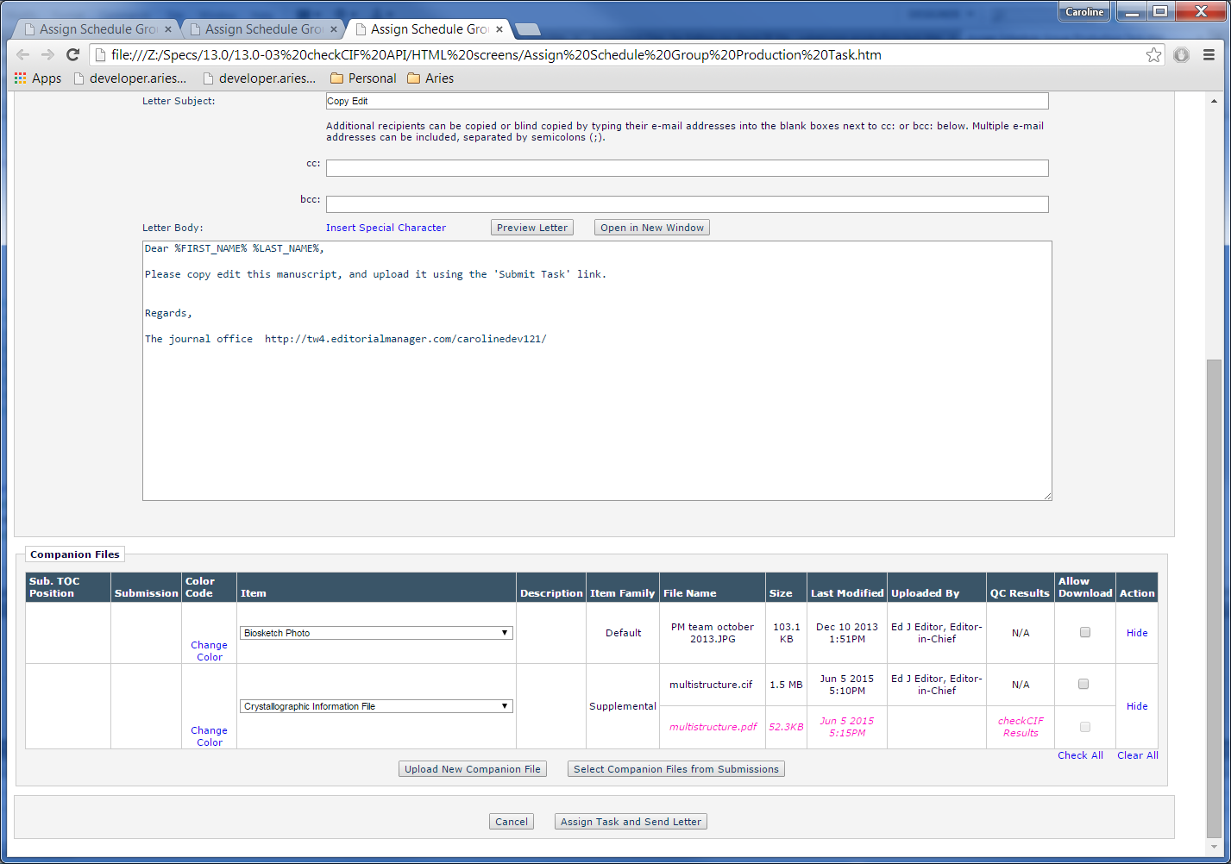

2.11.1 – when a Companion file is selected from this page and added to the Companion Files grid on the *Assign Schedule Group Production Task* page, any results PDFs associated with the added Companion file are also displayed in the grid.

assignScheduleGroupProductionTask.asp



SelectAssocCompanionFiles.asp

SelectAssocCompanionFiles.asp – no display changes

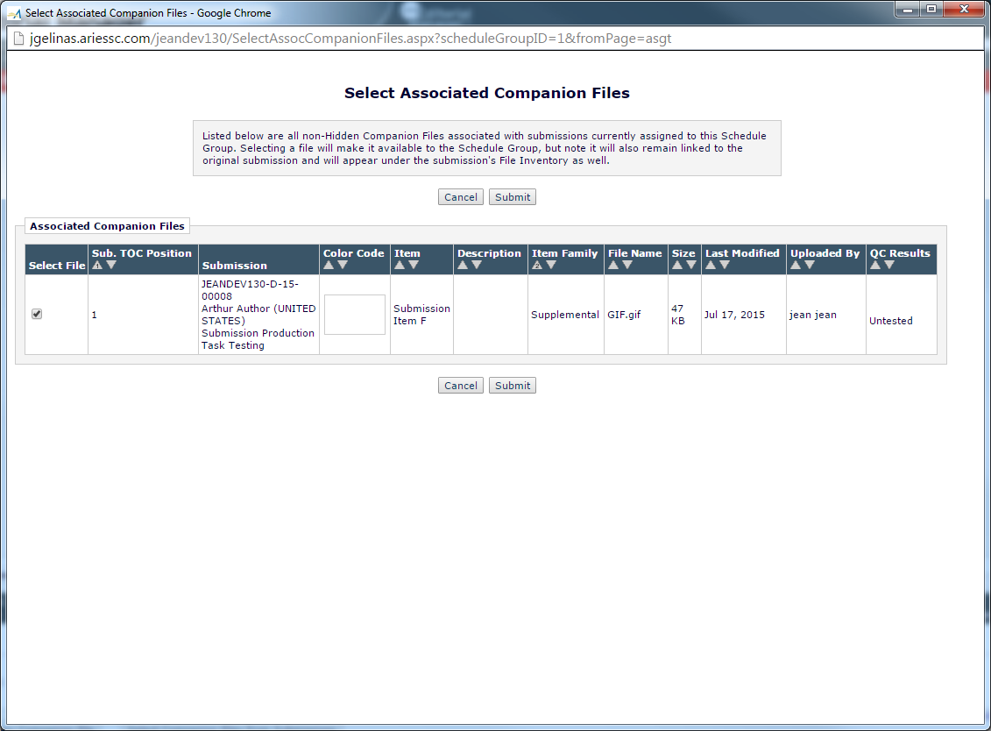

2.12.1

SearchResults.aspx

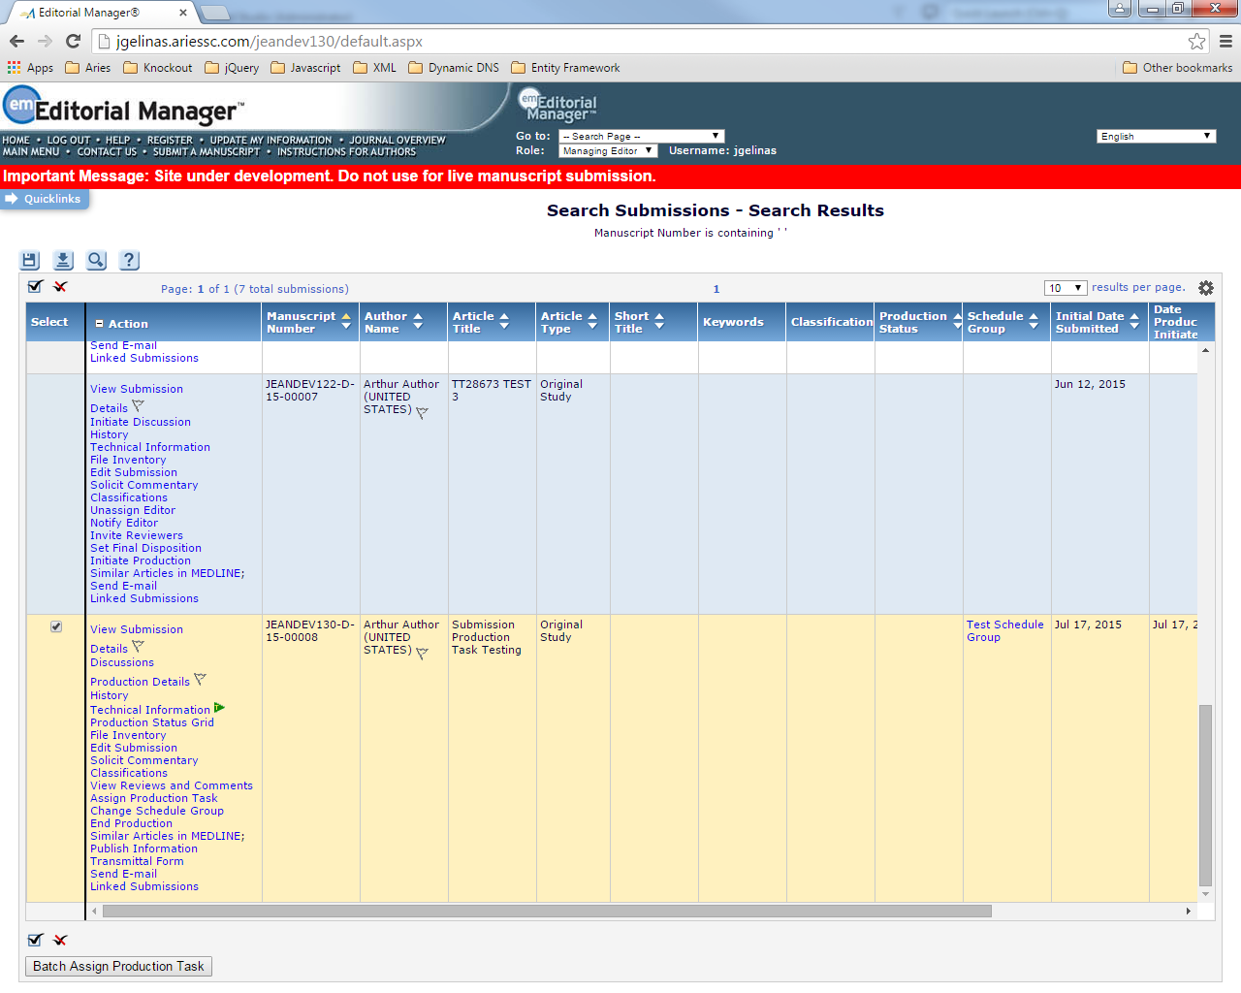

BatchAssignSubmissionTask.aspx

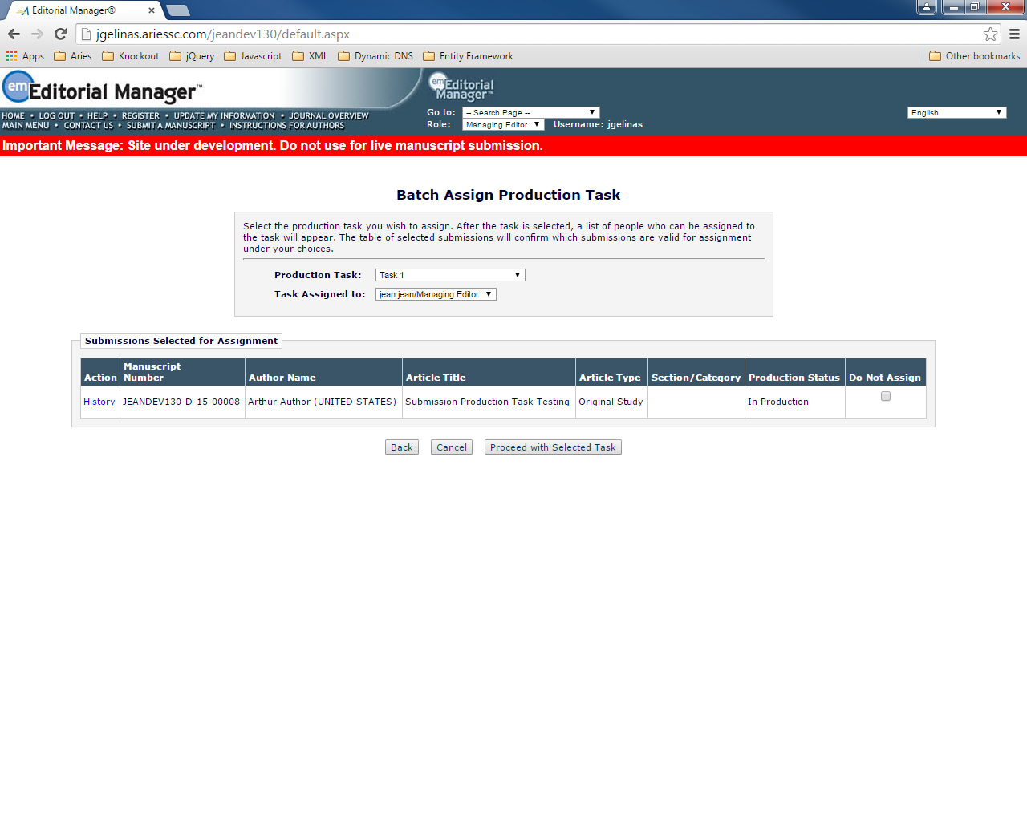

BatchAssignSubmissionTaskCustomize.aspx

28920 – get this error coming to the BatchAssignSubmissionTaskCustomize.aspx.

