13.0-33 Assign Author – Distilled

New Editor Role

Under Proposals/Commentaries

*‘Assign Authors (without invitation)’*

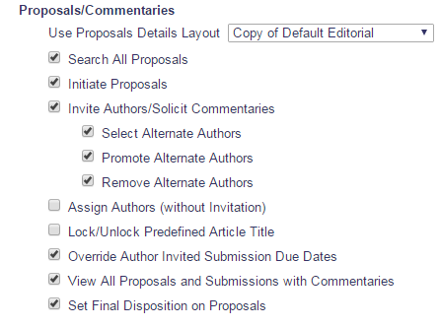

Through all ‘Search Author’ functionality and upload of ALF.

Search For Authors

searchAuthorsByNameAddr.asp

Search By Personal Classifications

searchAuthorsByPersonalClassifications.aspx

Upload Authors

uploadAuthorList.aspx

Assignment shows up in ‘My Accepted Invitations’ folder for author.

Flows:

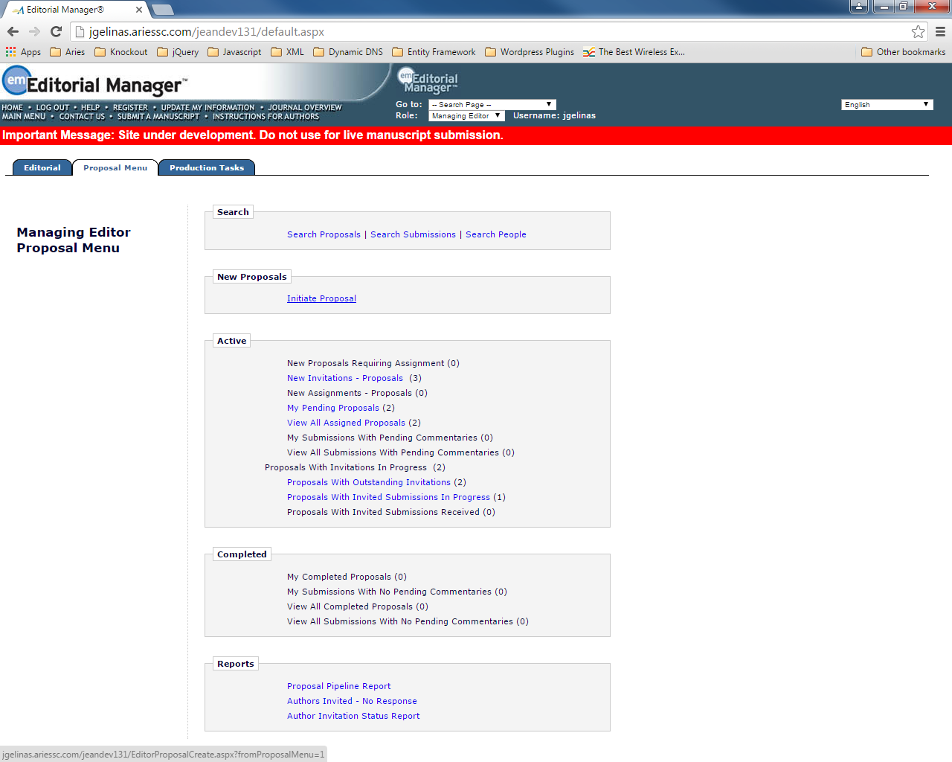

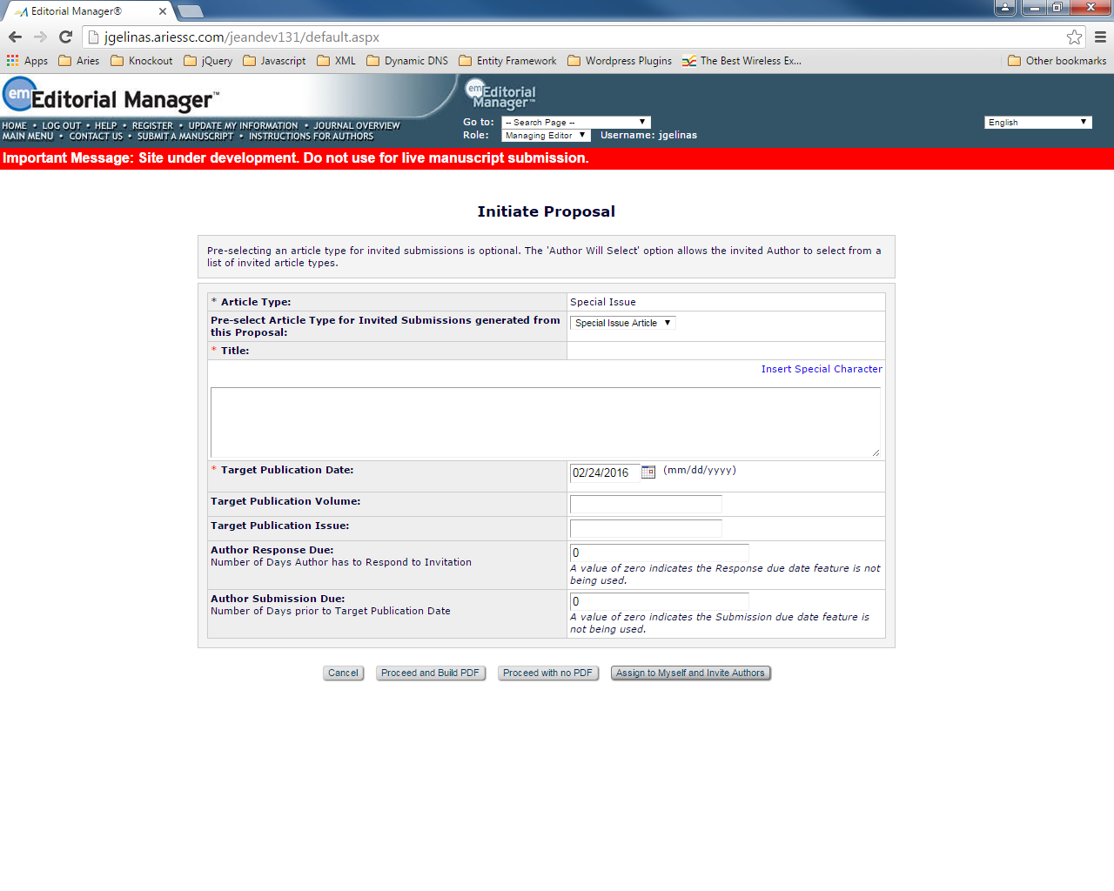

Author Selection Summary

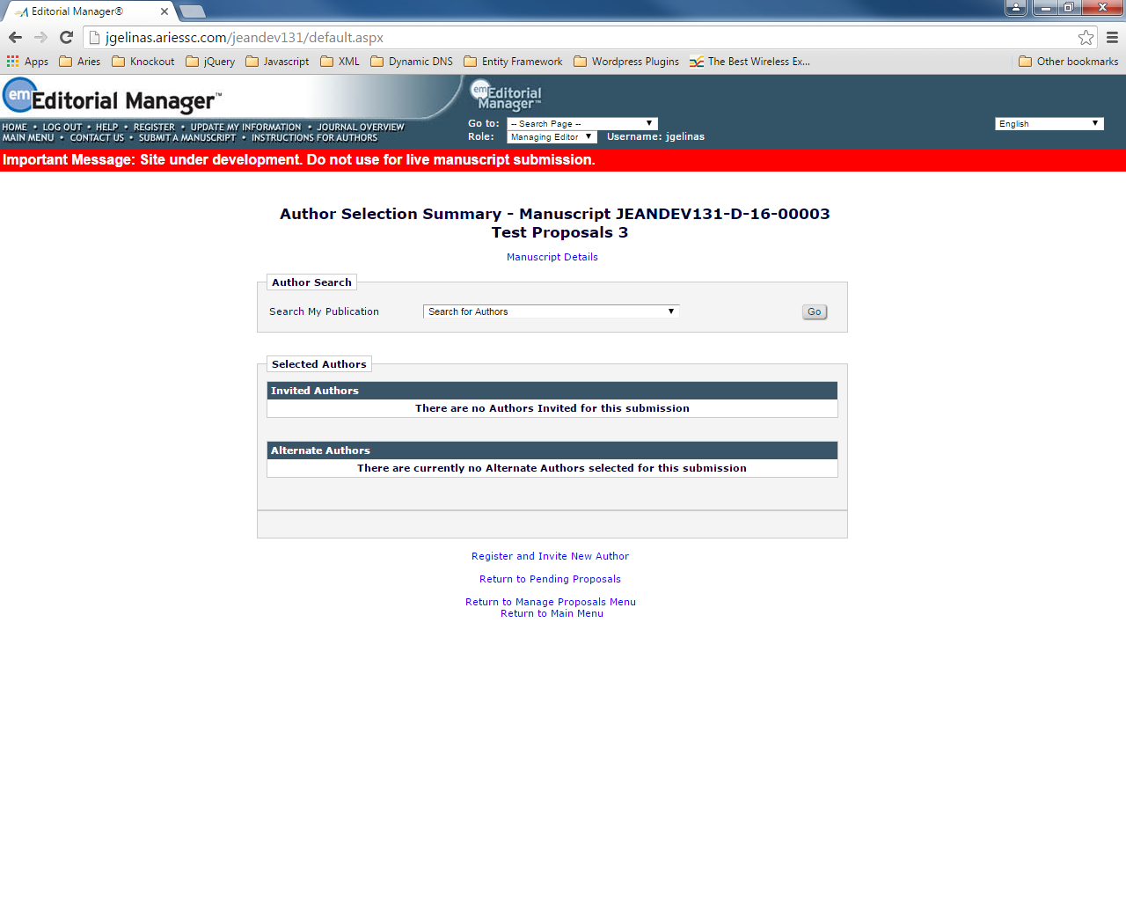

Search For Authors dropdown choice

searchAuthorsByNameAddress.asp

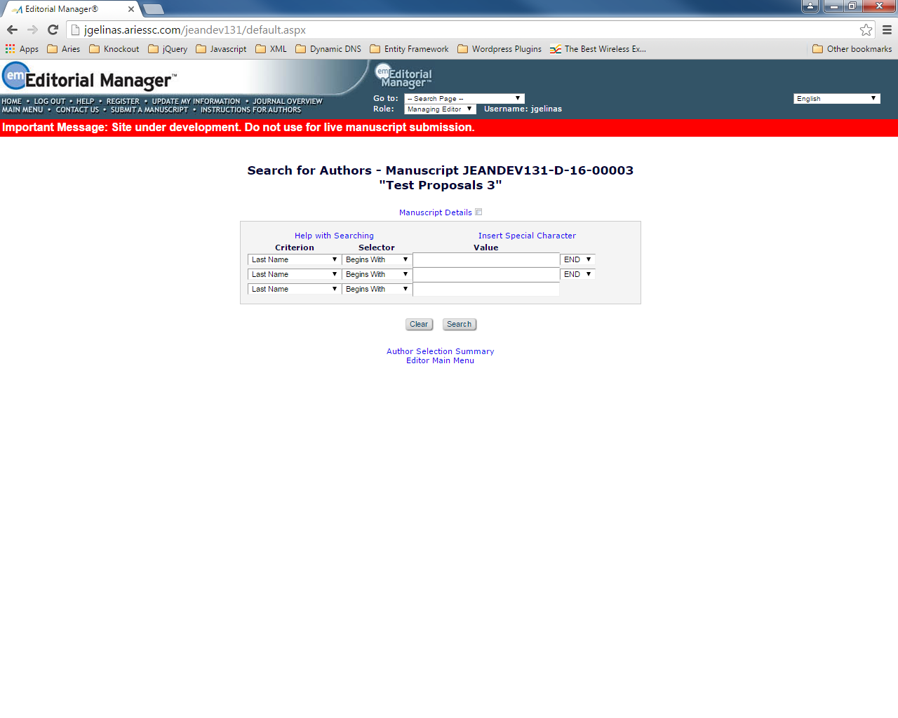

searchAuthorsByNameAddrResults.asp

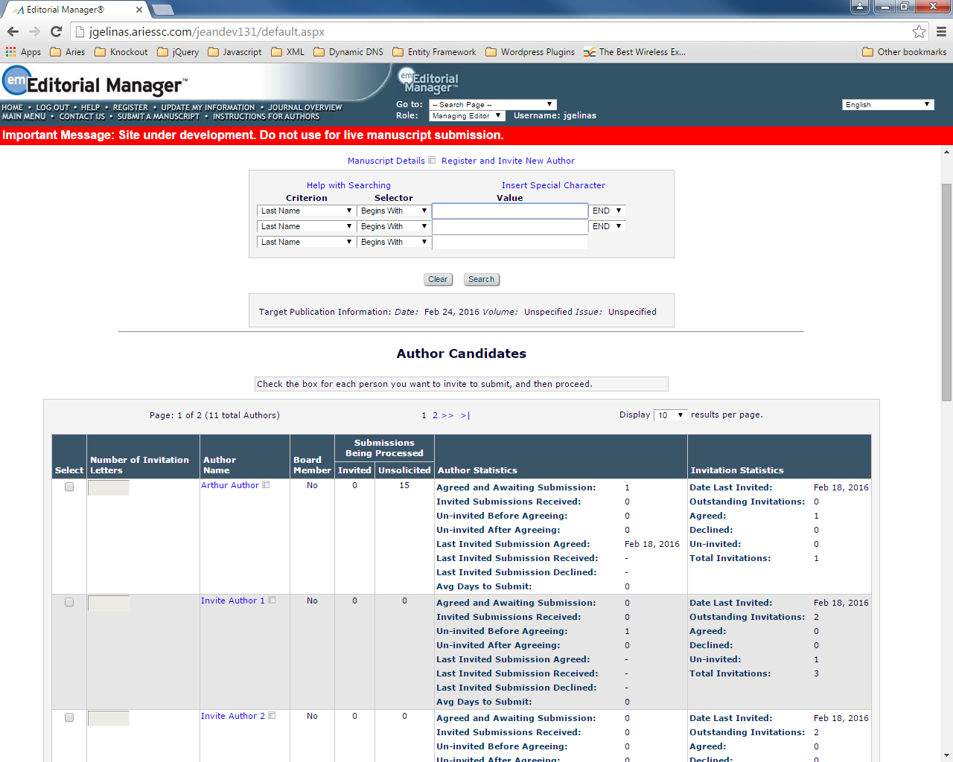

confirmAndCustomizeInvitedAuthors.aspx

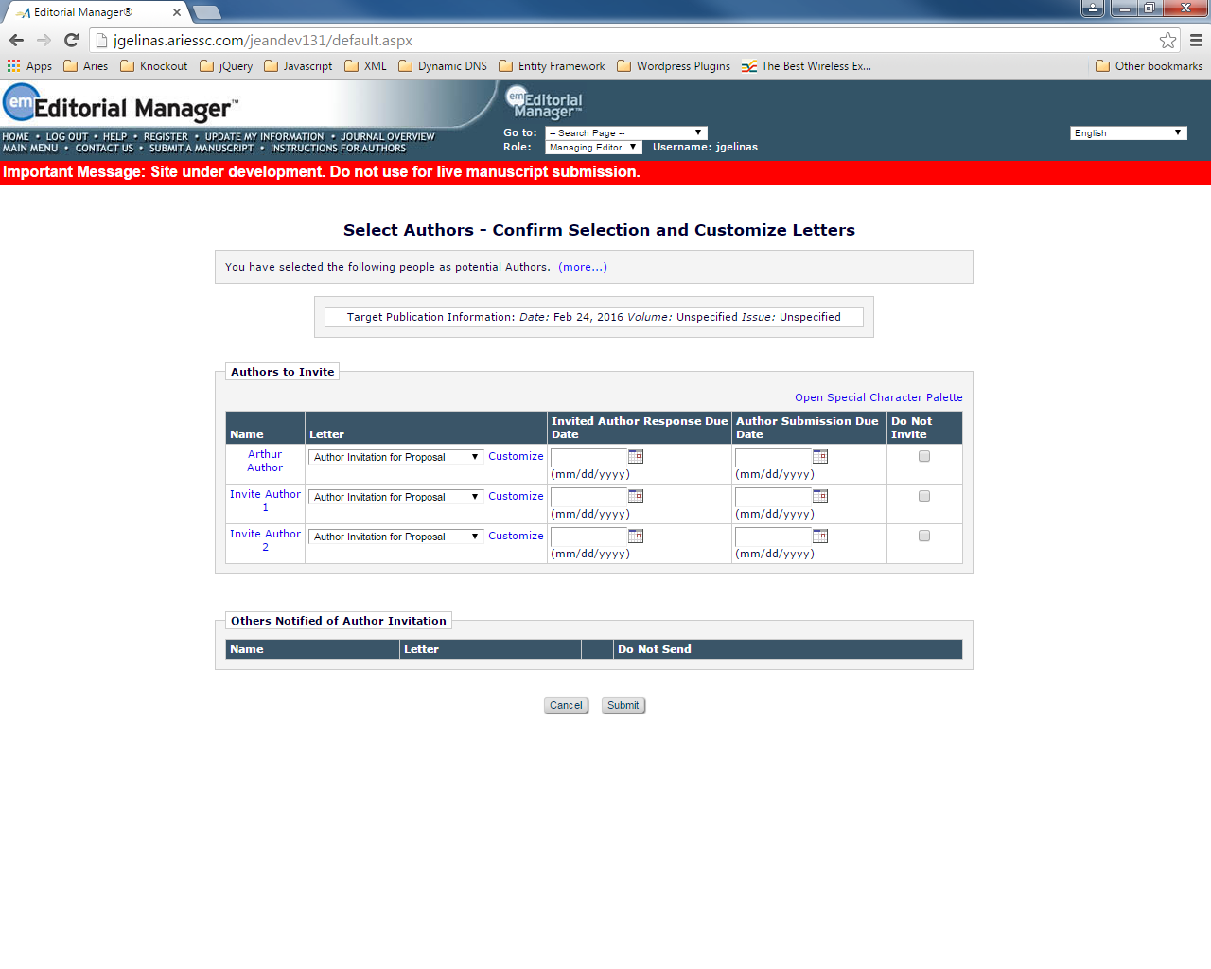

Search By Personal Classifications

searchAuthorsByPersonalClassifications.aspx

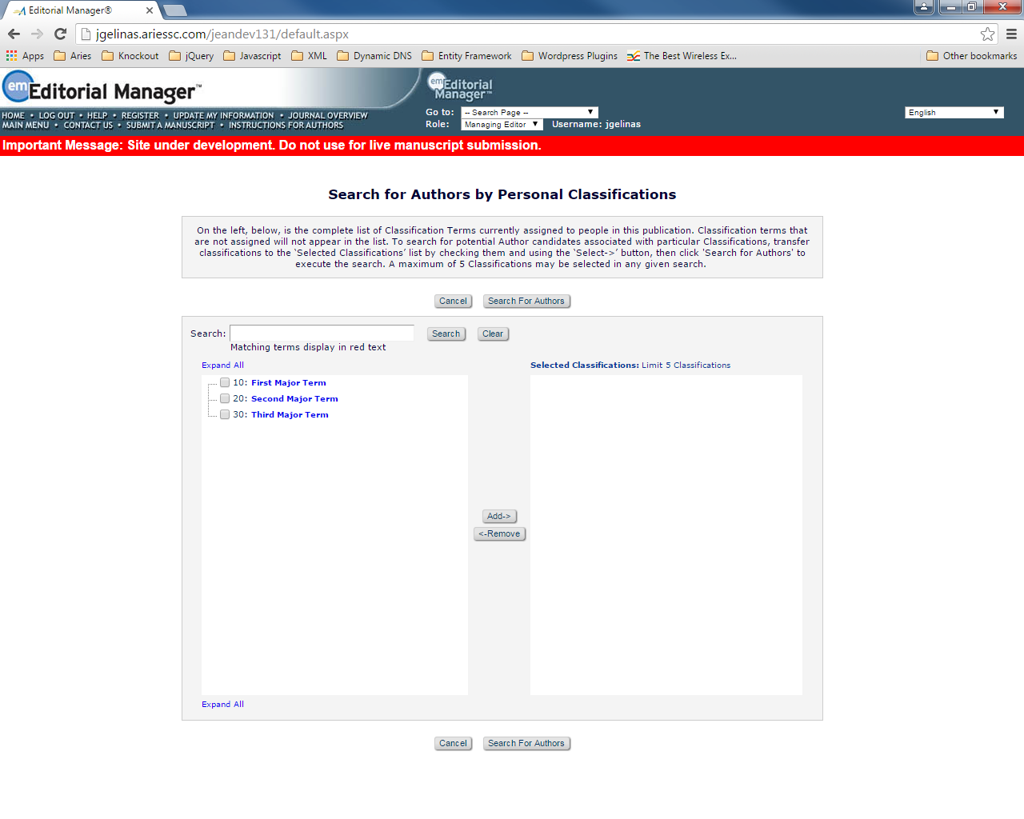

searchAuthorsByPersonalClassResults.asp

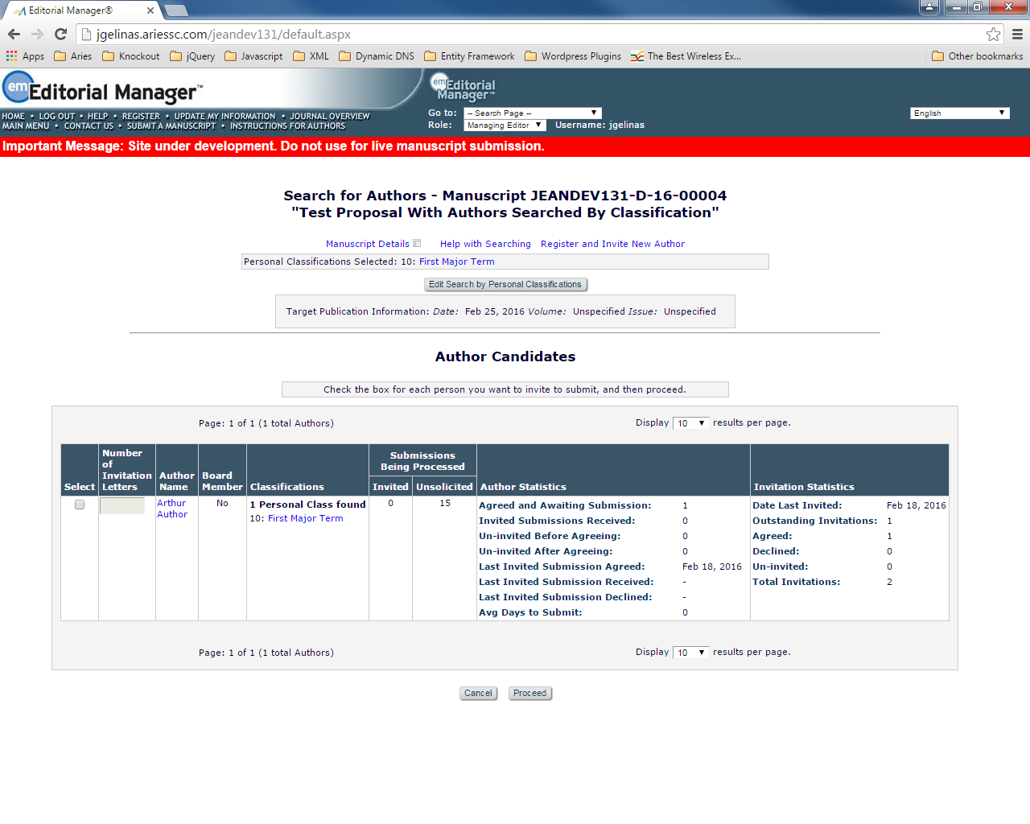

confirmAndCustomizeInvitedAuthors.aspx

Upload Authors

uploadAuthorList.aspx

authorSelectionSummary.aspx

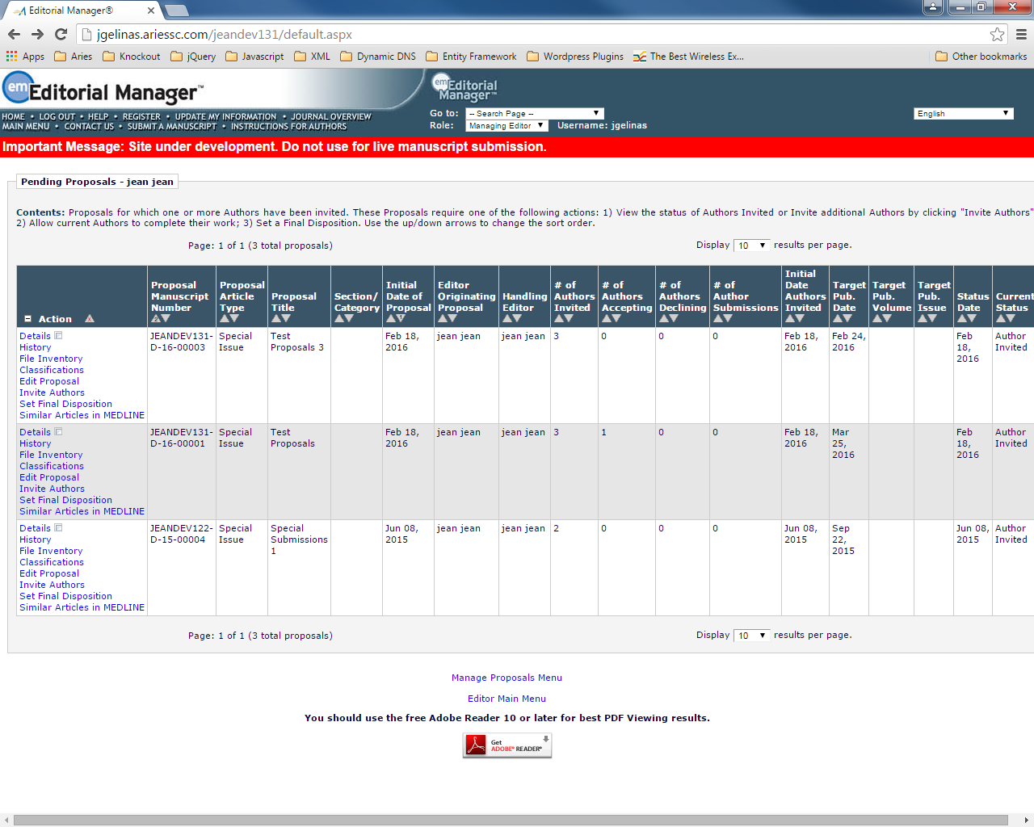

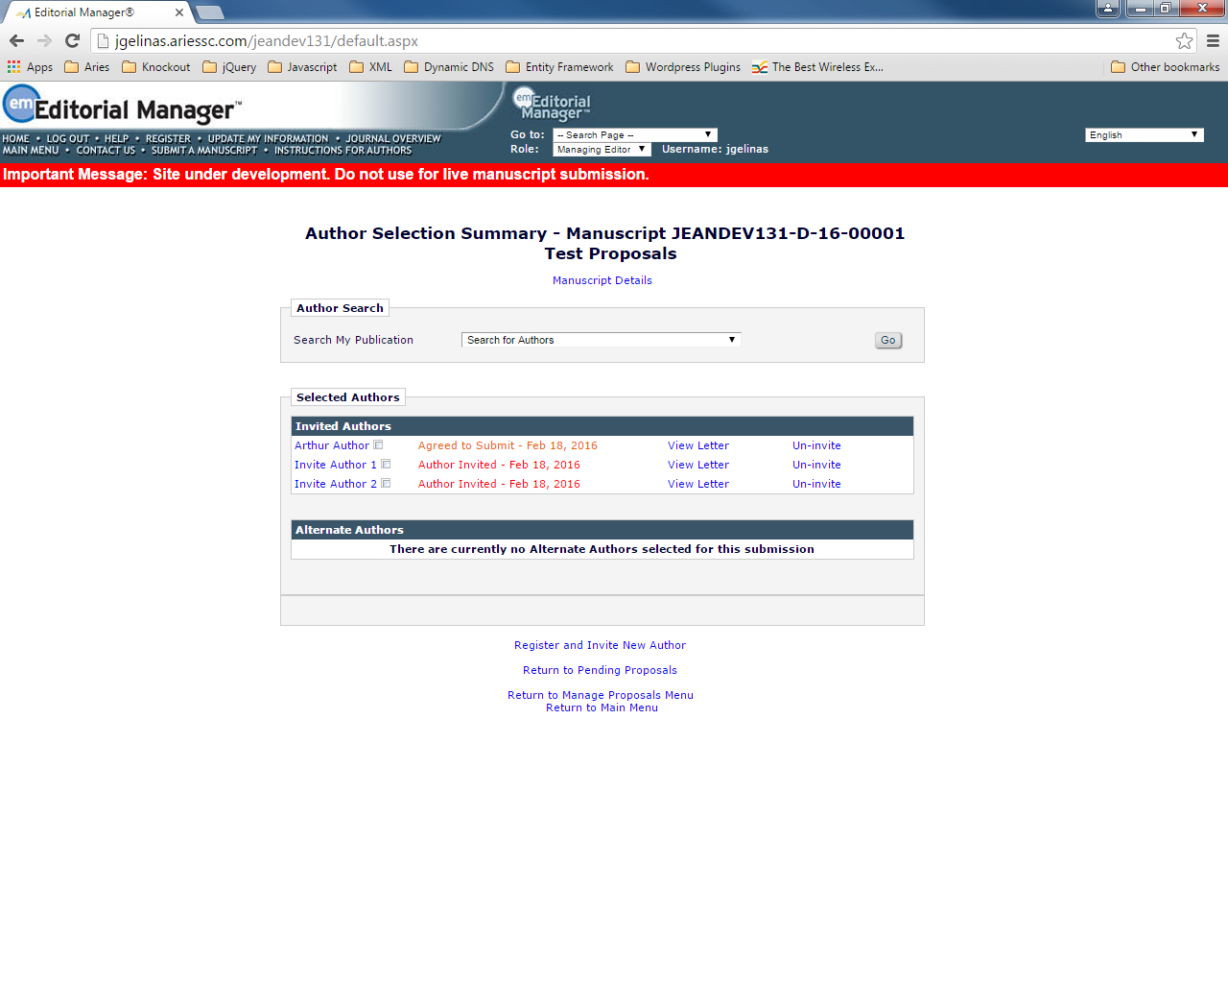

Un-invite links

Will only appear in summary until the point of acceptance.

After point of acceptance, *Un-Assign* link will appear instead (right away for assigned author)

Unassign of the author will not promote alternates.

uninviteAuthorButton_Click

singleButtonClick

show confirmAndCustomizeUninvitedAuthors.asp

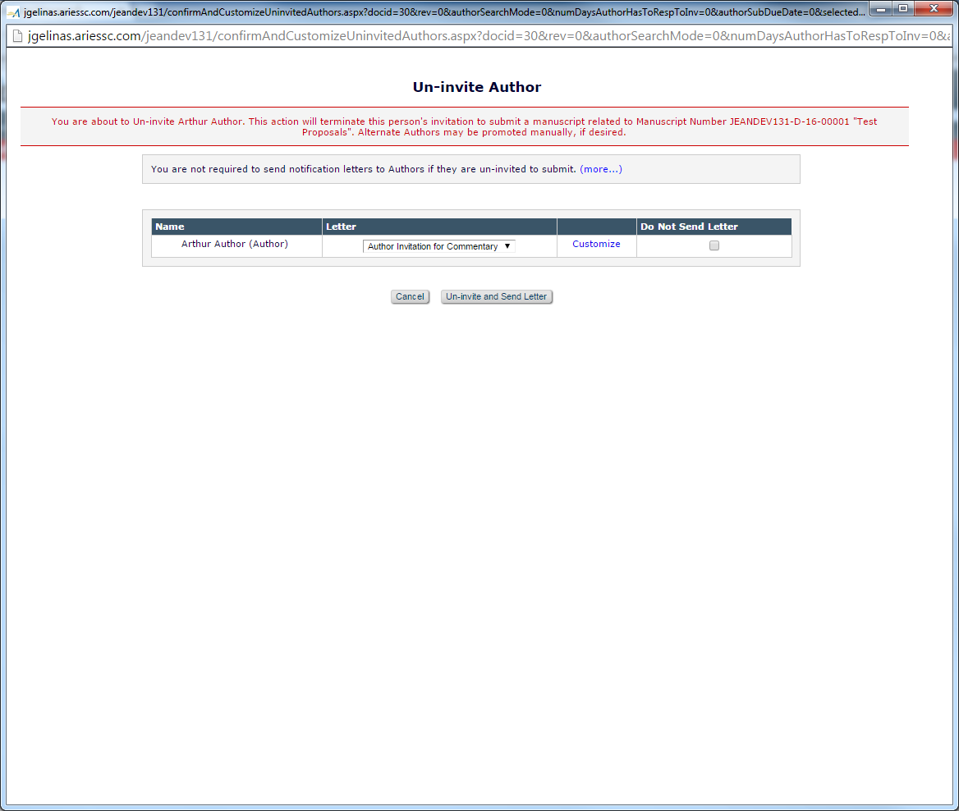

Invited Author Statuses

+ Author Assigned

+ Author Un-assigned after Agreeing

Same color and format as Author Univited status

+ Author Un-assigned after Assigning

View letter link will open new letters as configured in Action Manager Roles for the new events (Author Assigned, Author Unassigned after Agreeing, Author Unassigned After Assigning)

Action Manager Role Configuration

**Figure 2:** Mocked up ActionManager Role configuration page showing the new ‘Author Assigned (Not Invited) for Proposal’, ‘Author Assigned (Not Invited) for Commentary’, ‘Author Unassigned after Accepting Invitation’ and ‘Author Unassigned after Assignment’ events. The new events are highlighted, but not to be coded, in pink.

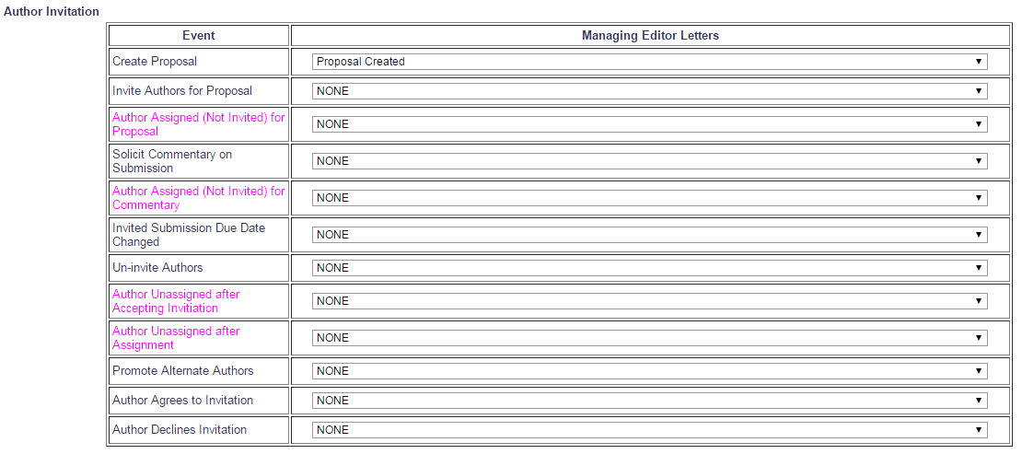

Action Manager Document Status

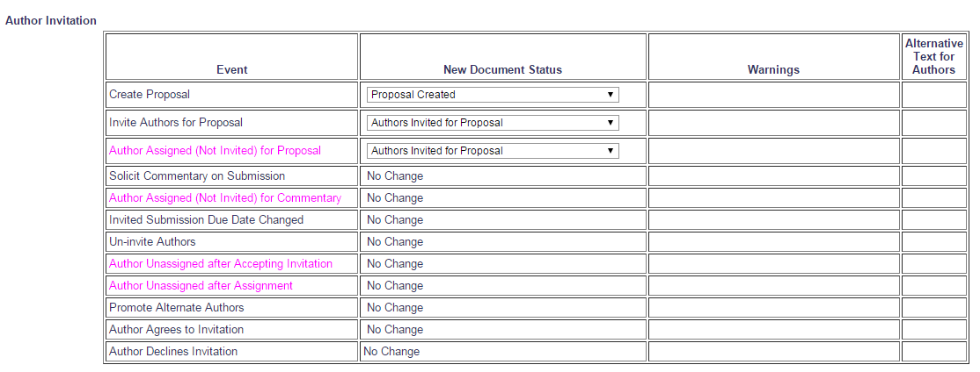

Upload Author List tooltip

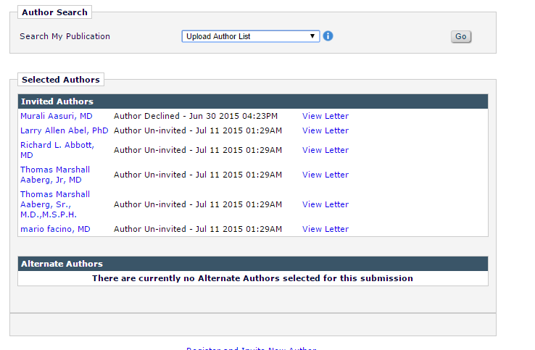

INVITE is a true/false field which will determine how an Author is selected by default when the list is imported. When set to TRUE an Author is selected for invitation, when FALSE for assignment, and if no value is provided no selection is made.

Upload Author file format

FIRSTNAME

LASTNAME

EMAIL

**INVITE – true (selected for invite), false (selected for direct assignment), no value, no selection is made**

TITLE

NOTE

ORCID