# CONFIDENTIAL AND PROPRIETARY

**Aries Systems Corporation**

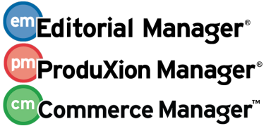

**Technical Specification**

14.0-02 v1

Suppress Enterprise Analystics and Cross-Publication Enterprise Analytics Standard Reports

**Status: DRAFT**

Copyright © 2016, Aries Systems Corporation

This document is the confidential and proprietary property of Aries Systems Corporation. The contents hereof are for use only by recipients specifically identified by Aries, and may not be further disclosed to any other third party. Specifications, designs and drawings contained herein are subject to withdrawal or change by Aries, without notice. Aries shall have no liability resulting from such withdrawal or change. Editorial Manager is a registered trademark and the property of Aries Systems Corporation.

Aries Systems reserves the right to share this specification with other individuals or organizations that have entered into confidentiality agreements with Aries Systems, in which case the specification will be appropriately blinded so that no identifying or proprietary information will be exposed.

CONFIDENTIAL AND PROPRIETARY 1

Contributors: 4

Document Revision History: 4

Summary: 4

References: 4

Design: 5

Admin Manager Main Menu 5

Data 5

+ Pages.Admin.AdminManagerMainMenu.ConfigEARMenus 5

Pages 5

Web\Common\Admin 5

AdminManager.aspx 5

New Config EAR Report Menus 6

Data 6

Journal 6

Translation 6

+ Pages.Admin.ConfigEARReportingMenus.PageTitle 6

+ Pages.Admin.ConfigEARReportingMenus.Instructions 6

+ Pages.Admin.ConfigEARReportingMenus.CheckboxText 6

+ Pages.Admin.ConfigEARReportingMenus.Confirm.PageTitle 6

+ Pages.Admin.ConfigEARReportingMenus.Confirm.Message 6

+ Pages.Admin.ConfigEARReportingMenus.Confirm.BackToEARReportingMenus 6

Code 7

Misc 7

EnumsAndIDs.txt 7

Aries.EditorialManager.Framework.Journal.ConfigObjects.ConfigItem 7

ConfigItemEnum.cs 7

+ EARConfigSettings.cs 7

Pages 8

Web/Common/Admin 8

+ ConfigEARReportingMenus.aspx 8

UpdateSettings 8

+ ConfigEARReportingMenus_Confirm.aspx 9

Display/Suppress Standard Reports Section 10

Pages 10

Web/Izenda 10

enterpriseReports.aspx.cs 10

Issues and Concerns: 11

Spec Changes 12

DBContent: 13

JOURNAL 13

UDB 14

# Contributors:

|  |  |
| --- | --- |
| Primary Engineer | Jean Gelinas |
| Senior Engineer | Andrew Pokrovski |
| Coding Engineer(s) | Jean Gelinas |

# Document Revision History:

|  |  |  |
| --- | --- | --- |
| 05/24/2016 | Jean Gelinas | Start |
|  |  |  |

# Summary:

Adds functionality to be able to suppress Editor Reports and Production Tracking Report sections of EAR & X-EAR.

# References:

# Design:

## Admin Manager Main Menu

### Data

#### + Pages.Admin.AdminManagerMainMenu.ConfigEARMenus

“Configure Enterprise Analytics Reporting Menus”

### Pages

#### Web\Common\Admin

##### AdminManager.aspx

Add translation hyperlink after managePublicationGroups

* ID = configEARMenus
* NavigateURL = ConfigEARReportingMenus.aspx
* ResourceID = Pages.Admin.AdminManagerMainMenu.ConfigEARMenus

## New Config EAR Report Menus

### Data

#### Journal

MASTER_CONFIG

Add new configuration record:

* CONFIG_ID = 334
* DESCRIPTION = Display All Standard EAR Reports
* VALUE = 1

#### Translation

##### + Pages.Admin.ConfigEARReportingMenus.Title

“Config EAR Reporting Menus Page”

##### + Pages.Admin.ConfigEARReportingMenus.Header

“Configure Enterprise Analystics Reporting Menus”

##### + Pages.Admin.ConfigEARReportingMenus.Instructions

“To display the Standard Reports section of the Enterprise Analytics Reporting menu(s), select the checkbox and click the Submit button.”

##### + Pages.Admin.ConfigEARReportingMenus.CheckboxText

“Display all standard Enterprise Analytics reports for all Editor Roles.”

##### + Pages.Admin.ConfigEARReportingMenus.Confirm.Header

“Configure Enterprise Analytics Reporting Menus Confirmation”

##### + Pages.Admin.ConfigEARReportingMenus.Confirm.SuccessMessage

“Your Enterprise Analytics Reporting Menus choice has been updated.”

##### + Pages.Admin.ConfigEARReportingMenus.Confirm.FailureMessage

“An error occurred in updating your Enterprise Analytics Reporting Menus choice. </br>”

##### + Pages.Admin.ConfigEARReportingMenus.Confirm.BackToEARReportingMenus

“Back to Configure Enterprise Analytics Reporting Menus”

### Code

#### Misc

##### EnumsAndIDs.txt

Add item in ConfigItemEnum section

* 334 – Display All Standard EAR Reports

#### Aries.EditorialManager.Web

##### UtilFunctions.cs

###### + VerifySysAdminViaEMData (EMData)

* Pass in em data object.
* Determine the currently logged on person’s editor role id (consider proxy if necessary)
* Return roleManager.IsSysAdmin.
* Set to be called by ajax function in ConfigEARReportingMenus.aspx (SaveConfigSettings)

##### + WebMethodResponses.cs

Meant to hold various response objects to be used when web methods are called to be turned into json and returned to the client.

###### + public class WebMethod_BasicResponse

* int ReturnValue (1 – success, 0 – failure)
* string ReturnMessage

#### Aries.EditorialManager.Framework.Journal.ConfigObjects.ConfigItem

##### ConfigItemEnum.cs

Add item to enumeration

* DisplayAllStandardEARReports = 334

##### EnterpriseAnalysticsReporting.cs

* + Public bool DisplayAllStandardEARReports
  + Return/populate ConfigItemEnum.DisplayAllStandardEARReports of _configItemsDic.

### Pages

#### Web/Common/Admin

##### + ConfigEARReportingMenus.aspx

Similar to ConfigureShardLetters.aspx

Config settings div.

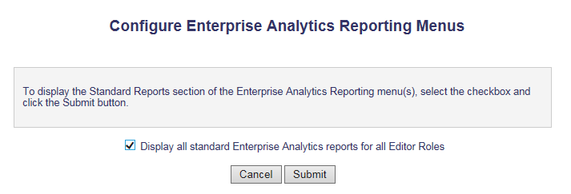

Title = Pages.Admin.ConfigEARReportingMenus.PageTitle

Instruction = Pages.Admin.ConfigEARReportingMenus.Instructions

Checkbox Text = Pages.Admin.ConfigEARReportingMenus.CheckboxText

Confirm div

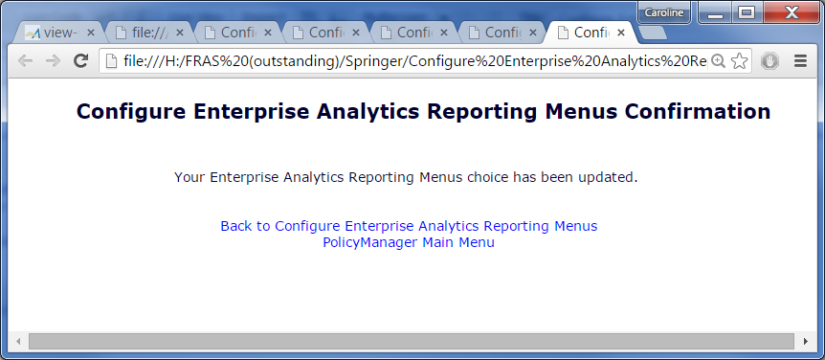

Title = Pages.Admin.ConfigEARReportingMenus.Confirm.PageTitle

Message = Pages.Admin.ConfigEARReportingMenus.Confirm.Message

EAR Reporting Menus Link = Pages.Admin.ConfigEARReportingMenus.Confirm.  
BackToEARReporting

Back to Policy Manager Link = Common.Navigation.Links.PolicyManager.MainMenu

+ checkboxChangeHandler – handles enabling/disabling submit button when config checkbox check status changes.

+ submitConfigSettings – sends the status of the config checkbox to web method at ConfigEARReportingMenus.aspx/SaveConfigSettings.

##### + ConfigEARReportingMenus.aspx.cs

###### Page_Load

* Create a ConfigSettingFactory object.
* Get config settings from the factory’s CreateConfigSettings method<EnterpriseAnalysticsReporting>
* Set checkbox per configSettings.DisplayAllStandardEARReports.

###### public static WebMethod_BasicResponse SaveConfigSettings (bool showStandardReports)

* Create new em data object
* Verify that the current user is a sys admin by calling UtilFunctions.VerifySysAdminViaEMData.
* Create a ConfigSettingFactory object.
* Get config settings from the factory’s CreateConfigSettings method<EnterpriseAnalysticsReporting>
* Set the configSettings.DisplayAllStandardEARReports = showStandardReports
* Update the configuration setting in the database by using MapperManager.ConfigSettingsMapper.UpdateConfigSettings (configSettings)

## Display/Suppress Standard Reports Section

### Pages

#### Web/Izenda

##### enterpriseReports.aspx

+ div to show if there are no reports to be shown because standard reports have been suppressed. Show text – Pages.Reports.EnterpriseAnalyticsReporting.NoReportsToShow.

##### enterpriseReports.aspx.cs

* + new private EnterpriseAnalyticsReporting _earConfigSettings

###### Page_PreInit

Populate _earSettings with new ConfigSettingFactory(mapperManager.Journal, mapperManager.JournalConnectionString).

CreateConfigSetting<EARConfigSettings>();

###### Page_Load

New var numberOfReports to keep running count of how many reports have been loaded.

Before report sections are configured:

* + - * !_earSettings.DisplayAllStandardEARReports
        + StandardReportsSection.Visible = false

Within report section configuration:

* Don’t configure StandardReportsSection if not visible

# Issues and Concerns:

1. What happens if the only thing to display on the page is the Standard Reports section?

# Spec Changes

* None currently.

# DBContent:

## JOURNAL

## UDB