**Results Template**

Clustering

# 1 Introduction

library(easystats)  
  
summary(report::report(sessionInfo()))

The analysis was done using the R Statistical language (v4.0.2; R Core Team, 2020) on macOS Catalina 10.15.6, using the packages factoextra (v1.0.7), effectsize (v0.4.1), ggplot2 (v3.3.2), stringr (v1.4.0), forcats (v0.5.0), tidyr (v1.1.2), readr (v1.3.1), dplyr (v1.0.3), rmarkdown (v2.6.6), here (v0.1), tibble (v3.0.6), purrr (v0.3.4), parameters (v0.10.1.1), insight (v0.11.1.1), see (v0.6.1.1), performance (v0.6.1.1), cluster (v2.1.1), modelbased (v0.4.0), easystats (v0.2.0), correlation (v0.5.0), bayestestR (v0.8.0.1), report (v0.2.0), dendextend (v1.14.0) and tidyverse (v1.3.0).

## 1.1 Data

df <- read_csv("data/class_wide_1.csv")

> Parsed with column specification:  
> cols(  
> .default = col_double(),  
> speaker = col_character(),  
> `54` = col_character()  
> )

> See spec(...) for full column specifications.

# 2 Clustering

## 2.1 Introduction

In this task, individuals heard spoken speech tokens and freely classified them into groups. Using hierarchical clustering we aim to see what clusters or groups appear as a result of the free classification task.

library(here)  
library(tidyverse) # data manipulation  
library(cluster) # clustering algorithms  
library(factoextra) # clustering visualization  
library(dendextend) # for comparing two dendrograms

### 2.1.1 Data Preparation

1. Rows are observations (individuals) and columns are variables
2. Any missing value in the data must be removed or estimated.
3. The data must be standardized (i.e., scaled) to make variables comparable (I am not doing this here)

### 2.1.2 Read in the data

clust_data <- read_csv(here("data", "class_wide_1.csv")) # read in data

> Warning: Missing column names filled in: 'X1' [1]

> Parsed with column specification:  
> cols(  
> .default = col_double(),  
> speaker = col_character(),  
> `54` = col_character()  
> )

> See spec(...) for full column specifications.

clust_data <- select(clust_data, -X1, -`54`) # remove extra col sub 54 has weird formatting  
  
clust_data <- as.data.frame(clust_data) # turn into df   
  
rownames(clust_data) <- clust_data$speaker # make row names speaker  
  
clust_data <- select(clust_data,-speaker) # remove extra col sub 54 has weird formatting  
  
head(clust_data)# show first couple rows

|  |  |  |  |  |  |  |  |  |  |  |  |  |  |  |  |  |  |  |  |  |  |  |  |  |  |  |  |  |  |  |  |  |  |  |  |  |  |  |  |  |  |  |  |  |  |  |  |  |  |  |  |  |  |  |  |  |  |  |  |  |  |  |  |  |  |  |  |  |  |  |  |  |  |  |  |  |  |  |  |  |  |  |  |  |
| --- | --- | --- | --- | --- | --- | --- | --- | --- | --- | --- | --- | --- | --- | --- | --- | --- | --- | --- | --- | --- | --- | --- | --- | --- | --- | --- | --- | --- | --- | --- | --- | --- | --- | --- | --- | --- | --- | --- | --- | --- | --- | --- | --- | --- | --- | --- | --- | --- | --- | --- | --- | --- | --- | --- | --- | --- | --- | --- | --- | --- | --- | --- | --- | --- | --- | --- | --- | --- | --- | --- | --- | --- | --- | --- | --- | --- | --- | --- | --- | --- | --- | --- | --- | --- |
|  | 8 | 7 | 1 | 10 | 11 | 12 | 14 | 15 | 16 | 17 | 18 | 19 | 2 | 20 | 23 | 25 | 26 | 27 | 28 | 29 | 3 | 30 | 31 | 32 | 33 | 34 | 35 | 36 | 38 | 4 | 40 | 41 | 42 | 43 | 44 | 45 | 46 | 47 | 48 | 49 | 5 | 50 | 51 | 52 | 53 | 55 | 56 | 58 | 59 | 6 | 78 | 87 | 90 | 91 | 96 | 105 | 110 | 111 | 115 | 121 | 123 | 125 | 132 | 133 | 135 | 148 | 151 | 152 | 153 | 155 | 156 | 157 | 158 | 159 | 160 | 161 | 162 | 163 | 164 | 165 | 166 | 167 | 168 | 169 |
| bengali_9 | 1 | 5 | 5 | 1 | 11 | 2 | 1 | 8 | 4 | 2 | 2 | 1 | 9 | 7 | 4 | 5 | 1 | 1 | 1 | 11 | 5 | 1 | 7 | 7 | 9 | 8 | 10 | 8 | 1 | 3 | 1 | 10 | 1 | 1 | 12 | 1 | 5 | 1 | 5 | 8 | 1 | 3 | 7 | 1 | 8 | 9 | 1 | 1 | 5 | 9 | 1 | 11 | 1 | 11 | 1 | 6 | 11 | 1 | 2 | 1 | 9 | 1 | 3 | 1 | 1 | 1 | 5 | 1 | 8 | 4 | 8 | 6 | 5 | 1 | 5 | 1 | 7 | 4 | 1 | 5 | 1 | 7 | 1 | 2 |
| bengali_13 | 6 | 5 | 5 | 7 | 14 | 4 | 2 | 7 | 4 | 2 | 6 | 3 | 9 | 1 | 4 | 5 | 4 | 2 | 3 | 11 | 12 | 1 | 8 | 11 | 9 | 8 | 10 | 11 | 1 | 4 | 12 | 1 | 1 | 8 | 11 | 1 | 5 | 4 | 1 | 8 | 5 | 4 | 7 | 3 | 8 | 9 | 1 | 8 | 11 | 7 | 1 | 11 | 1 | 11 | 1 | 6 | 11 | 7 | 8 | 6 | 9 | 1 | 6 | 2 | 3 | 6 | 9 | 1 | 8 | 4 | 10 | 6 | 5 | 2 | 1 | 14 | 7 | 6 | 4 | 5 | 1 | 4 | 2 | 4 |
| bengali_16 | 1 | 5 | 5 | 7 | 7 | 4 | 3 | 6 | 2 | 8 | 3 | 3 | 3 | 1 | 3 | 4 | 6 | 1 | 3 | 10 | 2 | 1 | 7 | 8 | 9 | 8 | 10 | 11 | 6 | 3 | 8 | 8 | 1 | 8 | 11 | 1 | 1 | 2 | 5 | 7 | 5 | 4 | 7 | 3 | 8 | 9 | 8 | 1 | 6 | 7 | 5 | 11 | 2 | 6 | 1 | 6 | 10 | 6 | 8 | 6 | 10 | 10 | 4 | 2 | 3 | 1 | 7 | 4 | 8 | 11 | 8 | 6 | 3 | 2 | 3 | 14 | 7 | 7 | 1 | 5 | 1 | 7 | 4 | 4 |
| gujarati_5 | 4 | 5 | 5 | 1 | 14 | 4 | 1 | 7 | 4 | 9 | 9 | 1 | 9 | 4 | 3 | 5 | 4 | 2 | 4 | 8 | 9 | 1 | 7 | 9 | 9 | 6 | 10 | 8 | 1 | 2 | 8 | 7 | 1 | 8 | 8 | 3 | 11 | 2 | 2 | 8 | 10 | 3 | 7 | 11 | 8 | 9 | 7 | 3 | 11 | 7 | 1 | 11 | 2 | 10 | 1 | 1 | 11 | 6 | 8 | 6 | 9 | 10 | 4 | 3 | 2 | 3 | 5 | 3 | 2 | 5 | 9 | 6 | 3 | 1 | 3 | 14 | 7 | 5 | 6 | 6 | 1 | 4 | 2 | 5 |
| gujarati_13 | 1 | 5 | 5 | 1 | 15 | 4 | 2 | 8 | 4 | 2 | 6 | 1 | 9 | 4 | 5 | 5 | 6 | 2 | 4 | 8 | 5 | 1 | 7 | 9 | 9 | 8 | 10 | 2 | 1 | 2 | 12 | 1 | 1 | 8 | 11 | 1 | 11 | 6 | 5 | 8 | 2 | 4 | 7 | 1 | 8 | 9 | 7 | 10 | 5 | 7 | 1 | 11 | 2 | 11 | 1 | 6 | 11 | 2 | 8 | 6 | 9 | 10 | 4 | 2 | 1 | 1 | 5 | 1 | 2 | 5 | 9 | 6 | 3 | 1 | 4 | 14 | 7 | 5 | 6 | 5 | 1 | 7 | 3 | 6 |
| gujarati_14 | 5 | 5 | 5 | 1 | 7 | 4 | 1 | 8 | 4 | 9 | 9 | 3 | 9 | 5 | 7 | 5 | 4 | 4 | 6 | 1 | 5 | 1 | 6 | 9 | 9 | 6 | 10 | 9 | 1 | 4 | 13 | 2 | 1 | 8 | 11 | 6 | 3 | 4 | 5 | 8 | 3 | 3 | 7 | 15 | 8 | 8 | 8 | 6 | 5 | 6 | 2 | 11 | 8 | 11 | 1 | 6 | 11 | 6 | 9 | 6 | 9 | 8 | 4 | 2 | 1 | 2 | 5 | 3 | 8 | 5 | 9 | 6 | 3 | 8 | 4 | 5 | 3 | 7 | 6 | 7 | 6 | 7 | 5 | 1 |

### 2.1.3 Agglomerative Hierarchical Clustering

I am going to cluster the data using average link clustering. Average link clustering computes all pairwise dissimilarities between the elements, and considers the average of these dissimilarities as the distance between clusters

# Dissimilarity matrix  
d <- dist(clust_data, method = "euclidean")  
  
# Hierarchical clustering using Average Linkage  
hc1 <- hclust(d, method = "average" )  
  
# Plot the obtained dendrogram  
plot(hc1, cex = 0.6, hang = -1)

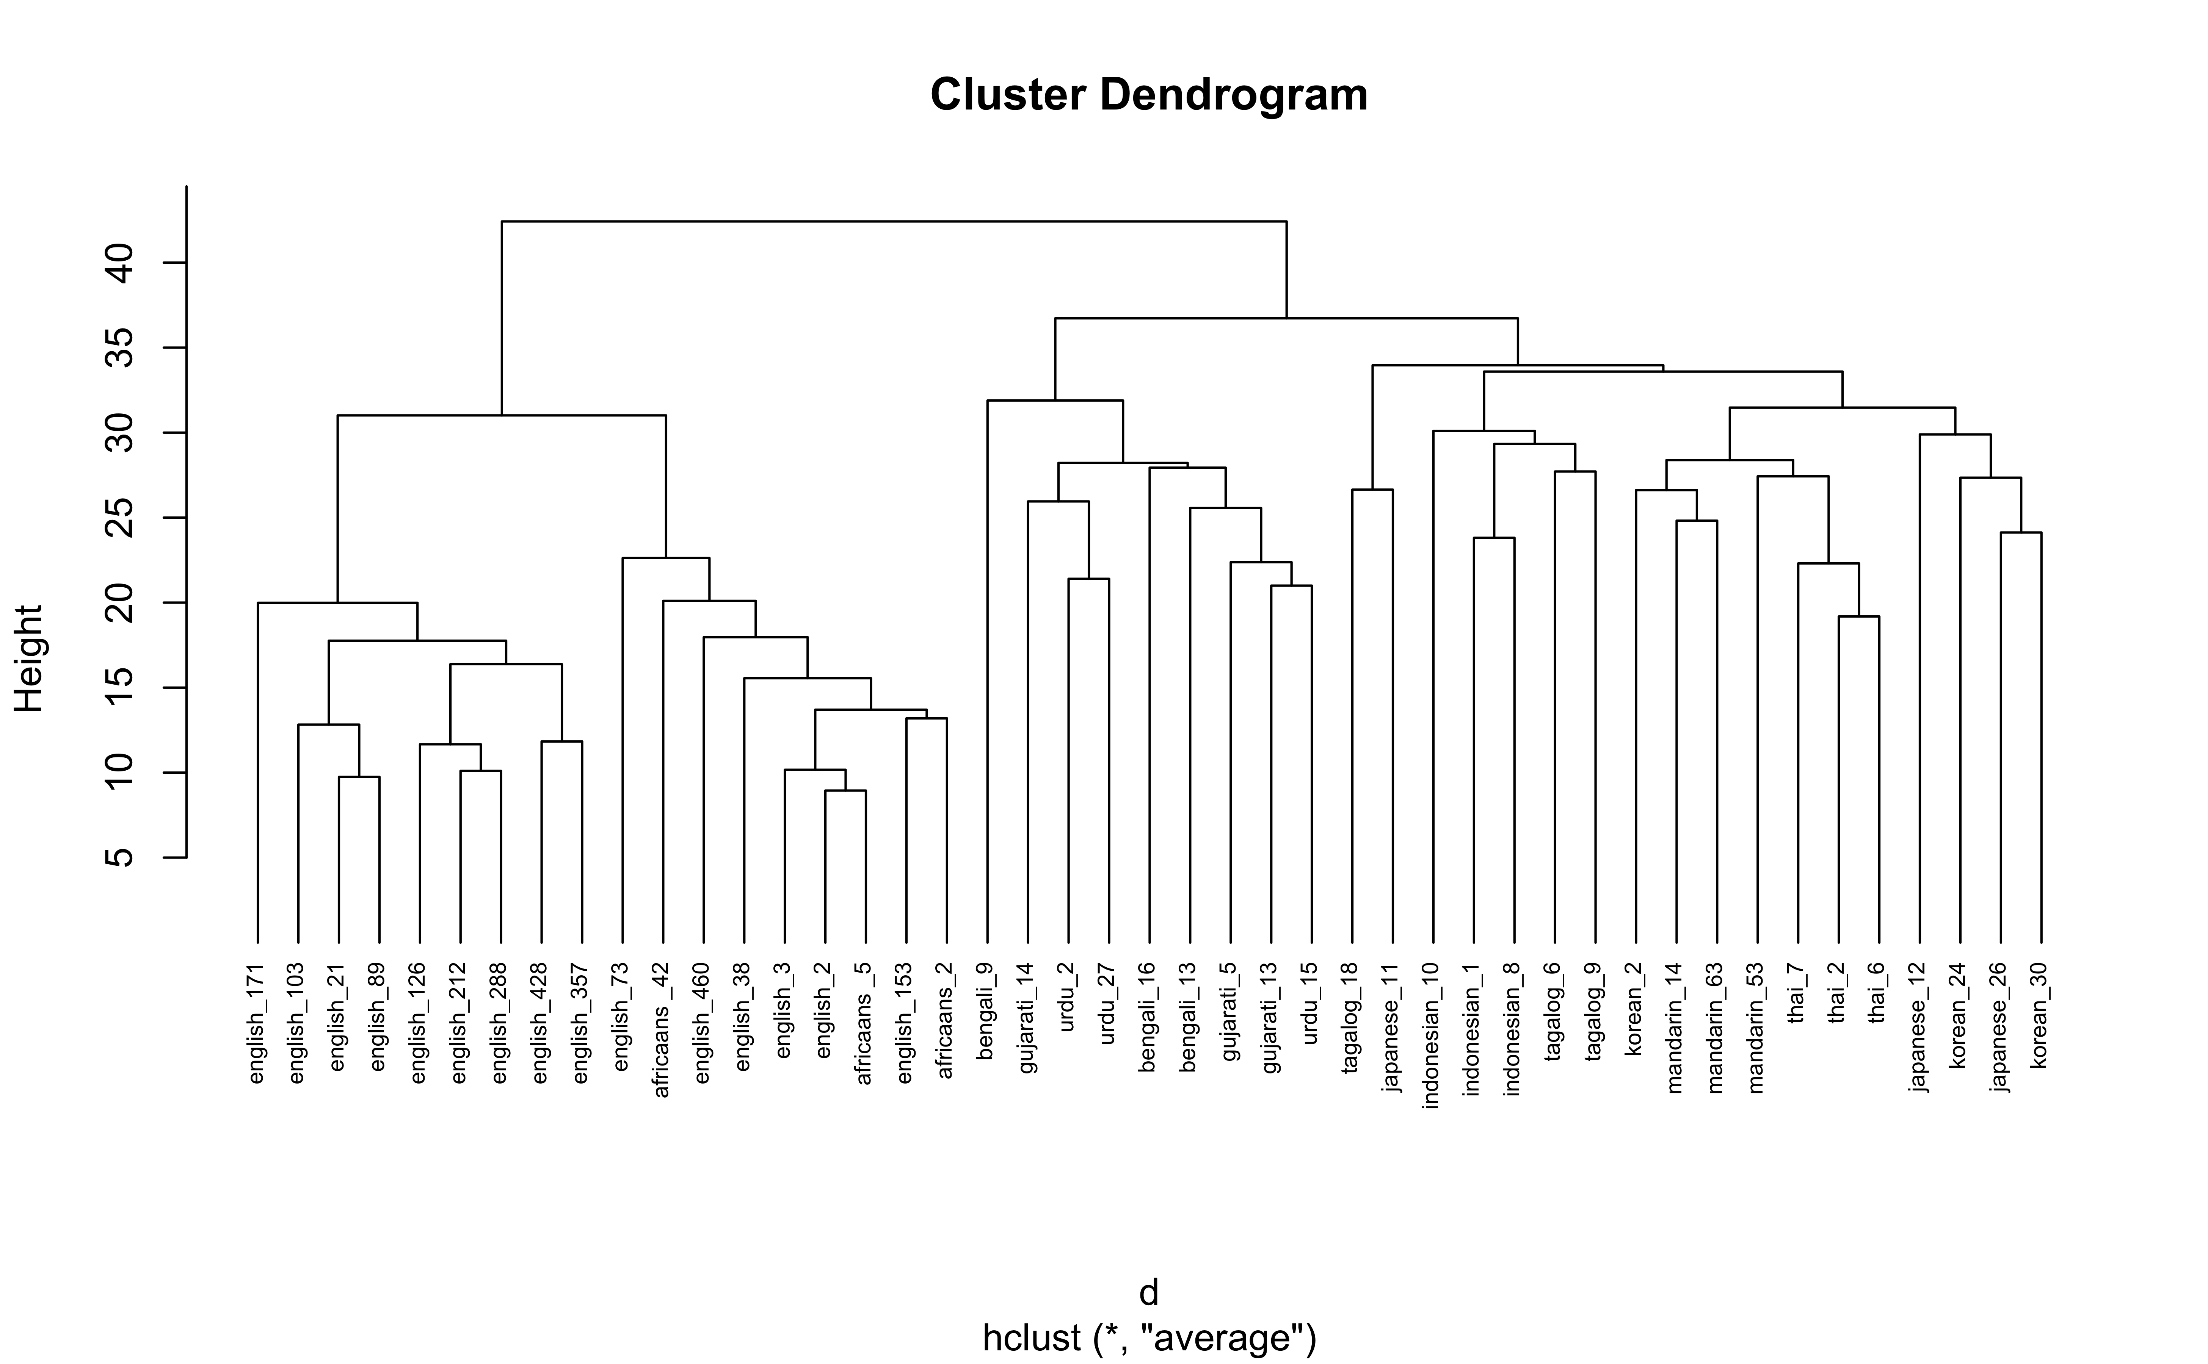

In the dendrogram displayed above, each leaf corresponds to one observation. As we move up the tree, observations that are similar to each other are combined into branches, which are themselves fused at a higher height.

The height of the fusion, provided on the vertical axis, indicates the (dis)similarity between two observations. The higher the height of the fusion, the less similar the observations are. Note that, conclusions about the proximity of two observations can be drawn only based on the height where branches containing those two observations first are fused. We cannot use the proximity of two observations along the horizontal axis as a criteria of their similarity.

The height of the cut to the dendrogram controls the number of clusters obtained. It plays the same role as the k in k-means clustering. In order to identify sub-groups (i.e. clusters), we can cut the dendrogram with cutree:

# Ward's method  
hc5 <- hclust(d, method = "average" )  
  
# Cut tree into 4 groups  
sub_grp <- cutree(hc5, k = 3)  
  
# Number of members in each cluster  
table(sub_grp)

> sub_grp  
> 1 2 3   
> 9 18 18

## sub_grp  
## 1 2 3 4   
## 7 12 19 12

### 2.1.4 Visualize clusters on dendrogram

plot(hc5, cex = 0.6)  
rect.hclust(hc5, k = 3, border = 2:5)

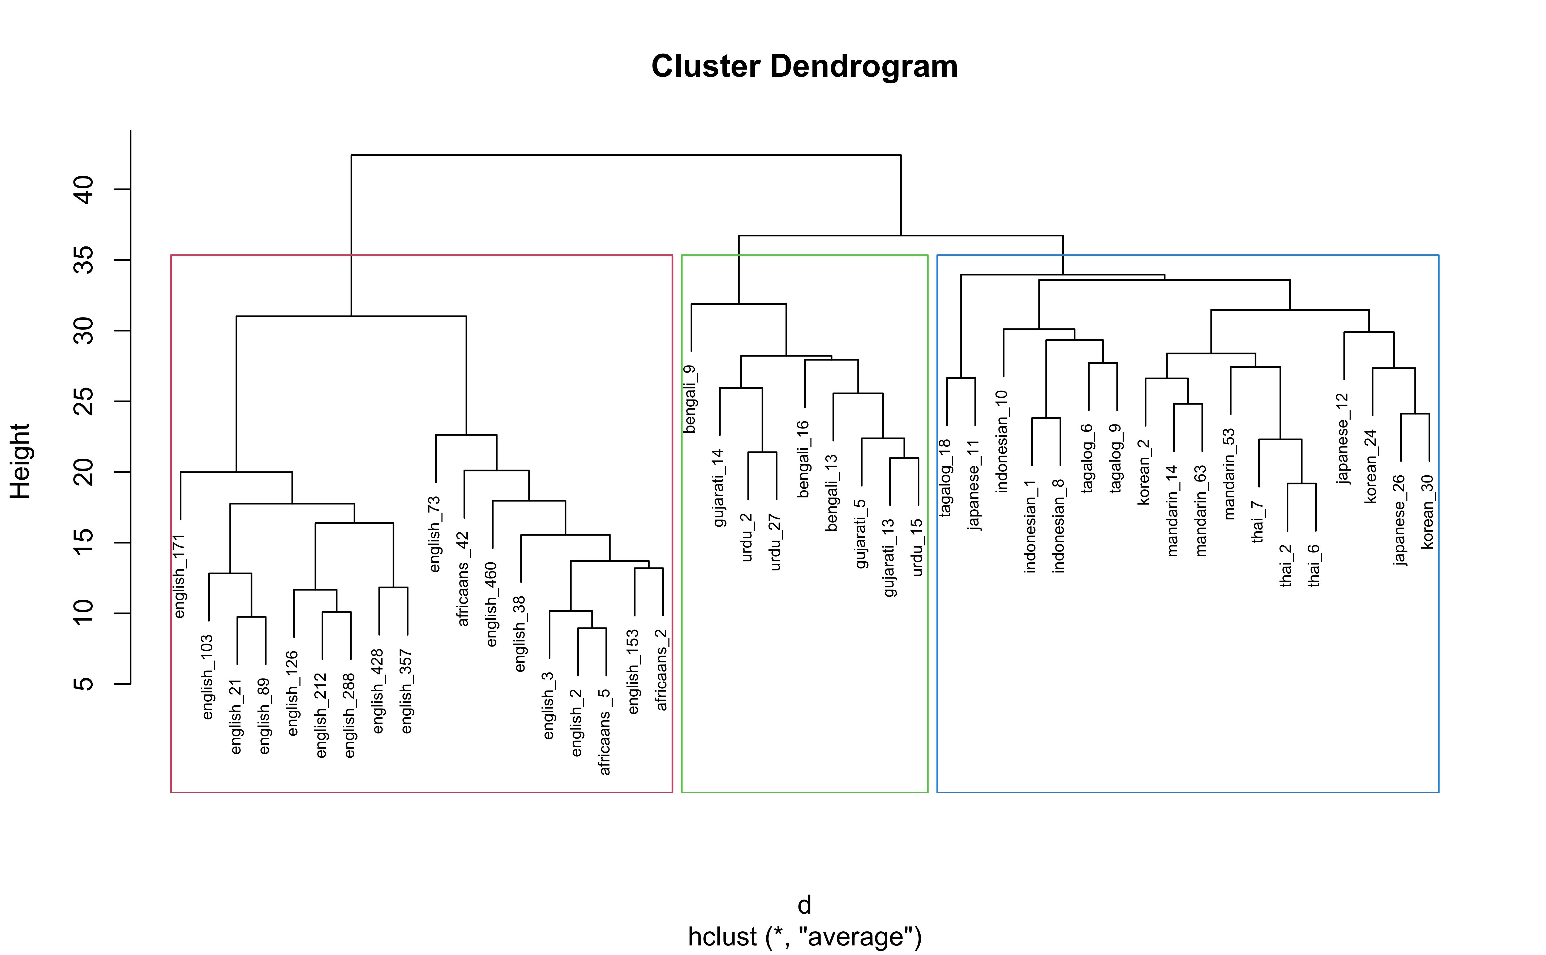

From this, we glean that 3 clusters seem to be adequate. Generally participants groups speakers into 3 clusters/groups:

* English/African into clust 1
* Indo/European into clust 2
* Asian into clust 3

clust_data <- clust_data %>%  
 mutate(cluster = sub_grp)

fviz_cluster(list(data = clust_data, cluster = sub_grp))

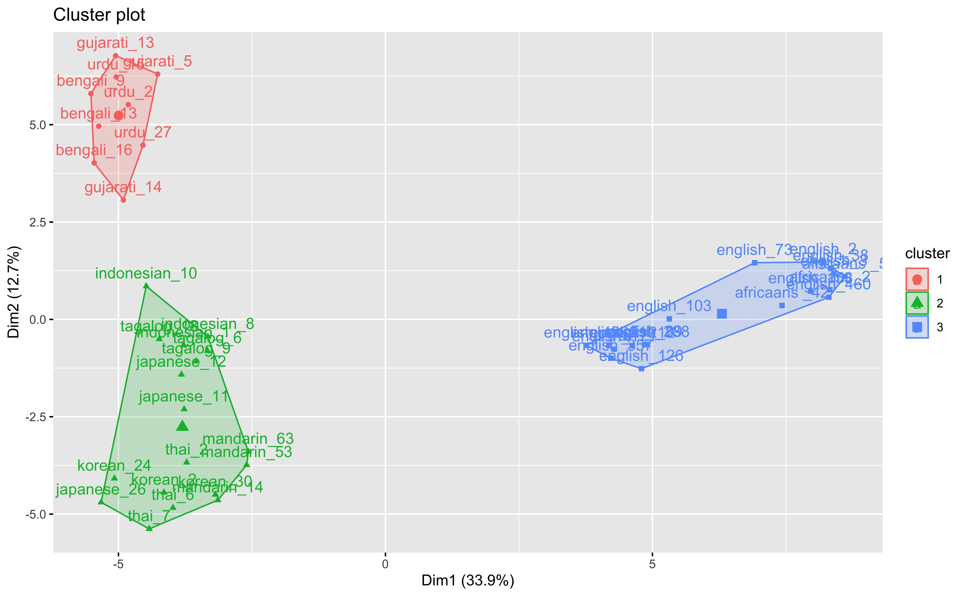

# 3 Full Code

The full script of executive code contained in this document is reproduced here.

# Set up the environment (or use local alternative `source("utils/config.R")`)  
source("https://raw.githubusercontent.com/RealityBending/TemplateResults/main/utils/config.R")   
  
fast <- FALSE # Make this false to skip the chunks  
library(easystats)  
  
summary(report::report(sessionInfo()))  
df <- read_csv("data/class_wide_1.csv")  
report::cite_packages(sessionInfo())  
library(here)  
library(tidyverse) # data manipulation  
library(cluster) # clustering algorithms  
library(factoextra) # clustering visualization  
library(dendextend) # for comparing two dendrograms  
  
  
clust_data <- read_csv(here("data", "class_wide_1.csv")) # read in data  
  
clust_data <- select(clust_data, -X1, -`54`) # remove extra col sub 54 has weird formatting  
  
clust_data <- as.data.frame(clust_data) # turn into df   
  
rownames(clust_data) <- clust_data$speaker # make row names speaker  
  
clust_data <- select(clust_data,-speaker) # remove extra col sub 54 has weird formatting  
  
head(clust_data)# show first couple rows  
  
# Dissimilarity matrix  
d <- dist(clust_data, method = "euclidean")  
  
# Hierarchical clustering using Average Linkage  
hc1 <- hclust(d, method = "average" )  
  
# Plot the obtained dendrogram  
plot(hc1, cex = 0.6, hang = -1)  
  
  
# Ward's method  
hc5 <- hclust(d, method = "average" )  
  
# Cut tree into 4 groups  
sub_grp <- cutree(hc5, k = 3)  
  
# Number of members in each cluster  
table(sub_grp)  
## sub_grp  
## 1 2 3 4   
## 7 12 19 12  
  
plot(hc5, cex = 0.6)  
rect.hclust(hc5, k = 3, border = 2:5)  
  
  
clust_data <- clust_data %>%  
 mutate(cluster = sub_grp)  
  
fviz_cluster(list(data = clust_data, cluster = sub_grp))

# 4 Package References

report::cite_packages(sessionInfo())

* Alboukadel Kassambara and Fabian Mundt (2020). factoextra: Extract and Visualize the Results of Multivariate Data Analyses. R package version 1.0.7. <https://CRAN.R-project.org/package=factoextra>
* Ben-Shachar, Makowski & Lüdecke (2020). Compute and interpret indices of effect size. CRAN. Available from <https://github.com/easystats/effectsize>.
* H. Wickham. ggplot2: Elegant Graphics for Data Analysis. Springer-Verlag New York, 2016.
* Hadley Wickham (2019). stringr: Simple, Consistent Wrappers for Common String Operations. R package version 1.4.0. <https://CRAN.R-project.org/package=stringr>
* Hadley Wickham (2020). forcats: Tools for Working with Categorical Variables (Factors). R package version 0.5.0. <https://CRAN.R-project.org/package=forcats>
* Hadley Wickham (2020). tidyr: Tidy Messy Data. R package version 1.1.2. <https://CRAN.R-project.org/package=tidyr>
* Hadley Wickham, Jim Hester and Romain Francois (2018). readr: Read Rectangular Text Data. R package version 1.3.1. <https://CRAN.R-project.org/package=readr>
* Hadley Wickham, Romain François, Lionel Henry and Kirill Müller (2021). dplyr: A Grammar of Data Manipulation. R package version 1.0.3. <https://CRAN.R-project.org/package=dplyr>
* JJ Allaire and Yihui Xie and Jonathan McPherson and Javier Luraschi and Kevin Ushey and Aron Atkins and Hadley Wickham and Joe Cheng and Winston Chang and Richard Iannone (2021). rmarkdown: Dynamic Documents for R. R package version 2.6.6. URL <https://rmarkdown.rstudio.com>.
* Kirill Müller (2017). here: A Simpler Way to Find Your Files. R package version 0.1. <https://CRAN.R-project.org/package=here>
* Kirill Müller and Hadley Wickham (2021). tibble: Simple Data Frames. R package version 3.0.6. <https://CRAN.R-project.org/package=tibble>
* Lionel Henry and Hadley Wickham (2020). purrr: Functional Programming Tools. R package version 0.3.4. <https://CRAN.R-project.org/package=purrr>
* Lüdecke D, Ben-Shachar M, Patil I, Makowski D (2020). “parameters:Extracting, Computing and Exploring the Parameters of Statistical Modelsusing R.” *Journal of Open Source Software*, *5*(53), 2445. <doi:10.21105/joss.02445> (URL: <https://doi.org/10.21105/joss.02445>).
* Lüdecke D, Waggoner P, Makowski D (2019). “insight: A Unified Interface toAccess Information from Model Objects in R.” *Journal of Open SourceSoftware*, *4*(38), 1412. doi: 10.21105/joss.01412 (URL:<https://doi.org/10.21105/joss.01412>).
* Lüdecke, Ben-Shachar, Waggoner & Makowski (2020). Visualisation Toolbox for ‘easystats’ and Extra Geoms, Themes and Color Palettes for ‘ggplot2.’ CRAN. Available from <https://easystats.github.io/see/>
* Lüdecke, Makowski, Waggoner & Patil (2020). Assessment of Regression Models Performance. CRAN. Available from <https://easystats.github.io/performance/>
* Maechler, M., Rousseeuw, P., Struyf, A., Hubert, M., Hornik, K.(2021). cluster: Cluster Analysis Basics and Extensions. R package version 2.1.1.
* Makowski, D., Ben-Shachar, M. S. & Lüdecke, D. (2020). *Estimation of Model-Based Predictions, Contrasts and Means*. CRAN.
* Makowski, D., Ben-Shachar, M. S. & Lüdecke, D. (2020). *The {easystats} collection of R packages*. GitHub.
* Makowski, D., Ben-Shachar, M. S., Patil, I., & Lüdecke, D. (2019). Methods and Algorithms for Correlation Analysis in R. Journal of Open Source Software, 5(51), 2306. 10.21105/joss.02306
* Makowski, D., Ben-Shachar, M., & Lüdecke, D. (2019). bayestestR: Describing Effects and their Uncertainty, Existence and Significance within the Bayesian Framework. Journal of Open Source Software, 4(40), 1541. <doi:10.21105/joss.01541>
* Makowski, D., Lüdecke, D., & Ben-Shachar, M.S. (2020). Automated reporting as a practical tool to improve reproducibility and methodological best practices adoption. CRAN. Available from <https://github.com/easystats/report>. doi: .
* R Core Team (2020). R: A language and environment for statistical computing. R Foundation for Statistical Computing, Vienna, Austria. URL <https://www.R-project.org/>.
* Tal Galili (2015). dendextend: an R package for visualizing, adjusting, and comparing trees of hierarchical clustering. Bioinformatics. DOI: 10.1093/bioinformatics/btv428
* Wickham et al., (2019). Welcome to the tidyverse. Journal of Open Source Software, 4(43), 1686, <https://doi.org/10.21105/joss.01686>

# 5 References