PORTFOLIO DOCS
Audience

The audience for the portfolio website is primarliy that of potential employers or recruiters. Therefore it needed to be a mix of simplicity, while also demonstrating some skill in the use of html, css and some javascript.

Design Decisions

The design went through a few iterations. I ended up using three colours – white, dark cyan and a slightly transparent black. This kept the pages not too busy with a keen focus on content. I attempted to illustrate a gallery on the home page which I found to be a somewhat unique way of showcasing my soon to be work. The home page also linked to simpler, more straightforward sub-pages if the user wished to get straight to the point.

Usability Heuristics

The design doesn’t distract the user from the point of the site, which is showcasing my portfolio work. I believe it is quite simple to figure out how to navigate the page and find what they are looking for without any confusion.

Wireframes

I spent a few hours getting the wireframing right which I think helped a lot in the process of building the site as I didn’t have to think too much about design and could focus on the implementation. That being said, I did end up changing some things as I went.

Home Page
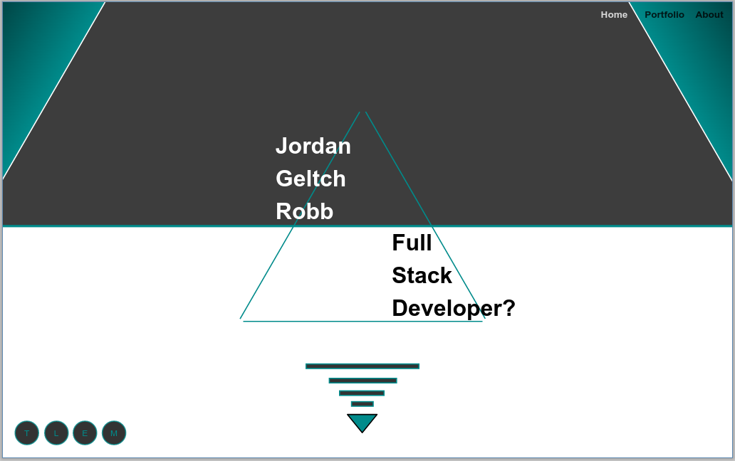

Portfolio Page

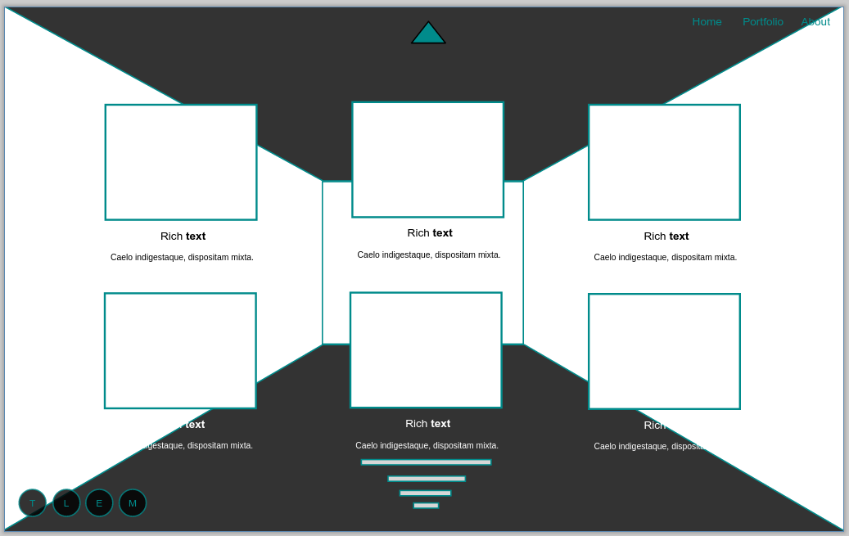

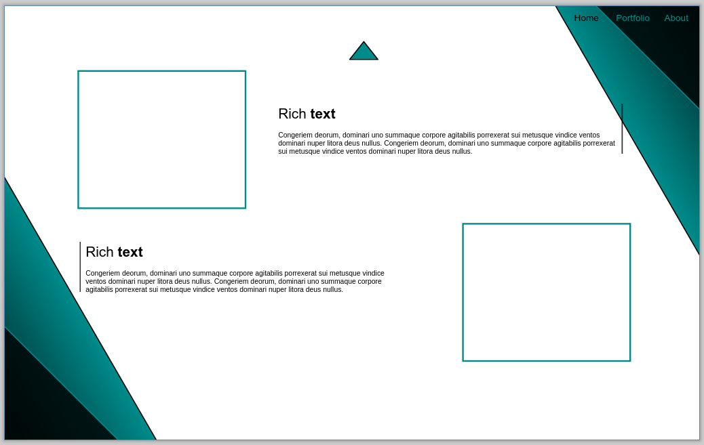
About Page

Style Guide

For the general style I went with minimal round edges to keep with the theme of the triangle logo. Everything on an angle was 60 degrees to match the triangle. I only put some slight rounded edges on the buttons and gthub and linked in images to offset the totally angular look. For the headings I always used a slanded sans serif font. For the paragraphs I offset that with a basic serif font. For colours I kept it simple, white, black with an 80% opacity, and a dark cyan which I think had a nice effect. I used pinterest to mood board and found these colours appealed to me and as it’s a website about me, I thought it fitting.

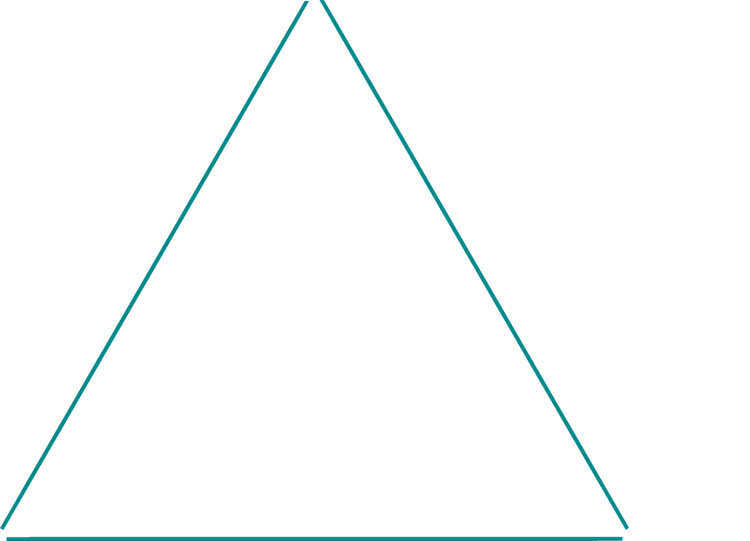
Personal Logo

Im not a great designer so I figured I’d just keep it simple for now!

