# **ClustSnow**

*Version 4.0  
Author: Joschka Geissler  
Last modified: 25 January 2025*

## **Background**

This documentation introduces the required steps for applying the ClustSnow model. ClustSnow allows the determination of snow distribution patterns from spatially distributed, multitemporal snow depth maps. ClustSnow is implemented in R (Version 4.1.0) and requires the following libraries to be installed:

Table 1: R-packages required for running the ClustMod model

|  |  |  |
| --- | --- | --- |
| **Name** | **Version** | **Literature** |
| raster | 3.4-13 | Hijmans (2021) |
| stringr | 1.5.0 | Wickham (2009) |
| caret | 6.0-88 | Kuhn (2008) |
| nixmass | 1.0.2 | Winkler et al. (2021) |

The ClustSnow workflow, introduced by Geissler et al. (2023) and Geissler et al. (2024) derives daily snow depth (HS) and snow water equivalent (SWE) maps based on observations. LiDAR HS maps are used to derive spatial clusters, thus areas exhibiting similar snow dynamics using the getCluster() function. These clusters can be ordered according to their mean snow depth using the orderCluster() funciotn. Daily synthetic HS time series for each clusters are generated by a probability-based merging of observed snow depth time series using ths hs.synth() function. Using the delta.swe model, the synthetic HS time series are converted to synthetic SWE time series. Based on the spatial clusters, the synthetic time series are extrapolated into space to create spatiotemporally continous maps of SWE and HS (createMap()-Function). SWE maps are only derived if the time series are continous and snow depth time series start with 0 m.

Please mind the directory structure required.

Ein Bild, das Text, Screenshot, Design enthält.

Required Input data and format:

## **Time series**

Name: hs_time_series.csv  
Seperator: ;  
Delimiter: .

Please indicate the date format in the R-script.

[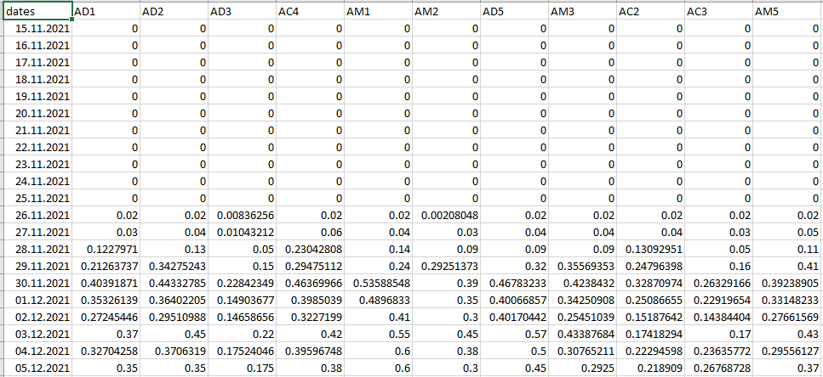](https://user-images.githubusercontent.com/132678556/236829160-d806ac74-130c-4aef-ac0c-e28c4d777bb8.png)

# Sensor Locations

Shapefile containing all sensor locations. Please indicate the name of the attribute containing the sensor ids in the data input section of the R-Script. Sensor ids must correspond to the header of the time series.

Name: hs_sensor_location.shp

## **HS maps**

Raster stack containing spatial maps of snow depth, acquired for instance with UAV-based LiDAR.

Name: hs_raster_stack.tif

############################################################################

# **CloudCompare_CoregisterLiDAR.R**

Co-Registration of LiDAR-derived point clouds using Cloud Compare Command Line Mode.

Wrapper Script for running the Co-Registration Workflow in R.

Note: Directories, AOI and filtering thresholds need to be adapted to the individual dataset.

More Info: Geissler et al. (2023)

###################################################

References

Geissler, J., Mazzotti, G., Rathmann, L., Webster, C., & Weiler, M. (2024). *ClustSnow: Utilizing temporally persistent forest snow patterns under variable environmental conditions.* https://doi.org/10.22541/essoar.172222597.78203131/v1

Geissler, J., Rathmann, L., & Weiler, M. (2023). Combining Daily Sensor Observations and Spatial LiDAR Data for Mapping Snow Water Equivalent in a Sub‐Alpine Forest. *Water Resources Research*, *59*(9), Article e2023WR034460. https://doi.org/10.1029/2023WR034460

Hijmans, R. J. (2021). *raster: Geographic Data Analysis and Modeling* [Software]. https://CRAN.R-project.org/package=raster

Kuhn, M. (2008). Building Predictive Models in R Using the caret Package. *Journal of Statistical Software*, *28*(5). https://doi.org/10.18637/jss.v028.i05

Wickham, H. (2009). *stringr: CRAN Contributed Packages* [Software]. https://doi.org/10.32614/CRAN.package.stringr

Winkler, M., Schellander, H., & Gruber, S. (2021). Snow water equivalents exclusively from snow depths and their temporal changes: the Δsnow model. *Hydrology and Earth System Sciences*, *25*(3), 1165–1187. https://doi.org/10.5194/hess-25-1165-2021