Chapter 1
INTRODUCTION

Chapter 1: Introduction
Wireless sensor networks hold great promise as an enabling technology for a variety of applications, including data collection and event detection. Advances in wireless networking, micro-fabrication and integration for example, sensors and actuators manufactured using micro-electromechanical system technology, (MEMS), and embedded microprocessors have enabled a new generation of massive-scale sensors networks suitable for a range of commercial and military applications. Designing, implementing, and operating a wireless sensor network involves a wide range of disciplines and many application-specific constraints. To pan out and take advantage of these systems, a holistic approach is needed and this is precisely what Wireless Sensor Networks delivers. With such technological advances come new challenges for information processing in sensor networks. What is needed are novel computational representation, algorithms and protocols and design methodologies, and tools to support distributed signal processing ,information storage and management, networking, and application development[1].
Consequently, a flurry of research activity has recently commenced in the sensor network domain, especially in wireless ad-hoc sensor networks. Sensors are equipped with wireless interfaces with which they can communicate with one another to form a network. These sensors are small, with limited processing and computing resources, and they are inexpensive compared to traditional sensors. They can sense, measure, and gather information from the environment and, based on some local decision process, they can transmit the sensed data to the user. Smart sensor nodes are low power devices equipped with one or more sensors, a processor, memory, a power supply, a radio, and an actuator. The network is ad hoc because it is decentralized and does not rely on a preexisting infrastructure, such as routers in wired networks or access points in managed (infrastructure) wireless networks. Instead, each node participates in routing by forwarding data for other nodes, and so the determination of which nodes forward data is made dynamically based on the network connectivity.
The various applications where WSN can be applied are in indoor/outdoor environmental monitoring, health and wellness monitoring, power monitoring, inventory location monitoring, factory and process automation, and seismic and structural monitoring, and tracking objects such as animals, humans, and vehicles [2].
1.1 Problem statement
Despite the tremendous potentials and its numerous advantages namely distributed localized computing, communication in which failure of one part of the network does not affect the operation in other part of the network, longer area coverage, extreme environment area monitoring, WSNs pose various challenges to research community.
Furthermore, the hop distance strategy in Wireless Sensor Networks (WSNs) has a major impact on energy consumption of each sensor node. Long-hop routing minimizes reception cost. However, a substantial power demand is incurred for long distance transmission. Since the transceiver is the major source of power consumption in the node, optimizing the routing for hop length can extend significantly the lifetime of the network.
Sensor nodes are considered to be homogeneous since the researches in the field of WSNs have been evolved, but in reality, homogeneous sensor networks hardly exist. Even homogeneous sensors have different capabilities like different levels of initial energy, depletion rate, etc. In heterogeneous sensor networks, typically, a large number of inexpensive nodes perform sensing, while a few nodes having comparatively more energy than the rest perform data filtering, fusion and transport.
This leads to the research on heterogeneous networks where two or more types of nodes are considered. The lifetime and reliability of the network can be improved by heterogeneity in wireless sensor networks. Heterogeneous sensor networks are very much useful in real deployments because they are more close to real life situations. Most of the recent energy efficient protocols designed for heterogeneous networks are based on the clustering technique, which are effective in scalability and energy saving for WSNs.
1.2 Objectives
The major objective of this project is to extend the network lifetime and to increase the time of the first dead node in the network or to increase the stability time in the network by using concepts of concentric clustering and k-theorem technique for cluster head selection. During Cluster Head selection, a k-theorem approach is used where depending upon the node density a set of nodes are chosen for cluster head selection.
By using two types of nodes namely normal nodes and advanced nodes where the latter has significantly more energy than the rest of the nodes in the network and can be used for large distance communication to the Base Station located at a considerable distance, the network of the lifetime can be extended by a suitable amount.
By dividing the network into concentric regions based on the position of advanced node, a zone based division approach can be implemented through which we can increase the stability period of the sensor nodes in the network.
1.3 Current Scope
Energy Efficiency oriented routing protocols in Heterogeneous Wireless Sensor Networks (HWSN) focus mainly on achieving maximized network lifetime [3]. Since the network is energy constrained, efficient usage of limited energy results in longer network lifetime. There are various ways to conserve energy of the nodes and clustering is one of them. In Low Energy Adaptive Clustering Hierarchy (LEACH) the nodes are grouped into clusters and led by a cluster head. Most of the available energy efficiency oriented routing protocols focus on modifying the probabilistic equation for selecting the cluster head in order to induce energy parameters in it rather than to be depending plainly on heuristic probability.
In Stable Election Protocol [SEP], the protocol mainly aims at increasing the stability time of the network or rather to delay the time for the first dead node in the network. SEP was a breakthrough protocol as it proved to be better than others in terms of stability. However the instability period which is the time between the death of first sensor node in the network and the time of the last dead node in the network was found to be very low. This project aims at bridging the gap between the stability and energy efficient protocols in a HWSN. This can be achieved by increasing both the stability and instability period of the network.
1.4 Future Scope
This project proposes a methodology to improve the stability and the instability period in the network. There is scope for improving to yield more precise results. The strategy used to form concentric circular regions can be researched upon more. We also present a equation to choose a Cluster Head from a candidate set of nodes. The parameters used in the equation can vary depending on the application. This equation used could also be enhanced in the future

Chapter 2
LITERATURE SURVEY

Chapter 2: Literature Survey
A wireless sensor networks (WSN) consist of a large number of sensors, these sensor nodes are either placed carefully or randomly deployed over a geographical area and networked through wireless links to form a WSN. These sensor nodes measure ambient condition in the surrounding environment that can be processed to reveal the characteristics of the phenomena occurring at the location where the sensor nodes are deployed.
Each sensor node in WSN is capable of communicating with each other and the base station (BS) for the purpose of data integration and dissemination. WSN are used mainly in military, civilian and for industrial applications. WSNs applications in the military field include battlefield surveillance, intrusion detection, target field and imaging. However, WSN are now used in many civilian application areas, including environment and habitat monitoring, health applications, home automation and traffic control.
WSN typically contains hundreds or thousands of sensor nodes which allows for sensing over larger geographical regions with greater accuracy. Each node has three basic components as shown in Figure 2.1.
- Sensing unit
- Processing unit
- Transmission unit
The node senses the data from the environment processes it and sends it to the base station. These nodes can either route the data to the base station or to other sensor nodes such that the data eventually reaches the base station. In most applications, sensor nodes are constraint in energy supply and communication bandwidth. These nodes are powered by irreplaceable batteries and hence network lifetime depends on the battery consumption. Innovative techniques are developed to efficiently use the limited energy and bandwidth resource. These techniques work by careful design and management at all layers of the networking protocol. For example, at the network layer, it is highly desirable to find methods for energy efficient route discovery and relaying of data from the sensor nodes to the Base Station (BS). So, the lifetime of the network is maximized.

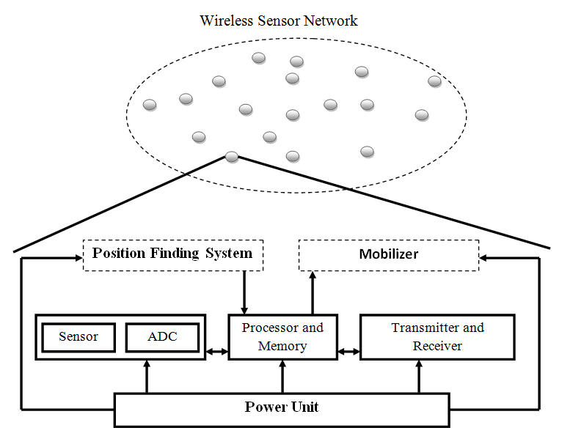
Figure 2.1: WSN and components of sensor node
2.2 Routing Protocols in Wireless Sensor Networks
Routing protocols in WSNs have a common objective of efficiently utilizing the limited resources of sensor nodes in order to extend the lifetime of the network. Different routing techniques can be adopted for different applications based on their requirements. Applications can be time critical or requiring periodic updates, they may require accurate data or long lasting, less precise network, they may require continuous flow of data or event driven output. Routing methods can even be enhanced and adapted for specific application.
Generally, there are two types of clustering schemes, the schemes which are applied to homogeneous networks where all the nodes have equal energy are called as homogeneous schemes and the clustering algorithms applied to heterogeneous networks are called as heterogeneous schemes. Clustering algorithms in Heterogeneous schemes are classified based on two main criterions: according to stability and energy efficiency. Selection of cluster head in energy efficient techniques generally depends on the initial energy, residual energy, and average energy of the network or energy consumption rate of combination of these. The stable election protocols for clustered Heterogeneous Wireless Sensor Networks (HWSN) prolong the time interval before the death of first node i.e. stability period. The classification of routing protocols in HWSN is shown in Figure 2.2.
i) Stability Oriented Clustering Protocols for Heterogeneous Wireless Sensor Networks: The Protocols in this classification increase the stability period of the wireless sensor networks. Stability period is actually the time interval before the death of the first node. It is very important for the applications where the response from the sensor nodes must be reliable. The common protocols in this classification are SEP [7], EDFCM [12], Base-station initiated clustering and ZREECR [8].
Routing Protocols in HWSN

Stability Oriented
Energy Efficiency oriented
1.SEP
2.EDFCM
3.ZREECR
1.EEHC
2.DEEC
3.DBEC

Figure 2.2: Classification of routing protocols in HWSNs
ii)Energy Efficient Clustering Protocol for HWSNs: The concept of cluster based routing is also utilized to perform energy efficient routing in WSNs. Efficient organization of sensor nodes into clusters is useful in reducing energy consumption in WSNs. Many energy-efficient routing protocols are designed based on the clustering structure of the HWSNs. Each clustering algorithm has mainly two phases: the cluster setup phase and steady state phase. For heterogeneous WSNs, a very critical task for clustering protocols is to select the cluster head so that least energy is consumed, and hence prolong the lifetime. The various protocols in this classification are Energy Efficient Heterogeneous Clustered scheme for wireless sensor networks (EEHC), Design of a distributed energy-eﬃcient clustering algorithm for heterogeneous wireless sensor networks (DEEC) [11], Stochastic Distributed Energy-Efficient Clustering (SDEEC) [14] and Cluster-based Service Discovery for Heterogeneous Wireless Sensor Networks (C4SD) [15].
2.2 Challenges of routing protocols
Node deployment in WSNs is application-dependent and can be either manual (deterministic) or randomized. In manual deployment, the sensors are manually placed and data is routed through predetermined paths. However, in random node deployment, the sensor nodes are scattered randomly, creating an ad hoc routing infrastructure. If the resultant distribution of nodes is not uniform, optimal clustering becomes necessary to allow connectivity and enable energy-efficient network operation. Inter-sensor communication is normally within short transmission ranges due to energy and bandwidth limitations. Therefore, it is most likely that a route will consist of multiple wireless hops.
Sensor nodes can use up their limited supply of energy performing computations and transmitting information in a wireless environment. As such, energy-conserving forms of communication and computation are essential. Sensor node lifetime shows a strong dependence on battery lifetime. In a multi-hop WSN, each node plays a dual role as data sender and data router. The malfunctioning of some sensor nodes due to power failure can cause significant topological changes, and might require re-routing of packets and reorganization of the network.
Data reporting in WSNs is application-dependent and also depends on the time criticality of the data. Data reporting can be categorized as either time-driven, event driven, query-driven, or a hybrid of all these methods. The time-driven delivery method is suitable for applications that require periodic data monitoring. As such, sensor nodes will periodically switch on their sensors and transmitters, sense the environment, and transmit the data of interest at constant periodic time intervals [4]. In event-driven and query-driven methods, sensor nodes react immediately to sudden and drastic changes in the value of a sensed attribute due to the occurrence of a certain event, or respond to a query generated by the BS or another node in the network [5]. As such, these are well suited to time-critical applications. A combination of the previous methods is also possible. The routing protocol is highly influenced by the data reporting method in terms of energy consumption and route calculations.
In many studies, all sensor nodes were assumed to be homogeneous (i.e., have equal capacity in terms of computation communication, and power). However, depending on the application a sensor node can have a different role or capability. The existence of a heterogeneous set of sensors raises many technical issues related to data routing. For example, some applications might require a diverse mixture of sensors for monitoring temperature, pressure, and humidity of the surrounding environment, detecting motion via acoustic signatures, and capturing images or video tracking of moving objects. Either these special sensors can be deployed independently or the different functionalities can be included in the same sensor nodes. Even data reading and reporting can be generated from these sensors at different rates, subject to diverse QoS constraints, and can follow multiple data reporting models. For example, hierarchical protocols designate a cluster head node different from the normal sensors. These cluster heads can be chosen from the deployed sensors or be more powerful than other sensor nodes in terms of energy, bandwidth, and memory. Hence, the burden of transmission to the BS is handled by the set of cluster heads.
Some sensor nodes may fail or be blocked due to lack of power, physical damage, or environmental interference. The failure of sensor nodes should not affect the overall task of the sensor network. If many nodes fail, medium access control (MAC) and routing protocols must accommodate formation of new links and routes to the data collection BSs. This may require actively adjusting transmit powers and signaling rates on the existing links to reduce energy consumption, or re-routing packets through regions of the network where more energy is available. Therefore, multiple levels of redundancy may be needed in a fault-tolerant sensor network.
The number of sensor nodes deployed in the sensing area may be on the order of hundreds or thousands, or more. Any routing scheme must be able to work with this huge number of sensor nodes. In addition, sensor network routing protocols should be scalable enough to respond to events in the environment. Until an event occurs, most sensors can remain in the sleep state, with data from the few remaining sensors providing coarse quality.
In many studies, sensor nodes are assumed fixed. However, in many applications both the BS or sensor nodes can be mobile. As such, routing messages from or to moving nodes is more challenging since route and topology stability become important issues, in addition to energy, bandwidth, and so forth. Moreover, the phenomenon can be mobile (e.g. a target detection/ tracking application). On the other hand, sensing fixed events allows the network to work in a reactive mode (i.e., generating traffic when reporting), while dynamic events in most applications require periodic reporting to the BS.
In a multi-hop sensor network, communicating nodes are linked by a wireless medium. The traditional problems associated with a wireless channel (e.g., fading, high error rate) may also affect the operation of the sensor network. In general, the required bandwidth of sensor data will be low, on the order of 1–100 kb/s. Related to the transmission media is the design of MAC. One approach to MAC design for sensor networks is to use time-division multiple access (TDMA)-based protocols that conserve more energy than contention-based protocols like carrier sense multiple access (CSMA) (e.g., IEEE 802.11). Bluetooth technology can also be used.
High node density in sensor networks precludes them from being completely isolated from each other. Therefore, sensor nodes are expected to be highly connected. This, however, may not prevent the network topology from being variable and the network size from shrinking due to sensor node failures. In addition, connectivity depends on the possibly random distribution of nodes. In WSNs, each sensor node obtains a certain view of the environment. A given sensor’s view of the environment is limited in both range and accuracy; it can only cover a limited physical area of the environment. Hence, area coverage is also an important design parameter in WSNs.
Since sensor nodes may generate significant redundant data, similar packets from multiple nodes can be aggregated to reduce the number of transmissions. Data aggregation is the combination of data from different sources according to a certain aggregation function (e.g., duplicate suppression, minima, maxima, and average). This technique has been used to achieve energy efficiency and data transfer optimization in a number of routing protocols. Signal processing methods can also be used for data aggregation. In this case, it is referred to as data fusion where a node is capable of producing a more accurate output signal by using some techniques such as beam forming to combine the incoming signals and reducing the noise in these signals.
In some applications, data should be delivered within a certain period of time from the moment it is sensed, or it will be useless. Therefore, bounded latency for data delivery is another condition for time-constrained applications. However, in many applications, conservation of energy, which is directly related to network lifetime, is considered relatively more important than the quality of data sent. As energy is depleted, the network may be required to reduce the quality of results in order to reduce energy dissipation in the nodes and hence lengthen the total network lifetime. Hence, energy-aware routing protocols are required to capture this requirement.
2.3 Low Energy Adaptive Clustering Hierarchy (LEACH)
Low Energy adaptive clustering hierarchy (LEACH) [6] is a popular energy efficient adaptive clustering algorithm that forms node clusters based on the received signal strength. The cluster head (CH) aggregates the sensed data from all transmits it to the BS as shown in figure 5. Leach assumes that the base station is immobile and is located far from the sensors.. At any point of time, all the nodes have data to send and nodes located close to each other have co-related data. The cluster head (CH) can perform data aggregation and data dissemination as shown in Figure 2.3.
In leach the nodes form local clusters with one of the nodes acting as a local sink or cluster head. If the same node would remain as the cluster head throughout the working of the network, it would die quickly because of the extensive load from the participating sensors in the cluster. Hence the rotation of the cluster head in every round is necessary to distribute the load uniformly. Further energy dissipation can be reduced by aggregating the data from various sensor nodes at the cluster head. The operation of leach is broken up into rounds where each round begins with a setup phase, followed by a steady state phase.
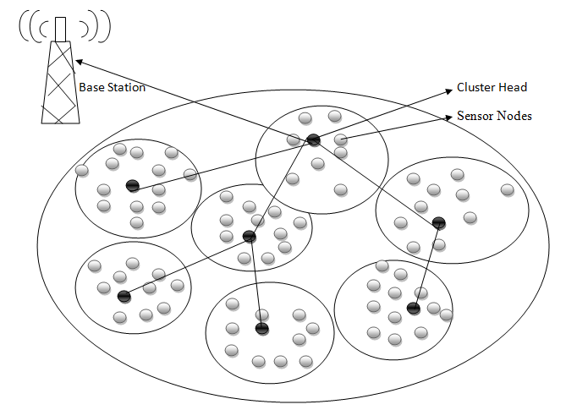
Figure 2.3: Clusters in WSN
The set up phase follows the following sequence
1. CH selection: Every round begins with a CH selection each node in the network decides whether to become the CH for the current round or not. Depending on the required percentage of cluster heads for the network and the number of times the node has been a cluster head. For any node n, the threshold equation for CH selection is given by,
Node i computes T(n) = P /(1- P * (r mod(1/P))_ ,if n € G
- ,otherwise
where, P is the desired percentage of CH, r is the current round and G is the set of nodes that have not been CH in the last 1/P rounds. Every node in G chooses a random number between 0 and 1 and if the number is less than the threshold value, it is selected as the CH for the current round.
2. Cluster Formation: Once the CHs have been selected, they advertise themselves to the remaining nodes. Based on the signal strength, the nodes decide which cluster to join.
3. Transmission Schedule Creation: Based on the number of nodes in the cluster, the CH allots different time slots for each node to transmit by adopting the basic time division multiple access (TDMA) scheduling.
In the steady state phase, the nodes transmit the sensed data to the CH and the CH aggregates the original data to carry only meaningful information. The aggregated data is then transmitted to the BS by CHs.
LEACH enhances the network lifetime by utilizing the resources efficiently, distributing the load uniformly, aggregating data at the CH to contain only the meaningful information, rotating the CH randomly to achieve balanced energy consumption. The main drawback of LEACH is that more energy is expedited as it involves one hop communication to the Cluster Head. Also, the sensors do not need to know the location or distance information. Depending on the applications, the different variations of LEACH such as LEACH-C (centralized), E-LEACH (enhanced) and M-LEACH (multi-hop) can be used.
2.4 Stable Election Protocol (SEP) for Clustered HWSNs:
Stable Election Protocol (SEP) [7] is a heterogeneity-aware protocol. It does not require energy knowledge sharing but is based on assigning weighted election probabilities of each node to be elected cluster head according to their respective energy. By using this approach, authors ensure that the cluster head is randomly selected based on the fraction of energy of each node; this assures that each nodes energy is uniformly used. In SEP, two types of nodes (normal and advanced) are considered. It is based on weighted election probabilities of each node to become cluster head according to the remaining energy in each node. This prolongs the stability period i.e. the time interval before the death of the first node. The problem that arises with the heterogeneity-oblivious protocols is that if the same threshold is set for both normal and advanced nodes then there is no guarantee that the number of cluster heads per round per epoch will be n × p_{opt}. SEP uses the following characteristic parameters of heterogeneity, namely the fraction of advanced nodes (m) and the additional energy factor between advanced and normal nodes (α). SEP talks about the fairness constraint on energy consumption i.e. advanced node get the chances to become the CH more often than the normal nodes. The solution of SEP is more applicable compared to any solution which assumes that each node knows the total energy of the network in order to adapt its election probability to become a cluster head according to its remaining energy. In this approach, a weight is assigned to the optimal probability p_{opt}. This weight must be equal to the initial energy of each node divided by the initial energy of the normal node. Let p_{nrm} and p_{adv} be the weighted election probability for normal nodes and the advanced nodes respectively. In order to maintain the minimum energy consumption, the average number of cluster heads per round per epoch must be constant and equal to n×p_{opt}. Virtually, there are n·(1+α·m) nodes with energy equal to the initial energy of a normal node. In the heterogeneous scenario, the average number of cluster heads per round per epoch is equal to n·(1 + α·m)·p_{nrm}. The weighed probabilities for normal and advanced nodes are, respectively: With help of these weighted probabilities thresholds for normal nodes and advanced node can be calculated. In most rounds, no cluster head is selected by SEP. In such rounds where no CH is selected, the data packets for normal nodes and the advanced nodes respectively. In order to maintain the minimum energy consumption, the average number of cluster heads per round per epoch must be constant and equal to n×p_{opt}. Virtually, there are n·(1+α·m) nodes with energy equal to the initial energy of a normal node. In the heterogeneous scenario, the average number of cluster heads per round per epoch is equal to n·(1 + α·m)·p_{nrm}. With help of these weighted probabilities thresholds for normal nodes and advanced node can be calculated. In most rounds, no cluster head is selected by SEP. In such rounds where no CH is selected, the data packets cannot be transmitted to the base station. This is a great disadvantage to the reliable transmission in the networks, especially for some important real-time transmission tasks.

2.5 Energy Efficient Concentric Clustering Scheme in Wireless Sensor Networks
Min-Woo Park, Jin-Young Choi, Yung-Ju Han and Tai-Myoung Chung proposed the Energy Efficient Concentric-Clustering Routing Scheme (EECCRS) [13] to overcome the problem of balancing energy dissipation in ECCRS. This scheme allocates a different number of sensor nodes to each cluster by considering energy dissipation of each cluster heads. As the simulation results, this scheme can obstruct the unbalance of energy dissipation of the cluster head. This scheme can better distribute energy dissipation among the whole networks better than the extended concentric-clustering routing scheme.
This scheme is a combination of Chain Based Routing scheme, Concentric-clustering routing scheme and Extended Concentric-clustering routing scheme. This scheme combated all the potential drawbacks and limitation of all the previous schemes. The goal of the scheme is to increase the efficiency of the data aggregation rate by decreasing the data size when data is aggregated. The main goal of the scheme was to distribute energy dissipation for extension of lifetime when the data aggregation efficiency is 0. The EECRS calculates the weight value for selection of cluster head. The weight value is in proportion to remaining energy of each sensor node and remaining average energy of the cluster. The weight value is inversely proportional the square of distance from the cluster head that is with the cluster head in the before level cluster. The weight is directly proportional to the average energy of all the nodes in the network and the residual energy of the node and is inversely proportional to distance to the next cluster head.
Every sensor node transmits data towards each cluster heads according to chains. The cluster head that is located at the last cluster transmits aggregated data to the next cluster head. Cluster head aggregates received data from the cluster head and sensor nodes in the same cluster. Then the cluster head transmits aggregated data to the next cluster head according to the chain. Thus every cluster head transmits sequentially towards the Base Station.

2.6 Zone-Based Residual Energy and Energy Consumption Rate
Li X. et al.[10] developed and analyzed a protocol based on residual energy and energy consumption rate (REECR). This protocol is an improvement of the previous work by the same authors. They presented the protocol based on the REECR rather than periodic rotation and stochastic election. REECR protocol was not perfect in balancing the energy and stability of network, so they proposed a zone based improvement of this REECR protocol, ZREECR (Zone-Based Residual Energy and Energy Consumption Rate). This protocol improves the stability period. The problem that is considered in this work is that the cluster head may be very near or very far from BS. In such a case, balancing the energy consumption is a very tough task and leads to instability. To solve this problem, the authors propose a zone based solution named ZREECR. This protocol divides the network into fixed-size zones, depending upon distance and orientation from base station. There are 12 fixed side zones that are shown in the Figure 2.4. It is expected that clusters near to the BS have smaller cluster sizes because CHs have to relay the data from the farther CHs to the BS. In this way CHs will save some significant amount of energy in intra-cluster data processing as well as inter-cluster relay traffic. The heterogeneous model of the network considers two type of node varying in energy; type_0 and type_1. In the first round the CHs are selected at geometric centers of the zones.
This avoids the situation of the very near and very far node to become CH. But in the second round the selection of the CH in each zone based on residual energy and energy consumption rate as follows:
Where P_{i}(t) is the possibility of each node to be selected as a cluster-head in each zone, and α are β weight coefficients. E_{i}(t) is the current residual energy of each node and Vi(t) is the energy consumption rate of each node. CHs collect the data from all sensor nodes in the network, aggregate it and send it to the BS. While forwarding the data to the BS every CH selects the closest CH in the direction of the BS. Although the authors presented an improvement in their work but this protocol is not energy efficient, compared to the previous one because the selection of the CH is done locally on zone level, and not on the network level; but on the other hand it is more stable than REECR.
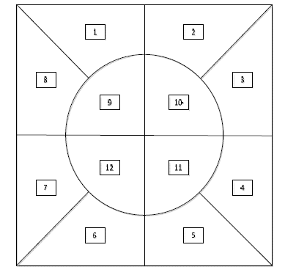
Figure 2.4: Classification of zones by ZREECR
2.7 Energy Balancing Through Cluster Head Selection Using K-Theorem in Homogeneous Wireless Sensor Networks
The proposed algorithm tends to balance energy in a cluster through energy efficient reliable cluster head selection. The objective of proposed algorithm is to improve the cluster head selection mechanism of LEACH. The operation of LEACH is divided into rounds. Each round consists of a setup phase and steady -state phase. In setup phase, coordinator node selects the cluster head for each cluster. In steady -state phase, sensor nodes sense the environment and transmit the sensed data to the corresponding Cluster Head for further onward transmission to the Coordinator Node and Base Station.
The philosophy behind the K-theorem is to select a candidate CHs based on bunch of sensor nodes in a cluster. The working of K-Theorem is quiet simple and was proposed to select optimal server location. The coordinator node set the value of ki for each cluster. The value of k_{i} is relative to the node density in a cluster and ratio (i.e. r) of the cluster heads in a WSN. It is the product of the number of nodes in a cluster (i.e. ni) and ratio r. The value of r can vary can vary from 0.01 to 0.99 but it should not be more than 0.50. The less the value of k_{i} is; the more the probability of getting local optima is. The value of k_{i} determines the k_{i} number of best sensor nodes that can serve as cluster head. The value of k_{i} also provides the alternative suboptimal options, so that we can select an optimal sensor node for cluster head.
For each sensor node deployed in the cluster, we choose it’s k_{i} nearest neighbors based on distance. The distance between sensor nodes can be calculated through received signal strength indicator (RSSI) that is described in detail in or any other localization technique. Multihop communication route is preferred while finding nearest neighboring nodes when distance is larger. As multihop communication is energy efficient compared to direct communication, so choosing a neighbor having multihop connection will consume less energy. As our objective is energy efficient cluster head selection, so we will prefer multihop communication over direct communication. The combined rating is calculated based on following criterion:
2.7.1. Residual energy
The residual energy of a node preferably is greater than the approximate energy dissipated in previous round by the cluster head.
2.7.2. Distance to coordinator node
The nodes having less distance from coordinator node should have higher probability to become cluster head. As energy consumption is directly proportional to the square of distance.
2.7.3. Node Reliability
As the role of cluster head is very crucial for successful operation of wireless sensor network. If a cluster head stops working, the whole cluster becomes dysfunctional. A candidate cluster head sensor node may fail due to lack of energy, physical damage or environmental interference. Reliability deals with continuity of service. The purpose of node reliability is to increase the trustworthiness. The reliability R _{i} (t) of a sensor node is modeled in using Poisson distribution to capture the probability of not having a failure within the time interval (0, t)
2.7.4. Degree of Mobility
The life time of the network is greatly influenced due to the mobility of a node. It can lead to higher topological changes and requires frequent cluster head reselection. Information about topological changes (due to dead nodes or node mobility) can be exchange during maintenance phase.

Chapter 3
SOFTWARE REQUIREMENTS SPECIFICATION

Chapter 3: Software Requirements Specification
3.1 Introduction
3.1.1 Purpose of the project
By employing clustering approach, the deployed sensor nodes configure themselves based on the position of advanced nodes to a concentric circles network topology. The objective of this project is to design an energy efficient routing protocol in a network such that the lifetime of the network is maximized and the death of the first sensor node is delayed. Energy efficiency is achieved by reducing the energy dissipation at each round of operation. Energy utilization is minimized right through the operation of the network which compensates for the excess overhead during the set-up phase. The cluster head performs the activity of data aggregation and dissemination to the base station. The load is balanced among all the sensor nodes in the cluster by rotating the role of cluster head throughout the cluster based on its residual energy and distance to the advanced node. Using the decentralized routing protocol, the sensor nodes route the information autonomously to the Cluster Head which aggregates the data and sends it to the respective advanced node of the cluster. Robustness to node failure is accomplished by establishing alternate paths from each sensor node to the cluster head.
3.1.2 Scope of the project
Incorporating the multi-hop connections inside the cluster increases the potential size of the each cluster, thus enabling to divide the network into small number of large-sized clusters. This feature boosts the scalability of the network. With the existence of multiple paths, node failures have no/little effect on the network. The energy-aware heuristic function assists in switching paths dynamically based on average energy, traffic and number of hops to reach the cluster head. Routing protocol designed in this project is adaptable to various scenarios, thus broadening the application domain. By varying the decisive parameters of the routing protocol it can be applied in several applications. The cluster operates autonomously without any intervention from the base station. Even during the set-up phase the sensor nodes self organize to form clusters. Thus the network is configured and operated based on the local network knowledge only.
3.1.3 Definitions, Acronyms and Abbreviations
Wireless Sensor Network (WSN): A sensor network is a group of specialized transducers with a communications infrastructure intended to monitor and record conditions at diverse locations. Commonly monitored parameters are temperature, humidity, pressure, wind direction and speed, illumination intensity, vibration intensity, sound intensity, power-line voltage, chemical concentrations, pollutant levels and vital body functions.
Sensor node: It is also known as a mote (chiefly in North America), is a node in a wireless sensor network that is capable of performing some processing, gathering sensory information and communicating with other connected nodes in the network. A mote is a node but a node cannot always be a mote.
Base Station (BS): A fixed station in a wireless sensor network, used for communicating with sensors. A base station is what links sensors to a wireless carrier's network. A base station provides local coverage for a wireless network. The area of coverage may be many miles or just a few city blocks. The coverage can be in all directions, or the antennas may be aimed only in one direction. In this project we imagine the Base Station to be at a corner of the network field.
Cluster: In a wireless sensor network, cluster is a group of sensor nodes in which one node will act as a cluster head, and remaining nodes will act as member nodes. The groups either may be overlapped or may be non-overlapped.
Cluster Head (CH): In a wireless sensor network, cluster head is sensor node which is capable of data aggregation and dissemination of data to advanced node.
Advanced node: In a wireless sensor network, the Advanced node is a sensor node which have residual energy greater than the threshold energy and are meant to forward collected information from the Cluster Head to the Base Station which are located far away.
Time Division Multiple Access (TDMA): It is a channel access method for shared medium networks. It allows several users to share the same frequency channel by dividing the signal into different time slots. The users transmit in rapid succession, one after the other, each using its own time slot. This allows multiple stations to share the same transmission medium (e.g. radio frequency channel) while using only a part of its channel capacity
LEACH -Low Energy Adaptive Clustering Hierarchy
SEP- Stable Election Protocol
EBK-Energy Balancing Through Cluster Head Selection Using K-Theorem
3.1.4 Overview of Document
This software requirements specification document gives a brief summary about the theoretical idea and implementation protocols of the project.
3.2 General Description
3.2.1 Project perspective
This project emphasizes on routing in concentric clustering network topology where the sensor nodes are grouped in concentric clusters. Each cluster is led by an advanced node and a cluster head which performs data aggregation and dissemination. It differs substantially from SEP protocol and EBK protocol by creating concentric clusters based on the location of the advanced node and selecting Cluster Head by K-Theorem technique. This routing protocol dynamically creates concentric clusters based on the position of the advanced node in the network which maximizes the lifetime of the network. The selection of cluster head based on residual energy and distance balances the load distribution among all the nodes in the network.
3.2.2 Product Functions
In this project we use the routing protocols that use the concept of creating concentric circles based on the position of the advanced node rather than to have a static circle in order to enhance the network performance. The fault tolerance of a protocol is measured by the likelihood that the Advanced node chosen to route information to the Base Station has more energy than the rest of the nodes in the network and can last a long time.
Sensor nodes use multi-hop communication to reach the Cluster Head. In a multi-hop WSN, each node plays a dual role as data sender and data router.
The protocols used in this project are cluster-based, which includes distributed cluster formation and based on the equation corresponding to Residual Energy and Distance selects sensor nodes as cluster head (CH) in one cluster and rotates this role to distribute the energy load among the sensors in the network. The CH nodes compress data arriving from nodes that belong to the respective cluster, and send an aggregated packet to the advanced node in order to reduce the amount of information that must be transmitted to the advanced node. The advanced node since has a lot of distance to the Base Station sends this aggregated data to the Base Station reducing the repeated communication between the Cluster Head or the sensor nodes with the Base Station.
3.2.3 General Constraint
In WSN there are many general constraints, each sensor node in the network consists of a non-rechargeable battery. As any node in the network is capable of directly communicating with the base station or with any other node, there exists a bandwidth constraint.
Since this protocol aims at creating concentric clusters and route information along the basis of these concentric regions, the Base Station of this network inherently has to be present at the corner of a network so that efficient concentric clustering can take place.
As a WSN consists of large number of sensor nodes which are static and densely deployed in a two-dimensional geographic space, there exists deployment problems. Generally all the WSN consist of large number of sensor nodes, therefore the cost of each sensor node should be feasible.
3.2.4 Assumptions and Dependencies
- The network is a static densely deployed network. It means a large number of sensor nodes are densely deployed in a two-dimensional geographic space, forming a network and these nodes do not move any more after deployment.
- Sensor nodes are location-unaware, i.e. a sensor node cannot get its location information through other mechanism such as GPS or position algorithms.
- The sensor nodes are statically deployed using the (x, y) co-ordinates given by the user.
- The energy of sensor nodes cannot be recharged.
- There exists only one base station, which is deployed at a fixed place outside and has infinity power, computability and memory.
- The CH nodes compress data arriving from nodes that belong to the respective cluster, and send an aggregated packet to the Advanced node in order to reduce the amount of information that must be transmitted to the Advanced Node.
- The Advanced node then re routes the information to the Base Station as the BS is located at a very far distance and more energy is dissipated in order to communicate with the BS.
- Any node is capable of directly communicating with the base station or with any other node.
- The Base station is located at the geometric edge of the network.
- Each node has a unique ID which is used to distinguish itself from the other nodes.
3.3 Specific Requirements
3.3.1 Functional requirements
The protocols uses an enhanced TDMA i.e., DRAND, MAC to reduce inter-cluster and intra-cluster collisions. By using the initiator timer design the decomposition of the network is increased.
The protocols used in this project are cluster-based, which includes distributed cluster formation and selects one sensor node as Cluster Head (CH) in the respective cluster and rotates this role to distribute the energy load among the sensors in the network. The CH nodes compress data arriving from nodes that belong to the respective cluster, and send an aggregated packet to the Advanced node.
In this project we use the routing protocols that use the concept of creating concentric circles based on the position of the advanced node rather than to have a static circle in order to enhance the network performance. The fault tolerance of a protocol is measured by the likelihood that the Advanced node chosen to route information to the Base Station has more energy than the rest of the nodes in the network and can last a long time.
Sensor nodes use multi-hop communication to reach the BS. In a multi-hop WSN, each node plays a dual role as data sender and data router.
    - Software requirements
- MATLAB version 7.0 or higher
- Runs on Windows platform
- Simulink.

3.3.3 Hardware requirements
- Processor : P4 and above (Minimum 1.66 GHz)
- Main Memory : Minimum 512MB Ram
- Secondary Storage : 5GB (minimum)

Chapter 4
SYSTEM DESIGN

Chapter 4: System Design
4.1 Flowchart
UI – input the number of
nodes

Generate random positions and energy for each node

Advanced node selection module

Creation of concentric cluster module
Cluster Head selection module

Time slot assignment using DRAND

Communication to base station and data tracing module

Simulation result analysis
Figure 4.1: Flowchart of HEEPSCC
The above flow chart describes the overview of the project; initially the user has to give the input which is in the form of number of nodes. For the nodes generated, their positions and energies are randomly assigned and displayed. Once the nodes are deployed, the base station sends out HELLO packets and determines the position of advanced nodes and creates a concentric cluster around them. Using the cluster head selection algorithm cluster heads are selected among the nodes. These cluster heads broadcasts the advertisement message to all its neighboring nodes and thus clusters are formed. DRAND (distributed randomized time slot assignment algorithm) method is used; it allows several nodes to share the same frequency channel by dividing the signal into different time slots. The cluster head aggregates the data from all the nodes in the cluster and this aggregated data is transmitted to the advanced node which in turn re routes the information to the base station.

4.2 Creation of Concentric Cluster module
The creation of concentric cluster phase takes place after the node deployment, where Base Station transmits HELLO packets. Upon receiving these HELLO packets, the node checks whether the energy is greater than the threshold value. If the energy of the sensor node is greater than the threshold energy, it classifies itself as an advanced node and sends back an acknowledgment to the Base Station. The Base Station sends out the information regarding the respective Advanced Node to the specific region.
BS broadcasts HELLO Packets to all nodes
If receiving node has energy > Threshold energy
Choose itself as advanced node and send back its location to base station
BS advertises elected Advanced Node to the specific region
Choose itself as normal node

Figure 4.2 Flowchart for creation of concentric cluster
Threshold energy= 1.5 *(Average network energy)

4.3 Cluster Head selection using K-Theorem
Set k value based on density of nodes. Advanced node broadcasts it to other nodes in the cluster.
Nodes report k no. of nearest neighbour to Advanced node
Advanced node selects candidate set of cluster heads.
Each node calculates CR using RE and distance.
Candidates report CR to advanced node.
Elect Cluster head based on highest CR

Figure 4.3: Flowchart of selection of cluster head using K-theorem
CR: Combined Rating.
R.E: Residual Energy.
k: Number of candidate cluster heads in the cluster(4-6) depending upon node density.

4.4 Sequence diagram
Base Station
Advanced node
Cluster Head
Other Nodes
Time Slot Assignment

Broadcast
Advanced node selection
Hello Packets
Report Back

Cluster formation
Send the selection info of advanced node
Send k- value
Report back
Cluster Head selection
Selects CH
Advertises CH selection

Time Slot Assignment
Time Slot Assignment for Communication

Time Slot Assignment

Base Station
Advanced node
Cluster Head
Other nodes
Sense
info

Data Transmission Phase
Transmit to CH

Aggregate & route info to advanced node

Forward information to Base Station

Figure 4.4 Sequence Diagram of HEEPSCC
The above Sequence diagram represents the process of the routing protocol. The HELLO packet is distributed throughout the entire network. The nodes with energies greater than the threshold are classified as advanced node and report back their position and energy back to the Base Station. Based on their geographical position, a concentric circle is formed around the advanced node. The nodes in the respective concentric region are classified as a cluster and all the nodes in the cluster report to the Cluster Head of the cluster while transmitting information. The Cluster Head is selected from a candidate set of Cluster Heads which are selected on the basis of their residual energy and the distance to the advanced node. The candidate Cluster Heads using a combined rating based on residual energy and distance to the advanced node give a combined rating value. The sensor from the set of candidate cluster head with the maximum combined rating is selected as the Cluster Head. All the nodes or sensors in the cluster report to the Cluster Head which aggregates the data and then forwards the information to the Base Station where the information is processed.

CHAPTER 5
DETAIL DESIGN

Chapter 5: Detail Design
Initially nodes are deployed in the field. During the node deployment each node is assigned with different energy levels ranging from 0-10 J. After the node deployment base station broadcasts hello packets to nodes. The node with energy above the threshold energy is classified as the advanced node which reports back to the sink thus forming a first concentric cluster. The entire working is divided into three phases.
1. Creation of a concentric cluster.
2. Election of cluster head.
3. Data transmission.

5.1 Creation of concentric cluster
Initially base station located at the corner of a network broadcasts hello packets to all the nodes in the network. The advanced node which has energy greater than the threshold energy sends back acknowledgement packets to the Base Station which includes unique id, its energy and location information. Initially when the first advanced node is encountered we draw an imaginary boundary thus forming a first concentric cluster. Similarly while encountering other advanced nodes similar concentric circles are formed. Thus the entire region is divided into n number of concentric clusters depending upon the number of advanced nodes. Advanced nodes are used to transmit data either single hop or multi hop. The region between the base station to the first advanced node encountered and the region between the subsequent base stations are classified as individual clusters. All the nodes in a cluster send data to cluster head which aggregates the data and send it to the base station. The advanced node then forwards this aggregated data information to the base station for processing.
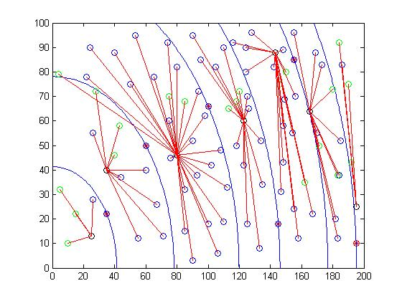

Figure 5.1: Node Deployment and Linkages

5.2 Cluster Head Election
All the nodes in a concentric cluster are required to send data to the advanced nodes. A proper way to assemble data is by electing cluster heads in the region. Cluster head selection is done through the K theorem.
The K theorem algorithm tries to balance energy in a cluster through a reliable energy efficient technique. The concentric clusters are formed and it is assumed that the advanced node is aware of the cluster formation and information. The K theorem algorithm for cluster head selection consists of following steps:
Step-I: The advanced node sets the value of k for each round for each cluster depending upon node density. It broadcasts the value of k to all the nodes in its cluster. The value of k is used to determine the k nearest number of nodes to it.
Step-II: All the sensor nodes in the cluster send the k number of nearest neighbors to the advanced node. The distance to the node can be calculated based on the time for the return signal received.
Step-III: The advanced node select candidate set of cluster heads i.e. C_{i} for each cluster in the network. The value of k_{i} is always equal to the number of candidate cluster heads in a cluster i.e. C.
Step-IV: The advanced node requests each node in the candidate set of cluster heads in the respective cluster to send their combined rating (CR).
Step-V: Each candidate cluster head node calculate its own combined rating based on two factors namely residual energy (RE) and distance to coordinator node (D). The exact relation of calculating combined rating is described in equation.
Step-VI: The coordinator node selects a node as cluster head among candidate set of cluster heads for each cluster based on combined rating. The node with the highest combined rating is elected as cluster head. Hence, higher the combined rating, higher the chances of it becoming the cluster head in the respective cluster.
The philosophy behind the K-theorem is to select a candidate CHs based on bunch of sensor nodes in a cluster. The working of K-Theorem is quiet simple and was proposed to select optimal server location. The advanced node set the value of k_{i} for each cluster. The value of k_{i} is relative to the node density in a cluster in a WSN. The value of k determines the k_{i} number of best sensor nodes that can serve as cluster head. The value of k_{i} also provides the alternative suboptimal options, so that we can select an optimal sensor node for cluster head. The combined rating is calculated based on following criterion:
- Residual energy (RE):
The residual energy of a node, which is the amount of energy remaining in the nodes is directly proportional to the combined rating. Nodes which can become cluster head must will dissipate more energy than any node as it has to perform data aggregation activity other than the usual sensing operation. This adds to the overhead and will dissipate more energy than the normal nodes in the cluster. Hence residual energy is directly proportional to the combined rating.
- Distance to coordinator node (D ):
The nodes having less distance from coordinator node should have higher probability to become cluster head. As energy consumption is directly proportional to the square of distance. Combined rating is calculated is using the following equation.
C.R = RE/(D)²
RE=Residual energy.
D=Distance between nodes.

5.3 Data Transmission
One of the major advantages of using K theorem algorithm is that it chooses cluster head based on distance and residual energy. After all the cluster heads have been chosen from each concentric cluster region data transmission takes place. All the non cluster head nodes report or send data to the cluster head, which in turn aggregates and transmits to the advanced nodes. Then the advanced node will transmit to the base station.

5.4 Pseudo code for HEEPSCC
Creation of concentric cluster
Begin
- Initially set boundaries for x and y co ordinates.
- Initialize total number of nodes uniformly over the field.
- If energy of nodes > certain_threshold(1.5*Average energy of the network),
- Calculate radius and plot them as advanced nodes.
- If energy of nodes >0 plot them as normal nodes.
- Calculate radius for advanced node and draw concentric cluster at that position.
- Increment number of clusters
End
Election of cluster head
- Check whether each node belongs one cluster using radius.
if(((dis(number).di)>R)&&((R)>(dis(number-1).di)))
- Assign number to nodes.
- For all the clusters find out candidate cluster heads in each Cluster.

- Select one node with highest residual energy and least distance to the advanced node as cluster head.

- Transmit data using radio transmission communication.

Chapter 6
IMPLEMENTATION

Chapter 6: Implementation
6.1 MATLAB
MATLAB (matrix laboratory) is a numerical computing environment and fourth-generation programming language. Developed by MathWorks, MATLAB allows matrix manipulations, plotting of functions and data, implementation of algorithms, creation of user interfaces, and interfacing with programs written in other languages, including C, C++, Java, and Fortran. Although MATLAB is intended primarily for numerical computing, an optional toolbox uses the MuPAD symbolic engine, allowing access to symbolic computing capabilities. An additional package, Simulink, adds graphical multi-domain simulation and Model-Based Design fordynamic and embedded systems.
It is a high-level language and interactive environment for numerical computation, visualization, and programming. Using MATLAB, you can analyze data, develop algorithms, and create models and applications. The language, tools, and built-in math functions enable you to explore multiple approaches and reach a solution faster than with spreadsheets or traditional programming languages, such as C/C++ or Java . You can use MATLAB for a range of applications, including signal processing and communications, image and video processing, control systems, test and measurement, computational finance, and computational biology. More than a million engine.

6.2 Advantages
MATLAB has several advantages over other methods or languages:
- Its basic data element is the matrix. A simple integer is considered an matrix of one row and one column. Several mathematical operations that work on arrays or matrices are built-in to the MATLAB environment. For example, cross-products, dot-products, determinants, inverse matrices.
- Vectorized operations. Adding two arrays together needs only one command, instead of a loop structure.
- The graphical output is optimized for interaction. You can plot your data very easily, and then change colors, sizes, scales, etc, by using the graphical interactive tools.
- MATLAB’s functionality can be greatly expanded by the addition of toolboxes. These are sets of specific functions that provided more specialized functionality. Ex: Excel link allows data to be written in a format recognized by Excel, Statistics Toolbox allows more specialized statistical manipulation of data (Anova, Basic Fits, etc)

6.3 Disadvantages
There are also disadvantages:
- It uses a large amount of memory and on slow computers it is very hard to use.
- It sits “on top” of Windows, getting as much CPU time as Windows allows it to have. This makes real-time applications very complicated.
- MATLAB is an interpreted language. The main disadvantage of interpreted languages is execution speed. When a language is compiled, all of the code is analyzed and processed efficiently, before the programmer distributes the application. With an interpreted language, the computer running the program has to analyze and interpret the code (through the interpreter) before it can be executed (each and every time), resulting in slower processing performance.

6.4 Simulink
Simulink is a block diagram environment for multidomain simulation and Model-Based Design. It supports system-level design, simulation, automatic code generation, and continuous test and verification of embedded systems. Simulink provides a graphical editor, customizable block libraries, and solvers for modeling and simulating dynamic systems. It is integrated with MATLAB, enabling you to incorporate MATLAB algorithms into models and export simulation results for further analysis. Simulink, developed by MathWorks, is a data flow graphical programming language tool for modeling, simulating and analyzing multi-domain dynamic systems. Its primary interface is a graphical block diagramming tool and a customizable set of block libraries. It offers tight integration with the rest of the MATLAB environment and can either drive MATLAB or be scripted from it. Simulink is widely used in control theory and digital signal processing for multidomain simulation and Model-Based Design.
Simulink is a software package for modelling, simulating, and analyzing dynamical
systems. It supports linear and nonlinear systems, modelled in continuous time, sampled time, or a hybrid of the two. Systems can also be multirate, i.e., have different parts that are sampled or updated at different rates.

6.5 Code for HEEPSCC
clear;
xm=200;
ym=100;
sink.x=0.0*xm;
sink.y=0.0*ym;
n=100;
Eo=0.1;
%Eelec=Etx=Erx
ETX=50*0.000000001;
ERX=50*0.000000001;
%Transmit Amplifier types
Efs=10*0.000000000001;
Emp=0.0013*0.000000000001;
%Data Aggregation Energy
EDA=5*0.000000001;
rmax=7000;
do=sqrt(Efs/Emp);
figure(1);

sum=0;
for i=1:1:n
if((s(i).E)>0)
plot(s(i).xd,s(i).yd,'o');
end
hold on;
end
cl=1;
dis(1).di=0;
for i=1:1:n
s(i).a=0;
if(s(i).E>5)
s(i).a=1;
advancednode(cl)=i;
cl=cl+1;
R=sqrt( (s(i).xd)^2 + (s(i).yd )^2 );
if(R<=ym)
plot(s(i).xd,s(i).yd,'red *');

dis(cl).di=R;
dis(cl).n=cl;
th = linspace( 0, pi/2, 100);
x = R*cos(th) + 0;
y = R*sin(th) + 0;
plot(x,y);
else
plot(s(i).xd,s(i).yd,'red *');
R=sqrt( (s(i).xd)^2 + (s(i).yd )^2 );
dis(cl).di=R;
dis(cl).n=cl;
th = linspace( 0,asin(ym/R), 100);
x = R*cos(th) + 0;
y = R*sin(th) + 0;
plot(x,y);
end
end
hold on;
end
for j=1:1:cl-1
% comparing each number with the next and swapping
for i=1:1:cl-1
if dis(i).di>dis(i+1).di
% temp is a variable where the numbers are kept
% temporarily for the switch
temp=dis(i).di;
dis(i).di=dis(i+1).di;
dis(i+1).di=temp;
end
end
end
for i=1:1:n
R=sqrt( (s(i).xd)^2 + (s(i).yd )^2 );
nequal=1;
number=2;
max=cl;
while(nequal==1&&number<cl+1)
if(((dis(number).di)>R)&&((R)>(dis(number-1).di)))
s(i).n=number-1;
nequal=0;
end
if((dis(number).di)==R)
s(i).n=number-1;
end
if(R>dis(max).di)
s(i).n=max;
nequal=0;
end
number=number+1;
end
end

for i=1:1:n
count(i)=0;
end
for i=1:1:cl
for j=1:1:n
%j;
if(s(j).n==i&&s(j).a==0)
m(j).firstr=100;
m(j).secondr=100;
m(j).thirdr=100;
m(j).fourthr=100;
m(j).first=0;
m(j).second=0;
m(j).third=0;
m(j).fourth=0;
for k=1:1:100
if(s(k).n==i&&j~=k&&s(k).a==0)
R=sqrt( (s(j).xd-s(k).xd)^2 + (s(j).yd-s(k).yd )^2 );
%k
%R
if(R<=m(j).firstr)
m(j).fourthr=m(j).thirdr;
m(j).fourth=m(j).third;
m(j).thirdr=m(j).secondr;
m(j).third=m(j).second;
m(j).secondr=m(j).firstr;
m(j).second=m(j).first;
m(j).firstr=R;
m(j).first=k;

%m(j).first
%m(j).second
%m(j).third
%m(j).fourth % m(j).first
elseif(R<=m(j).secondr)
m(j).fourthr=m(j).thirdr;
m(j).fourth=m(j).third;
m(j).thirdr=m(j).secondr;
m(j).third=m(j).second;
m(j).secondr=R;
m(j).second=k;

%m(j).third
%m(j).fourth
%m(j).second
elseif(R<=m(j).thirdr)
m(j).fourthr=m(j).thirdr;
m(j).fourth=m(j).third;
m(j).thirdr=R;
m(j).third=k;
% m(j).third
%m(j).fourth
%m(j).third
elseif(R<=m(j).fourthr)
m(j).fourthr=R;
m(j).fourth=k;
% m(j).fourth
end
%plot(s(k).xd,s(k).yd,'*');
%hold on;
end
end
if(m(j).first~=100)
%m(j).first
%m(j).second
%m(j).third
%m(j).fourth

count(m(j).first)=count(m(j).first)+1;
count(m(j).second)=count(m(j).second)+1;
count(m(j).third)=count(m(j).third)+1;
count(m(j).fourth)=count(m(j).fourth)+1;
end
end
end
end
for i=1:1:cl
ktheorem(i).n1=0;
ktheorem(i).n2=0;
ktheorem(i).n3=0;
ktheorem(i).n4=0;
f=0;
for j=1:1:n
if(s(j).a~=1 && s(j).n==i)
f=f+1;
if(f==1)
ktheorem(i).n1=j;
elseif(f==2)
ktheorem(i).n2=j;
elseif(f==3)
ktheorem(i).n3=j;
elseif(f==4)
ktheorem(i).n4=j;
else
if(count(j)>=count(ktheorem(i).n1))
ktheorem(i).n4=ktheorem(i).n3;
ktheorem(i).n3=ktheorem(i).n2;
ktheorem(i).n2=ktheorem(i).n1;
ktheorem(i).n1=j;
elseif(count(j)>count(ktheorem(i).n2))
ktheorem(i).n4=ktheorem(i).n3;
ktheorem(i).n3=ktheorem(i).n2;
ktheorem(i).n2=j;
elseif(count(j)>count(ktheorem(i).n3))
ktheorem(i).n4=ktheorem(i).n3;
ktheorem(i).n3=j;
else
ktheorem(i).n4=j;
end
end
end
end
end
for i=1:1:cl
plot(s(ktheorem(i).n1).xd,s(ktheorem(i).n1).yd,'green o');
plot(s(ktheorem(i).n2).xd,s(ktheorem(i).n2).yd,'green o');
plot(s(ktheorem(i).n3).xd,s(ktheorem(i).n3).yd,'green o');
plot(s(ktheorem(i).n4).xd,s(ktheorem(i).n4).yd,'green o');
%hold on;
end
%hold off;
for r=1:1:rmax

hold off;
dead_nodes=0;
%figure(1);
r
for i=1:1:n
s(i).useful=1;
if((s(i).E)>0)
plot(s(i).xd,s(i).yd,'o');
else
dead_nodes=dead_nodes+1;
round(i)=dead_nodes;
plot(s(i).xd,s(i).yd,'red o');
s(i).useful=0;
end
hold on;
end
for i=1:1:cl-1
R=sqrt( (s(advancednode(i)).xd)^2 + (s(advancednode(i)).yd )^2 );
if(R<=ym)
plot(s(advancednode(i)).xd,s(advancednode(i)).yd,'red *');
th = linspace( 0, pi/2, 100);
x = R*cos(th) + 0;
y = R*sin(th) + 0;
plot(x,y);
else
plot(s(advancednode(i)).xd,s(advancednode(i)).yd,'red *');
R=sqrt( (s(advancednode(i)).xd)^2 + (s(advancednode(i)).yd )^2 );
th = linspace( 0,asin(ym/R), 100);
x = R*cos(th) + 0;
y = R*sin(th) + 0;
plot(x,y);
end
end
%hold on;
for i=1:1:cl
plot(s(ktheorem(i).n1).xd,s(ktheorem(i).n1).yd,'green o');
plot(s(ktheorem(i).n2).xd,s(ktheorem(i).n2).yd,'green o');
plot(s(ktheorem(i).n3).xd,s(ktheorem(i).n3).yd,'green o');
plot(s(ktheorem(i).n4).xd,s(ktheorem(i).n4).yd,'green o');
%hold on;
if(i==cl)
j=i-1;
else
j=i;
end
combined1=s(ktheorem(i).n1).E/(( (s(advancednode(j)).xd-s(ktheorem(i).n1).xd)^2 + (s(advancednode(j)).yd- s(ktheorem(i).n1).yd)^2 ));
combined2=s(ktheorem(i).n2).E/(( (s(advancednode(j)).xd-s(ktheorem(i).n2).xd)^2 + (s(advancednode(j)).yd- s(ktheorem(i).n2).yd)^2 ));
combined3=s(ktheorem(i).n3).E/(( (s(advancednode(j)).xd-s(ktheorem(i).n3).xd)^2 + (s(advancednode(j)).yd- s(ktheorem(i).n3).yd)^2 ));
combined4=s(ktheorem(i).n4).E/(( (s(advancednode(j)).xd-s(ktheorem(i).n4).xd)^2 + (s(advancednode(j)).yd- s(ktheorem(i).n4).yd)^2 ));
if(combined1>combined2)
if(combined1>combined3)
if(combined1>combined4)
ccn(i)=ktheorem(i).n1;
else
ccn(i)=ktheorem(i).n4;
end
else
if(combined3>combined4)
ccn(i)=ktheorem(i).n3;
else
ccn(i)=ktheorem(i).n4;
end end
else
if(combined2>combined3)
if(combined2>combined4)
ccn(i)=ktheorem(i).n2;
else
ccn(i)=ktheorem(i).n4;
end
else
if(combined3>combined4)
ccn(i)=ktheorem(i).n3;
else
ccn(i)=ktheorem(i).n4;
end
end
end
plot(s(ccn(i)).xd,s(ccn(i)).yd,'black o');
end
for i=1:1:cl
f=0;
if(i==cl)
j=i-1;
end
for k=1:1:n
% hold off;
if(s(k).E>0&&k~=i&&s(k).a==0&&k~=ccn(i)&&s(k).n==i)
dis=sqrt(((s(k).xd)-(s(ccn(i)).xd))^2+((s(k).yd)-(s(ccn(i)).yd))^2);
x=[s(k).xd,s(ccn(i)).xd];
y=[s(k).yd,s(ccn(i)).yd];
f=f+1;
plot(x,y,'red');
if (dis>do)
s(k).E=s(k).E((ETX+EDA)*(4000)+Emp*4000*(dis*dis*dis*dis ));
end
if (dis<=do)
s(k).E=s(k).E- ( (ETX+EDA)*(4000) +Efs*4000*(dis* dis ));
end
% hold on;
s(ccn(i)).E = s(ccn(i)).E- ( (ERX + EDA)*4000 );
end
end
dis=sqrt(((s(advancednode(j)).xd)-(s(ccn(i)).xd))^2+((s(advancednode(j)).yd)-(s(ccn(i)).yd))^2);
if(dis>do)
s(advancednode(j)).E=s(advancednode(j)).E- 10*( (ETX+EDA)*(4000) + Emp*4000*( dis*dis*dis*dis ));
else
s(advancednode(j)).E=s(advancednode(j)).E- 10*( (ETX+EDA)*(4000) + Emp*4000*( dis*dis ));
end
end
end

Chapter 7
TESTING

Chapter 7: Testing
The HEEPSCC protocol for Heterogeneous Wireless Sensor Networks was simulated for varying number of sensor nodes in the network in counts of 100,150,200 and 250 nodes. The below graphs show the test results for the varying number of rounds with the graph indication of dead nodes vs round number. The HEEPSCC protocol is compared against the two renowned protocols of SEP and CCS.
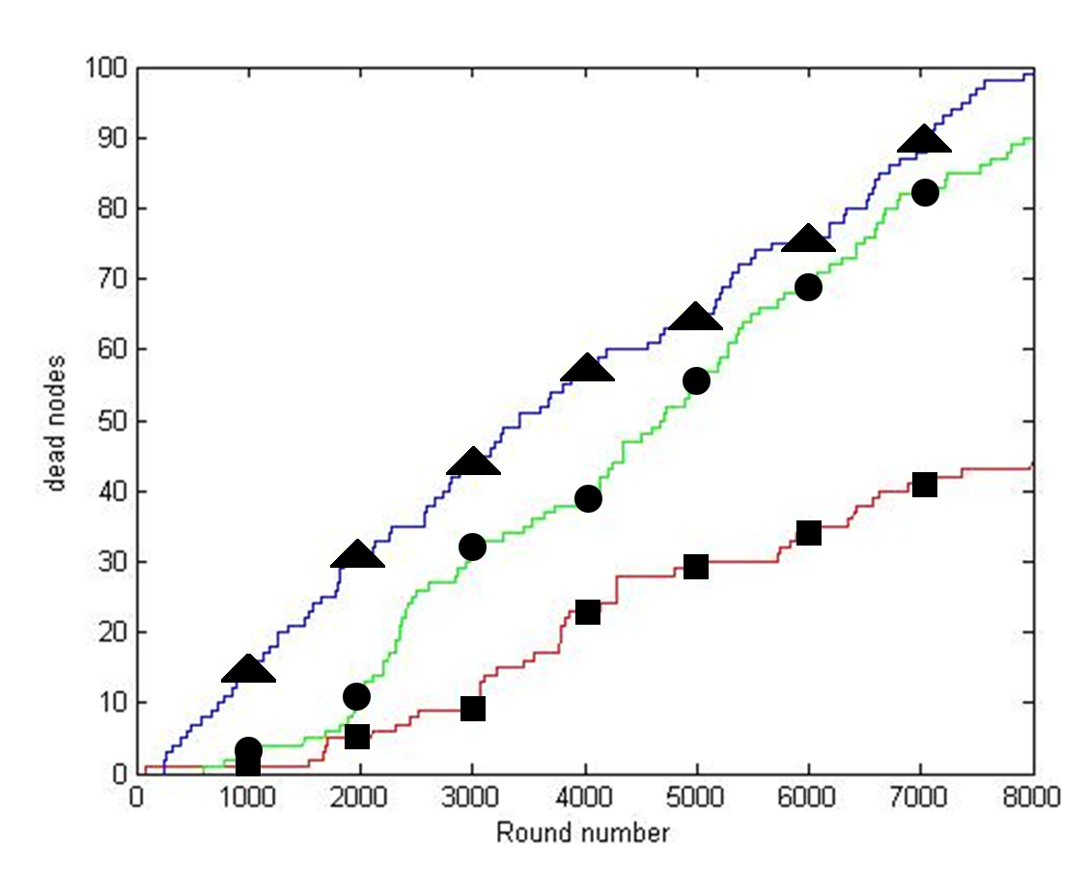
SEP HEEPSCC CCS
Figure 7.1: Protocol comparisons for 100 nodes
Above graph indicates a graph of the number of dead nodes as the round number increases. At the end of 8000 rounds the number of dead nodes in SEP, CCS and HEEPSCC are 99, 91 and 42 respectively. From the above results it can be concluded that HEEPSCC is 53.8% more efficient than SEP and 57.5% more efficient than CCS.

The below graphs represent the results of simulation for 150 nodes.
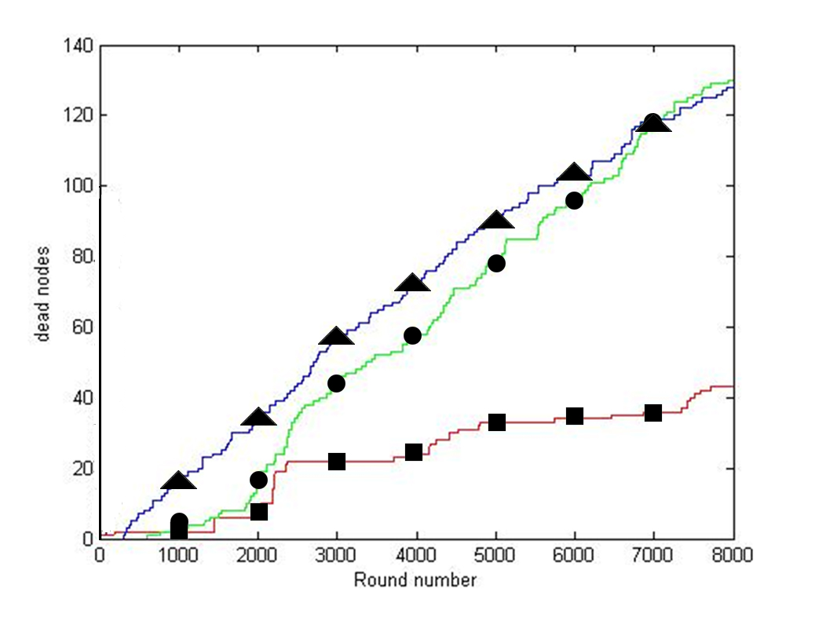
SEP HEEPSCC CCS
Figure 7.2: Protocol comparison for 150 nodes
Above graph indicates a graph of the number of dead nodes as the round number increases. At the end of 8000 rounds the number of dead nodes in SEP, CCS and HEEPSCC are 128, 126 and 43 respectively. From the above results it can be concluded that HEEPSCC is 66.4% more efficient than SEP and 64.87% more efficient than CCS.

The below graphs represent the results of simulation for 200 nodes.
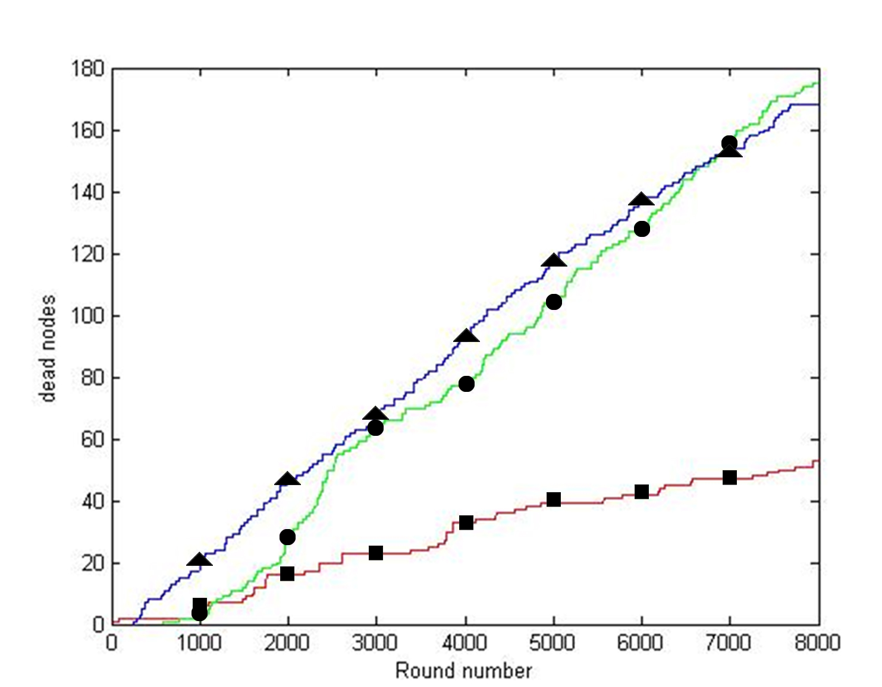
SEP HEEPSCC CCS
Figure 7.3: Protocol comparison for 200 nodes
Above graph indicates a graph of the number of dead nodes as the round number increases. At the end of 8000 rounds the number of dead nodes in SEP, CCS and HEEPSCC are 175, 170 and 54 respectively. From the above results it can be concluded that HEEPSCC is 69.14% more efficient than SEP and 68.23% more efficient than CCS.

The below graphs represent the results of simulation for 250 nodes.
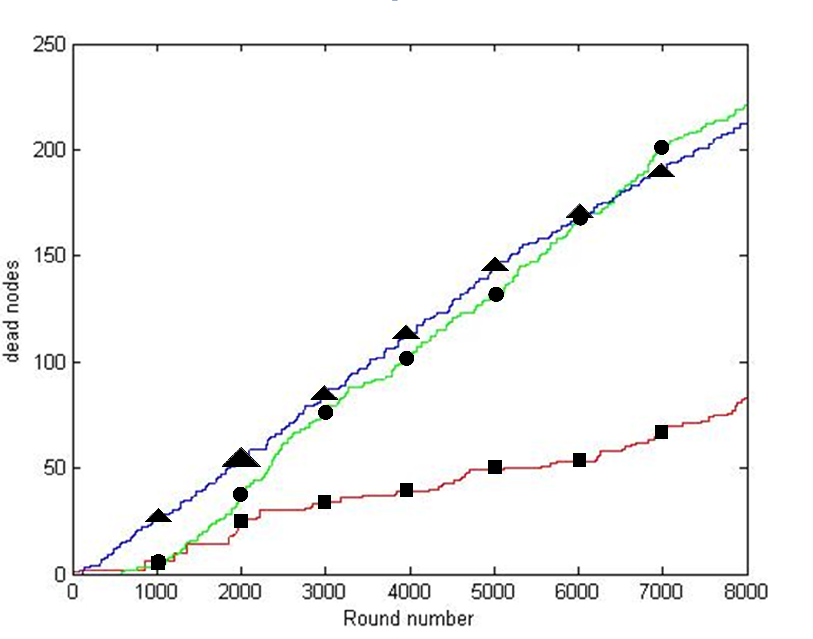
SEP HEEPSCC CCS
Figure 7.4: Protocol comparison for 250 nodes
Above graph indicates a graph of the number of dead nodes as the round number increases. At the end of 8000 rounds the number of dead nodes in SEP, CCS and HEEPSCC are 215, 210 and 82 respectively. From the above results it can be concluded that HEEPSCC is 61.8% more efficient than SEP and 60.95% more efficient than CCS.
From the above graphs it can be observed that as the number of nodes in the network increases, the number of dead nodes at the end of 8000 nodes is far less when compared to the other protocols in Heterogeneous WSN. It can also be observed from the graphs that even though the stability cannot be achieved to that ranges of SEP, the stability period has much better than the CCS protocol. However the number of dead nodes was found to be much lesser or the network lifetime in the network was found to be much higher than SEP or CCS.

Chapter 8
CONCLUSION AND FUTURE WORK

Chapter 8: Conclusion and Future work
8.1 Conclusion
WSNs have discovered a wide range of applications in the recent era. Growing demand for WSN has accelerated the research and development of routing protocols used in WSN. Prolonging the network lifetime and increasing the stability period has become the most crucial part in HWSN. Our proposed new protocol for heterogeneous wireless sensor network, Hybrid Energy Efficient Protocol using Stable Concentric Clustering is based on the residual energy of sensor nodes and location information of the sensor nodes. HEEPSCC is a hybrid model that bridges the gap between stability and energy efficiency in heterogeneous networks.
In this protocol we have used the concept of creation of concentric cluster based on the position of the advanced nodes and K theorem for choosing cluster head. With the usage of k theorem and choosing a cluster head based on its residual energy and distance, HEEPSCC can delay the death of the first node in the network thus increasing the stability period in the network lifetime. The division into cluster, based on the position of the advanced nodes and selection of cluster head based on the combined rating will make sure that the network will exist for longer time.
From the simulation results it can be observed that HEEPSCC is 53.8%, 66.4%, 69.14% and 61.8% more efficient than SEP for 100, 150, 200 and 250 nodes respectively and 57.5%, 64.87%, 68.23% and 60.95% more efficient than CCS for 100, 150, 200 and 250 nodes respectively. From the graphs it can be observed that as the number of nodes in the network increases, the number of dead nodes at the end of 8000 rounds is far less when compared to the other protocols in Heterogeneous WSN. Therefore, it can be concluded that nodes following HEEPSCC in HWSN can survive for a longer time when compared to protocols such as SEP or CCS.
8.2 Future work
Since the network is energy constraint, efficient usage of limited energy results in longer network lifetime. In heterogeneous networks each node is allocated with different amount of energy. In this proposed protocol we have concentrated on both stability and energy efficiency. This project proposes a methodology to improve the stability and the instability period of nodes in the network. There is scope for improving to yield more precise results. We also present an equation to choose a Cluster Head from a candidate set of nodes. The parameters used in the equation can vary depending on the application. This equation used could also be enhanced in the future. The equation can be altered in such a way so as to concentrate specifically on stability or on extending the network lifetime. The protocol was simulated for a limited number of nodes ranging from 100-250 nodes; the protocol can further be enhanced to cover more number of nodes and sufficient changes to accommodate larger number of nodes. This protocol was designed considering a heterogeneous network with identical sensors and different amounts of energy, another type of heterogeneous network with different kinds of sensors having different processing capabilities can also be incorporated in the scope of this protocol with suitable changes.

Chapter 9
REFERENCES

Chapter 9: References
[1] J. Hill, R. Szewczyk, A, Woo, S. Hollar, D. Culler, and K. Pister, System Architecture Directions for Networked Sensors, ASPLOS, November 2000.
[2] Application of wireless sensor networks to aircraft control and health management systems Rama K. YEDAVALLI, Rohit K. BELAPURKAR Department of Mechanical and Aerospace Engineering, The Ohio State University, Columbus Ohio 43210, U.S.A.
[3] K. Akkaya and M. Younis, .A survey on routing protocols for wireless sensor networks., Elsevier Journal of Ad Hoc Networks 3 (3), 2005, 325.349.
[4] M. Younis, M. Youssef and K. Arisha, .Energy aware management in cluster-based sensor networks., Computer Networks, 43 (5), 2003, 649 668.
[5] K. Dasgupta, K. Kalpakis and P. Namjoshi, .An efficient clustering. based heuristic for data gathering and aggregation in sensor networks,. in: Proceedings of the IEEE Wireless Communications and Networking Conference (WCNC, 2003), New Orleans, LA, March 2003.
[6] W.R. Heinzelman, A. Chandrakasan, and H. Balakrishnan, “Energy-efficient Communication Protocol for Wireless Microsensor Networks”, in IEEE Computer Society Proceedings of the Thirty Third Hawaii International Conference on System Sciences (HICSS '00), Washington, DC, USA, Jan. 2000, vol. 8, pp. 8020.
[7] "SEP: A Stable Election Protocol for clustered heterogeneous wireless sensor networks" Georgios Smaragdakis, Ibrahim Matta and Azer Bestavros. Second International Workshop on Sensor and Actor Network Protocols and Applications (SANPA 2004).
[8] Z. Haibo, W. Yuanming, H. Yanqi and X. Guangzhong, "A novel stable selection and reliable transmission protocol for clustered heterogeneous wireless sensor networks", Computer Communications, In Press, Corrected Proof
[9] S. Varma, N. Nigam and U.S. Tiwary, "Base station initiated dynamic routing protocol for heterogeneous Wireless Sensor Network using clustering", Wireless Communications
[10] X. Li, D. Huang and Z. Sun, "A Routing Protocol for Balancing Energy Consumption in Heterogeneous Wireless Sensor Networks", MSN 2007, LNCS 4864, 2007, 79.88.
[11] Li Qing , Qingxin Zhu and Mingwen Wang, "Design of a distributed energy-efficient clustering algorithm for heterogeneous wireless sensor networks", Computer Communications, Volume 29,Issue 12, August 2006, 2230-2237.
[12] Haibo Zhou, Yuanming Wu, Yanqi Hu, Guangzhong Xie, A novel stable selection and reliable transmission protocol for clustered heterogeneous wireless sensor networks, Computer Communications, Volume 33, Issue 15, 15 September 2010, Pages 1843-1849, ISSN 0140-3664, 10.1016/j.comcom.2010.06.001.
[13] Min-Woo Park; Jin-Young Choi; Young-Ju Han; Tai-Myoung Chung, "An Energy Efficient Concentric Clustering Scheme in Wireless Sensor Networks," INC, IMS and IDC, 2009. NCM '09. Fifth International Joint Conference on, vol., no., pp.58,61, 25-27 Aug.2009 doi: 10.1109/NCM.2009.307.
[14] B. Elbhiri, R. Saadane, D. Aboutajdine, "Stochastic Equitable Distributed Energy-Efficient Clustering (SDEEC) for Heterogeneous Wireless Sensor Networks" ICGST-CNIR Journal, Volume 9, Issue 2, December 2009.
[15] R.S. Marin-Perianu and J. Scholten, 2007. Cluster-based service discovery for heterogeneous wireless sensor networks, International Journal of Parallel, Emergent and Distributed Systems.

CHAPTER 10
APPENDIX

10.1 Snapshots
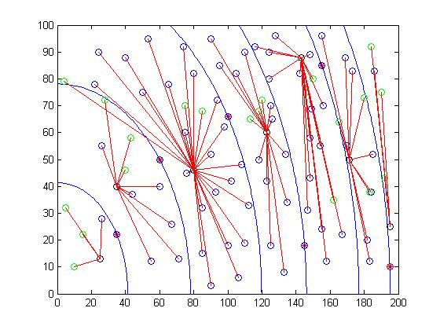
Figure 10.1: Working Snapshot 1
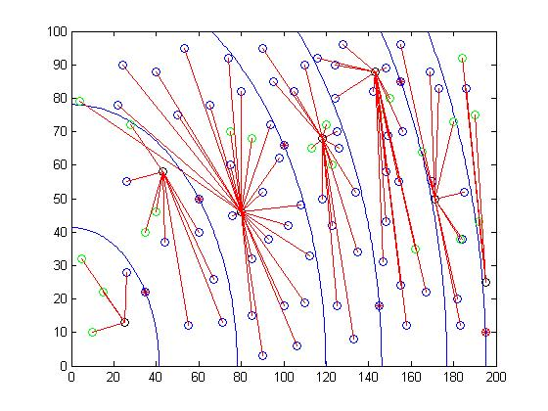
Figure 10.2: Working Snapshot 2

