Pizza Runner Case Study
Link to case study: https://8weeksqlchallenge.com/case-study-2/

Entity Relationship Diagram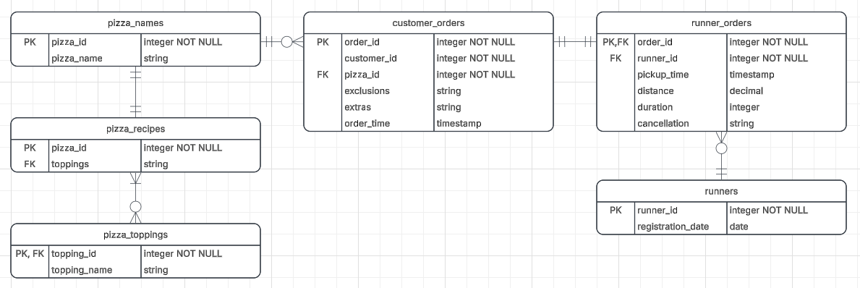
- Created using Lucidchart
- Entities, Primary Keys (PK) and Foreign Keys (FK)
  - Pizza_names
    - PK - pizza_id
  - Customer_orders
    - PK - order_id
    - FK - pizza_id
  - Runner_orders
    - PK, FK - order_id
    - FK - runner_id
  - Runners
    - PK - runner_id
  - Pizza_recipes
    - PK - pizza_id
    - FK - toppings
  - Pizza_toppings
    - PK, FK - toppings_id
- Relationships
  - runners.runner_id → runner_orders.runner_id (1-to-many)
  - customer_orders.order_id → runner_orders.order_id (1-to-1)
  - pizza_names.pizza_id → customer_orders.pizza_id (1-to-many)
  - pizza_names.pizza_id → pizza_recipes.pizza_id (1-to-1)
  - pizza_recipes.toppings → pizza_toppings.topping_id (1-to-many)
  - pizza_recipes.pizza_id → pizza_recipes_ toppings.pizza_id (1-to-many)

BigQuery SQL

Schema creation, data insert, cleaning and normalization
- `schema_dataset`, `customer_orders_cleaned`, `runner_orders_cleaned`

Pizza Metrics
- How many unique customer orders were made? `unique_order_count`
  - 
- How many of each type of pizza was delivered? `count_of_pizza_types_delivered`
  - 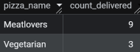
- What was the maximum number of pizzas delivered in a single order? `max_pizza_count`
  - 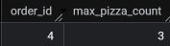
- For each customer, how many delivered pizzas had at least 1 change and how many had no changes? `pizzas_with_and_without_changes`
  - 
- What was the volume of orders for each day of the week? `orders_per_week_day`
  - 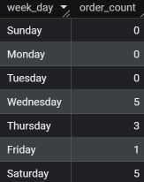

Runner and Customer Experience
- What was the average time in minutes it took for each runner to arrive at the Pizza Runner HQ to pickup the order? `pickup_time_avg`
  - 
- Is there any relationship between the number of pizzas and how long the order takes to prepare? Orders with 2+ pizzas take longer to prepare, with order #10 as the exception; `pizzas_made_per_min`
  - 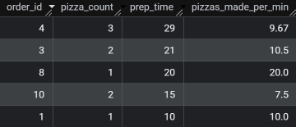
- What was the average distance travelled for each customer? `avg_distance_traveled_per_customer`
  - 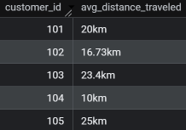
- What was the difference between the longest and shortest delivery times for all orders? `short_long_duration_diff`
  - 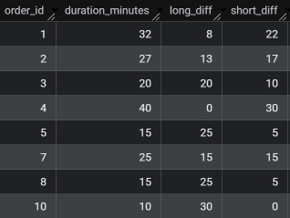
- What was the average speed for each runner for each delivery and do you notice any trend for these values? For each runner the later the order_time, the higher the average speed. `avg_runner_speed_per_order`
  - 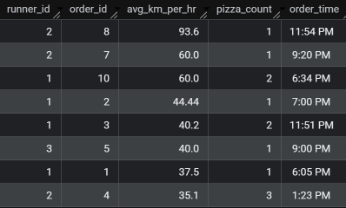

Ingredient Optimisation
- What was the most commonly added extra? `most_common_extra`
  - 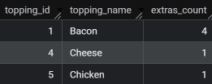
- What was the most common exclusion? `most_common_exclusion`
  - 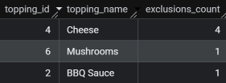
- Generate an order item for each record in the customers_orders table in the following format: Meat Lovers - Exclude Cheese, Bacon - Extra Mushroom, Peppers; `itemized_orders`
  - 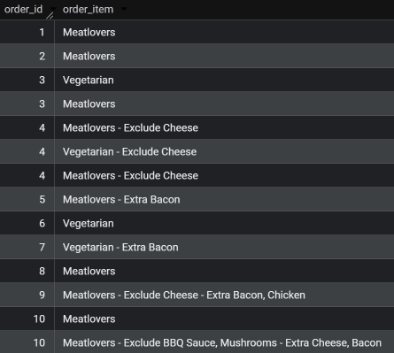
- Generate an alphabetically ordered comma separated ingredient list for each pizza order from the customer_orders table and add a 2x in front of any relevant ingredients; `order_items_ingredients`
  - 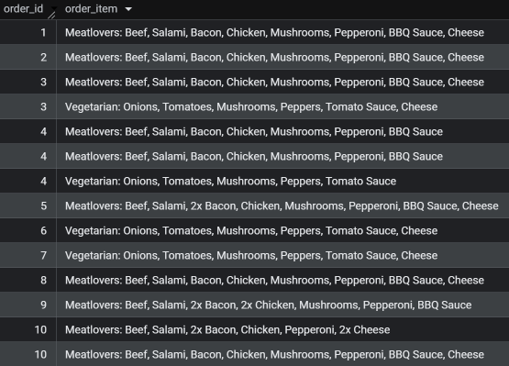
- What is the total quantity of each ingredient used in all delivered pizzas sorted by most frequent first? `total_topping_count`
  - 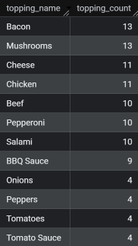

Pricing and Ratings
- If a Meat Lovers pizza costs $12 and Vegetarian costs $10 and there were no charges for changes - how much money has Pizza Runner made so far if there are no delivery fees? `pizza_profit`
  - 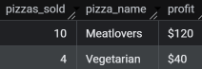
- What if there was an additional $1 charge for any pizza extras? Add cheese is $1 extra; `pizza_profit_extra_costs`
  - 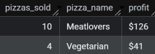
- The Pizza Runner team now wants to add an additional ratings system that allows customers to rate their runner. How would you design an additional table for this new dataset - generate a schema for this new table and insert your own data for ratings for each successful customer order between 1 to 5.
  - `runner_ratings`, `delivery_pace`
  - 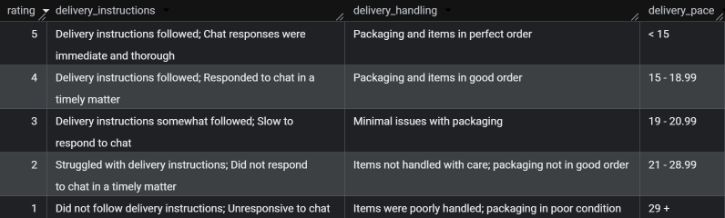
- Using your newly generated table - can you join all of the information together to form a table which has the following information for successful deliveries? (Customer_id, Order_id, Runner_id, Rating, Order_time, Pickup_time, Time between order and pickup, Delivery duration, Average speed, Total number of pizzas); `successful_orders_ratings`
  - 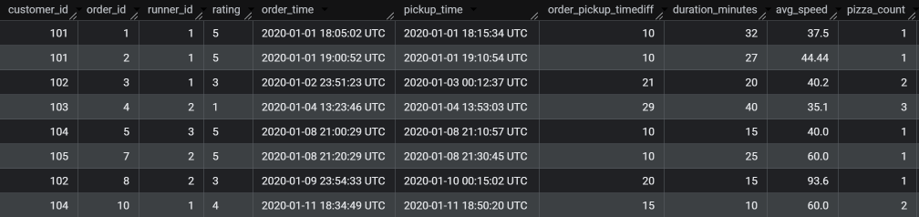
- If a Meat Lovers pizza was $12 and Vegetarian $10 fixed prices with no cost for extras and each runner is paid $0.30 per kilometre traveled - how much money does Pizza Runner have left over after these deliveries? `net_profit`
  - 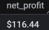

Bonus Questions
- If Danny wants to expand his range of pizzas - how would this impact the existing data design? Write an INSERT statement to demonstrate what would happen if a new Supreme pizza with all the toppings was added to the Pizza Runner menu?
  - New row values in fields pizza_id, pizza_name, and toppings would need to be added to tables pizza_names and pizza_recipes
  - `test_new_pizza_insert`, `new_pizza_insert`
  - 