Hurricane-induced mortality switches mangroves from carbon sink to methane source
Jonathan Gewirtzman, Elisabeth Powell, Frannie Adams, Sean Charles, Erin Delaria, Cheryl Doughty, Lin Xiong, Lucy Carruthers, Addison Colwell, Atticus Stovall, Glenn Wolfe, Judith Rosentreter, Derrick Vaughn, Anthony Campbell, Mingyu Zhang, Samuel Tsao, Megan Brueck, Ben Girgenti, Mike Norton, Jessie Peterman, Ayia Lindquist, William Chen, [Jordan Peccia, Irvan Luhung,] Sparkle Malone, Benjamin Poulter, David Lagomasino, Peter Raymond
[Affiliations as in the NCC draft. Corresponding: J. Gewirtzman.]
Draft for Science (Research Article: ≤3,000-word main text, 5 display items, ~50 references; Materials and Methods in the supplementary materials). Condensed from manuscript_NCC_draft.md; detailed statistics, per-site values and secondary analyses are in the supplement. Figure panels follow output/figures/main/Fig1–Fig5. Placeholders in brackets.
One-sentence summary. Hurricane-killed mangroves become methane-amplified carbon sources, a climate feedback missing from blue-carbon accounting.

Abstract
Saline mangroves are assumed to emit little methane, and blue-carbon accounting treats them as strong sinks. We resolved methane and CO2 exchange from six surfaces across intact, regenerating and hurricane-killed (“ghost”) mangrove in the Florida Everglades, scaled them with terrestrial laser scanning, and checked them against tower and airborne eddy covariance. Intact forest emitted methane well above emission-factor assumptions, mostly from soils and prop roots. Mortality raised emission eightfold, shifted it to flooded water surfaces, and reversed the porewater salinity–methane relationship, with methane accumulating at seawater sulfate. Ghost forest was a net source, switching the radiative balance by ~6,400 g CO2-eq m−2 yr−1 (20-year horizon), a third of it from methane. Scaled across Caribbean mangrove lost in 2017, the switch adds ~1.1 Tg CO2-eq yr−1: a disturbance feedback absent from current accounting.
[~130 words; Science limit 125]

Main text
Mangrove forests store 2–10 Pg of carbon along tropical and subtropical coasts and are central to blue-carbon policy and nature-based climate solutions (refs). Like all wetlands they also produce methane, which warms the climate 81 times more than CO2 over 20 years and 28 times more over 100. Whether methane offsets mangrove carbon uptake has been treated as settled: tidal sulfate and oxygen sustain microbial processes that outcompete methanogens, so the IPCC 2013 Wetlands Supplement sets mangrove methane to zero above 18 PSU and blue-carbon methodologies allow it to be excluded (refs; [CHECK: VM0033 salinity criterion]). That framework rests mainly on soil measurements. Methane also leaves wetlands through water surfaces, roots, stems and dead wood (refs), and methanogens that use substrates sulfate reducers do not compete for can persist in sulfate-rich and even hypersaline sediment (refs). Component-resolved methane budgets for intact mangroves are nearly absent, and none has been checked against an independent ecosystem-scale measurement.
Mangroves are also increasingly killed. Intense tropical cyclones defoliate canopies, kill roots and pond water behind fallen wood, leaving standing “ghost forests” that can persist for years (refs). Loss of root oxygen transport, a pulse of dead biomass and persistent flooding should all favour methane, but how mortality changes each emission pathway, and whether it changes the net radiative balance, is unknown. The proportion of intense cyclones is rising ([CHECK: IPCC AR6 WGI Ch. 11]), so this is a question about a growing climate feedback.
As part of NASA’s BlueFlux campaign, we measured methane and CO2 across a hurricane-disturbance gradient in the Florida coastal Everglades, where Hurricane Irma (September 2017) left extensive ghost forest (Fig. 1). We combined chambers on six surfaces (water, soil, prop roots, stems, downed wood and leaves) at intact, regenerating and ghost sites in wet- and dry-season campaigns, terrestrial laser scanning (TLS) of woody surface area, the US-Skr eddy-covariance tower and CARAFE airborne eddy covariance (Fig. 1c), and porewater chemistry with sediment metagenomes.
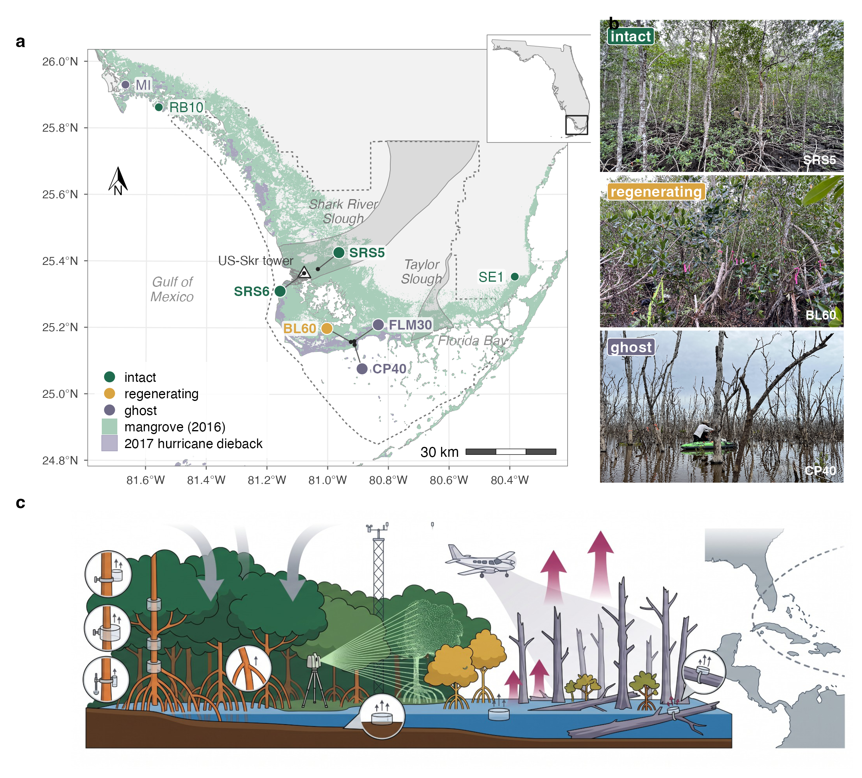
Fig. 1. Study system and measurement design. (A) South Florida study sites by forest class (core sites large; supporting sites small), mangrove extent in 2016 (Global Mangrove Watch v3.0), 2017 hurricane dieback (Taillie et al. 2020), the US-Skr eddy-covariance tower and Everglades National Park (dashed). (B) Intact (SRS5), regenerating (BL60) and ghost (CP40) forest. (C) Measurement design: chambers on stems at several heights, prop roots, sediment, water and downed wood; terrestrial laser scanning; tower and airborne eddy covariance. [Draft illustration; labels pending.]

Methane from every surface
Across 752 chamber fluxes, every surface except leaves emitted methane in every forest class (Fig. 2a). Water and soil had the highest rates (17.6 and 17.1 nmol m−2 s−1 across sites), followed by stems (8.0) and prop roots (3.5), and more than 90% of stem, root and water fluxes were positive. Mortality raised per-area emission sharply: relative to intact forest, ghost-forest stems emitted ~40 times more methane, water surfaces ~18 times more, and soils twice as much, with the highest soil and water rates at the regenerating site (Fig. 2a). CO2 efflux from stems, roots, soils and water was positive in all classes, and leaves were the only net CO2 sink (Fig. 2b).
Woody emission was organized by height. Methane from stems and prop roots peaked at the water line in every class and declined upward (generalized additive model, p < 0.001 in each class; Fig. 2d), the signature of sediment-derived gas venting through the lower bole; stem CO2 showed no such gradient (Fig. 2e). The water-line peak was 13–28 times higher in disturbed than intact forest, and the classes converged by ~1 m. Once height and class were accounted for, species, season and whether a stem was alive or dead had little effect: dead stems kept venting methane.
High per-area rates did not translate into large stand-level fluxes. TLS showed that intact forest carries ~5.0 m2 of surface per m2 of ground, of which prop roots, stems and branches are about a quarter, while ghost forest retains ~1.3 m2 m−2, mostly open water (Fig. 2c). Most woody surface lies far above the water line, where flux is lowest (Fig. 2f). Stems therefore contributed <1% of stand methane in both intact and ghost forest, whereas the dense prop-root zone of intact Rhizophora forest contributed ~28% (Fig. 3a). This bears directly on a recent global estimate that mangrove stems emit ~730 Gg CH4 yr−1 (Qin et al. 2025): scaled by measured bark area, intact Everglades stems emitted ~0.01 g CH4 m−2 yr−1, several hundred times less than that model predicts per unit ground area for mangroves in Mexico and Brazil (~7 g CH4 m−2 yr−1). Stem flux must be scaled by measured bark area and its height profile, not inferred from soil flux.
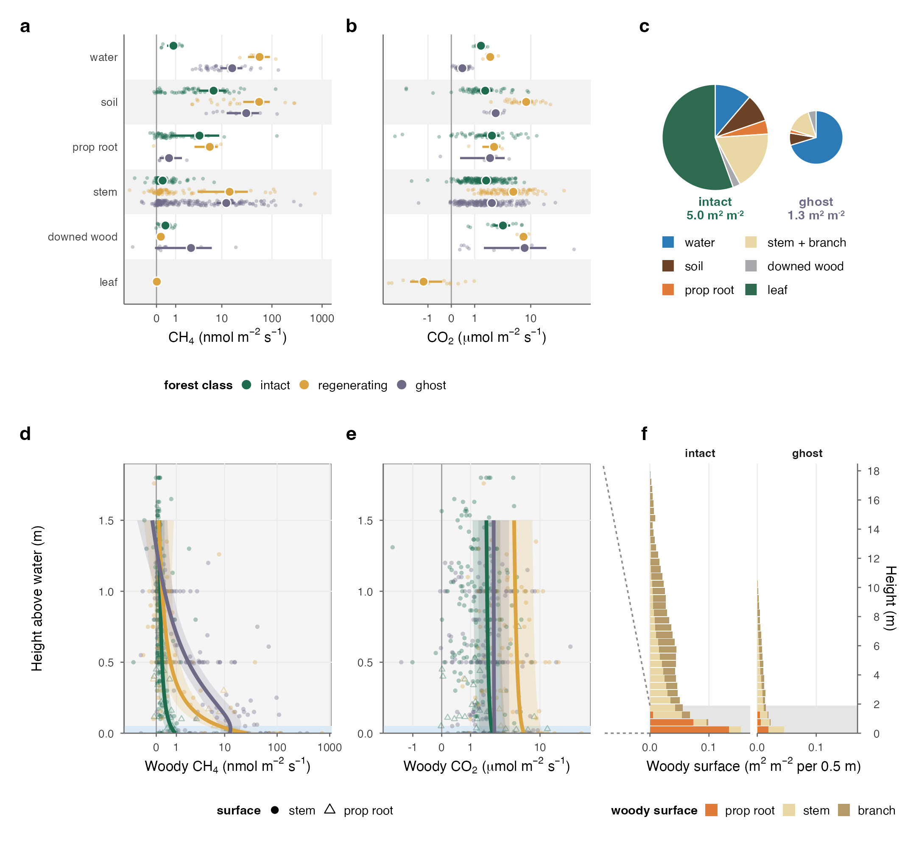
Fig. 2. Flux rates and the surfaces they act on. (A) CH4 and (B) CO2 flux per unit surface by component and forest class (points, individual measurements; large points, means; bars, 95% bootstrap CIs for n ≥ 4; inverse-hyperbolic-sine axes). (C) Surface per unit ground area by component; pie area proportional to the total. (D) CH4 and (E) CO2 per unit woody surface by height above water, with generalized additive model fits (95% CI). (F) TLS woody surface by 0.5 m height bin; grey band, the chamber-sampled range enlarged in (D) and (E).

Mortality multiplies stand methane
Scaling each surface’s flux by its area gives stand budgets (Fig. 3). Intact forest emitted 1.5 g CH4 m−2 yr−1 (2.5 at the most productive site), mostly from soils (55%) and prop roots (28%), with tidal water 14% (Fig. 3a). This is far above the zero that Tier-1 factors assign at these salinities, so wetland methane budgets omit an intact saline-mangrove source. Ghost forest emitted 11.9 g CH4 m−2 yr−1, eight times more, ~87% of it through flooded water surfaces (Fig. 3a,d). Mortality thus moves emission from root-permeated, tidally drained sediment to permanently ponded water. Leaves dominated intact-forest respiration, whereas ghost-forest respiration came from water, sediment and standing and downed dead wood (Fig. 3b). The budgets were insensitive to how stem flux was extrapolated above measured heights (≤4%), because stems are a small term, and ghost-forest emission rests mainly on directly measured water fluxes scaled by inundated area (fig. S_[ED7]_).
Two independent measurements check these budgets. Airborne eddy covariance disaggregated to intact and ghost forest agreed with the chamber budgets within uncertainty in both seasons, ranking ghost above intact methane in the wet season (airborne 51 ± 27 vs 29 ± 16 nmol m−2 s−1; chambers 36 vs 4) and matching net CO2 exchange in sign and magnitude (Fig. 3c,e,f). Bottom-up intact CO2 uptake (−1,025 g C m−2 yr−1) matched the long-term tower estimate for the same forest (−1,170 ± 127; Fig. 3d). The methods share no measurements, so their agreement does not depend on any one method’s assumptions. [PLACEHOLDER — July 2024 airborne deployment (E. Delaria): one sentence on whether the intact–ghost contrast holds in the summer wet season, which our chamber campaigns did not sample. Fig. 3c.]
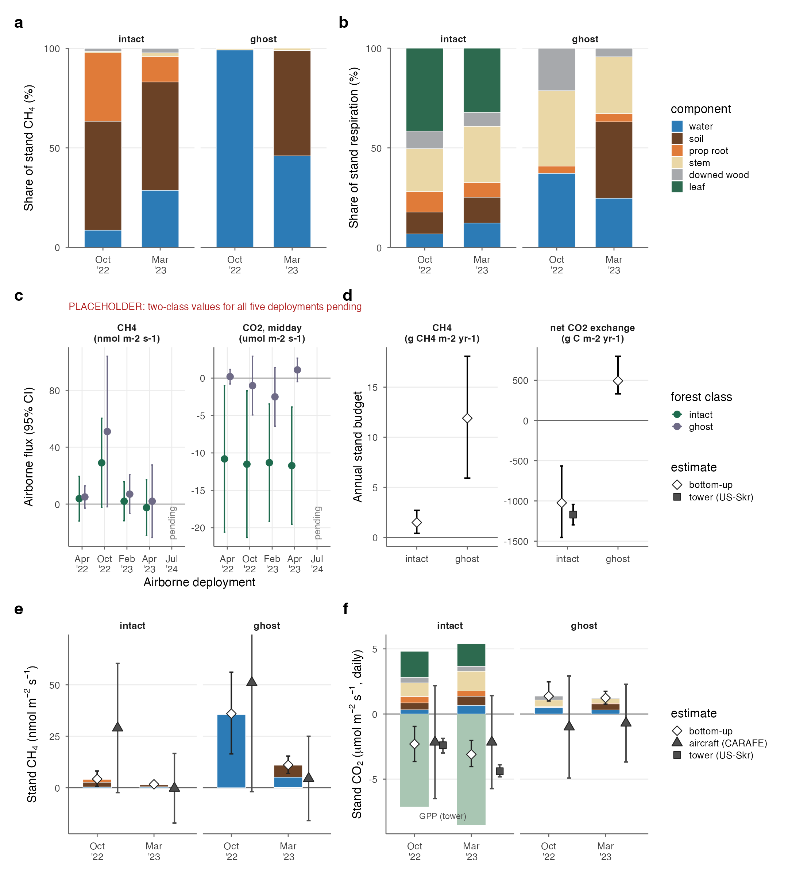
Fig. 3. Stand budgets and independent closure. Share of stand (A) CH4 and (B) respiration by component and campaign. (C) Airborne CH4 and midday CO2 for intact and ghost forest by deployment [July 2024 pending]. (D) Annual stand CH4 and net CO2 exchange (Monte Carlo 95% intervals) with the tower estimate (Barr et al. 2010). Stand (E) CH4 and (F) CO2 by campaign, stacked by component, with bottom-up totals (diamonds), airborne (triangles) and tower (squares) estimates; intervals 95%.

Methane despite seawater sulfate
Porewater chemistry separated the forest classes (Fig. 4). The first principal component (43% of variance) contrasted salty, sulfate-rich, reduced, high-methane and high-ammonium ghost-forest porewater with oxidized intact-forest porewater; the second (24%) picked out the high dissolved organic carbon and alkalinity of the regenerating site (Fig. 4a). Ammonium at the ghost site (200–320 μM) exceeded 24 years of monitoring at the intact sites by more than an order of magnitude, a level matched in that record only after Irma (Supplementary Table S11), consistent with decomposing roots and the loss of root uptake.
The relationship between salinity and methane reversed (Fig. 4b). Across three porewater rounds, methane fell with salinity in intact and regenerating forest (r = −0.48), as expected where sulfate reduction suppresses methanogenesis, but rose with salinity in ghost forest (r = 0.60, p = 0.03). Ghost-forest porewater held seawater-level sulfate (~30 mM) alongside the highest dissolved methane, and alkalinity of 11–33 mM showed that sulfate reduction remained active everywhere (Fig. 4c). Methane therefore accumulated alongside sulfate reduction, not after it. [PLACEHOLDER — metagenomes (Peccia lab): whether methylotrophic methanogens (mttB/mtbB/mtmB, Methanosarcinaceae) dominate the mcrA pool at the ghost site, normalized per gram of sediment and organic carbon, and whether methane oxidizers (pmoA) decline; Fig. 4d–f.] Mortality thus inverts the redox expectation that governs methane in intact saline mangrove.
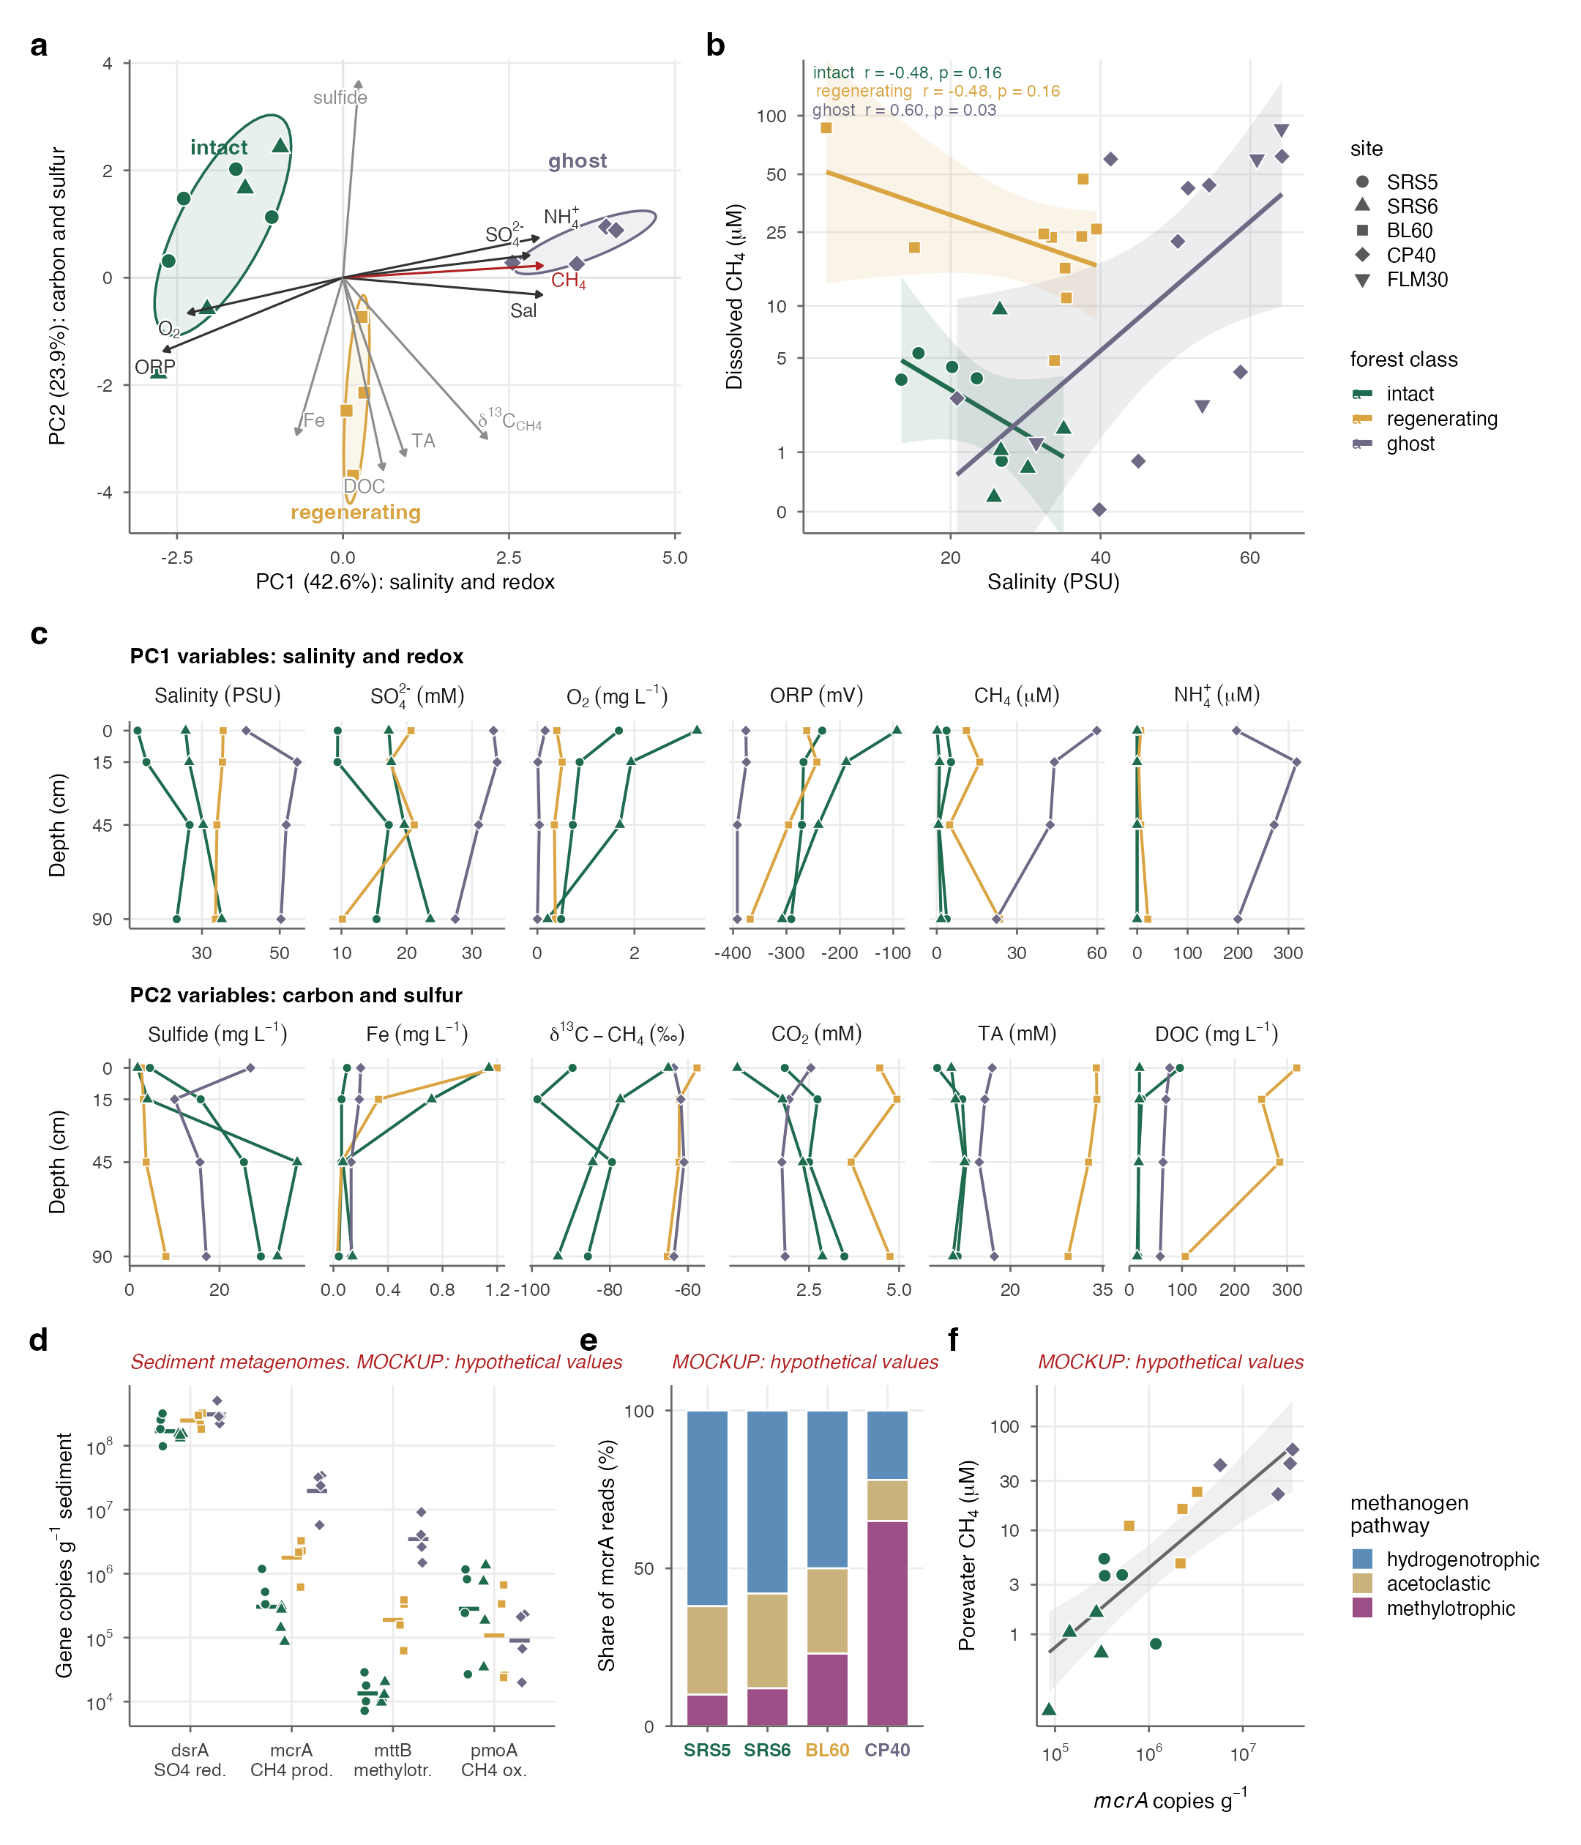
Fig. 4. A geochemical regime shift. (A) Principal components of porewater chemistry (October 2025; 13 variables); ellipses, 68% class ellipses; arrows, loadings, CH4 in red. (B) Porewater salinity versus dissolved CH4 across three sampling rounds with class regressions. (C) Depth profiles, grouped by the principal component each variable loads on. (D to F) [PLACEHOLDER — sediment metagenomes: marker genes per gram of sediment; methanogen pathway composition; mcrA versus porewater CH4.]

From sink to source
Intact forest was a strong net sink: net CO2 uptake (−3,755 g CO2 m−2 yr−1) dwarfed methane (+121 g CO2-eq at GWP20), which offset 3% of it (Fig. 5a). Ghost forest was a net source (+2,775 g CO2-eq m−2 yr−1 at GWP20; +2,141 at GWP100). Losing the canopy turned its CO2 balance positive, and methane supplied 35% of its warming at GWP20 (16% at GWP100; 42% with GWP*). Mortality therefore switched the radiative balance by ~6,400 g CO2-eq m−2 yr−1 at GWP20 (~5,800 at GWP100), and Monte Carlo intervals for the two states did not overlap (intact −5,233 to −1,939; ghost +1,922 to +3,978). Accounting for lateral carbon export to tidal waters shrinks the intact sink but leaves a switch of ~5,500 (fig. S_[ED9]_), and across all analytical choices we tested the switch stayed between ~5,600 and ~8,000 (Supplementary Table S10).
Scaled across the Caribbean, the switch is large. In a Landsat map of 2017 hurricane damage (Taillie et al. 2020), 173 km2 of mangrove showed little recovery, 95% of it after Irma, mainly in northern Cuba and south Florida (Fig. 5c). At the measured per-area switch, this loss adds ~1.1 Tg CO2-eq yr−1 at GWP20 (0.7–1.6), including 1.8 Gg CH4 yr−1 of induced methane (Fig. 5b). Our ghost sites showed no canopy recovery five to six years after landfall, so this forcing recurs each year until stands recover. The estimate is conservative: the map captures only 60 of the 108 km2 of post-Irma Florida dieback (Lagomasino et al. 2021), and it omits peat collapse and ghost-forest lateral losses. [OPTIONAL PLACEHOLDER — global extension: apply the per-area switch to cyclone-driven mangrove mortality worldwide (global loss products × storm tracks), with bounds.]
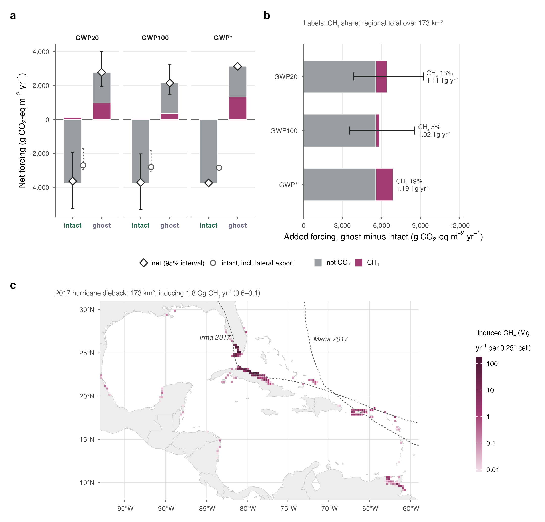
Fig. 5. Climate consequence. (A) Net forcing of intact and ghost forest at GWP20, GWP100 and GWP*, stacked by CO2 and CH4; diamonds, net with Monte Carlo 95% intervals; circles, intact net ecosystem carbon balance including lateral export. (B) The intact-to-ghost switch per m2, split into CO2 and CH4, with the CH4 share and the regional total. (C) Induced CH4 from 2017 hurricane dieback per 0.25° cell, with the tracks of Irma and Maria.

Implications
Two revisions follow for mangrove methane accounting: a non-zero baseline for intact saline forest, and an explicit dependence on disturbance state. Hypersaline ghost forest (50–64 PSU) emitted eight times more methane than intact forest, the opposite of what salinity thresholds predict. Mortality also changes where methane escapes: from sediment and roots to ponded water. Rates are setting-dependent, though: a ghost site in the Ten Thousand Islands emitted an order of magnitude less than the Everglades ghost sites (Supplementary Text S.T8), and the regenerating stand emitted as much as ghost forest, so recovery of the canopy does not promptly restore low methane.
Hurricane mortality is therefore a positive climate feedback missing from blue-carbon accounting. The area we scaled reflects essentially one storm, and the proportion of intense cyclones is projected to rise. Because recovery restores the sink, the feedback strengthens the case for conserving intact mangrove and restoring damaged stands, including restoring tidal exchange where ponding persists ([CHECK: Lewis 2005]). Blue-carbon crediting should carry both an accurate methane baseline and a permanence-risk term for disturbance, and the methane benefit of restoration should be measured rather than assumed.
Our conclusions are bounded by a space-for-time gradient, two chamber campaigns, literature-based lateral export and burial, and a regenerating class without TLS or airborne closure (supplementary materials). None changes the direction or robustness of the switch. Measuring every pathway, scaling by measured structure and checking against airborne fluxes shows that a hurricane-killed mangrove is not a diminished sink but a methane-amplified source.
[Main text ≈ 1,750 words; ~1,250 words of headroom under the 3,000-word limit]

Supplementary materials (to assemble)
Materials and Methods (from the NCC draft Methods and SI S.M1–S.M19); Supplementary Text S.T1–S.T11; figs. S1–S10 (currently ED1–ED10); Tables S1–S11; references.
[CHECK flags carried over: VM0033 salinity criterion; IPCC AR6 WGI Ch. 11 cyclone projections; Lewis 2005; E. Delaria airborne uncertainty definition; inorganic-N dilution; D. Lagomasino on the 2017 layer definition.]

