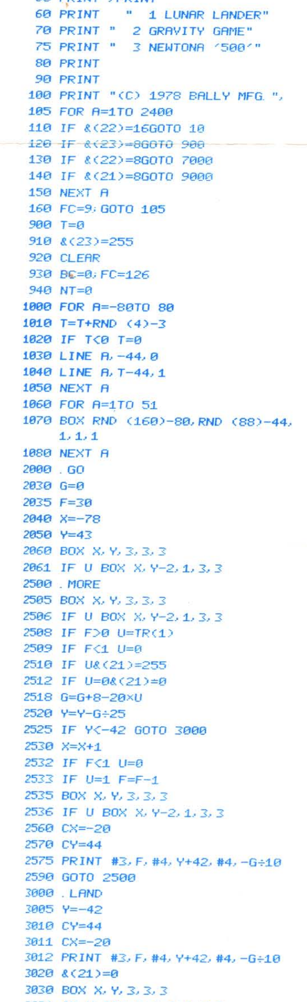

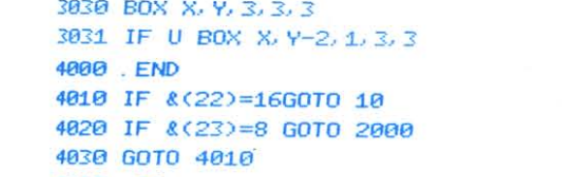

https://ballyalley.com/tape_manuals/misc/Bally%20BASIC%20Tape%20(Software%20No%201).pdf