DPLYR Practice and Applications

Instructions: Generate and email an Rmarkdown file and a Word file that shows all R coding and required output.

library(tidyverse)

library(dplyr)

mpg

1) From the mpg data frame, use and show R code to produce a new data table that only shows data for the three variables **manufacturer**, **model**, and **drv**.

2) From the mpg data frame, use and show R code to produce a new data table that shows data for all vehicles whose city mileage **cty** is less than 17.

Print the first 20 rows.

3) From the mpg data frame, use and show R code to produce a new data table that only shows data for the **manufacturer** *ford* , **class** of *suv* vehicles in the **year** *2008*) (You should only see 3 vehicles)

4) From the mpg data frame, use and show R code to produce a new data table that shows highway mileage **hwy** only for *dodge* vehicles in descending order. Print the first 15 rows.

5) Use the pipping method to create a new data table from the mpg data frame that outputs the variables **model**, **class**, and **cty.** This new data table also only shows city mileage for values less than 20 in descending order for the **model** *mustang.* Print the first 6 rows.

6)

Set your working directory to your desktop

Go to Github, locate and open the astronautsdata excel file.

Then save the astronautsdata excel file to your desktop

Read in the astronautsdata into your R studio IDE. Assign the data to the variable AD.

Use the coding below

**read_csv("astronautsdata.csv") -> AD**

**AD**

7)

Use dplyr functions to select the column variables Name, Gender,

MilitaryBranch ,SpaceWalks, and SpaceFlights from the astronauts data.

8)

Now modify the table that you obtained for #7 by using Rcode to produce

a table that only shows female astronauts.

9) Show and use R code that will produce the following data table.

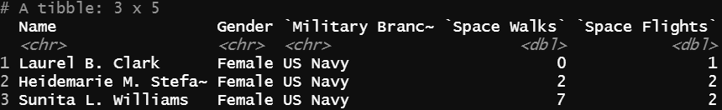

10) Show and use R code that will produce the mean number of Space Walks based

on the gender of the astronauts.