Would You Please
UI Design Specification
Companion to the PRD — v2.9
Prepared: July 22, 2026
Status: Draft for Review
Classification: Confidential

Contents
Contents 1
1. Introduction 4
1.1 Purpose 4
1.2 Relationship to the PRD 4
1.3 Versioning and change control 4
1.4 Scope and roadmap 4
1.5 Naming conventions in this document 4
2. Design Principles 5
3. Color Palette 5
3.1 Core tokens 5
3.2 Contrast and accessibility 6
3.3 Use restrictions 6
4. Typography 7
4.1 Family and fallback 7
4.2 Type scale 7
4.3 Numerals and dates 8
5. Iconography 8
5.1 Functional icon family 8
5.2 Logo treatment 9
5.3 Sizing rule 10
6. Components 10
6.1 Primary button (Create Request, Create ToDo) 10
6.2 Chip filter row 10
6.3 Column header bar with sort pill 11
6.4 List row — Sent / Received 11
6.5 List row — ToDo 11
6.6 Search bar 11
6.7 Group label 12
6.8 Header band 12
6.9 Information-only icon 12
6.10 Text input 13
6.11 Secondary button 13
6.12 Modal dialog 13
6.13 Toast 14
6.14 Subscription / Account banner 14
6.15 Reserved ad slot 14
6.16 Lookup and picker fields 15
6.17 Calendar and clock pickers 15
6.18 Storage warning strip (New in v2.9) 15
7. Layout and Spacing 16
7.1 Breakpoints 16
7.2 Spacing scale 16
7.3 Screen margins 17
8. Interaction Patterns 17
8.1 Sorting 17
8.2 Filtering 17
8.3 Truncation 17
8.4 Overdue treatment 17
8.5 Queued state 17
8.6 Print 18
8.7 Expand to full page 18
8.8 Voice search 18
8.9 Reduced motion 18
9. Screen Specifications 18
9.1 Main Screen (Dashboard) 18
9.2 Create Request 20
9.3 Respond to Request 23
9.4 Create / Edit ToDo 27
9.5 Dialog Thread 27
9.6 Detailed Item 27
9.7 Expanded Full-Page List 28
9.8 Find / Select / Add Contact 28
9.9 Add / Edit Contact 28
9.10 User Creation / Login / Profile 32
9.11 Onboarding / Welcome 32
9.12 Notification / Activity Feed 32
9.13 Settings 33
9.14 Subscription / Upgrade 33
9.15 Non-Registered Recipient Web Response 33
9.16 Request Notification Email Template 34
9.17 Banners — Sign-up, Early-User Ad-Deferral, 60-Day Trial 34
9.18 Empty and Error States 34
9.19 Storage Maintenance 35
10. Accessibility 38
10.1 Touch targets 38
10.2 Color contrast 38
10.3 Keyboard navigation 38
10.4 Screen readers 38
10.5 Reduced motion 38
10.6 Text scaling 38
11. Asset Inventory 38
11.1 Functional icons (v4.0; Contract added in v2.1; label-affordance glyphs added in v2.7) 38
11.2 Logo (v7.2 Checked Request) 39
11.3 Fonts 39
12. Open Design Questions 39
Schedule A — Revision History 40

1. Introduction

1.1 Purpose
This document is the visual and interaction specification for Would You Please. It defines the design system (color palette, typography, icon library, component specifications, spacing rules) and the layout of every screen in the application. It serves designers, front-end developers, and product reviewers as the single source of truth for how the product looks and behaves at the surface.

1.2 Relationship to the PRD
The Product Requirements Document (PRD) describes what the product does and why: the data model, business rules, notifications matrix, scalability targets, monetization, and roadmap. This UI Design Specification describes how the product looks. The two documents are kept separate so each can evolve at its own pace: the PRD changes when scope or business rules change; this specification changes far more frequently as designs iterate. Cross-references between the two documents are by section number (for example, the Main Screen layout in §9.1 below corresponds to PRD §3 functional behavior and PRD Figure 12.1).

1.3 Versioning and change control
This document and the PRD use independent version numbers. The UI Specification version (starting at v1.0) is bumped whenever a substantive change is made to a token, component, or screen. Minor copy edits and clarifications do not require a version bump. Each section has its own change history at the end of this document (§12).

1.4 Scope and roadmap
v1.0 includes the complete design system (§§3–8) and a fully-specified Main Screen (§9.1). Sections §9.2 through §9.18 are skeleton placeholders for the remaining screens listed in PRD §14.2. Each placeholder identifies the screen, its purpose, the components it will use, and the open design questions for that screen. Subsequent versions of this document will replace each placeholder with a fully-designed screen specification.

1.5 Naming conventions in this document
Screen and component names are set in plain title case: Create Request, Add Contact, Respond to Request, Storage Maintenance. The lowercase form names the action rather than the screen — a user creates a request on Create Request. A section reference accompanies the first mention of a screen within a section. Double quotation marks are reserved for verbatim product copy, so a quoted string in this document is always text the user sees on screen.
No italic, bold, or colored treatment is applied to screen names. Quotation marks already mean verbatim copy, so quoting a screen name would leave “Create Request” ambiguous between the name of the screen and the literal label on the button; figure captions are set in italic; bold carries table lead-ins; and color fails in print and greyscale. The convention applies prospectively — sections conform as they are revised rather than by a sweep of the document. New in v2.9.

2. Design Principles
Five principles guide every decision in this specification.
- Plain and accountable. The product is built around tracked promises between people. The UI should make the state of every request obvious at a glance — who, when, status — without ornament.
- Person-to-person, not team-to-team. The UI does not assume the user has an organization, workspace, or admin. There is no project setup. A user opens the app and sends a request.
- Cross-platform parity. The same controls and the same vocabulary appear on web, iOS, Android, and Windows. Layout adapts to viewport width but content and controls do not change between platforms.
- Web-first for the Pilot. Per PRD v6.0, the Pilot ships as a responsive web app. All component specifications in this document target the web first; native ports preserve the same components.
- Touch-first sizing, mouse-friendly. All interactive controls meet a 40-pixel minimum hit area so they are tappable on a phone. The same controls remain comfortable to click with a mouse on desktop.

3. Color Palette
Twelve tokens define every color the product uses. The palette is intentionally compact so that screens stay visually unified and brand recognition stays strong. Hex values are authoritative; CSS files, native asset catalogs, and SVG sources must use these exact values.

3.1 Core tokens
Swatch | Token | Hex | Usage
 | Brand Blue | #2A5FC8 | Logo, app name, clickable icons, buttons, column-header bars, section sub-headings (Sent, Received), selected-chip outline, read-only detail field labels (§9.3)
 | Blue (pressed) | #1E4AA0 | Button base shadow and active/pressed state
 | Alert Red | #D32F2F | The Overdue chip label and its selected outline, overdue row text, inline error messages (§6.10), and storage-critical states (§6.18) — status-only from v2.5: red means Overdue, error, or impending irreversible loss and nothing else
 | Sort Highlight | #FFE34D | Pill background around the active sort column. The sole yellow in the system from v2.5
 | Icon Grey | #6B7280 | Strokes and fills for information-only icons (Dialog, Attachment)
 | Ink | #1F2933 | Primary text, row name, description, ToDo description; group labels (§6.7, from v2.5)
 | Ink Soft | #5A6675 | Dates, captions, tagline, secondary text
 | Row Tint | #F6F7F9 | Zebra striping between adjacent rows in lists
 | Strip | #E5ECF7 | Background of the section-card chips strip on Sent, Received, and ToDos (see §6.2). Slightly darker than Row Tint so individual chip selection areas remain visible against it.
 | Rule | #E2E6EC | Grid lines, table borders, divider lines
 | Band | #E7E7E7 | Neutral fill of the group-label heading bands (Requests, ToDos, and screen-title bands such as Add Contact) and of the search-bar surface (§6.6). Deliberately neutral rather than blue-family so the group level reads distinctly from the blue-tinted Strip. New in v2.5.
 | Input Border | #7E8A9A | 1-px boundary of text inputs, the scope pull-down, the search field, and the country-code selector. Approximately 3.5:1 against white, clearing the WCAG 2.1 §1.4.11 3:1 non-text minimum. Rule remains for hairlines, dividers, and card borders only. New in v2.5.
 | Focus Tint | #EDF2FD | Fill of the focused text field (§6.10) and the banner attention wash (§6.14). A state fill, not a surface tint. New in v2.5.
 | Focus Halo | 0 0 0 3px rgba(42,95,200,.22) | Outer glow on focused text inputs (§6.10). New in v2.5.
 | Scrim | #1F2933 @ 45% | Overlay behind modal dialogs (§6.12): Ink at 45% opacity over the underlying screen. Swatch shows the token composited on white.

3.2 Contrast and accessibility
All token combinations used for text-on-background in normal weight meet WCAG 2.1 AA contrast (4.5:1) at body size or larger. The combinations that require attention are: Alert Red on Row Tint (overdue rows) — re-verified as passing AA against the lighter #F6F7F9 introduced in v2.5 (contrast improves relative to v2.4); Ink Soft at 12 px on Strip (the §9.9 gating notice) — approximately 4.9:1; and Input Border on white — approximately 3.5:1 against the 3:1 non-text minimum (WCAG 2.1 §1.4.11). The former Brand-Blue-on-Field-Yellow verification is retired with the token. Designers must re-check contrast whenever a new token combination is introduced.

3.3 Use restrictions
Brand Blue and Alert Red are the only saturated colors used at scale. Decorative gradients and additional accent colors are not part of this system. The only tinted backgrounds permitted are: Band (group-label heading bands and the search-bar surface), Row Tint (zebra striping in lists), and Strip (the section-card chips strips and full-width form chip rows; see §6.2). Focus Tint is a state fill, not a surface. Adding any new token requires updating §3.1 in a new version of this document. The Scrim token (§3.1, added in v2.3) is an overlay, not a background tint; it appears only behind modal dialogs (§6.12). Strip additionally surfaces chip rows used as labeled form controls (§6.2, §9.9). The v2.4 Settings segment is removed in v2.5.

4. Typography
A single family carries the entire UI. Inter is used everywhere; weight (not a second face) creates hierarchy. Inter was chosen because it pairs naturally with the system UI font on iOS, Android, and Windows — when Inter is unavailable, the OS native takes over without a visual jolt.

4.1 Family and fallback
Primary family: Inter (regular, medium, semibold, bold, extrabold). Fallback stack: system-ui, Segoe UI, Roboto, Helvetica, Arial, sans-serif. On the Web Pilot Inter is loaded from a self-hosted woff2 with font-display: swap, so first paint uses the system font and Inter swaps in once loaded; this avoids a flash of invisible text.

4.2 Type scale
Element | Size | Weight | Sample
App name (wordmark) | 27 px | 800 (extrabold) | Would You Please
Tagline | 13.5 px | 600 (semibold) | Tracking Requests and ToDos
User name (removed in v2.0) | 12.5 px | 700 (bold) | —
Date and time (removed in v2.0) | 11 px | 400 (regular) | —
Section heading (Sent, Received) | 18 px | 800 (extrabold) | Sent
Group label (red) | 18 px | 800 (extrabold) | Requests
Chip filter label | 12 px | 500 / 700 | All Open Overdue Done
Column header (on blue bar) | 11 px | 700 (bold) | To Date Due Done
Row name (To / From) | 12.5 px | 600 (semibold) | Atley, Roman
Date | 12 px | 500 (medium) | 8-15-25
Due date (bold unless Done) | 12 px | 700 (bold) | 6-15-25
Description (Sent / Received) | 12.5 px | 700 · 2-line clamp | Recommend annual planning…
ToDo line: Priority / Category / desc. | 12.5 px | 700 / 700 / 400 | ASAP Future Dev — Respond to dev quote…
Search field placeholder | 13 px | 400 (regular) | Search Would You Please

4.3 Numerals and dates
All dates in lists use tabular-figures so digits align vertically when stacked. Date format in list rows is M-D-YY for the user's locale; the Detail screen uses the locale-aware long form (e.g. July 1, 2025). Timestamps are stored in UTC; display follows the user's profile time zone. Deadline dates falling within thirty days may carry the weekday in the locale-aware long form (for example, Wednesday, September 8) where naming the day materially aids planning; the year is omitted where the date is necessarily near-term and its inclusion would force a wrap, and retained wherever the same date appears in email or in a summary that may be read later (new in v2.9).

5. Iconography
Eleven functional icons and one logo mark are used throughout the product. Icons split into two groups that look and behave differently: clickable icons are rendered in brand blue, sized for a 40-pixel touch target with a 23-pixel glyph; information-only icons are smaller (15 pixels) and rendered in icon-grey to indicate they are not interactive. This pairing rule is the most important visual convention in the product and should not be broken. A third group, new in v2.7, contains label-affordance glyphs (§6.16): small grey-toned marks rendered inside resting field labels — lookup, calendar, clock — at approximately 120% of the label font size, vertically centered on the label text; they are part of the label, not controls, and have no touch target.

5.1 Functional icon family
Icon | Name | Category | Behavior
 | Expand | Clickable | Opens the section as a full page with the same filter and sort state. On the full-page view this icon is replaced by Contract (next row).
 | Contract | Clickable | Returns from the full-page Expanded view back to the main screen, preserving filter and sort state. Shown only on the full-page view, in the same right-aligned position as Expand on the main screen.
 | Print | Clickable | Prints the section as currently filtered and sorted, prompting whether to include Dialog.
 | Voice search | Clickable | Captures a spoken search term in place of typing.
 | Search | Clickable | Submits the current search term, scoped by the pull-down to the left.

 | Dialog | Information-only | Indicates one or more Dialog entries (Questions, Answers, or Comments) exist on this item.
 | Attachment | Information-only | Indicates one or more attachments exist on this item.
 | Lookup | Label affordance | Inside the resting label of a type-ahead field (§6.16); signals that focusing the field opens an automatic pull-down that matches as you type. Deliberately distinct from Search: the plain magnifier always executes a search.
 | Calendar | Label affordance | Inside the resting label of a date field (§6.16); signals a month-forward calendar picker on focus.
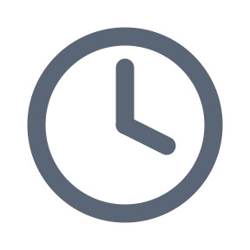 | Clock | Label affordance | Inside the resting label of a time field (§6.16); signals a now-forward time picker on focus.

5.2 Logo treatment
The selected logo mark is the v7.2 “Checked Request” — an outlined speech bubble with three light-blue text lines and a navy check mark angled across the upper right. Two variants exist: a light-background variant (outlined bubble, used in the application UI and on white pages) and a dark-background variant (filled white bubble, used on brand-blue or dark marketing surfaces). The horizontal lockup exists in matched light- and dark-background variants; the stacked lockup format previously planned has been dropped. See the asset inventory in §11.

Figure 5.1 — Logo, light-background variant (v7.2 Checked Request)

5.3 Sizing rule
Clickable icons render at 23 pixels inside a 40-pixel square hit area (a 9-pixel margin on each side ensures the target meets the ≥44-pixel mobile minimum when the visual padding around the control is included). Information-only icons render at 15 pixels and have no hit area. The visual size difference is intentional: it tells the user, without any label, which icons respond to a tap. Label-affordance glyphs (§6.16) render at approximately 120% of the resting label’s font size (≈17 px against the 14-px resting label), vertically centered on the label text, inside text inputs, and disappear when the label floats; they have no hit area.

6. Components
Components are the reusable interface parts that combine to form screens. Each component is specified once here; screens in §9 reference the component name rather than re-describing it.

6.1 Primary button (Create Request, Create ToDo)

6.1.1
Anatomy: Filled brand-blue button with white 13-px / bold label, flat Brand Blue fill (no gradient, no bottom shadow), 11-px corner radius, 9-px vertical / 16-px horizontal padding.
States: Default; hover (fill lightens slightly); pressed (fill becomes Blue Pressed); disabled (60% opacity).
Notes: Always carries a verb that matches the resulting state — "Create Request" then a toast "Request created." Never used for navigation.

6.2 Chip filter row

6.2.1
Anatomy: Horizontal row of two-to-four single-select chips. Each chip is a pill with a 12-px / 600 label, 12-px horizontal padding, 5-px vertical padding (30-px minimum hit height), 9-px corner radius, and a 6-px gap between adjacent chips. Chips sit on the Strip color token (§3.1) so each chip’s outline is always visible against its background.
States: Selected chip: white pill fill with a 1.5-px Brand Blue outline, label set to Brand Blue / 700, with a faint Brand-Blue drop shadow (0 1 2 rgba(42,95,200,.18)). Unselected: translucent white fill (.5 alpha) with a hairline ink outline (.10 alpha), label set to Ink / 600. Overdue (Sent and Received only): the chip label is set to Alert Red / 600 when unselected; when selected, the outline and label both become Alert Red / 700 with an Alert-Red drop shadow (0 1 2 rgba(211,47,47,.18)). Hover: unselected chip fill brightens to .8-alpha white. Focus: a 2-px Brand-Blue focus ring outside the chip.
Notes: Replaces the radio filter row used in v1.0–v2.0. Lives inside the section card’s Strip-tinted header area, sharing the row with the Expand and Print clickable icons (right-aligned). Sent and Received maintain independent filter state and place the chip row beneath their brand-blue sub-heading; ToDos has no sub-heading row, so its chip row sits directly inside the Strip area with Expand/Print at the right end, matching the Sent/Received icon placement. ToDos uses three chips (All / Open / Done) because the due date is optional and Overdue does not apply. From v2.4 chip rows may also appear inside forms as labeled single-select controls . From v2.5 the form variant is a full-width Strip row — no border, 9-px radius, 44-px minimum height, 6-px vertical / 10-px horizontal padding — with the chip pair at the left and, where applicable, an inline notice (Ink Soft, 12 px) filling the remaining width, vertically centered. On narrow viewports the notice may wrap to three lines and the row grows; there is no stack-back breakpoint. First use: "Send Requests by", §9.9).

6.3 Column header bar with sort pill

6.3.1
Anatomy: Brand-blue bar with white 11-px / 700 column labels and 6-px column gap matching the row grid below it. The active sort column is wrapped in a Sort-Highlight pill (#FFE34D) with a ▲ or ▼ caret.
States: Inactive column: white label only. Active ascending: pill with ▲. Active descending: pill with ▼. Tapping any header column promotes it to active in default direction; tapping the active column toggles direction.
Notes: Defaults: Sent and Received sort by Due descending. ToDos sort by Priority ascending (ASAP, SOON, LATER). Sort state persists across sessions per user.

6.4 List row — Sent / Received

6.4.1
Anatomy: Two-line row (three lines when the Request carries a Due Time, PRD §2.7) with a 4-column grid matching the header above (To/From, Date, Due, Done). Line one carries the four columns; line two carries information-only icons followed by a 2-line clamped bold description. When a Due Time is present, the time renders on an additional line beneath the date in the Due column, inheriting the row’s bold/red treatment.
States: Default; hover (Row Tint deepens slightly); overdue (entire row text in Alert Red); done (Done date populated, Due un-bolds); queued (small grey "Queued" badge before the description).
Notes: Tapping the row opens the Detailed Item screen (§9.6). Long-press on mobile shows a context menu for Cancel, Mark Done, Copy.

6.5 List row — ToDo

6.5.1
Anatomy: Single flowing line with hanging indent for icons. Sequence: optional information-only icons, then Brand-Blue Priority label (ASAP / SOON / LATER), then bold Category if present, then " — " em-dash, then regular-weight description. Two-line clamp applies to the description.
States: Default; hover; done (Priority moves to Ink Soft, description gets a strike-through).
Notes: Color on the Priority label removes the need for a separator after it. When the user does not adopt Categories, the row reads cleanly as "ASAP Finish the PRD…" with no orphan punctuation.

6.6 Search bar

6.6.1
Anatomy: Fixed at the bottom of the main screen. Four parts left-to-right: scope pull-down (12-px / 700, white fill, 1-px Input Border), search field (white fill, 1-px Input Border, 13-px placeholder), voice-search icon (clickable), search icon (clickable). The bar sits on a Band surface.
States: Default; focused (field border deepens to Brand Blue); voice listening (microphone pulses).
Notes: Scope options: All, Requests, ToDos, To, From, Category, Date. Pressing Enter in the field is equivalent to tapping the search icon. The two search-bar glyphs — Voice search and Search — render at 24 px inside standard 40-px touch targets. The search bar appears on the main screen only. The v2.4 Settings segment and gear are removed in v2.5; settings/account functions are reached through the bottom banner (§6.14).

6.7 Group label

6.7.1
Anatomy: An 18-px / 800 Ink label ("Requests", "ToDos") sitting on its own Band (#E7E7E7) heading band at the start of a major screen region, with the section’s primary button to its right on the same band.
States: Always present; no state variants.
Notes: The Create Request and Create ToDo primary buttons appear to the right of this label rather than in the header, creating a consistent action pattern across both groups. From v2.5 the band carries no hairlines: the #E7E7E7 fill self-defines its edges against the white header above and the form or list surface below.

6.8 Header band

6.8.1
Anatomy: Single band at the top of the main screen. Line one: logo (left) with wordmark. Line two: tagline under the wordmark. The user name and date/time previously shown on this band were removed in v2.0 (a login is always required, so the session is already identified).
States: Always present; user name updates with profile changes; date and time refresh on a 30-second tick.
Notes: Drops the "For:" prefix and the weekday from earlier drafts to reclaim horizontal space without losing identifying information. The header band carries no bottom rule (v2.3): on every screen, the first heading band (Band, §6.7) sits flush beneath the header with no top margin and no top hairline, recovering 12 px of vertical space. Subsequent heading bands on the same screen keep the 11-px top margin and top hairline.

6.9 Information-only icon

6.9.1
Anatomy: 15-px icon in Icon Grey rendered immediately before content it qualifies (description on a Sent/Received row, or Priority on a ToDo row).
States: Default only; not interactive.
Notes: Used for Dialog and Attachment. Multiple information-only icons stack horizontally with 5-px gap. They never appear in clickable icon-blue.

6.10 Text input

6.10.1
Anatomy: Floating-label field: the 14-px / 500 Ink Soft label sits inside the field at rest and rises above the value (approximately 11-px / 600) when the field is focused or holds a value; the risen label is Brand Blue while focused, Ink otherwise. The field is white at rest with a 1-px Input Border, 9-px corner radius, 50-px minimum height (room for the risen label), 20-px top / 10-px horizontal / 6-px bottom padding, and 14-px Ink value text. Multi-line variant (Notes and similar): 84-px minimum height, vertical resize, 1.4 line height, 500-character limit per the app-wide text convention. Phone variant: a country-code selector button (78-px minimum width, 600 weight, 50-px height to match, with a small down caret) precedes the number field in a single row with an 8-px gap; the floating label applies to the number field only; the selector defaults to a visible code derived from the browser locale (for example "US +1") and is never blank; values are stored in E.164 form, which SMS invitations require.
States: Rest (white fill, Input Border); focused (Focus Tint fill, 1-px Brand Blue border, Focus Halo); error (inline Alert Red message directly below the field — the screen’s primary action is never disabled to signal an error; see §9.9.3).
Notes: White-at-rest fields with the blue focus family replace the v2.4 yellow-means-active convention: a blue tint marks only the focused field, never the whole form, consistent with the Brand Blue focus rings used throughout (§10.3). The label’s rise transition is suppressed under reduced motion (§8.9).

6.11 Secondary button

6.11.1
Anatomy: White-filled button with a 1.5-px Brand Blue outline, Brand Blue 12.5-px / 700 label, 11-px corner radius, 8-px vertical / 14-px horizontal padding. No bottom shadow (the shadow is reserved for the Primary button, §6.1).
States: Default; pressed (fill changes to Row Tint); focus (2-px Brand Blue focus ring at 2-px offset).
Notes: Used for the dismissive or lower-priority action placed beside a Primary button — for example Cancel next to Save on the Add Contact heading band (§9.9). Two filled primary buttons never share a band; opposite actions must not carry equal visual weight.

6.12 Modal dialog

6.12.1
Anatomy: White card, 11-px corner radius, 16-px vertical / 18-px horizontal padding, width the smaller of 88% of the viewport and 380 px, drop shadow (0 8 28 rgba(20,30,50,.28)), horizontally centered with its center near 34% of viewport height. Body text 13.5-px Ink at 1.45 line height. The card sits above a full-screen Scrim (§3.1).
States: Acknowledge-only variant — no buttons; a click or tap anywhere (card or scrim) dismisses (used by the no-contact interception dialog, §9.9.5, Figure 9.9.2). Action variant — carries a Primary button (§6.1) and, where needed, Secondary buttons (§6.11) for the remaining choices (used by the duplicate-contact dialog, §9.9.4).
Notes: Announce as role alertdialog to screen readers with the body text as the accessible label. The scrim blocks interaction with the screen beneath.

6.13 Toast

6.13.1
Anatomy: Transient confirmation strip: 13-px / 600 white text on Ink, 11-px corner radius, 10-px vertical / 14-px horizontal padding, bottom-center of the viewport above the search bar (§6.6) where present. Text wraps to two lines at most.
States: Default — auto-dismisses after 4 seconds; a tap dismisses immediately. Under reduced motion (§8.9) the toast fades rather than slides.
Notes: Carries a short past-tense confirmation ("Request created.") or a single-sentence consequence ("Without adding at least one Contact, Requests cannot be created." — §9.9.5). Sentence-case microcopy is the current convention; final case treatment is an open question in §12.

6.14 Subscription / Account banner

6.14.1
Anatomy: Full-width strip fixed at the bottom of the screen, below the search bar (§6.6) where one exists. White fill, 1-px Rule top hairline, minimum 40-px height (§10.1). Centered 13-px / 700 Brand Blue label, by tier — free user: "See Subscription Features and Other Options"; subscriber: "Account Options and Features". The entire strip is tappable: for free users it opens Subscription / Upgrade (§9.14); for subscribers it opens Settings / account management (§9.13).
States: Default; pressed (Row Tint fill); attention wash — when a free user taps the Text chip (§9.9), the banner washes Focus Tint for approximately 2 seconds to draw the eye, consistent with the v2.5 blue-means-active convention; no wash under reduced motion (§8.9).
Notes: Visibility — both tiers, on all screens (supersedes the v2.4 free-tier-only rule). The label and destination differ by tier (see Anatomy). The reserved ad slot (§6.15) remains free-tier only.

6.15 Reserved ad slot

6.15.1
Anatomy: Fixed 50-px strip at the true bottom edge of the screen, free tier only, below the Subscription banner (§6.14). 1-px Rule top hairline; a single 320×50 ad unit centered horizontally. The 50-px reservation is fixed so the page never shifts when the ad loads.
States: Ad loaded; ad unfilled (the reservation remains, empty, to preserve layout stability).
Notes: Free-tier bottom stack order, top to bottom: search bar (where present), Subscription banner, ad slot. The banner buffers the ad from the search-bar icons, reducing accidental ad taps. Combined free-tier bottom chrome is approximately 148 px on the main screen (56-px search bar + 41-px banner + 51-px ad slot); subscribers carry the search bar and the banner (~97 px); the ad slot never appears on the paid tier. Do not use the 320×100 unit; it pushes fixed chrome to roughly 30% of a small phone viewport.

6.16 Lookup and picker fields

6.16.1
Anatomy: A floating-label text input (§6.10) whose resting label is preceded by a label-affordance glyph (§5.1) at approximately 120% of the resting label’s font size (≈17 px against the 14-px label), vertically centered on the label text, with a 6-px gap before the label text. Calendar and Clock render in Ink Soft #5A6675 to match the resting label; Lookup renders as a faded-grey magnifier (Input Border #7E8A9A) overlaid by a solid Ink #1F2933 down-pointer, with a white knockout breaking the lens stroke around the pointer. Three glyphs: Lookup (wyp_icon_lookup.svg) on contact and Category type-ahead fields; Calendar (wyp_icon_calendar.svg) on date fields; Clock (wyp_icon_clock.svg) on time fields. Type-ahead pull-down list: white surface, 1-px Rule border, Focus Halo, 8-px corner radius; rows at 44-px minimum touch height; hover/active row fill Row Tint; the prefix matching the typed characters rendered in Brand Blue at weight 600. The list opens beneath the field at field width on mobile and as an anchored popover at the Desktop breakpoint (§7.1).
States: At rest the glyph is part of the label. When the label floats (focus, or value present) the glyph is not shown — the floated label is text only; it reappears only when the field returns to empty-at-rest. Field focus states are unchanged from §6.10 (Focus Tint fill, 1-px Brand Blue border, Focus Halo). Exception — picker fields (Calendar, Clock): the affordance glyph persists beside the floated label whenever the field holds a value, serving as the visible cue to re-open the picker, since a picker field has no text to retype; the field itself remains the tap target and the glyph is still not a separate control. Type-ahead Lookup fields keep the default rule (glyph hidden once a value is present), because they are edited by typing. First applied to Done Date / Done Time (§9.3) and the Due Date / Due Time pickers (§9.2).
Notes: The Lookup glyph is deliberately distinct from the Search action icon (wyp_icon_search.svg): the magnifier alone always means execute a search; the magnifier-with-down-pointer always means this field looks up as you type. Glyphs are not controls and have no hit area — the whole field is the tap target. First adopted for Create Request (§9.2); reuse on any future type-ahead or picker field.

6.17 Calendar and clock pickers
Status: placeholder (to be designed in a subsequent version). Purpose: visual design of the month-forward calendar and the now-forward digital clock opened by §6.16 picker fields. Until specified, the Web Pilot uses the browser-native date and time pickers styled to palette 1; the behavioral constraints (month-forward with past dates disabled; now-forward when the due date is today) are defined in §9.2.3.

6.18 Storage warning strip (New in v2.9)

6.18.1
Anatomy: Full-width strip rendered flush beneath the header band (§6.8) and above the first heading band, supplying its own bottom hairline since §6.8 leaves none. Minimum 40-px height (§10.1), growing to accommodate wrapped copy at narrow widths. Label at 13 px on the left, action text at 13 px / 800 right-aligned with a single right-pointing angle. The entire strip is one control; activating it opens Storage Maintenance (§9.19). Canonical mockup source: WYP_storage_warning_strip_palette1.html.
States: Caution — 20% or less of attachment storage remaining; label and action in Brand Blue at weight 600 on Focus Tint #EDF2FD with a 1-px Brand Blue bottom rule; main screen only. Critical — 10% or less remaining, or storage full; label and action in Alert Red at weight 700 on white between 1-px Alert Red top and bottom rules; every screen. Lapse countdown — a subscription grace window is open (PRD §6.3); Critical treatment. Pressed state fills Row Tint (Caution: a deeper Focus Tint). Only one strip renders at a time, and the lapse countdown supersedes both Caution and Critical while a grace window is open. Above the Caution threshold the strip is absent.
Copy: sentence case per §6.13, stating the condition and its consequence rather than a gesture — “click” is mouse-specific in a touch-first product. Caution: “Attachment storage is 82% full.” with the action “Free up space ›”. Critical: “Attachment storage is full. New attachments will fail.” with the same action. Lapse countdown: “Your subscription ended. Attachments over 100 MB are removed in 12 days, on Wednesday, September 8.” with the action “Review ›”. The percentage is live; the countdown states days remaining and the date deletion runs, not days elapsed since lapse (§4.3 governs the weekday form).
Notes: No new palette token is introduced — Caution reuses Focus Tint and Brand Blue, and Critical reuses Alert Red under the usage clause extended in §3.1, impending irreversible deletion being an error condition rather than decoration. An amber treatment was considered and rejected: it would require amending §3.1, which names Sort Highlight the sole yellow in the system from v2.5, together with §3.2 and the closed list of permitted tinted backgrounds in §3.3. Alert Red is not placed on Row Tint here, so the strip never enters the visual register that signals Overdue. Placement is deliberately not a chip inside the header band: PRD §3.1 records that the user name and the date and time were removed from the header in v10 because the clock overlapped the tagline at Galaxy S24+ width, and a chip beside the wordmark reoccupies exactly that reclaimed space.

7. Layout and Spacing

7.1 Breakpoints
The Web Pilot is responsive. Three breakpoints govern the main screen layout.
Breakpoint | Width range | Layout behavior
Mobile | ≤ 600 px | Header band stacked. Sent, Received, and ToDos sections stack vertically full-width. Search bar fixed at bottom. This is the layout shown as Figure 9.1.
Tablet | 601–1024 px | Header band on one line. Sections stack vertically but each section gets wider columns. Search bar fixed at bottom.
Desktop | ≥ 1025 px | Optional two-column layout: Sent and Received in the left column, ToDos in the right column. Search bar may move to the top-right of the screen on very wide viewports.

7.2 Spacing scale
All spacing values are multiples of 4 pixels: 4, 8, 12, 16, 24, 32, 48, 64. Component-internal spacing (padding inside a button, gap between a label and a dot) and component-external spacing (gap between two sections, margin around the screen) both draw from this scale.

7.3 Screen margins
Mobile: 16-px left and right outer margin, 14-px inside the header band, 14-px on each list section. Tablet and desktop: outer margin increases to 24 px; section width caps at 720 px on very wide screens so list rows do not stretch beyond a comfortable scan length.

8. Interaction Patterns
Patterns described here apply across multiple screens. They are documented once to keep individual screen specifications short.

8.1 Sorting
Tapping a column header promotes that column to active and sorts in its default direction (descending for date columns, ascending for text and Priority). Tapping the active column header again reverses direction. Sort state persists per user and per section (Sent and Received have independent sort state). The header on the next visit shows the same sort that was last set.

8.2 Filtering
The chip filter row above each section list (§6.2) applies a status filter (All / Open / Overdue / Done for Requests; All / Open / Done for ToDos). Filter state persists per section. The default on first launch is Open. Selecting a chip is exclusive within its row (single-select), matching the behavior of the radio filter row used in v1.0–v2.0.

8.3 Truncation
Request descriptions on Sent and Received rows and ToDo descriptions are clamped to two lines. When truncation occurs, the last three visible characters of the second line are replaced with an ellipsis (…). The full text is visible on the Detailed Item screen and on the Respond screen.

8.4 Overdue treatment
A row is overdue when its Due date is in the past and it is not Done. The entire row — name, dates, description, icons — is rendered in Alert Red. The row sorts and filters normally; it is not promoted to the top of the list unless the user explicitly sorts by Due.

8.5 Queued state
When a Request, Response, or Dialog entry is composed while the network is unreachable, the item is held on the device and rendered with a small grey "Queued" badge before its description. The badge clears automatically when the item is delivered. The user receives a push notification at the moment of delivery.

8.6 Print
Tapping the print icon in a section header prints that section as currently filtered and sorted. A modal first asks: "Include Dialog (Questions, Answers, Comments)?" with the default set to Yes. For each item, the printed output lists any attachment filenames (not the attachment contents). Print is also available from the expanded full-page list view (§9.7).

8.7 Expand to full page
Tapping the expand icon in a section’s chips strip opens that section as a full-screen list, inheriting the current filter and sort. On the full-page view, the Expand icon is replaced by the Contract icon (§5.1, §11.1) in the same right-aligned position; tapping Contract returns to the main screen with filter and sort state preserved. Standard back navigation also returns to the main screen.

8.8 Voice search
Tapping the microphone icon in the search bar begins a voice capture session that posts the transcribed text into the search field. The microphone pulses while listening; tapping it again before completion cancels. The same scope pull-down applies as for typed search.

8.9 Reduced motion
When the user has set "reduce motion" at the OS level, all animations are replaced with instantaneous state changes: the chip outline appears without easing, the sort pill swaps without a slide, the microphone does not pulse.

9. Screen Specifications
This chapter contains a section per screen. §9.1 is fully specified. §§9.2 through §9.18 are skeleton placeholders for the remaining screens listed in PRD §14.2 and will be replaced with complete designs in subsequent versions of this document. Each placeholder names the screen, states its purpose, lists the components from §6 it will reuse, and notes the open questions specific to that screen.

9.1 Main Screen (Dashboard)
The main screen is the entry point for every signed-in session. It shows three independently scrollable sections — Sent (Requests sent to others), Received (Requests sent to the logged-in user), and ToDos — under a persistent header band, with a search bar fixed at the bottom.

9.1.1 Mockup
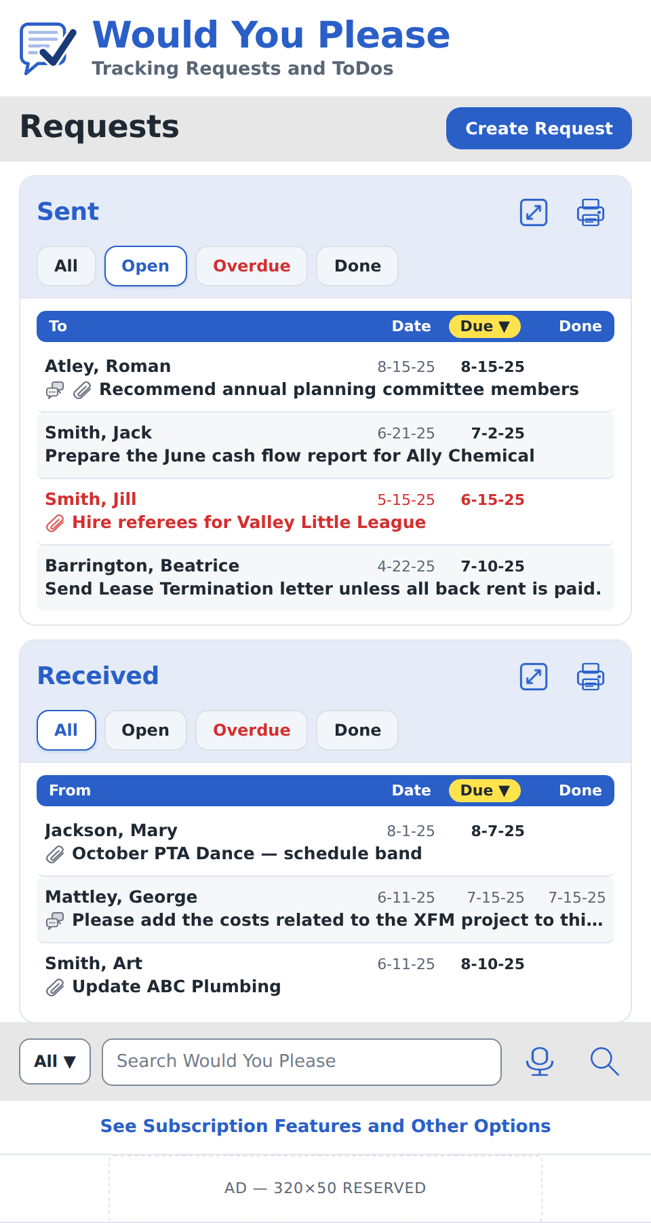
Figure 9.1 — Main screen (v2.5 design) at mobile-browser width. Neutral Band heading bands with Ink labels, flat primary buttons, neutral zebra striping, and the search bar without the v2.4 Settings segment. Canonical mockup source: WYP_main_screen_palette1.html. Header band shows the v7.2 Checked Request logo with the enlarged wordmark and tagline. Each section card carries its filter chips in a Strip-tinted area alongside the Expand and Print icons (right-aligned). Chips are shown in their selected (Sent: Open; Received: All; ToDos: Open) and unselected states.

9.1.2 Composition
- Header band (§6.8) — logo + wordmark + user name on line one; tagline + date and time on line two.
- Group label "Requests" (§6.7) on a Band heading band with the Create Request primary button (§6.1) to its right.
- Sent section card: brand-blue "Sent" sub-heading and the Expand and Print clickable icons (§5.1) right-aligned share the top of the Strip-tinted area; chip filter row (§6.2) with All / Open / Overdue / Done sits beneath them on the same strip; column header bar (§6.3) with To / Date / Due / Done; list of rows (§6.4).
- Received section: same composition as Sent but with From column and independent filter and sort state.
- Group label "ToDos" (§6.7) on a Band heading band with the Create ToDo primary button (§6.1) to its right. (Expand and Print icons are NOT on this band; they live on the chips strip inside the ToDos section card below, matching Sent and Received.)
- ToDos section: chip filter row (§6.2) with All / Open / Done on the Strip-tinted area, with the Expand and Print clickable icons right-aligned in the same strip; column header bar (§6.3) with Priority — Category — Description; list of rows (§6.5).
- Search bar (§6.6) fixed at the bottom of the viewport.

9.1.3 Behavior
- On first load the Sent and Received filters default to Open; the ToDos filter defaults to Open. Each section's filter persists independently across sessions.
- Default sort: Sent and Received by Due descending; ToDos by Priority ascending.
- Tapping a row in Sent or Received opens the Detailed Item screen (§9.6). Tapping a row in ToDos opens Create/Edit ToDo (§9.4) in edit mode.
- Tapping the search field collapses the on-screen sections downward and raises the keyboard. The search field commits on Enter or on tap of the search icon.
- When a section has zero items matching the active filter, the row area shows an empty state (§9.18).

9.1.4 Responsive behavior
Per §7.1, the mockup above is the mobile rendering (≤ 600 px). At the Tablet breakpoint the header band collapses to a single line; the three sections continue to stack but each gets wider columns and the description column reads more naturally without truncation. At the Desktop breakpoint Sent and Received may share a two-column layout with ToDos to the right; full mockups for Tablet and Desktop will be added in a subsequent version of this document.

9.1.5 Edge cases
- Brand-new user, zero items in all three sections — show three empty states with a primary action in each.
- Network unreachable — items composed while offline appear with the Queued badge; refresh icon spinner appears in the header band.
- Recipient identified during compose was not a registered user — the Sent row shows a Queued badge until the recipient opens the secure web response link and creates an account or responds without creating one.
- Very long category name on a ToDo — the Category is truncated mid-word with an ellipsis so the description still fits two lines.

9.2 Create Request
Status: fully specified in v2.7.
Purpose: Compose and send a new Request: recipient (contact lookup), due date, optional due time, optional Category, description (500 chars), optional attachments. Sending is part of creating; there is no separate send step or screen.
PRD reference: PRD §3.2 (functional requirements), §2.1 (Request key fields, including Due Time added in v12.4), §2.6 (Contact data model and zero-contact interception), §2.7 (Due Time and Overdue).

9.2.1 Mockup
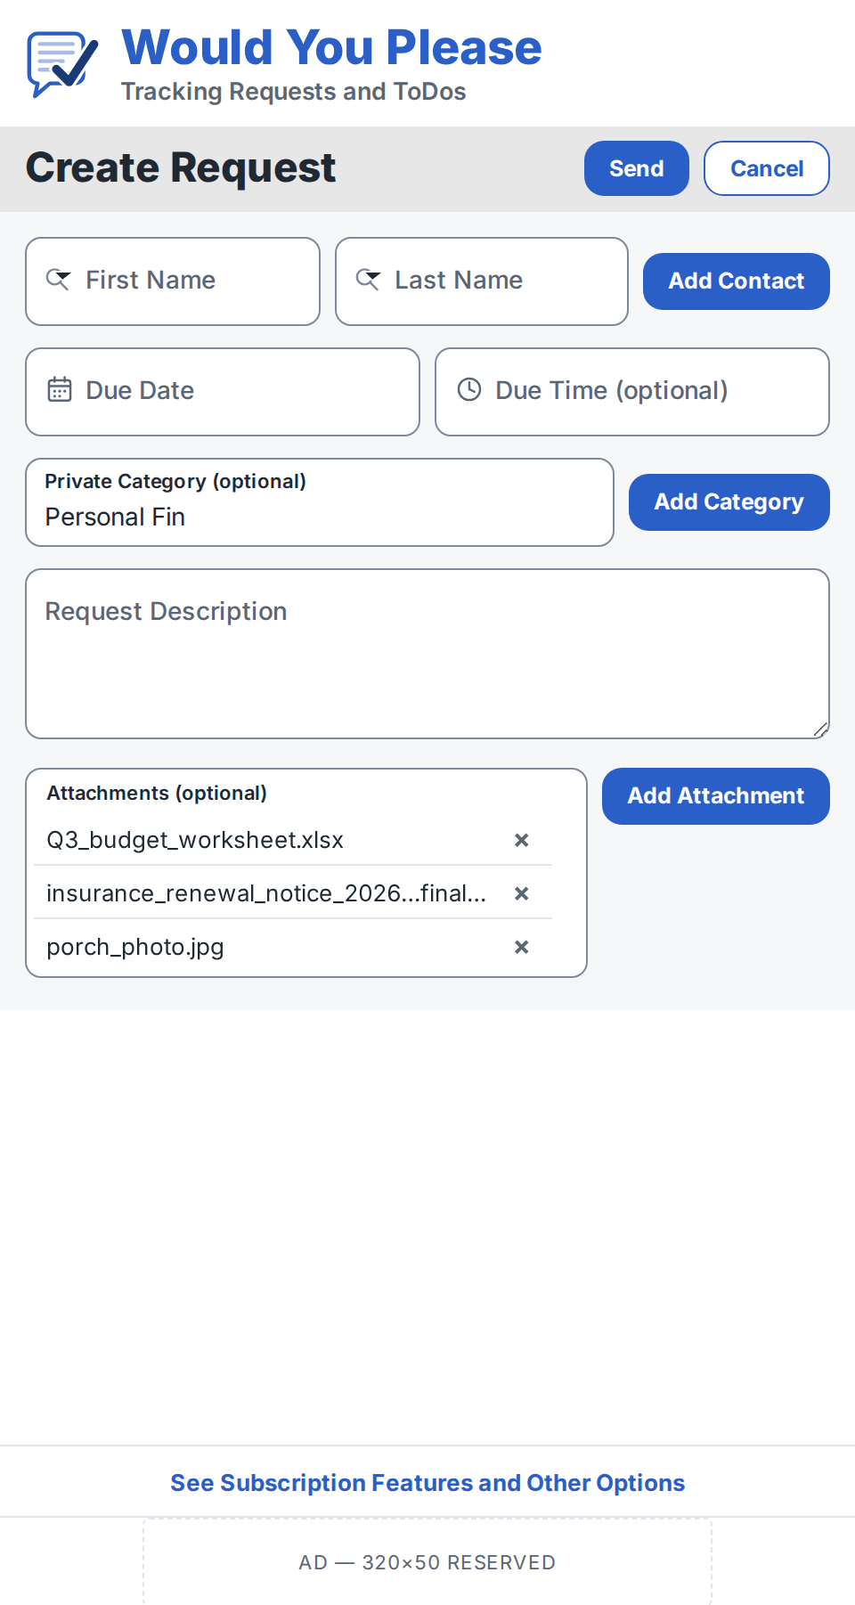
Figure 9.2.1 — Create Request at mobile-browser width. “Create Request” group label on a Band heading band flush beneath the header (no top rule, per §6.8), with Send (Primary, §6.1) and Cancel (Secondary, §6.11) right-aligned on the same band. Lookup and picker fields (§6.16) carry their affordance glyphs inside the resting labels; the Category field is shown filled to illustrate the risen-label state without the glyph. Attachments render as a list panel with per-row remove controls. Canonical mockup source: WYP_create_request_palette1.html (figure embedded at 480-px width, 2x).

9.2.2 Composition
- Header band (§6.8) — logo, wordmark, and tagline, identical to the main screen.
- Group label “Create Request” (§6.7) on a Band heading band flush beneath the header, with Send (Primary button, §6.1) and Cancel (Secondary button, §6.11) right-aligned on the same band — the heading-band-plus-buttons pattern established on Add Contact (§9.9).
- Form area on Row Tint #F6F7F9.
- Recipient row: First Name and Last Name lookup fields (§6.16) side by side, with the Add Contact primary button right-aligned on the same row. After a contact is selected, a one-line delivery-channel caption (Ink Soft, 12 px) appears beneath the row: “Will be sent by Email” or “Will be sent by Request Texting” per the contact’s delivery channel (PRD §2.6).
- Due row: Due Date (calendar picker field, §6.16) and Due Time (optional; clock picker field, §6.16) side by side.
- Category row: Category lookup field (§6.16, optional) with the Add Category primary button right-aligned.
- Request Description — multi-line text input (§6.10), 500-character limit, vertically resizable at the Desktop breakpoint.
- Attachments panel — bordered list area (Input Border at rest) with the Add Attachment primary button top-aligned beside it. Each attached file renders as one list row: filename (truncated mid-string with an ellipsis if too long) and a remove (×) control at the row’s right. A vertical elevator appears when the list exceeds the fixed panel height; the panel itself does not grow.
- Subscription / Account banner (§6.14) and, on the free tier, the reserved ad slot (§6.15) fixed at the bottom of the viewport, identical to the main screen.

9.2.3 Behavior
- Required fields: recipient (a selected contact), Due Date, Request Description. Optional fields are explicitly labeled “(optional)”: Due Time, Category, Attachments. Send validates the three required fields and marks failures inline per the §6.10 error treatment; Send is never disabled.
- Lookup fields (First Name, Last Name): on focus, a pull-down list of the user’s contacts opens beneath the field (§6.16). Typed characters filter by left-to-right prefix match, with the matched prefix highlighted. The First Name field lists and sorts contacts as “First Last”; the Last Name field lists and sorts as “Last, First”. Selecting a contact from either list fills both name fields and closes the list. When the typed text matches no contact, the list shows a single row — “Add ‘{typed text}’ as a new contact…” — which opens Add / Edit Contact (§9.9) with the name pre-filled.
- Add Contact button: opens Add / Edit Contact (§9.9); on Save the user returns with the new contact selected in both name fields (PRD §2.6).
- Due Date: on focus, a month-forward calendar opens at the current month; dates before today are disabled (picker visual design: §6.17 placeholder; the pilot uses the browser-native picker styled to palette 1).
- Due Time: on focus, a now-forward digital clock picker opens; when the selected Due Date is today, times before now are disabled; otherwise all times are selectable. Due Time is inert (with a hint caption) until a Due Date is set.
- Category: type-ahead over the user’s existing categories (§6.16 pull-down anatomy); a value must be selected from the list or created via Add Category — raw free text is not accepted. Add Category opens a one-field modal dialog (§6.12) that creates the category (enforcing the 20-category cap, PRD §2.3) and selects it on save. Rename and delete remain in Settings.
- Request Description: 500-character limit; a live character counter appears once the text passes 400 characters.
- Attachments: Add Attachment opens the platform file picker; maximum 10 per Request, 25 MB per file, and 50 MB per Request (PRD §2.1). At 10 the button is disabled with the caption “Maximum of 10 attachments”; removing a file re-enables it. A file breaching either size cap is rejected inline per the §6.10 error treatment, naming the cap it exceeds (new in v2.9).
- Send: on successful validation the Request is sent by the contact’s delivery channel — Email always on the free tier; Email or Request Texting per the contact record for subscribers (PRD §2.6). If the recipient is unreachable or not registered, the Sent row carries the Queued badge (§8.5, §9.1.5). On success the user returns to the main screen with the new item visible in Sent.
- Cancel: if any field has been modified, a confirm-discard modal dialog (§6.12) asks “Discard this Request?” with Discard / Keep editing; otherwise Cancel returns to the main screen immediately.

9.2.4 Responsive behavior
Per §7.1 the mockup is the mobile rendering (≤ 600 px), where the paired fields (First/Last, Date/Time) sit side by side and pull-down lists open at field width beneath their field. At the Tablet breakpoint the form gains horizontal padding and the Description area grows taller. At the Desktop breakpoint the form is centered at a fixed maximum width; pull-down lists and the calendar and clock pickers render as anchored popovers rather than full-width sheets.

9.2.5 Edge cases
- Zero contacts on entry — an acknowledge-only interception dialog (§6.12, §9.9.5) routes through Add / Edit Contact; on Save the user returns with the new contact selected (PRD §2.6).
- Typed name matches no contact — the pull-down shows only the “Add ‘{typed text}’ as a new contact…” row.
- 20-category cap reached — the Add Category dialog shows an inline error (“You’ve reached the maximum of 20 categories”) and its save control is disabled.
- 10-attachment cap reached — Add Attachment disabled with caption, per §9.2.3.
- Attachment exceeds 25 MB, or the Request's attachments would exceed 50 MB in total — the file is rejected inline naming the cap it exceeds (PRD §2.1); files already attached are unaffected.
- Network unreachable at Send — the Request is composed and queued; the Sent row carries the Queued badge (§8.5).
- Very long attachment filename — truncated mid-string with an ellipsis so the remove control stays visible.
- Due Date is today with all remaining times past (edge of day) — the clock picker opens on the next selectable minute.

9.3 Respond to Request
Status: fully specified in v2.8.
Purpose: The registered recipient’s view of a Request sent to them. From here the recipient reads the request, adds it to their calendar, records completion (Done Date and, where relevant, Done Time), participates in the Dialog thread, downloads the sender’s attachments and adds their own, and sends the response back to the sender. There is no separate free-text response field — the recipient’s reply is carried by the Done state, the Dialog thread, and any response attachments (owner decision 2026-07-21).
PRD reference: PRD §3.3 and §3.5 (received-request response and Dialog access), §2.1 (Request fields), §2.3 (Category is private to the sender — not shown here), §2.7 (Due Time and Overdue), §4 (Dialog), §7.3 (.ics calendar delivery). The non-registered web response (§9.15) is the token-based analogue of this screen and is specified separately.

9.3.1 Mockup
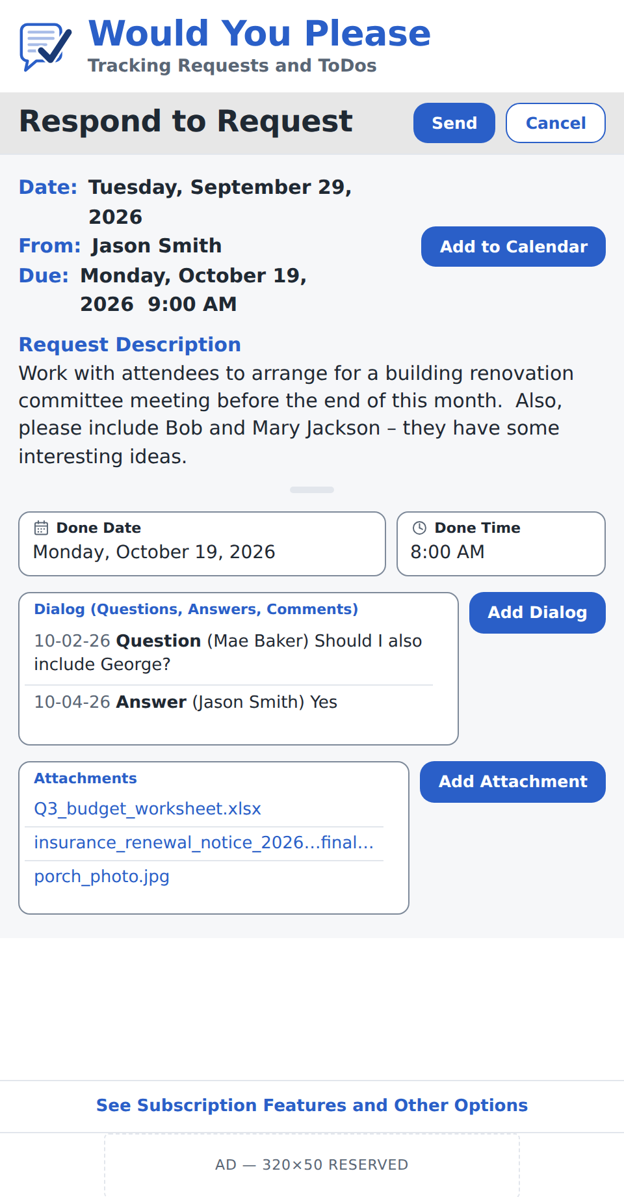
Figure 9.3.1 — Respond to Request at mobile-browser width. “Respond to Request” group label on a Band heading band flush beneath the header (§6.8), with Send (Primary, §6.1) and Cancel (Secondary, §6.11) right-aligned on the same band. The request header (Date, From, Due) uses read-only detail labels in Brand Blue (§3.1) with Ink values, and Add to Calendar (Primary, §6.1) sits beside it. The Category is deliberately absent — it is private to the sender (PRD §2.3). Done Date and Done Time are picker fields (§6.16) shown in a representative completed state (Done Date on the Due Date, so Done Time is shown); their calendar and clock glyphs persist because a value is present (§6.16 exception). The Dialog thread and the request’s attachments render as list panels with vertical elevators — request attachments are read-only download links — with Add Dialog and Add Attachment (Primary, §6.1) beside each panel. Canonical mockup source: WYP_respond_to_request_palette1.html (figure embedded at 480-px width, 2x).

9.3.2 Composition
- Header band (§6.8) — logo, wordmark, and tagline, identical to the main screen.
- Group label “Respond to Request” (§6.7) on a Band heading band flush beneath the header, with Send (Primary, §6.1) and Cancel (Secondary, §6.11) right-aligned on the same band.
- Form area on Row Tint #F6F7F9.
- Request header — three read-only lines: Date (when the Request was sent), From (the sender’s name), and Due (the due date, with the Due Time appended when the Request carries one, shown in the viewer’s local time zone per §2.7). Labels use Brand Blue read-only detail labels (§3.1); values are Ink. The Category is not shown — it is private to the sender (PRD §2.3). Add to Calendar (Primary, §6.1) is right-aligned beside the header and downloads an .ics for the request’s due date/time (PRD §7.3).
- Request Description — the sender’s description, read-only, beneath a Brand Blue “Request Description” sub-heading.
- Done row: Done Date (calendar picker field, §6.16) and Done Time (clock picker field, §6.16) side by side. Done Date is the wider field so it can hold the weekday-long date (consistent with the Due line, e.g. “Monday, October 19, 2026”); Done Time is the narrower field. Neither is auto-filled. Done Time is present only when the chosen Done Date equals the Request’s Due Date (see §9.3.3).
- Dialog panel — a bordered list panel (§9.2.2 anatomy) labelled “Dialog (Questions, Answers, Comments)” showing the thread, each entry as date, bold type (Question / Answer / Comment), (author), and text; a vertical elevator appears when the thread exceeds the panel. Add Dialog (Primary, §6.1) is top-aligned beside it and opens the Dialog composer (§9.5). Never labelled “Q&A”.
- Attachments panel — a bordered list panel showing the Request’s attachments, read-only and downloadable: each filename is a Brand Blue download affordance, with no remove control, since the recipient cannot overwrite or delete the sender’s files. Add Attachment (Primary, §6.1) is top-aligned beside it and adds the recipient’s own response attachments, which render as removable (×) rows in the same panel. A vertical elevator appears when the list overflows.
- Subscription / Account banner (§6.14) and, on the free tier, the reserved ad slot (§6.15) fixed at the bottom of the viewport, identical to the main screen.

9.3.3 Behavior
- Marking done vs. responding: recording completion is optional and separate from sending. To mark the Request Done the recipient selects a Done Date (and, where shown, a Done Time); leaving the Done fields empty and using Add Dialog or Send lets the recipient participate — ask a Question, post a Comment, add attachments — without completing the item. Because the Done fields are not auto-filled, Send never marks an item Done implicitly (owner decision 2026-07-21).
- Done Date: on focus a calendar picker opens (§6.16; visual design §6.17 placeholder, browser-native in the Pilot). The selected date displays in the locale-aware weekday-long form, matching the Due line (§4.3). The calendar glyph persists while a value is present so the picker can be re-opened (§6.16 exception).
- Done Time: shown only while the selected Done Date equals the Request’s Due Date and the Request carries a Due Time; on any other Done Date, or when the Request is date-only, the field is hidden. The rule is evaluated live — setting Done Date to the Due Date reveals Done Time, moving it away hides it. Rationale: the time of day changes the on-time / Overdue outcome only on the due date itself, and only when the Request has a Due Time (§2.7). On focus a clock picker opens (§6.16); the clock glyph persists while a value is present.
- Add to Calendar: downloads an .ics carrying the request’s due date and, if present, Due Time (PRD §7.3).
- Dialog: Add Dialog opens the Dialog composer (§9.5) to post a Question, Answer, or Comment; posted entries append to the thread and notify the sender (PRD §4). Editing and deletion of entries follow §9.5.
- Attachments: request attachments download on tap and cannot be removed. Add Attachment opens the platform file picker to add response attachments (removable before Send); the combined count is capped at 10 (PRD §2.1), and downloading, editing, and re-uploading a copy adds a new file without overwriting the original.
- Send: transmits the response — Done state (if set), any new Dialog entries, and any response attachments — to the sender and returns the recipient to the main screen, confirmed by a “Response sent.” toast (§6.13). Setting a Done Date sets the item’s Status to Done (§8.4); an Overdue Request completed after its due date/time is recorded Done but retains its Overdue history per PRD §2.7.
- Cancel: if the recipient has set a Done value, drafted a Dialog entry, or staged an attachment, a confirm-discard modal (§6.12) asks “Discard your response?” with Discard / Keep editing; otherwise Cancel returns to the main screen immediately.

9.3.4 Responsive behavior
Per §7.1 the mockup is the mobile rendering (≤ 600 px), where Done Date and Done Time sit side by side and the picker sheets open at field width. At the Tablet breakpoint the form gains horizontal padding and the panels grow taller. At the Desktop breakpoint the form is centered at a fixed maximum width, and the calendar and clock pickers render as anchored popovers.

9.3.5 Edge cases
- Request is date-only (no Due Time) — the Done Time field never appears, whatever Done Date is chosen; completion is recorded to the day.
- Recipient completes before the due date — if the recipient picks an earlier Done Date, Done Time stays hidden, since the time matters only on the due date.
- Recipient participates without completing — Send with the Done fields empty posts Dialog and attachments and leaves Status unchanged (Open or Overdue).
- Overdue at response time — the request row and Due line carry the Overdue treatment (§8.4); recording a Done Date does not erase the Overdue record (PRD §2.7).
- Long attachment filename — truncated mid-string with an ellipsis so the row stays on one line.
- 10-attachment cap reached (request plus response attachments) — Add Attachment is disabled with the “Maximum of 10 attachments” caption (§9.2.3).
- Offline at Send — the response is queued and the item carries the Queued badge (§8.5, §9.1.5).

9.4 Create / Edit ToDo
Status: placeholder (to be designed in a subsequent version).
Purpose: Compose or edit a personal ToDo: Priority (ASAP/SOON/LATER), optional Category, description, optional attachments, optional convert-to-Request.
PRD reference: PRD §3.4 and §2.5 (unified Request/ToDo data model).
Components reused from §6:
- Primary button (§6.1)
- Chip filter row (§6.2) repurposed for Priority
Open design questions:
- Should converting a ToDo to a Request delete the original or archive it?
- How does Category autocomplete present on small screens?

9.5 Dialog Thread
Status: placeholder (to be designed in a subsequent version).
Purpose: Threaded view of Questions, Answers, and Comments attached to a Request or ToDo. Replaces the v3.0 Q&A screen.
PRD reference: PRD §4 (Dialog).
Components reused from §6:
- Information-only icons (§6.9) for Attachment
- Primary button (§6.1) — "Post"
Open design questions:
- How is the Q / A / Comment type selected before posting — pill row or pull-down?
- Should the queued badge appear on the thread entry or on the parent item only?

9.6 Detailed Item
Status: placeholder (to be designed in a subsequent version).
Purpose: Read-only view of a Request or ToDo with full description, attachments list, Dialog summary, and response (if any). Reached by tapping a row on the main screen.
PRD reference: PRD §3.2/§3.3 (post-response read state).
Specified in v2.9 ahead of the full design: when an attachment is removed on Storage Maintenance (§9.19.4), the item carries a tombstone — a single line in Ink Soft in the attachments area, aggregated across removals, reading “1 attachment removed by Jim Kelley on Sep 8, 2027.” Because attachment storage is charged to the requestor including files the recipient added (PRD §2.1), a sender clearing space will routinely remove another party's files, and the record must not change silently.
Components reused from §6:
- Information-only icons (§6.9)
- Group label (§6.7) for status banner
Open design questions:
- Does the sender's Detailed Item view differ from the recipient's?
- Where does the Cancel / Edit action live for an Open item?

9.7 Expanded Full-Page List
Status: placeholder (to be designed in a subsequent version).
Purpose: Full-screen rendering of a single list section (Sent, Received, or ToDos) with the same filter, sort, and print controls as on the main screen.
PRD reference: PRD §3.7.
Components reused from §6:
- Column header bar (§6.3)
- List row (§6.4 or §6.5)
- Chip filter row (§6.2)
Open design questions:
- Does the expanded view include pagination, infinite scroll, or all-at-once rendering?
- Should bulk actions (multi-select) be supported here?

9.8 Find / Select / Add Contact
Status: retired in v2.7 (owner decision, 2026-07-20).
The compose-flow contact picker is now the inline type-ahead on Create Request (§9.2, component §6.16), and direct contact entry is Add / Edit Contact (§9.9). No standalone Find / Select / Add Contact screen exists; the section heading is retained to preserve numbering. The duplicate-detection behavior recorded here in v2.3 remains specified in §9.9.4, and the Phase 2 contact-import consent question moves to PRD §9.3 (Contact Import).

9.9 Add / Edit Contact
Status: fully specified in v2.3.
Purpose: Direct form for entering or editing a single contact's name, email, phone, and notes.
PRD reference: PRD §3.8 (legacy).

9.9.1 Mockup
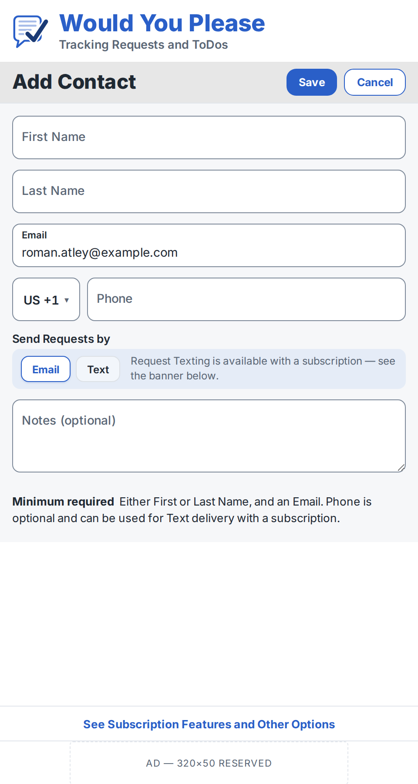
Figure 9.9.1 — Add Contact at mobile-browser width. "Add Contact" group label on a Band heading band sitting flush beneath the header (no top rule, per §6.8), with Save (Primary, §6.1) and Cancel (Secondary, §6.11) on the same band. Text inputs (§6.10) are floating-label fields, white at rest on the Row-Tint form area; the phone field carries the country-code selector; the minimum-required caption closes the form. Canonical mockup source: WYP_add_contact_palette1_floating.html.

9.9.2 Composition
- Header band (§6.8) — logo, wordmark, and tagline, identical to the main screen.
- Group label "Add Contact" (§6.7) on a Band heading band flush beneath the header, with Save (Primary button, §6.1) and Cancel (Secondary button, §6.11) right-aligned on the same band. Top placement keeps Save visible without scrolling and matches the established heading-band-plus-button pattern.
- Form area on Row Tint: five text inputs (§6.10) in the order First Name, Last Name, Email, Phone, Notes. First Name leads, matching North American entry habit and browser autofill order; autofill hints (given-name, family-name, email, tel-national) are set accordingly.
- Phone uses the §6.10 phone variant: country-code selector defaulting to a visible locale-derived code (never blank), followed by the national-number field.
- "Send Requests by" chip group (new in v2.4) directly after Phone: a field label in the standard label style over a full-width Strip row (§6.2 form variant) — chips Email and Text at the left, with a persistent inline notice (Ink Soft, 12 px) filling the remaining width. Free user: "Request Texting is available with a subscription — see the banner below." Subscriber: "Request Texting is included in your subscription — see the Account banner below for other options."
- Notes is the multi-line variant (§6.10): optional, 500-character limit per the app-wide text convention (PRD §3.8).
- Minimum-required caption below the form, by tier (v2.9). Free tier: "Minimum required — Either First or Last Name, and an Email. Phone is optional and can be used for Text delivery with a subscription." Subscriber: "Minimum required — Either First or Last Name, and either an Email or a Phone."

9.9.3 Behavior
- Minimum-required rule (add and edit alike), tier-scoped in v2.9: the contact must carry either a First or a Last Name. On the free tier it must also carry an Email, free-tier delivery being email-only — a phone-only contact could never be sent to. For a subscriber it must carry an Email or a Phone; save-time channel validation is unchanged, so the field matching the selected delivery channel must be populated. The rule is scoped by tier because a subscriber who reaches a contact only by Request Texting has no reason to hold an email address for them.
- Save is always enabled. If the minimum is not met on Save, inline Alert Red messages appear beneath the offending fields; disabling the button would hide why it does not work and is less discoverable and less screen-reader friendly.
- Phone numbers are stored as E.164 (country code included), required for SMS invitations via SNS/Twilio. The visible "+1" default derived from the browser locale is not US-specific — Canada is also +1.
- Delivery default and auto-follow: Email is selected by default. Until the user taps a chip explicitly, the selection follows data entry — filling Phone while Email is empty switches the selection to Text (subscribers only), and vice versa. Once tapped, the choice sticks; only Save-time validation intervenes.
- Subscription gating: for a free user, tapping Text does not change the selection — Email stays selected and the Subscription / Account banner (§6.14) washes Focus Tint for ~2 s (no wash under reduced motion, §8.9); the notice is persistent and does not appear or move on tap. A subscriber’s tap simply selects Text. The stored delivery method is per contact (PRD §3.8).
- Save-time channel validation: if the field matching the selection is empty on Save, an inline Alert Red message appears beneath that field (e.g. "Text delivery needs a phone number."); Save remains enabled per the always-enabled convention.
- Cancel discards edits and returns to the screen that opened the form (see §9.9.5 for the no-contact interception exception).

9.9.4 Duplicate handling on Save
If the entered email or phone matches an existing contact, Save is intercepted by an action-variant modal dialog (§6.12): "This email matches your existing contact [Name]." (or "This phone number matches…"), with three actions — Update that contact, Save as new, and Cancel. Update that contact merges the entered values into the existing record; Save as new creates a second contact; Cancel returns to the form unsaved. This resolves the duplicate-surfacing question formerly open in §9.8.

9.9.5 No-contact interception
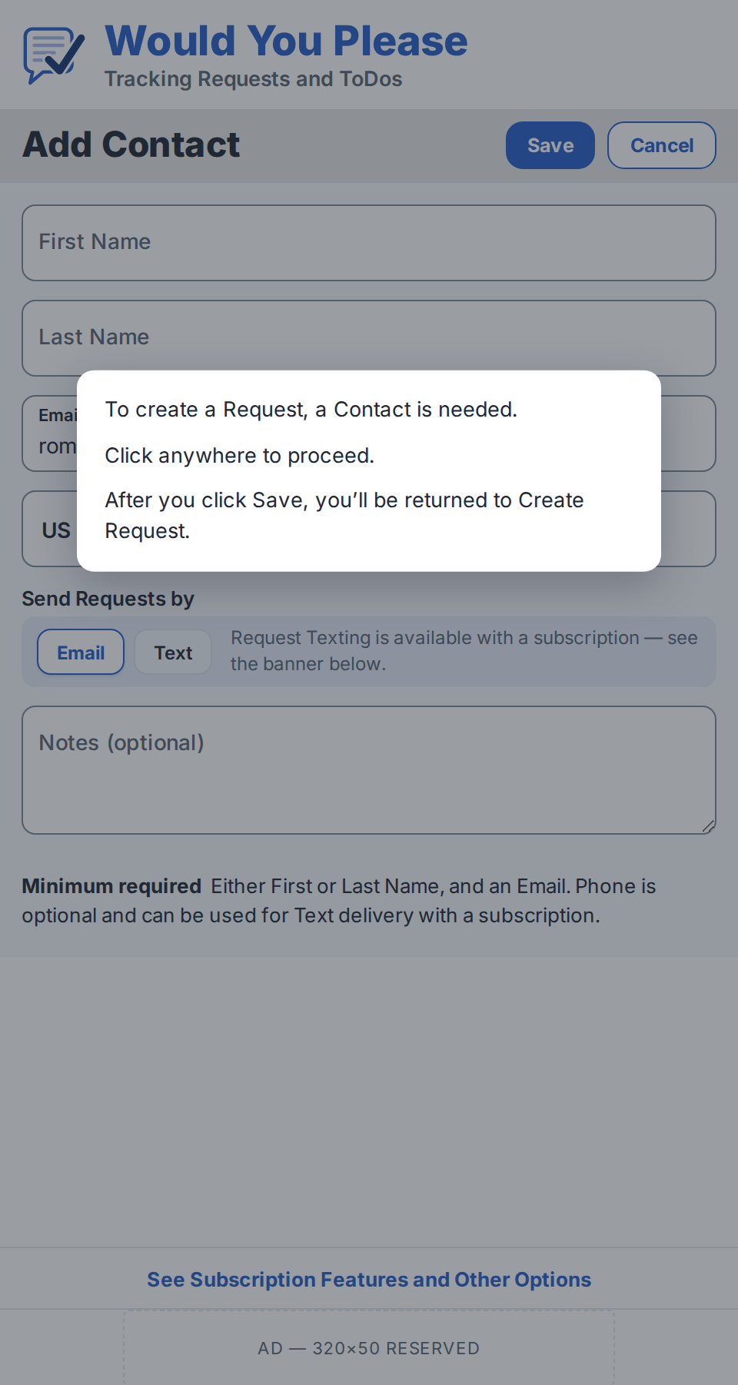
Figure 9.9.2 — No-contact interception. The acknowledge-only modal dialog (§6.12) over the Scrim (§3.1); a click or tap anywhere dismisses it. Canonical mockup source: WYP_add_contact_no_contact_dialog_palette1.html.
- Tapping Create Request with zero contacts routes to Add Contact and shows an acknowledge-only modal: "To create a Request, a Contact is needed. Click anywhere to proceed. After you click Save, you’ll be returned to Create Request." The opening clause names the action and stays lowercase; the closing clause names the screen (§1.5).
- Save then returns to Create Request with the new contact pre-selected.
- Cancel returns to the main screen — not to Create Request, which would immediately re-trigger the interception — with the toast (§6.13) "Without adding at least one Contact, Requests cannot be created."
Open design questions:
- How are merged-from sources (Outlook EntryID, etc.) displayed?
- Should Create Request offer a one-off override of the contact’s default delivery channel? (Phase 2 candidate.)

9.10 User Creation / Login / Profile
Status: placeholder (to be designed in a subsequent version).
Purpose: Sign-up, sign-in, password reset, and profile edit flows. Includes Google and Apple OAuth.
PRD reference: PRD §3.9 (legacy) and §7.1 (security).
Components reused from §6:
- Primary button (§6.1) — "Sign in" / "Create account" / "Save"
Open design questions:
- What is the minimum viable profile (time zone, display name, notification preferences)?
- Does the Pilot include phone/SMS login (Phase 2 per PRD §10)?

9.11 Onboarding / Welcome
Status: placeholder (to be designed in a subsequent version).
Purpose: First-visit experience for the Web Pilot: brief value proposition, sign-in or sign-up, and the PWA "install to home screen" prompt.
PRD reference: PRD §14.2 (new for the Web Pilot).
Components reused from §6:
- Primary button (§6.1) — "Get started"
- Header band (§6.8)
Open design questions:
- Is the PWA install prompt offered on first visit, after a delay, or after first Request sent?
- Does the welcome screen show sample data or an empty state with a single call to action?

9.12 Notification / Activity Feed
Status: placeholder (to be designed in a subsequent version).
Purpose: Chronological list of recent events: requests received, responses received, Dialog activity, queued items delivered, overdue alerts.
PRD reference: PRD §7.3 (notifications matrix).
Components reused from §6:
- List row (§6.4 variant)
- Information-only icons (§6.9)
Open design questions:
- Is the feed unified across all event types or split into tabs?
- How long are entries retained on the feed before they roll off?

9.13 Settings
Status: placeholder (to be designed in a subsequent version).
Purpose: Account, notifications, subscription, time zone, categories, custom fields, sign-out. Reached from the Settings gear in the Strip-tinted segment of the search bar (§6.6) on the main screen; task screens carry no Settings entry (v2.4).
PRD reference: PRD §3.9 (legacy), §6 (monetization), §9.2 (custom fields).
Components reused from §6:
- Primary button (§6.1) — "Save"
- Chip filter row (§6.2) for toggle groups
Open design questions:
- Settings as a single scroll or as a hub with sub-pages?
- Where does the user delete their account (PIPEDA right-to-deletion)?

9.14 Subscription / Upgrade
Status: placeholder (to be designed in a subsequent version).
Purpose: Web checkout flow that upgrades a free-tier user to the paid tier via Stripe. Shows the $17.95/year price, the 60-day trial offer, and the early-user ad-deferral status if applicable. Opened from the Subscription banner (§6.14) on any free-tier screen, or from Settings (§9.13).
PRD reference: PRD §6 (monetization, v8.0 pricing) and §6.1 (launch promotions).
Components reused from §6:
- Primary button (§6.1) — "Start 60-day trial"
Open design questions:
- Does the trial start immediately at sign-up or require explicit opt-in?
- What is the post-trial reminder cadence and channel?

9.15 Non-Registered Recipient Web Response
Status: placeholder (to be designed in a subsequent version).
Purpose: Browser view delivered by secure single-use token: the recipient sees the original Request, can respond, view attachments, and participate in Dialog without creating an account.
PRD reference: PRD §4 and §7.1 (secure web response links).
Components reused from §6:
- List row (§6.4 read-only variant)
- Primary button (§6.1) — "Send Response"
- Sign-up banner (§9.17)
Open design questions:
- Persistence of recipient state across the token's life — same response editable or single-shot?
- What expiration is shown when a token has timed out?

9.16 Request Notification Email Template
Status: placeholder (to be designed in a subsequent version).
Purpose: The email a non-registered recipient receives when a Request is sent to them. Plain-text response link plus an .ics calendar attachment with the due date.
PRD reference: PRD §7.3 and v7.0 decisions on .ics + plain-link delivery.
Components reused from §6:
- Header band (§6.8 — email variant)
Open design questions:
- Does the .ics attachment include a reminder offset or just the due date?
- How is unsubscribe handled when the recipient is not (yet) a user?

9.17 Banners — Sign-up, Early-User Ad-Deferral, 60-Day Trial
Status: placeholder (to be designed in a subsequent version).
Purpose: Three inline banners that promote conversion: a sign-up banner under the response form on §9.15; an ad-deferral banner shown to early users explaining when ads will appear; a 60-day trial banner offered after first Request received.
PRD reference: PRD §6.1 (launch promotions) and §14.2 (new in v7.0).
Components reused from §6:
- Primary button (§6.1)
- Group label (§6.7) styling for banner headline
Open design questions:
- Dismissal model — once per session, permanent, or remember-for-N-days?
- Banner placement on small viewports — top of viewport or inline above the fold?

9.18 Empty and Error States
Status: placeholder (to be designed in a subsequent version).
Purpose: Shared illustrations and copy for empty-list, zero-search-result, network-error, and not-found conditions.
PRD reference: Implied across all PRD list-bearing sections.
Components reused from §6:
- Group label (§6.7)
- Primary button (§6.1) — call-to-action verb varies per state
Open design questions:
- Single illustration set or per-section custom illustrations?
- How is the call-to-action chosen — context-dependent verb or a single "Start here"?

9.19 Storage Maintenance
Status: fully specified in v2.9.
Purpose: List every attachment charged to the account with its size and origin, and let the user download or remove files to recover space. Reached from the storage warning strip (§6.18) and from the Account screen — a screen reachable only from a warning could not be used to prevent one.
PRD reference: PRD §2.1 (attachment limits and storage accounting), §6 (tier storage figures), §6.3 (subscription lapse and auto-deletion).

9.19.1 Mockup
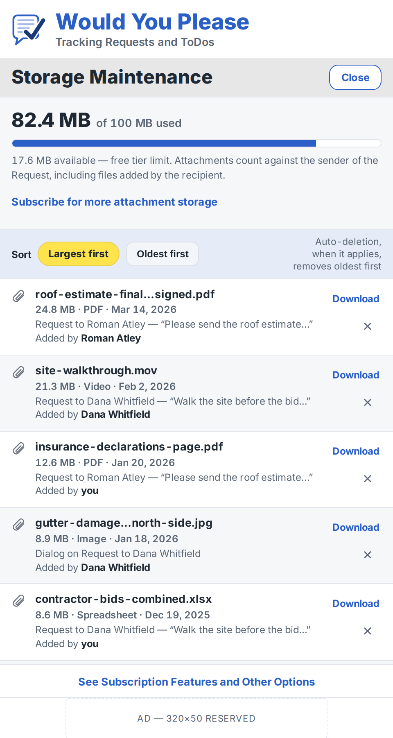
Figure 9.19.1 — Storage Maintenance at mobile-browser width. “Storage Maintenance” group label on a Band heading band flush beneath the header (no top rule, per §6.8) with Close (Secondary, §6.11); summary block on Row Tint carrying the proportional bar, the accounting rule, and the contextual offer; sort strip on Strip with the active sort pill (§6.3); attachment rows below. The footer note and the attachment limits sit below the fold. Canonical mockup source: WYP_storage_maintenance_palette1.html.

9.19.2 Composition
- Header band (§6.8) — logo, wordmark, and tagline, identical to the main screen.
- Group label “Storage Maintenance” (§6.7) on a Band heading band flush beneath the header, with Close (Secondary button, §6.11) right-aligned. There is no commit action: removals apply immediately, each behind its own confirmation (§9.19.4).
- Summary block on Row Tint: used and limit on one line — the figure at 24 px / 800 with “of 100 MB used” at 13.5 px / 600 in Ink Soft — then a proportional bar, then a note at 12 px in Ink Soft giving available space, the tier, and the accounting rule. The bar fills Brand Blue and switches to Alert Red at the Critical threshold, matching §6.18.
- Contextual offer closing the summary block (§9.19.6).
- Sort strip on Strip #E5ECF7: the active sort pill (§6.3) and one alternate chip, with a note right-aligned recording that auto-deletion removes oldest first.
- Attachment rows, one per file (§9.19.3), reusing the attachments-panel row anatomy of §9.2.2 so no new component is introduced. Alternate rows carry Row Tint.
- Footer note in Ink Soft: removal is permanent, affects both parties, and leaves a record on the item, so files should be downloaded first; followed by the attachment limits (25 MB per file, 50 MB per Request, 10 per Request, Response, and Dialog entry).
- Subscription / Account banner (§6.14) and, on the free tier, the reserved ad slot (§6.15) at the bottom of the viewport, identical to the main screen.

9.19.3 Behavior
- Each row shows the attachment icon (§5.1) and three lines: the filename at 13.5 px / 700, truncated mid-string with an ellipsis; size, type, and date at 12 px / 600 in Ink Soft, separated by middots; and the source line, naming the parent Request, Dialog entry, or ToDo, then the contributor — “Added by Roman Atley” or “Added by you,” with the name in Ink at weight 700. The source line matters because storage is charged to the requestor including files the recipient added (PRD §2.1).
- At the row's right, stacked: Download as text in Brand Blue at 12 px / 700, and the remove control, a × glyph in a 34-px target taking Alert Red on hover and press. Download is text rather than an icon because the icon family has ten members and no download glyph; adding one would require an eleventh asset and a new group in §5.1 and §11.1 for the same affordance the text already carries, consistent with the filename-as-link decision in §9.3.
- Download is not optional chrome. Without it the only way to comply with a storage warning is to lose the file permanently.
- Sort defaults to largest first, with one alternate, oldest first. The two orders differ deliberately: auto-deletion under a lapse (PRD §6.3) removes oldest first, but manual cleanup is only efficient largest first, so the screen optimizes for the user's task rather than mirroring the system's rule. The note beside the sort strip states the difference so the default does not mislead.
- Close returns to the immediately prior screen; the Enter key does the same when focus is not within a field (§10.3).

9.19.4 Removal and tombstones
- The remove control opens an action-variant modal dialog (§6.12) naming the file, the space recovered, the permanence, and the effect on the other party: “Remove ‘site-walkthrough.mov’? This frees 21.3 MB and cannot be undone. Dana Whitfield will no longer see the file, and the Request will show that an attachment was removed.” Cancel (Secondary) and Remove (Primary) are right-aligned.
- Removal leaves a tombstone on the parent item (§9.6): a single line in Ink Soft in the attachments area, aggregated rather than one line per file — “1 attachment removed by Jim Kelley on Sep 8, 2027.” Aggregation matters because a sender clearing space will routinely remove files the recipient uploaded, and an unaggregated record would bury the item under tombstones.

9.19.5 Contextual offer
- The summary block closes with a tappable line in Brand Blue at 13 px / 700 in a 40-px target, the treatment used by the subscription banner (§6.14): “Subscribe for more attachment storage” on the free tier, “Renew to keep these attachments” during a lapse grace window. The line is absent for a subscriber, who has no defined upgrade path until storage add-ons are specified (PRD §15.2).
- No figure is promised. PRD §6 states the free tier as up to 100 MB and the paid tier only as perpetual retention with add-ons available, so the copy says “more” until those numbers exist.
- The offer is not bolded within the summary note and does not quote the banner's own label. Emphasis without an affordance produces a phrase that reads as a control but is not one, and the repeated string would read as a duplicated element rather than two deliberate placements. The persistent banner is retained; the contextual line names the specific benefit at the moment it is legible, and the banner stays generic.

9.19.6 Responsive behavior
Per §7.1 the mockup is the mobile rendering (≤ 600 px), where each attachment row stacks its three lines and the Download and remove controls stack at the row's right. At the Tablet breakpoint the size, type, and date line moves inline with the filename. At the Desktop breakpoint the list is centered at a fixed maximum width and the source line moves to a second column, keeping one row to one line.

9.19.7 Edge cases
- No attachments — the list is replaced by an empty state (§9.18) reading “No attachments are using storage.”, with the summary block retained.
- A file whose parent item has been deleted — the row remains with the source line reading “Item no longer exists,” since the storage is still charged.
- Storage at or over the limit — the summary bar renders Alert Red and the §6.18 Critical strip is present above the heading band on this screen as on every other.
- A lapse grace window is open — the summary note gains the deletion date, and the offer reads “Renew to keep these attachments.”
- Very long filename — truncated mid-string with an ellipsis so the size line and the controls stay visible, per §9.2.2.
Open design questions:
- Does the list support multi-select for bulk removal? Ties to the same question open on §9.7.
- Where does the contextual offer lead — the Subscription / Upgrade screen (§9.14) whole, or a storage section within it once that screen is structured?
- Close is a placeholder for whatever back affordance §9 eventually adopts; the specification defines none.

10. Accessibility
Accessibility is a hard requirement, not a nice-to-have. The product is intended for personal and small-team use including users with motor, visual, or cognitive variation.

10.1 Touch targets
Every interactive control has a minimum 40-pixel hit area; clickable icons are sized to meet the ≥44-pixel mobile recommendation when component padding is counted.

10.2 Color contrast
All text-on-background combinations used in the product meet WCAG 2.1 AA at body weight. Two combinations were verified explicitly in §3.2. Designers must re-verify whenever a new combination is introduced.

10.3 Keyboard navigation
Every screen is fully operable from a keyboard. Tab order follows reading order. The active sort column, the active chip option, and the focused button each show a visible focus ring in Brand Blue. "Enter" submits the focused form; "Escape" closes modals. On a screen with no form to submit, "Enter" activates the heading band’s dismissive control — Close, or Cancel where no Close is present — when focus is not within a field (new in v2.9).

10.4 Screen readers
All icons carry an aria-label that matches the icon name in §5. Chip groups carry an aria-label naming the section they filter. The active sort column announces its direction. Information-only icons are presence-marked ("Dialog present", "Attachments present") so a screen-reader user does not lose the visual cue.

10.5 Reduced motion
When the user has set prefers-reduced-motion at the OS level, all transitions are replaced with instantaneous state changes (see §8.9).

10.6 Text scaling
All typography is set in relative units (rem/em on web, dynamic type on native). The layout remains usable up to 200% browser zoom on the Pilot; truncation gracefully extends to a third line at higher scales rather than clipping content.

11. Asset Inventory

11.1 Functional icons (v4.0; Contract added in v2.1; label-affordance glyphs added in v2.7)
- wyp_icon_dialog.svg — speech bubble with question mark (Dialog indicator)
- wyp_icon_attachment.svg — paperclip (Attachment indicator)
- wyp_icon_expand.svg — expand arrows (open full-page view)
- wyp_icon_contract.svg — contract arrows (return from full-page view to main screen) — new in v2.1
- wyp_icon_print.svg — printer (print filtered/sorted list)
- wyp_icon_voice_search.svg — microphone (voice search)
- wyp_icon_search.svg — magnifying glass (execute search)
- wyp_icon_lookup.svg — faded-grey magnifying glass (Input Border #7E8A9A) overlaid by a solid Ink down-pointer with a white knockout (lookup affordance inside resting labels of type-ahead fields) — new in v2.7
- wyp_icon_calendar.svg — calendar (date-picker affordance inside resting labels; Ink Soft) — new in v2.7
- wyp_icon_clock.svg — clock (time-picker affordance inside resting labels; Ink Soft) — new in v2.7

11.2 Logo (v7.2 Checked Request)
- wyp_logo_checked_request_light_bg.svg — outlined bubble; for white or light backgrounds (used in app UI)
- wyp_logo_checked_request_dark_bg.svg — filled white bubble; for brand-blue or dark surfaces
- wyp_logo_horizontal_light_bg.svg — mark + brand-blue wordmark + grey tagline; for white or light surfaces (matches main-screen header proportions in Figure 9.1)
- wyp_logo_horizontal_dark_bg.svg — mark + white wordmark + light-blue tagline; for brand-blue or navy surfaces (transparent background; host surface supplies the color)

11.3 Fonts
- Inter (woff2) — regular, medium, semibold, bold, extrabold
- System fallback stack — system-ui, Segoe UI, Roboto, Helvetica, Arial, sans-serif

12. Open Design Questions
Open questions specific to individual screens are listed in each placeholder under §9. The questions below apply to the design system as a whole and should be resolved before the next version of this document.
- Dark mode — single-token swap (semantic tokens) or a separate light/dark palette pair? When?
- Localization — minimum first-language set for the Pilot? Which languages need RTL support in §10?
- Brand voice in microcopy — do toasts and empty states use sentence case (current) or title case for emphasis?
- Component library packaging — should the components in §6 be released as a versioned NPM package alongside this doc?
- Motion grammar — is there a house easing curve and standard duration, or is motion ad hoc per component?

Schedule A — Revision History
Moved from the front matter in v2.5 for readability; one entry per version. The history was previously a single front-matter paragraph.
v1.0 — initial Design System (palette, typography, iconography, components, spacing, interaction patterns) and Main Screen specification embedded as Figure 12.1 in PRD v9.0; skeleton placeholders for the remaining 13 screens listed in PRD §14.2.
v2.0 — main-screen refinements adopted after a Galaxy S24+ review (PRD v10): header band reduced to logo + enlarged wordmark + enlarged tagline (“Tracking Requests and ToDos”), with the user name and date/time removed; group labels shortened to “Requests” / “ToDos”, enlarged, and placed on Field-Yellow heading bands; new Section card component for Sent / Received / ToDos, with brand-blue sub-headings and right-aligned Expand/Print icons; Overdue filter label rendered in red; list dates set smaller with wider spacing; Figure 9.1 re-rendered to match.
v2.1 — filter pattern modernized (PRD v11): radio buttons replaced by a Chip filter row (§6.2) with a white-pill outlined-selected state, on a new Strip color token (§3.1); chips placed inside each section’s tinted strip alongside the Expand/Print clickable icons; ToDos head reorganized so the Expand and Print icons live on the chips strip (matching Sent and Received) rather than on the ToDos heading band; new Contract clickable icon added (§5.1 and §11.1) for the full-page Expanded views to return to the main screen; Figure 9.1 re-rendered to match. The remaining screens (§9.2–§9.18) remain skeleton placeholders.
v2.2 — logo asset inventory updated (§11.2) to mirror PRD v11.1: horizontal lockup completed in matched light- and dark-background variants (wyp_logo_horizontal_light_bg.svg, wyp_logo_horizontal_dark_bg.svg); the previously planned stacked lockup format was dropped.
v2.3 — Add / Edit Contact screen fully specified (§9.9, Figures 9.9.1–9.9.2), replacing its placeholder: field order First Name / Last Name / Email / Phone / Notes; minimum-required rule (either First or Last Name, and either Email or Phone); phone country-code selector defaulting to a visible locale-derived code, stored as E.164; duplicate-contact modal on Save (resolving the §9.8 open question); and the no-contact interception flow from Create Request. Design system extended to match: new Scrim token (§3.1); new components Text input (§6.10, including the phone country-code variant), Secondary button (§6.11), Modal dialog (§6.12), and Toast (§6.13); header band note added (§6.8) — no bottom rule, with the first Field-Yellow heading band sitting flush beneath the header.
v2.4 — Per-contact Request delivery channel added to Add / Edit Contact (§9.9): "Send Requests by" Email / Text chip pair (§6.2 anatomy on a Strip surface) placed after Phone. Email is the default; Text selection is available to subscribers only, with an inline gating notice for free users. Validation requires the field matching the selection, so free-tier contacts require an Email, with Phone optional for later subscription use or reference. New components: Subscription banner (§6.14 — free tier, all screens) and Reserved ad slot (§6.15 — 320×50 at the bottom edge; stack order search bar, banner, ad). Search bar (§6.6) gains a leading Strip-tinted Settings segment with a new gear icon (wyp_icon_settings.svg — the eighth icon), main screen only, opening Settings (§9.13). Figures 9.1, 9.9.1, and 9.9.2 regenerated from the updated mockups; Figure 9.1 now also reflects the v2.3 header-rule removal.
v2.5 — Palette modernization (“palette option 1”, owner decisions 2026-07-15/16): Brand Blue retained unchanged; primary buttons flattened (§6.1); Row Tint moved to neutral #F6F7F9; Field Yellow retired and removed from §3.1; new tokens Band #E7E7E7 (neutral heading-band fill), Input Border #7E8A9A, Focus Tint #EDF2FD, and Focus Halo; group labels moved from Alert Red to Ink on Band (§6.7), making red exclusively a status color. Text input (§6.10) redesigned with floating labels, 50-px minimum height, and a Focus Tint + Brand Blue border + Focus Halo focus state. “Send Requests by” (§6.2, §9.9) compressed to a full-width Strip row with a persistent, tier-differentiated gating notice using the locked feature name “Request Texting”. Search-bar Settings segment and gear removed (§6.6); the bottom banner (§6.14, renamed Subscription / Account banner) now shows for both tiers with tier wording and carries the settings/account entry; heading bands drop their hairlines. The free-tier banner label is “See Subscription Features and Other Options” (renamed from “See Subscription Options and Features” to make non-subscription settings discoverable, resolving that open question). Figures 9.1 and 9.9.1 regenerated from WYP_main_screen_palette1.html and WYP_add_contact_palette1_floating.html.
v2.6 — two open design questions closed (owner decisions, 2026-07-17): Band #E7E7E7 confirmed as final after on-device review, and the ToDos chips strip retains the Strip surface #E5ECF7, preserving the uniform rule that Strip means section-card control surface across Sent, Received, and ToDos. The §3.1 provisional note on the Band hex is removed and both items are removed from the §12 open-questions list. No token values, components, or figures changed.
v2.7 — Create a Request fully specified (§9.2; canonical mockup WYP_create_request_palette1.html), replacing its placeholder: heading-band Send/Cancel, inline contact type-ahead, optional Due Time, inline Add Category, attachments list panel. New component §6.16 Lookup and picker fields — label-affordance glyphs (lookup, calendar, clock) rendered inside resting floating labels, three new grey-toned SVG assets (the lookup pointer in solid Ink over a faded Input Border magnifier), rendered at ≈120% of the resting label font size and vertically centered — with §6.17 placeholder for the calendar and clock pickers. Sent/Received rows gain a third line when a Request carries a Due Time (§6.4, PRD §2.7). §9.8 Find / Select / Add Contact retired (inline type-ahead supersedes it); icon family extended to eleven with a third, label-affordance group (§5.1, §11.1). Owner decisions 2026-07-20.
v2.8 — Respond to Request fully specified (§9.3, Figure 9.3.1; canonical mockup WYP_respond_to_request_palette1.html), replacing its placeholder: read-only request header (Date / From / Due) with Add to Calendar (.ics, PRD §7.3); no free-text response field — the recipient replies through the Done state, the Dialog thread, and response attachments; Done Date / Done Time are selected with their pickers, not auto-filled, with Done Date in the weekday-long form matching Due and the narrower Done Time shown only when Done Date equals the Due Date and the Request carries a Due Time. Request attachments are read-only and downloadable (no overwrite); the recipient’s own response attachments are removable. §6.16 gains a picker-field exception — the calendar / clock glyph persists once a value is present so the picker stays re-openable, while type-ahead Lookup glyphs still hide when floated; the exception also covers the Due Date / Due Time pickers on Create a Request (§9.2). §3.1 Brand Blue usage extended to read-only detail field labels (§9.3). Category confirmed private to the sender and omitted from this screen; the Create a Request field label becomes “Private Category (optional)” (PRD §2.3; mockup updated). Owner decisions 2026-07-21.
v2.9 — Screen names normalized and two new specifications added (owner decisions, 2026-07-22). Add a Contact becomes Add Contact and its Primary button becomes Save; Create a Request becomes Create Request, the lowercase action phrasing left unchanged; Respond to Request retained over “Request Response” as a verb phrase that instructs a first-time recipient. New §1.5 records the naming convention. The §9.9 minimum-required rule becomes tier-scoped: Email required on the free tier, Email or Phone for subscribers, with a prompt rather than a block when a lapsed user opens a phone-only contact. New component §6.18 Storage warning strip (Caution and Critical severities from existing tokens; no amber added) and new screen §9.19 Storage Maintenance (canonical mockup WYP_storage_maintenance_palette1.html, Figure 9.19.1), with attachment-removal tombstones recorded against §9.6. §3.1 extends the Alert Red usage clause; §4.3 gains a weekday exception for deadline dates within thirty days; §10.3 gains the Enter-key behavior for screens with no form; §9.2.3 and §9.2.5 carry the new 25 MB per file and 50 MB per Request caps. Figures 9.2.1, 9.9.1, and 9.9.2 re-rendered from the updated mockups. Two corrections: §9.1.2 (both bands) and §9.9.2 still described heading bands as Field-Yellow, a token retired in v2.5 and replaced by Band #E7E7E7, and the §9.9.5 figure caption omitted the _palette1 suffix from the mockup filename. The §3.2 note recording the token’s retirement and the v2.0, v2.3, and v2.5 history entries stand as written.

