March 5, 2018.

For the creation of the local, SQLite-based CRM app I:

* Created the schematic diagram (see attached Draw.io resource schematic_diagram.xml) as portrayed in figure 1.

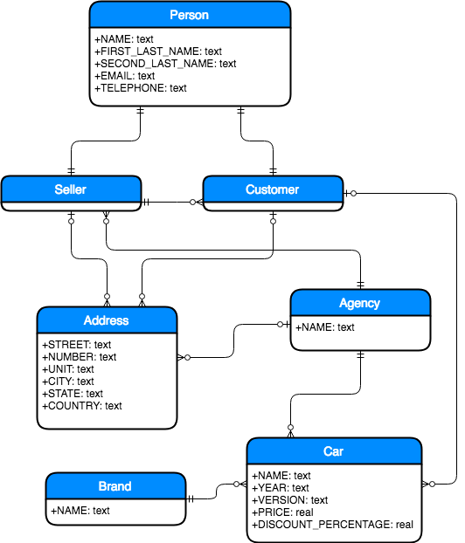

Figure 1: Schematic Diagram

* Created DDL SQL script for the construction of the database.
* Created the Java classes for the representation of all entities in the diagram.
* Created the DB interface Java class (Models) for managing the DB and in-memory entity representation.

Jonathan Ginsburg.