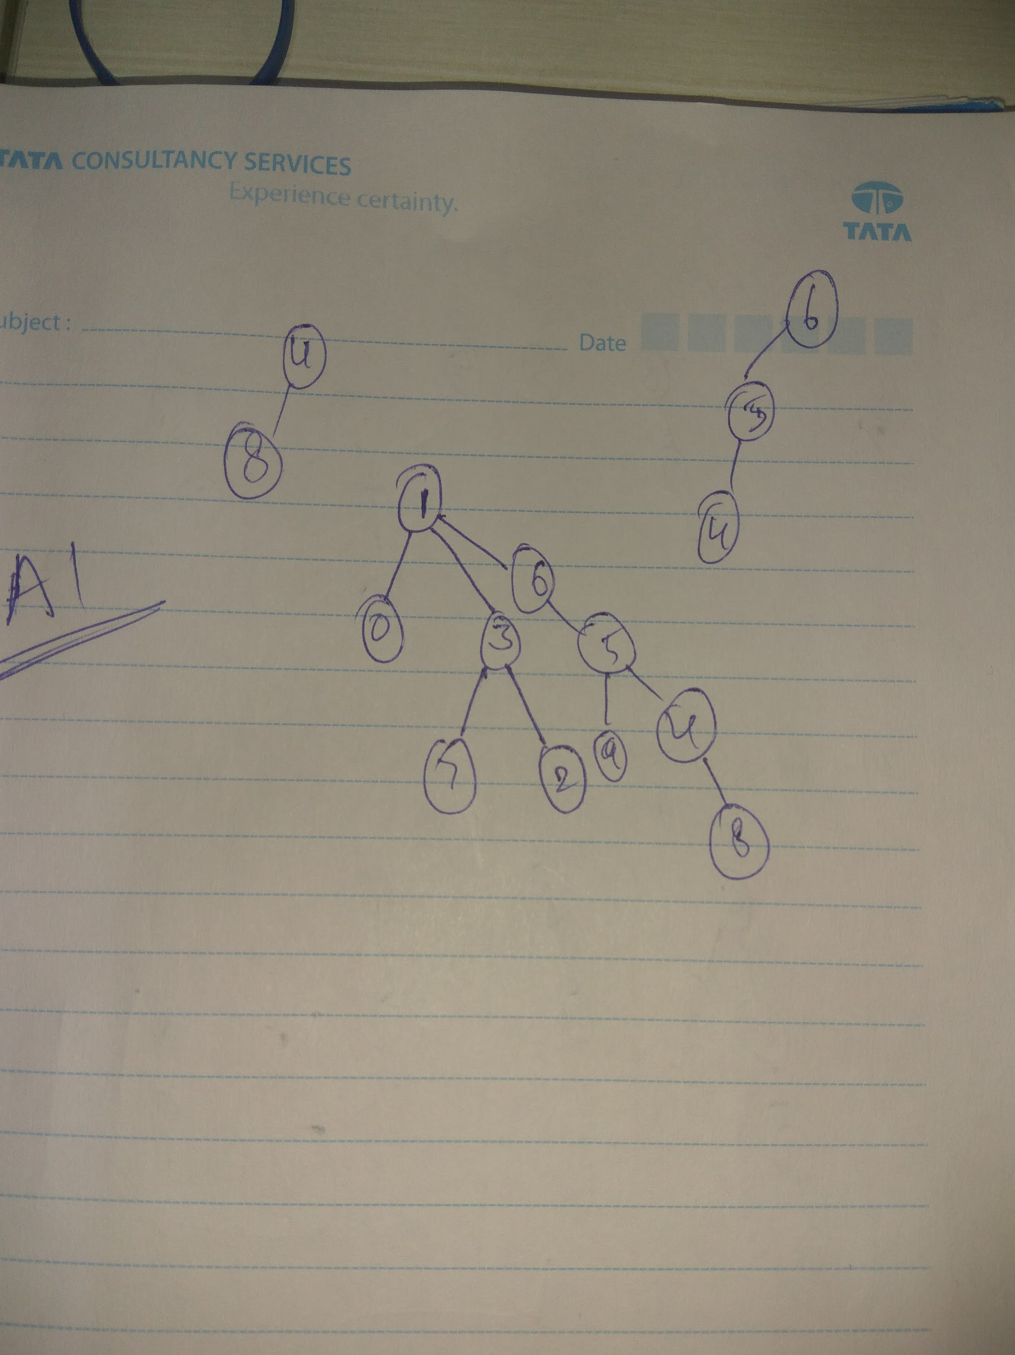

This is not weighted quick union. When 5 should be connected to 6. The size of 5 is 2 and the size of 6 is 1. Hence, according to weighted quick union, 6 must be added to 5 in this case. But according to the one dimensional array we are adding 5 to 6.