Breadboard Keyer Demo for ARROW Field Day
A Morse Code Practice Keyer Kit
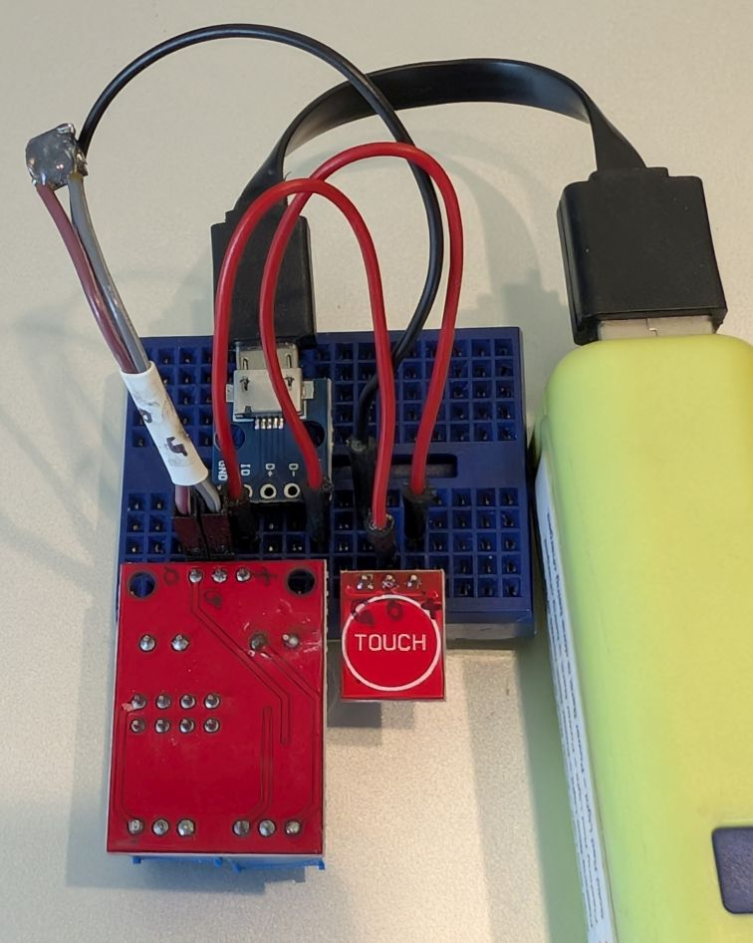

© 2026 AC8ES

- Parts
  - 3x jumper wires (colors may vary)
  - 1x solderless breadboard
  - 1x mini speaker
  - 1x USB power connector module
  - 1x touch sensor
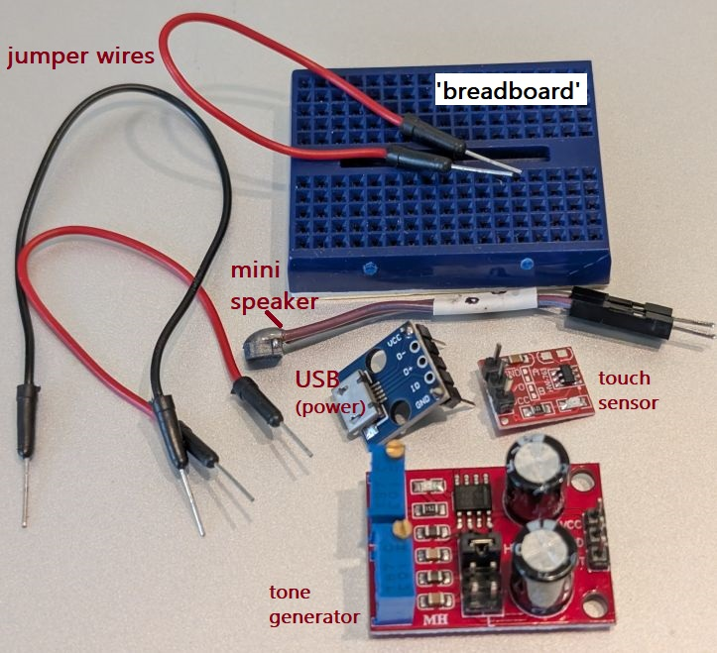
  - 1x tone generator
☞ Parts’ appearances and colors may vary.
  - not included: USB power bank
  - not included: USB power cable
- What is a solderless breadboard?
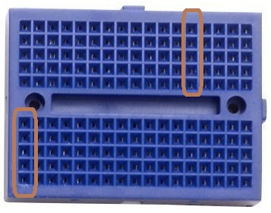
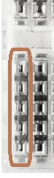
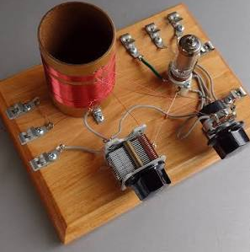
  - It let’s you easily mount components and connect them together. Each vertical section of five holes are electrically connected via a metal strip inside. There is no connection between adjacent metal strips.
In the “old days”
Why the term “breadboard”?
- From the 1920’s, people screwed wire clips and vacuum tubes (sockets) and other components to actual wooden breadboards to build circuits.
(images from https://www.facebook.com/groups/ARNewsline/posts/10158915416309210, https://www.ebay.com/itm/253106065602)
  - Each component or jumper wire has a pin that can plug into a hole into the breadboard.
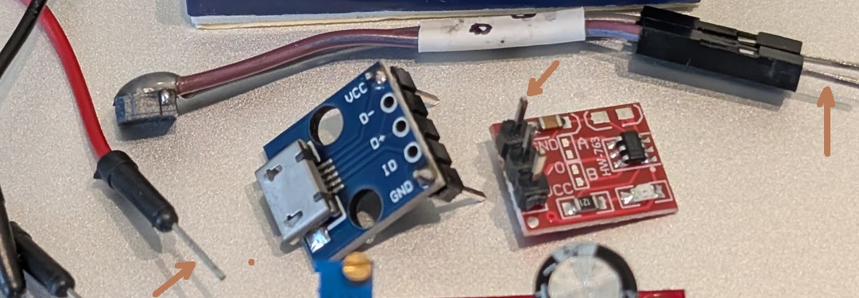
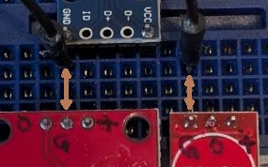
  - Here, the pins labeled “GND”, “G”, and “G” are all connected.
- The black jumper wire connects the pins labeled “G”.
- The breadboard itself connects “GND” to “G”.
- Keyer Block Diagram
  - Power comes from an external USB power bank.
  - This 5 volts powers the touch sensor-- it doesn’t directly power anything else!
  - When the sensor is touched, its output supplies power to the tone generator, which turns it on.
  - The tone generator output drives the mini speaker.
(images from: USB: https://www.pololu.com/product/2586, touch: https://wled.discourse.group/t/sp511e-ttp223-touchpad-tutorial/8725, 555: https://rhoelect.gr/product/ne555-timer-module-yl-107/, speaker: https://www.aliexpress.us/item/3256809353431502.html)

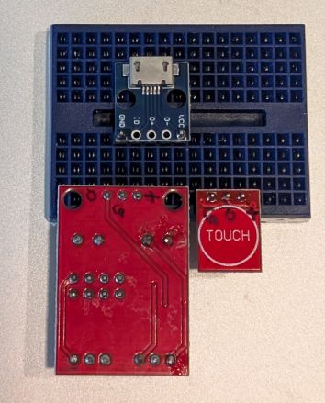
- Start assembly by mounting the modules onto the breadboard.
☞ Refer to Appendix: Pictorial Layout for a pictographic layout.
☞ These directions build the “Passive buzzer” variant in Appendix: Schematic Variations; a slightly simpler version can be built if an “active buzzer” is available.
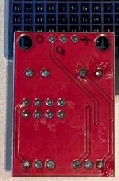
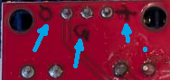
  - Mount the tone generator-- “parts upside down”-- with the pins in the bottom row. The pin on the left, “O”, should be in the fourth column.
☞ It will be helpful to mark the pins as shown:
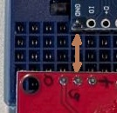
  - Mount the USB connector module, “parts on top”, in the top row of the bottom half of the breadboard. Its left-most pin, “GND”, should also be in the fourth row. This way, “GND” and “G” are connected via the metal strip inside the breadboard.
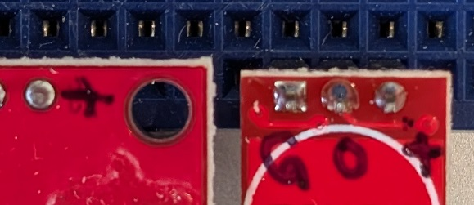
  - Mount the touch module, “parts upside down”, on the bottom row, next to the tone generator.
☞ Again, it will be helpful to mark the pins as shown:

- Add jumper wires.
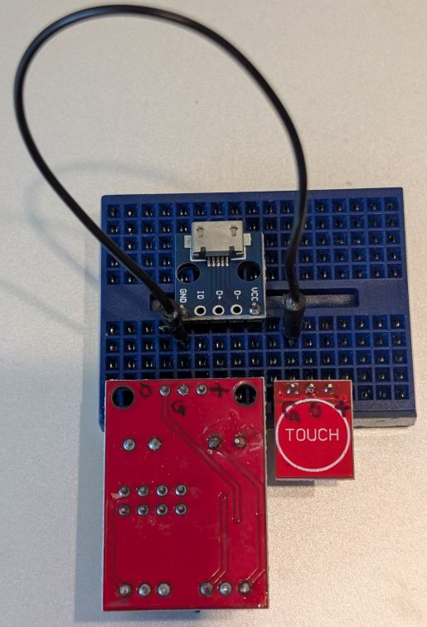
  - Using the 2nd row of the breadboard’s bottom half, connect a jumper wire from “GND” (USB module) to “G” of the touch module.
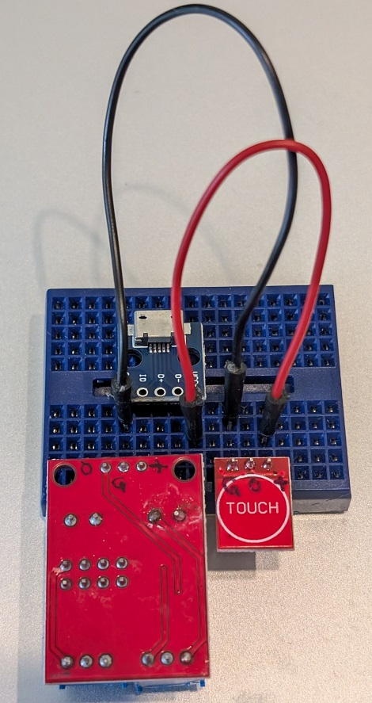
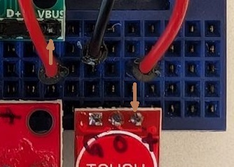
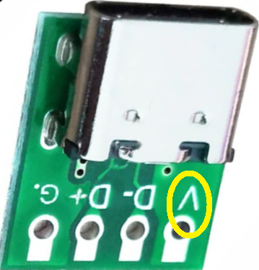
  - Using the 3rd row of the breadboard’s bottom half, connect a jumper wire from “VBUS” (USB module) to “+” of the touch module.
☞ The USB module you have may differ from what’s shown. Just connect “VBUS” or “V” or the equivalent pin.
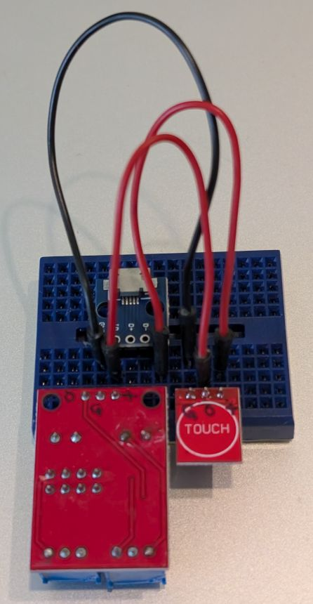
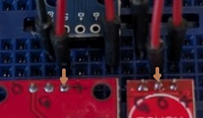
  - Using the 4th row of the breadboard’s bottom half, connect a jumper wire from “+” (tone generator module) to “O” of the touch module.
☞ Remember, the output of the touch module actually powers the tone generator.
- Add speaker.
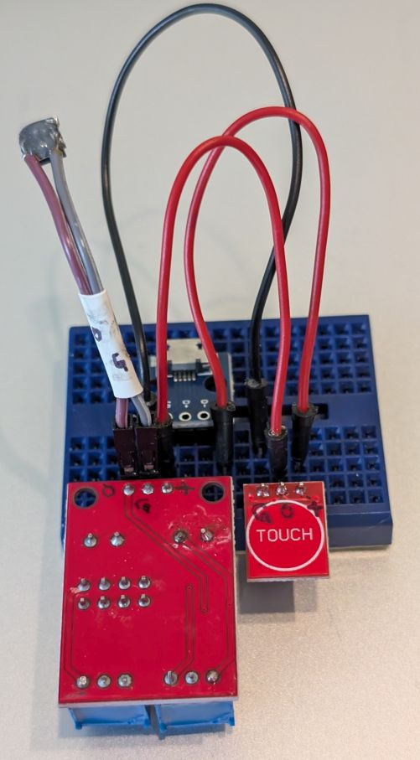
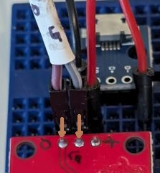
  - Again using the 4th row of the breadboard’s bottom half, connect the speaker’s “G” pin to the “G” breadboard column.
Connect the speaker’s “O” lead to the “O” pin of the tone generator module.
☞ If the speaker leads are not marked, then they are interchangeable.
- Connect USB power bank.
  - Make sure the power bank is off.
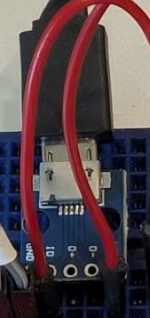
  - Plug a USB power cable between a power bank and the USB module.
- Test!
  - Turn on the power bank.
  - Tap the touch module.
    - The red LED on the touch module’s “part’s side” will light.
    - The speaker will beep-- listen carefully; it’s a bit quiet.
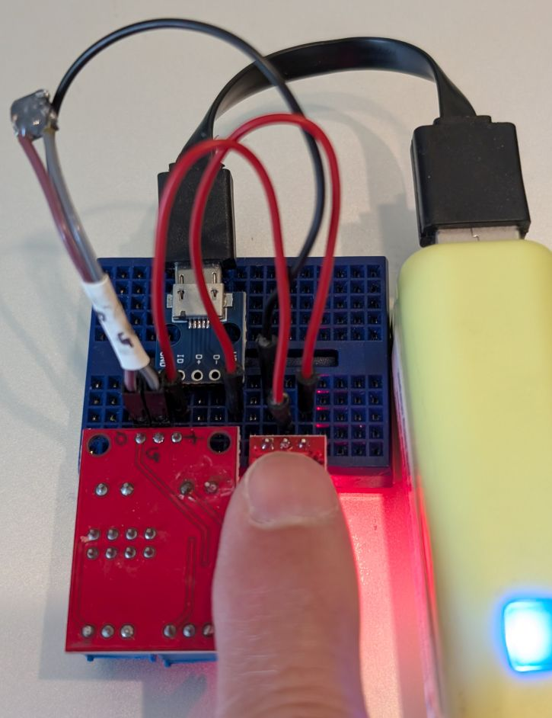
  - ☞If the sensor turns on when your finger is hovering just above it, you can affix a small square of cardboard on top of the sensor.
- International Morse Code
    - The length of a dot is one unit.
    - A dash is three units.
    - The space between parts of the same letter is one unit.
    - The space between letters is three units.
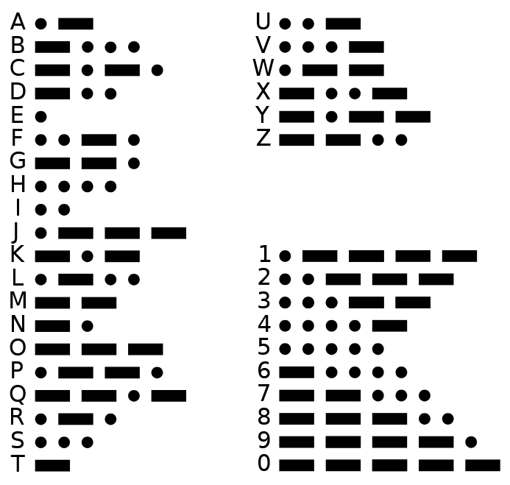
    - The space between words is seven units.

Appendix: Pictorial Layout
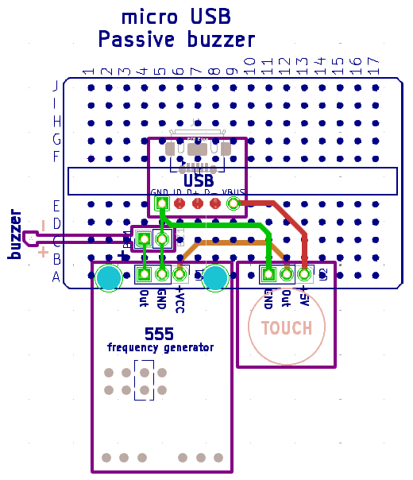

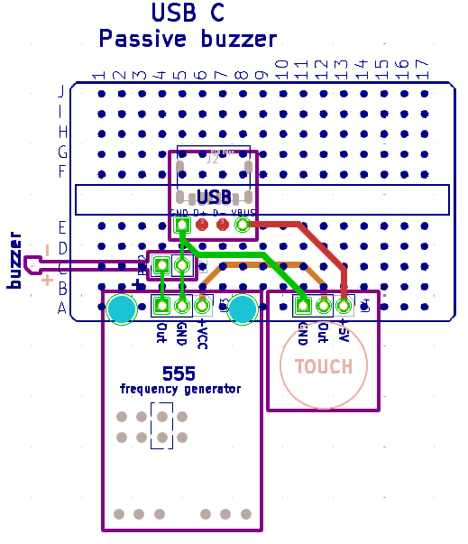
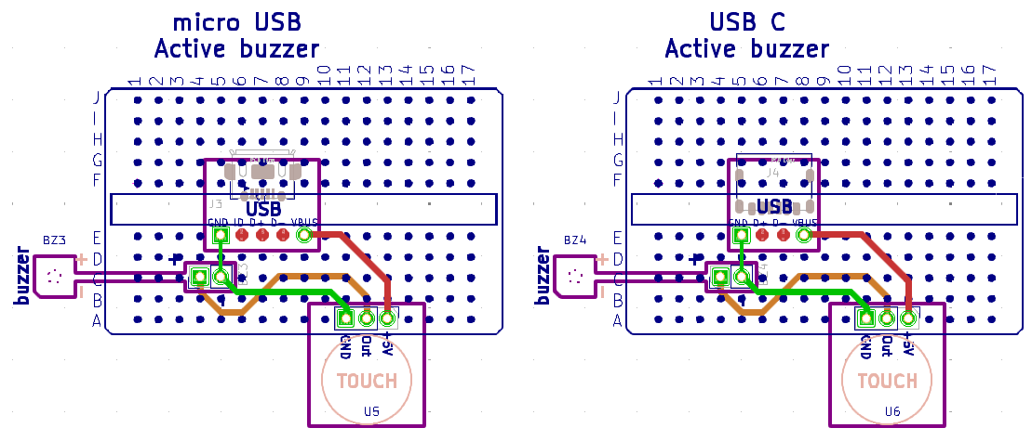

Appendix: Schematic Variations
