Wiring Harness PCB Panel for the uBitx
by AC8ES

Features
- Speeds wiring to the uBitx mic, speaker, and keyer sockets, and encoder
- Encoder on breakaway PCB section allows for separate mounting location
- Reduces wiring errors
- Allows use of an inexpensive Baofeng speaker mic
- Easily mounts to an enclosure
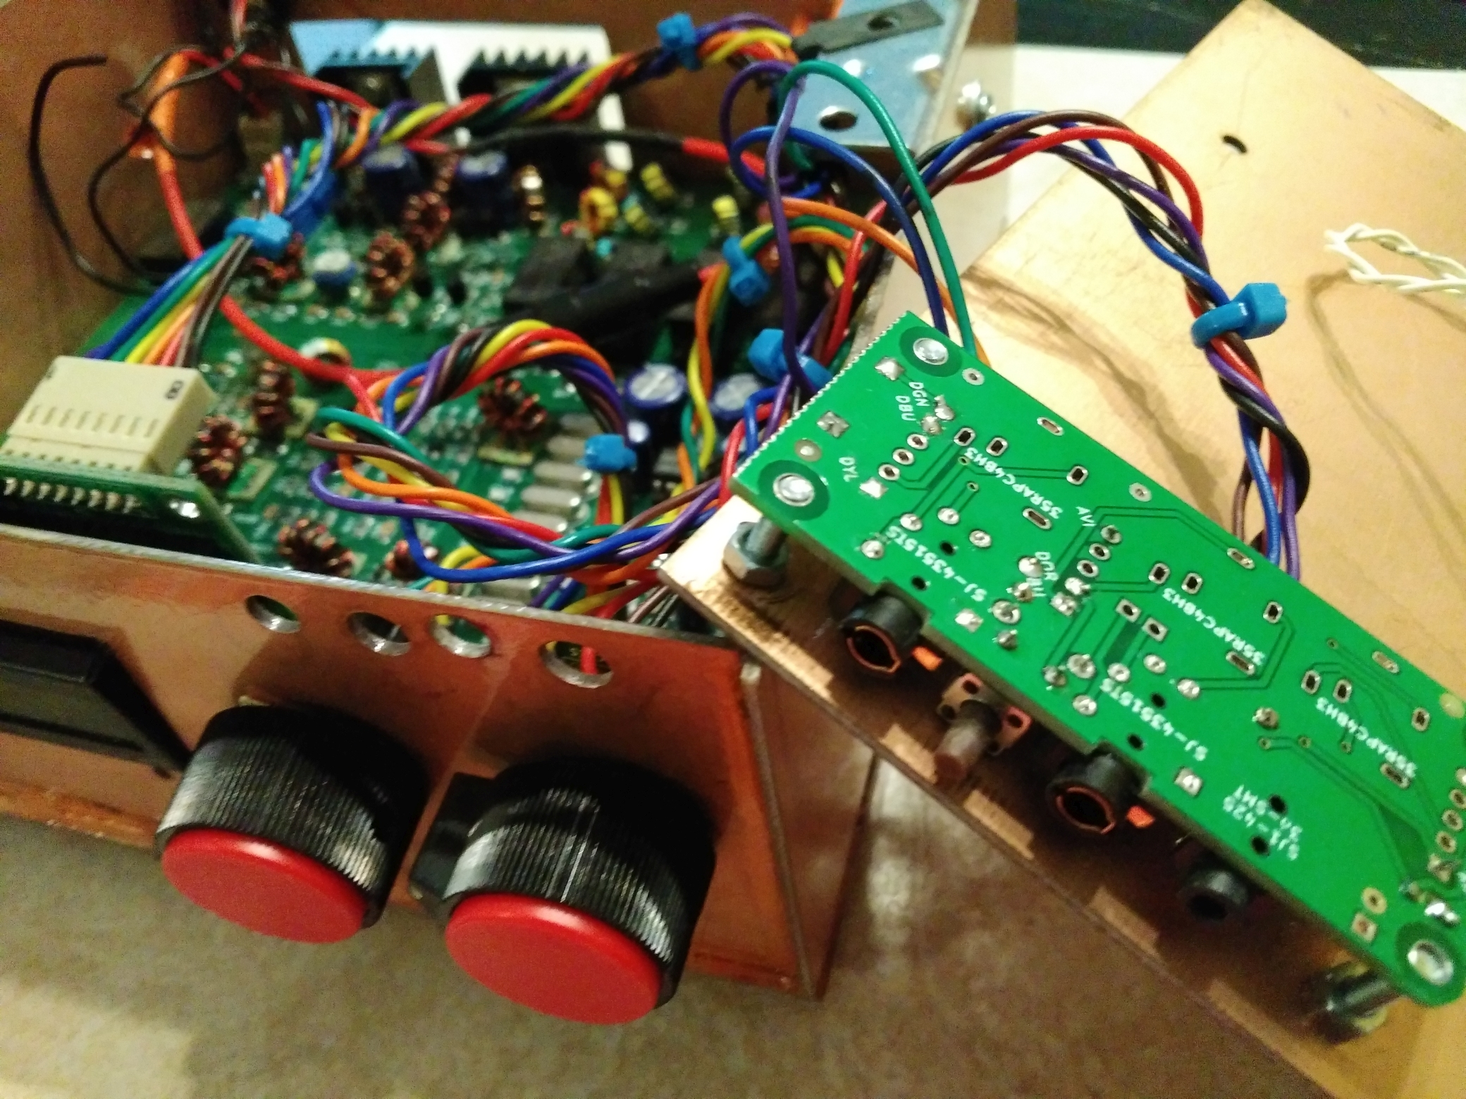
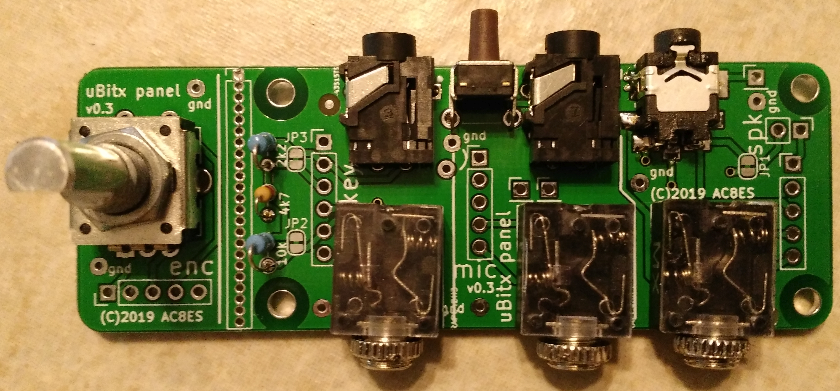

If you want to use the uBitx kit's microphone and 3.5mm sockets, install the three sockets as shown in the bottom of the photo.
If you want to use a Baofeng speaker mic, install the three user-supplied sockets (1x 2.5mm, 2x 3.5mm) as shown at the top of the photo.
It is not necessary to install both sets of sockets.
The kit-supplied tuning encoder is used in either case. BEFORE any components are soldered, the encoder section should be carefully scored with a hobby knife, along the vertical holes shown, on both sides on the board. Warp the board with paper to protect its surface, then break the sections apart using a vise.
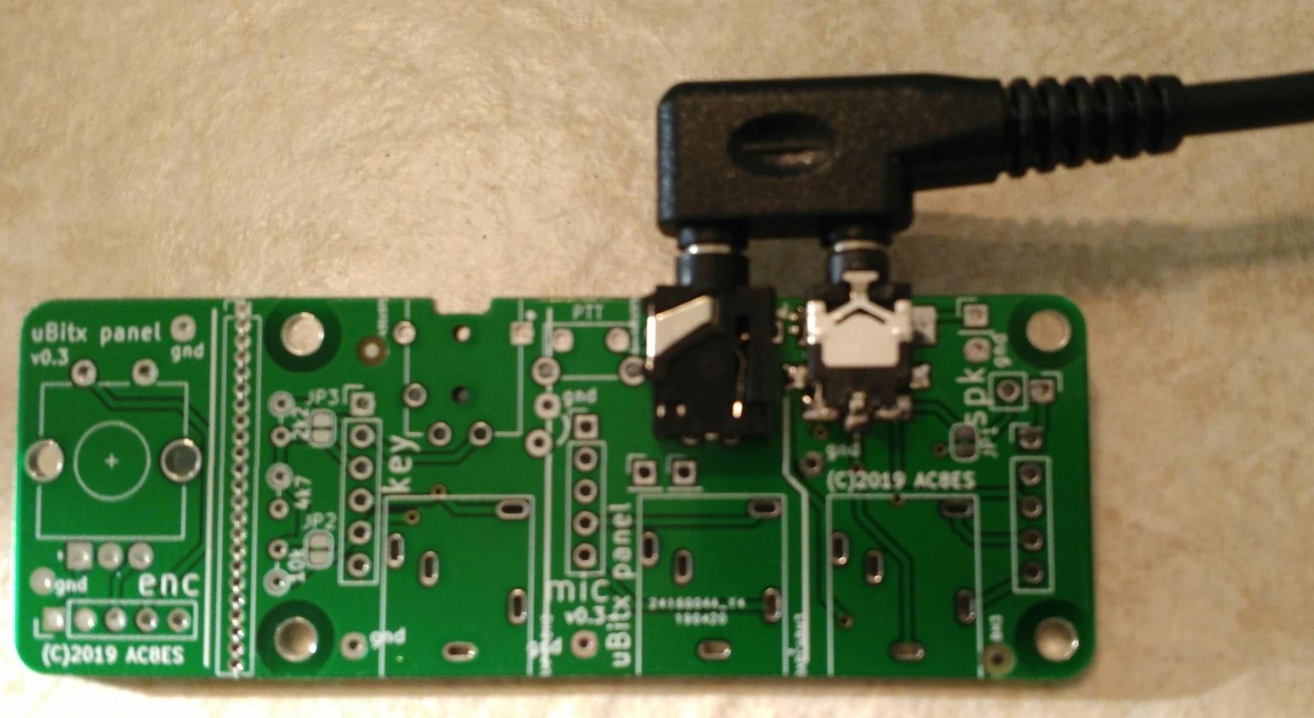
If you want to use a Baofeng speaker mic (11.5mm C-C plugs), solder the 3.5mm socket (not supplied with the uBitx, p/n XXXXXX) FIRST. Insert the 2.5mm socket (not supplied with the uBitx, p/n XXXXXX) onto the 2.5mm plug, then insert the 3.5mm plug into the 3.5mm socket. This will keep the two sockets lined up while you solder the 2.5mm socket.
Solder the wiring connections from the back, following the silkscreened audio/digital color codes:
Dxx= digital wiring harness, where xx is the color (e.g., DYL= digital yellow)
Axx= audio wiring harness, where xx is the color (e.g., ABN= audio brown)
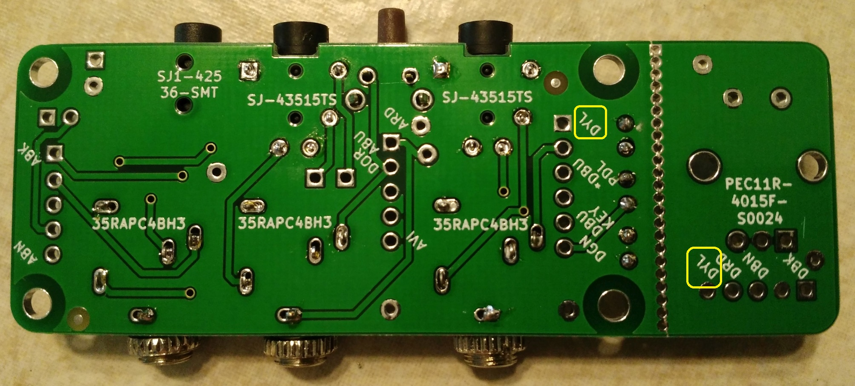
(Note: solder the digital yellow wire to the encoder section; see the lower-right marking in the photo above.)
If you want to use an iambic paddle keyer, cut the traces at JP2 and JP3:
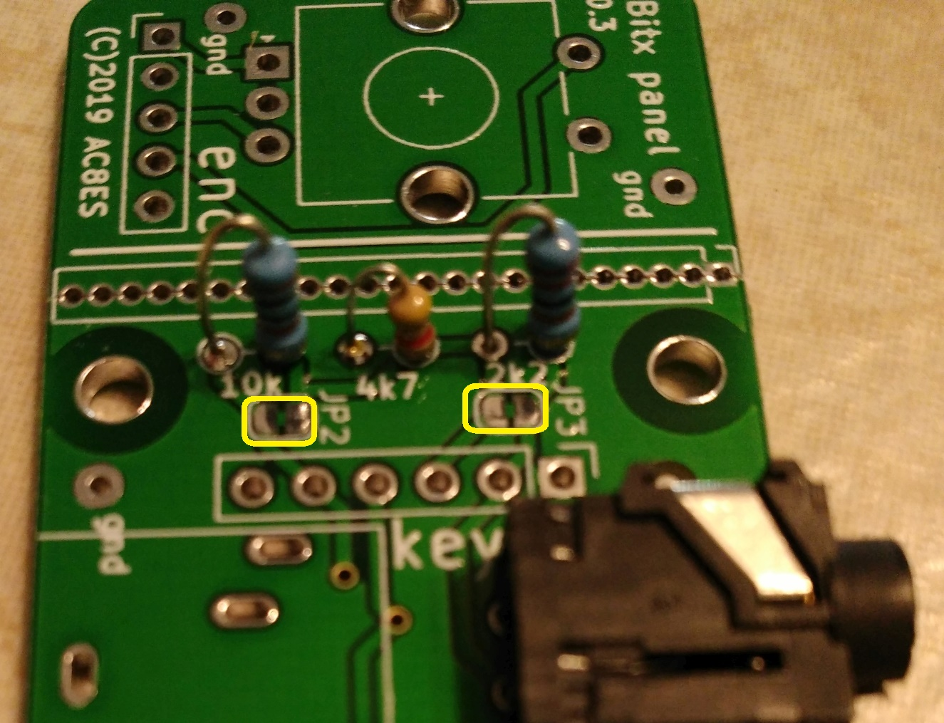
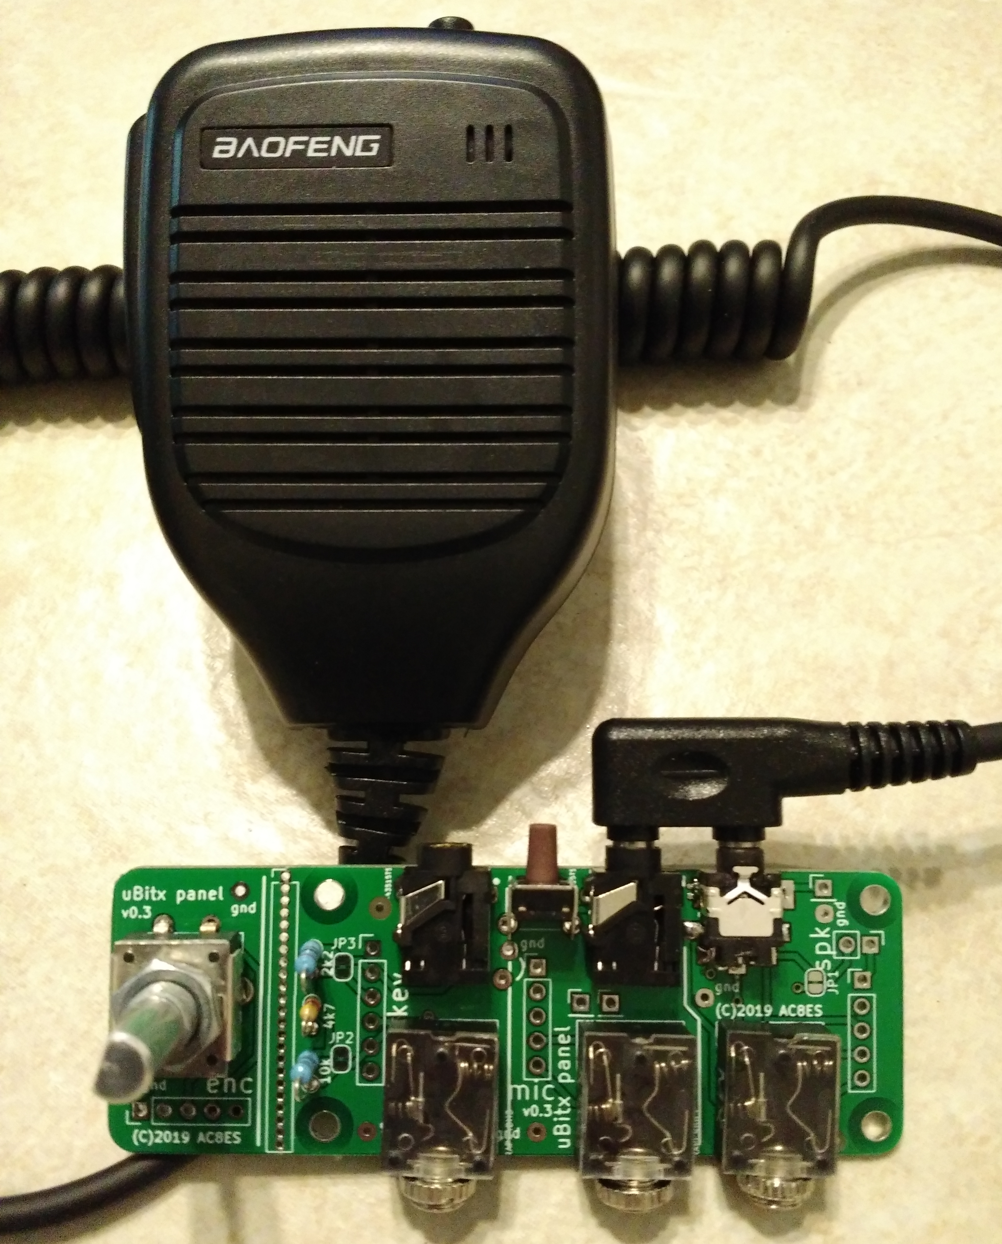

73 de AC8ES, jglandorf @ gmail dot com


