Title: Ultra-compact THz 50:50 Power Splitter with Perceptron Based Algorithm

Outline

1. Introduction
   1. Why THz

Over the last few years, wireless data traffic has exponentially increased.[1] In the Edholm’s law said “Required data rates double every 18 months.”[2]Therefore wireless communication need THz-band for ‘beyond 5G’. However, THz has too much water vapor absorption to long distance wireless communication. Therefore, THz optical fiber communication should be studied before wireless communication.

* 1. What is Power Splitter

The Nobel prize in physics 2009 was divided, and one of that is optical fiber communication.[3]In addition, Silicon-on-Insulator(SOI) fabrication technology improve recent year. It stimulates the study of optical fiber communication. The power splitters are needed to channel specific fractions of input power into different output channels.[4] Therefore we need to design THz power splitter. Subwavelength graphene waveguide[5], Multi-output splitter without grating structure[6] was developed.

* 1. Advantage of the design with machine learning

Before the machine learning, device designer work with Direct Binary Search (DBS)[7], self-imaging[8][9][10], sweep parameter based on specific structure[11]. These methods have districted design structure and limitation to improve performance. The machine learning

1. Material and Methods
   1. Material

The 1 $×$ 2 power splitter consists of one input waveguide, two output waveguide and a square slab. The device design begins with a silicon(Si) slab 500 µm $×$ 500 µm region which is discretized into 20 $×$ 20 pixels with the radius of 9 µm. The circle void is much easier in fabrication the square void which has sharp corner. The proposed device is 50:50 power splitter. Therefore, we set symmetry pixel structure. The Si slab and etched air hole refractive indices are fixed to $n_{Si}=3.41$ and $n_{air}=1$, respectively. The input mode is the fundamental TM mode. We aim to broadband transmission 275 µm – 325 µm, not to maximize the operation bandwidth.

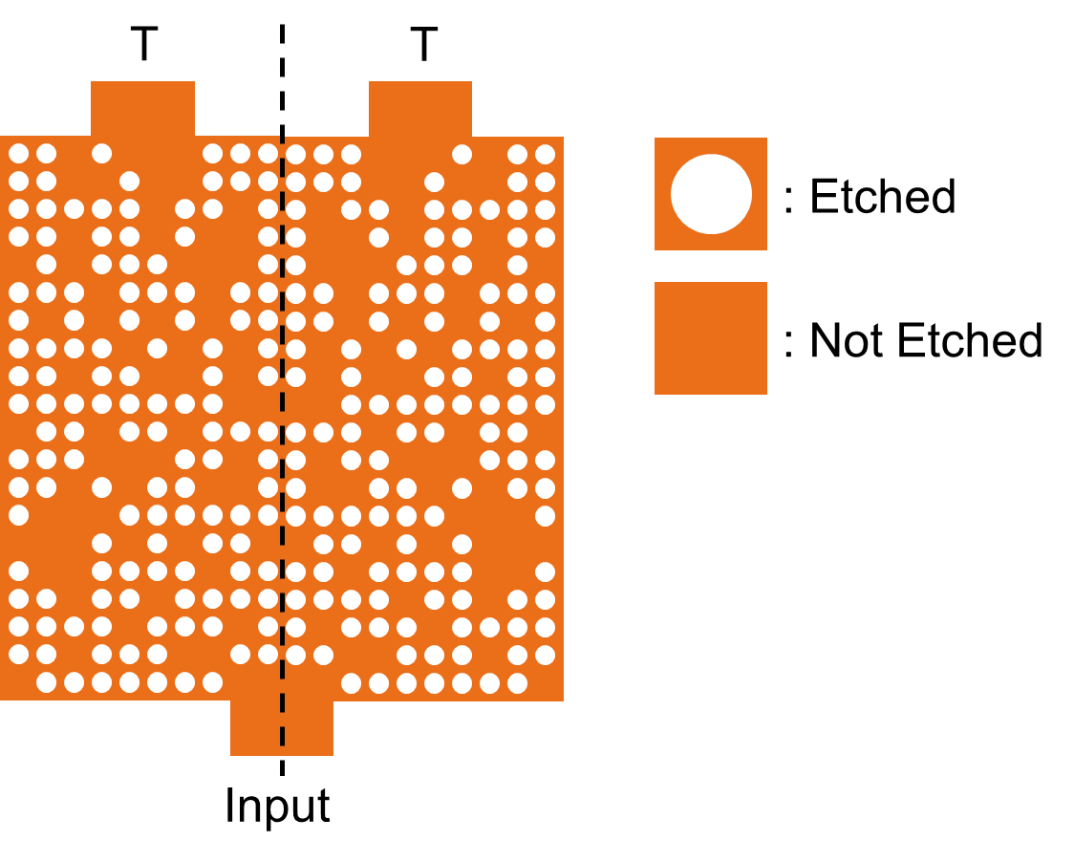

* 1. Method

The algorithm has two algorithm’s property[12]: additive update features of the Perceptron[13] and reward system of the Reinforcement Learning[14]. The algorithm consists of two phase: Training and Inference. In the training phase, we calculate reward of the training data. The training data are random photonic structure which described by 20 $×$ 10 binary matrix. Not etched pixels (Si) are “0” and etched pixels (air) are “0” in the binary matrix. The reward is defined as follows:

$$reward=min⁡(T_{1})$$

We don’t add reflection term, because maximizing transmission effect is enough to reduce the reflection. In inference phase, accumulate the reward in a summation matrix, and activate with average unit step function. If the element of the summation matrix is bigger than average of elements, the pixel state should be 1. On the other hand, if the element is smaller than average, the pixel state should be 0. The algorithm doesn’t need time to learning model, because it learns with reward. Therefore, if we already have training data, the algorithm is almost fastest machine learning algorithm for photonic device design.

We use Finite Difference Time Domain (FDTD) method to generated training data. In the simulation, we set the environment to 2D FDTD and symmetry boundary for time saving. We use commercially available software Lumerical FDTD solution on 2 Intel Xeon CPU with 2.5 GHz clock speed and 383 GB RAM. It takes 10,000data/days to collect simulation data. The complete FDTD simulations took 4 days.

1. Results
   1. Perceptron and Reinforcement Learning

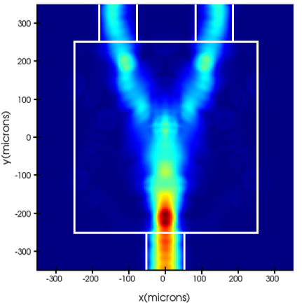

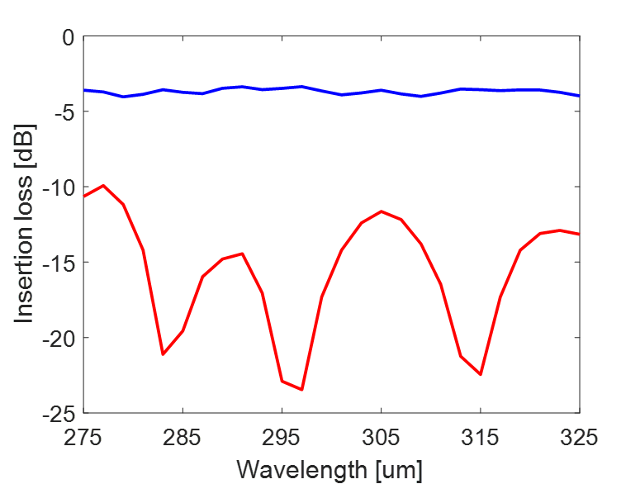

The performance of any splitter is defined by its insertion loss and distribution of input power into the two output waveguides[15]

* 1. sdf

1. Discussion

1. I. F. Akyildiz, J. M. Jornet, and C. Han, “Terahertz band: Next frontier for wireless communications,” Physical Communication, vol. 12, pp. 16–32, 2014.
2. S. Cherry, “Edholms law of bandwidth,” IEEE Spectrum, vol. 41, no. 7, pp. 58–60, Jul. 2004.
3. The Nobel Prize in Physics 2009. NobelPrize.org. Nobel Media AB 2019. Wed. 9 Oct 2019. <https://www.nobelprize.org/prizes/physics/2009/summary/>
4. W. S. C. Chang, *Fundamentals of guided-wave optoelectronic devices*. Cambridge: Cambridge University Press, 2010.
5. Z. Guo, X. Nie, F. Shen, H. Zhou, Q. Zhou, J. Gao, and K. Guo, “Actively Tunable Terahertz Switches Based on Subwavelength Graphene Waveguide,” Nanomaterials, vol. 8, no. 9, p. 665, 2018.
6. F. Zhang, K. Song, and Y. Fan, “New 2D diffraction model and its applications to terahertz parallel-plate waveguide power splitters,” Scientific Reports, vol. 7, no. 1, Sep. 2017.
7. L. Lu, M. Zhang, F. Zhou, and D. Liu, “An Ultra-compact Colorless 50:50 Coupler Based on PhC-like Metamaterial Structure,” Optical Fiber Communication Conference, 2016.
8. M. Bachmann, P. A. Besse, and H. Melchior, “General self-imaging properties in N × N multimode interference couplers including phase relations,” Applied Optics, vol. 33, no. 18, p. 3905, 1994.
9. L. Soldano and E. Pennings, “Optical multi-mode interference devices based on self-imaging: principles and applications,” Journal of Lightwave Technology, vol. 13, no. 4, pp. 615–627, 1995.
10. Y. Tian, J. Qiu, M. Yu, Z. Huang, Y. Qiao, Z. Dong, and J. Wu, “Broadband 1 × 3 Couplers With Variable Splitting Ratio Using Cascaded Step-Size MMI,” IEEE Photonics Journal, vol. 10, no. 3, pp. 1–8, 2018.
11. P. Besse, E. Gini, M. Bachmann, and H. Melchior, “New 2×2 and 1×3 multimode interference couplers with free selection of power splitting ratios,” Journal of Lightwave Technology, vol. 14, no. 10, pp. 2286–2293, 1996.
12. M. Turduev, E. Bor, C. Latifoglu, I. H. Giden, Y. S. Hanay, and H. Kurt, “Ultracompact Photonic Structure Design for Strong Light Confinement and Coupling Into Nanowaveguide,” Journal of Lightwave Technology, vol. 36, no. 14, pp. 2812–2819, 2018.
13. F. Rosenblatt, “The perceptron: A probabilistic model for information storage and organization in the brain.,” *Psychological Review*, vol. 65, no. 6, pp. 386–408, 1958.
14. M. V. Otterlo and M. Wiering, “Reinforcement Learning and Markov Decision Processes,” *Adaptation, Learning, and Optimization Reinforcement Learning*, pp. 3–42, 2012.
15. W. S. C. Chang, *Fundamentals of guided-wave optoelectronic devices*. Cambridge: Cambridge University Press, 2010.