Classical Electrodynamics (Physics course 503)

Problem set #7

Due date: 6pm, May 1 (Tue), 2018

Submission: HW box in physics building.

***1.*** What collection of image charges solves the problem pictured in Fig. 16.5?

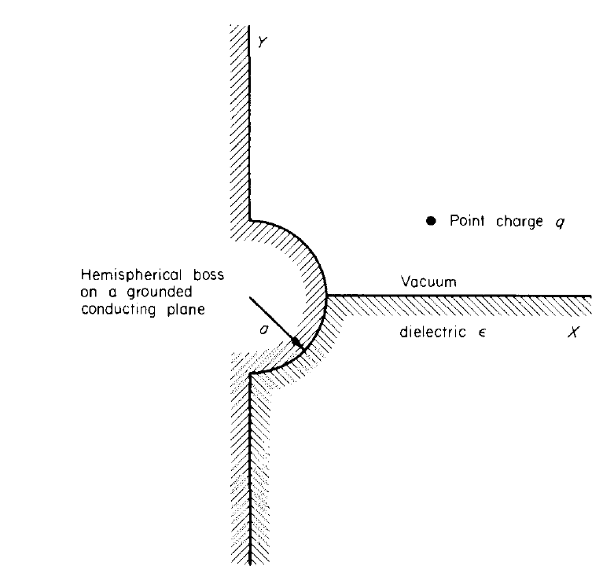Fig. 16.5.

***2.*** A circular cylinder of dielectric is placed in a uniform electric filed, the axis of the cylinder being perpendicular to the field. Find the potential everywhere.

***3.*** A conducting sphere of radius a carries charge q. The dielectric constant outside the sphere varies with the radial distance from the center of the sphere according to

$$ε=1+\frac{b}{r}.$$

1. Find the potential in the region outside the sphere.
2. What will the polarization surface charge density on the dielectric surface at r=a be?

***4.*** Jackson 4.1

***5.*** Jackson 4.6