Classical Electrodynamics (Physics course 503)

Problem set #9

Due date: 6pm, May 15 (Tue), 2018

Submission: HW box in physics building.

***1.*** A circular cylinder of length *L* and radius *a* has uniform magnetization M parallel to its axis. Find B and H at all points on the axis of the cylinder.

***2.*** Two wires in the form of circles with centers at (0, 0, *±a)* and radii *b* are parallel to the *X* Y-plane. Each carries current / but the currents in thetwo wires flow in opposite directions. Calculate the magnetic quadrupoletensor for the system.

***3.*** Two bar magnets, each having the shape of a right circular cylinder of radius *a* and length *b* and each having uniform magnetization M in the direction of its axis, are placed end to end so that their magnetic moments compensate. This arrangement is depicted in Fig. 19.1. What is its quadrupole moment?

***4.*** For a finite solenoid wound with *N* turns per unit length and carrying current /, show that the magnetic field at a point *P* on the axis is given approximately by

$$H = \frac{2πNI}{c}(cos θ_{1} + cos θ_{2}).$$

The angles are defined in Fig. 19.2.

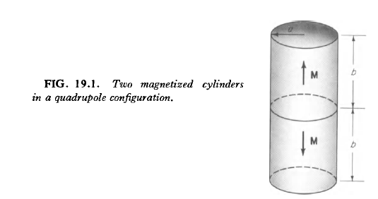

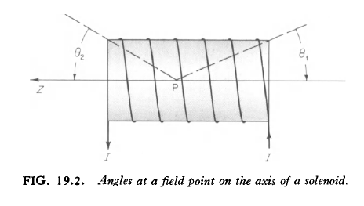

***5.*** Current is carried at uniform density down a circular shell, inner radius *b1* and outer radius *b2*, and up a return wire, radius *a*, located inside the shell. Find the self-inductance per unit length of this circuit. First demonstrate that the inductance is insensitive to the position of the internal wire.

***6.*** A thin-walled cylindrical nonmagnetic metal tube has radius *R,* wall thickness *b (b<<R)* and length *L (L>> R).* The tube materialhas conductivity σ. A coil of *n* turns per unit length is wound tightlyaround the outside of the tube. It carries a current *I*.

(a) Find the magnetic induction B at the center of the solenoid.

(b) The current, having been maintained at the value *I* since *t* = $-∞$, is switched off at *t =* 0, the winding being left open-circuited. Find B(t) at the center of the solenoid neglecting the displacement current.

(c) Under what conditions can the displacement current be neglected safely? Your answer here should be in the form of one or more inequalities involving geometrical and/or constitutive parameters.