09_quota_model Case study
Findings:
The flat commission structure paid about $5.5 million more than a marginal structure would have over 2021 to 2025. The annual overpay grew from about $0.64 million in the first year to $1.57 million in the last, and it grew every year.
Over the same period (2021-2025) commissions more than doubled, while margin dollars grew only 62% and quota attainment stayed steady near 100%.
Background:
The company noticed increasing payout to reps. For this reason, a study was commissioned to determine if payout was in line with company growth or if reps were being overpaid based upon the commission structure.
This study undertook the task of determining if the current commission structure overpaid reps. Then a comparison was done of two alternate plans to give options for payout structures.
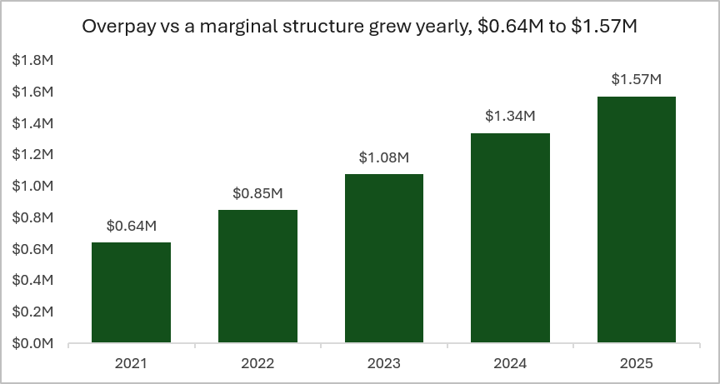 | Overpay more than doubled over the 5 year span (2021-2025).
 | Flat payouts went above the 45% warning line in 2023. Alternately, Indexed & marginal commission plans remain well below the warning line, with indexed consistently around 40%.
 | Through this case study it was revealed that the commissions were increasing at a much faster rate than were margin dollars. Commissions rose 108% from 2021 to 2025; margin dollars up 62%.

Recommendations:
Index the tiers to align with the company growth target. This effectively keeps the payout rate below the 45% target line.
The indexed plan effectively keeps the payout rate around 40% versus the current plan which has ballooned to over 50% and heading towards the 60% threshold. A switch to this plan has an estimated effect of saving ~$3.1M over 5 years as compared to the current plan.

Limits:
With this being a synthetic set of data, the outcomes are based solely on numbers. There are no behavioral considerations taken into account.

