Gitit user's manual
Bryanna Denney
Mike Salata
Steven Sennebogen

Introduction:
Git is a version control tool. Essentially, git will allow you to save multiple versions of your project, with more added features. Simply, git makes working on projects easier.

Have you ever started out on a feature in your code that changed many parts of the project, only to realize that you were headed on the wrong path and you need to “undo” the last 2 hours? Well, what git allows you to do is reverse your changes to the previous version that you saved.

Have you ever tried to work on a group without any version control? Git allows you to easily share your code with others. Git also provides a way to merge multiple changes to the same document, allowing more time to actually code and less time to integrate everyone's changes.

Have you ever lost parts of your project, or even worse all of your project, because it became corrupted or your machine broke? Git gives you the interface to keep multiple copies of your project on different machines. You can easily add multiple remote location to keep all of your projects.

There are more features that one can learn, but there are two ways to use git. There is the command line version and the graphical interface. Our goal is to present another way to use git through a new graphical interface that is more intuitive. We have named our project Gitit.

Terminology:
repository: a project that is using git. Usually refers to all of the project's directories and folders as a whole.

Adding Git to a Project on Your Local Machine:
If, on your local machine, you have a project that you would like to add git to, you will be creating what is called a git repository. This is a project that is using git. Having git connected to a project will mean that there are hidden folders within your project that will store the versions that you save of your project.
In Gitit, there are two ways to add git to a new project: File->New
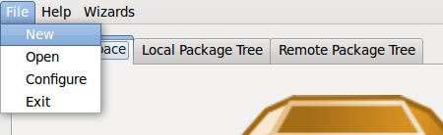
and Wizards->New Project.
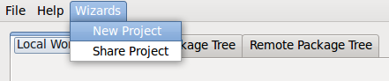
If you are new to git, I recommend the wizard.
You will need to specify that you are doing a local git repository.
Next, you need to pick a directory for git to changed into a repository. Everything inside that directory will be added to git including all files within subdirectories. Make sure that everything you want for the project is within it.
After submitting the required information, Gitit will create the git repository in the directory you specified.
Saving a version (Making a commit):
After you add or open the project, Gitit should load some information to the Local Workspace tab.
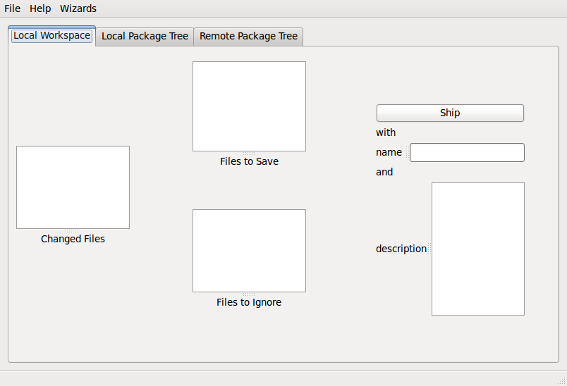
All of your files within the project should be located in the “Changed Files” box. Click the arrows according to what you want to do with the file. If you want to save the file in this version, go ahead and click the arrow leading to “Files to Save”. If you want to ignore the file, go ahead and click the arrow leading to “Files to Ignore”. Gitit will remember those files each time you load your project.
If you make a mistake, there are arrows leading from “Files to Save” to “Files to Ignore” and vice versa.
In order to save a version of your project, all of your files will need to be either saved or ignored.
Once finished, you can now start saving a version of your project, called making a commit. A commit is a saved version of your project. Make sure to name your commit and make a description. These are vital to do because you will be able to look at your commits and may need to revert to one of them. How hard would it be if none of them were named or had a description?
Once you hit “Ship”, Gitit will create the commit for you.
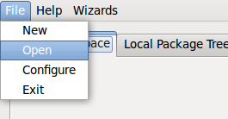
Opening a Git Repository:
If you have already created a git repository and just need to open it to create a commit, then you will use File->Open.
Gitit should then load the information to the Local Workspace tab and you can save a version (make a commit). See the Saving a version (Making a commit) section.

