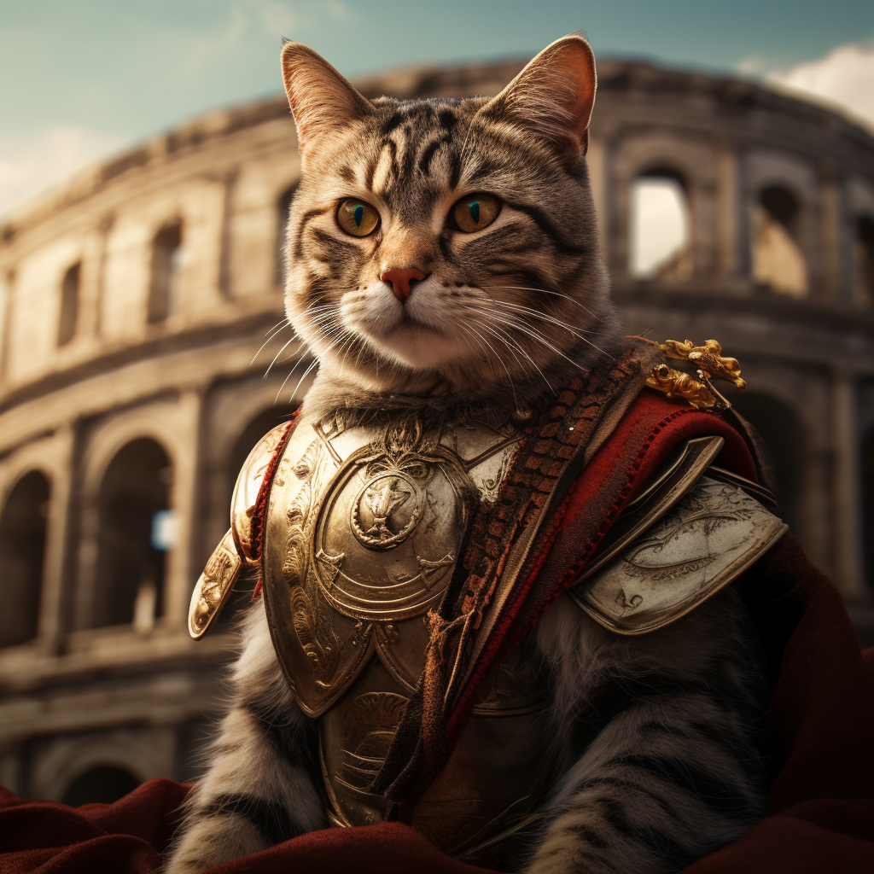

An Image as a title should be downgraded to a normal paragraph!