Juan Gonzalez
CS-255

CS 255 System Design Document Template

This template lays out all the different sections that you need to complete for Project Two. Each section has guidance to prompt your thinking. You will need to continually reference the interview transcript as you work to make sure that you are addressing your client’s needs. There is no required length for the final document. Instead the goal is to complete each section based on what your client’s needs are. Remove this note when you are finished, and replace all bracketed text with the relevant information.

UML Diagrams

UML Use Case Diagram
[In Module Six, you were asked to complete a use case diagram based on your system design. If you would like to make any adjustments to your diagram, please do so. Please insert your use case diagram here. Check to make sure that you included appropriate components and symbols and that your design meets the client’s needs.]
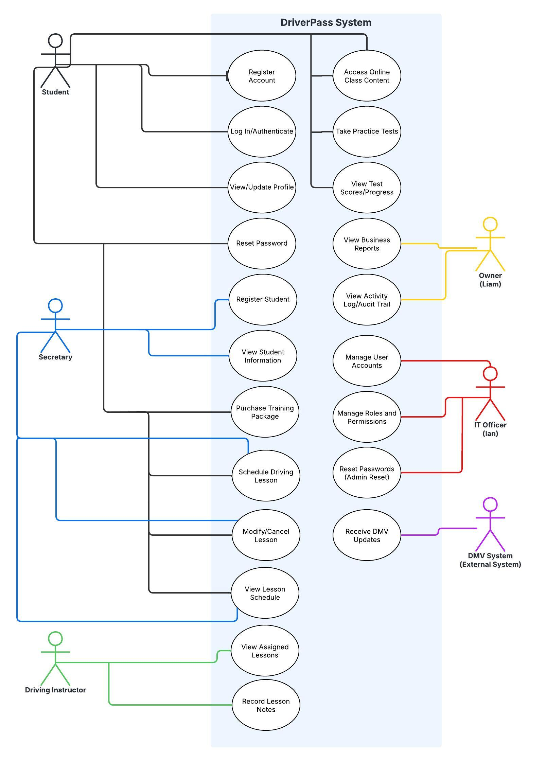

UML Activity Diagrams
[You were asked to choose two use cases and create two activity diagrams, one for each use case. Please insert both of your activity diagrams here. Check to make sure that you included appropriate components and symbols and that your design meets the client’s needs.]
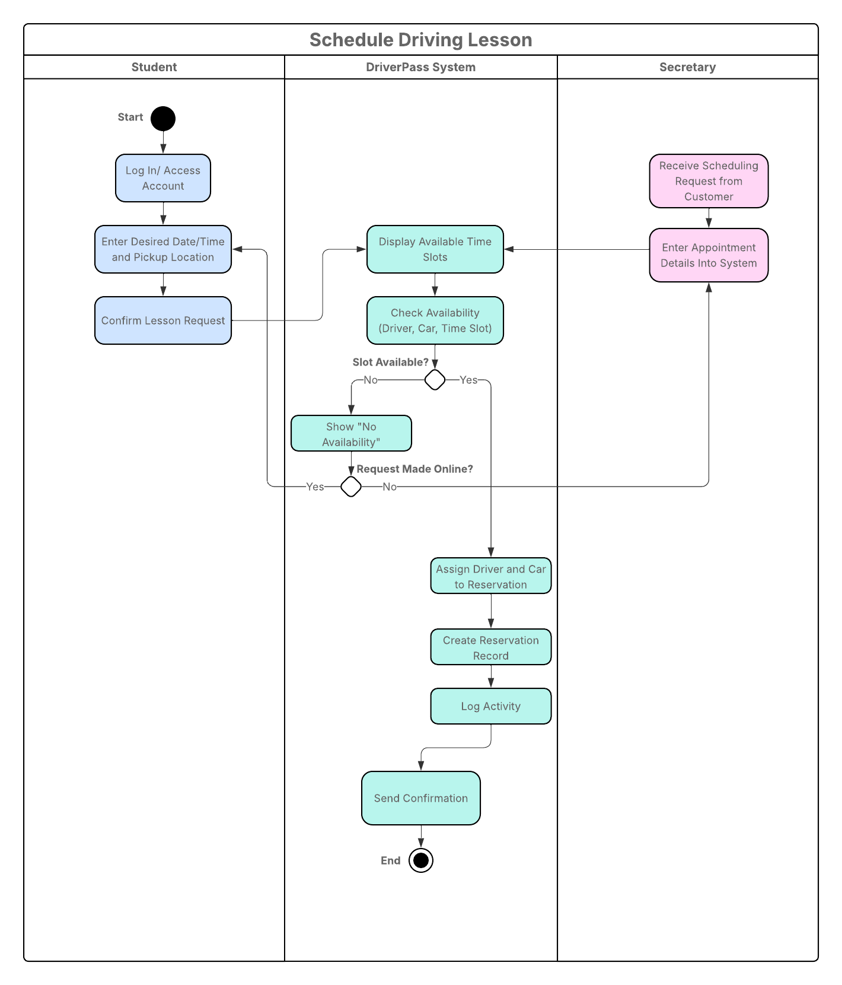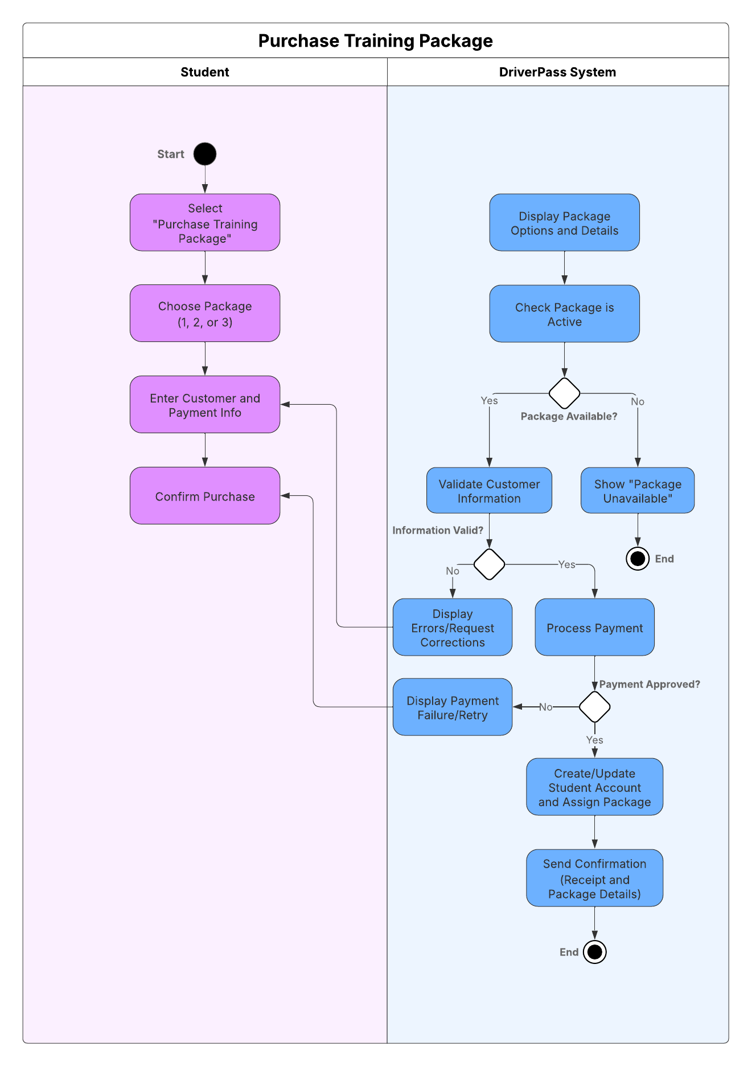

UML Sequence Diagram
[You were asked to create a sequence diagram based on one of the use cases you chose. Please insert your sequence diagram here. Check to make sure that you included appropriate components and symbols and that your design meets the client’s needs.]
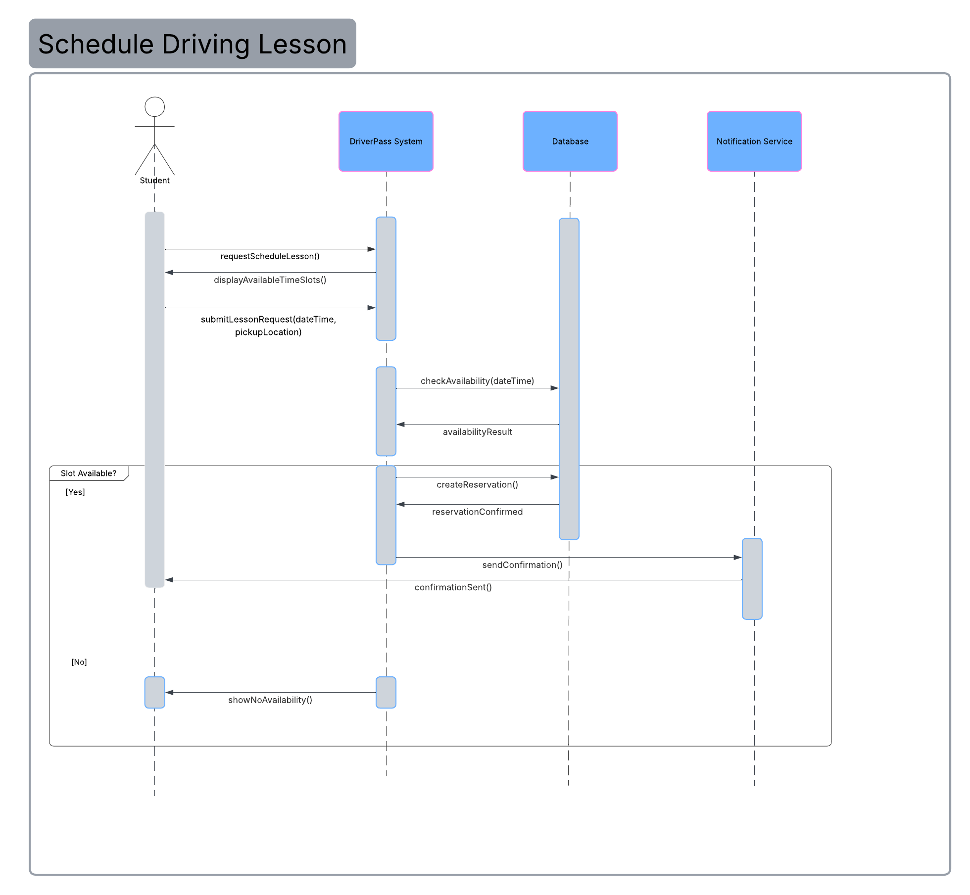

UML Class Diagram
[You were asked to create a class diagram based on the different classes and attributes needed for your system design. You are not required to include methods, but you may if you wish. Please insert your class diagram here. Check to make sure that you included appropriate components and symbols and that your design meets the client’s requirements.]
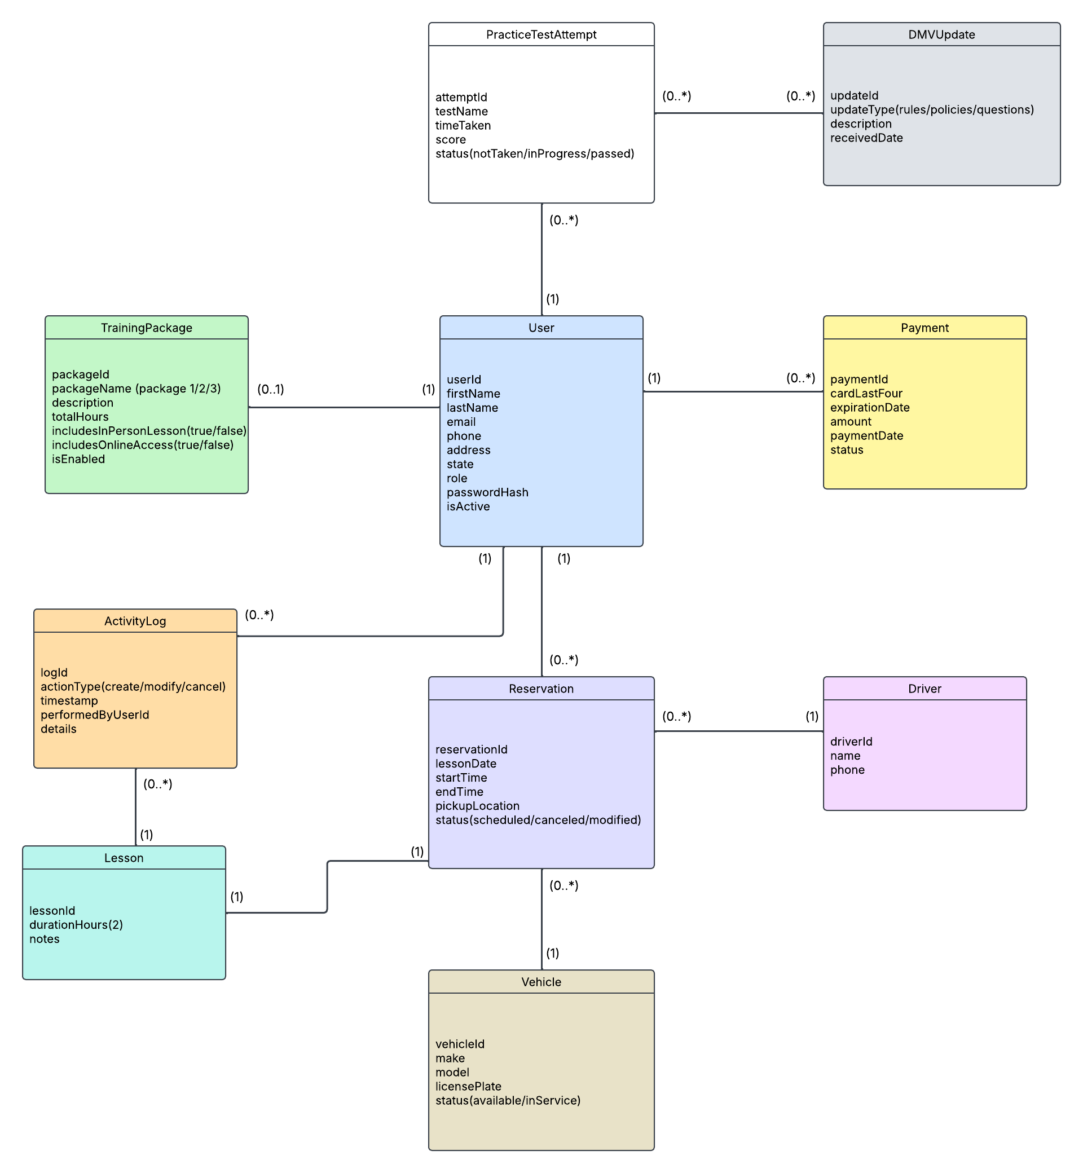

Technical Requirements
[Based on the diagrams you have created, describe the technical requirements of your system. These requirements should address the required hardware, software, tools, and infrastructure necessary for your system design.]

The use case diagram illustrates the different users of the DriverPass system and the actions they can perform. Students can purchase training packages, schedule driving lessons, and access learning materials. Staff members can assist with scheduling and account management, while administrators maintain system access and oversight. This design ensures users only have access to features relevant to their roles.

