# ARDUINO CLIMATE CONTROL

OPERATOR’S MANUAL

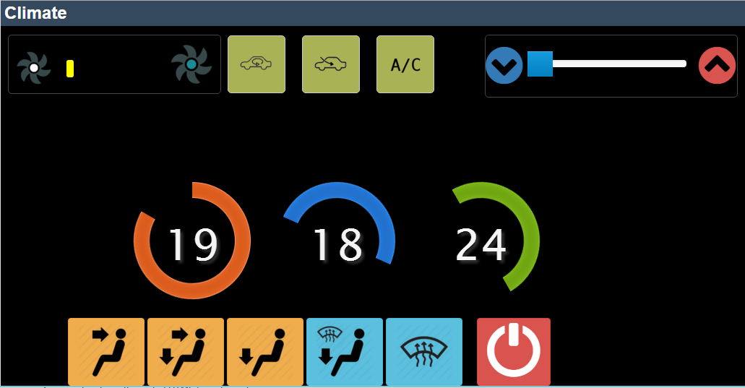

# Control Codes

|  |  |  |
| --- | --- | --- |
| **Code** | **Arduino pin** | **Action** |
| 999 | -- | Close all output pins |
| ***Servo*** |  |  |
| 10-90 | 5 | Control servo angle 0-90 deg. |
| ***Vents*** |  |  |
| 190 | 6 | Face vent |
| 191 | 7 | Face and feet vents |
| 192 | 8 | Feet vent |
| 193 | 9 | Feet and windows vents |
| 194 | 10 | Windows vents |
| 195 | -- | All vents offs |
| ***Airflow*** |  |  |
| 196 | 11 | Circulate air inside |
| 197 | 12 | Circulate air from outside |
| ***AC*** |  |  |
| 198 | 13 | AC on |
| 199 | -- | AC off |
| ***Fan*** |  |  |
| 300 |  | Fan Off. AC Off |
| 325 | A1 | Fan speed 1 (min) |
| 350 | A2 | Fan speed 2 |
| 375 | A3 | Fan speed 3 |
| 400 | A4 | Fan speed 4 (max) |
|  |  |  |

# Control Dashboard

* Location: C://uWamp/www
* Address: http://127.0.0.1 or <http://localhost>
* uWamp server must be running. Currently set to start automatically. If not, click on icon on desktop
* Open dashboard icon on desktop
* Troubleshooting
  + If the dashboard hangs or loading for long. Open command prompt and type TASKKILL /IM /F apache* <ENTER> TASKKILL /IM /F uwamp* <ENTER> then start the uWamp server again
  + If nothing is happening when you click dashboard buttons
    - Shutdown server (TASKKILL /IM /F apache* <ENTER> TASKKILL /IM /F uwamp* <ENTER>)
    - run putty.exe in C://uwamp/www, select SERIAL radio button, change to COM3 and click OPEN
  + 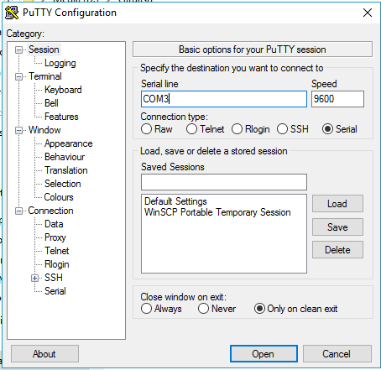
  + You can test the serial by typing the codes above on the putty terminal that opens
* Arduino source code is included if you need to reassign pins or add new functions