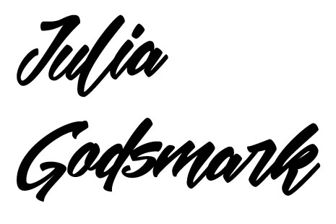

­

CONTACT

PROFILE

* Dynamic and creative digital designer that is intrigued by the connection between user experience, design and technology
* Strong ability to understand the consumer and translate their needs to a website or email marketing campaign
* Collaborate cross-functionally via communication in order to brainstorm and develop creative and new ideas
* Skilled at developing visual artifacts that demonstrate proof of concept via, storyboarding, creatig comps, prototypes, and wireframs in order to tell the story of a product to various stakeholders



linkedin/julia-godsmark

www.juliagodsmark.com

juliagodsmark@gmail.com

856.472.2465

­

EDUCATION

UX/FRONT END DEV. PROGRAM

Metis

December 2014

A.A.S. WEB DEVELOPMENT

Bergen Community College

Obtained 24 Credits

May 2014

B.A. ECONOMICS

Rutgers University

January 2011

DIGITAL DESIGNER

*Hanover Direct / Weehawken, NJ / April 2015 – Present*

* Design and develop impactful and responsive web pages for the e-commerce site, The Company Store
* Create new and time sensitive landing pages to market special promotions and new products
* Maintain web assets in order to showcase new products and communicate a message to consumers that wil grab their attention and connect with their needs
* Development and code email marketing campaigns, that have increased click through and website veiws due to hypotheses based on user prediction behavior
* Collaborate with marketing and prodcut development teams in order to establish a seamless message to consumers about products
* Communicate consistently and thoroughly with design team in order to produce work efficiently and effectively, exceeding the goals of the company

EXPERIENCE

SKILLS

* UI Design
* Responsive Design
* Wireframes
* User Flow
* Site Maps
* Adobe Photoshop
* Illustrator
* Sketch3
* Invision
* HTML5
* CSS3
* JQuery
* Git

DIGITAL DESIGN INTERN

*Hudson Horizons / Saddle Brook, NJ / January – April 2015*

* Enhanced client’s website fueled by consumer research, improving the user experience
* Increased SEO by making wedsites responsive through HTML and CSS
* Redesigned websites while adhering to client’s brand and style guidelines using CSS3 best practices