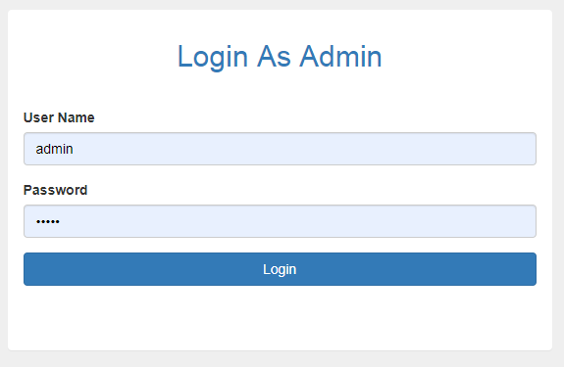

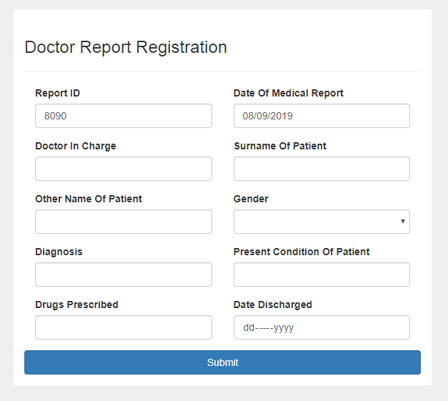

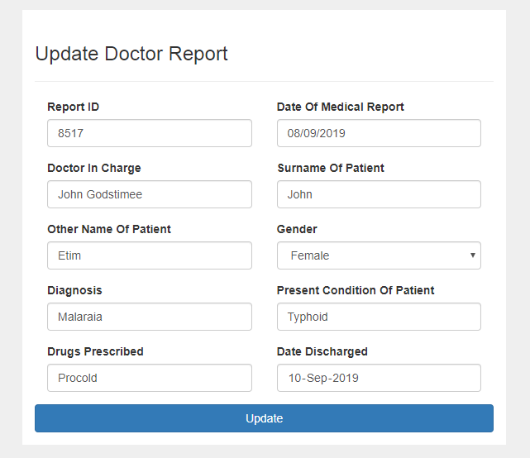

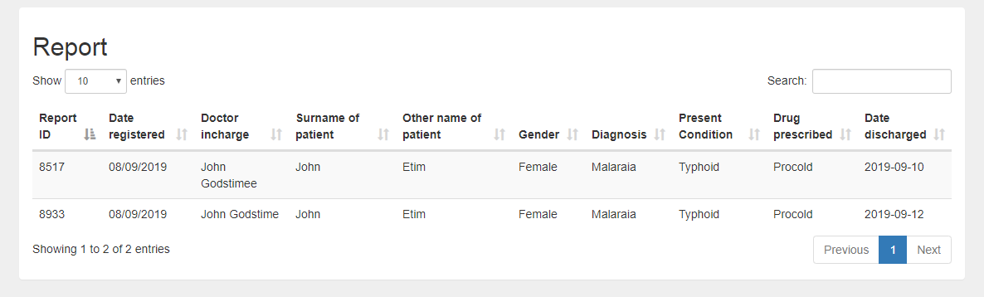

<?php

namespace Mini\Model;

use Mini\Core\Model;

use PDO;

class Register extends Model

{

public function getPatientInfo($id){

$query = $this->db -> prepare("SELECT * FROM patient_tbl WHERE reportId = ? LIMIT 1");

$query -> execute(array($id));

$result = $query->fetch();

return $result;

}

public function registerPatient($reportId,$date,$doctorInCharge,$surnameOfPatient,$otherNameOfPatient,$gender,$diagnosis,$presentCondition,$drugsPrescribed,$dateDischarged){

$queryInsert = $this->db->prepare("INSERT INTO patient_tbl (id,reportId,dateRegistered,doctorInCharge,surnameOfPatient,otherNameOfPatient,gender,diagnosis,presentCondition,drugsPrescribed,dateDischarged) VALUES(?,?,?,?,?,?,?,?,?,?,?)");

$queryInsert->execute(array('',$reportId,$date,$doctorInCharge,$surnameOfPatient,$otherNameOfPatient,$gender,$diagnosis,$presentCondition,$drugsPrescribed,$dateDischarged));

// die();

// print_r($this->db->errorInfo());

if($queryInsert){

$this->msg->success('Registration successful.', $_SERVER['HTTP_REFERER']);

}else{

$this->msg->success('Unable to register at this time, please try again later.', $_SERVER['HTTP_REFERER']);

}

}

public function updatePatient($reportId,$date,$doctorInCharge,$surnameOfPatient,$otherNameOfPatient,$gender,$diagnosis,$presentCondition,$drugsPrescribed,$dateDischarged){

$queryUpdate = $this->db->prepare("UPDATE patient_tbl set doctorInCharge=?,surnameOfPatient=?,otherNameOfPatient=?,gender=?,diagnosis=?,presentCondition=?,drugsPrescribed=?,dateDischarged=? WHERE reportId = ?");

$queryUpdate->execute(array($doctorInCharge,$surnameOfPatient,$otherNameOfPatient,$gender,$diagnosis,$presentCondition,$drugsPrescribed,$dateDischarged,$reportId));

// print_r($this->db->errorInfo());

if($queryUpdate){

$this->msg->success('Successfully updated.', $_SERVER['HTTP_REFERER']);

}else{

$this->msg->error('Unable to update at this time, please try again later.', $_SERVER['HTTP_REFERER']);

}

}

public function report(){

$query = $this->db -> prepare("SELECT * FROM patient_tbl ORDER BY id DESC");

$query->execute();

if($query->rowCount()>0){

?>

<h2 class=""> Report</h2>

<div class="table-responsive">

<table class="table table-hover table-striped">

<thead>

<tr>

<th>Report ID</th>

<th>Date registered </th>

<th>Doctor incharge</th>

<th>Surname of patient</th>

<th>Other name of patient</th>

<th>Gender</th>

<th>Diagnosis</th>

<th>Present Condition</th>

<th>Drug prescribed</th>

<th>Date discharged</th>

</tr>

</thead>

<?php

while($row = $query->fetch(PDO::FETCH_ASSOC)){

?>

<tr>

<td><?php echo $row['reportId'];?></td>

<td> <?php echo $row['dateRegistered'];?> </td>

<td><?php echo $row['doctorInCharge'];?></td>

<td><?php echo $row['surnameOfPatient'] ;?> </td>

<td><?php echo $row['otherNameOfPatient'] ;?> </td>

<td><?php echo $row['gender'] ;?> </td>

<td><?php echo $row['diagnosis'] ;?> </td>

<td><?php echo $row['presentCondition'] ;?> </td>

<td><?php echo $row['drugsPrescribed'] ;?> </td>

<td><?php echo $row['dateDischarged'] ;?> </td>

</tr>

<?php

}

?>

</table>

</div>

<?php

}else{

echo '<div>

<a class="list-group-item">No Record Found.</a>

</div>';

}

}

public function updateReport(){

$query = $this->db -> prepare("SELECT * FROM patient_tbl ORDER BY id DESC");

$query->execute();

if($query->rowCount()>0){

?>

<h2 class=""> Report</h2>

<div class="table-responsive">

<table class="table table-hover table-striped">

<thead>

<tr>

<th>Report ID</th>

<th>Date registered </th>

<th>Doctor incharge</th>

<th>Surname of patient</th>

<th>Other name of patient</th>

<th>Gender</th>

<th>Diagnosis</th>

<th>Present Condition</th>

<th>Drug prescribed</th>

<th>Date discharged</th>

<th>Update</th>

</tr>

</thead>

<?php

while($row = $query->fetch(PDO::FETCH_ASSOC)){

?>

<tr>

<td><?php echo $row['reportId'];?></td>

<td> <?php echo $row['dateRegistered'];?> </td>

<td><?php echo $row['doctorInCharge'];?></td>

<td><?php echo $row['surnameOfPatient'] ;?> </td>

<td><?php echo $row['otherNameOfPatient'] ;?> </td>

<td><?php echo $row['gender'] ;?> </td>

<td><?php echo $row['diagnosis'] ;?> </td>

<td><?php echo $row['presentCondition'] ;?> </td>

<td><?php echo $row['drugsPrescribed'] ;?> </td>

<td><?php echo $row['dateDischarged'] ;?> </td>

<td> <a class="btn btn-info" href="<?php URL ?>update?reportId=<?php echo $row['reportId']?>">Update</a></td>

</tr>

<?php

}

?>

</table>

</div>

<?php

}else{

echo '<div>

<a class="list-group-item">No Record Found.</a>

</div>';

}

}

}

<?php

namespace Mini\Model;

use Mini\Core\Model;

use PDO;

class Home extends Model

{

public function adminLogIn($email,$password){

if(!empty($email) or !empty($password)){

$query = $this->db->prepare("SELECT * FROM admin_tbl WHERE email=? LIMIT 1");

$query -> execute(array($email));

if ($query->rowCount()>0){

$result = $query->fetch(PDO::FETCH_ASSOC);

$email= $result["email"];

$adminId = $result["id"];

$adminId = $result["id"];

$passwordDb = $result["password"];

$verify = password_verify($password,$passwordDb);

if ($verify){

$_SESSION["adminId"] = $adminId;

header('location:'.URL.'register/report');

}else{

return $this->msg->error('Invalid username and password combination.', URL);

}

}else{

return $this->msg->error('Invalid username and password combination.', URL);

}

}else{

return $this->msg->error('Invalid username and password combination.', URL);

}

}

}

<?php

$msg = new \Mini\Libs\FlashMessages();

use Mini\Model\Lend;

?>

<div class="container">

<div class="row">

<div class="col-md-6 col-md-offset-3" style="background-color:white; margin-top:10px; padding-top:20px;">

<?php $msg->display();?>

<h3> Doctor Report Registration </h3>

<hr>

<form action="<?php $_SERVER['PHP_SELF'];?>" method="POST" class="" role="form" enctype="multipart/form-data">

<div class="col-md-6">

<div class="form-group">

<label class="" for="">Report ID </label>

<input type="text" class="form-control" name="reportId" value="<?php echo rand(9999,7777) ?>">

</div>

</div>

<div class="col-md-6">

<div class="form-group">

<label class="" for="">Date Of Medical Report </label>

<input type="text" class="form-control" name="date" value="<?php echo date("d/m/Y")?>">

</div>

</div>

<div class="col-md-6">

<div class="form-group">

<label class="" for="">Doctor In Charge</label>

<input type="text" name="doctorInCharge" class="form-control">

</div>

</div>

<div class="col-md-6">

<div class="form-group">

<label class="" for="">Surname Of Patient</label>

<input type="text" class="form-control" name="surnameOfPatient">

</div>

</div>

<div class="col-md-6">

<div class="form-group">

<label class="" for="">Other Name Of Patient</label>

<input type="text" class="form-control" name="otherNameOfPatient">

</div>

</div>

<div class="col-md-6">

<div class="form-group">

<label for="my-select">Gender</label>

<select id="my-select" class="form-control" name="gender">

<option value=""></option>

<option value="Male">Male</option>

<option value="Female">Female</option>

</select>

</div>

</div>

<div class="col-md-6">

<div class="form-group">

<label class="" for="">Diagnosis</label>

<input type="text" class="form-control" name="diagnosis">

</div>

</div>

<div class="col-md-6">

<div class="form-group">

<label class="" for="">Present Condition Of Patient</label>

<input type="text" class="form-control" name="presentCondition">

</div>

</div>

<div class="col-md-6">

<div class="form-group">

<label class="" for="">Drugs Prescribed</label>

<input type="text" class="form-control" name="drugsPrescribed">

</div>

</div>

<div class="col-md-6">

<div class="form-group">

<label class="" for="">Date Discharged</label>

<input type="date" class="form-control" name="dateDischarged">

</div>

</div>

<div class="form-group">

<button type="submit" name="regBtn" class="btn btn-primary btn-block">Submit</button>

</div>

</form>

</div>

</div>

</div>