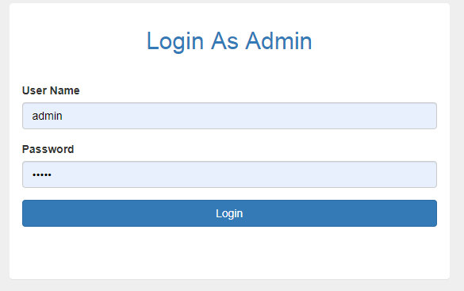

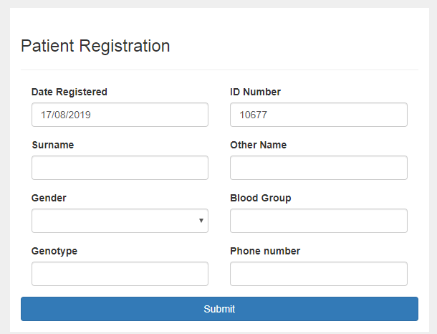

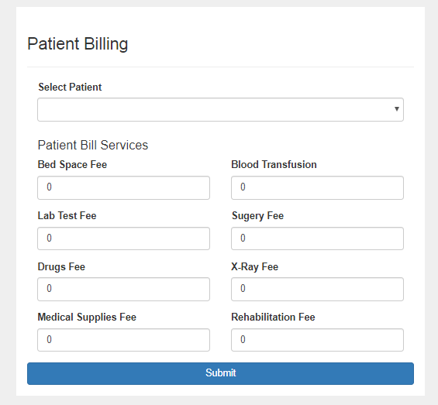

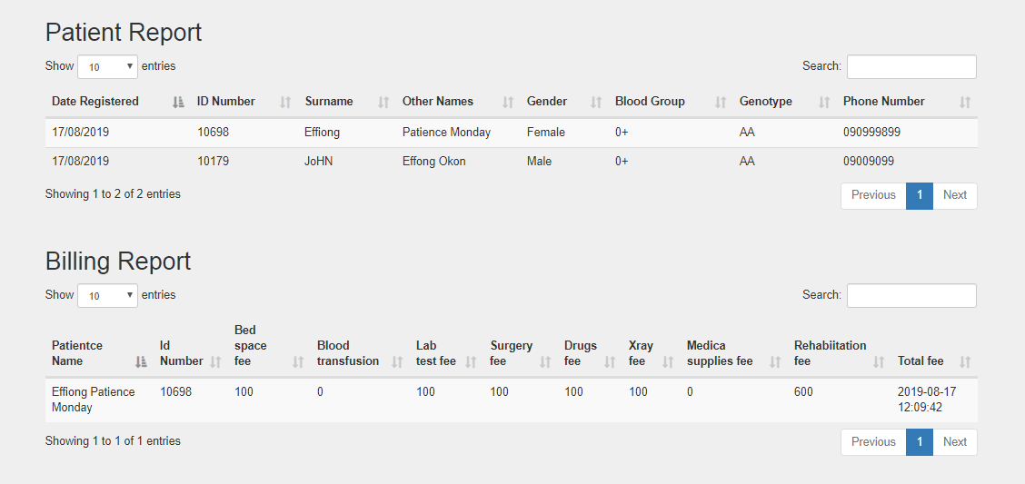

<?php

namespace Mini\Model;

use Mini\Core\Model;

use PDO;

class Register extends Model

{

public function getPatientInfo($idNumber){

$query = $this->db -> prepare("SELECT * FROM patient_tbl WHERE id_number = ? LIMIT 1");

$query -> execute(array($idNumber));

$result = $query->fetch();

return $result;

}

public function selectPatient(){

$query = $this->db -> prepare("SELECT * FROM patient_tbl");

$query -> execute();

while($row = $query->fetch(PDO::FETCH_ASSOC)){

?>

<option value="<?php echo $row['id_number'];?>"><?php echo $row['id_number']. " - ". $row['surname']." ".$row['other_name'];?></option>

<?php

}

}

public function regBilling($idNumber,$bloodTransfusion,$labTestFee,$sugeryFee,$drugFee,$xRayFee,$medicalSuppliesFee,$rehabilitationFee,$total){

$queryInsert = $this->db->prepare("INSERT INTO billing_tbl (id,id_number,blood_transfusion,lab_test_fee,surgery_fee,drug_fee,xray_fee,medical_supplies_fee,rehabilitation_fee,total,created_at) VALUES(?,?,?,?,?,?,?,?,?,?,now())");

$queryInsert->execute(array('',$idNumber,$bloodTransfusion,$labTestFee,$sugeryFee,$drugFee,$xRayFee,$medicalSuppliesFee,$rehabilitationFee,$total));

// print_r($this->db->errorInfo());

if($queryInsert){

$this->msg->success('Billing registration successful with total of '.$total, $_SERVER['HTTP_REFERER']);

}else{

$this->msg->success('Unable to register billing at this time, please try again later.', $_SERVER['HTTP_REFERER']);

}

}

public function registerPatient($dateRegistered,$idNumber,$surname,$otherName,$gender,$bloodGroup,$genotype,$phoneNumber){

$queryInsert = $this->db->prepare("INSERT INTO patient_tbl (id,date_registered,id_number,surname,other_name,gender,blood_group,genotype,phone_number) VALUES(?,?,?,?,?,?,?,?,?)");

$queryInsert->execute(array('',$dateRegistered,$idNumber,$surname,$otherName,$gender,$bloodGroup,$genotype,$phoneNumber));

// print_r($this->db->errorInfo());

if($queryInsert){

$this->msg->success('Patient registration successful with ID number of '.$idNumber, $_SERVER['HTTP_REFERER']);

}else{

$this->msg->success('Unable to register patient at this time, please try again later.', $_SERVER['HTTP_REFERER']);

}

}

public function patientReport(){

$query = $this->db -> prepare("SELECT * FROM patient_tbl ORDER BY id DESC");

$query->execute();

if($query->rowCount()>0){

?>

<h2 class=""> Patient Report</h2>

<div class="table-responsive">

<table class="table table-hover table-striped">

<thead>

<tr>

<th>Date Registered</th>

<th>ID Number</th>

<th>Surname</th>

<th>Other Names</th>

<th>Gender</th>

<th>Blood Group</th>

<th>Genotype</th>

<th>Phone Number</th>

</tr>

</thead>

<?php

while($row = $query->fetch(PDO::FETCH_ASSOC)){

?>

<tr>

<td><?php echo $row['date_registered'];?></td>

<td> <?php echo $row['id_number'];?> </td>

<td><?php echo $row['surname'];?></td>

<td><?php echo $row['other_name'] ;?> </td>

<td><?php echo $row['gender'] ;?> </td>

<td><?php echo $row['blood_group'] ;?> </td>

<td><?php echo $row['genotype'] ;?> </td>

<td><?php echo $row['phone_number'] ;?> </td>

</tr>

<?php

}

?>

</table>

</div>

<?php

}else{

echo '<div>

<a class="list-group-item">No Record Found.</a>

</div>';

}

}

public function billingReport(){

$query = $this->db ->prepare("SELECT * FROM billing_tbl ORDER BY id DESC");

$query->execute();

if($query->rowCount()>0){

?><h2>Billing Report</h2>

<div class="table-responsive">

<table class="table table-hover table-striped">

<thead>

<tr>

<th>Patientce Name</th>

<th>Id Number</th>

<th>Bed space fee</th>

<th>Blood transfusion</th>

<th>Lab test fee</th>

<th>Surgery fee</th>

<th>Drugs fee</th>

<th>Xray fee</th>

<th>Medica supplies fee</th>

<th>Rehabiitation fee</th>

<th>Total fee</th>

</tr>

</thead>

<?php

while($row = $query->fetch(PDO::FETCH_ASSOC)){

?>

<tr>

<td><?php echo $this->getPatientInfo($row['id_number'])->surname." ".$this->getPatientInfo($row['id_number'])->other_name;?></td>

<td> <?php echo $row['id_number'];?> </td>

<td><?php echo $row['blood_transfusion'];?></td>

<td><?php echo $row['lab_test_fee'];?></td>

<td><?php echo $row['surgery_fee'];?></td>

<td><?php echo $row['drug_fee'];?></td>

<td><?php echo $row['xray_fee'];?> </td>

<td><?php echo $row['medical_supplies_fee'];?> </td>

<td><?php echo $row['rehabilitation_fee'];?> </td>

<td><?php echo $row['total'];?> </td>

<td><?php echo $row['created_at'];?> </td>

</tr>

<?php

}

?>

</table>

</div>

<?php

}else{

echo '<div>

<a class="list-group-item">No Record Found.</a>

</div>';

}

}

}

<?php

$msg = new \Mini\Libs\FlashMessages();

use Mini\Model\Lend;

?>

<div class="container">

<div class="row">

<div class="col-md-6 col-md-offset-3" style="background-color:white; margin-top:10px; padding-top:20px;">

<?php $msg->display();?>

<h3> Patient Registration</h3>

<hr>

<form action="<?php $_SERVER['PHP_SELF'];?>" method="POST" class="" role="form" enctype="multipart/form-data">

<div class="col-md-6">

<div class="form-group">

<label class="" for="">Date Registered </label>

<input type="text" class="form-control" name="date" value="<?php echo date("d/m/Y")?>">

</div>

</div>

<div class="col-md-6">

<div class="form-group">

<label class="" for=""> ID Number</label>

<input type="text" class="form-control" value="<?php echo rand(9873,10998)?>" name="idNumber">

</div>

</div>

<div class="col-md-6">

<div class="form-group">

<label class="" for="">Surname</label>

<input type="text" name="surname" class="form-control">

</div>

</div>

<div class="col-md-6">

<div class="form-group">

<label class="" for="">Other Name</label>

<input type="text" class="form-control" name="otherName">

</div>

</div>

<div class="col-md-6">

<div class="form-group">

<label class="" for="">Gender</label>

<select name="gender" id="inputgender" class="form-control" required="required">

<option value=""></option>

<option value="Male">Male</option>

<option value="Female">Female</option>

</select>

</div>

</div>

<div class="col-md-6">

<div class="form-group">

<label class="" for="">Blood Group</label>

<input type="text" class="form-control" name="bloodGroup">

</div>

</div>

<div class="col-md-6">

<div class="form-group">

<label class="" for="">Genotype</label>

<input type="text" class="form-control" name="genotype">

</div>

</div>

<div class="col-md-6">

<div class="form-group">

<label class="" for="">Phone number </label>

<input type="text" class="form-control" name="phoneNumber">

</div>

</div>

<div class="form-group">

<button type="submit" name="regPatient" class="btn btn-primary btn-block">Submit</button>

</div>

</form>

</div>

</div>

</div>