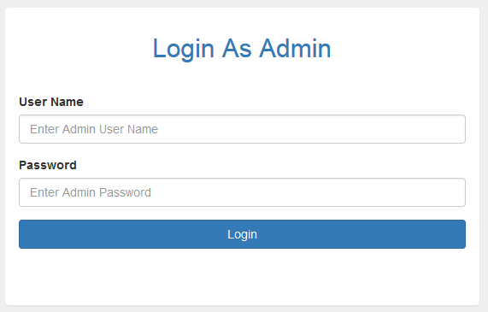

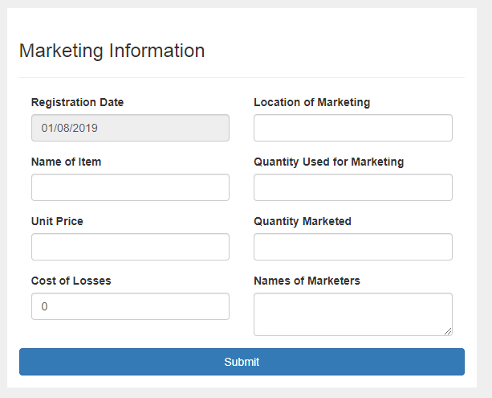

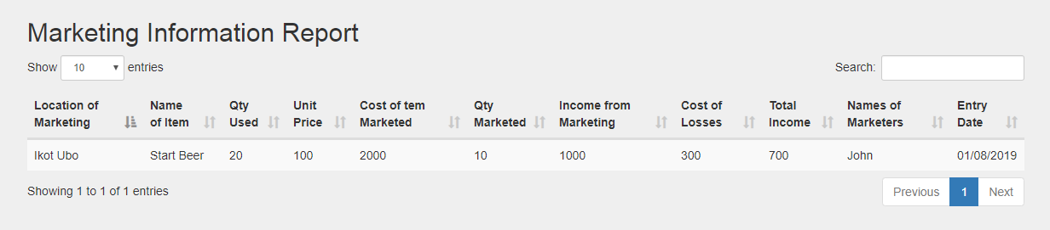

<?php

namespace Mini\Model;

use Mini\Core\Model;

use PDO;

class Register extends Model

{

public function register($locationOfMarketing,$nameOfItem,$qtyUsed,$unitPrice,$costOfItemMarketed,$quantityMarketed,$incomeFromMarketing,$costOfLosses,$totalIncome,$namesOfMarketers,$regDate){

$regDate = date("d/m/Y");

$queryInsert = $this->db->prepare("INSERT INTO register_tbl (id,location_of_marketing,name_of_item,qty_used,unit_price,cost_of_item_marketed,qty_marketed,income_from_marketing,cost_of_losses,total_income,names_of_maketers,registration_date) VALUES(?,?,?,?,?,?,?,?,?,?,?,?)");

$queryInsert->execute(array('',$locationOfMarketing,$nameOfItem,$qtyUsed,$unitPrice,$costOfItemMarketed,$quantityMarketed,$incomeFromMarketing,$costOfLosses,$totalIncome,$namesOfMarketers,$regDate));

// print_r($this->db->errorInfo());

if($queryInsert){

$this->msg->success('Marketing information successfully registered.', $_SERVER['HTTP_REFERER']);

}else{

$this->msg->success('Unable to register at this time, please try again later.', $_SERVER['HTTP_REFERER']);

}

}

public function record(){

$query = $this->db -> prepare("SELECT * FROM register_tbl ORDER BY id DESC");

$query->execute();

if($query->rowCount()>0){

?>

<h2 class=""> Marketing Information Report</h2>

<div class="table-responsive">

<table class="table table-hover table-striped">

<thead>

<tr>

<th>Location of Marketing</th>

<th>Name of Item</th>

<th>Qty Used</th>

<th>Unit Price</th>

<th>Cost of tem Marketed</th>

<th>Qty Marketed</th>

<th>Income from Marketing</th>

<th>Cost of Losses</th>

<th>Total Income</th>

<th>Names of Marketers</th>

<th>Entry Date</th>

</tr>

</thead>

<?php

while($row = $query->fetch(PDO::FETCH_ASSOC)){

?>

<tr>

<td><?php echo $row['location_of_marketing'];?></td>

<td> <?php echo $row['name_of_item'];?> </td>

<td><?php echo $row['qty_used'];?></td>

<td><?php echo $row['unit_price'] ;?> </td>

<td><?php echo $row['cost_of_item_marketed'] ;?> </td>

<td><?php echo $row['qty_marketed'] ;?> </td>

<td><?php echo $row['income_from_marketing'] ;?> </td>

<td><?php echo $row['cost_of_losses'] ;?> </td>

<td><?php echo $row['total_income'] ;?> </td>

<td><?php echo $row['names_of_maketers'] ;?> </td>

<td><?php echo $row['registration_date'] ;?> </td>

</tr>

<?php

}

?>

</table>

</div>

<?php

}else{

echo '<div>

<a class="list-group-item">No Record Found.</a>

</div>';

}

}

}

<?php

$msg = new \Mini\Libs\FlashMessages();

use Mini\Model\Register;

$Church = (new Register);

?>

<div class="container">

<div class="row">

<?php

$Church->record();

?>

</div>

</div>

<?php

$msg = new \Mini\Libs\FlashMessages();

use Mini\Model\Lend;

?>

<div class="container">

<div class="row">

<div class="col-md-6 col-md-offset-3" style="background-color:white; margin-top:10px; padding-top:20px;">

<?php $msg->display();?>

<h3> Marketing Information</h3>

<hr>

<form action="<?php $_SERVER['PHP_SELF'];?>" method="POST" class="" role="form" enctype="multipart/form-data">

<div class="col-md-6">

<div class="form-group">

<label class="" for="">Registration Date </label>

<input type="text" disabled class="form-control" name="regDate" value="<?php echo date("d/m/Y")?>">

</div>

</div>

<div class="col-md-6">

<div class="form-group">

<label class="" for="">Location of Marketing </label>

<input type="text" class="form-control" name="locationOfMarketing">

</div>

</div>

<div class="col-md-6">

<div class="form-group">

<label class="" for="">Name of Item</label>

<input type="text" name="nameOfItem" class="form-control">

</div>

</div>

<div class="col-md-6">

<div class="form-group">

<label class="" for="">Quantity Used for Marketing</label>

<input type="number" class="form-control" name="qtyUsed">

</div>

</div>

<div class="col-md-6">

<div class="form-group">

<label class="" for="">Unit Price</label>

<input type="text" class="form-control" name="unitPrice">

</div>

</div>

<!-- <div class="col-md-6">

<div class="form-group">

<label class="" for="">Cost of Item to be Marketed</label>

<input type="text" class="form-control" name="costOfItemMarketed">

</div>

</div> -->

<div class="col-md-6">

<div class="form-group">

<label class="" for="">Quantity Marketed</label>

<input type="text" class="form-control" name="quantityMarketed">

</div>

</div>

<!-- <div class="col-md-6">

<div class="form-group">

<label class="" for="">Income From Marketing</label>

<input type="text" class="form-control" name="incomeFromMarketing">

</div>

</div> -->

<div class="col-md-6">

<div class="form-group">

<label class="" for="">Cost of Losses</label>

<input type="number" name="costOfLosses" value="0" class="form-control">

</div>

</div>

<!-- <div class="col-md-6">

<div class="form-group">

<label class="" for="">Total Income</label>

<input type="text" name="totalIncome" class="form-control">

</div>

</div> -->

<div class="col-md-6">

<div class="form-group">

<label class="" for="">Names of Marketers</label>

<textarea name="namesOfMarketers" class="form-control" required="required"></textarea>

</div>

</div>

<div class="form-group">

<button type="submit" name="registerBtn" class="btn btn-primary btn-block">Submit</button>

</div>

</form>

</div>

</div>

</div>