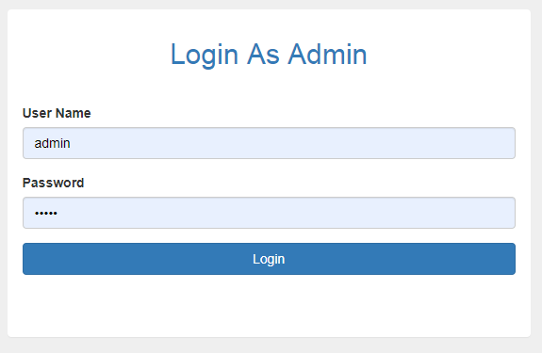

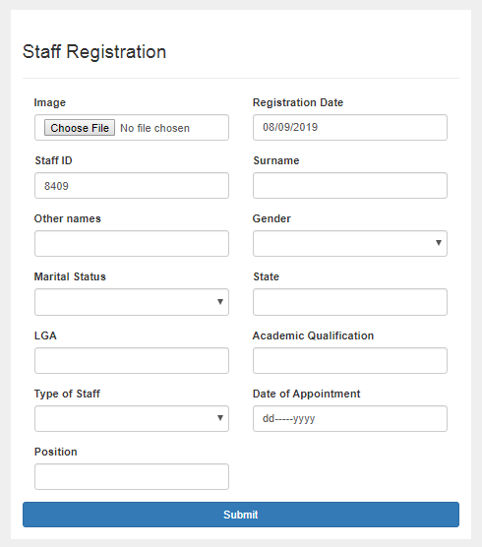

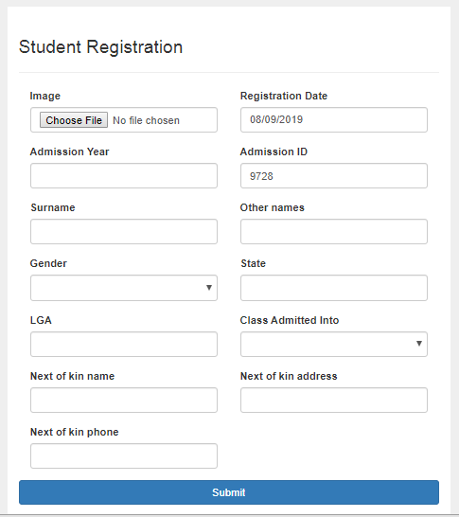

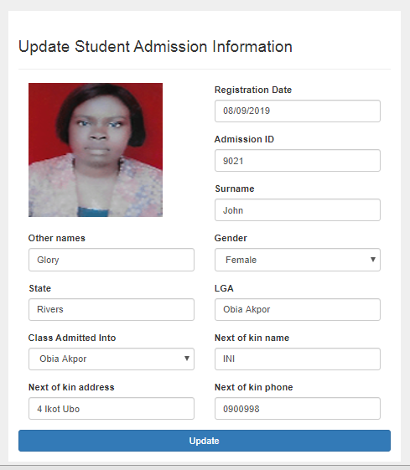

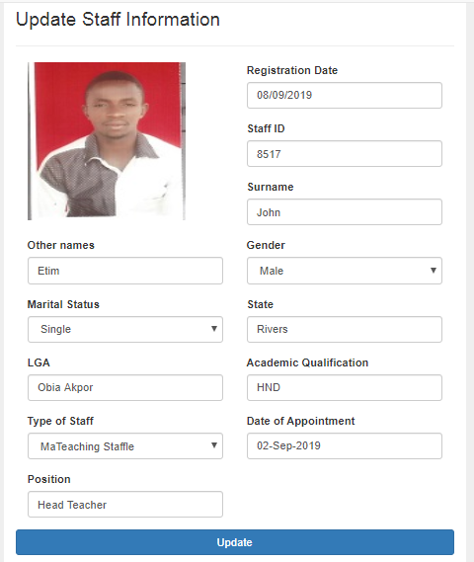

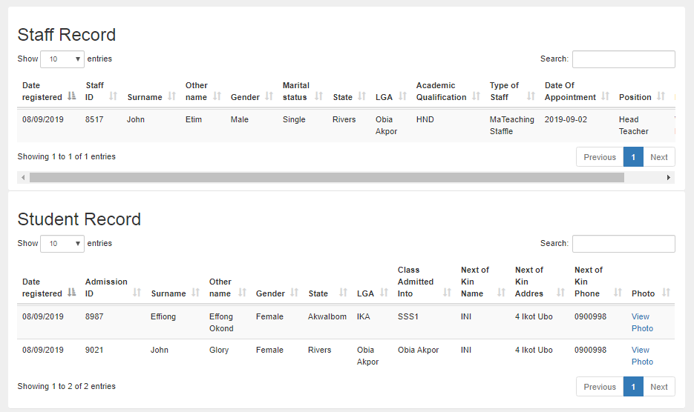

<?php

namespace Mini\Model;

use Mini\Core\Model;

use PDO;

class Register extends Model

{

public function getStaffInfo($id){

$query = $this->db -> prepare("SELECT * FROM staff_tbl WHERE staffId = ? LIMIT 1");

$query -> execute(array($id));

$result = $query->fetch();

return $result;

}

public function registerStaff($fileName,$temporaryFile,$registrationDate,$staffId,$surname,$otherName,$gender,$maritalStatus,$state,$lga,$academicQualification,$typeOfStaff,$dateOfAppointment,$position){

$materialCode = rand(3000,10000).rand(9000,10000).rand(200,4000);

$writerCodeForThisMat = $materialCode;

$temp = explode(".", $fileName);

$newFileName = $writerCodeForThisMat . '.' . end($temp); //renaming the material with

move_uploaded_file($temporaryFile,'staffImage/'.$newFileName);

$queryInsert = $this->db->prepare("INSERT INTO staff_tbl (id,registrationDate,staffId,surname,otherName,gender,maritalStatus,state,lga,academicQualification,typeOfStaff,dateOfAppointment,position,photo) VALUES(?,?,?,?,?,?,?,?,?,?,?,?,?,?)");

$queryInsert->execute(array('',$registrationDate,$staffId,$surname,$otherName,$gender,$maritalStatus,$state,$lga,$academicQualification,$typeOfStaff,$dateOfAppointment,$position,$newFileName));

// die();

// print_r($this->db->errorInfo());

if($queryInsert){

$this->msg->success('Registration successful.', $_SERVER['HTTP_REFERER']);

}else{

$this->msg->success('Unable to register at this time, please try again later.', $_SERVER['HTTP_REFERER']);

}

}

public function updateStaff($staffId,$surname,$otherName,$gender,$maritalStatus,$state,$lga,$academicQualification,$typeOfStaff,$dateOfAppointment,$position){

// die($staffId);

$queryUpdate = $this->db->prepare("UPDATE staff_tbl set surname=?,otherName=?,gender=?,maritalStatus=?,state=?,lga=?,academicQualification=?,typeOfStaff=?,dateOfAppointment=?,position=? WHERE staffId = ?");

$queryUpdate->execute(array($surname,$otherName,$gender,$maritalStatus,$state,$lga,$academicQualification,$typeOfStaff,$dateOfAppointment,$position,$staffId));

// print_r($this->db->errorInfo());

if($queryUpdate){

$this->msg->success('Successfully updated.', $_SERVER['HTTP_REFERER']);

}else{

$this->msg->error('Unable to update at this time, please try again later.', $_SERVER['HTTP_REFERER']);

}

}

public function staffRecord(){

$query = $this->db -> prepare("SELECT * FROM staff_tbl ORDER BY id DESC");

$query->execute();

if($query->rowCount()>0){

?>

<h2 class=""> Staff Record</h2>

<div class="table-responsive">

<table class="table table-hover table-striped">

<thead>

<tr>

<th>Date registered </th>

<th>Staff ID</th>

<th>Surname</th>

<th>Other name </th>

<th>Gender</th>

<th>Marital status</th>

<th>State</th>

<th>LGA</th>

<th>Academic Qualification</th>

<th>Type of Staff</th>

<th>Date Of Appointment</th>

<th>Position</th>

<th>Photo</th>

</tr>

</thead>

<?php

while($row = $query->fetch(PDO::FETCH_ASSOC)){

?>

<tr>

<td><?php echo $row['registrationDate'];?></td>

<td> <?php echo $row['staffId'];?> </td>

<td><?php echo $row['surname'];?></td>

<td><?php echo $row['otherName'] ;?> </td>

<td><?php echo $row['gender'] ;?> </td>

<td><?php echo $row['maritalStatus'] ;?> </td>

<td><?php echo $row['state'] ;?> </td>

<td><?php echo $row['lga'] ;?> </td>

<td><?php echo $row['academicQualification'] ;?> </td>

<td><?php echo $row['typeOfStaff'] ;?> </td>

<td><?php echo $row['dateOfAppointment'] ;?> </td>

<td><?php echo $row['position'] ;?> </td>

<td> <a href="<?php echo URL. 'staffImage/'.$row['photo'] ;?>">View Photo</a> </td>

</tr>

<?php

}

?>

</table>

</div>

<?php

}else{

echo '<div>

<a class="list-group-item">No Record Found.</a>

</div>';

}

}

public function updateStaffRecord(){

$query = $this->db -> prepare("SELECT * FROM staff_tbl ORDER BY id DESC");

$query->execute();

if($query->rowCount()>0){

?>

<h2 class=""> Update Staff Record</h2>

<div class="table-responsive">

<table class="table table-hover table-striped">

<thead>

<tr>

<th>Date registered </th>

<th>Staff ID</th>

<th>Surname</th>

<th>Other name </th>

<th>Gender</th>

<th>Marital status</th>

<th>State</th>

<th>LGA</th>

<th>Academic Qualification</th>

<th>Type of Staff</th>

<th>Date Of Appointment</th>

<th>Position</th>

<th>Update</th>

</tr>

</thead>

<?php

while($row = $query->fetch(PDO::FETCH_ASSOC)){

?>

<tr>

<td><?php echo $row['registrationDate'];?></td>

<td> <?php echo $row['staffId'];?> </td>

<td><?php echo $row['surname'];?></td>

<td><?php echo $row['otherName'] ;?> </td>

<td><?php echo $row['gender'] ;?> </td>

<td><?php echo $row['maritalStatus'] ;?> </td>

<td><?php echo $row['state'] ;?> </td>

<td><?php echo $row['lga'] ;?> </td>

<td><?php echo $row['academicQualification'] ;?> </td>

<td><?php echo $row['typeOfStaff'] ;?> </td>

<td><?php echo $row['dateOfAppointment'] ;?> </td>

<td><?php echo $row['position'] ;?> </td>

<td> <a class="btn btn-info" href="<?php URL ?>updateStaff?staffId=<?php echo $row['staffId']?>">Update</a></td>

</tr>

<?php

}

?>

</table>

</div>

<?php

}else{

echo '<div>

<a class="list-group-item">No Record Found.</a>

</div>';

}

}

// _______________________________________nONE TEACHING STAFF ____________________________________________________

public function getStudentInfo($id){

$query = $this->db -> prepare("SELECT * FROM student_tbl WHERE admissionId = ? LIMIT 1");

$query -> execute(array($id));

$result = $query->fetch();

return $result;

}

public function registerStudent($fileName,$temporaryFile,$registrationDate,$admissionId,$surname,$otherName,$gender,$state,$lga,$classAdmittedInto,$nextOfKinName,$nextOfKinAddress,$nextOfKinPhone){

$materialCode = rand(3000,10000).rand(9000,10000).rand(200,4000);

$writerCodeForThisMat = $materialCode;

$temp = explode(".", $fileName);

$newFileName = $writerCodeForThisMat . '.' . end($temp); //renaming the material with

move_uploaded_file($temporaryFile,'studentImage/'.$newFileName);

$queryInsert = $this->db->prepare("INSERT INTO student_tbl (id,registrationDate,admissionId,surname,otherName,gender,state,lga,classAdmittedInto,nextOfKinName,nextOfKinAddress,nextOfKinPhone,photo) VALUES(?,?,?,?,?,?,?,?,?,?,?,?,?)");

$queryInsert->execute(array('',$registrationDate,$admissionId,$surname,$otherName,$gender,$state,$lga,$classAdmittedInto,$nextOfKinName,$nextOfKinAddress,$nextOfKinPhone,$newFileName));

// die();

print_r($this->db->errorInfo());

if($queryInsert){

$this->msg->success('Registration successful.', $_SERVER['HTTP_REFERER']);

}else{

$this->msg->success('Unable to register at this time, please try again later.', $_SERVER['HTTP_REFERER']);

}

}

public function updateStudent($admissionId,$surname,$otherName,$gender,$state,$lga,$classAdmittedInto,$nextOfKinName,$nextOfKinAddress,$nextOfKinPhone){

$queryUpdate = $this->db->prepare("UPDATE student_tbl set surname=?,otherName=?,gender=?,state=?,lga=?,classAdmittedInto=?,nextOfKinName=?,nextOfKinAddress=?,nextOfKinPhone=? WHERE admissionId = ?");

$queryUpdate->execute(array($surname,$otherName,$gender,$state,$lga,$classAdmittedInto,$nextOfKinName,$nextOfKinAddress,$nextOfKinPhone,$admissionId));

// print_r($this->db->errorInfo());

if($queryUpdate){

$this->msg->success('Successfully updated.', $_SERVER['HTTP_REFERER']);

}else{

$this->msg->error('Unable to update at this time, please try again later.', $_SERVER['HTTP_REFERER']);

}

}

public function studentRecord(){

$query = $this->db -> prepare("SELECT * FROM student_tbl ORDER BY id DESC");

$query->execute();

if($query->rowCount()>0){

?>

<h2 class=""> Student Record</h2>

<div class="table-responsive">

<table class="table table-hover table-striped">

<thead>

<tr>

<th>Date registered </th>

<th>Admission ID</th>

<th>Surname</th>

<th>Other name </th>

<th>Gender</th>

<th>State</th>

<th>LGA</th>

<th>Class Admitted Into</th>

<th>Next of Kin Name</th>

<th>Next of Kin Addres</th>

<th>Next of Kin Phone</th>

<th>Photo</th>

</tr>

</thead>

<?php

while($row = $query->fetch(PDO::FETCH_ASSOC)){

?>

<tr>

<td><?php echo $row['registrationDate'];?></td>

<td> <?php echo $row['admissionId'];?> </td>

<td><?php echo $row['surname'];?></td>

<td><?php echo $row['otherName'] ;?> </td>

<td><?php echo $row['gender'] ;?> </td>

<td><?php echo $row['state'] ;?> </td>

<td><?php echo $row['lga'] ;?> </td>

<td><?php echo $row['classAdmittedInto'] ;?> </td>

<td><?php echo $row['nextOfKinName'] ;?> </td>

<td><?php echo $row['nextOfKinAddress'] ;?> </td>

<td><?php echo $row['nextOfKinPhone'] ;?> </td>

<td> <a href="<?php echo URL. 'studentImage/'.$row['photo'] ;?>">View Photo</a> </td>

</tr>

<?php

}

?>

</table>

</div>

<?php

}else{

echo '<div>

<a class="list-group-item">No Record Found.</a>

</div>';

}

}

public function updateStudentRecord(){

$query = $this->db -> prepare("SELECT * FROM student_tbl ORDER BY id DESC");

$query->execute();

if($query->rowCount()>0){

?>

<h2 class=""> Update student Record</h2>

<div class="table-responsive">

<table class="table table-hover table-striped">

<thead>

<tr>

<th>Date registered </th>

<th>Student ID</th>

<th>Surname</th>

<th>Other name </th>

<th>Gender</th>

<th>State</th>

<th>LGA</th>

<th>Class Admitted Into</th>

<th>Next of Kin Name</th>

<th>Next of Kin Addres</th>

<th>Next of Kin Phone</th>

<th>Action</th>

</tr>

</thead>

<?php

while($row = $query->fetch(PDO::FETCH_ASSOC)){

?>

<tr>

<td><?php echo $row['registrationDate'];?></td>

<td> <?php echo $row['admissionId'];?> </td>

<td><?php echo $row['surname'];?></td>

<td><?php echo $row['otherName'] ;?> </td>

<td><?php echo $row['gender'] ;?> </td>

<td><?php echo $row['state'] ;?> </td>

<td><?php echo $row['lga'] ;?> </td>

<td><?php echo $row['classAdmittedInto'] ;?> </td>

<td><?php echo $row['nextOfKinName'] ;?> </td>

<td><?php echo $row['nextOfKinAddress'] ;?> </td>

<td><?php echo $row['nextOfKinPhone'] ;?> </td>

<td> <a class="btn btn-info" href="<?php URL ?>updateStudent?admissionId=<?php echo $row['admissionId']?>">Update</a></td>

</tr>

<?php

}

?>

</table>

</div>

<?php

}else{

echo '<div>

<a class="list-group-item">No Record Found.</a>

</div>';

}

}

}

<?php

$msg = new \Mini\Libs\FlashMessages();

use Mini\Model\Lend;

?>

<div class="container">

<div class="row">

<div class="col-md-6 col-md-offset-3" style="background-color:white; margin-top:10px; padding-top:20px;">

<?php $msg->display();?>

<h3>Staff Registration </h3>

<hr>

<form action="<?php $_SERVER['PHP_SELF'];?>" method="POST" class="" role="form" enctype="multipart/form-data">

<div class="col-md-6">

<div class="form-group">

<label class="" for="">Image</label>

<img src="" height="80" width="80" alt="" id="previewimageid">

<input type="file" class="form-control" name="file" onchange="previewimage(event)">

</div>

</div>

<div class="col-md-6">

<div class="form-group">

<label class="" for="">Registration Date </label>

<input type="text" class="form-control" name="registrationDate" value="<?php echo date("d/m/Y")?>">

</div>

</div>

<div class="col-md-6">

<div class="form-group">

<label class="" for="">Staff ID </label>

<input type="text" class="form-control" name="staffId" value="<?php echo rand(9999,7777) ?>">

</div>

</div>

<div class="col-md-6">

<div class="form-group">

<label class="" for="">Surname </label>

<input type="text" name="surname" class="form-control">

</div>

</div>

<div class="col-md-6">

<div class="form-group">

<label class="" for="">Other names </label>

<input type="text" class="form-control" name="otherName">

</div>

</div>

<div class="col-md-6">

<div class="form-group">

<label for="my-select">Gender </label>

<select id="my-select" class="form-control" name="gender">

<option value=""></option>

<option value="Male">Male</option>

<option value="Female">Female</option>

</select>

</div>

</div>

<div class="col-md-6">

<div class="form-group">

<label for="my-select">Marital Status </label>

<select id="my-select" class="form-control" name="maritalStatus">

<option value=""></option>

<option value="Single">Single</option>

<option value="Married">Married</option>

<option value="Devoiced">Devoiced</option>

</select>

</div>

</div>

<div class="col-md-6">

<div class="form-group">

<label class="" for="">State</label>

<input type="text" class="form-control" name="state">

</div>

</div>

<div class="col-md-6">

<div class="form-group">

<label class="" for="">LGA</label>

<input type="text" class="form-control" name="lga">

</div>

</div>

<div class="col-md-6">

<div class="form-group">

<label class="" for="">Academic Qualification</label>

<input type="text" class="form-control" name="academicQualification">

</div>

</div>

<div class="col-md-6">

<div class="form-group">

<label class="" for="">Type of Staff</label>

<select id="my-select" class="form-control" name="typeOfStaff">

<option value=""></option>

<option value="MaTeaching Staffle">Teaching Staff</option>

<option value="Non Teaching">Non Teaching</option>

</select>

</div>

</div>

<div class="col-md-6">

<div class="form-group">

<label class="" for="">Date of Appointment</label>

<input type="date" class="form-control" name="dateOfAppointment">

</div>

</div>

<div class="col-md-6">

<div class="form-group">

<label class="" for="">Position</label>

<input type="text" class="form-control" name="position">

</div>

</div>

<div class="form-group">

<button type="submit" name="regTeachingStaffBtn" class="btn btn-primary btn-block">Submit</button>

</div>

</form>

</div>

</div>

</div>

<script type="text/javascript">

function previewimage(event) {

var output = document.getElementById('previewimageid');

output.src = URL.createObjectURL(event.target.files[0]);

};

</script>

<?php

namespace Mini\Model;

use Mini\Core\Model;

use PDO;

class Home extends Model

{

public function adminLogIn($email,$password){

if(!empty($email) or !empty($password)){

$query = $this->db->prepare("SELECT * FROM admin_tbl WHERE email=? LIMIT 1");

$query -> execute(array($email));

if ($query->rowCount()>0){

$result = $query->fetch(PDO::FETCH_ASSOC);

$email= $result["email"];

$adminId = $result["id"];

$adminId = $result["id"];

$passwordDb = $result["password"];

$verify = password_verify($password,$passwordDb);

if ($verify){

$_SESSION["adminId"] = $adminId;

header('location:'.URL.'register/staff');

}else{

return $this->msg->error('Invalid username and password combination.', URL);

}

}else{

return $this->msg->error('Invalid username and password combination.', URL);

}

}else{

return $this->msg->error('Invalid username and password combination.', URL);

}

}

}