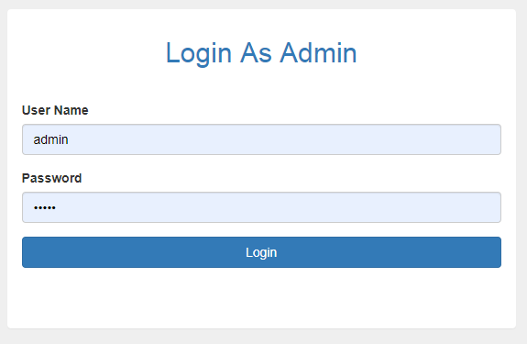

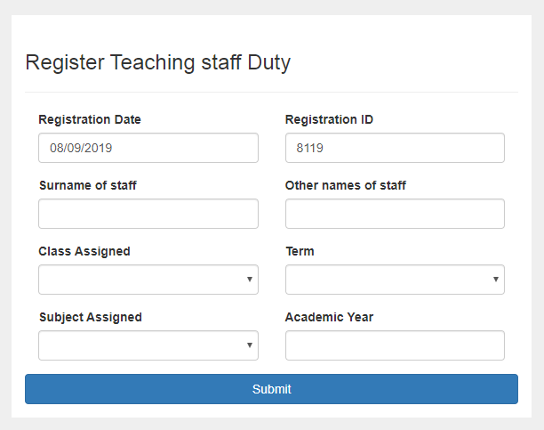

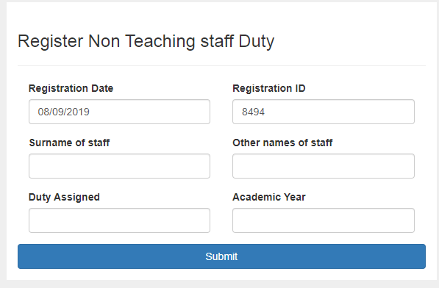

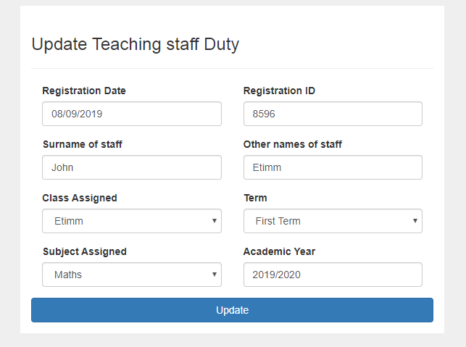

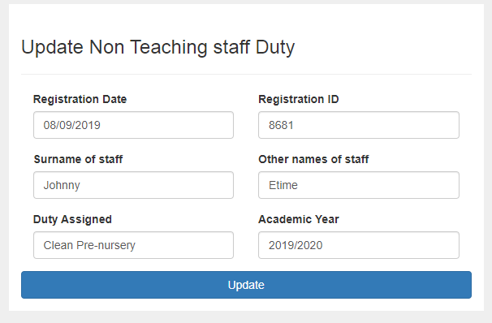

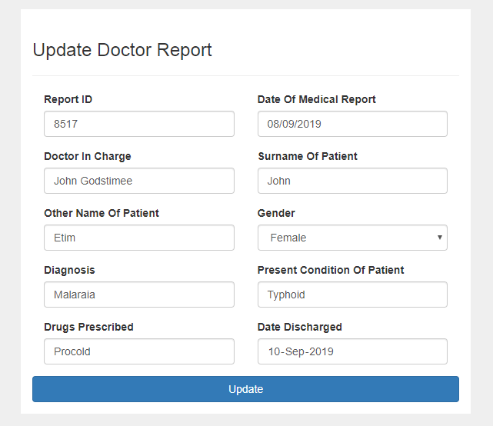

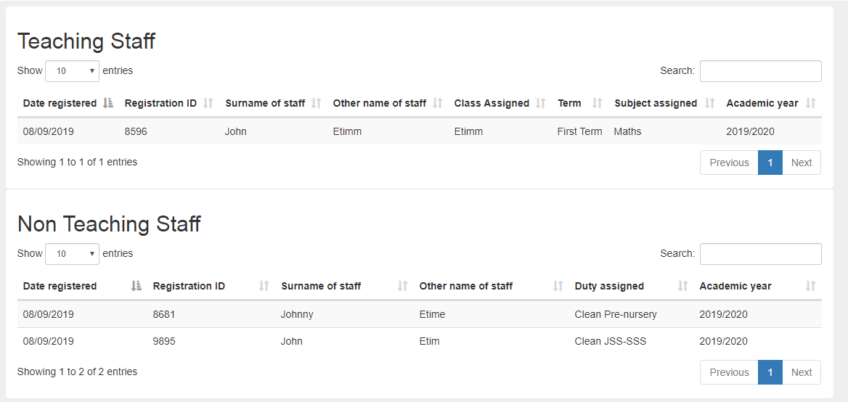

<?php

$msg = new \Mini\Libs\FlashMessages();

use Mini\Model\Lend;

?>

<div class="container">

<div class="row">

<div class="col-md-6 col-md-offset-3" style="background-color:white; margin-top:10px; padding-top:20px;">

<?php $msg->display();?>

<h3>Register Non Teaching staff Duty </h3>

<hr>

<form action="<?php $_SERVER['PHP_SELF'];?>" method="POST" class="" role="form" enctype="multipart/form-data">

<div class="col-md-6">

<div class="form-group">

<label class="" for="">Registration Date </label>

<input type="text" class="form-control" name="registrationDate" value="<?php echo date("d/m/Y")?>">

</div>

</div>

<div class="col-md-6">

<div class="form-group">

<label class="" for="">Registration ID </label>

<input type="text" class="form-control" name="registrationId" value="<?php echo rand(9999,7777) ?>">

</div>

</div>

<div class="col-md-6">

<div class="form-group">

<label class="" for="">Surname of staff</label>

<input type="text" name="surnameOfStaff" class="form-control">

</div>

</div>

<div class="col-md-6">

<div class="form-group">

<label class="" for="">Other names of staff</label>

<input type="text" class="form-control" name="otherNameOfStaff">

</div>

</div>

<div class="col-md-6">

<div class="form-group">

<label class="" for="">Duty Assigned</label>

<input type="text" class="form-control" name="dutyAssigned">

</div>

</div>

<div class="col-md-6">

<div class="form-group">

<label class="" for="">Academic Year</label>

<input type="text" class="form-control" name="academicYear">

</div>

</div>

<div class="form-group">

<button type="submit" name="regNonTeachingStaffBtn" class="btn btn-primary btn-block">Submit</button>

</div>

</form>

</div>

</div>

</div>

public function admin()

{

if(isset($_POST['loginBtn'])){

$password = trim($_POST['password']);

$email = trim($_POST['email']);

if(empty($password)){

$this->msg->error('Password is required.');

}if(empty($email)){

$this->msg->error('User name is required.');

}

if ($this->msg->hasErrors()){

header('location:' . $_SERVER['HTTP_REFERER']);

}else{

(new \Mini\Model\Home)-> adminLogIn($email,$password);

}

}else{

// html data

$data["title"] = "Admin"; /* for <title></title> inside header.php in this case */

// load views

$this->View->render('home/index', $data);

}

}

public function logout()

{

unset($_SESSION['adminId']);

header('location:'. URL.'home');

}

<?php

namespace Mini\Model;

use Mini\Core\Model;

use PDO;

class Register extends Model

{

public function getTeachingStaffInfo($id){

$query = $this->db -> prepare("SELECT * FROM teaching_tbl WHERE registrationId = ? LIMIT 1");

$query -> execute(array($id));

$result = $query->fetch();

return $result;

}

public function registerTeachingStaff($registrationDate,$registrationId,$surnameOfStaff,$otherNameOfStaff,$classAssigned,$term,$subjectAssigned,$academicYear){

$queryInsert = $this->db->prepare("INSERT INTO teaching_tbl (id,registrationDate,registrationId,surnameOfStaff,otherNameOfStaff,classAssigned,term,subjectAssigned,academicYear) VALUES(?,?,?,?,?,?,?,?,?)");

$queryInsert->execute(array('',$registrationDate,$registrationId,$surnameOfStaff,$otherNameOfStaff,$classAssigned,$term,$subjectAssigned,$academicYear));

// die();

// print_r($this->db->errorInfo());

if($queryInsert){

$this->msg->success('Registration successful.', $_SERVER['HTTP_REFERER']);

}else{

$this->msg->success('Unable to register at this time, please try again later.', $_SERVER['HTTP_REFERER']);

}

}

public function updateTeachingStaff($registrationId,$surnameOfStaff,$otherNameOfStaff,$classAssigned,$term,$subjectAssigned,$academicYear){

$queryUpdate = $this->db->prepare("UPDATE teaching_tbl set surnameOfStaff=?,otherNameOfStaff=?,classAssigned=?,term=?,subjectAssigned=?,academicYear=? WHERE registrationId = ?");

$queryUpdate->execute(array($surnameOfStaff,$otherNameOfStaff,$classAssigned,$term,$subjectAssigned,$academicYear,$registrationId));

// print_r($this->db->errorInfo());

if($queryUpdate){

$this->msg->success('Successfully updated.', $_SERVER['HTTP_REFERER']);

}else{

$this->msg->error('Unable to update at this time, please try again later.', $_SERVER['HTTP_REFERER']);

}

}

public function teachingStaffRecord(){

$query = $this->db -> prepare("SELECT * FROM teaching_tbl ORDER BY id DESC");

$query->execute();

if($query->rowCount()>0){

?>

<h2 class=""> Teaching Staff</h2>

<div class="table-responsive">

<table class="table table-hover table-striped">

<thead>

<tr>

<th>Date registered </th>

<th>Registration ID</th>

<th>Surname of staff</th>

<th>Other name of staff</th>

<th>Class Assigned</th>

<th>Term</th>

<th>Subject assigned</th>

<th>Academic year</th>

</tr>

</thead>

<?php

while($row = $query->fetch(PDO::FETCH_ASSOC)){

?>

<tr>

<td><?php echo $row['registrationDate'];?></td>

<td> <?php echo $row['registrationId'];?> </td>

<td><?php echo $row['surnameOfStaff'];?></td>

<td><?php echo $row['otherNameOfStaff'] ;?> </td>

<td><?php echo $row['classAssigned'] ;?> </td>

<td><?php echo $row['term'] ;?> </td>

<td><?php echo $row['subjectAssigned'] ;?> </td>

<td><?php echo $row['academicYear'] ;?> </td>

</tr>

<?php

}

?>

</table>

</div>

<?php

}else{

echo '<div>

<a class="list-group-item">No Record Found.</a>

</div>';

}

}

public function updateTeachingStaffRecord(){

$query = $this->db -> prepare("SELECT * FROM teaching_tbl ORDER BY id DESC");

$query->execute();

if($query->rowCount()>0){

?>

<h2 class=""> Teaching Staff</h2>

<div class="table-responsive">

<table class="table table-hover table-striped">

<thead>

<tr>

<th>Date registered </th>

<th>Registration ID</th>

<th>Surname of staff</th>

<th>Other name of staff</th>

<th>Class Assigned</th>

<th>Term</th>

<th>Subject assigned</th>

<th>Academic year</th>

<th>Update</th>

</tr>

</thead>

<?php

while($row = $query->fetch(PDO::FETCH_ASSOC)){

?>

<tr>

<td><?php echo $row['registrationDate'];?></td>

<td> <?php echo $row['registrationId'];?> </td>

<td><?php echo $row['surnameOfStaff'];?></td>

<td><?php echo $row['otherNameOfStaff'] ;?> </td>

<td><?php echo $row['classAssigned'] ;?> </td>

<td><?php echo $row['term'] ;?> </td>

<td><?php echo $row['subjectAssigned'] ;?> </td>

<td><?php echo $row['academicYear'] ;?> </td>

<td> <a class="btn btn-info" href="<?php URL ?>updateTeachingStaff?registrationId=<?php echo $row['registrationId']?>">Update</a></td>

</tr>

<?php

}

?>

</table>

</div>

<?php

}else{

echo '<div>

<a class="list-group-item">No Record Found.</a>

</div>';

}

}

// _______________________________________nONE TEACHING STAFF ____________________________________________________

public function getNonTeachingStaffInfo($id){

$query = $this->db -> prepare("SELECT * FROM non_teaching_tbl WHERE registrationId = ? LIMIT 1");

$query -> execute(array($id));

$result = $query->fetch();

return $result;

}

public function registerNonTeachingStaff($registrationDate,$registrationId,$surnameOfStaff,$otherNameOfStaff,$dutyAssigned,$academicYear){

// die(443);

$queryInsert = $this->db->prepare("INSERT INTO non_teaching_tbl (id,registrationDate,registrationId,surnameOfStaff,otherNameOfStaff,dutyAssigned,academicYear) VALUES(?,?,?,?,?,?,?)");

$queryInsert->execute(array('',$registrationDate,$registrationId,$surnameOfStaff,$otherNameOfStaff,$dutyAssigned,$academicYear));

// die();

// print_r($this->db->errorInfo());

if($queryInsert){

$this->msg->success('Registration successful.', $_SERVER['HTTP_REFERER']);

}else{

$this->msg->success('Unable to register at this time, please try again later.', $_SERVER['HTTP_REFERER']);

}

}

public function updateNonTeachingStaff($registrationId,$surnameOfStaff,$otherNameOfStaff,$dutyAssigned,$academicYear){

$queryUpdate = $this->db->prepare("UPDATE non_teaching_tbl set surnameOfStaff=?,otherNameOfStaff=?,dutyAssigned=?,academicYear=? WHERE registrationId = ?");

$queryUpdate->execute(array($surnameOfStaff,$otherNameOfStaff,$dutyAssigned,$academicYear,$registrationId));

// print_r($this->db->errorInfo());

if($queryUpdate){

$this->msg->success('Successfully updated.', $_SERVER['HTTP_REFERER']);

}else{

$this->msg->error('Unable to update at this time, please try again later.', $_SERVER['HTTP_REFERER']);

}

}

public function nonTeachingStaffRecord(){

$query = $this->db -> prepare("SELECT * FROM non_teaching_tbl ORDER BY id DESC");

$query->execute();

if($query->rowCount()>0){

?>

<h2 class=""> Non Teaching Staff</h2>

<div class="table-responsive">

<table class="table table-hover table-striped">

<thead>

<tr>

<th>Date registered </th>

<th>Registration ID</th>

<th>Surname of staff</th>

<th>Other name of staff</th>

<th>Duty assigned</th>

<th>Academic year</th>

</tr>

</thead>

<?php

while($row = $query->fetch(PDO::FETCH_ASSOC)){

?>

<tr>

<td><?php echo $row['registrationDate'];?></td>

<td> <?php echo $row['registrationId'];?> </td>

<td><?php echo $row['surnameOfStaff'];?></td>

<td><?php echo $row['otherNameOfStaff'] ;?> </td>

<td><?php echo $row['dutyAssigned'] ;?> </td>

<td><?php echo $row['academicYear'] ;?> </td>

</tr>

<?php

}

?>

</table>

</div>

<?php

}else{

echo '<div>

<a class="list-group-item">No Record Found.</a>

</div>';

}

}

public function updateNonTeachingStaffRecord(){

$query = $this->db -> prepare("SELECT * FROM non_teaching_tbl ORDER BY id DESC");

$query->execute();

if($query->rowCount()>0){

?>

<h2 class=""> Teaching Staff</h2>

<div class="table-responsive">

<table class="table table-hover table-striped">

<thead>

<tr>

<th>Date registered </th>

<th>Registration ID</th>

<th>Surname of staff</th>

<th>Other name of staff</th>

<th>Duty assigned</th>

<th>Academic year</th>

<th>Update</th>

</tr>

</thead>

<?php

while($row = $query->fetch(PDO::FETCH_ASSOC)){

?>

<tr>

<td><?php echo $row['registrationDate'];?></td>

<td> <?php echo $row['registrationId'];?> </td>

<td><?php echo $row['surnameOfStaff'];?></td>

<td><?php echo $row['otherNameOfStaff'] ;?> </td>

<td><?php echo $row['dutyAssigned'] ;?> </td>

<td><?php echo $row['academicYear'] ;?> </td>

<td> <a class="btn btn-info" href="<?php URL ?>updateNonTeachingStaff?registrationId=<?php echo $row['registrationId']?>">Update</a></td>

</tr>

<?php

}

?>

</table>

</div>

<?php

}else{

echo '<div>

<a class="list-group-item">No Record Found.</a>

</div>';

}

}

}