Basics for building patios, walkways, and driveways

The installation of Unilock products requires creativity, experience and attention to detail. The beauty of the product is often judged by the quality of the installation. Shoreline Landcare uses Unilock brick pavers in all our hardscape designs. We have the right tools and team to build you a long lasting outdoor living space that adds value to your home and family. We have a step by step system to install pavers and wall units.

Step 1: Planning

We design a 2D or 3D plan showing measurements and grade elevations. We then calculate the amount of materials and estimate the cost of your project. We deliver color samples of all pavers that will be used in the project plus any accessories.

Step 2: Preparation
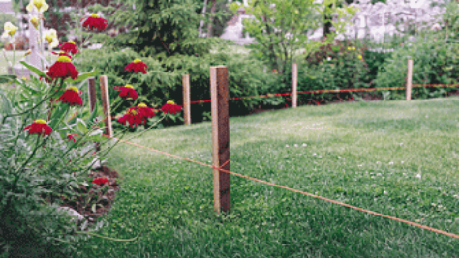

We mark locations of the patio, walkway, or driveway and call J.U.L.I.E to locate and mark all utilities.

Step 3: Excavation
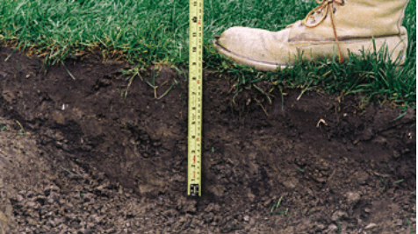

We excavate 12” deep to install pavers. Other depths are needed for stone pillars and other heavy structures.

Step 4: Base
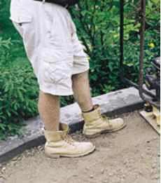
We then fill the area with gravel and compact every 2” with a Rammer Compactor for a “solid” base. We grade the base as closely as possible to the final contour of the finished job. Slope all installations away from the house for drainage purposes. The gravel will be 3" below finished height.

Step 5: Screeding

Pavers are laid on a 1" bed of coarse sand, placed directly on the compacted base. Guides are then setup so that your pavers are ¾" above the finished level to allow for compacting. We level the sand evenly by pulling a 2x4 along the guides. Once we have completed the area, we remove the guides, and fill in the grooves.

Step 6: Laying the Pavers
We place the pavers directly on the screeded bed of sand. We start laying along the longest straight side keeping lines straight using string lines. This will minimize the cutting required. We make sure the lines of your pavers are square, 90° to each other, to fit properly.
Step 7: Cutting
We may need to cut pavers that don't fit along edges or around objects. We mark the pavers and cut with either a guillotine cutter or masonry saw.
Step 8: Edging
Edge restraints are a critical element to the durability of a paver installation. They prevent the pavers from moving and shifting over time. We space each nail 1’.
Step 9: Compacting
After the installation is complete, including edge restraints, the pavers will be swept clean and then compacted with a plate compactor. This helps settle the pavers into the bedding sand and creates a flat surface. (For patterns such as circles, we put some jointing sand in first to stabilize the smaller pieces.) We do a minimum of three passes with the compactor going in different directions.
Step 10: Finishing
The last step is to sweep specially graded Unilock® Polymeric Jointing Sand into the joints between the pavers. This locks the pavers together creating a very durable surface and protects the project from weeds, insects and erosion.

