

The Benefits of Interlocking Concrete Pavers Versus Other Paving Solutions Are Numerous

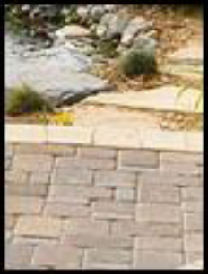
- A vast variety of paving styles
- Unlimited color possibilities
- Create your own design
- Low cost, no maintenance
- 50-year life expectancy
- No cracking
- 3 times stronger than poured concrete
- Perfect for freeze-thaw conditions
- Paver move with soil conditions
- Easy installation

DESIGN FLEXIBILITY
The many shapes, patterns, and colors of Concrete Pavers allow for design creativity, as well as delineation of pavement areas, such as parking lanes, cross walks, and intersections. The beauty of pavers adds value and visual appeal to any property. By adding flexibility not possible with rigid pavement, pavers can flow with existing landscaping to deliver beauty to any property.

MANY SHAPES AND COLORS
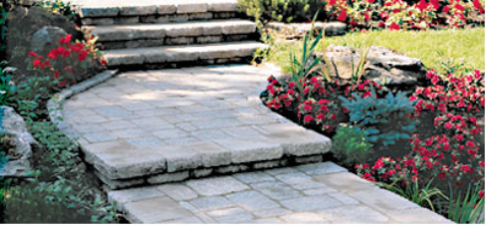
Suppliers stock rustic stone-like pavers to those that look like clay brick. Light colored pavers offer a cooler surface around patios and pool decks.

INITIAL PAVER INSTALLATION COST
Cost savings can be achieved for small and simple projects by a home owner installing the pavement themselves with the aid of a good DIY installation manual, usually provided by the manufacturer of the paver products. Generally, concrete pavers are less expensive than clay pavers, granite pavers or sandstone pavers. When considering maintenance and replacement costs, pavers offer an economical long-term alternative to other types of pavement.

PAVER STRENGTH
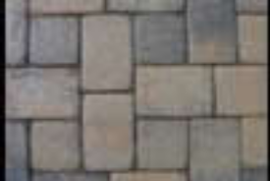
Concrete pavers are extremely dense units which possess exceptional strength and durability, superior stability under severe loads, and are unaffected by the extremes of heat and frost. Each unit has joints that allow for a small amount of movement without cracking. Factory made pavers last for decades.

EASY TO REPAIR
Remove and reinstate the same pavers with no ugly patches after repairs to the base or underground utilities. Asphalt, concrete, and stamped concrete can't make this claim. Pavers are low-maintenance and offer low life-cycle costs

MAINTENANCE
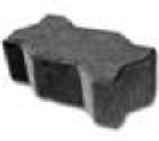
Stained or broken pavers can be easily replaced without patches. Dark colored pavers can help hide stains. Ants and weeds in joints can be prevented with sealers or herbicides. Pavers can be repaired by lifting the affected area, re-grading and re-compacting the base and bedding sand and reinstalling the same pavers. It is an inexpensive procedure that leaves no unsightly repair patches.

WINTER DURABILITY & SNOW REMOVAL
Snow can be plowed, blown or shoveled just like asphalt or concrete pavements. The chamfered (beveled) edge of pavers will prevent you from catching an edge with the plow or shovel. Using de-icing products like salt or calcium chloride will not harm or pit the pavers. Electric or liquid snow-melting systems work well under concrete pavers, eliminating snow removal while reducing slip hazards. Smooth surface allows for easy snow removal. Pavers can be colored dark to help melt snow faster. Snow-melt systems can be installed to eliminate snow and ice removal. Concrete pavers resist deterioration of freezing and thawing cycles and deicing salts better than asphalt and better than ordinary poured in place concrete.

WEATHER RESISTANCE
Pavers can be used in any climate and can be trafficked immediately upon compaction. The joints between the pavers eliminate the cracking common with traditional asphalt and concrete pavements.

DURABILITY
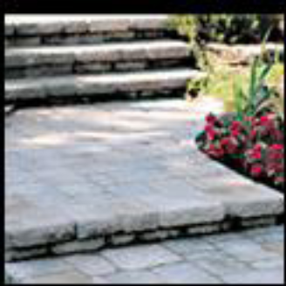
Interlocking concrete pavers are a flexible system and allow for movement, they are almost indestructible, the pavement system moves in unison with the earths usual tendency to swell and contract over the long term thus avoiding any serious damage.

VERSATILITY
Pavers can be applied in both residential and commercial settings, including surface coverings for driveways, parking lots, promenades, sidewalks, pool decks, patios, streets, golf cart paths and even roof gardens. Interlocking concrete pavers are a sensible and aesthetically attractive choice for all outdoor surfaces.

SAFETY
On both vehicular and pedestrian applications pavers have a non-skid surface even when the pavers are wet they are safe to walk or drive a vehicle over them.

Call Shoreline Landcare at 630-551-5224 for a free estimate or click here

