# ASHRAE: Support document

## Solar radiation profile

### Nomenclature

- [-]

### Calculation procedure

The following procedure is advised by ASHRAE in Ashrae Fundamentals 2017, Chapter 14. The relevant parameters and its calculation is presented bellow.

All trigonometric functions and other expressions which operate with angles are in degrees.

The solar constant () is defined as the intensity of solar radiation on a surface normal to the sun’s rays, just beyond the earth’s atmosphere, at the average earth-sun distance.

The extraterrestrial radiant flux varies throughout the year, its variation is accounted by the equation:

Example of calculation for each day number:

Figure 1

The apparent solar time (AST) is given by:

The longitude of the local time meridian (LSM) can be approximated by:

If Daylight savings time (DST) is implemented during the time of year that is being analyzed, it has to be accounted for:

The equation of time, which accounts for a difference in minutes in the apparent solar time, caused by the earth’s motion relative to the sun, can be calculated by:

Example of calculation for each day number:

Figure 2

The earth’s equatorial plane is tilted at an angle of 23.45° to the orbital plane. The solar declination angle, related with this angle, varies throughout the year. It is responsible for the changing seasons and their unequal periods of daylight and darkness.

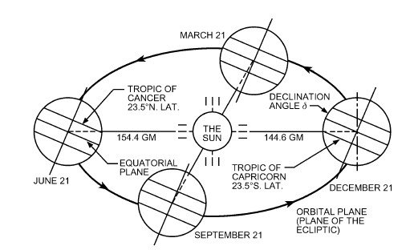

Figure 3 – Solar declination illustration.

The solar declination angle is given by:

Example of calculation for each day number:

Figure 4

Additional angles of interest are represented in the figure bellow for an example surface.

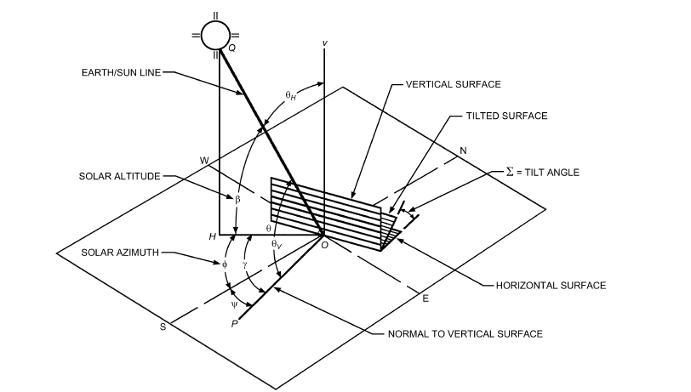

Figure 5

The hour angle, defined as the angular displacement of the sun east or west of the local meridian caused by the rotation of the earth.

The solar altitude angle is defined by the equation bellow:

The azimuth angle can be obtained by solving the system of equations bellow:

The solar-surface azimuth angle is defined bellow:

The surface azimuth is a direct measure of the orientation of the surface:

Table 1

|  |  |  |  |  |  |  |  |
| --- | --- | --- | --- | --- | --- | --- | --- |
| **Surface Azimuth - ψ - [⁰]** | | | | | | | |
| N | NE | E | SE | S | SW | W | NW |
| 180 | -135 | -90 | -45 | 0 | 45 | 90 | 135 |

The incidence angle can be calculated through:

Beam and diffuse clear sky irradiance depend on the location specific parameters, such as the optical depths ( and - measured in weather stations) and the relative optical mass. Optical depts vary with the month of the year and have to be determined for the month of interest.

The relative optical mass can be calculated through the following correlation:

With the empirical coefficients ab and ad given by:

Some outlier values in solar irradiance were detected, after some investigation it was traced back to very high values of m. A literature review on m was conducted and a survey of the value of m when calculated with different correlations was found. The survey indicated that a value of m higher than 16 was extremely unlikely. The formula used was limited to a maximum value of 16 and the outliers where eliminated.

Table 2

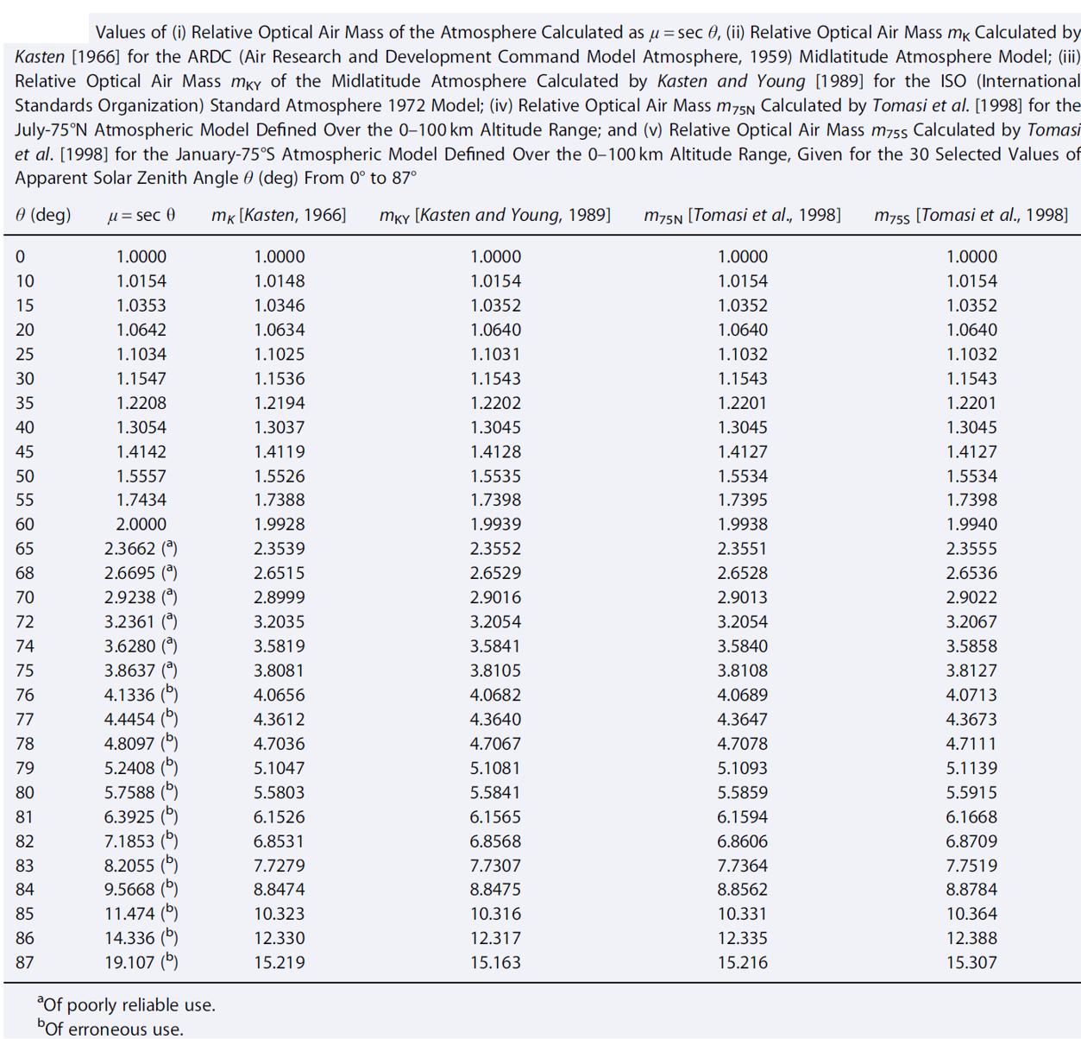

On the actual surface, the total irradiance is given by:

With the beam irradiance given by:

The diffuse irradiance can be calculated through:

If :

If :

With:

Additionally, the ground-reflected irradiance can be calculated through:

The value for ground reflectance, , is a location-specific and can vary greatly. ASHRAE recommends 0.2 as a reasonable approximation.

Figure 6

With the parameters described before, the solar irradiance hour profile can be determined for every location if it is known:

* Location specific parameters: Latitude, Longitude, Time Zone and Optical Depths (available from Weather Stations data).
* Date of interest: If the goal is to determine the maximum solar load, the 21st of each month is usually the day where irradiance is at its peak. The month of interest for cooling is usually the result of climate data analysis and corresponds to the hottest month – also location-specific.
* Surface specific parameters: surface azimuth, tilt angle.

An example of climatic data and the location-specific inputs consulted is presented bellow:

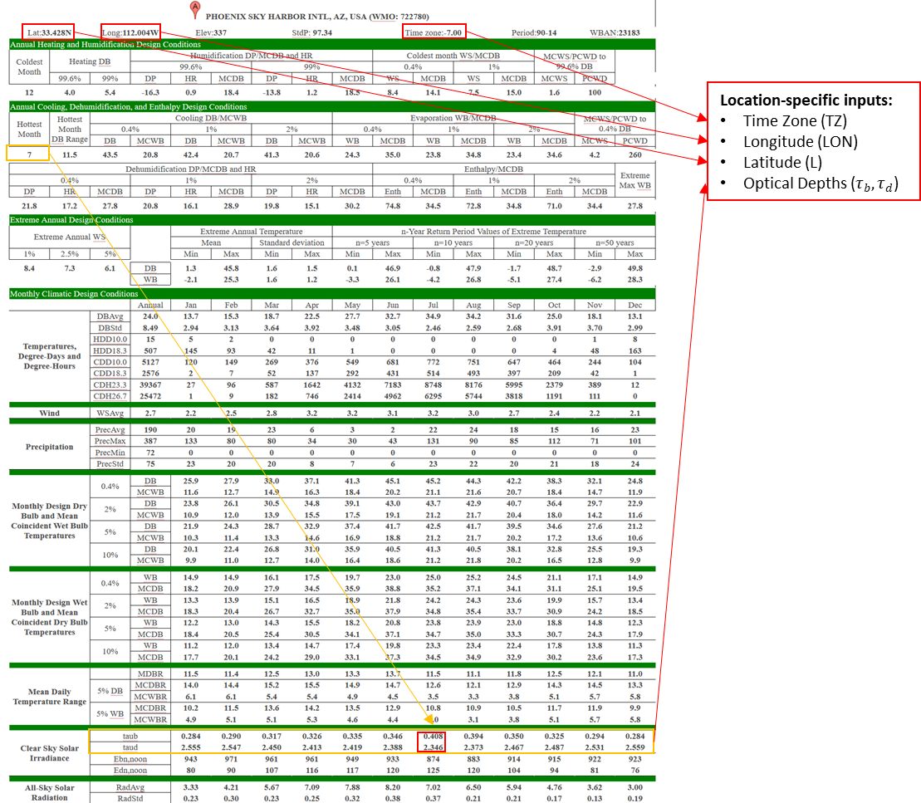

Figure 7

Example of irradiance day profiles for different surface azimuths:

Figure 8

## Dry-bulb Temperature profile

To determine the day dry-bulb temperature profile, ASHRAE provides a normalized profile which has been shown to be representative of both dry-bulb and wet-bulb temperature daily profiles in design-days.

The normalization is as follows:

With f being the normalized factor that account for hour variations in temperatures. f is presented in Figure 9.

The maximum dry-bulb temperature, maximum wet-bulb temperature and respective temperature variations are provided by ASHRAE for the design-day desired (either for cooling, heating or dehumidifying).

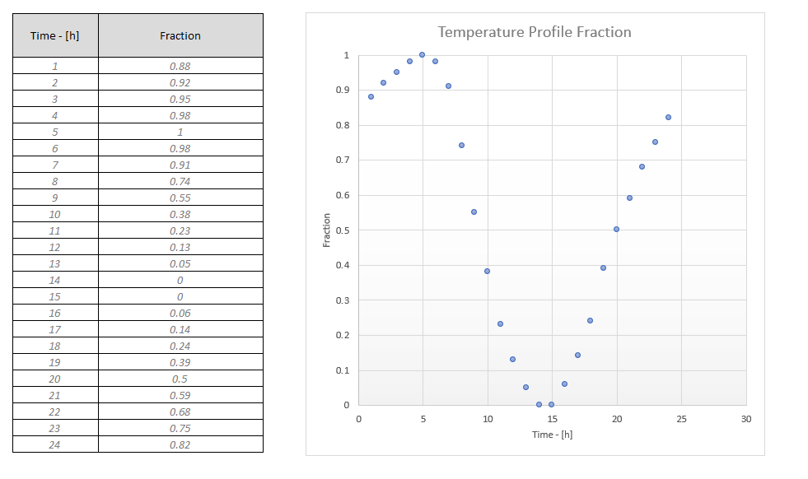

Figure 9

An example of both dry and wet-bulb temperature profile is shown bellow for Riverside, California.