**Exploring Web Development with Python: A Comprehensive Study with Applications (Blog) Built in Flask and Django**

Julia Gongala

B00402569

School of Computing, Engineering

and Physical Sciences

BSc (Honours) Web and Mobile Development

University of the West of Scotland

Supervisor: Tony Gurney

Moderator: Pablo Salva Garcia

# Declaration

This dissertation is submitted in partial fulfillment of the requirements for the degree of Web and Mobile Development (Honours) in the University of the West of Scotland.

I declare that this dissertation embodies the results of my own work and that it has been composed by myself. Following normal academic conventions, I have made due acknowledgement to the work of others.

Name: Julia Krystyna Gongala

Signature: J. Gongala

Date: 27th March 2024

**COMPUTING HONOURS PROJECT SPECIFICATION FORM**

*(Electronic copy available on the Aula Computing Hons Project Site)*

**Project Title:** "Exploring Web Development with Python: A Comprehensive Study with Applications (Blog) Built in Flask and Django."

**Student:** Julia Gongala  **Banner ID:** B00402569

**Programme of Study:** BSc (Hons) in Web and Mobile Development

**Supervisor:** Tony Gurney

**Moderator:** Pablo Salva Garcia

**Outline of Project:** *(a few brief paragraphs)*

Web development is a cornerstone of the digital age, driving the way we interact with information and services on the internet. In this dynamic landscape, Python, renowned for its versatility and user-friendly syntax, has emerged as a powerhouse for web application development. This dissertation embarks on an exciting journey, offering a comprehensive study enriched with hands-on applications. Our focal point is the creation of a fully functional blog website, a journey we undertake using two prominent Python web frameworks: Flask and Django.

Python's selection as the centrepiece of this exploration is not arbitrary but rooted in its growing popularity among developers. Python's elegant and readable syntax, coupled with a vast ecosystem of libraries and frameworks, has propelled it into the forefront of web development. Its seamless integration with web frameworks makes it an ideal choice for building robust and feature-rich web applications. Flask and Django, two noteworthy representatives of Python's web development prowess, each bring their unique strengths to the table, making them ideal subjects for this comprehensive study.

Our voyage commences with a brief introduction to the expansive realm of web development and Python's pivotal role within it. We set the stage for a deeper dive into Flask and Django, shedding light on their significance in the web development landscape.

As we navigate this study, we combine theoretical insights with hands-on practice. Our primary objective is to construct a functional blog website using both Flask and Django, unravelling their capabilities and dissecting their inner workings. This project-based approach ensures that we not only grasp the theoretical concepts but also gain practical experience in creating web applications. We explore the steps required to set up development environments, configure databases, implement user authentication, and craft user-friendly interfaces.

Furthermore, we undertake a comparative analysis of Flask and Django, offering a nuanced understanding of their strengths and limitations. This analysis empowers developers to make informed decisions when selecting the most suitable framework for their specific projects. It serves as a testament to Python's adaptability, showcasing how it caters to diverse web development needs.

Deployment, testing, and debugging, crucial facets of web development, receive their due attention in this exploration. We explore various deployment options for Flask and Django applications, ensuring that our web projects transcend the realm of local development environments and reach a global online audience.

In addition, we address the critical issue of web application security, examining common vulnerabilities and emphasizing best practices for mitigation. This discussion underscores the significance of secure coding practices within the context of web development with Python.

In conclusion, Exploring Web Development with Python: A Comprehensive Study with Applications (Blog) Built in Flask and Django embarks on a captivating journey through the expansive world of web development with Python. It underscores Python's pivotal role in this domain and showcases the capabilities of Flask and Django through the creation of a fully functional blog website. By the culmination of this exploration, readers will possess not only the knowledge but also the practical skills to embark on their web development ventures confidently or make informed choices when selecting the right framework for their projects.

**A Passable Project will:**

* Introduction to Web Development and Python
* Flask and Django Introduction
* Building basic Blog with Flask and Django where user will be able to add, delete, edit and see posts to compare both frameworks and select better for advanced blog.
* Comparative Analysis for both frameworks showing their features.
* Deployment and Testing of the application

**A First Class Project will:**

* Framework Comparison and Analysis. A detailed and insightful comparison between Flask and Django, highlighting not only their strengths and weaknesses but also their suitability for specific use cases – Blog using literature review and blog development
* Advanced Blog Development. A feature-rich and highly polished blog application built using selected framework, that has been chosen through comprehensive study to justify all arguments and decision, demonstrating not only the core functionality (CRUD) but also advanced features like user profiles, or uploading images. Advanced blog will incorporate modern practices and techniques.
* Demonstration Knowledge. A clear demonstration of knowledge in modern web development, Python, Flask, Django, and related popular technologies.
* Using References and Citations. Accurate and extensive citation and referencing of all sources, demonstrating a deep understanding of the academic context.

**Reading List:**

* *"Django for Beginners"* by William S. Vincen
* *"Django for APIs"* by William S. Vincent
* *"Two Scoops of Django 3.x"* by Daniel Roy Greenfeld and Audrey Roy Greenfeld
* *"Flask Web Development"* by Miguel Grinberg
* *"Flask By Example"* by Gareth Dwyer
* *"Building RESTful Python Web Services"* by Gaston C. Hillar
* *"Python Web Development with Django"* by Jeff Forcier, Paul Bissex, and Wesley Chun
* *"Test-Driven Development with Python"* by Harry J.W. Percival
* Django Official Documentation
* Flask Official Documentation

**Resources Required:** *(hardware/software/other)*

* Personal workstation with Visual Studio Code and Python installed
* Git and GitHub for version control and collaboration.
* Web browser for research and testing.
* Hosting platform (e.g., Heroku, AWS, or a VPS) for deployment.
* Testing tools

**Marking Scheme: Marks**

Introduction 5%

Literature Review 15%

Development 30%

Comparative Analysis 30%

Testing 10%

Conclusion 10%

**AGREED:**

**Student Supervisor Moderator**

**Name:** Julia Gongala  **Name:** Tony Gurney **Name:** Pablo Salva Garcia

**IMPORTANT:**

1. ***By agreeing to this form all parties are confirming that the proposed Hons Project will include the student undertaking practical work of some sort using computing technology / IT, most frequently achieved by the creation of an artefact as the focus for covering all or part of an implementation life-cycle.***
2. ***By agreeing to this form all parties are confirming that any potential ethical issues have been considered and if human participants are involved in the proposed Hons Project then ethical approval will be sought through approved mechanisms of the School of CEPS Ethics Committee.***

Table of Contents

Declaration 2

Table of Figures 8

Acknowledgements 9

Abstract 10

1. Introduction 11

2. Background 14

2.1 Background of web application development 14

2.1.1 Front – End Development 14

2.1.2 Back – End Development 15

2.1.3 Full – Stack Development 15

2.1.4 Responsive Design 16

2.1.5 Security 17

2.2 Front - End Technologies 18

2.2.1 HTML 18

2.2.2 CSS 18

2.2.3 JavaScript 19

2.3 Back - End Technologies 20

2.3.1 PHP 20

2.3.2 Ruby 20

2.3.3 Java 20

2.3.4 C++ 21

3. Python 22

3.1 Django 23

3.2 Flask 24

3.3 FastAPI 25

3.4 Bottle 25

3.5 Pyramid 26

4. Comprehensive Analysis 27

4.1 Design and Requirements 27

4.1.1 Universal Design 27

4.1.2 Universal Design Storyboard 27

4.1.2.1 Landing Page / Home Page 27

4.1.2.2 Register Page 27

4.1.2.3 Login Page 28

4.1.2.4 Community/Posts Page 28

4.1.2.5 Add Post Page 28

4.1.2.6 Edit Post Page 28

4.1.3 Database Design – EER Diagram 28

4.2 Flask 28

4.3 Django 28

References 29

# Table of Figures

Figure 1 Growth of major programming languages (StackOverflow, 6/09/2017) 11

Figure 2 How Front-end development works (frontendmasters.com, n/d) 13

Figure 3 How back-end development works (codeburst.io, 29/07/2020) 14

Figure 4 Complete Stack Development in an End-to-End Workflow(mongodb.com, n/d) 15

Figure 5 Django and Flask in Top 15 frameworks (survey.stackoverflow.co, 2023) 23

Figure 6 Django official logo (djangoproject.com, n/d) 23

Figure 7 Flask official logo (wikipedia.org, n/d) 24

# Acknowledgements

I would like to express my heartfelt gratitude to my parents for their unwavering support and encouragement in all aspects of my work. A special thanks to my boyfriend, David, for dedicating his time, providing continuous support, and engaging in long, meaningful discussions about my ideas and challenges. I am also grateful to my supervisor, Tony, whose previous guidance in Python language has been instrumental in shaping my journey in this research topic. Lastly, a big thank you to my moderator, Pablo, for his ongoing support.

# Abstract

In the realm of web development, Python has emerged as a powerhouse, valued for its simplicity, readability, and robust ecosystem. This research undertakes a thorough exploration of Python's pivotal role in web development, focusing on its frameworks, libraries, and practical applications. As scalable and efficient web solutions become increasingly sought after by businesses, a nuanced understanding of Python becomes imperative.

The intricacies of Python's contributions to web development are delved into, shedding light on its flagship frameworks, namely Django and Flask. Through real-world implementations, the aim is to showcase how these frameworks empower developers to create robust and maintainable web applications. The examination extends beyond the server-side, exploring Python's seamless integration with front-end technologies, providing a holistic perspective on its position in the dynamic landscape of contemporary web development.

The proposed technologies and features are meticulously tailored to address the project's goals. Django, with its batteries-included philosophy, offers a comprehensive and structured approach to building web applications, ensuring scalability and maintainability. Flask, on the other hand, provides a lightweight and flexible framework, ideal for smaller projects or when customization is paramount.

Furthermore, the research emphasizes the integration of Python with front-end technologies. This integration ensures a cohesive development experience, allowing for the creation of interactive and responsive user interfaces.

In practical terms, the study will provide developers and businesses with actionable insights into leveraging Python's strengths for optimal web development outcomes. Whether through the powerful abstractions of Django or the lightweight agility of Flask, Python's versatility is harnessed to meet the diverse needs of modern web applications. As businesses navigate the complexities of the digital landscape, understanding the intricacies of Python in web development becomes not only beneficial but essential for achieving success in delivering scalable, efficient, and user-friendly web solutions.

# Introduction

The evolution of programming languages has indeed been marked by a captivating journey, reflecting the dynamic nature of technology and the ever-changing landscape of the computing industry. As time progresses, the narrative of programming languages becomes more intricate, characterized by the emergence of new paradigms, tools, and methodologies.

In the 1960s and 1970s, the advent of high-level programming languages like Fortran, Lisp, and COBOL was witnessed, aiming to enhance productivity and portability. Scientific and engineering computations were the focus of Fortran, while Lisp pioneered the concept of symbolic expressions and recursion, and COBOL targeted business applications. The groundwork laid by these languages set the stage for subsequent innovations and the development of more user-friendly programming languages.

The 1980s and 1990s ushered in the era of personal computing, giving rise to languages like C, C++, and Java. System programming saw C as the language of choice due to its low-level capabilities, while C++ introduced object-oriented programming concepts, adding a layer of abstraction. Java, designed for platform independence, gained popularity for developing applications that could run on any device with a Java Virtual Machine (JVM).

In the late 1990s and early 2000s, dynamic languages such as Python and Ruby emerged, emphasizing simplicity and readability. Widespread acceptance of Python was driven by its clear syntax and versatility. Simultaneously, JavaScript rose to prominence as the scripting language for web browsers, enabling dynamic and interactive web pages.

As the internet continued to evolve, the demand for web development languages and frameworks increased. PHP, alongside Python and Ruby, played a crucial role in server-side scripting, powering dynamic web applications. The shift towards more responsive and interactive web experiences was marked by the introduction of AJAX (Asynchronous JavaScript and XML).

The rise of mobile computing in the 2010s led to the prominence of languages like Swift for iOS and Kotlin for Android development. New avenues for building mobile applications efficiently were provided by the development of cross-platform frameworks such as React Native and Flutter. (Karunanayake, Feb 24, 2023)

A critical aspect of modern programming revolves around the indispensable role of frameworks. These frameworks serve as pivotal tools, furnishing developers with pre-built structures and utilities that significantly streamline the development process. Distinguished by their unique syntax and architecture, these frameworks provide a higher level of abstraction. This, in turn, empowers programmers to direct their focus towards crafting application-specific logic, alleviating the need to grapple with intricate low-level details.

While the adoption of various frameworks may initially present a learning curve, the adaptability of programmers becomes paramount. It is through this adaptability that developers can harness the distinctive advantages that each framework brings to the table. Embracing the diversity of frameworks is not just a necessity; it is a strategic approach that enables developers to optimize their workflow, enhance productivity, and build robust and efficient software solutions tailored to the specific needs of their projects. As the programming landscape continues to evolve, the ability to navigate through different frameworks and judiciously select the most suitable one for a given task emerges as a valuable skill for developers aiming to stay at the forefront of innovation.

Collaboration among programmers, particularly within diverse teams, presents a multifaceted challenge that hinges on clear communication and unified practices. In this intricate landscape, the strategic choice of frameworks becomes pivotal, serving as a cornerstone for harmonizing team expertise and aligning with project requirements. The aim is to establish an environment where collaboration can flourish seamlessly.

The significance of framework selection is underscored by its impact on the team's ability to work cohesively. When frameworks are chosen with consideration for the team's proficiency and project specifications, it lays the groundwork for an efficient collaboration process. A well-aligned framework not only facilitates smoother communication but also enables developers to leverage their expertise, fostering a sense of shared understanding within the team.

However, the integration of disparate frameworks within a project introduces an additional layer of complexity. This complexity necessitates the establishment of seamless communication channels and a shared comprehension of the chosen frameworks among team members. This shared understanding becomes paramount to ensure a cohesive and productive development environment, where team members can collaborate without unnecessary friction or misunderstandings.

In essence, successful collaboration in programming teams is not only contingent on effective communication but also on the thoughtful selection and integration of frameworks. By aligning frameworks with team expertise and project needs, and fostering a shared understanding, development teams can navigate the challenges of diverse collaborations more effectively, resulting in streamlined workflows and successful project outcomes.

The intricate interplay of challenges and solutions within the programming landscape serves as a compelling backdrop for thesis, titled 'Exploring Web Development with Python: A Comprehensive Study with Applications (Blog) Built in Flask and Django.' This research delves into the dynamic realm of web development, placing a particular emphasis on Python, a versatile programming language that has witnessed remarkable growth, as illustrated in Figure 1.

Figure 1 Growth of major programming languages (StackOverflow, 6/09/2017)

As depicted in Figure 1.1, Python has experienced substantial popularity in recent years, emerging as a leading choice among developers for various applications. The thesis aims to unravel the factors contributing to Python's ascendancy in the programming landscape, exploring its versatility and adaptability in the context of web development.

Within the scope of this research, our focus is directed towards two prominent web frameworks Flask and Django. An in-depth study is conducted to elucidate their distinct features, strengths, and applications. Practical examples and the undertaking of blog development serve the purpose of showcasing how these frameworks contribute to the creation of dynamic and robust web applications.

The strategic choice of Flask, renowned for its simplicity and flexibility, alongside Django, celebrated for its batteries-included approach, sets the stage for a comparative analysis. This approach not only brings to light the unique attributes of each framework but also provides insights into the trade-offs involved in selecting a framework based on specific project requirements. Through hands-on exploration and real-world application, the research endeavours to offer a nuanced understanding of how Flask and Django cater to different aspects of web development, enabling developers to make informed choices aligned with their project goals.

Moreover, the challenges and benefits associated with integrating these frameworks into collaborative web development projects are delved into by the study. Emphasis is placed on the importance of clear communication and shared understanding among team members, highlighting the necessity for cohesive collaboration when working with diverse frameworks. Addressing the collaborative aspects of web development, the research aims to contribute practical insights that extend beyond individual proficiency with the frameworks, recognizing the significance of teamwork in achieving successful project outcomes.

In essence, the aspiration of this study is to be a valuable resource for programmers and developers navigating the evolving landscape of web development using Python and its associated frameworks. Through a comprehensive exploration of Flask and Django, coupled with practical examples and a focus on collaborative dynamics, professionals are equipped with the knowledge and perspectives needed to thrive in the dynamic and ever-changing world of web development.

# Background

## Background of web application development

Web application development is a multifaceted process that involves creating and maintaining software applications accessible through web browsers. It encompasses both front-end and back-end components, each playing a crucial role in delivering a seamless and interactive user experience.

### Front – End Development

The front end, often referred to as the client-side, constitutes the user interface (UI) and user experience (UX) layer of a web application. It is the part of the application that users directly interact with, encompassing elements like buttons, forms, and visual components. Figure 2 illustrates the communication flow between the front end and back end, showcasing how user interactions are processed and data is exchanged.

Figure 2 How Front-end development works (frontendmasters.com, n/d)

Front-end development primarily relies on three fundamental technologies: HTML (Hypertext Markup Language), CSS (Cascading Style Sheets), and JavaScript. HTML serves as the backbone, structuring the content and defining the page's semantic structure. CSS comes into play for styling, determining the layout, colours, and overall visual presentation of the web pages. JavaScript, on the other hand, introduces interactivity, enabling developers to create dynamic and responsive user interfaces.

The integration of these technologies allows front-end developers to craft visually appealing and user-friendly experiences. HTML provides the skeletal structure, CSS adds the aesthetic layer, and JavaScript injects behaviour and responsiveness, creating a cohesive and engaging user interface. (Robbins, 2018)

The evolution of front-end development has seen the emergence of powerful frameworks such as React, Angular, and Vue.js. These frameworks provide a structured and organized approach to building web applications, facilitating the development process and enhancing application performance. React, developed by Facebook, utilizes a component-based architecture, Angular, maintained by Google, is a comprehensive framework, and Vue.js, known for its simplicity, offers a flexible and adaptable solution. These frameworks help manage the complexity of large-scale applications, promote code reusability, and ensure efficient rendering of UI components.

Moreover, front-end development has been further streamlined by the use of JavaScript libraries and tools. Libraries like jQuery simplify DOM manipulation, making it easier for developers to interact with the document object model. Task runners and bundlers like Webpack assist in optimizing and organizing code, improving performance and maintainability. (Lolugu, 2023)

In conclusion, front-end development is a crucial aspect of web application creation, focusing on delivering seamless and visually appealing user experiences. The utilization of HTML, CSS, and JavaScript, along with modern frameworks and libraries, empowers developers to build interactive and dynamic interfaces, ultimately enhancing the overall usability and success of web applications.

### Back – End Development

Back-end development, also known as server-side development, plays a pivotal role in shaping the functionality and performance of web applications. It encompasses the creation of servers, databases, and application logic that power the front end and this could be seen on Figure 3. Essential to managing and storing data, handling business logic, and executing server-side operations, back-end development employs various programming languages such as Python, Ruby, Java, and PHP, along with server technologies like Node.js. The choice of databases, such as MySQL, PostgreSQL, and MongoDB, is crucial for efficient data storage and retrieval.

Figure 3 How back-end development works (codeburst.io, 29/07/2020)

As noted by renowned software developer and author Martin Fowler in 1999, any fool can write code that a computer can understand. Good programmers write code that humans can understand. This underscores the significance of writing clear and maintainable code in the back end, ensuring scalability and long-term viability of a web application. Clear, human-readable code promotes collaboration, ease of debugging, and facilitates future modifications or updates. (Martin Fowler, 1999)

Frameworks play a crucial role in simplifying and expediting the back-end development process. Popular frameworks like Django (Python), Ruby on Rails (Ruby), and Express.js (Node.js) provide pre-built modules and structures. These frameworks adhere to best practices, enhancing the efficiency and reliability of back-end development. They not only expedite the development process but also contribute to the creation of robust and scalable applications. (Rose, 2020)

In recent years, the demand for scalable and efficient back-end systems has driven the development of microservices architecture. This approach involves breaking down applications into smaller, independent services that communicate with each other, promoting flexibility, scalability, and ease of maintenance. The shift towards containerization and orchestration tools such as Docker and Kubernetes further aids in deploying, scaling, and managing back-end services seamlessly.

### Full – Stack Development

The roots of Full Stack Development can be traced back to the need for more streamlined and efficient development processes. As web applications grew in complexity, with an increasing demand for seamless user experiences and real-time interactions, the traditional siloed approach became a bottleneck. Full Stack Development addresses this challenge by empowering developers with a comprehensive skill set that spans the entire application stack. This encompasses not only proficiency in front-end technologies such as HTML, CSS, and JavaScript but also expertise in back-end languages, databases, server management, and API integration. (Mcfarland, 2014). Figure 4 illustrates the concept of Complete Stack Development in an End-to-End Workflow.

Figure 4 Complete Stack Development in an End-to-End Workflow(mongodb.com, n/d)

Frameworks play a pivotal role in shaping the Full Stack Development landscape. They provide pre-built components and tools that expedite development, ensuring a standardized and efficient workflow. Examples such as MEAN (MongoDB, Express.js, Angular, Node.js) and MERN (MongoDB, Express.js, React, Node.js) represent Full Stack Development frameworks that have gained popularity for their ability to seamlessly integrate various technologies across the entire stack. (MongoDb, 2021)

The advent of microservices architecture has further catalysed the evolution of Full Stack Development. Microservices break down monolithic applications into smaller, independently deployable services, allowing developers to work on specific components of the application stack without disrupting the entire system. This modular approach aligns well with the Full Stack Development ethos, enabling developers to build and scale applications more efficiently. (Richardson, 2019)

In conclusion, Full Stack Development has emerged as a pivotal approach in the realm of web application development, responding to the demand for versatile and skilled developers. The evolution of this paradigm reflects the ever-changing landscape of technology and the need for holistic solutions to complex challenges. As the digital ecosystem continues to evolve, Full Stack Development is likely to remain a cornerstone, empowering developers to navigate the intricacies of both front-end and back-end development seamlessly.

### Responsive Design

Responsive design has emerged as an indispensable component of contemporary web application development, driven by the necessity to accommodate an increasingly diverse array of devices and screen sizes accessing online content. Ethan Marcotte, in his seminal work "Responsive Web Design," introduced the concept, emphasizing the need for websites to adapt seamlessly to various devices, from smartphones to desktop monitors. The traditional approach of creating separate versions for different devices proved impractical as the digital landscape continued to evolve. (Marcotte, 2010)

A cornerstone principle of responsive design involves the implementation of fluid grids. Marcotte advocates for the use of relative units like percentages instead of fixed units, allowing content to flexibly expand or contract within its container to fill the available space (Marcotte, 2010). This ensures that web applications maintain a cohesive structure and readability across different screen sizes.

Flexible images, as championed by web designer Brad Frost in "Atomic Design," are another critical aspect of responsive design. Frost underscores the importance of employing CSS techniques to ensure that images scale proportionally, adapting seamlessly to diverse screen dimensions (Frost, 2016).This approach prevents issues such as image overflow or pixelation and contributes to an optimal user experience.

Media queries, a key feature of responsive design, enable developers to apply specific styles based on the characteristics of the user's device. By defining breakpoints in the code, developers can create responsive layouts that adjust to varying screen widths, heights, and resolutions. This level of customization ensures that web applications not only adapt to different devices but also prioritize usability and visual aesthetics (Marcotte, 2010).

In conclusion, responsive design stands as a fundamental element in the backdrop of web application development, offering a solution to the challenges posed by the ever-expanding diversity of devices. It empowers developers to create adaptive, user-friendly applications that deliver a consistent and engaging experience across the dynamic landscape of digital platforms.

### Security

Security is a paramount concern in the backdrop of web application development, given the increasing frequency and sophistication of cyber threats. As web applications become integral to various aspects of daily life, from online banking to healthcare services, ensuring the confidentiality, integrity, and availability of user data is imperative. The Open Web Application Security Project (OWASP) provides a comprehensive guide, "OWASP Top Ten," highlighting the most critical web application security risks. Common vulnerabilities, such as injection attacks, cross-site scripting (XSS), and broken authentication, underscore the need for robust security practices (OWASP, 2021).

Authentication and authorization mechanisms play a pivotal role in securing web applications. Implementing secure user authentication, multi-factor authentication (MFA), and proper authorization controls are essential steps to prevent unauthorized access and protect sensitive user data. Security protocols, such as OAuth 2.0 and OpenID Connect, provide standardized frameworks for secure authentication and authorization in web applications (Hardt, 2012).

Additionally, the use of secure coding practices is crucial in mitigating vulnerabilities at the development stage. Integrating security into the software development life cycle (SDLC) through tools like static code analysis and dynamic application security testing (DAST) helps identify and address security flaws early in the development process (opentext, N/A).

Encryption is a cornerstone of web application security, safeguarding data in transit and at rest. Implementing secure communication protocols like HTTPS ensures the confidentiality and integrity of data exchanged between users and the web application. Regular security audits and penetration testing are essential to assess the overall security posture of a web application and identify potential vulnerabilities that may have been overlooked during development (Sheffer, 2015)

In conclusion, security is an ongoing and integral consideration in the background of web application development. Adhering to best practices outlined by organizations like OWASP, implementing robust authentication mechanisms, secure coding practices, and encryption protocols are critical steps to fortify web applications against evolving cyber threats. Integrating security measures throughout the development life cycle ensures a proactive approach to safeguarding user data and maintaining the trust of users in an increasingly interconnected digital landscape.

* + 1. Integration and Collaboration

Successful web application development necessitates a harmonious collaboration between front-end and back-end developers. Tim Berners-Lee, the visionary behind the World Wide Web, articulated the social dimension of the web, stating, "The Web is more a social creation than a technical one. I designed it for a social effect—to help people work together” (Berners-Lee, 2000). This insight underscores the importance of collaboration not only between developers but also in crafting applications that foster user interaction and engagement.

At the heart of this collaboration lies the crucial role of Application Programming Interfaces (APIs), acting as the linchpin between the front end and back end. APIs facilitate seamless communication, allowing these components to exchange data and functionalities effectively. This synergy ensures that user interactions on the front end trigger the requisite processes and data manipulations on the back end, creating a cohesive and responsive user experience.

Moreover, collaboration extends beyond the development team, encompassing various stakeholders involved in the project. Effective communication and collaboration are vital in Agile methodologies, as highlighted in the Agile Manifesto's principles, which emphasize individuals and interactions over processes and tools (Beck, 2001). Collaborative tools, such as project management platforms, version control systems, and communication channels, play a pivotal role in facilitating teamwork and ensuring project success.

In conclusion, web application development is a multifaceted endeavour that relies on the symbiotic collaboration between front-end and back-end development. This collaboration extends to the broader project team, aligning with Tim Berners-Lee's vision of the web as a social creation that facilitates people working together. As the web development landscape evolves, staying attuned to emerging trends, embracing collaborative methodologies, and leveraging effective tools are essential for navigating the dynamic challenges of modern web application development (Sharma, 2023).

## Front - End Technologies

Front-end technologies refer to the technologies and tools used in the development of the user interface (UI) and user experience (UX) of a website or web application. Front-end development is responsible for creating the visual elements that users interact with, as well as ensuring a smooth and responsive user experience.

### HTML

HTML, an acronym for HyperText Markup Language, stands as a pivotal technology in the realm of front-end development, with its origins traced back to 1989 when it was conceived by the visionary Tim Berners-Lee. As articulated by Jon Duckett in the seminal work "HTML and CSS: Design and Build Websites," HTML functions as the bedrock of web content, furnishing web pages with a structured and coherent format that can be intelligibly deciphered by web browsers. Duckett's insights underscore the foundational role that HTML plays in orchestrating information to achieve a compelling and organized presentation.

Fundamentally, HTML employs a systematic arrangement of elements, tags, and attributes to annotate text within a document, defining the structure of content like headings, paragraphs, lists, images, and links. Web browsers interpret this markup to render content in a visually organized manner.

The oversight and governance of HTML fall under the purview of two influential bodies, namely the World Wide Web Consortium (W3C) and the Web Hypertext Application Technology Working Group (WHATWG). These entities are tasked with establishing and upholding the specifications for HTML, ensuring a standardized approach that fosters consistency and compatibility across various browsers.

HTML seamlessly collaborates with other key web technologies such as CSS (Cascading Style Sheets) for styling and layout, and JavaScript for dynamic behaviour. This triumvirate—HTML, CSS, and JavaScript—constitutes the fundamental technologies underpinning the construction of contemporary, interactive web applications.

In summation, HTML serves as the structural cornerstone of web content, providing the essential framework and organization necessary for a compelling and effective presentation. Mastery of HTML is indispensable for individuals engaged in web development, whether their focus lies in front-end design or extends to the development of comprehensive full-stack applications (Duckett, 2011).

### CSS

CSS, an acronym for Cascading Style Sheets, stands as a cornerstone in front-end technology, contributing significantly to the aesthetics and styling of web pages. The concept of CSS was introduced in 1994. Eric Meyer, a notable figure within the CSS community, emphasizes a fundamental principle of web development— the separation of concerns. CSS excels in achieving this separation by distinguishing content (HTML) from presentation, providing developers with the flexibility to modify a website's visual style without impacting its underlying structure or content. This separation promotes modularity, enhancing code maintainability and fostering collaboration among developers.

Eric Meyer's advocacy for the separation of concerns underscores the significance of CSS in maintaining clean, modular, and maintainable code in web development projects. This approach allows for the efficient management of visual elements, making it easier to implement changes and improvements without disrupting the overall structure.

CSS is meticulously designed to ensure compatibility with various web browsers, with modern browsers adhering to specifications set by the World Wide Web Consortium (W3C). Nevertheless, achieving consistent cross-browser compatibility can pose challenges, prompting developers to utilize vendor prefixes and employ other techniques to address browser-specific issues. The dynamic nature of the web landscape necessitates adaptive strategies to accommodate diverse browser behaviours.

In summary, CSS empowers developers by offering precise control over the visual presentation of web pages, enabling the creation of aesthetically pleasing and responsive user interfaces. The principle of separating content and presentation, championed by CSS, remains pivotal in upholding the integrity of web development projects through the cultivation of clean, modular code (Eric Meyer, 2017).

### JavaScript

JavaScript, hailed as the ubiquitous language of the web, marked its inception in 1995, aiming to inject interactivity and dynamic behaviour into web pages. Marijn Haverbeke, in the authoritative "Eloquent JavaScript," underscores its unique status as the sole language universally executable across major web browsers, cementing its indispensability for front-end developers. This unparalleled versatility positions JavaScript as a foundational technology for crafting responsive and interactive user interfaces.

The language has undergone substantial evolution, notably with the establishment of ECMAScript standards, introducing novel features and capabilities. The proliferation of influential JavaScript libraries and frameworks, including jQuery, React, Angular, and Vue.js, has further broadened the horizons for constructing sophisticated web applications.

A distinctive trait of JavaScript is its dual functionality, operating seamlessly on both client-side and server-side environments. The advent of server-side JavaScript frameworks like Node.js facilitates the use of a unified programming language for entire web application development, fostering code reuse and streamlining the overall development process.

JavaScript's asynchronous nature, empowered by constructs like Promises and Async/Await, plays a pivotal role in crafting responsive and efficient web applications. This proves particularly crucial for tasks such as data retrieval from servers, ensuring a fluid and uninterrupted user experience.

Beyond its dominance in client-side development, JavaScript is increasingly asserting its relevance in serverless computing and the emergence of progressive web applications (PWAs). Its integration with technologies like WebAssembly empowers developers to harness high-performance computing directly in the browser, unlocking novel possibilities for web applications.

In conclusion, the sustained popularity and continual evolution of JavaScript solidify its status as a fundamental language in front-end development. Its capacity to deliver interactivity, coupled with its adaptability across client and server environments, positions it as an indispensable tool for creating contemporary and feature-rich web applications (Haverbeke, 2018).

## Back - End Technologies

Backend technologies are responsible for the server-side logic and data processing of a web application. They handle tasks such as database interactions, user authentication, and server-side scripting.

### PHP

PHP, short for "Hypertext Preprocessor," stands as a server-side scripting language widely employed in web development. Originating from the hands of Rasmus Lerdorf in 1994, PHP has grown into a robust and adaptable language, with contributions from a global community of developers. Its development is characterized by collaboration and open-source ethos.

PHP finds its forte in the creation of server-side functionalities for web applications. It excels in tasks such as managing HTTP requests, interfacing with databases, and dynamically generating content. The language's appeal lies not only in its simplicity but also in the expansive ecosystem of extensions and frameworks it offers. Notable examples include Laravel, Symfony, and WordPress, each playing a vital role in different aspects of web development.

Crucially, PHP's journey has been shaped by a diverse and engaged community of developers. This collaborative effort has been instrumental in the language's evolution. The official PHP website, found at php.net, serves as a centralized resource for documentation and community discussions. This open-source model has allowed PHP to adapt continuously to the changing needs of web development.

In the dynamic realm of web technologies, PHP retains its relevance, thanks to ongoing updates and enhancements. This adaptability ensures that PHP remains a valuable tool for developers tackling diverse projects. The collaborative spirit and open development model contribute not only to PHP's longevity but also to its capacity for innovation (Kevin Tatroe, 2020).

### Ruby

Ruby, a dynamic and object-oriented programming language, has garnered popularity for its simplicity and flexibility since its creation in the mid-1990s by Yukihiro "Matz" Matsumoto. Particularly renowned for backend development, Ruby stands out due to its clean syntax, object-oriented paradigm, and robust support for metaprogramming.

Matz, the visionary behind Ruby, crafted the language with a focus on optimizing programmer satisfaction. The design philosophy aimed not only at efficiency but also at making the coding process enjoyable. This emphasis on human-centric design has significantly contributed to Ruby's widespread adoption in the development community.

One of Ruby's standout features is its support for metaprogramming, a powerful capability allowing developers to write code that dynamically modifies itself at runtime. This feature empowers the creation of flexible and expressive solutions, facilitating the development of frameworks and libraries that leverage dynamic behaviours. A prime example is Ruby on Rails, a revolutionary web development framework that adheres to a convention-over-configuration approach. This paradigm automates numerous aspects of web application development, enabling developers to concentrate more on the application's logic rather than being bogged down by repetitive configuration tasks (Matsumoto, 2001).

### Java

Java, a versatile programming language with a rich history, has been a stalwart in the realm of backend development since its inception. Conceived by James Gosling and Mike Sheridan at Sun Microsystems, Java officially debuted in 1995, introducing the revolutionary concept of "Write Once, Run Anywhere" (WORA). This principle underscores Java's ability to execute programs on any device equipped with a Java Virtual Machine (JVM), enhancing its portability and cross-platform compatibility.

The ascendancy of Java in backend development can be attributed to its platform independence, robust feature set, and the unwavering support of a vibrant community. This has positioned Java as a preferred choice for constructing expansive, enterprise-level applications and web services. (Obregon, 2023).

Java's prowess in backend development is accentuated by features such as multithreading, scalability, and a vast array of libraries, exemplified by Java EE, now Jakarta EE. These attributes collectively facilitate the creation of resilient and scalable server-side applications, meeting the demands of large-scale enterprise environments.

The enduring relevance of Java in backend development is underscored by its extensive ecosystem, platform independence, and a remarkable history. Niemeyer and Knudsen highlight how Java remains a popular and enduring choice for developers aiming to construct robust and scalable server-side applications (Patrick Niemeyer, 2002).

In summary, Java's enduring legacy, platform independence, and comprehensive feature set have solidified its standing in the realm of backend development. Its ability to meet the demands of enterprise-level applications, coupled with a dynamic ecosystem, ensures that Java remains a resilient and favoured language for constructing powerful and scalable server-side solutions.

### C++

C++, a versatile programming language originating from the innovative mind of Bjarne Stroustrup at Bell Labs in the early 1980s, officially debuted in 1985. Serving as an extension of the C programming language, C++ incorporates robust object-oriented programming features, adding a layer of sophistication to its predecessor.

This programming language has garnered widespread acceptance, particularly in system-level programming and backend development, owing to its distinctive features and capabilities. Notably, C++'s close interaction with hardware and its support for low-level memory manipulation render it exceptionally well-suited for tasks demanding optimization, resource control, and efficiency (Stroustrup, N/A)

C++ maintains its relevance as a versatile language with a substantial impact on system-level and backend development. It strikes a balance between high-level abstractions and performance, making it a preferred choice for building efficient and reliable backend systems across diverse domains.

As the language has evolved, its adaptability and enduring popularity in the realm of backend development persist. C++ continues to play a pivotal role in addressing the complex demands of modern system architecture, emphasizing both performance and maintainability.

# Python

Python, celebrated for its readability and adaptability, has risen to prominence as a favoured choice for back-end development. Its popularity can be attributed to a rich assortment of libraries and tools that significantly contribute to the creation of robust server-side applications. Guido van Rossum, the visionary creator of Python, founded the language in 1991 with the aim of seamlessly combining user-friendly features with the robust capabilities inherent in more complex alternatives (Rossum, 2009). Van Rossum, inspired by the principles of open source, envisioned Python as an accessible language for beginners, embracing straightforward constructs while bringing an element of enjoyment to computing. The whimsical name "Python" itself draws inspiration from the legendary British comedy group Monty Python (Team, 2022).

In the domain of back-end development, Python's success is rooted in its adaptability and integration capabilities. The language excels in interfacing with databases, facilitating efficient data management. Alex Martelli, a Python Software Foundation Fellow, underscores Python's minimalist syntax and idioms, which can be extended to meet diverse programming demands. This flexibility empowers developers to tailor solutions to the specific requirements of back-end systems (Martelli, 2006).

A crucial aspect of Python's effectiveness in back-end tasks is its support for asynchronous programming. Features like async/await enable the development of scalable and responsive server-side applications. David Beazley, author of "Python Essential Reference," emphasizes the growing importance of asynchronous programming as web services continue to proliferate.

Python's extensive standard library further solidifies its standing as a robust back-end technology. Mark Lutz, author of "Learning Python: Powerful Object-Oriented Programming," highlights the inclusion of modules for networking, file handling, and data serialization, streamlining the development process. According to Lutz, Python's support modules simplify tasks that would be complex in other languages (Lutz, 2013).

In conclusion, Python's ascendancy in back-end technology is driven by its readability, versatility, and feature-rich standard library. Its adaptability to diverse tasks, from seamless database interaction to advanced asynchronous programming, positions it as a formidable choice for developers crafting sophisticated server-side solutions.

The next phase of the discussion delves into an exploration of two of the most popular Python frameworks, Flask and Django, as illustrated in Figure 4. This phase aims to provide an in-depth analysis of their key features, strengths, and use cases, shedding light on their respective contributions to web development. Additionally, attention will be given to highlighting distinctions and comparisons with other prominent Python frameworks, enriching the understanding of the diverse landscape in Python web development.

Figure 5 Django and Flask in Top 15 frameworks (survey.stackoverflow.co, 2023)

## Django

Figure 6 Django official logo (djangoproject.com, n/d)

Django, a high-level Python web framework, is renowned for its emphasis on rapid development, clean design, and adherence to the "Don't Repeat Yourself" (DRY) principle, as highlighted by Vincent (Vincent, 2020).The Model-View-Controller (MVC) architectural pattern serves as a foundation for creating maintainable and scalable web applications.

The modular nature of Django is a key strength, with reusable components called "apps" facilitating easy integration into various projects (Adrian Holovaty, Jacob Kaplan-Moss, 2009). This modular approach enhances collaboration among developers and aids in efficient code organization.

The Object-Relational Mapping (ORM) system in Django simplifies database interactions by allowing developers to work with database models using Python code. Daniel and Audrey Greenfeld emphasize that the Django ORM provides a Pythonic interface for interacting with databases, offering flexibility across various database backends (Daniel Roy Greenfeld, Audrey Roy Greenfeld , 2021).

Django's templating engine plays a vital role in separating logic from presentation, promoting code readability and maintainability. As Django's official documentation notes, the template system is designed to express presentation, not program logic, providing a full-fledged programming language for human-readable presentation logic (Django, N/D).

Another standout feature is Django's built-in administrative interface, often referred to as a 'batteries-included' solution, as described by Vincent. This interface simplifies data management during development and testing phases, offering ease of use and customization options for different models (Vincent, 2020).

In conclusion, Django's design principles, modular architecture, ORM system, templating engine, and administrative interface collectively contribute to its effectiveness as a Python web framework. As outlined by various authors, these features make Django a popular choice among developers for building robust and scalable web applications. As the framework evolves, its commitment to these principles ensures its continued relevance in the ever-changing landscape of web development.

## Flask

Figure 7 Flask official logo (wikipedia.org, n/d)

Flask, a lightweight and versatile Python web framework, is known for its simplicity and adaptability. Developed by Armin Ronacher, it stands out as a user-friendly solution with the fundamental tools required for web application development. Ronacher, in his blog post "Design Decisions for Flask," underscores Flask's minimalist philosophy, emphasizing its microframework nature that allows developers the autonomy to make crucial decisions for their projects. This deliberate design choice empowers developers to cherry-pick and integrate specific libraries and tools tailored to their project needs, positioning Flask as a pragmatic choice across diverse applications (Ronacher, 2010).

In Miguel Grinberg's book the assertion that Flask is not merely a toy but a microframework designed for professionals underscores its credibility and suitability for real-world projects. Flask adheres to the WSGI standard, ensuring compatibility with various web servers and deployment options. This flexibility, as highlighted by Grinberg, speaks to Flask's versatility and practicality in the hands of developers aiming to accomplish tangible results efficiently (Grinberg, 2018).

An exemplary feature of Flask is its integrated development server, simplifying the local testing of applications. Ronacher's emphasis on Flask being both easy to set up within minutes and powerful enough to scale up to complex applications showcases its scalability and user-friendly nature (Ronacher, 2010). Furthermore, Flask's templating engine, Jinja2, as elucidated in "Flask By Example" by Dwyer, adds another layer of simplicity and dynamism to the framework. The Jinja2 templating engine enables developers to create dynamic and modular HTML templates, fostering the creation of complex and reusable designs (Dwyer, 2016).

While Flask provides the essential components for web development, its open-ended architecture allows developers to incorporate additional libraries and tools based on their preferences. This adaptability contributes significantly to Flask's popularity among developers seeking a lightweight and customizable framework for Python web applications. As Flask continues to evolve, its commitment to simplicity and extensibility remains pivotal, reinforcing its standing in the dynamic Python web development ecosystem.

## FastAPI

FastAPI is a cutting-edge web framework designed for building APIs with Python 3.7 and above, leveraging the power of standard Python type hints. This modern framework is engineered to deliver exceptional performance, making it a preferred choice for developers seeking efficiency and speed in their web development projects.

One of FastAPI's standout features is its automatic generation of OpenAI and JSON Schema documentation. This capability not only streamlines the documentation process but also ensures that the API documentation is always up-to-date, reducing the burden on developers to manually maintain documentation. FastAPI empowers developers to focus more on writing code and less on documentation, fostering a streamlined and efficient development workflow.

The framework incorporates a robust dependency injection system that simplifies the management of dependencies in the application. This feature enhances code organization and promotes modularity, allowing developers to structure their projects in a clean and maintainable way. FastAPI's dependency injection system contributes to the overall maintainability and scalability of the codebase.

FastAPI excels in handling concurrent requests efficiently through its asynchronous support. By leveraging asynchronous programming concepts, the framework enables developers to write code that can handle multiple requests concurrently, enhancing the application's responsiveness and overall performance. This makes FastAPI an ideal choice for applications that require high levels of concurrency, such as real-time systems or data-intensive applications.

Another key advantage of FastAPI is its focus on fast development, achieved through automatic data validation and serialization. The framework leverages Python type hints to automatically validate incoming data and serialize outgoing data, reducing the likelihood of errors and providing a more robust data processing pipeline. This feature not only accelerates development but also enhances the reliability of the resulting applications.

In conclusion, FastAPI stands out as a modern and high-performance web framework for API development in Python. Its automatic documentation generation, dependency injection system, asynchronous support, and automatic data validation and serialization contribute to a development experience that is both efficient and reliable (Ramírez, N/D).

## Bottle

Bottle, a minimalistic and lightweight micro-framework, stands out as an excellent choice for small projects and rapid prototyping in the realm of web development. Its simplicity and straightforward design make it an appealing option for developers seeking a compact solution that doesn't compromise on functionality.

One distinctive feature of Bottle is its single-file framework structure, which sets it apart from more extensive frameworks. This simplicity not only makes Bottle easy to understand and use but also ensures that it remains highly approachable for developers, particularly those working on smaller-scale projects or quick prototypes. The absence of external dependencies further enhances its portability and ease of deployment.

The framework incorporates a built-in templating engine, providing developers with a means to dynamically generate HTML content and render web pages efficiently. This built-in feature eliminates the need for external template engines, contributing to the overall lightweight nature of Bottle. This simplicity is advantageous for small-scale projects where an uncomplicated templating solution suffices without adding unnecessary complexity.

Bottle supports essential features such as routing and request handling, allowing developers to define the structure of their web applications and manage incoming HTTP requests effectively. Despite its minimalist design, Bottle provides sufficient functionality to facilitate the creation of small applications and microservices, making it a suitable choice for projects with limited scope and complexity.

In conclusion, Bottle emerges as a straightforward and lightweight micro-framework that caters to the needs of developers working on small-scale projects and prototypes. Its single-file architecture, lack of external dependencies, built-in templating engine, and support for routing and request handling collectively make it an efficient and accessible choice for those seeking simplicity and agility in their web development endeavours (Hellkamp, 2022).

## Pyramid

Pyramid, versatile and modular web framework, stands out as a powerful solution for developers seeking flexibility and scalability in their web development projects. Unlike one-size-fits-all frameworks, Pyramid allows developers to selectively choose the components they need, making it suitable for a wide range of applications, from small-scale projects to large and complex systems.

One of the key features of Pyramid is its extensible configuration system, which empowers developers to tailor the framework to their specific requirements. This flexibility in configuration allows for a fine-grained control over the application's behaviour and structure, making Pyramid adaptable to a diverse array of use cases. This extensibility is particularly valuable for developers who prioritize customization and wish to avoid unnecessary bloat in their projects.

Pyramid incorporates a built-in support for URL routing and view dispatching, simplifying the process of mapping URLs to the appropriate views within the application. This facilitates the creation of organized and maintainable code, enhancing the overall structure of web applications developed using Pyramid. The framework's commitment to convention over configuration ensures that developers can focus on building their applications rather than dealing with cumbersome setup procedures.

The framework's support for various templating engines provides developers with the freedom to choose the template language that best suits their preferences and project requirements. This flexibility allows for seamless integration with popular templating engines, catering to diverse developer preferences and promoting a comfortable development environment.

Furthermore, Pyramid distinguishes itself by offering a wide range of extensions and plugins, fostering an ecosystem of additional features and functionalities. This extensibility enables developers to enhance their applications with ease, leveraging existing plugins or developing custom ones to meet specific needs. This feature-rich ecosystem contributes to Pyramid's reputation as a comprehensive and adaptable web framework.

In conclusion, Pyramid's flexibility, extensibility, and modular design make it an ideal choice for developers seeking a web framework that can scale from small applications to large and complex projects. Its extensible configuration system, built-in support for URL routing and view dispatching, compatibility with various templating engines, and rich ecosystem of extensions and plugins collectively position Pyramid as a robust and customizable web development solution (Consulting, 2023).

# Comprehensive Analysis

In this section, a comprehensive exploration and comparison of two widely-utilized web frameworks, Flask and Django, will be undertaken. The goal is to provide a comprehensive overview of both frameworks by developing basic blogs with identical features, allowing for a thorough examination of their respective strengths and weaknesses. The overarching objective is to gain insights into the capabilities and nuances of Flask and Django through this comparative exploration.

## Design and Requirements

### Universal Design

During the initial phases of the design process, a prototype for blog application has been crafted to structure the arrangement of elements.

Outlined below is an illustrative representation of each blog page, showcasing the proposed layout from the viewpoint of a distinct user role. In instances where the page is accessible to a different user type, modifications are typically confined to the navigation bar, which features options tailored to the specific user category.

This method ensures that each user's experience is optimized for their role without compromising the overall design coherence. This strategy not only fosters a user-centric design but also mitigates potential issues related to redundancy or excessive similarity between user interfaces.

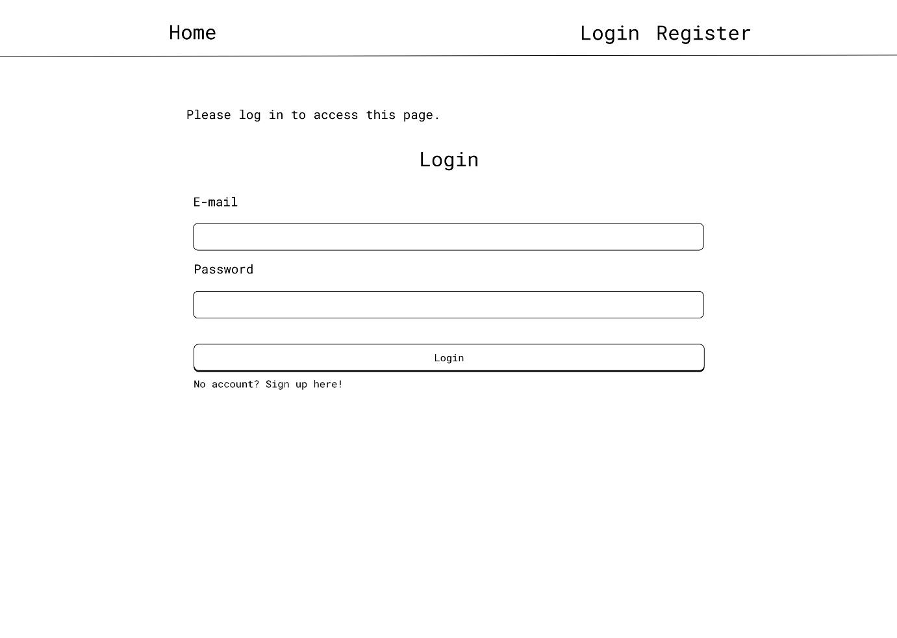

Figure 8 Home Page with Login From - any user view

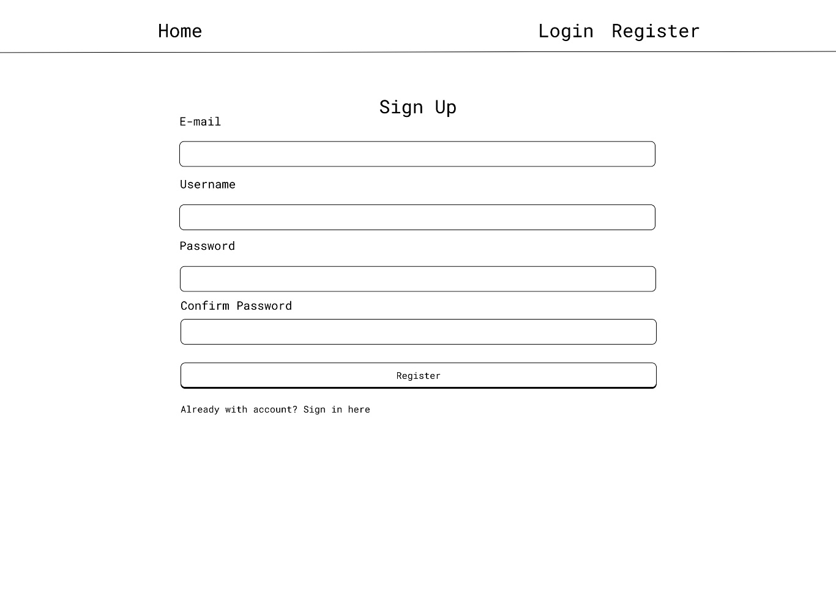

Figure 9 Register Page

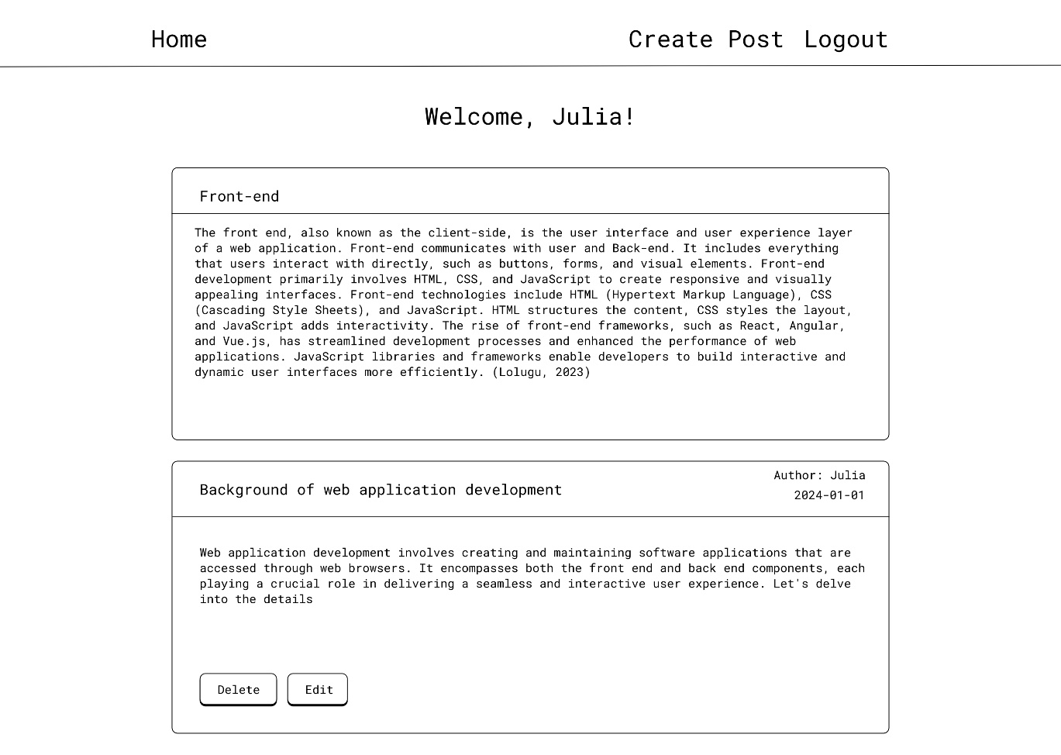

Figure 10 Home page for authorised user

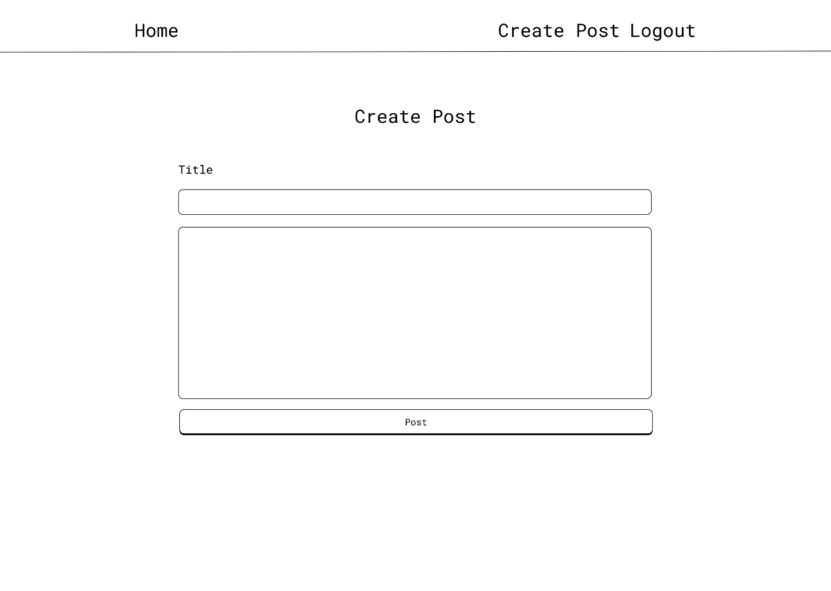

Figure 11 Create Post Page

### Universal Design Storyboard

In the development of the application, an overview for each page has been meticulously crafted, adopting a storyboard format. Each page is thoroughly outlined with its specific title, URL, actionable items, and the potential outcomes associated with those actions. Furthermore, the user has conscientiously emphasized the potential actors or users connected to each page, distinguishing among administrators, authenticated users, and non-authenticated users. This method not only facilitates a comprehensive understanding of the application's structure but also serves as a preventive measure against plagiarism. By infusing unique content and a personalized touch into the overview, the user has ensured an original and distinct representation of the application's functionality.

### Landing Page / Home Page

|  |  |
| --- | --- |
| Title | Home |
| Actor(s) | Non - authenticated users |
| Actions | 1. Login to an existing account 2. Register a new account |
| Outcome | 1. User redirected to login page 2. User redirected to register page |

### Register Page

|  |  |
| --- | --- |
| Title | Register |
| Actor(s) | Non - authenticated users |
| Actions | User initiates account registration by providing relevant information:   1. Username 2. Email 3. Password 4. Confirm Passwort 5. Register Button |
| Outcome | 1. User redirected to login page 2. User redirected to register page |

### Login Page

### Community/Posts Page

### Add Post Page

### Edit Post Page

### Database Design – EER Diagram

## Flask

## Django

# References

Adrian Holovaty, Jacob Kaplan-Moss, 2009. *The Definitive Guide to Django: Web Development Done Right (Expert's Voice in Web Development).* 2 ed. s.l.:Apress.

Beck, K. B. M. v. B. A. C. A. C. W. F. M. .. &. K. J., 2001. *Manifesto for Agile Software Development.* [Online]   
Available at: https://agilemanifesto.org/  
[Accessed 30 12 2023].

Berners-Lee, S. T., 2000. *Weaving the Web: The Original Design and Ultimate Destiny of the World Wide Web.* s.l.:Harper Business.

Consulting, A., 2023. *The Pyramid Web Framework.* [Online]   
Available at: https://docs.pylonsproject.org/projects/pyramid/en/latest/  
[Accessed 28 02 2024].

Daniel Roy Greenfeld, Audrey Roy Greenfeld , 2021. *Two Scoops of Django 3.X: Best Practices for the Django Web Framework.* s.l.:Two Scoops Press.

Django, N/D. *Django Documentation.* [Online]   
Available at: https://docs.djangoproject.com/en/4.2/ref/templates/language/  
[Accessed 10 November 2023].

Duckett, J., 2011. *HTML and CSS: Design and Build Websites.* 1 ed. s.l.:Wiley.

Dwyer, G., 2016. *Flask By Example.* s.l.:Packt Publishing.

Eric Meyer, E. W., 2017. *CSS: The Definitive Guide - Visual Presentation for the Web..* 4 ed. s.l.:O′Reilly.

Frost, B., 2016. *Atomic Design by Brad Frost.* [Online]   
Available at: https://atomicdesign.bradfrost.com/  
[Accessed 06 03 2024].

Grinberg, M., 2018. *Flask Web Development: Developing Advanced Web Applications with Python.* 2 ed. s.l.:O′Reilly.

Hardt, D. C., 2012. *Internet Engineering Task Force (IETF).* [Online]   
Available at: https://datatracker.ietf.org/doc/html/rfc6749  
[Accessed 06 03 2024].

Haverbeke, M., 2018. *Eloquent Javascript, 3rd Edition: A Modern Introduction to Programming.* 3 ed. s.l.:No Starch Press,US.

Hellkamp, M., 2022. *Bottle: Python Web Framework.* [Online]   
Available at: https://bottlepy.org/docs/dev/index.html  
[Accessed 29 02 2024].

Karunanayake, Y., Feb 24, 2023. *Simple History of Programming Languages.* [Online]   
Available at: https://medium.com/@yureshcs/simple-history-of-programming-languages-db299d16b8e4  
[Accessed 02 01 2024].

Kevin Tatroe, P. M., 2020. *Programming PHP.* 4 ed. s.l.:O'Reilly Media, Inc..

Lolugu, K. V., 2023. *Let’s Code the User Experience.* [Online]   
Available at: https://bootcamp.uxdesign.cc/lets-code-the-user-experience-c47c72f50700  
[Accessed 30 10 2023].

Lutz, M., 2013. *Learning Python: Powerful Object-Oriented Programming.* 5 ed. s.l.:O′Reilly.

Marcotte, E., 2010. *Responsive Web Design.* 4 ed. s.l.:A Book Apart.

Martelli, A., 2006. *Python in a Nutshel.* s.l.:O′Reilly.

Martin Fowler, K. B. J. B. W. O. a. D. R., 1999. *Refactoring: Improving the Design of Existing Code..* s.l.:Addison-Wesley.

Matsumoto, Y., 2001. *Ruby in a Nutshell.* 1 ed. s.l.:O'Reilly Media.

Mcfarland, D., 2014. *JavaScript & jQuery: The Missing Manual.* 3 ed. s.l.:O'Reilly Media, Inc, USA.

MongoDb, I., 2021. *The MEAN Stack.* [Online]   
Available at: https://www.mongodb.com/mern-stack  
[Accessed 15 01 2024].

Obregon, A., 2023. *A Journey Through Time: The History of Java Programming Language.* [Online]   
Available at: https://medium.com/@AlexanderObregon/a-journey-through-time-the-history-of-java-programming-language-9b285d139333  
[Accessed 15 11 2023].

opentext, N/A. *What is Dynamic Application Security Testing (DAST)?.* [Online]   
Available at: https://www.opentext.com/what-is/dast#:~:text=By%20conducting%20DAST%20during%20the,damage%20to%20your%20brand%20reputation.  
[Accessed 05 03 2024].

OWASP, 2021. *OWASP Top Ten.* [Online]   
Available at: https://owasp.org/www-project-top-ten/  
[Accessed 06 03 2024].

Patrick Niemeyer, J. K., 2002. *Learning Java.* 2 ed. s.l.:Oreilly & Associates Inc.

Ramírez, S., N/D. *FastAPI.* [Online]   
Available at: ttps://fastapi.tiangolo.com/  
[Accessed 06 03 2024].

Richardson, C., 2019. *Microservice Patterns.* 1 ed. s.l.:Manning Publications.

Robbins, J. N., 2018. *Learning Web Design.* 5 ed. s.l.:O'Reilly Media, Inc, USA.

Ronacher, A., 2010. *Design Decisions in Flask.* [Online]   
Available at: https://flask.palletsprojects.com/en/2.3.x/design/  
[Accessed 11 11 2023].

Rose, S., 2020. *A Complete Guide to the Back-End Mobile App Development!.* [Online]   
Available at: https://codeburst.io/a-complete-guide-to-the-back-end-mobile-app-development-9609f5979231  
[Accessed 14 01 2024].

Rossum, G. v., 2009. *A Brief Timeline of Python.* [Online]   
Available at: https://python-history.blogspot.com/2009/01/brief-timeline-of-python.html   
[Accessed 15 11 2023].

Sharma, R., 2023. *Best Practices for Front-End and Back-End Integration in Full Stack Development.* [Online]   
Available at: https://medium.com/@rishani.ynr/best-practices-for-front-end-and-back-end-integration-in-full-stack-development-bbd21b36399c   
[Accessed 05 11 2023].

Sheffer, U., 2015. Recommendations for Secure Use of Transport Layer Security (TLS). *Internet Engineering Task Force (IETF),* Volume 2070-1721 , p. 26.

Stroustrup, B., N/A. *Bjarne Stroustrup's homepage!.* [Online]   
Available at: http://www.stroustrup.com/  
[Accessed 21 11 2023].

Team, E., 2022. *Guido van Rossum: The Father of Python.* [Online]   
Available at: https://enki.tech/guido-van-rossum-the-father-of-python/  
[Accessed 21 11 2023].

Vincent, W. S., 2020. *Django for Beginners: Build Websites with Python and Django: 1 (Welcome to Django).* s.l.:WelcomeToCode.