Servo robot with radio controls – Paisley YMCA

First, like in all projects, we must test the components are working.

Step 1. Test the Servo

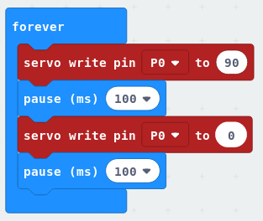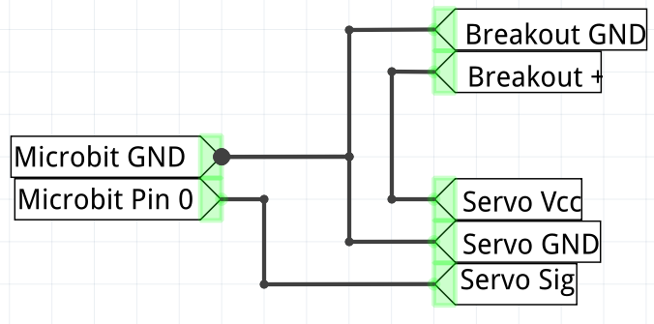

The servo uses 5 volts of power, meaning we have to use the 5v breakout power to power them. Luckily, the control wire of the servo can accept the 3v signal coming from our microbit. We do not have to use a transistor.  
  
Servos use a different colour scheme for their wires. RED is power, BROWN is ground and ORANGE is signal/control.

Remember, all grounds have to be connected by a wire to form common ground.

Step 2. Test both servos.

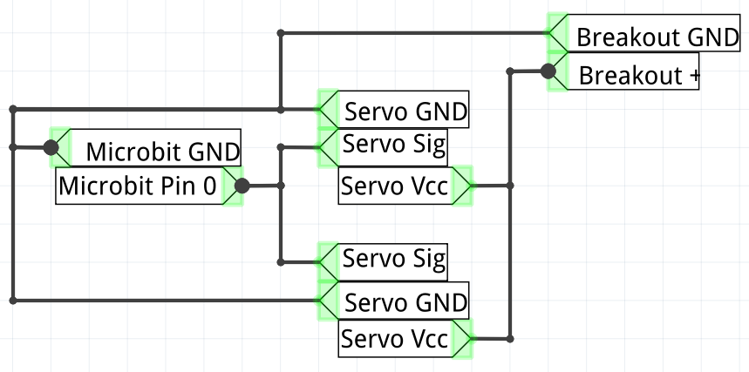

Now test if our batteries can happily power both of the servo motors and that both servos are in operational order.

Step 3: complete the circuits

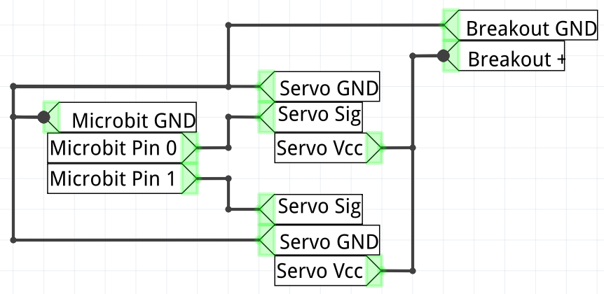

Change the circuit so that each servo is using a different digital pin of the microbit for control and the circuitry is completed!

Let’s move on to the radio-control portion of this project.

Step 4: code the controller microbit

After setting the radio group, all we need the controller to do is send a number over to the microbit controlling the server. We all use the LED display to show us what is happening.

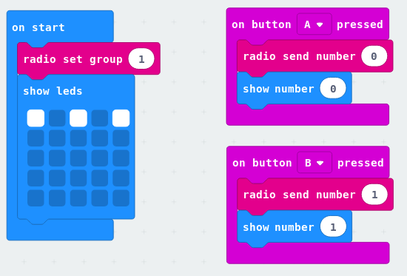

Step 5: Coding the servo-operating microbit

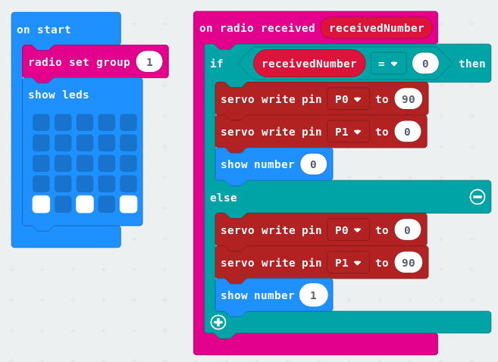

We set the radio group to be the same as the controller, then display some leds showing it was waiting for a signal. When a signal is received, we move the servos and show on the screen that this signal was read.