Sierra API calls

GETTING STARTED

1. Download either Postman or Chrome ARC RESTful API client
2. Patience!
3. Create an account with the Sierra Developer Network: <https://developer.iii.com/>
4. Open the Sierra API documentation and tutorials: <https://techdocs.iii.com/sierraapi/Content/titlePage.htm>
5. Open the Sierra API interactive documentation: <https://www.livermore.lib.ca.us/iii/sierra-api/swagger/index.html>

PART ONE: TEST IT OUT ON THE SIERRA SANDBOX

1. Complete the two tutorials here: <https://techdocs.iii.com/sierraapi/Content/zTutorials/tutList.htm>

PART TWO: SET UP WITH LPL SIERRA API: AUTHENTICATION

1. Request a client key from the Sierra administrator
   1. In the admin app
   2. Sierra administrator should scope this appropriately
2. Set up a client secret
3. Convert the client key and secret using a base 64 translator:
   1. Go to <https://www.base64encode.org/>
   2. Enter your client key and secret in the following format <client_key>:<client_secret>
   3. Example: Key: WO0rS+IFzwLnso/kmPGM6S9h5Lv8 Secret: pleaseletmein

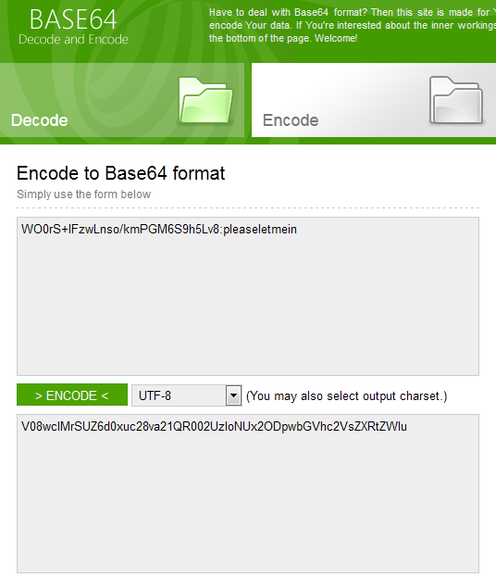

1. Go to the RESTful API client to get a bearer token:
   1. Select the Post method
   2. Enter our token URI in the URL field: <https://www.livermore.lib.ca.us/iii/sierra-api/v3/token>
      1. The version piece may change upon upgrade
   3. In headers, toggle to source mode, use Authorization: Basic <converted string from #3>

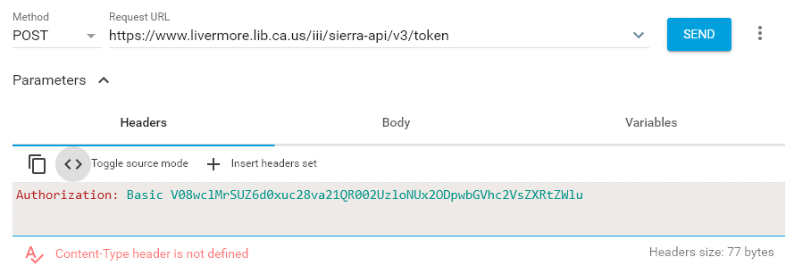

* 1. In body, select raw input and enter <grant_type=client_credentials>

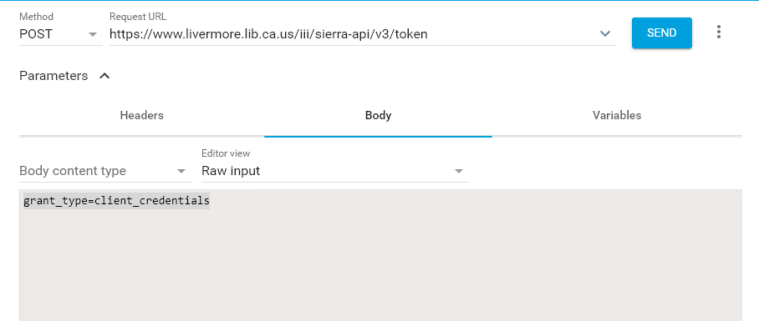

* 1. Then click send:

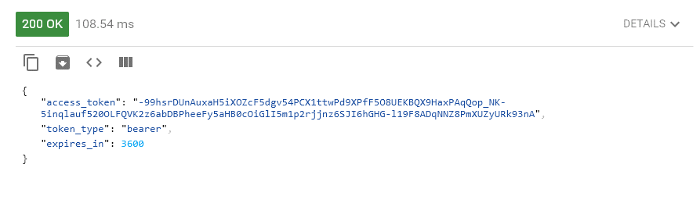

* 1. This will give you the bearer token you will need to perform searches in the API but it only lasts for a short session! You’ll need to send another token request for a new bearer authentication ID for subsequent sessions (you’ll get a 401 unauthorized error, that will let you know you’ve timed out)

PART THREE: API SEARCHES

1. Select the Get method, then use the URI appropriate for the endpoint you are searching:
   1. Patrons, Bibs, etc.
   2. The fines API will not be added until Sierra release 4.3
   3. Example for querying patron fines:
      1. https://www.livermore.lib.ca.us:443/iii/sierra-api/v4/patrons/1001139/fines
2. Use the bearer token assigned to you from the Sierra API authorization from #4 in Part 2. You must also change the authorization to “bearer”:

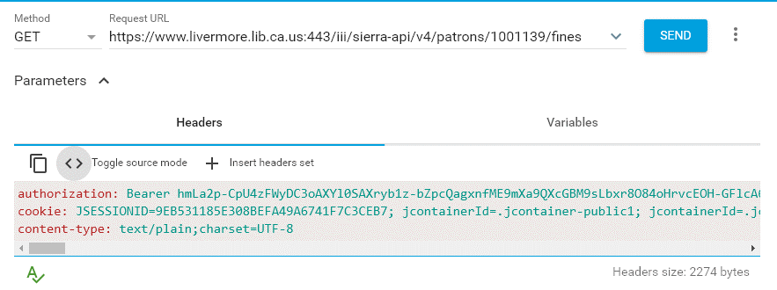

1. You may also set up parameters to ensure that you aren’t selecting suppressed or deleted records as well, or you can specify by date range.
   1. Examples here: <https://techdocs.iii.com/sierraapi/Content/zAppendix/fineObjectExample.htm>