STUDENT ONE CARD LOADING PROCESS

PART ONE: DATA CLEANING AND NORMALIZATION

1. Receive file from LVJUSD IT representative. These should be arriving on a monthly basis, per MOU
   1. For first two loads, LVJUSD IT representative sent CD over to LPL with data file
   2. In process for setting up FTP currently
2. Make a copy of the Excel file, put the original file in the “raw files” folder in :\..\..\..\raw files. Name the new file in this format:
   1. LIVE_SOC_<yyyymmdd>.csv
3. In the copied file, analyze the middle names of the students. The data was messy in the original test load and you may want to pare this down to just the middle initial if possible
   1. Came in full names, initial, and blank
   2. You may be able to use an Excel formula for this, but I exported the data column to a text editor and used a regular expression to clean the data
   3. ([A-Z])(.*)$ REPLACE \1 (this one may also work if you notice many names beginning with a lower case 🡪 (.{1})(.*)$ REPLACE \1
   4. Insert this newly transformed data column next to the original column to verify integrity
4. Concatenate names
   1. Currently the names are in three columns (last, first, middle) and they need to be concatenated into a single column to prepare for load
   2. Add a comma column (right of surname), space column (right of comma column) period column (right of middle initial)

|  |  |  |  |  |  |  |
| --- | --- | --- | --- | --- | --- | --- |
| SURNAME | COMMA | FIRST | SPACE | MIDDLE | PERIOD | FORMULA |
| SMITH | , | BOB |  | B | . | =CONCAT(A2,B2,C2,D2,E2,F2) |

* 1. Copy names into text editor to clean extra space for names without a middle initial
  2. Re-copy data back into Excel into a new column to verify
  3. Add new column to the right of the name with =UPPER() formula
  4. Paste values into new column for normalized values

1. Insert a column to the right of the address and city columns and then use =UPPER() formula to normalize values
2. Add additional data columns (including blank columns) for patron record fixed fields – see template or previous loads for examples.
   1. The csv file will have 20 columns. The table below is split in two, but would be the header row for a ready-to-load file

|  |  |  |  |  |  |  |  |  |  |
| --- | --- | --- | --- | --- | --- | --- | --- | --- | --- |
| Student barcode | Enrollment ID | Concatenated name | - (constant data) | CC (pickup location, constant data) | YOUT (card type, constant data) | Birth date | Expiry date (constant data) | Phone number | LVJUSD Student One Card (constant data) |
| Address | Blank (constant data) | City | CA (constant data) | Zip code | 82 (constant data) | 1 (constant data) | - (constant data) | - (constant data) | Email address |

1. Save the spreadsheet as a .csv file

PART TWO: LOADING THE FILE

1. In Sierra, go to Data Exchange, and select the “Load Patron records (pta)” from the drop down
2. Get PC and select the file
3. Prep the file, then test to ensure the expected number of student records overlay. I believe LVJUSD may be sending the same student data in successive files
4. Click the “create review file” box and load the file

PART THREE: POST LOAD CLEANUP

1. Go to create lists, copy the newly created file into an available review file
2. Go to global update, select patron record type, and then the appropriate review file you just populated
3. Create the following processing rules:
   1. Change fixed field < notice preference (268) < <any> < z (email)

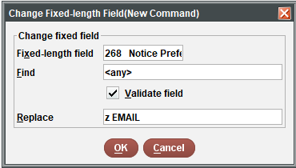

* 1. Then for each enrollment ID (134536, 133397, 130393, 132670), Copy variable field < copy u unique id < value < add x note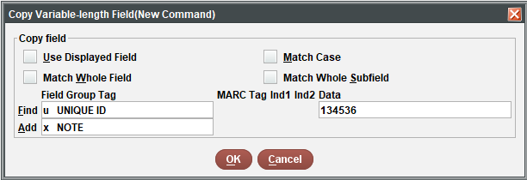

1. Run the processes, then verify that everything looks okay in the review file
2. Go back to global update and process the following rules:
   1. For each enrollment ID, Delete duplicate field < x note < value

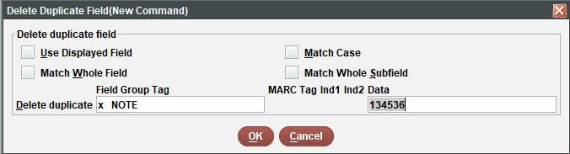

* 1. For each enrollment ID, Delete variable length field < u unique id < value

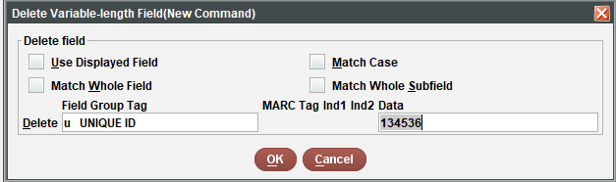

1. Go back to the review file, and check to see if all the data look correct. The goal is to preserve existing data in the unique ID field and move the enrollment ID to an internal note. Don’t empty the file yet!

PART THREE: CHECK FOR PTYPE

1. Open a new review file, store patron type records, and query the review file containing all the loaded student records
   1. Look for the student birth date earlier than this day sixteen years ago:

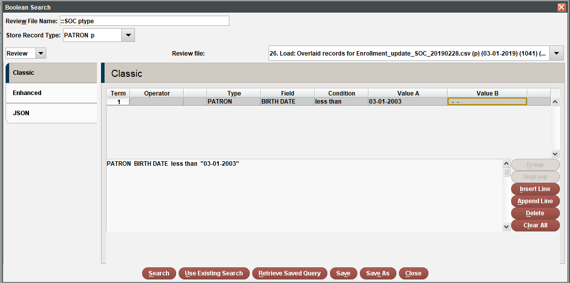

* 1. For those patron records, go to rapid update and change the ptype to adult.
  2. Empty both review files

PART FOUR: CREATE DUPLICATE STUDENT REPORT

1. Create a new review file looking for the birth date range represented in the original student load file. The easiest way to do this is to just sort the original loaded file by birth date and find the range of dates
2. Export the student name, birthdate, and patron record number for this review file. Open this file in Excel
3. Using conditional formatting, look for duplicate values in the data set, then sort the sheet by cell color
4. Output the duplicate values and send along to PS staff for patron record merge procedures